**COS 10004 Computer Systems – Lab 01**

**Mario Stavreski ID: 103055993**

**AND Gate**

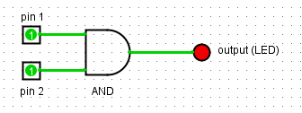

|  |  |  |
| --- | --- | --- |
| Pin 1 | Pin 2 | Output |
| 0 | 0 | 0 |
| 0 | 1 | 0 |
| 1 | 0 | 0 |
| 1 | 1 | 1 |

**NOT Gate**

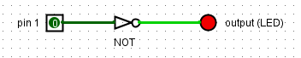

|  |  |
| --- | --- |
| Pin | Output |
| 0 | 1 |
| 1 | 0 |

**NAND Gate**

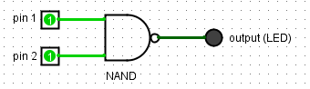

|  |  |  |
| --- | --- | --- |
| Pin 1 | Pin 2 | Output |
| 0 | 0 | 1 |
| 0 | 1 | 1 |
| 1 | 0 | 1 |
| 1 | 1 | 0 |

**Half Adder**

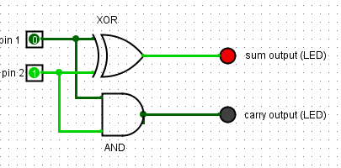

|  |  |  |  |
| --- | --- | --- | --- |
| Pin 1 | Pin 2 | Sum Output | Carry Output |
| 0 | 0 | 0 | 0 |
| 0 | 1 | 1 | 0 |
| 1 | 0 | 1 | 0 |
| 1 | 1 | 0 | 1 |

**Full Adder**

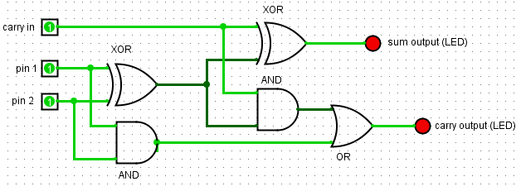

|  |  |  |  |  |
| --- | --- | --- | --- | --- |
| Pin 1 | Pin 2 | Carry in | Sum output | Carry output |
| 0 | 0 | 0 | 0 | 0 |
| 1 | 0 | 0 | 1 | 0 |
| 0 | 1 | 0 | 1 | 0 |
| 0 | 0 | 1 | 1 | 0 |
| 1 | 1 | 0 | 0 | 1 |
| 1 | 0 | 1 | 0 | 1 |
| 0 | 1 | 1 | 0 | 1 |
| 1 | 1 | 1 | 1 | 1 |