**COS 10004 Computer Systems – Lab 01**

**Mario Stavreski ID: 103055993**

# 4-bit Register

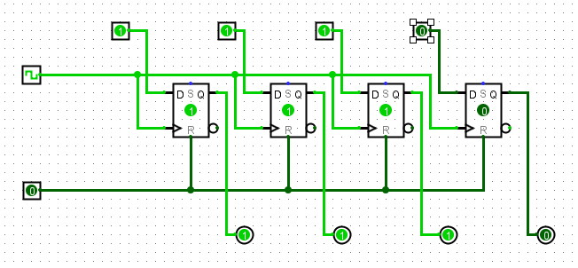

|  |  |  |
| --- | --- | --- |
| Ox | Input | Output |
| 0 | 0000 | 0000 |
| 1 | 0001 | 0001 |
| 2 | 0010 | 0010 |
| 3 | 0011 | 0011 |
| 5 | 0101 | 0101 |
| A | 1010 | 1010 |
| B | 1011 | 1011 |
| C | 1100 | 1100 |
| D | 1101 | 1101 |
| E | 1110 | 1110 |
| F | 1111 | 1111 |

Counters are fundamental to modern computing architectures. Review the lecture slides on counters and answer the following questions:

* 1. Name one crucial role (hardware) counters play in modern computing architectures?
* A computer has a lot of needs for counters which are designed and built into modern processors such as to keep count of events or clock pulses etc…
  1. Describe in a few sentences how a ripple counter works. How does the “ripple” occur ?
* A ripple counter is an asynchronous counter where only the first flip-flop is clocked by an external clock. All subsequent flip-flops are clocked by the output of the preceding flip-flop.

# JK Ripple Counter

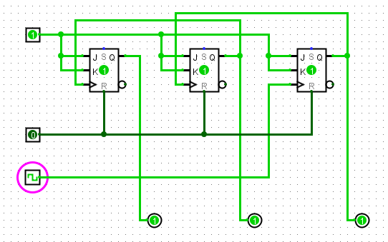

# JK Counter with a common clock

