**COS 10004 Computer Systems – Lab 01**

**Mario Stavreski ID: 103055993**

* 1. ROM (read only memory): All reading at full speed. Just get the address and go there. – contents built-in at time of manufacture
  2. Ram (random access memory): Ram stores the data the temporarily on the computer but rom stores the data permanently
  3. Dynamic RAM is the most common type of memory in use today. Inside a dynamic RAM chip, each memory cell holds one bit of information and is made up of two parts: a transistor and a capacitor. In static RAM, a form of flip-flop holds each bit of memory. A flip-flop for a memory cell takes 4 or 6 transistors along with some wiring, but never has to be refreshed.
  4. USB sticks use flash memory. We should not rely on essential data storage because it is incompatible with backups. The Neumann (or Princeton) architecture is distinguished by the use of a single path to reach a main memory that stores both instructions and data. Harvard architecture is associated with separate memories.

2. 8589934592 bits are needed to address all bytes in the system’s RAM.

3. The major difference between the two architectures is that in a Von Neumann architecture all memory is capable of storing all program elements, data and instructions; in a Harvard architecture the memory is divided into two memories, one for data and one for instructions.

4. Cache memory, also called CPU memory, is high-speed static random access memory (SRAM) that a computer microprocessor can access more quickly than it can access regular random access memory.

5. 1. Internal interrupt 2. Software interrupt 3. External interrupt

5.1 An interrupt controller polls all devices on a computer to identify which one submitted the request.

6. Stacks offer a way of organising and accessing memory without random (indexed) access: – There are hardware stacks and software stacks.

6.1 A stack allows us to mothball/backup/hibernate a process/ task at will on the receipt of an interrupt or code invocation.

To do this, we:

1. push instructions/data that we will need later onto the stack;

2. do the task;

3. and then pop the stored data back off the stack and

4. continue as before

6.2 Peek: Allows the inspection of the topmost element on a stack without removing the element.

Swap: Also referred to as “exchange,” the positions of the two top elements of the stack are swapped, the first element becoming the second and the second becoming the top.

Duplicate: The highest element in the stack is popped and then pushed back onto the stack twice, resulting in a duplicate of the original element.

Rotate: Also known as "roll," this specifies the number of components in a stack that are rotated in order. Rotating the top four items of a stack, for example, moves the topmost element into the fourth place while the next three elements move up one position.

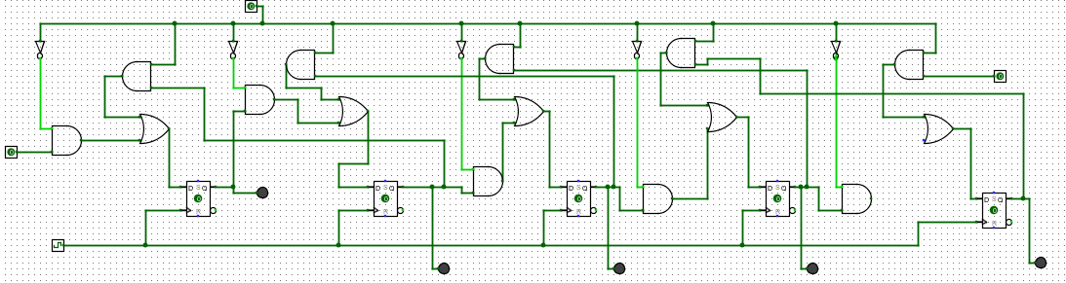7.

10.

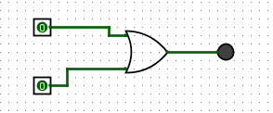

11.

