Dynamic Pricing Model for Local Events & Experiences

Objective
To develop a dynamic pricing algorithm for local events in India (such as movie releases, concerts, and workshops), based on:
- Event metadata (genre, title)
- Real-time web demand (Google Trends)
- Estimated sentiment from event descriptions
- Competitor pricing
- Reinforcement learning-based price optimization
This helps event organizers optimize their revenue by adjusting ticket prices intelligently.

Setup Instructions

1. Environment Setup -
Install Python (recommended: 3.9 or above)
- Install required packages:
- pip install pandas numpy selenium matplotlib seaborn scikit-learn pytrends
Download the appropriate Chrome WebDriver version for your browser and place it in your working directory.

2. Required Files
- Python Jupyter Notebook (.ipynb) provided with full implementation
- CSV export for Power BI (event_data.csv)
- Power BI .pbix dashboard (exported file)

3. Data Sources Used
- BookMyShow (India) – Scraped event/movie titles and genres via Selenium
- Google Trends API – For demand estimation based on search volume
- Genre Sentiment Mapping – Predefined sentiment values for simplicity
- Simulated Competitor Pricing – Due to limited public APIs for local pricing

Model Explanation

- Data Collection: Used Selenium, Google Trends API, genre-to-sentiment mapping, and simulated competitor pricing
- Data Processing: Combined all attributes including price calculated by formula: price = 5 * sentiment + 0.3 * competitor_price + noise
- ML Model: Linear Regression; fallback to RMSE as R2 was undefined
- Reinforcement Learning (Q-Learning): States as sentiment level, actions as price points
- Visualization: Done in Power BI

Results & Insights

Total Events Analyzed: 5
Events Used in Pricing Model: 5
Model RMSE: ~71.68

Q-Table Pricing Strategy (Normalized Rewards)

Sentiment | ₹500 | ₹800 | ₹1000 | ₹1200 | ₹1500
low | 0.00 | 0.00 | 0.00 | 0.00 | 0.00
medium | 0.41 | 0.44 | 0.45 | 0.41 | 0.41
high | 0.78 | 0.82 | 0.97 | 0.99 | 1.00

Interpretation:
- Events with high sentiment (e.g. blockbusters) should be priced closer to ₹1200–₹1500
- Medium sentiment events are optimal around ₹1000
- Low sentiment events are not recommended for premium pricing

Recommendations

- Increase dataset size (scrape more than 5 events)
- Integrate Twitter API for real-time public sentiment
- Use real competitor data instead of simulation
- Extend model with time-based dynamic pricing

Power BI Dashboard Screenshots
The following screenshots illustrate the visual insights derived from the dynamic pricing model:
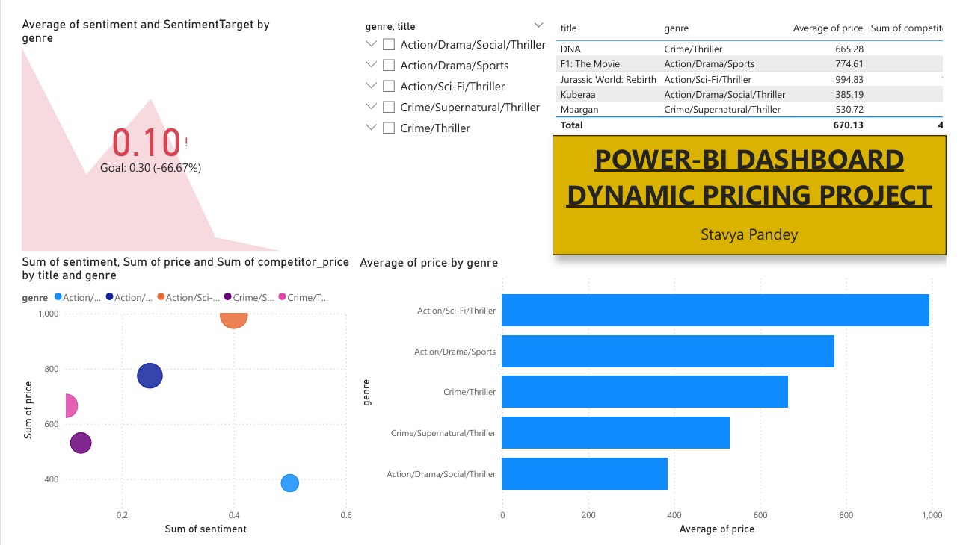
Thanks,
Stavya Pandey

