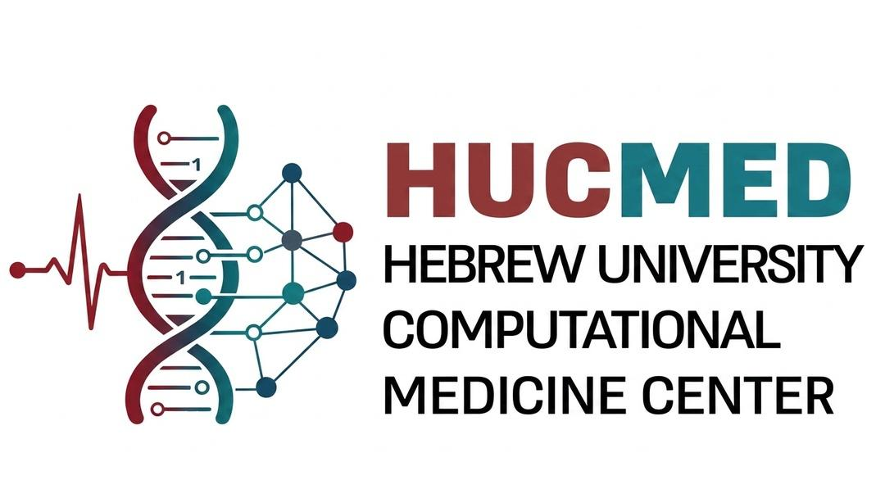

Call for Proposals — HUCMED Seed Grant Program
Advancing Computational Research in Cancer and Mother & Child Health
Submission Deadline | Funding Period
15 June 2026 | 12 months, starting October 2026
1. Overview and Objective
The Hebrew University Center for Computational Medicine (HUCMED) is pleased to announce a new Seed Grant Program to catalyze high-impact, interdisciplinary research in computational medicine. The program supports the generation of proof-of-concept (POC) results and preliminary data that position investigators to compete successfully for larger external funding.
2. Research Areas
Proposals must fall within one of the following two tracks:
- Track A — Cancer: multi-omics integration, predictive modeling, technology development, and personalized treatment algorithms.
- Track B — Mother & Child Health: developmental biology, prenatal diagnostics, neonatal monitoring, and pediatric precision medicine.
3. Eligibility and Collaboration
Open to researchers from the Hebrew University and its affiliated hospitals and institutions. Priority will be given to collaborative proposals submitted by two or more Principal Investigators that bridge basic research and clinical application. A Principal Investigator may participate in only one proposal under this call.
4. Funding and Budget
- Award: USD 25,000 per project, shared between the participating laboratories.Allowable costs: research personnel, data access fees, computational resources, and consumables directly related to the research.
5. Evaluation Committee
Proposals will be reviewed by an ad hoc committee of subject-matter experts convened by HUCMED.
6. Proposal Structure
Applications must be submitted in English as a single PDF. Format: 3 pages max. (including references; figures), 11 pt font, 1.5 spacing, ½-inch margins.
The proposal must include:
- Scientific Abstract (250 words maximum).
- Introduction and Hypothesis: state of the art and the specific clinical challenge.
- Collaborative Plan: scientific synergy between the participating PIs.
- Computational Medicine Approach: integration of computational tools with clinical/translational research.
- Path to Scale: specific large-scale funding programs (e.g., ISF, ERC, NIH) targeted on the basis of the POC results.
The same PDF must additionally include a concise budget justification and a short CV (2 pages max.) for each PI.
7. Reporting and Affiliation
- Reporting: a single summary report upon completion of the 12-month funding period.
- Affiliation: all resulting publications, presentations, and grant applications must acknowledge HUCMED and the Azrieli OMICs Center.
Submission: all applications must be submitted through the official online application form by 15 June 2026. Late or non-compliant submissions will not be considered.

