Root production in perennial grasslands

Stacy A. Smith-updated 7 June 2019

Goal: Estimate root-rhizome production in perennial grassland species in relation to seasonality, spatial variation, simulated grazing (clipping/manure addition) and vegetative composition.

Experimental design

* Location: BRU
* Length of study: Mar – Nov
* Soil type: Pomona sand 0-2% slopes (based on Web Soil Survey)
* 3 treatments (control, clipping only, clipping + manure)
* 8 blocks (4 bahia, 4 mixed bahia+perennial peanut), each 10-m2
* 2 subplots/block (3-m2) + 1 mini subplot (1-m2)/block for chamber measurements only
* Root production measured initially with ingrowth cores (March – May, May-Nov) and then we installed minirhizotron tubes in May
* ~~Root production measured with sequential ingrowth cores (dia=8-cm, len=30-cm, mesh=4-mm polyester fabric lining with wire mesh support)~~
  + ~~6 soil core harvests (4 2-mo harvests and 2 half harvests)~~
* ~~8 blocks x 2 subplots x 3 treatments x 2 cores/treatment = 96 ingrowth cores at a given time~~

|  |  |  |
| --- | --- | --- |
| **Month** | **Date** | **Task** |
| March | 1-5 | Plot set-up, rake thatch |
| 6-14 | **INSTALLED** cores **#1** and **#2** |
| 14 | Baseline soil temp/VWC, applied clipped treatment |
| 15 | Applied manure treatment |
| April | 1 | Record soil temp and VWC |
| 15-16 | Apply clip and manure treatments, collect/weigh clipped material |
| May | 1 | Record soil temp and VWC |
| 6-14 | **REMOVED** core **#2**, **INSTALL** core **#4** |
| 15-16 | Apply clip and manure treatments, collect/weigh clipped material |
| June | 1 | Record soil temp and VWC |
| 13-14 | Apply clip and manure treatments, collect/weigh clipped material |
| July | 1 | Record soil temp and VWC |
| 5-15 | **REMOVE** core **#1** ~~and~~ **~~#4~~**~~,~~ **~~INSTALL~~** ~~cores~~ **~~#3~~** ~~and~~ **~~#5~~** |
| 16-17 | Apply clip and manure treatments, collect/weigh clipped material |
| August | 1 | Record soil temp and VWC |
| 15-16 | Apply clip and manure treatments, collect/weigh clipped material |
| September | 1 | Record soil temp and VWC |
| ~~9-13~~ | **~~REMOVE~~** ~~core~~ **~~#5~~**~~,~~ **~~INSTALL~~** ~~core~~ **~~#6~~** |
| 16-17 | Apply clip and manure treatments, collect/weigh clipped material |
| October | 1 | Record soil temp and VWC |
| 15-16 | Apply clip and manure treatments, collect/weigh clipped material |
| November | 1 | Record soil temp and VWC |
| 6-15 | **REMOVE** cores **~~#3~~** ~~and~~ **~~#6~~ #4** |
| 15-18 | Clip all treatments (including controls), collect and weigh clipped material |

**Diagram of initial experimental design with 8 treatment blocks (green) at BRU. Experimental treatments within subplots (orange) and mini subplots (blue) will be randomly assigned. The ingrowth core measurements were altered after the installation of minirhizotron tubes.**

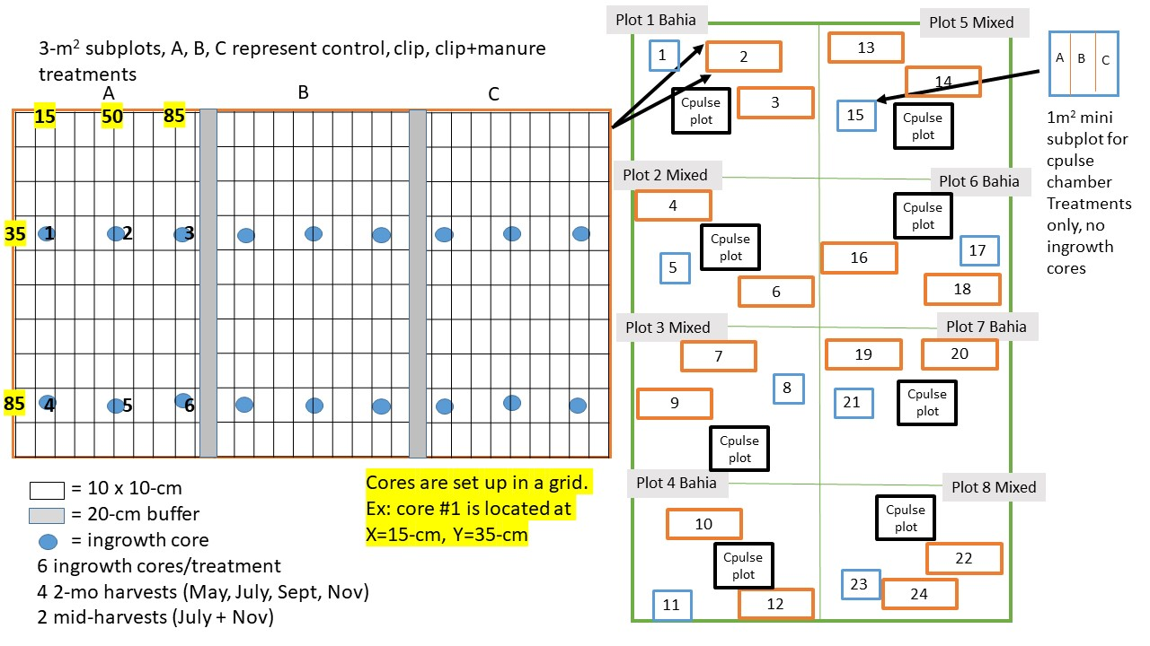

**\***

**\***

**\***

**\***

**\***

**\***

**\***

**\***

**X**

**X**

**X**

**X**

**X**

**X**

**X**

**X**

**X**

**\*minirhizotron tubes were installed in 8 plots on 7 May 2019. At that time we removed core #2 and installed core #4. We decided not to install cores #3, 5, and 6. Core #1 will be removed in July and #4 will be removed in November.**

Subplot installation

* There are 2 types of subplots per block = two 3-m2 (for ingrowth cores) and one 1-m2 (for allowing future chamber pulse-chase to get short-term allocation patterns)
* All subplots subjectively located based on vegetation criteria (bahia or mixed bahia+peanut)
* All subplots are divided evenly into thirds (A, B, C in diagram) and treatments randomly assigned
* All thatch was removed at installation (by raking) within all subplots (and treatments)
* FOR MINI SUBPLOTS (1-m2) ONLY we created a buffer between the treatments using aluminum metal sheeting (10” width x 1 m wide). Aluminum sheeting was buried 4” belowground, leaving 6” aboveground
* FOR 3-m2 subplots, there is a 20-cm buffer between treatments
* All subplots are labeled (plot,treatment) on the top (north) left corner flag (e.g. 1A, 1B, 1C)

Installation of ingrowth cores

* Use soil auger to remove initial soil core at 45 degree angle, to a depth of ~28-cm
  + first and second core are kept separate, to maintain soil horizon
* Sieve soil cores, individually, through ¼” mesh screen to remove all large roots
* Insert ingrowth frame into the ground
* Replace sieved soil, first with the bottom and then top core, into ingrowth core frame, packing (with dowel) to a similar bulk density
* Sequential cores will be installed ~20-cm apart
* Cores are labeled (in diagram) 1-6 and organized in a grid system. Cores 1 and 3 are half treatment cores, 2, 4, 5 and 6 are 2-mo cores.
* Installation of ingrowth cores was discontinued after the minirhizotron tubes were installed (May 7). Core #1 remained a half treatment core. Core #2 a two-month core and core #4 a 6-month core.

Treatment application

* Clipping treatment
  + Clip all aboveground vegetation to ~3” height monthly, prior to manure application
  + Use pvc frame to ensure consistent height, clip with electric hedgetrimmer
  + Collect all cut material after each clipping, dry (60 C) and weigh (nearest 10th g)
  + Control treatments will be clipped at the end of experiment
* Manure application
  + Applied monthly, ideally post clipping
  + Ideal range for monthly manure application = 450g/m2 , weighed with kitchen scale, total monthly collection ~8.5-kg, ~3/4 of a 5-gal bucket
    - Within 1-m2 treatment areas (3-m2 subplots) we apply 450g/month. Total monthly application = 1-m2 x 16 = 16-m2 x 450g/m2 = 7.20 kg per month
    - Within 0.33-m2 mini subplots (1-m2) apply 150-g/month. Total monthly application = 1/3m x 8 = 2.4-m2 x 450g/m2 = 1.08 kg/month
  + Spread manure evenly across treatment plot
  + Collect subsample of manure to dry (in oven) and prepare for %C and %N analysis. (Ball grind, send to Jason, request 3 separate runs from the same vial)

Soil temperature and soil moisture

* Collected monthly, from the center of each treatment area (both subplots and mini-subplots)
* Collect to a depth of 11-cm, this includes the entire probe for soil moisture but a subset of the probe for temperature

Extraction of ingrowth cores

* Using shovel, make two insertions along the side of the ingrowth core, and prop up core with tip of shovel
* Refrigerate cores during processing if you need to store for 1-2 days
* Dry sieve through 2-mm sieve, then transfer to 1-mm sieve and rinse, try to remove rocks/charcoal/debris
* Dry roots/rhizomes at 60 deg until weights are stabilized (~2 days)
* Separate roots from rhizomes before weighing (if possible-we were not able to do this for the May harvest), weigh to nearest 10th decimal

Notes from Katie Cooley’s thesis on calculations

* Katie was able to detect differences in rate of entry and biomass between cultivars
* Biomass multiplied by constant (100,000/[pi*3.75^2]) to convert to kg ha-1
* Net accumulation rate = biomass/# days core in place (kg ha-1 d-1)

Notes about manure collection/application at BRU

Contact Danny Driver (352) 538-1401 with any questions or concerns. He offered to let me know when cows are penned each month. In March we collected manure within the cattle pen. Cows had been rounded up from the pasture the day prior for vaccinations, so this was opportune since calving had just ended and bulls were about to be put out on the pastures. Manure was easily scraped up from the pen and shoveled into a bucket. We used ~3/4 of a 5-gallon bucket.

In March cows were supplemented with cotton seed and corn gluten at a rate of 4lbs/head/day. Cows are vaccinated for vibriosus (spp??, basically cow VD) and given a mineral supplement (Sel Plex). Antibiotics are given on a case by case basis and horomones are only given to sync heat or during embryo transfer (2cc prostoglanic and 2cc RH).

Each month we collect a subsample of manure and collect a wet and dry and deliver ground sample to Jason for EAIRMS. We request Jason conduct 3 runs from our single sample.

March manure was applied on 3/15, wet weight=495g, dry=260g (wt%N 0.60-0.71, wt%C 11.67-13.20)

In April we applied 1-day old manure, wet weight = 434g, dry=210g (wt%N 1.02-1.09, wt%C 19.73-20.84)

Manure was not applied in May due to logistical constraints with labor and timing of cattle penning.

In June we applied 1-day old manure on 6/6, wet weight =

Minirhizotron tube installation

Twenty-four minirhizotron tubes were installed into 8 treatment plots (2,4,9,10,13,18,20,22) on 7 May 2019. Prior to installation, we removed ingrowth core #2, but retained core #1. Tubes are constructed of acrylic, 3’ in length (91.44-cm) and 2” (5.08-cm) diameter, complete with a waterproof bottom seal and cap. Tubes were installed using a tractor affixed with a Kelly bar implement, drilled to a depth of 123-cm at a 45 degree angle. Tubes were oriented east-west through the center of each 1x1-m plot. Tubes were pushed by hand (and mallet if needed) into the drilled hole, making complete contact with soil, reaching a depth of ~45-cm. Approximately 15-cm (76.44-cm belowground) of the tube remained aboveground and was spray painted black to block light entrance and covered with reflective bubble insulation to preserve then longevity of the plastic.

Minirhizotron photos

Each minirhizotron tube at BRU records 44-45 photos (referred to as locations along tube). At the initiation of this project, all photos were referenced at location one, and only one tube had 45 locations.

The login for the minirhizotron camera computer is Btc and the password is taped to the top of the computer screen (3522733408). It is best for organization of the data if you record all photos into one session, even if it takes more than one day. You can do this by pausing before you exit, instead of ending the session. Tube lengths are 76-cm, spacing=13.5-mm, locations/tube = 45.

Prior to taking images make sure there is no condensation inside of the tube. Be careful to not shift the tube when inserting/removing camera. After positioning camera, make you are completely zoomed out and in focus. Images are saved to the computer C:\btc2\images\BRUrootstudy_images. You will need a flash drive to transfer the images.

Processing minirhizotron images

For each session you will acquire 1057 images. Store images in a unique folder by session. I usually store the raw images on the server, but you will need to work off the desktop to do the processing. You will also need the winrhizotron key (usb in cabinet above sink).

* Insert winrhizotron key
* Save images onto desktop
* You may also need to pull the winrhizotron program off the network and save a shortcut to the desktop (ifas\AGR\GROUPS\Rowlandlab\WinRHIZOtron\
* Open program -it will ask you to select source but hit cancel and ok program
* Load calibration (calibration tab\load calibration) navigate to winRHIZOtron folder on network (link above) and select “BTC7-2014-system”. This is the calibration that the Rowland lab created. If the load link is not active, make sure “object of known dimensions” is selected. If “intrinsic” is selected it will not give you the option to load.
* Click on acquisition icon
* Select how you want the image to load. Initially used “tube current session” but for sequential image processing, “tube current and previous sessions” may be best.
* Navigate to the image folder on desktop
* Once image is open, the program will prompt you to either create a new text file or open previous one
* To trace roots, will need to select the root tracing mode.
* Refer to Win RHIZOTRON manual (2011) for more details (stored in cabinet above sink)

Some general guidelines used during processing

* For roots with hairs, traced area was widened to include hairs with root. The idea was to capture all areas of uptake.
* In general, we did not trace roots we could not confirm. You can always go back at add/delete roots from previous sessions later
* Did not trace spider webby masses
* Kept a log for each tube on questionable issues

Field list

Soil core installation

* Ingrowth cores (n=96)
* Soil auger
* 2-3 buckets (to hold soil)
* ¼” sieve
* Hand shovel
* Gloves
* Dowel (to compress soil into core)
* Sharpee to label subplot flags

Treatments

* 5-gal buckets and lids
* Shovel
* Gloves
* Kitchen scale
* Manure rake
* Rake (to remove thatch and collect clipped material)
* Safety equipment for handling manure (Gloves, respirator, etc)
* Hand clippers, hedgetrimmer
* Paper bags (for collecting clipped material)
* Sharpee (for labeling) paper bags
* Datasheet

Core removal

* Shovel or hand trowel
* Gloves
* Plastic bags (to hold cores)
* Sharpee (to label bags)
* Plastic bins (to carry cores), there will be 48 in May and Sept and 96 in July and Nov
* Sieves (2 and 1-mm) and screen? (to catch fine roots)
* Hose nozzle
* Paper bags (for roots/rhizomes)

Weighing biomass (clipped aboveground and belowground)

* Scale
* Datasheets/pencil
* Weigh boats

Soil moisture/temperature

* Soil moisture and temperature monitors
* Datasheet
* Cloth to wipe probes clean

Minirhizotron photos

* Camera
* Computer
* Batteries (2) make sure to charge the night prior
* Cart
* Umbrella
* Rags+long pole to clean condensation from inside tubes
* Extra zip ties
* Flash drive