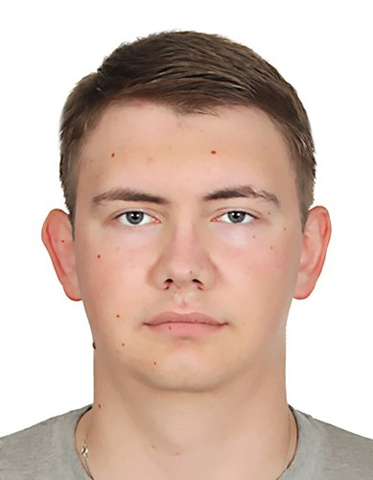 | Dryagin Vadim  Male, 21 year, born on 6 September 2001  +7 (960) 9884716 — preferred means of communication  draginvadim@gmail.com  Another site: https://github.com/Umbreella  Reside in: Omsk  Citizenship: Russia  Ready to relocate, not ready for business trips
Desired position and salary
Python Backend Developer
Specializations:
— Programmer, developer

Employment: full time, project work, work placement
Work schedule: full day, remote working
travel time to work: any
Education
Vocational secondary
2025 | Omsk State Technical University  Faculty of distance learning, Applied informatics in economics
2022 | Omsk Aviation College named after N.E. Zhukovsky  Programming in computer systems (Diploma with honour)
Key skills
Languages | Russian — Native
Skills | Python Django DRF Celery FastAPI SQLAlchemy Unittest PyTest GraphQL SQL PostgreSQL Redis Git Docker HTML CSS JavaScript
Additional information
About me | IT Portfolio (Login details) - https://umbreella-dev.ru/  Projects:  1, Unicat - Online Courses with Mail Verification, Online Payment, PDF Certificate Generation.  • Backend - Python, Django, DRF, Celery, GraphQL, Unittest, PostgreSQL, Redis  Source code: https://github.com/Umbreella/unicat_backend  REST-API: https://unicat.umbreella-dev.ru/api/docs/  GraphQL: https://unicat.umbreella-dev.ru/graphql/docs/  • Frontend - HTML, CSS, Bootstrap, JavaScript, React  Source code: https://github.com/Umbreella/unicat_frontend  WEB: https://unicat.umbreella-dev.ru/  2. Abz.Agency - Online directory of employees (more than 50,000 people).  • Backend - Python, Django, DRF, Unittest, PostgreSQL  Source code: https://github.com/Umbreella/abz_agency_test  REST-API: https://abzagency.umbreella-dev.ru/api/docs/  • Frontend - HTML, CSS, Bootstrap, JavaScript  WEB: https://abzagency.umbreella-dev.ru/  3. Shoptoday - REST-API for an online store, with products, users, banking transactions.  • Backend - Python, FastAPI, PyTest, PostgreSQL  Source code: https://github.com/Umbreella/shoptoday_backend  REST-API: https://shoptoday.umbreella-dev.ru/api/docs/

