**System program - Assignment 1**

**SFP**

The purpose of this assignment is to become familiar with data representation of computer systems, especially about floating point numbers. You will design and implement **16-bit floating** point type, so called here *small* floating point or **sfp** that is compatible with most of IEEE standard 754 behaviors (explained in the class material 02_3_float.pdf); recall that you’ve learned about 32 bits (*single* precision) and 64 bits (*double* precision) standards.

In this assignment, you will implement the type cast and the addition operation of **sfp** that are defined in the below specification section. It is not permitted to use any library that is specifically designed for such different floating point types.

The format of **sfp** contains

* bit sign (s),
* 5-bit exponent (exp),
* 10-bit significand (frac).

The format of **sfp** is laid out as follows.

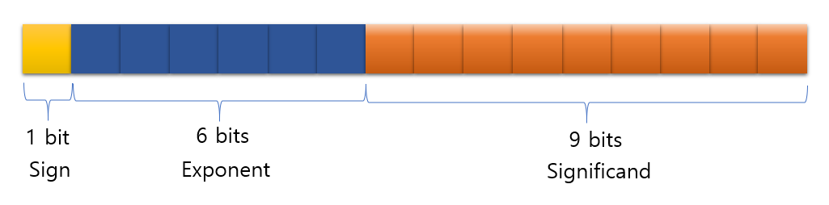

**1 bit**

**Sign**

**5 bit**

**Exponent**

**10 bit**

**Significand**

1. **Specification of sfp :**

In C, **sfp** is represented as below.

typedef unsigned short sfp;

In order to utilize such a newly implemented data type, it is required to design and implement functions supporting conversion with several conventional data types. To do so, you will implement the following four type-cast functions (type conversion with **int** and **float**). In addition, you will also implement one arithmetic operation, the addition function.

/* convert int into sfp */

sfp int2sfp(int input);

/* convert sfp into int */

int sfp2int(sfp input);

/* convert float into sfp */

sfp float2sfp(float input);

/* convert sfp into float */

float sfp2float(sfp input);

sfp sfp_add(sfp in1, sfp in2);

You will also implement the following bit stream function so that you will be able to return the bit stream of **sfp** data for the result evaluation.

char* sfp2bits(sfp result);

1. **Detail specification of sfp :**

sfp int2sfp(int input), sfp float2sfp(float input)

* These functions are used to convert **int** data type, and float data type into **sfp** data type, respectively. The return data type is **sfp**.
* For the value which exceeds the range of **sfp** (overflow), mark the result as ±ꝏ. (The sign must be ensured clearly. Note that +ꝏ and -ꝏ are different.)
* Use round-to-zero as rounding mode.
* For **int** 0, mark the result as **sfp** +0.0

|  |  |
| --- | --- |
| **Input (int, float)** | **Output (sfp)** |
| >maximum of sfp | +ꝏ |
| <minimum of sfp | -ꝏ |
| int 0 | +0.0 |
| Round-to-zero mode | |

**Special result values for int2sfp and float2sfp**

int sfp2int(sfp input)

* This function is used to convert **sfp** data type into **int** data type. The return data type is **int**.
* +ꝏ and -ꝏ is represented as TMax and TMin of **int**, respectively.
* NaN is converted into TMin.
* Use round-toward-zero as rounding mode.

|  |  |
| --- | --- |
| **Input (sfp)** | **Output (int)** |
| +ꝏ | TMax |
| -ꝏ | TMin |
| ±NaN | TMin |
| Round-to-zero mode | |

**Special result values for sfp2int**

float sfp2float(sfp input)

* This function is used to convert **sfp** data type into **float** data type. The return data type is **float**.
* Note that there is no exception or error cases since **float** type is capable of covering all the value range of **sfp**.

sfp sfp_add(sfp in1, sfp in2)

* Two **sfp** variables are given as inputs. The result is a **sfp** data type value representing the sum of the inputs.
* For the result which **exceeds** the range of **sfp** (overflow), mark the result as infinity. (the sign must be ensured clearly)
* Use round-to-even rounding mode.
* Casting **sfp** to **float** or **double** for this addition are prohibited in the function. Manipulating the bits of the two **sfp** variables is required.

|  |  |  |
| --- | --- | --- |
| in1 | in2 | result |
| +ꝏ | +ꝏ | +ꝏ |
| +ꝏ | -ꝏ | NaN |
| +ꝏ | Normal Value | +ꝏ |
| -ꝏ | -ꝏ | -ꝏ |
| -ꝏ | Normal Value | -ꝏ |
| NaN | Any Value | NaN |

**Special result values for sfp_add**

sfp sfp_mul(sfp in1, sfp in2)

* Two **sfp** variables are given as inputs. The result is a **sfp** data type value representing the multiplication of the inputs.
* For the result which **exceeds** the range of **sfp** (overflow), mark the result as infinity. (the sign must be ensured clearly)
* Use round-to-even rounding mode.
* Casting **sfp** to **float** or **double** for this multiplication are prohibited in the function. Manipulating the bits of the two **sfp** variables is required.

|  |  |  |
| --- | --- | --- |
| in1 | in2 | result |
| +ꝏ | +ꝏ | +ꝏ |
| +ꝏ | -ꝏ | -ꝏ |
| -ꝏ | -ꝏ | +ꝏ |
| +ꝏ | Normal Value | +ꝏ |
| -ꝏ | Normal Value | -ꝏ |
| ±ꝏ | 0 | NaN |
| NaN | Any Value | NaN |

**Special result values for sfp_mul**

char* sfp2bits(sfp result)

* This function is used to return the bit stream of **sfp** data type. (e.g. if **sfp** val means 15 in decimal, char *string=sfp2bits(val); has “0100101110000000”)
* Use malloc() in the function for returning a string. The returned string can be freed by the caller of sfp2bits().

1. **Example :**

Each line of an input file contains only a number. The first line denotes the number of inputs as int. Given the number of inputs, the following lines include int type inputs. Same format of input lines is followed for the case of float type inputs.

Input file

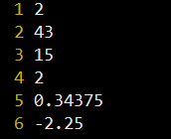

**Execution result**

1. **Note**

* Skeleton code is given in **sfp.c**. Input cases and scoring system will be implemented by TA.
* **Include a pdf file (or doc file) that explains your design and code in your sfp.c file.** The file name is studentid.pdf.
* After implementing all functions, type “make” on your terminal, and execute “hw1”.
* Zip all the files relevant to this assignment such as **sfp.c, sfp.h, hw1.c, Makefile, studentid.pdf**. The zipped file name must have a form of “**studentid.tar**” (e.g. 2017719486.tar).
* Submit your assignment by uploading the zipped file to icampus.
* If **plagiarism** is detected, 0 point will be given and additional penalty will be considered.

