Population Health and Economic Impact of Different Types of Storms in the United States of America

Balogun Stephen Taiye

## SYNOPSIS

Storms and other severe weather conditions have both public health and economic impacts to the nation. Loss of lives and injuries, damages to crops and properties are huge losses the direct and indirect impact of which can have dire consequences in the longer term.  
This study was conducted using the storm database of the [National Oceanic and Atmospheric Adminstrations (NOAA)]("https://d396qusza40orc.cloudfront.net/repdata%2Fdata%2FStormData.csv.bz2"). The data was collected between 1950 and November 2011. Population health impact measures *Fatalities* and *Injuries* caused by storms while the Economic impact measures (in dollars) values of *properties* and *crops* damaged during storms.  
The study shows that **Tornado** storms has the highest population health impact.  
**Flood storms** however has the highest economic impact.

## DATA PROCESSING

The downloaded file used for this studies is a csv.bz2 zipped file named rawData

library(knitr)  
opts_chunk$set(echo = TRUE, warning = FALSE, message = FALSE)

## reading in the data and unzipping the file  
rawData <- "https://d396qusza40orc.cloudfront.net/repdata%2Fdata%2FStormData.csv.bz2"  
if(!file.exists("rawData.csv.bz2")) {  
download.file(url = rawData, destfile = "./rawData.csv.bz2")  
}  
  
library(R.utils) ## to unzip the bz2 formatted file  
if(!file.exists("rawData.csv")) {  
bunzip2(filename = "./rawData.csv.bz2", destname = "./rawData.csv")  
}  
  
rawData <- read.csv("./rawData.csv") ## reads in the csv file

The rawData was downloaded on 2015-08-21.  
The rawData contains 902297 rows and 37 columns.  
Next a bit of data processing is done to make the data more tidy and subset the required data for this analysis.

names(rawData) <- tolower(names(rawData)) ## changes column names from capital letters to small letters  
names(rawData) <- gsub(pattern = "*_", replacement = ".", x = names(rawData))  
## replaces '_' in column names with '.'  
library(dplyr)  
requiredData <- select(rawData, c(evtype, fatalities, injuries, propdmg, propdmgexp,   
 cropdmg, cropdmgexp))  
library(printr) ## to display nicely formatted tables  
head(requiredData)

|  |  |  |  |  |  |  |
| --- | --- | --- | --- | --- | --- | --- |
| evtype | fatalities | injuries | propdmg | propdmgexp | cropdmg | cropdmgexp |
| TORNADO | 0 | 15 | 25.0 | K | 0 |  |
| TORNADO | 0 | 0 | 2.5 | K | 0 |  |
| TORNADO | 0 | 2 | 25.0 | K | 0 |  |
| TORNADO | 0 | 2 | 2.5 | K | 0 |  |
| TORNADO | 0 | 2 | 2.5 | K | 0 |  |
| TORNADO | 0 | 6 | 2.5 | K | 0 |  |

The propdmgexp and the cropdmgexp columns of the data represents the exponential values of properties damaged and crops damaged respectively.  
The letters **[hH], K, [mM] and B** represents **hundreds, thousands millions and billions** respectively.

These letters are replaced with their corresponding exponents in numbers using the code below.

requiredData$propdmgexp <- gsub(pattern = "[hH]", replacement = 2,  
 x = requiredData$propdmgexp)  
requiredData$propdmgexp <- gsub(pattern = "K", replacement = 3,  
 x = requiredData$propdmgexp)  
requiredData$propdmgexp <- gsub(pattern = "[mM]", replacement = 6,  
 x = requiredData$propdmgexp)  
requiredData$propdmgexp <- gsub(pattern = "B", replacement = 9,  
 x = requiredData$propdmgexp)  
requiredData$cropdmgexp <- gsub(pattern = "[kK]", replacement = 3,   
 x = requiredData$cropdmgexp)  
requiredData$cropdmgexp <- gsub(pattern = "[mM]", replacement = 6,   
 x = requiredData$cropdmgexp)  
requiredData$cropdmgexp <- gsub(pattern = "B", replacement = 6,   
 x = requiredData$cropdmgexp)

Now that the *letter exponents* have been replaced by their *numeric* equivalents, i proceed to multiply the propdmg with the propdmgexp and the cropdmg with the cropdmgexp to get the absolute values of propertiesDamaged and cropsDamaged respectively.

Data <- mutate(requiredData,   
 propertiesDamaged = propdmg * 10^as.numeric(propdmgexp))  
Data <- mutate(Data,   
 cropDamaged = cropdmg * 10^as.numeric(cropdmgexp))

The processed Data now looks like this:

head(Data)

|  |  |  |  |  |  |  |  |  |
| --- | --- | --- | --- | --- | --- | --- | --- | --- |
| evtype | fatalities | injuries | propdmg | propdmgexp | cropdmg | cropdmgexp | propertiesDamaged | cropDamaged |
| TORNADO | 0 | 15 | 25.0 | 3 | 0 |  | 25000 | NA |
| TORNADO | 0 | 0 | 2.5 | 3 | 0 |  | 2500 | NA |
| TORNADO | 0 | 2 | 25.0 | 3 | 0 |  | 25000 | NA |
| TORNADO | 0 | 2 | 2.5 | 3 | 0 |  | 2500 | NA |
| TORNADO | 0 | 2 | 2.5 | 3 | 0 |  | 2500 | NA |
| TORNADO | 0 | 6 | 2.5 | 3 | 0 |  | 2500 | NA |

Finally for data processing, i remove the columns used for the merging since they are no longer needed. I call this new data finalData

finalData <- select(Data, -c(propdmg, propdmgexp, cropdmg, cropdmgexp))  
head(finalData)

|  |  |  |  |  |
| --- | --- | --- | --- | --- |
| evtype | fatalities | injuries | propertiesDamaged | cropDamaged |
| TORNADO | 0 | 15 | 25000 | NA |
| TORNADO | 0 | 0 | 2500 | NA |
| TORNADO | 0 | 2 | 25000 | NA |
| TORNADO | 0 | 2 | 2500 | NA |
| TORNADO | 0 | 2 | 2500 | NA |
| TORNADO | 0 | 6 | 2500 | NA |

## RESULTS

### ***across the US, which types of events are most harmful with respect to population health?***

To answer this question, I made a subset of the final data containing the event type evtype, fatalities and injuries; add-up the total of fatalities and injuries for each of the evtype and arrange them from the most harmful to the least harmful.

impactOnPopulation <- finalData %>%  
 group_by(evtype) %>%  
 summarise(fatalities = sum(fatalities, na.rm = TRUE),   
 injuries = sum(injuries, na.rm = TRUE))  
  
impactFatalities <- arrange(impactOnPopulation[, 1:2], desc(fatalities))  
head(impactFatalities)

|  |  |
| --- | --- |
| evtype | fatalities |
| TORNADO | 5633 |
| EXCESSIVE HEAT | 1903 |
| FLASH FLOOD | 978 |
| HEAT | 937 |
| LIGHTNING | 816 |
| TSTM WIND | 504 |

impactInjuries <- arrange(impactOnPopulation[, c(1, 3)], desc(injuries))  
head(impactInjuries)

|  |  |
| --- | --- |
| evtype | injuries |
| TORNADO | 91346 |
| TSTM WIND | 6957 |
| FLOOD | 6789 |
| EXCESSIVE HEAT | 6525 |
| LIGHTNING | 5230 |
| HEAT | 2100 |

Next I plot a bar graph of fatalities and injuries for the 10 most harmful event types using the ggplot2 plotting system.

library(ggplot2)  
plot1 <- ggplot(data = impactFatalities[1:10, ], aes(x = evtype, y = fatalities))  
plot1 <- plot1 + geom_bar(stat = "identity") +   
 labs(title = "10 leading causes of Fatalities", x = "event types") +  
 theme_bw()  
print(plot1)

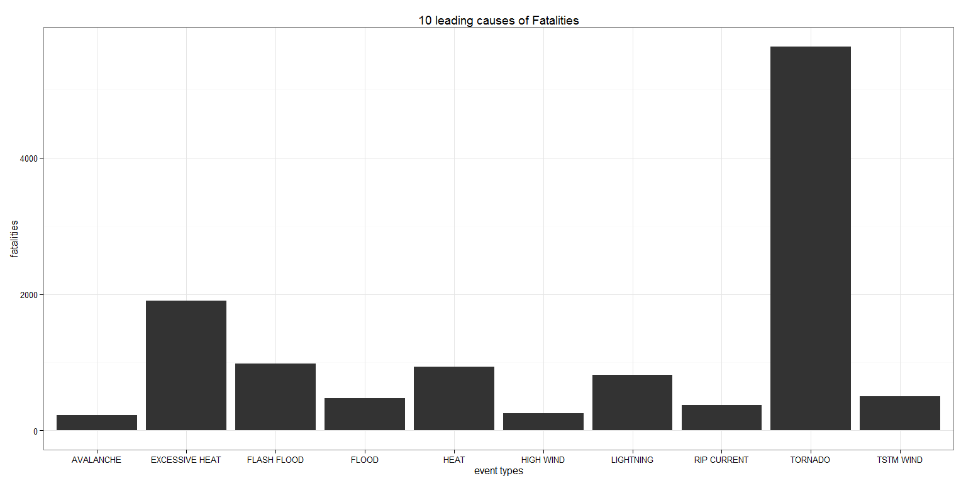

percent <- with(impactFatalities, round((fatalities[1] / sum(fatalities) * 100), digits = 2))  
print(percent)

[1] 37.19

This shows that evtype tornado has the highest fatalities accounting for 37.19% of all fatalities.

plot2 <- ggplot(data = impactInjuries[1:10, ], aes(x = evtype))  
plot2 <- plot1 + geom_bar(stat = "identity") +   
 labs(title = "10 leading causes of Injuries", x = "event types") +   
 theme_bw()  
print(plot2)

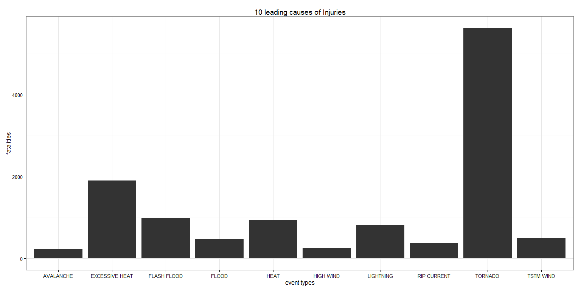

percent2 <- with(impactInjuries, round((injuries[1] / sum(injuries) * 100), digits = 2))  
print(percent2)

[1] 65

This also shows that evtype tornado has the highest injuries accounting for 65% of all fatalities.  
Therefore, evtype tornado has the most harmful population health effect of all the event types.  
### ***across the US, which types of event have the greatest economic consequence***  
First I made a subset of the finalData containing evtype, propertiesDamaged, and cropsDamaged; add-up the total for each of the evtype, then and the columns propertiesDamaged¬ andcropdDamaged` together and arrange the output in descending order.

impactOnEconomy <- finalData %>%   
 group_by(evtype) %>%  
 summarise(propertiesDamaged = sum(propertiesDamaged,   
 na.rm = TRUE),   
 cropsDamaged = sum(cropDamaged, na.rm =TRUE))  
impactOnEconomy <- mutate(impactOnEconomy,   
 impact = propertiesDamaged + cropsDamaged)  
impactOnEconomy <- arrange(impactOnEconomy, desc(impact))  
  
head(impactOnEconomy)

|  |  |  |  |
| --- | --- | --- | --- |
| evtype | propertiesDamaged | cropsDamaged | impact |
| FLOOD | 144657709800 | 5661968450 | 150319678250 |
| HURRICANE/TYPHOON | 69305840000 | 1099382800 | 70405222800 |
| TORNADO | 56947380614 | 414953270 | 57362333884 |
| STORM SURGE | 43323536000 | 5000 | 43323541000 |
| HAIL | 15735267456 | 3025954470 | 18761221926 |
| FLASH FLOOD | 16822673772 | 1421317100 | 18243990872 |

Lastly, I plot a bar graph of the economic consequences(impact) of the top ten event types.

plot3 <- ggplot(data = impactOnEconomy[1:10, ], aes(x = evtype, y = impact / 10^9))  
plot3 <- plot3 + geom_bar(stat = "identity") +   
 labs(title = "economic impact of top 10 events", x = "event type",   
 y = "Economic impact(trillion Dollars)") +   
 theme_bw()  
print(plot3)

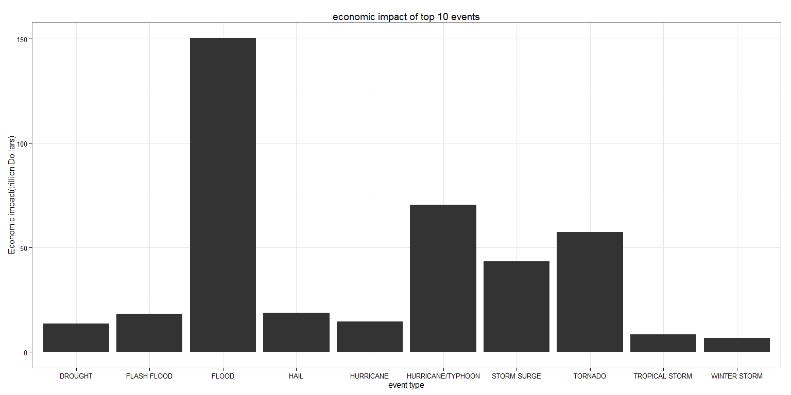

percent3 <- with(impactOnEconomy, round((impact[1] / sum(impact) * 100), digits = 2))  
print(percent3)

[1] 32.42

This also shows that evtype flood has the highest impact on the economy accounting for 32.42% of all economic losses.

## CONCLUSION

The study shows that from the data available, tornado storms have the highest population health impact while flood has the highest economic health impact.

sessionInfo()

## R version 3.2.2 (2015-08-14)  
## Platform: x86_64-w64-mingw32/x64 (64-bit)  
## Running under: Windows 7 x64 (build 7601) Service Pack 1  
##   
## locale:  
## [1] LC_COLLATE=English_United States.1252   
## [2] LC_CTYPE=English_United States.1252   
## [3] LC_MONETARY=English_United States.1252  
## [4] LC_NUMERIC=C   
## [5] LC_TIME=English_United States.1252   
##   
## attached base packages:  
## [1] stats graphics grDevices utils datasets methods base   
##   
## other attached packages:  
## [1] ggplot2_1.0.1 printr_0.0.4 dplyr_0.4.2 R.utils_2.1.0   
## [5] R.oo_1.19.0 R.methodsS3_1.7.0 knitr_1.11   
##   
## loaded via a namespace (and not attached):  
## [1] Rcpp_0.12.0 magrittr_1.5 MASS_7.3-43 munsell_0.4.2   
## [5] colorspace_1.2-6 R6_2.1.0 stringr_1.0.0 highr_0.5   
## [9] plyr_1.8.3 tools_3.2.2 parallel_3.2.2 grid_3.2.2   
## [13] gtable_0.1.2 DBI_0.3.1 htmltools_0.2.6 yaml_2.1.13   
## [17] lazyeval_0.1.10 assertthat_0.1 digest_0.6.8 reshape2_1.4.1   
## [21] formatR_1.2 codetools_0.2-14 evaluate_0.7.2 rmarkdown_0.7   
## [25] labeling_0.3 stringi_0.5-5 scales_0.2.5 proto_0.3-10