Abstract

The present incidence stands at 16.5%. The target of the project is to reduce the incidence to <10% by December 2015 through institution of 4 phases of PDSA cycles.

**Taiye Balogun**

stbalo2002@gmail.com

Incidence of Primary postpartum Haemorrhage in A PRIVATE hospital IN ILORIN, NIGERIA

A Quality Improvement Project

Table of Contents

ABBREVIATIONS 2

**DEFINE** 3

PROJECT TITLE 3

AIM 3

NEED FOR PROJECT 3

PROJECT SPONSOR 3

PROJECT TEAM 3

PROJECT SCOPE 4

PROJECT BOUNDARIES 4

PRIMARY METRICS 4

SECONDARY METRICS 4

“AS IS” PROCESS MAP 5

BENCHMARKING 6

LITERATURES 6

**MEASURE** 8

EXCLUSION CRITERIA: 8

METHOD OF DATA COLLECTION 8

**ANALYSE** 11

Table 3.1 11

Table 3.2 12

Table 3.3 13

Table 3.4 14

CAUSE AND EFFECT DIAGRAM 15

**IMPROVE** 16

PROJECT GOAL (Specific Aim) 16

IMPROVEMENT PLAN 16

PHASES OF IMPROVEMENT PLAN 16

“TO BE” FLOW CHART 18

**CONTROL** 19

AIM OF CONTROL 19

MEASUREMENT OF IMPROVEMENT 19

CONTROL PLAN 19

CONTROL CHART 19

**CONCLUSION** 21

CHALLENGES 21

OBSERVATIONS 21

References 22

# ABBREVIATIONS

1. ACOG American Congress of Obstetricians and Gynaecologists
2. CCT Controlled Cord Traction
3. FISQua Fellow, International Society for Quality in Healthcare
4. IM Intramuscular
5. ISQua International Society for Quality in Healthcare
6. IV Intravenous
7. MB; BS Bachelor of Medicine, Bachelor of Surgery
8. N/saline Normal Saline (0.9% saline)
9. OAUTH Obafemi Awolowo University Teaching Hospital, Nigeria
10. PPH Postpartum Haemorrhage
11. PPPH Primary Postpartum Haemorrhage
12. RN Registered Nurse
13. SOGC Society of Obstetricians and Gynaecologists of Canada
14. UITH University of Ilorin Teaching Hospital, Nigeria
15. WHO World Health Organization

# **DEFINE**

## PROJECT TITLE

Incidence of Primary Postpartum Haemorrhage in Olanrewaju Hospital. A quality improvement project.

## AIM

To reduce the incidence of Primary Postpartum Haemorrhage

## NEED FOR PROJECT

1. **Need to improve quality of care:** high incidence of PPH is associated with poor quality indices including:

* Prolonged hospital stay
* Increased maternal morbidity and mortality
* Increased need for blood transfusion
* Poor rating of patient experience of care

1. **Need to decrease cost:** PPH increases the cost of care both for the patient and for the Hospital. Increase cost of care by the Hospital minimises profit and decreases Return on Investment
2. **Need to improve customer satisfaction.**

## PROJECT SPONSOR

The project sponsor is the Management of THE Hospital. The management will provide:

* Basic stationeries
* Human Resources
* Information (Health records and relevant Hospital protocols.
* Other resources as needed by the team.

## PROJECT TEAM

* Balogun Stephen T. (MB; BS, FISQua, SSGB)
* Oyinloye Omotayo A. (MB; BS, Associate Fellow ISQua)
* Opeyemi Muinat O. (RN)
* Onifade Rebecca T. (RN)

## PROJECT SCOPE

1. Retrieve delivery records from January 2014
2. Determine the following parameters:
   1. Number of vaginal deliveries
   2. Number of vaginal deliveries with episiotomy
   3. Number of vaginal deliveries with perineal tear
   4. Number of PPPH cases.
   5. Causes of PPPH in identified cases
3. Analyse the data using R (version 3.1.3), Microsoft EXCEL(2103) and QI Macros (2015)
4. Design improvement parameters
5. Implement designed plans using Plan -> Do -> Study -> Act (PDSA) cycles
6. Measure improvement overtime and institute a control plan to sustain improvement
7. Incorporate improvement into routing operations.

## PROJECT BOUNDARIES

The followings are out of the scope of the project:

* Caesarean deliveries
* Pre-term deliveries (gestational age <35 weeks)
* Low birth weight babies (birth weight <2 Kg)
* Babies delivered before arrival into the Labour room
* Patients with abnormal placentation, bleeding diathesis and structural uterine abnormalities
* Unbooked patients (patients with antenatal visits less than 3)

## PRIMARY METRICS

This define the measurement by which the success of the project will be defined.

The primary metric is a specific decrease in incidence of PPPH (the specific value will be stated in chapter 4)

## SECONDARY METRICS

These are the other parameters that will be improved indirectly by undertaking the project. These parameters include:

* Reduction in the rate of episiotomy
* Reduction in the rate of perineal tears
* Reduction in the rate of cervical lacerations.

## “AS IS” PROCESS MAP

This aims to make a flow chart of the present intrapartum experience.

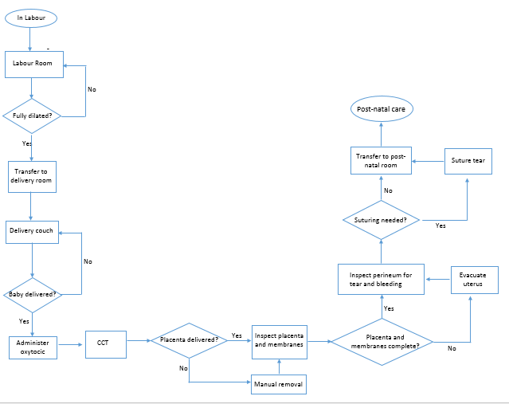Table 1.1

A “TO BE” flow chart will be created later during the improvement phase.

Flow chart of care during labour and delivery.

## BENCHMARKING

This involves comparing the Hospital protocols for the prevention of PPPH and the incidence of PPPH with industries and/or best practice.

The data of the incidence of PPPH in the Hospital will be collected during the project and presented in chapter 2.

The present Hospital protocol for the management of PPPH are:

1. **PREVENTION**
2. In low risk patients

* Ergometrine 0.5mg (IM) for patients with normal blood pressure.
* Oxytocin 10 IU (IM) for patients with elevated blood pressure

1. In high risk patients1
   * 600ug misoprostol inserted rectally with either of ergometrine or oxytocin as stated above.
2. **TREATMENT**
3. Ergometrine 0.5mg (IM) with misoprostol 800 µg inserted into the rectum for patients with normal blood pressure.
4. Oxytocin 10 IU (IM) with misoprostol 800 µg inserted into the rectum for patients with elevated blood pressure

## LITERATURES

1. **INCIDENCE OF PPH**
   * OAUTH (K.O., Mar 2010) 1.68% (88% of which were unbooked patients)
   * Ile-Ife (A.E., April 2013 ) 3.4% (in primary facilities)

3.9% (in secondary facilities)

1.6% (in tertiary facility)

* UITH (Ijaiya M.A, 2003) 4.5%
* Umuahia (Anya A.E, 1999) 2.72%
* JUTH (T.M., 2011) 0.95%
* WHO (WHO, 2012) 2%
* SOGC (Leduc, October 2009) 5%
* ACOG (ACOG, October 2013) 4-6%( incidence of PPPH)

[1]

1. **PREVENTION OF PPH2,3**

* WHO (WHO, 2012) 10 IU oxytocin (IV or IM)
* SOGC (Leduc, October 2009) 10 IU oxytocin (IM)
* ACOG (ACOG, October 2013) 10 IU oxytocin (IM)

1. **TREAMENT OF PPPH2**

* WHO (WHO, 2012) oxytocin (IV)
* SOGC (Leduc, October 2009) 20-40 IU oxytocin in 250 mL of N/saline
* ACOG (ACOG, October 2013) 10-40 IU oxytocin in 1L of N/saline
* UITH 20-40 IU oxytocin in 500mL of N/saline[2]

# **MEASURE**

For the purpose of this project, primary postpartum haemorrhage is defined as a blood loss of 500 mL or more within the first 24 hours after birth.

The data were collected by retrieving case notes of patients obtainable from the Hospital Records Department from January 2014 to April 2015.

## EXCLUSION CRITERIA:

* Patients outside the scope of the project
* Patients with incomplete records
* Patients without documentation of estimated blood loss.

## METHOD OF DATA COLLECTION

For each month, a Roles and Responsibilities Matrix was used. A team member was designated as responsible/accountable for data collection, another team member designated to be consulted while the remaining team members were informed.

Below is an example of the Roles and Responsibilities Matrix.

Table 2.1

|  |  |  |  |  |
| --- | --- | --- | --- | --- |
| Month | member A | member B | Member C | Member D |
| Jan | Resp/acct. | Consult | Inform | Inform |
| Feb | Consult | Resp/acct. | Inform | Inform |
| March | Inform | Inform | Resp/acct. | consult |

The Intrapartum and 24-hour postpartum records were reviewed and data regarding the estimated blood loos (blood loss at delivery and within the 24 hours period) and other parameters were collected.

A check sheet was used to collect the data for each month and the sheets were subsequently collated.

Below is the sample of the check sheet that was used for monthly data collection.

Table 2.2

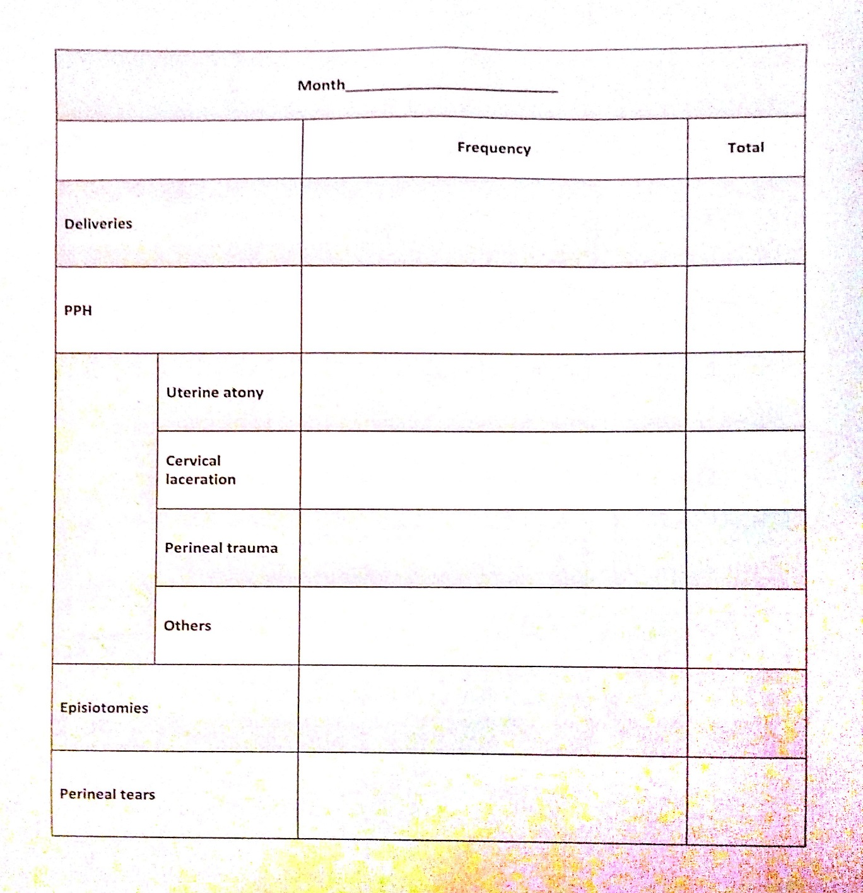

The check sheets were collated and a summary of data record was generated using Microsoft Excel 2013. The summary of the data is shown below.

Table 2.3



Table showing summary of data collated between January 2014 and April 2015.

The incidence of episiotomy and perineal tear for the month of April 2015 were not collected.

All “Other” causes of primary postpartum haemorrhage identified in this project were due to retained products of conceptio**n.**

# **ANALYSE**

## Table 3.1

|  |  |  |  |
| --- | --- | --- | --- |
| **Months** | **%PPPH** | **%episiotomy** | **%perineal tear** |
| January | 8.0 | 16.0 | 44.0 |
| February | 24.0 | 16.0 | 36.0 |
| March | 27.3 | 22.7 | 40.9 |
| April | 6.7 | 13.3 | 46.7 |
| May | 10.7 | 28.6 | 32.1 |
| June | 5.0 | 10.0 | 55.0 |
| July | 16.7 | 27.8 | 66.7 |
| August | 17.6 | 17.6 | 44.1 |
| September | 17.9 | 10.7 | 46.4 |
| October | 17.6 | 20.6 | 38.2 |
| November | 14.8 | 37.0 | 37.0 |
| December | 21.4 | 35.7 | 39.3 |
| January | 8.6 | 31.4 | 54.3 |
| February | 17.9 | 14.3 | 60.7 |
| March | 29.4 | 29.4 | 29.4 |
| April | 18.8 | NA | NA |
|  |  |  |  |
|  | Summary |  |  |
| mean | 16.5 | 22.4 | 44.0 |
| min | 5.0 | 10.0 | 29.4 |
| median | 17.9 | 20.6 | 44.0 |
| max | 29.4 | 37.0 | 66.7 |

Table of percentages of PPPH, episiotomies and perineal tears

The average incidence of primary postpartum haemorrhage is 16.5% which is higher than any of the incidence in the literatures surveyed.

About a quarter of the patients had episiotomy, compared to WHO recommendation of 2%, and almost half of the patients had perineal tear.

## Table 3.2

Table showing ratio of deliveries to PPPH in each month

July had the least number of deliveries recorded, 18, and January 2015 has the highest number, 35. However, June has the least number of primary postpartum haemorrhage, 1 while March 2015 has the highest, 10.

## Table 3.3

Pareto chart (80:20 principle)

Uterine atony accounts for 49% of causes of primary postpartum haemorrhage and together with perineal trauma account for a little over 80% of causes of PPPH.

## Table 3.4

This shows the pattern of PPPH over the period of data collection.

## CAUSE AND EFFECT DIAGRAM

A brain-storming section was conducted to identify the possible causes of PPPH. Thereafter, affinity diagram was used to group the suggested causes.

Policies

No postpartum review

Choice of uterotonics

No policy on urinary bladder emptying



PPPH

Early transfer of patient

Delay in administering uterotonics

**Doctors**

People

Injudicious augmentation

Failure to identify high risk patients

**Patients**

**Nurses**

Frequent episiotomy

Failure to promptly establish breastfeeding

Straining in first stage of labour

Fundal pressure

Procedure

# **IMPROVE**

## PROJECT GOAL (Specific Aim)

The goal of the project is to reduce the incidence of PPPH to <10% by December 2015.

## IMPROVEMENT PLAN

This will be achieved through implementation of several cycles of PDSA.

**The Plan stage:** here, we will research the best way to implement a chosen plan and itemise the way it will be executed

**The Do Stage:** here, the improvement point is executed and data collected as planned

**The Study stage:** the data is analyzed and measured to see whether there is improvement, and what further changes need to be made.

**The Act stage:** decisions are made based on the studies to decide where further improvements are needed.

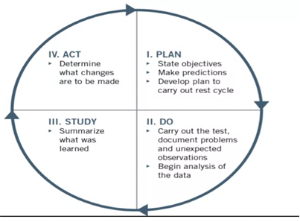

## PHASES OF IMPROVEMENT PLAN

A Nominal Group Technique section was conducted using the available data to identify possible implementation plans. The following plans were generated.

* Improve monitoring of postpartum patients
* Judicious augmentation of labour
* Uterine massage
* Seminar/training of staff
* Immediate postpartum urinary bladder emptying and encouragement of patients to urinate frequently during the first 24 hrs
* Prompt establishment of breast feeding
* Review of hospital policy of the prevention of PPPH
* Improve counselling of patients on labour experience
* Improve history taking to identify risk factors (including previous history of PPH, history of easy bruisability, blood group of patient, placenta location)
* Institution of Interval postpartum repair

The above listed plans were subsequently grouped into 4 improvement phases, considering importance and feasibility. The groups are:

1. **Seminar/ training of staff on:**
   1. Adequate antenatal preparation of patients
   2. Labour and delivery
   3. Routine bladder emptying immediate postpartum
   4. Monitoring of postpartum patients.
2. Review of hospital policy on prevention of primary postpartum haemorrhage.
3. Develop a protocol for the augmentation of labour
4. Develop a policy for interval postpartum review.

An improvement plan will be executed monthly using the PDSA cycle and data collected after each execution to see the impact of each of the improvement plan.

Finally, a “TO BE” flow chart was developed.

## “TO BE” FLOW CHART

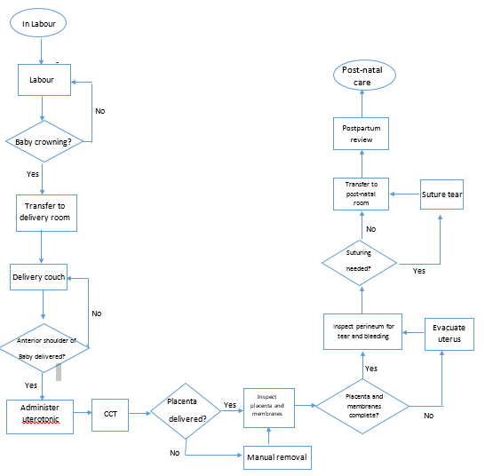

# **CONTROL**

## AIM OF CONTROL

In this phase, we will aim to:

* control the factors that can affect the implemented plans
* Measure the effect of the implemented plans on the project.

## MEASUREMENT OF IMPROVEMENT

1. **Outcome measurement:** this measures the functional, clinical, cost and satisfaction outcome of the improvement project

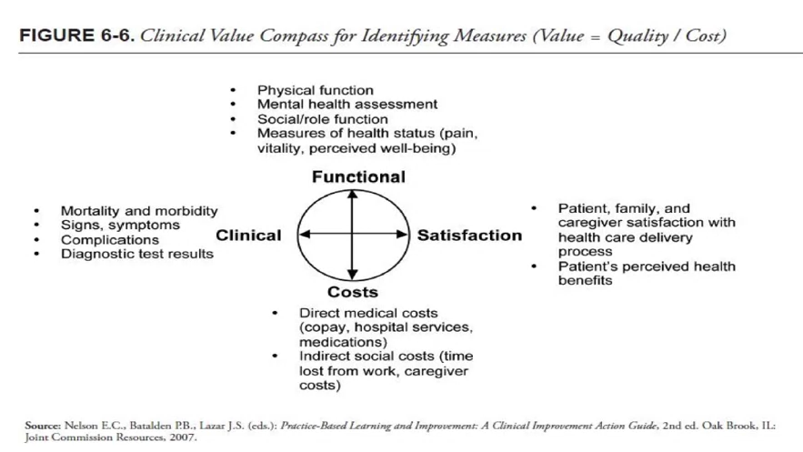

1. **Balancing measurement:** measures whether the project creates a new problem e.g. staff dissatisfaction
2. **Process measurement:** measures the compliance rate with implemented changes.

## CONTROL PLAN

This will be developed during the control phase. It involves development of methodology for data collection during execution of improvement plans.

## CONTROL CHART

We will use the control chart to plot the data collected with the control plan. The control chart will help us to see if the instituted plans keep the PPPH incidence within a specified control limit or not.

Finally, a control plan for sustaining benefits will be developed with the aim of incorporating the benefits into routine operations.

The project will have a closing phase meeting. The focus of the closing phase meeting will be:

* Review of the project
* Identify challenges faced during the project
* Document lessons learnt

The project will then be closed and continued as a routine operation.

Interval data collected will be done (probably quarterly) to monitor the sustenance of the project.

# **CONCLUSION**

## CHALLENGES

The project so far has largely been a successful one and has exceeded my expectations. I am indeed hopeful that it will be able to reduce the incidence of primary postpartum haemorrhage to way below 10% by December 2015. However, it has not been without its challenges.

The following are some of the major challenges the project faced:

* **Resources:** many of the resources used for this project was provided by the admin. Department of the Hospital. However, some were provided by the project initiator/leader and team members.
* **Time constraint:** this slowed down the project as finding the best time when all team members will be available was very difficult.

## OBSERVATIONS

We observed the recent anxiety and aggressiveness of some members of staff (both doctors and nurses) in preventing primary postpartum haemorrhage thus necessitating practices outside the Hospital policy. This is occurring despite the fact that the present policy is not strictly adhered to.

Some of these practices include:

* Routine passage of misoprostol (600/800 µg) for all postpartum patients.
* Use of misoprostol 800 µg per rectum and oxytocin infusion (usually 20 IU) for management of patients with primary postpartum haemorrhage.

We believe members of staff need to be encouraged to stick to the Hospital polices and to report new advances in management of patients through appropriate media to ensure its review and possibly incorporation into Hospital policies.

We hope to start planning the first phase of improvement plans as soon as this report is approved and the order given.

We are hopeful the first phase will be implemented and data collected by July 2015.

Thank you so much for giving us the chance to contribute our parts towards patient safety and quality improvement.

# References

A.E., O. (April 2013 ). The prevalence, managment and outcome of primary postpartum haemorrhage in selected health care facilities in Nigeria. *International Journal of Nursing and Midwifery vol 5(3)*, 28-34.

ACOG. (October 2013). *Optimizing protocols in Obstetrics, management of obstetric haemorrhage.* ACOG.

Anya A.E, A. S. (1999). Trends in maternal mortality due to haemorrhage at the Federal Medical Centre, Umuahia. *tropical journal of Obstetrics and Gynaecology 16*, 1-5.

Ijaiya M.A, A. A. (2003). Analysis of 348 consecutive cases of primary postpartum haemorrhage in a tertiary hospital in Nigeria. *Journal of Obstetrics and Gynaecology 23*, 374-377.

K.O., A. (Mar 2010). Postpartum Haemorrhage in a Teaching Hospital in Nigera: A 5-year experience. *Afr Health Sci., 10*(1), 71-74.

Leduc, D. ( October 2009). *Active management of the third stage of labour: prevention and treatment of postpartum haemorrhage.* SOGC.

T.M., J. (2011). Postpartum maternal morbidity in Jos, north-central Nigeria. *Nigerian Journal of Clinical Practice vol 14*, 1-4.

WHO. (2012). *WHO recommendation for the prevention and treatment of postpartum haemorrhage.* Geneva: WHO.

1. High risk patients in this context include patients with previous history of PPH, grand multiparous patients.
2. All the literatures reviewed chose oxytocin as their first choice and only recommend misoprostol in the absence of oxytocin for patients who do not have adequate response to oxytocin.

   3  Active Management of third Stage of Labour (AMTSL) is practiced and is recommended by all literatures.