Procedure # 01-011

Software Issue Management Process

Revision: T

Effective Date: July 15, 2016

Document Approvals Required: R&D, Quality, Marketing, Operations

Document Revision History

| Revision | Date | Name | Changes With Reasons |
| --- | --- | --- | --- |
| A - S | See previous versions of this document. | | |
| T | June 16, 2016 | John Lindahl | Updated formatting, fixed typos, and removed unnecessary TeamTrack user instructions as the process is now also used with Sparkflow (JIRA). Instructions for those tools are now posted online.  Added scope sentence that process must be followed for all confirmed and potential defects.  Changed Marketing role from Product Manager/Area Product Owner simply to Marketing Product Owner. This allows Technical Marketing also to fill the role in addition to Product Managers.  Clarified that CRM ticket number is required when customer defects are reported via customer support  Added important note to cross-functional review that all four members must participate and explained that missing members can be covered in a separate review.  Added disposition option for cross functional team to move defect to another team.  Updated the Corrective Action paragraph to clarify Quality determines the need for a formal Trackwise CAPA.  Removed option for resolution owner to choose "specify that the defect cannot be reproduced" as this was redundant with requesting a review.  Added table for determining Priority based on severity and likelihood.  Added requirement for cross functional teams to determine the need to fix defects in previous releases.  Added section 3 for Customer / Support Notifications. |

Contents

1 Overview 3

1.1 Process Flow 3

1.2 Scope 3

1.3 Roles 3

2 Process Details 5

2.1 Identify Defect and Submit a Defect Report 5

2.2 Support Engineer Review 6

2.3 Customer Feedback Meeting 6

2.4 Cross-functional Team Review (Classification) 7

2.5 Resolution 9

2.6 Fix Verification 9

2.7 Investigations 9

2.8 Request Cross Functional Review 9

3 Customer / Support Notifications 11

4 Product Release Criteria 11

5 Reference Documents 12

# Overview

## Process Flow

The Software Issue Process specifies how software defects are reported and resolved. All issues that are confirmed defects or suspected to be defects are submitted to this process.

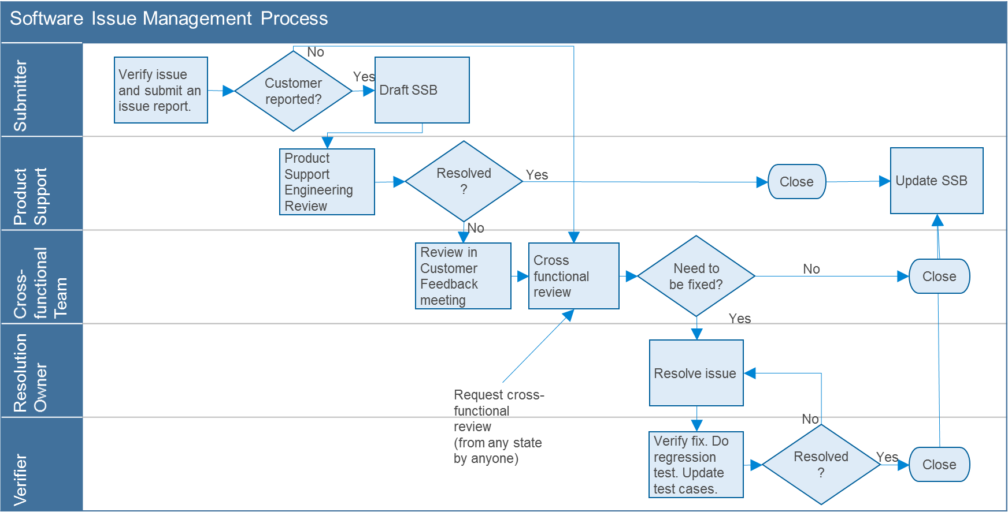

This process is supported by defect management software that implements the requirements of this process (for example, TeamTrack or Sparkflow).

## Scope

This process covers the software issue tracking process. All confirmed and potential defects with SID products must be submitted to this process. It is not intended to cover reactive support with customers which is covered by Procedure # 06-017 Laboratory Informatics Customer Support Process.

## Roles

People work together in the following roles:

|  |  |
| --- | --- |
| Role | Responsibilities |
| Submitter | Software development and support team members submit defects to the process. Submitters are responsible for submitting accurate reports with as complete and accurate information as possible. For customer reported defects, the Submitter also drafts a problem statement and any workarounds in the Software Status Bulletin (SSB). |
| Product Support | The Product Support Engineer assigned to the product is responsible for reviewing customer-reported defects to check if a solution is already known and request additional information that may be needed. The Product Support Engineer also updates the SSB as additional information becomes available. |
| Cross-functional Team | The Cross-functional Team is comprised of members from Marketing, R&D, Quality and Product Support. The Cross-functional Team is responsible for determining the disposition of all reported defects. Within the Cross-functional Team, members have the following responsibilities:  Marketing Product Owner (Technical Marketing Scrum Product Owner or Product Manager/Area Product Owner) – The Product Owner is responsible for:   * + Assessing brand/product impact   + Owning the resolution final decision and customer experience and assisting with customer communication and management communication when needed   + Monitoring and reporting the health of the overall product with Senior Management   R&D Project Manager (Scrum Development Team R&D) – The Project Manager is responsible for:   * + Articulating the technical impact on product,   + Providing cost estimates on solution; * Providing timeline (and its effects on other CPE commitments, i.e. projects, and NPI commitments) along with recommendation on resourcing   Product Support Engineer is responsible for:   * + Articulating the urgency and voice of the customer (VOC) with how the defect impacts the customer’s lab operation   + Ensuring Prestos are up to date and accurate   + Ensures that SSB initial summaries are completed   + Serves as the liaison between the Field and the Factory   Quality Lead (Software Quality Engineer or Scrum Development Team Software Test Lead) – The Quality Lead is responsible for:   * + Ensuring this process is followed (defects are transitioned according to the process, full cross-functional team is present, documentation requirements are fulfilled, etc.)   + Supporting use of the defect tracking software (submitting user access requests to IT, adding new revision numbers, new user training, etc.)   + Providing testing timeline along with recommendation on resourcing to the R&D project manager   + Leading the review of software quality trends |
| Resolution Owner | The Resolution Owner is responsible for fixing the cause of the defect, documenting the changes made, and recommending regression tests to perform. |
| Verifier | The Verifier is responsible for verifying the reported defect has been resolved, performing regression testing, and documenting the verification activities performed. |
| Investigation Owner | The Investigation Owner is responsible for performing the investigation and providing the findings from the investigation. |

# Process Details

## Identify Defect and Submit a Defect Report

The submitter must document all the known facts about the defect, or suspected defect, including details of how to reproduce the defect or the details of the attempts to reproduce.

Reasonable effort must be made by the submitter to reproduce the defect and to reproduce it in its simplest terms. If reproducing the defect is unreasonable, submitter is to provide all available information that can realistically be gathered so it can be reproduced in an Agilent test facility. Submitter must check if the defect is already known problem and, if so, add any new information to the already existing defect. If the defect is similar but not the same, enter a new defect.

The following minimum information must be submitted:

|  |  |
| --- | --- |
| Role | Responsibilities |
| Title | A brief one line description as the defect subject |
| Description | A complete description of the defect with enough information for someone else to reproduce it |
| Severity | An initial view of the severity, according to the CAG/LSG Software Defect Severity Standard (LSCA-QA120): <http://sharedoc.collaboration.agilent.com/sites/LSCAQuality/SD/KP/Business%20Management%20System%20(Quality-EH-S)/037799.docx>   * + Critical   + Serious   + Medium   + Low |
| Product Number | Specific product being used where defect was observed. |
| Occurred in Revision | Specific version being used where defect was observed. |
| Customer Type | If reported by a customer, select External. Otherwise, choose Internal. |
| Customer Info | For customer type External, identify the customer reporting the defect with references to other records such as support call ticket number (if submitted via customer support).  Information related to business impact should also be included. |

For customer-reported defects, the submitter should draft an initial Software Status Bulletin (SSB) to keep the customer informed:

|  |  |
| --- | --- |
| Include in SSB | Proposed must be selected to ensure an SSB is written to keep the field and customer informed of the status |
| SSB Problem Description Title* | Short title for the defect |
| SSB Problem Description* | Description of how a user experiences the defect and any explanation of the reason for the defect |
| Temporary Fix* | Action that users take to work around the defect |
| Fix Note* | The current plan to address the defect. Initially, it can say that the defect is under investigation. Later, it should say when the defect is planned to be addressed, how it will be addressed (software change, documentation, etc.). If no fix is planned, it should say the temporary fix is the final resolution. |

* Preliminary entry at time of submission. The cross-functional team will update as new information becomes available.

## Support Engineer Review

For New defects/suspected defects, reported by external customers, the Product Support Engineer for the product is responsible for performing the initial review to ensure all necessary information has been provided. This is to be done prior to the customer feedback meeting. If the defect is resolved through this process, it is closed.

## Customer Feedback Meeting

The purpose of this meeting is for Marketing to obtain customer relevant information to either clarify the defect or highlight the business impact. The information gathered will be used as part of the defect classification process.

## Cross-functional Team Review (Classification)

For New internal defects or external customer defects confirmed by Product Support, the Cross-functional team is responsible for reviewing and classifying each defect. The cross functional review team is comprised of the R&D Project Manager, Marketing Product Owner, Product Support Engineer, and the Quality lead.

The team dispositions defects as follows:

* Accept the defect so it goes to the planned state (Classify)
* Request more information
* Indicate it is a user misunderstanding
* Decide it will not be fixed
* Move defect to a different team

The classification fields are as follows:

|  |  |
| --- | --- |
| Project | Verify that the defect belongs to the selected project and, if not, reassign it |
| Fix Version | Enter the target release revision where the defect will be fixed (usually the revision corresponding to the current active project). If a defect is deferred to be fixed in a future release, specify “Backlog” (it will then get assigned to a specific release when that project starts). |
| Resolution | For defects that are resolved immediately such as user misunderstanding |
| Resolution Owner | The owner of the defect when it goes to the Planned state |
| Severity | Confirm or correct the severity based on the current information about the defect |
| Priority | Set based on severity and likelihood. Use the following tables to determine. |

Priority 1 – 3 scale for Serena Business Manager (TeamTrack):

|  |  |  |  |  |  |
| --- | --- | --- | --- | --- | --- |
|  |  | Severity based on the LSAG QA120 standard | | | |
|  |  | Low | Medium | Serious | Critical |
| Likelihood | 5 – mandatory task | 3 | 1 | 1 | 1 |
| 4 – highly likely task | 3 | 2 or 3 | 1 or 2 | 1 |
| 3 – infrequent task | 3 | 3 | 2 | 2 |
| 2 – corner case, ambiguous usage | 3 | 3 | 2 | 2 |
| 1 – unlikely task, not always reproducible | 3 | 3 | 3 | 2 |
| 0 – unsupported task | 3 | 3 | 3 | 3 |

Priority 1 – 5 scale for Sparkflow (JIRA):

|  |  |  |  |  |  |
| --- | --- | --- | --- | --- | --- |
|  |  | Severity based on the LSAG QA120 standard | | | |
|  |  | Low | Medium | Serious | Critical |
| Likelihood | 5 – mandatory task | 4 | 3 | 2 | 1 |
| 4 – highly likely task | 4 | 3 or 4 | 2 or 3 | 1 |
| 3 – infrequent task | 4 | 4 | 3 | 2 |
| 2 – corner case, ambiguous usage | 4 | 4 | 3 | 3 |
| 1 – unlikely task, not always reproducible | 4 | 4 | 4 | 3 |
| 0 – unsupported task | 5 | 5 | 4 | 4 |

Red = Must fix; Yellow = Want fix; Black = Close, Do not fix

Note: neither business value nor implementation risk is part of this definition. Teams must report for management review any Must defects proposed not to be fixed for these reasons.

Determining Need to Fix Previous Releases

The team must determine if each defect needs to be fixed in a previously released version. If so, a copy of the defect must be created for the next service release or hotfix. If the defect was reported by a customer, the copy should be changed to internal so it isn’t double counted in trending of customer-reported issues.

Documentation of Decisions

In addition, notes must be added as follows:

|  |  |
| --- | --- |
| Meeting log | A text note must be entered with names of the people representing the 4 functions of the cross-functional team. |
| Justification Note | For the following dispositions, a text note must be entered that explains the rationale for each decision:   * + Deferred defects (target fix version is set to a future release or to the backlog)   + Defects closed as do not fix   + User misunderstanding   The rationale must explain the reason the decision was made (for example, high risk of introducing new defects / low likelihood of occurrence). |

Initiation of Corrective/Preventive Action

The team must consider if any defect requires further action beyond correction of the defect. This is appropriate if a pattern of similar defects is observed that may have a common cause. When corrective action is required to prevent future occurrences, enter a note referencing where this action is tracked (planned project, improvement initiative, etc.). Quality is responsible for determining the need for a formal Trackwise CAPA.

## Resolution

In the Planned state, a defect is owned by someone responsible for resolving it (usually an R&D engineer). The **Resolution Owner** can choose to:

* fix the defect
* request more information
* request a review

When a defect is fixed, the **Resolution Owner** must:

* describe how the defect was resolved in the Resolution field
* provide details of engineering testing performed
* describe impact of code changes and recommended regression testing

## Fix Verification

Defects that have been fixed will be verified to ensure that fix is correct. The **Verifier** assigned to do this is the original submitter whenever possible. This person is responsible for the following:

* Repeat the operations that were originally reported by the submitter.
* Perform any recommended testing indicated by the engineer who made the fix.
* Recommend to the Software Test leader any additional testing that should be performed.

If the fix is verified, the **Verifier** accepts the resolution. If not, the Verifier rejects the resolution.

## Investigations

The **Investigation Owner** for defects where additional information is requested will provide the requested information and click the action button to indicate it has been provided.

## Request Cross Functional Review

At any time, anyone may request a review of a defect. Some examples when this may be appropriate:

* Planned resolution of a defect may introduce new problems
* There is disagreement about the manner in which the defect was resolved (i.e. customer requests reconsideration of the decision based on additional information or factors.)

# Customer / Support Notifications

The Cross-functional Team must determine the need to notify customers or support teams of issues found in released versions. Use the following table:

|  |  |  |  |  |  |
| --- | --- | --- | --- | --- | --- |
|  |  | Severity based on the LSAG QA120 standard | | | |
|  |  | Low | Medium | Serious | Critical |
| Likelihood | 5 – mandatory task |  |  |  |  |
| 4 – highly likely task |  |  |  |  |
| 3 – infrequent task |  |  |  |  |
| 2 – corner case, ambiguous usage |  |  |  |  |
| 1 – unlikely task, not always reproducible |  |  |  |  |
| 0 – unsupported task |  |  |  |  |

Red = Send a customer notification, publish Service Note, publish Software Status Bulletin  
Yellow = Publish Service Note, publish SSB  
Grey = Publish SSB  
White = No notification required

To send a customer notification, do the following:

* Draft the letter using the Customer Notification Letter Example.docx file (found in ECM under \SID Genera\Other Documents\Document Templates\01 General)
* Review the letter with the Cross-Function Team
* Contact the SubscribeNet team to plan the customer distribution list (typically to all customers entitled to a particular product/version).
* Send the letter to the Quality Manager for approval with the distribution plan.
* Upon approval, ask the SubscribeNet team to proceed with distribution.

# Product Release Criteria

This section specifies the criteria by which project teams will determine whether or not a new product version can be released with regard to the defects reported against the product. The product team is responsible for verifying the following:

* No defects are open with the Fix Version equal to the version being released (including defects waiting for more information or waiting for verification)
* No New defects for the product are awaiting classification with any Fix Version (to ensure none need to be addressed)

# Reference Documents

|  |  |  |
| --- | --- | --- |
| Document # | Title | P/B/S/C |
| LSCA-QA109 | LSAG Product Lifecycle Standard | P |
| 01-003 | SID Software Development Process | S |
| 03-011 | Software Test Procedure | S |
| 06-017 | Customer Support Process | S |
| 06-021 | Software Status Bulletin Process | S |

Key:

* Parent documents, higher level, that direct this document (P);
* Business documents, outside the LSAG quality system but within Agilent, that supplement this document (B);
* Sibling documents, same level, that supplement this document (S);
* Child documents that are driven by this document (C);