**Project3**

**F74046365 李昕樺**

包含原本的紅鳥及障礙物的黑鳥在內，共有5種鳥，黑鳥是障礙物，黃鳥按鍵會加速，藍鳥按鍵會減速，咖啡鳥會有3隻

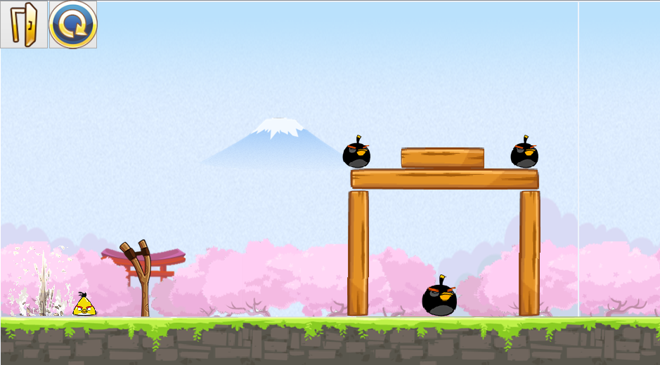

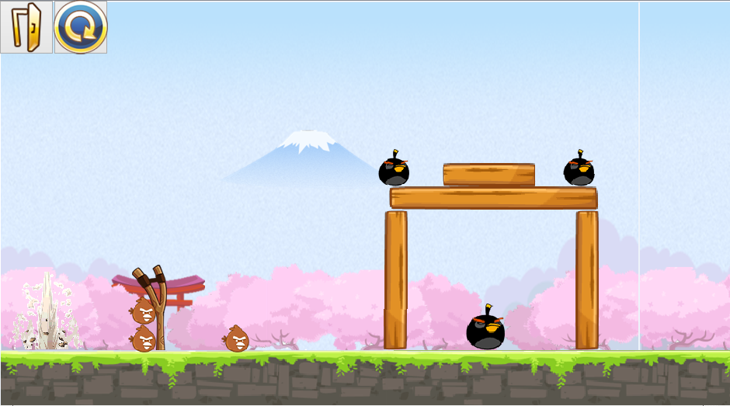

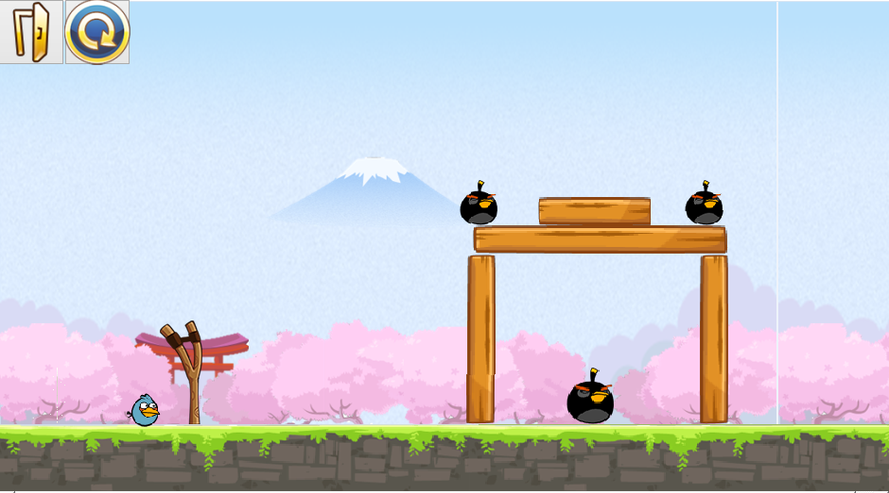

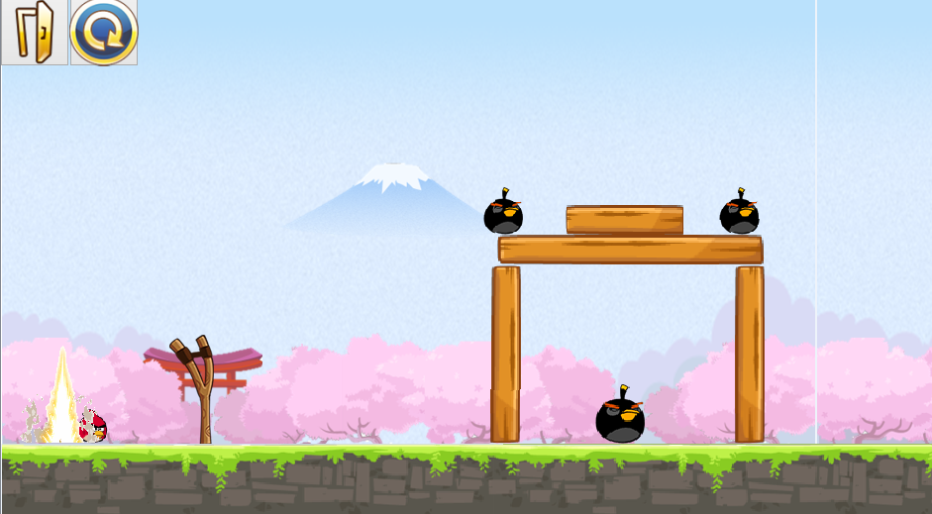

**UML**

|  |
| --- |
| MainWindow |
| -scene : QgraphicsScene *  -world : b2world *  -itemList : Qlist<GameItem *>  -timer : Qtimer  -birdie : Bird  -x,V,Vx,Vy,Cursor_x1,Cursor_y1,Cursor_x2,Cursor_y2 count : int  -pixItem : QgraphicsPixmapItem *  -birdieY : YellowBird *  -birdieB : BlueBird *  -birdieR1,birdieR2,birdieR3 : BrownBird *  -Pig1,Pig2,Pig3 : PigBird *  -barrier1,barrier2,barrier3,barrier4 : Barrrier *  -button1,button2: QpushButton *  -action : Qaction *  -player : QmediaPlayer *  -movie : Qmovie *  -label : Qlabel * |
| +<<explicit>>Maindow(parent:Qwidget *=0) : void  +~MainWindow()  +showEvent(QShowEvent *) : void  +eventFilter(QObject *,event : Qevent *) : bool  +closeEvent(QCloseEvent *) : void  +EXIT_REBOOT : static int const  +delete_bird() : void  +<<signal>>quitGame() : void  -<<slots>>tick() : void  -<<slots>>QUITSLOT() : void  -<<slots>>Btn1() : void  -<<slots>>slotReboot() : void |

|  |
| --- |
| GameItem |
| #g_body : b2Body *  #g_pixmap : QgraphicsPixmapItem  #g_size : QsizeF  #g_world : b2World  #g_worldsize : static QsizeF  #g_windowsize : static QSizeF |
| +GameItem(world:b2World *)  +~GameItem()  +setGlobalSize(worldsize:QsizeF,windowsize:QsizeF):static void  +<<slots>>paint() : void |

|  |
| --- |
| Barrier |
|  |
| +Barrier(x:float,y:float,w:float,h:float,timer:Qtimer*,pixmap:Qpixmap,  world:b2World*,scene:QgraphicsScene *) |

|  |
| --- |
| Bird |
|  |
| +Bird(x:float,y:float,w:float,h:float,timer:Qtimer*,pixmap:Qpixmap,  world:b2World*,scene:QgraphicsScene *)  +setLinearVelocity(velocity:b2Vec2) : void |

|  |
| --- |
| BlueBird |
|  |
| +BlueBird(x:float,y:float,w:float,h:float,timer:Qtimer*,pixmap:Qpixmap,  world:b2World*,scene:QgraphicsScene *)  +setLinearVelocity(velocity:b2Vec2) : void |

|  |
| --- |
| BrownBird |
|  |
| +BrownBird(x:float,y:float,w:float,h:float,timer:Qtimer*,pixmap:Qpixmap,  world:b2World*,scene:QgraphicsScene *)  +setLinearVelocity(velocity:b2Vec2) : void |

|  |
| --- |
| PidBird |
|  |
| +PigBird(x:float,y:float,w:float,h:float,timer:Qtimer*,pixmap:Qpixmap,  world:b2World*,scene:QgraphicsScene *)  +setLinearVelocity(velocity:b2Vec2) : void |

|  |
| --- |
| YellowBird |
|  |
| +YellowBird(x:float,y:float,w:float,h:float,timer:Qtimer*,pixmap:Qpixmap,  world:b2World*,scene:QgraphicsScene *)  +setLinearVelocity(velocity:b2Vec2) : void |

|  |
| --- |
| Land |
|  |
| +Land(x:float,y:float,w:float,h:float,timer:Qtimer*,pixmap:Qpixmap,  world:b2World*,scene:QgraphicsScene *)  +setLinearVelocity(velocity:b2Vec2) : void |