S&C June 2009 Model Answer

This is the “Specimen” paper, written by the exam board as an example of what GCSE S&C exams were going to look like; no-one ever actually sat this paper! As with the other examples of these, I’ve included my commentary as I’ve gone along, so you can see my thinking at each stage…

**Teacher’s notes:** As often happens, we open with some short-answer questions to task basic knowledge.

The bioglass question threw me a bit; I confess, I had to Google this, and even Wikipedia’s article doesn’t suggest the same thing that the mark scheme does!

1a i. Aluminium

1a ii. Aluminium is both strong and lightweight. As it is non-ferrous, it will not rust over time.

1a iii. [Bioglass](http://en.wikipedia.org/wiki/Bioglass) has the advantage of not getting mouldy, and is resistant to fingerprints.

1a iv. Steel

1a v. Steel is both cost-effective and hardwearing material.

1b. Idea 1: Crank, link and slider

Idea 2: Worm gear with spur gear

Idea 3: Rack and pinion

1c i. Crank, link and slider

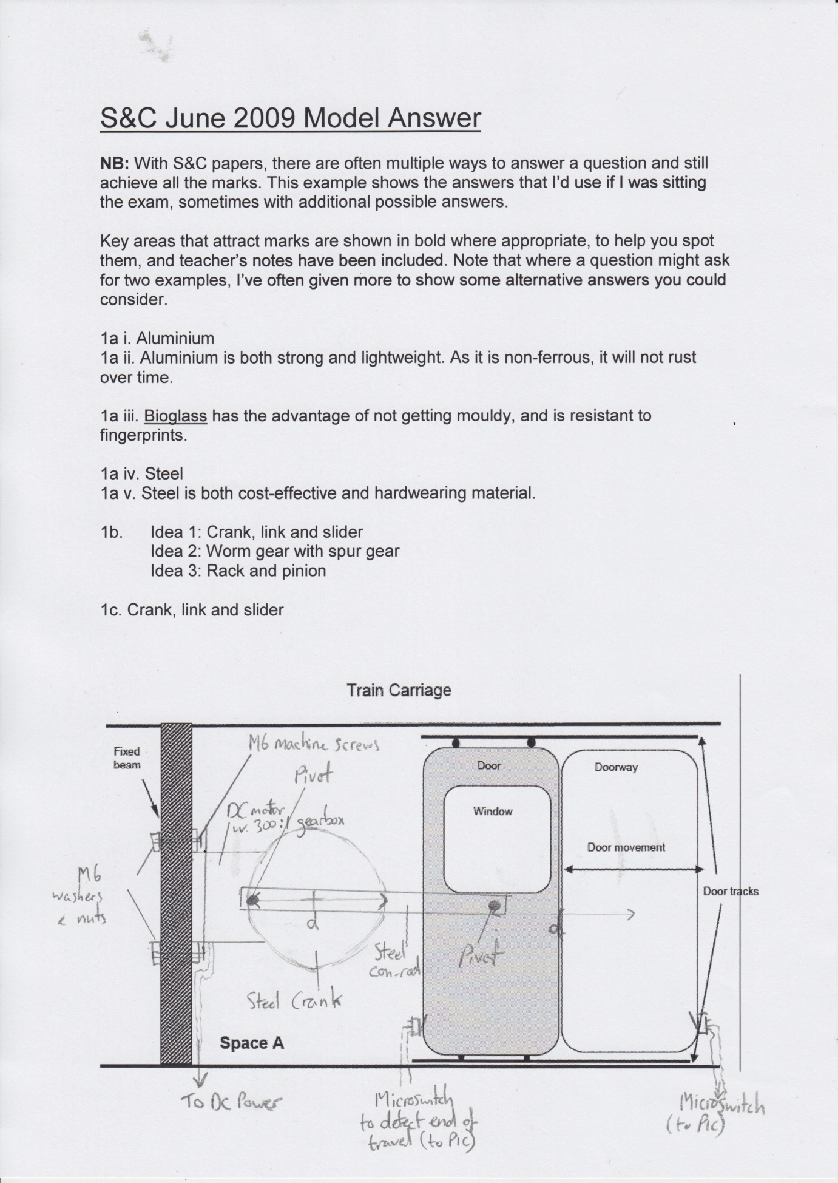

1c ii. When a signal is sent from the controller PIC, the DC motor is energised, causing the crank to slowly rotate. This in turn pushes the conrod to the right, and as this is attached to the door, it also slides into position. When the door strikes the microswitch, the PIC stops the motor.

**Teacher’s notes:** I was initially tempted to mount my motor onto the floor of the train, until I spotted that the question specifically states I had to put it onto the fixed beam.

I also quite liked the idea of using a rack and pinion here too, but thought I’d try something different.

1c iii. Adv. 1: The mechanism can be mounted inside the train wall body, so there are limited exposed parts.

Adv. 2: There are few moving parts

1d i. A microswitch (as shown in my diagram)

1d ii. Issue 1: Should not move so quickly as to cause injury.

Issue 2: Should not be able to open while train is moving.

1e. A higher ratio gearbox would slow the door, and increase the amount of torque.

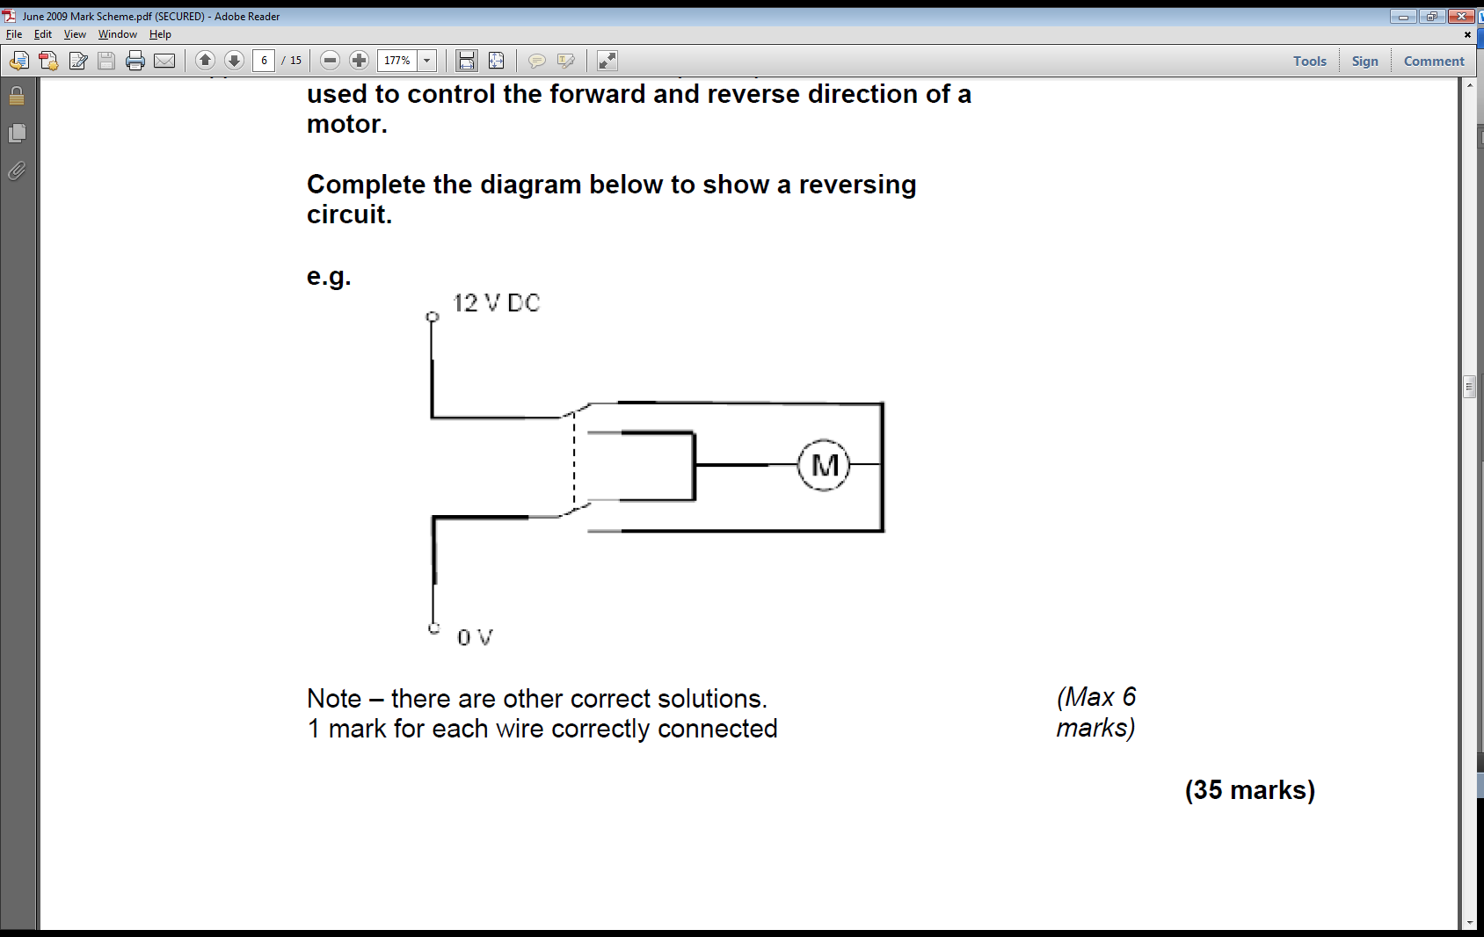

1f.

**Teacher’s notes:** Have you noticed that placing the motor terminals horizontally allows for the creation of a very neat diagram when setting up a DPDT switch.

2a. Breadboards consist of copper strips with holes located above them in a plastic housing which allow circuits to be temporarily created during the design stage. The advantage of these are the ability to quickly modify a design without needing to solder, and to swap in and out components (*eg for resistors of different values*). The problem with them is that they wires can be knocked loose, and they can become complex as design complexity increases.

**Teacher’s notes:** To ensure I got all 6 marks here, I split my answer into 2x 3 mark paragraphs. For each technique, I stated what it was, then what was good and bad about it.

PCBs are permanent circuits, where the components are soldered into place and the legs trimmed. They have the advantage of being more robust and are normally smaller than a breadboard or stripboard equivalent, but they take time and skill to design. Changing the design is very difficult (and often impossible) once the board has been built.

2b. Modelling on a computer allows for designs to be quickly changed when a virtual component “blows”, and virtual instruments can make debugging easier.

2c. Building the circuit on stripboard would allow the circuit to be built quickly, and to be sufficiently robust to endure testing.

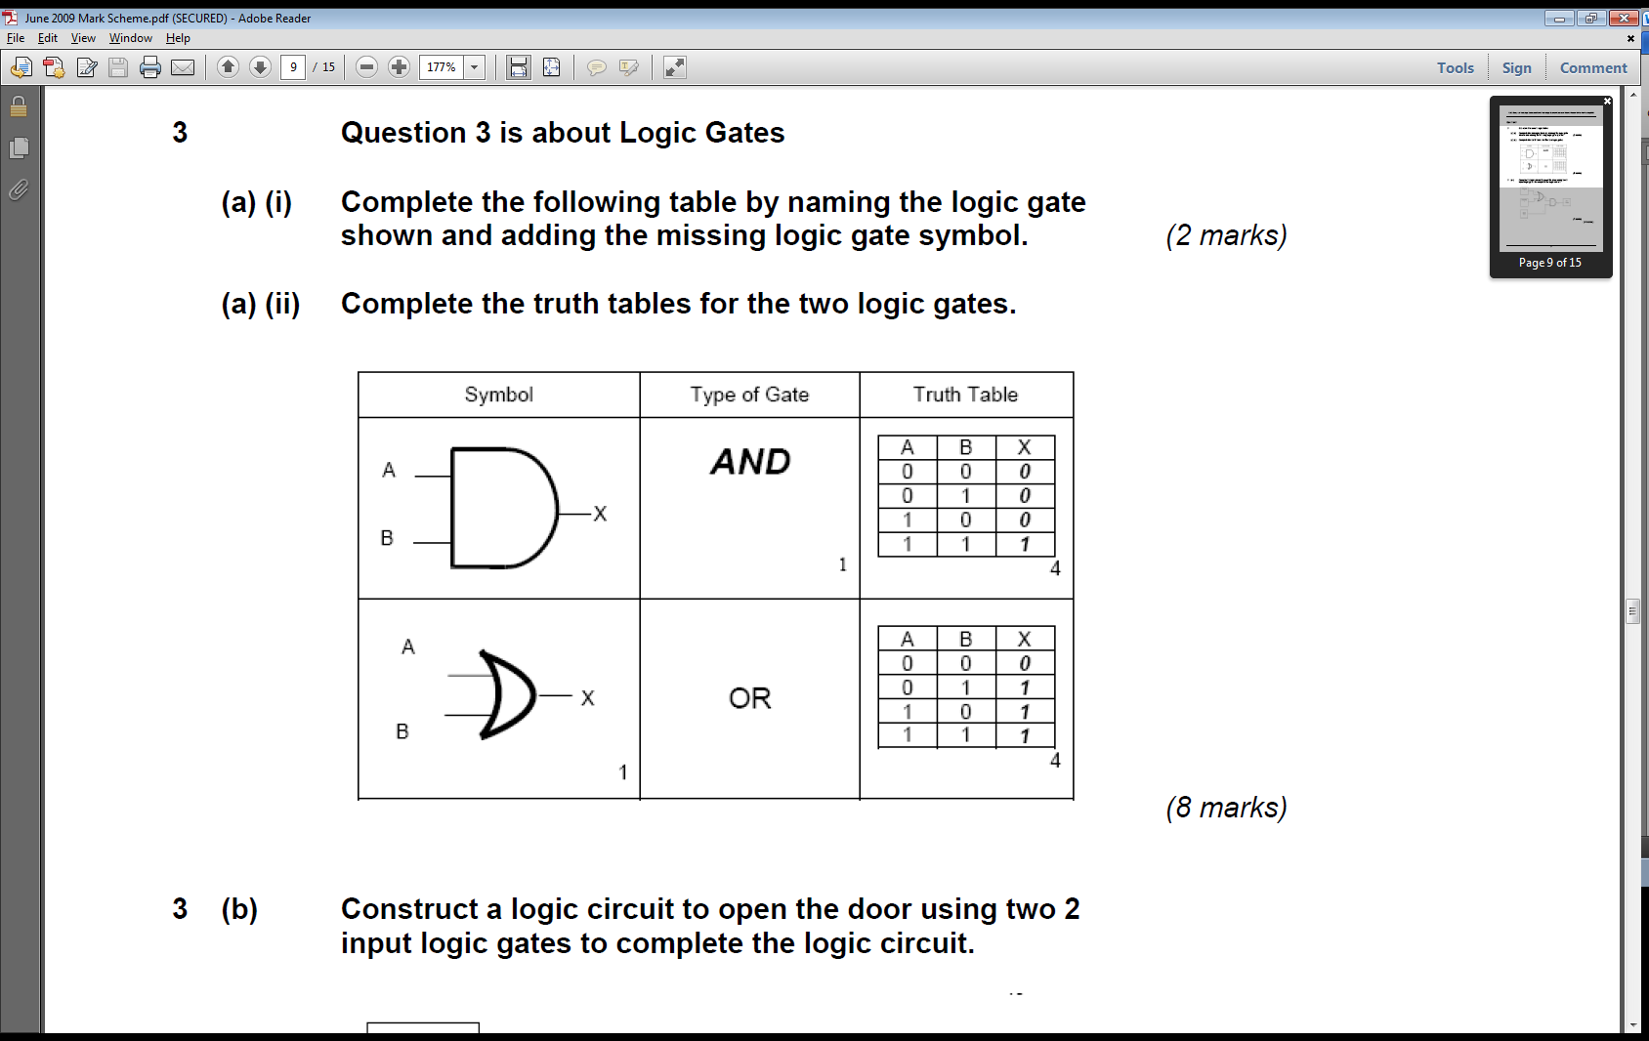a i.

3a ii.

**Teacher’s notes:** A typical logic question; some easy marks at the start, with a slightly trickier part later on to see if you can design your own logic network.

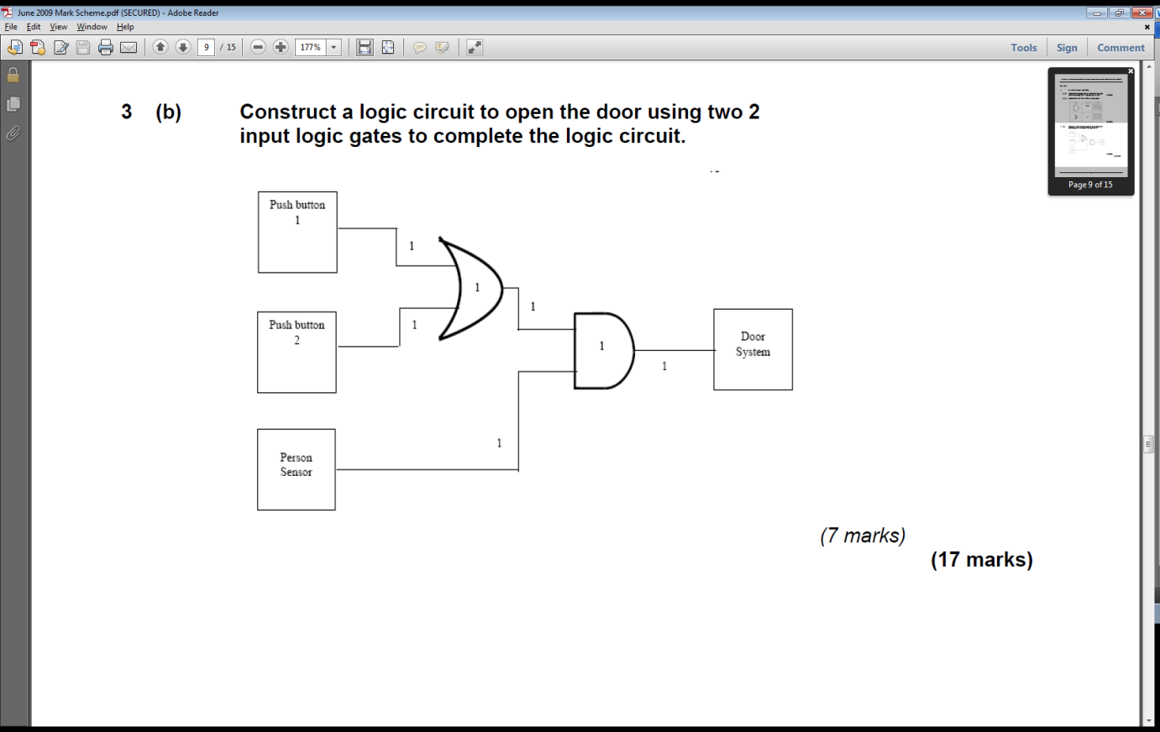3b.

**Teacher’s notes:** As so often happens with this type of question, the examiner actually gives you the gates to use in CAPITALISED **bold** type in the question.

“Push Switch 1 **OR** Push Switch 2 is pressed **AND** the lift control states it is safe to open.”

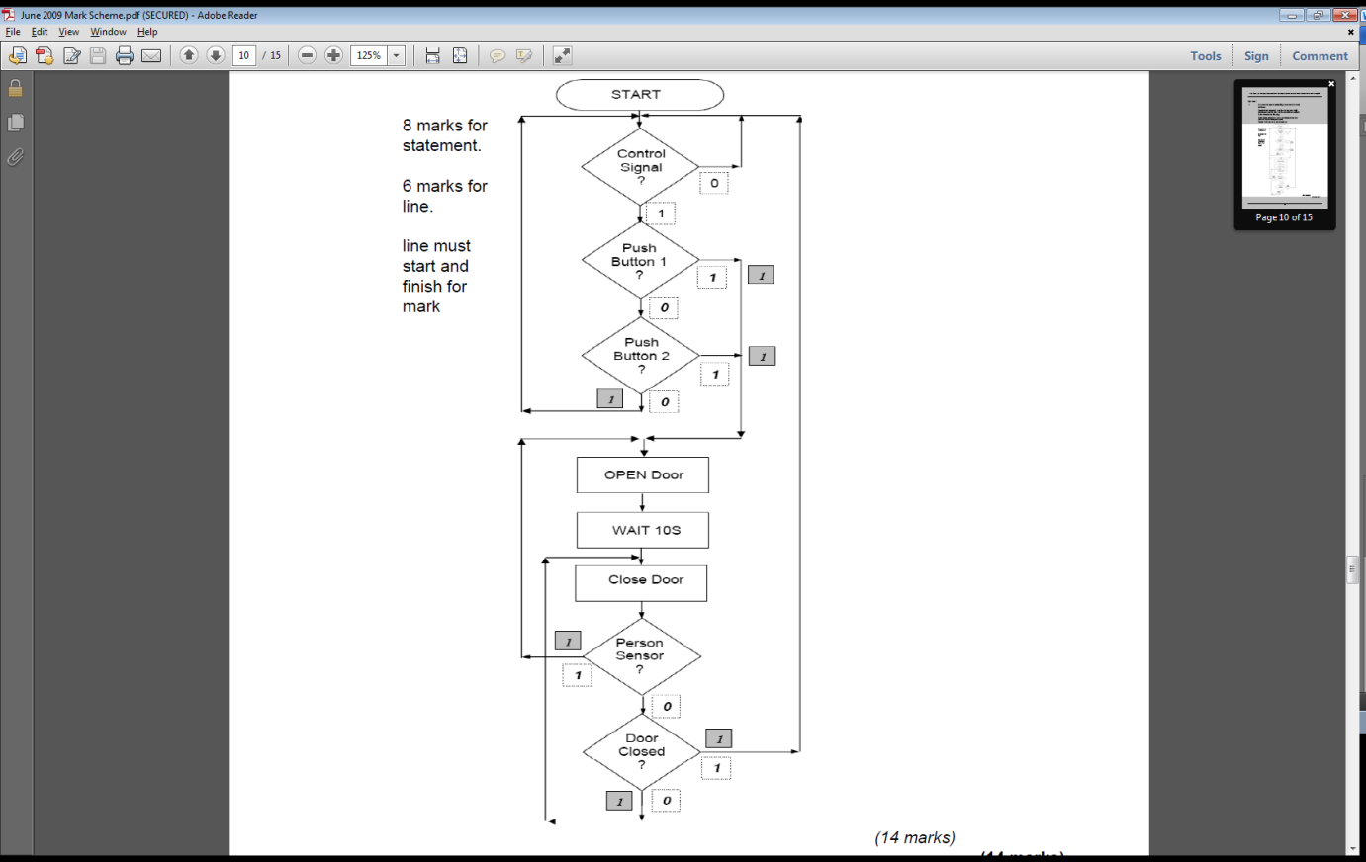4.

**Teacher’s notes:** Programming questions such as these have occurred in every exam paper from 2009-2013, and consistently carry more marks than any other single question on the paper. As such, it is vital to your success that you prepare for these, and don’t lose any marks unnecessarily. When practicing these types of questions, do a checklist in your mind along the lines of:

1. Have I added any missing flowlines?

2. Are there are 2 flowlines from all the decision diamonds?

3. Have I put “0” and “1” rather than “yes/no” on the diamonds?

4. Did I use parallelograms for output control?

5. Rectangles for time delays?

Watch out for things that can be overlooked with outputs. If the instructions say something like “turn on the light for 20s”, remember that this will need 3 flow shapes. One to turn on the light, one to wait 20s and one to turn it off again afterwards.

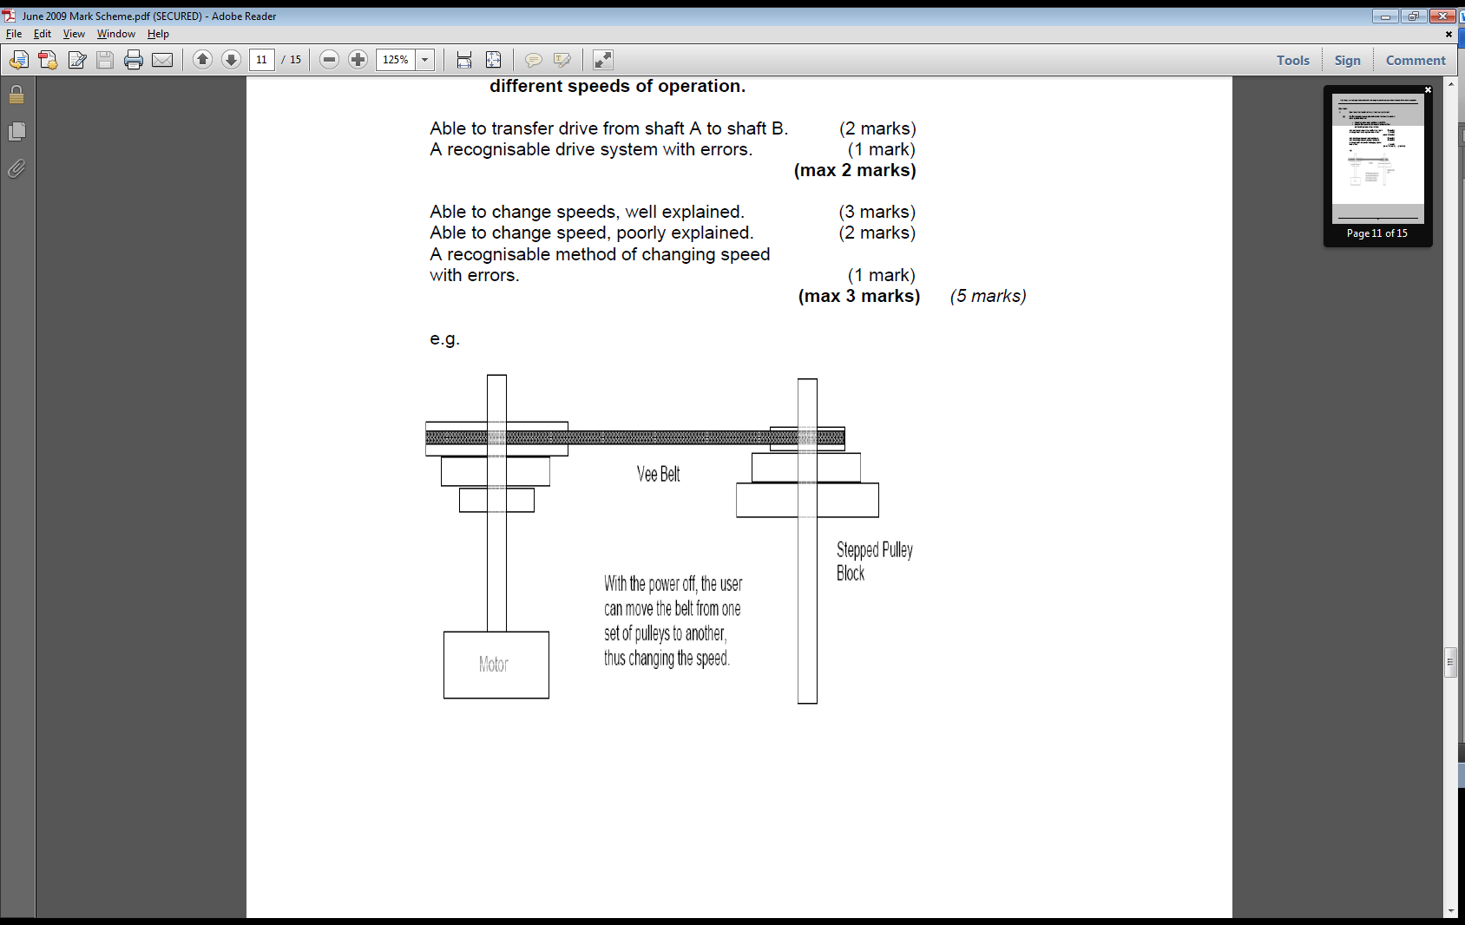5a.

**Teacher’s notes:** This is how the pillar drills in the classrooms actually work.

5b i. This means the drill could have an emergency stop button as well as an on/off button to make it safer to use.

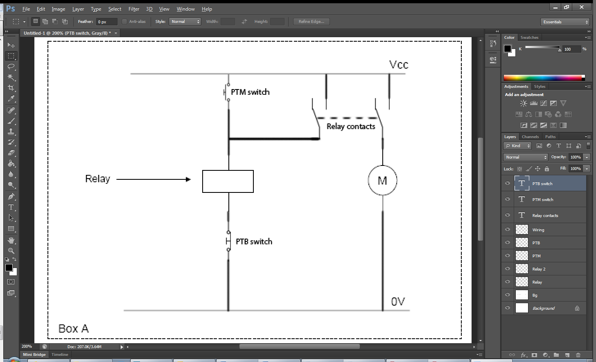5b ii.

**Teacher’s notes:** In order to draw the diagram the question paper asked for in the space provided, I had to show the relay contacts away from the relay coil (shown by a rectangle).

Connecting relay output pins back to the coil (as has been done here) is a clever way of creating a latching circuit. Once the PTM switch has energised the coil, the (now closed”) left-hand relay SPDT switch carries current through the coil, holding the relay open. Pushing the PTB switch cuts the current to the coil, causing the relay to flip back to being open, ready for next use.

**Shown in “Off” position.**

6a. I’d start this with a visual check to ensure that all the soldered joints are good, and that there are no dry joints. Next, I’d look at the different components and check that all the right resistors have been used, that diodes are oriented correctly and that ICs are installed the right way up. Once done, I’d connect the power supply and quickly check any ICs and voltage regulators for overheating as an indication of a short circuit. Assuming it powered up without incident, I could then start to test its individual inputs and outputs to ensure it functions as intended.

**Teacher’s notes:** We stock 5% (gold band at the end) resistors in school, as they balance low cost with good error tolerance. Different tolerances are available, up to white-band resistors, with +/-0.005% tolerances for highly specialised scientific instruments.

6b. Resistors with high tolerances (e.g. +/-1%) will have values closer to the value stated on the component, and therefore will perform more accurate readings compared to a resistor with a 20% tolerance (for instance).

6c. A standard multimeter can measure: Continuity, resistance, DC voltage, AC voltage, current and can often measure transistor gain (hFE) too.

6d. Having daughter-boards allows for individual boards to be replaced if/when faults occur, which in turn will extent the serviceable life of the product. It can also make the design of the product more efficient, such as by allowing 7-seg drivers to be closer to the component they are for. Finally, it allows an upgrade path for hardware, where as better daughter-boards (e.g. including new ICs or new features) are developed, they can be put into the system.

7a. Keypad -> Logic Check -> Relay -> Solenoid

7b i.

7b ii. When the coil inside the relay is energised/de-energised, it generates back-EMF (an electromotive force) which has the potential to damage the transistor. The backward facing diode soaks up the temporarily occurring EMF, discharging it back through the solenoid until it is dissipated.

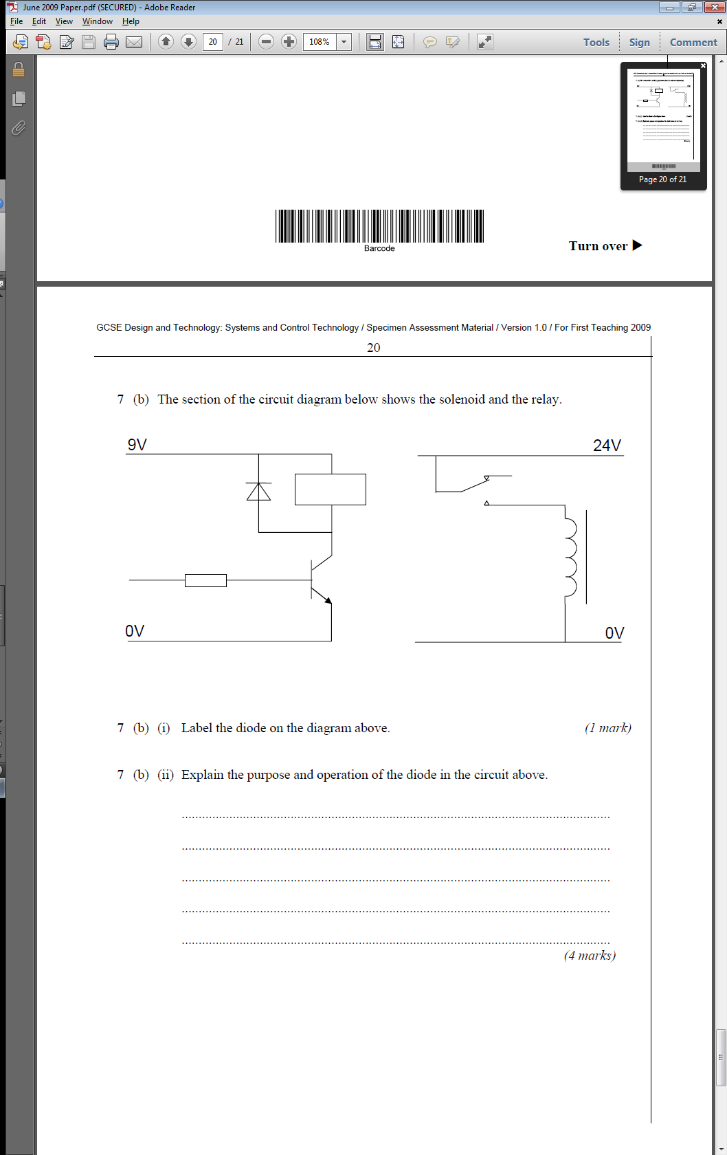

Flyback diode

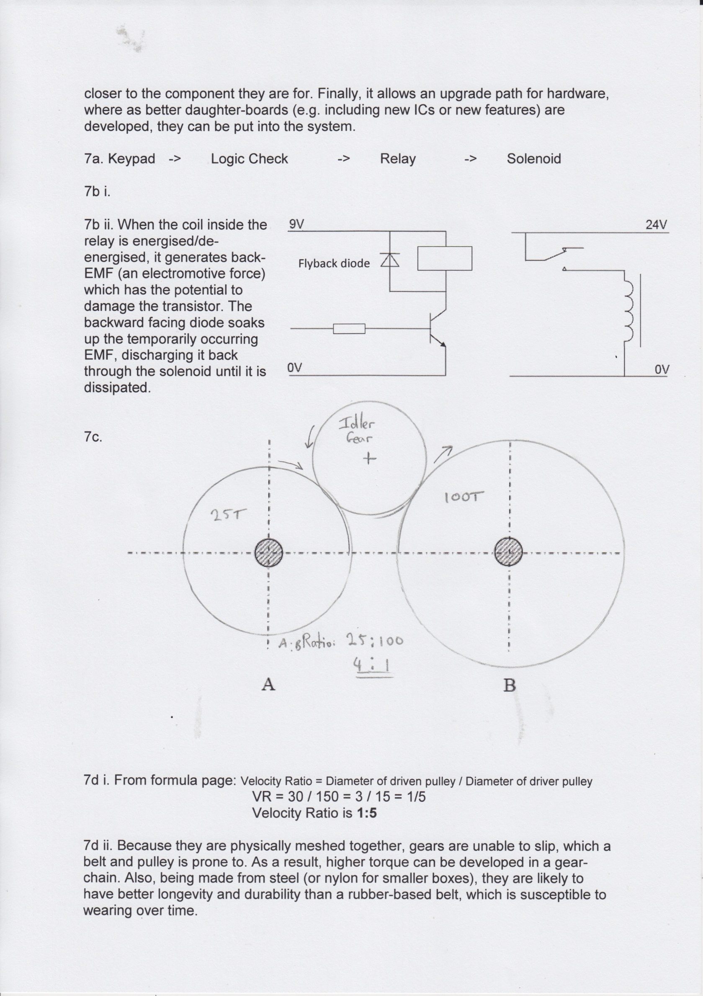

7c.

**Teacher’s notes:** I could have used 2 gears here and gotten all the marks, but I’d have gone over the dotted lines provided by the exam board. I decided to show off instead by adding the idler gear, and showing the direction of rotation for the gears. I also stated how many teeth I’d have put on my driver and driven gears, so that it was clear that driven gear B would spin more slowly (with more torque) than gear A. The inclusion of showing the ration was probably unnecessary, but again, if it was my GCSE, I wouldn’t want to leave anything to chance!

7d i. From formula page: Velocity Ratio = Diameter of driven pulley / Diameter of driver pulley

VR = 30 / 150 = 3 / 15 = 1/5

Velocity Ratio is **1:5**

7d ii. Because they are physically meshed together, gears are unable to slip, which a belt and pulley is prone to. As a result, higher torque can be developed in a gear-chain, and being made from steel (or nylon for smaller boxes), they are likely to have better longevity and durability than a rubber-based belt, which is susceptible to wearing over time.

**Teacher’s notes:** They asked for one advantage; I don’t like to take chances, so I managed to work three things into my answer.