S&C June 2010 Model Answer

**NB:** With S&C papers, there are often multiple ways to answer a question and still achieve all the marks. This example shows the answers that I’d use if I was sitting the exam, sometimes with additional possible answers.

Key areas that attract marks are shown in bold where appropriate, to help you spot them, and teacher’s notes have been included. Note that where a question might ask for two examples, I’ve often given more to show some alternative answers you could consider.

1a. Design Specification

Consideration 1: Reprogrammable

Explanation 1: So students can try controlling the system

Statement 1: A download socket to be mounted on the housing exterior.

Consideration 2: Power source

Explanation 2: The model needs to be conveniently portable.

Statement 2: The lift should be able to run on AA batteries.

Consideration 3: Materials

Explanation 3: Students will need to see how the model works

Statement 3: The housing should be made from a clear thermoplastic

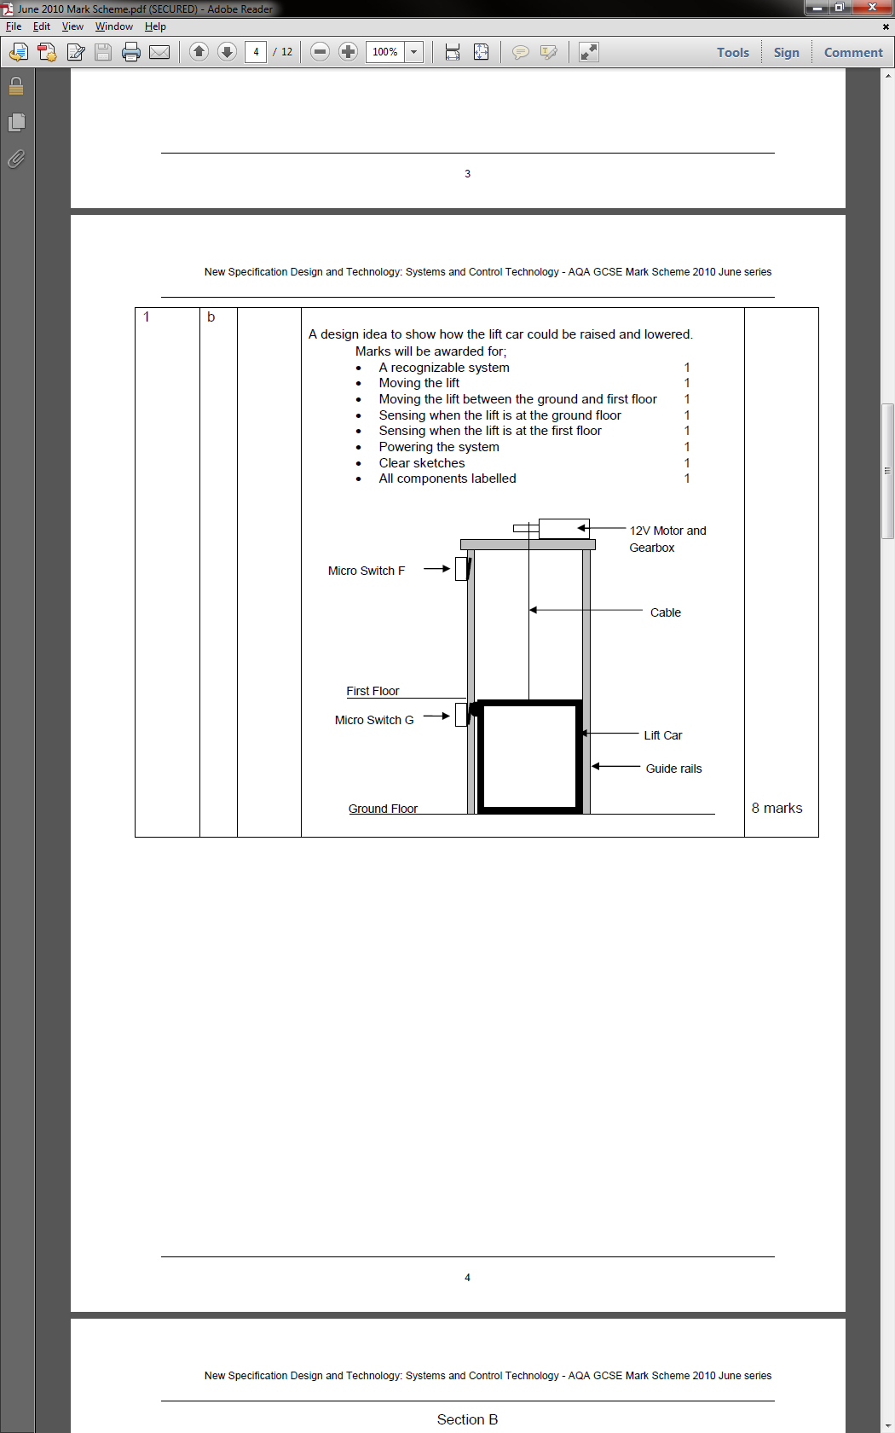

1b.

**Teacher’s notes:** A simple solution is usually best with situations like these. I’ve gone with the mark-scheme solution, as I like the idea of putting a protruding part on the side of the lift car that catches the microswitches on the way past.

If it were me, I’d have put the switches on the floor surface and ceiling of the shaft though, as I’d be concerned that switch G might get snagged by the protrusion on the way back down.

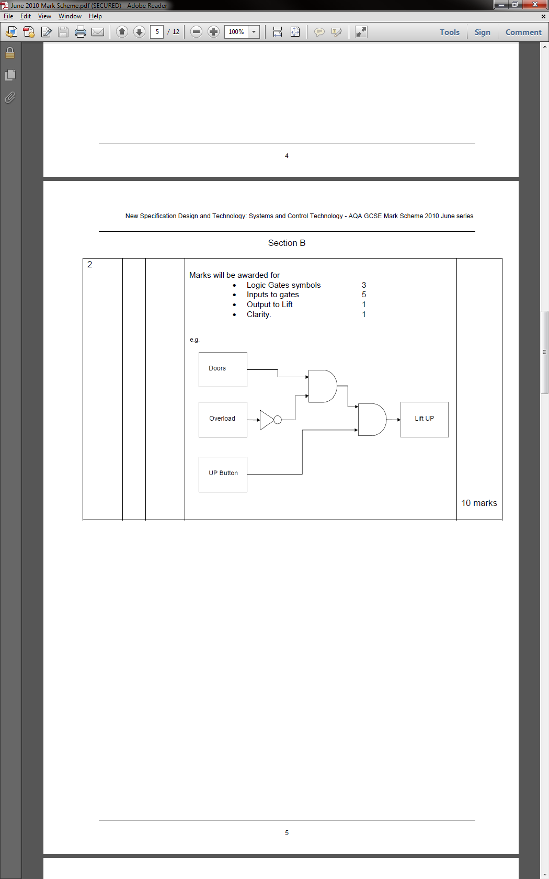2.

**Teacher’s notes:** By putting the conditions for the lift going up into a sentence, you can work out the logic.

“Doors must be shut **AND** the lift is **NOT** overloaded **AND** the up button is pushed”.

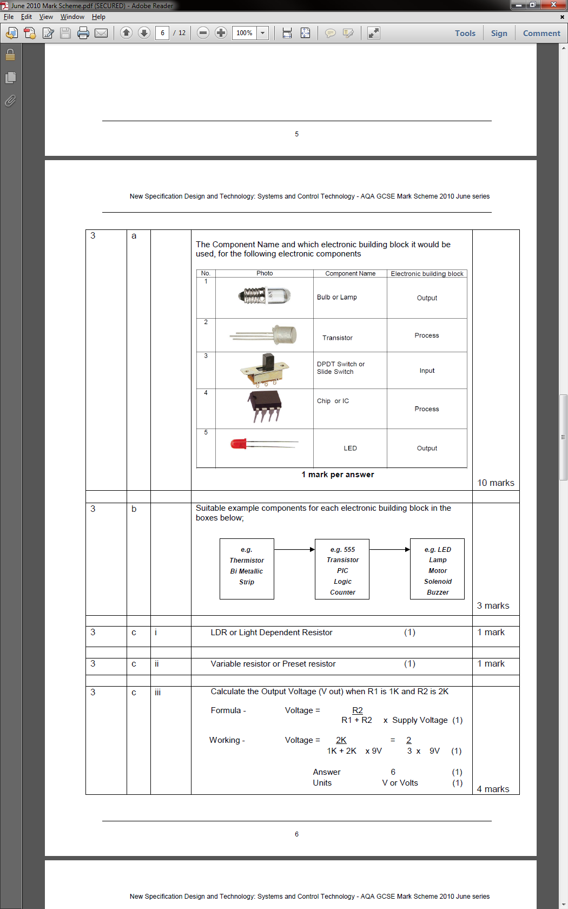

3a.

**Teacher’s notes:** Make sure you know the differences between inputs (components that send information in to a PIC (e.g. temperature data, whether a switch is pushed, light levels), processes (components that decide what to do with inputs) and outputs (things a PIC can control, e.g. motors, lamps, LEDs, solenoids, LCD panels)

**Teacher’s notes:** I could have used a buzzer or LED for my output, but I liked the idea of using an LCD so I could show a specific temperature.

3b. Thermistor -> PIC -> LCD panel

3c i. LDR

**Teacher’s notes:** A potentiometer has 3 pins by not connecting the third, it can be used as a VR). A variable resistor only has two. Make sure you know the difference!

3c ii. Variable resistor

3c iii. Formula: V = R2 / (R1 + R2) x Supply voltage

Working: V = 2000 / (1000+2000) x 9

Answer: 6V

4a. A breadboard can be used, where the components are placed in the board without the need to solder. This gives an accurate indication of whether or not the circuit design will work when made as a PCB.

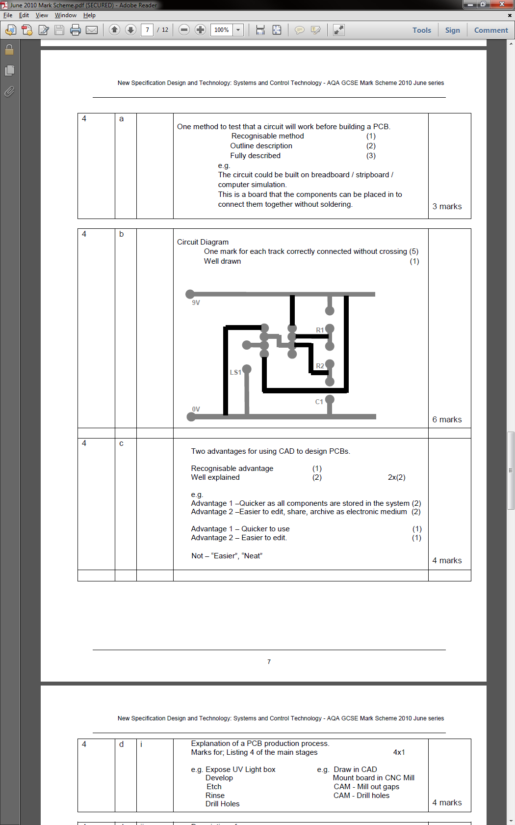4b.

**Teacher’s notes:** Looking over all the instances of these types of question, the examiner appears to favour 555 circuits. They carry a good number of marks, and with practice can be worked through quickly.

Make sure you take advantage of the gaps in the tracks (like where the resistors and capacitors will go) to help you route everything.

4c. Advantage of CAD to design PCBs.

1: Location of holes (e.g. for PIC chips) will be more accurate than when hand-drawn

2: Changes can be made without the need to re-draw the artwork by hand

3: PCB can be simulated in software to test it works correctly

4. Distributing the work is easier in an electronic format, as it can be emailed

4d i. PCB Production process

1. Expose the photoboard with the artwork underneath it in a UV box

**Teacher’s notes:** I’m glad I read the next question before I started writing my answer, otherwise I’d have ended up duplicating a lot of work in part *ii*.

2. Board goes into the developer tank, removing softened photoresist.

3. Board goes into the etchant, to remove copper areas.

4. Stripper solution used to remove remaining photoresist.

4d ii. An appropriately sized piece of photoboard has its protective cover removed, and is placed on top of the (inverted) artwork in the UV light box, and turned on for 3 minutes. Once complete, the board is placed in the (preheated) developer tank where the softened photoresist is washed away in about 20s. The board is then washed, before being placed in the (pre-heated, bubbling) etch tank for around 5 minutes until all the unwanted copper has been etched away. The board is the removed and washed, and a stripping solution is used to remove the last of the photoresist. All that remains is to trim the board more precisely to size, and to drill the holes so that the board is ready for soldering. Optionally, the board can be placed in a bath of (warm) tinning solution for around 5 minutes, to provide a protective layer and help solder flow better when soldering.

**Teacher’s notes:** It’s pretty standard to ask you for details on how to make a PCB; I tried to include all the little details (like pre-heating the tank) to maximize my chance of getting all the available marks.

5a i. Aluminium

**Teacher’s notes:** I’m not really into gardening, but I thought about other greenhouses I’ve seen, and decided to go with aluminium. I could also have said pine (not “wood”) as it’s easy to cut and join parts, or ABS (not “plastic”) because of its durability, low cost and weather resistance.

5a ii. Aluminium is light-weight, strong and will stand up well to the weather conditions of being outside.

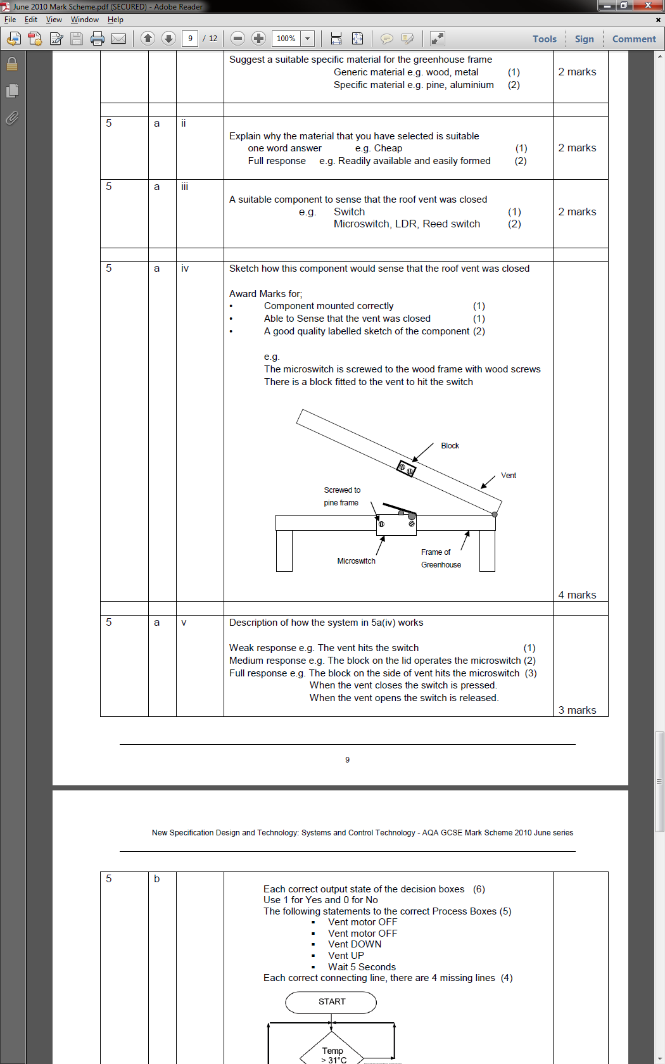5a iii. Microswitch

5a iv.

**Teacher’s notes:** In the interests of keeping things simple, I chose a microswitch, which will give me reliable operation and the ability to detect whether the vent is open or closed. The wooden block will ensure the closure is detected.

5a v. As the vent moves down to close, the block will come into contact with the microswitch, closing the circuit (likely sending a pulse to a PIC). When the vent is opened again, the microswitch will be released, breaking the circuit (and again, a PIC could detect this).

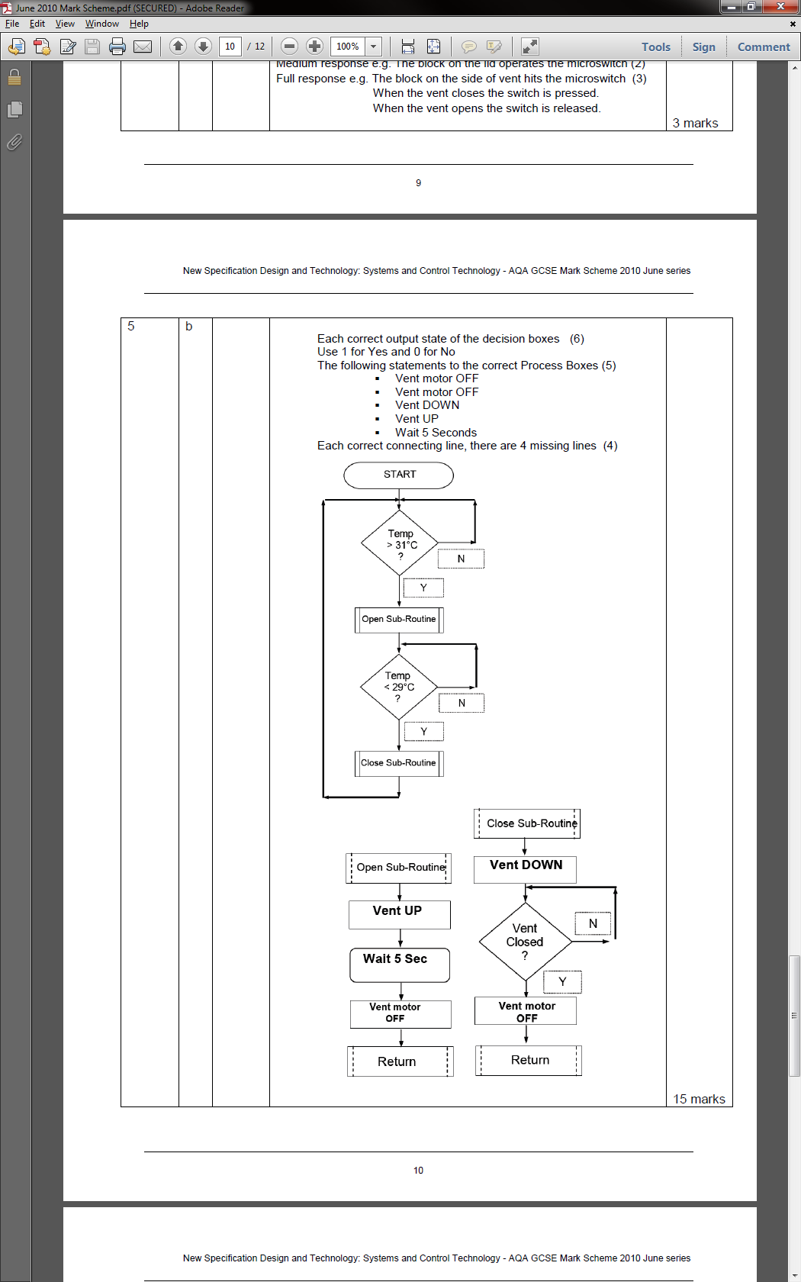

5a vi.

**Teacher’s notes:** Flow chart questions have made an appearance in every exam paper at some point, and are usually the highest scoring single question on the paper.

Practice the questions from other papers, and you should be in a strong position to pick up some (relatively) easy marks. Make sure that all your decision shapes (diamonds) have both 0 and 1 (Y and N) output flow lines.

6a. Problems with electronic curtains

Problem: Days aren’t uniform length, so a time will quickly open and close at the wrong time of day

Solution: Use an LDR to detect light level

Problem: A PIC can’t drive a motor directly, as it can’t provide enough current.

Solution: An h-bridge or a transistor connected to a DPDT relay would cure this.

6b. Drive systems

Problem: High speed = low torque

Solution: Add a gearbox to increase the available torque.

Problem: Belt probably slips

**Teacher’s notes:** The examiner will almost certainly ask about a system you are likely to have limited/zero knowledge about. The idea is that you can imagine how systems (like electronic curtains) could work, and also anticipate problems they may have.

Solution: Use a chain and sprocket.

6c i. This is a spurious use of electricity for a novelty application (although disabled users would benefit from having these). Electricity mostly comes from fossil fuels, which are a non-renewable energy source that contributes to global warming.

6c ii. Wind turbines and Solar power.

6c iii. Advantages of eco-friendly energy sources

1. Sustainable energy sources, so will not run out.

2. So not release CO2 into the atmosphere

3. After initial expenditure of energy to produce them, they generate something for nothing.

4. Can be more cosmetically attractive than traditional power stations.

**Teacher’s notes:** Social, Moral, Environmental and Sustainability questions will appear at some point in every paper. Sometimes they only carry a few marks, but on other occasions they carry considerably more. You may often find you can combine your S&C knowledge with learning from other subject areas (e.g. Geography or Science) to help with your answers.