S&C June 2012 Model Answer

**NB:** With S&C papers, there are often multiple ways to answer a question and still achieve all the marks. This example shows the answers that I’d use if I was sitting the exam, sometimes with additional possible answers (e.g. the first question asks for two examples, and I’ve given 4).

Key areas that attract marks are shown in bold where appropriate, to help you spot them, and teacher’s notes have been included. Note that where a question might ask for two examples, I’ve often given more to show some alternative answers you could consider.

1a.

The **Safety** of the design, to ensure that fingers and limbs can’t be caught in the mechanical parts.

The **power source** for the system, as mains power is unlikely to be present in a garden greenhouse.

The **materials** to make the system from, as the system will need to have some resistance to weather.

The **dimensions** of the product, to ensure it doesn’t take up too much space in the greenhouse.

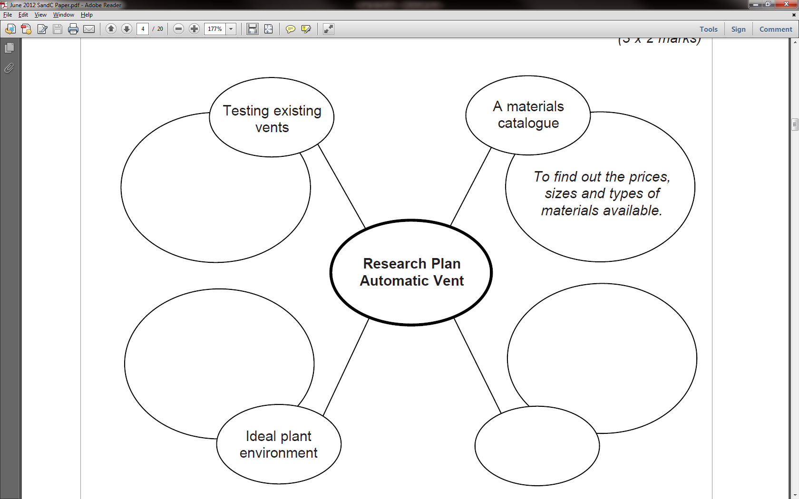

1b.

To identify strengths, weaknesses and identify how others have solved the problem

Indication of mounting requirements for the mechanism.

Light and moisture requirements.

Greenhouse

catalogue

1c. The details on the plant environment will help inform the way that any PIC program will need to be set up. The materials catalogue will give an indication as to what different materials could be used to manufacture the product from. Testing pre-existing products may provide inspiration for different ways to solve the brief.

1d.

R1. The vent must be able to run on batteries charged by solar power

E1. To ensure the product can work unattended for extended periods.

R2. The mechanical parts of the system must be enclosed

E2. So that fingers / plants can’t get trapped in them

R3. Must be water resistant

E3. As it will be exposed to moisture and humidity in its working environment.

R4. Must be manufactured for under £30

E4. So that it can be sold at a competitive price.

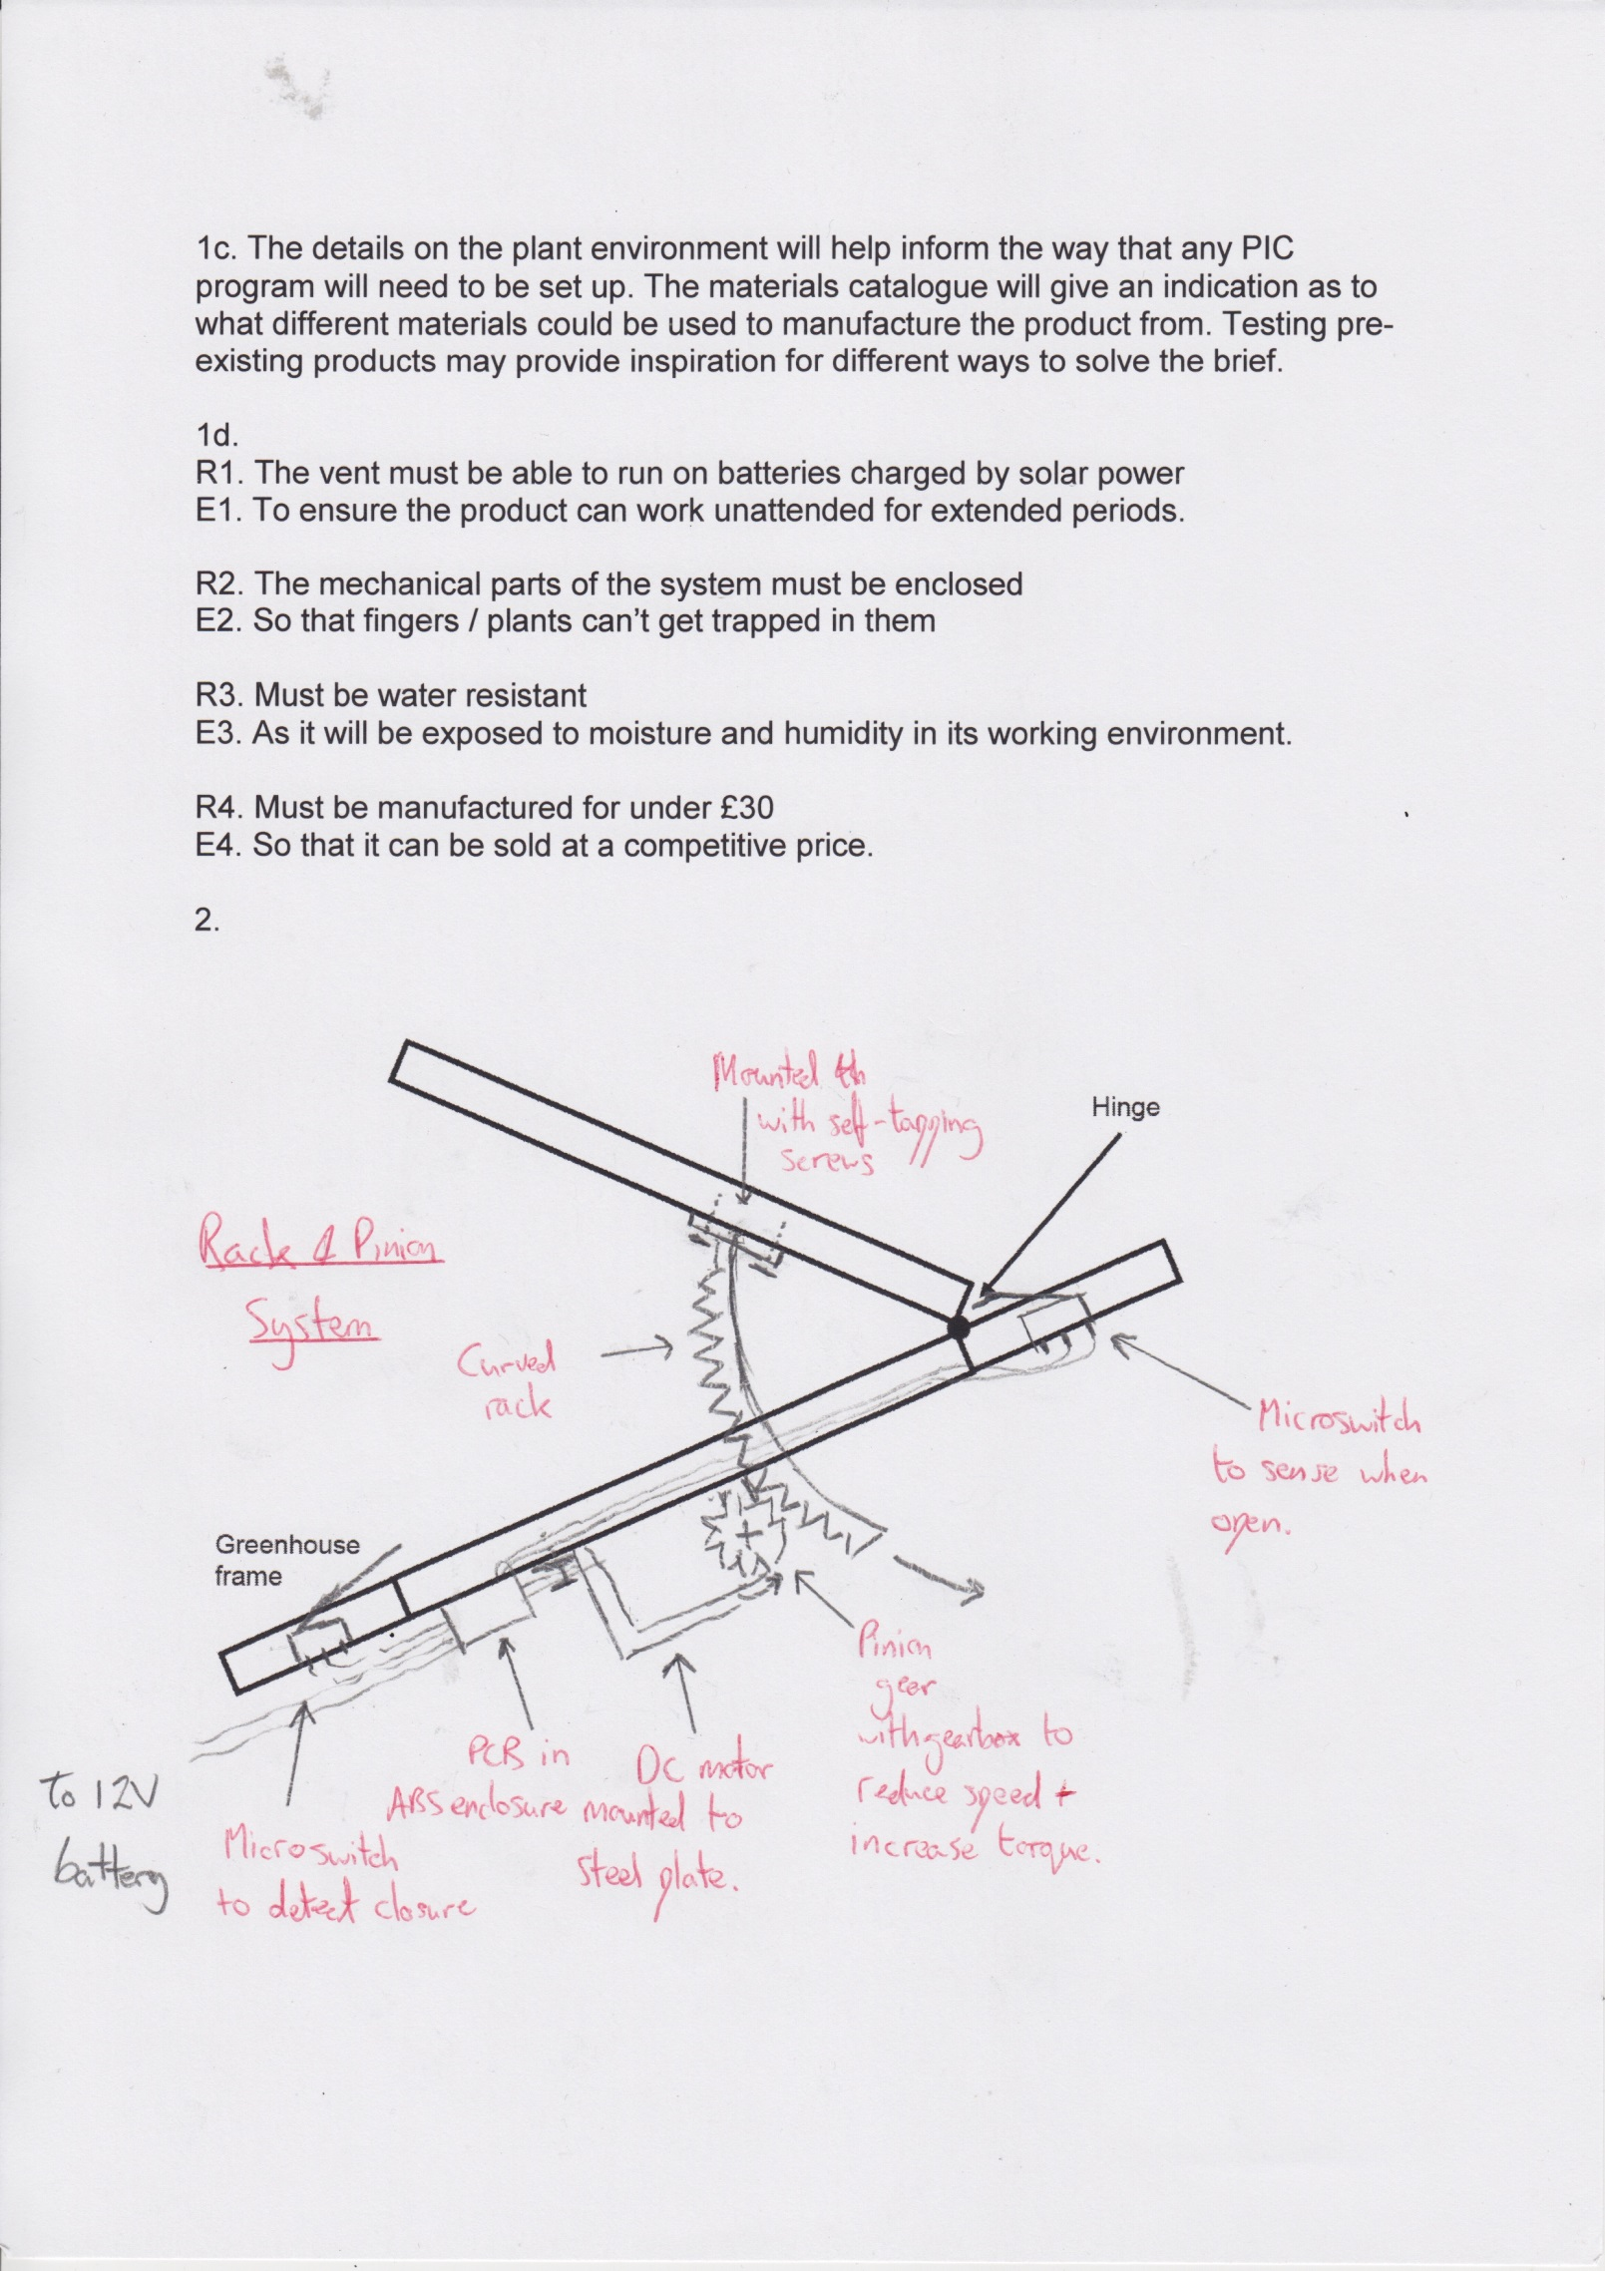2.

**Teacher’s notes:** There aren’t a lot of problems you’ll encounter in GCSE design-type questions that can’t be solved with the careful application of either cams or rack and pinion gears. In this case, I used a curved rack (although I could have used a straight one) so that as the window closes, the rack doesn’t end up protruding into the greenhouse as something for people to catch their heads on. To get all the marks, you’ll see I labelled every part I added, named the system (shown underlined – 1 mark for this) and showed both my power source and how all the various parts would be fastened to the greenhouse. I also made sure I included detail on the materials I’d use.

3a. See the mark scheme.

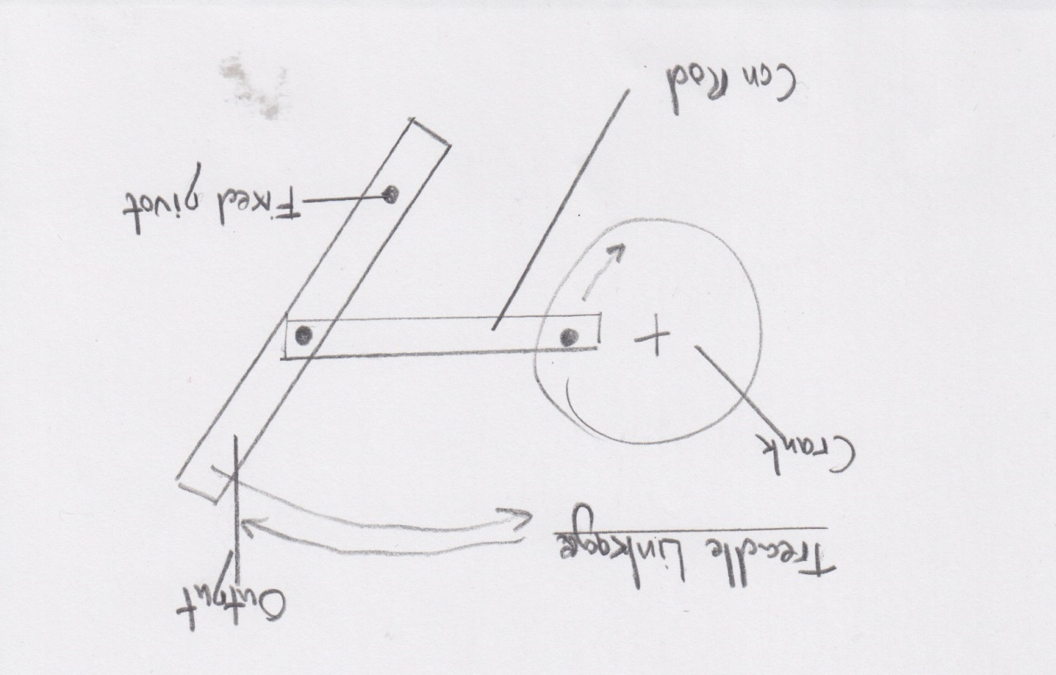

**Teacher’s notes:** The BBC bitesize site has excellent notes on this area, and mechanisms/linkages come up every year in the exam. In this question, I could also have drawn a “peg and slot” mechanism too. Avoid dropping marks by labelling everything, naming the parts and not forgetting to label your pivot points.

3b.

**Teacher’s notes:** I could also have used Crown gears here. On reflection, I could perhaps have written a couple of sentences about how this works to help ensure I got 4 marks.

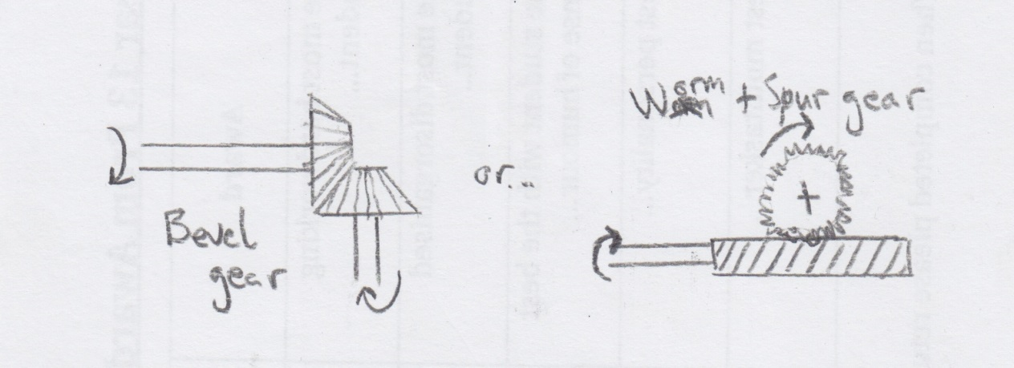

3c.

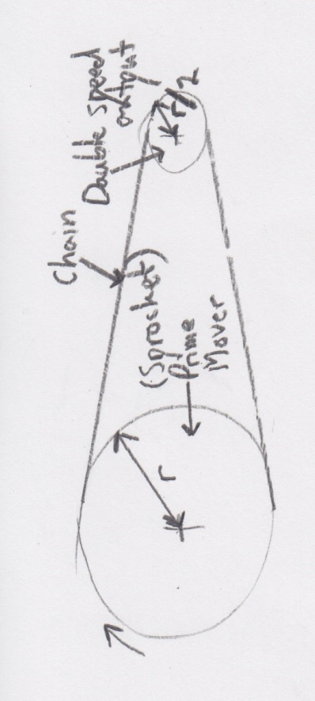

**Teacher’s notes:** A chain and sprocket setup (a sprocket is a gear designed to be chain driven) has the advantage of not slipping when compared to a pulley and belt system, although it would need oiling to reduce friction and noise. I could have also used two gears meshed together to solve the problem. I made sure I got the marks for speed reduction by showing that the driven sprocket is half the radius of the driver.

3d.

4a.

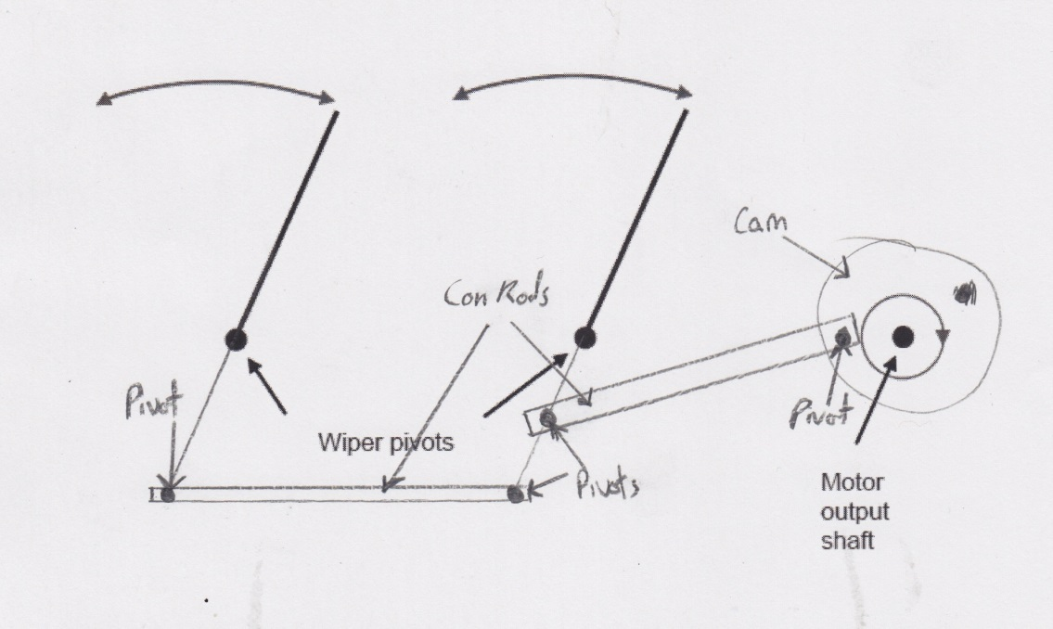

**Teacher’s notes:** The treadle linkage converts rotary to oscillating motion, which is perfect for this problem. I read the “Marks will be awarded for” section carefully, and double-checked afterwards that I’d met all the criteria.

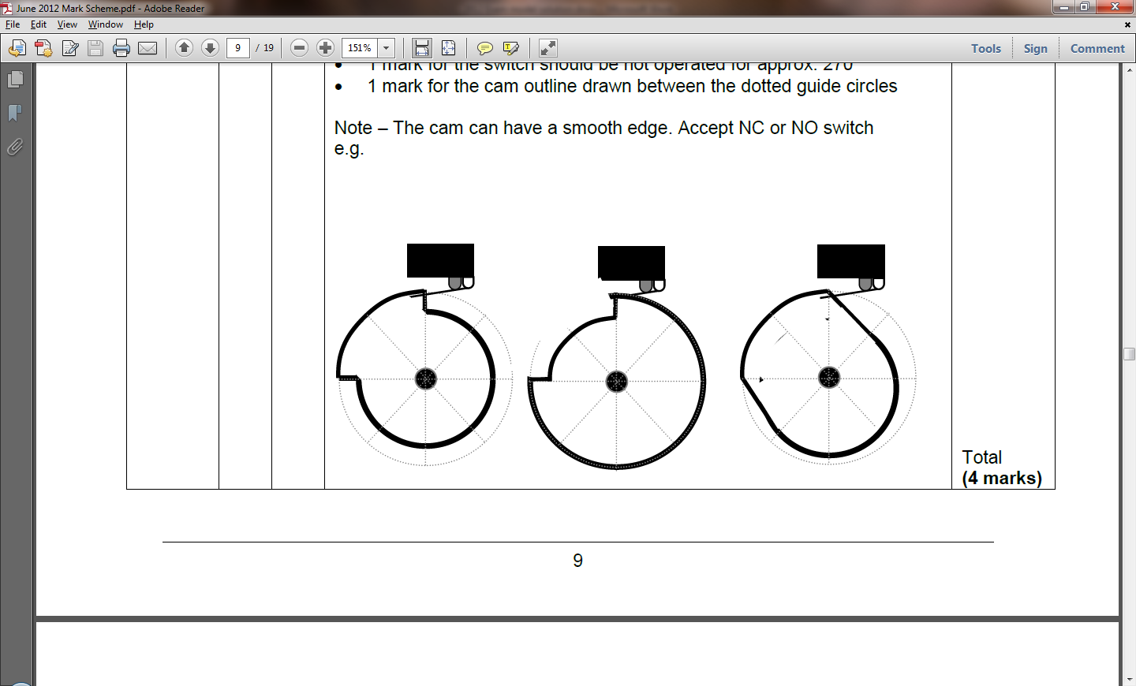4b.

**Teacher’s notes:** This is effectively 1 mark for each quarter of a circle you draw correctly.

As is so often the case with S&C questions, you must **read the question carefully**. The first time I went to write my own answer, I just shaded a quarter of the circle, which would have seen me score 0!

4c. Microswitch

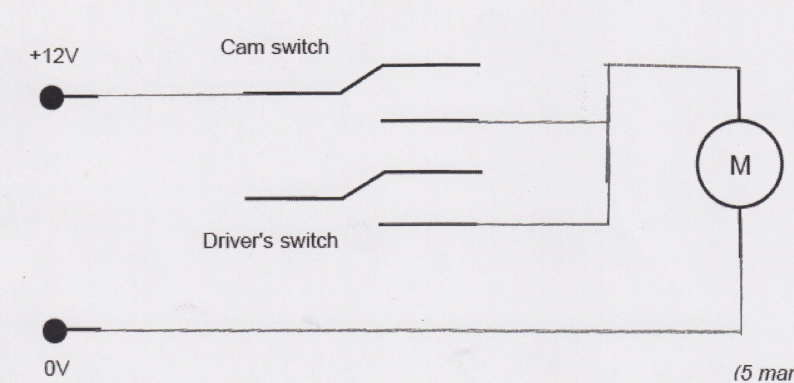

4d.

**Teacher’s notes:** Again, an easy question to slip up on, if you’ve not read the instructions. When I first glanced at this question, I assumed (without reading the text) that I was being asked to connect up a DPDT switch. It was only when I read it properly that I realised I was making a sort of “OR” switch, where the motor was powered up by either of two switches.

5a. i. The machine should have a drip tray to catch overflowing coffee, so that it can’t go on the floor and create a trip-hazard,

ii. The electronic parts should be located away from the “wet” parts of the machine, to reduce the risk of electrocution,

iii. The machine should have no sharp or protruding parts, to reduce the risk of accidental injury to users

iv. Steam produced by the machine should be vented from the top of the machine, to reduce the risk of burns.

**Teacher’s notes:** This is a 4 mark question, in which you’re asked to list two things. As such, I figured out that when writing my answer, I’d need to explain why each point was important to score full marks.

5b. Solenoid valve. (*Note: These are commonly used in things like dishwashers, washing machines, fountains, central heating systems and so on. This way, a flow of water/oil/gas can be instantly turned on/off electronically when needed.)*

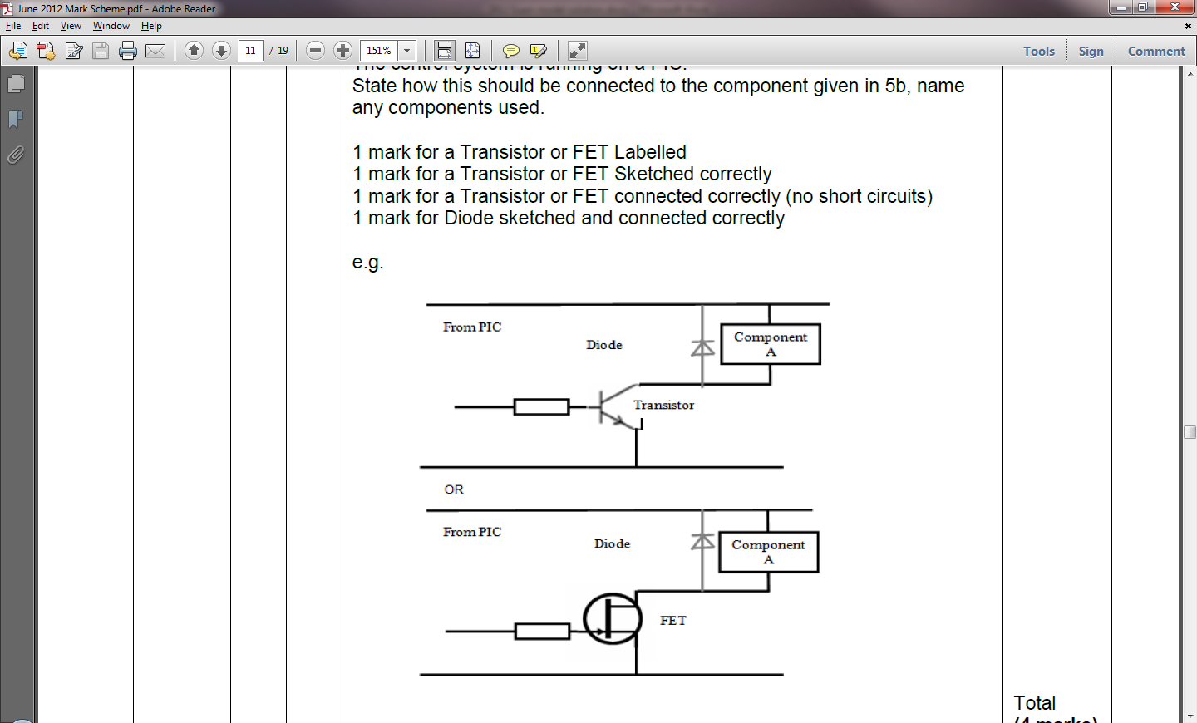5c.

**Teacher’s notes:** The key here to getting 4 marks is to both draw the components correctly using the right circuit symbols (2 marks) and to say what they are (2 marks).

Don’t forget the flyback diode – this is a common mistake!

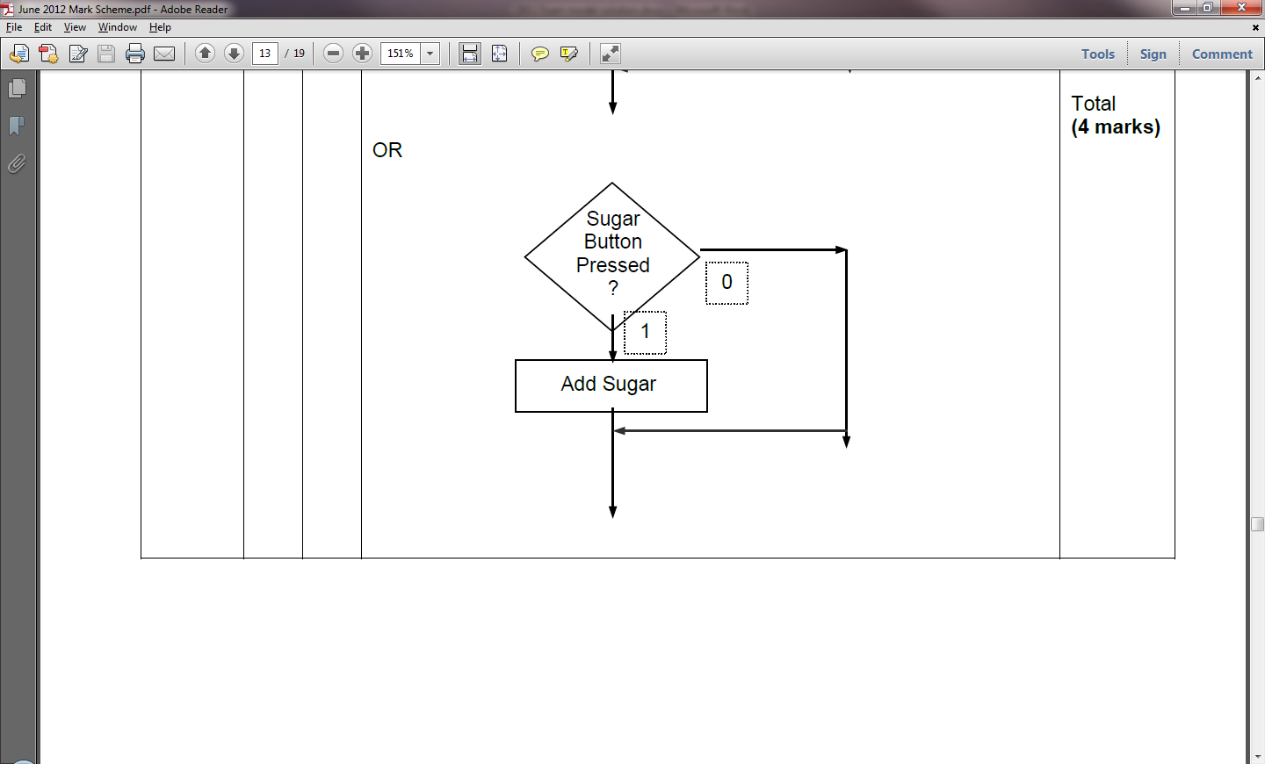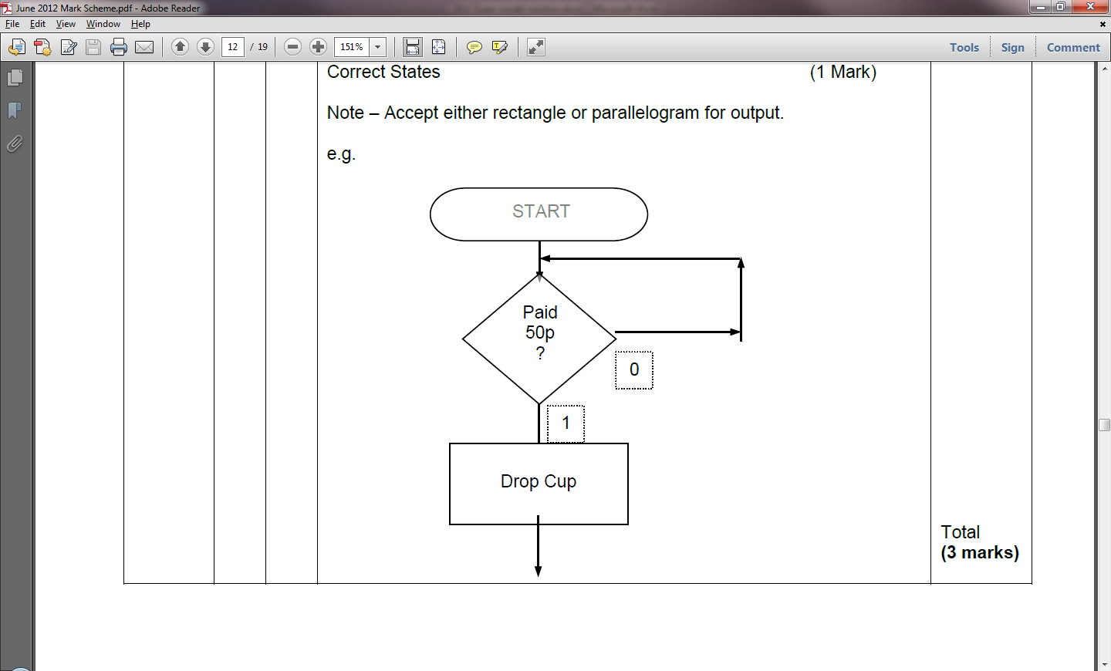

5d. i. 5d. ii.

5d. iii. The subroutine turns on the valve (to allow coffee to flow), waits for 5 seconds (to let the cup fill), then turns it off again (to cease the flow of coffee). Once done, the subroutine returns control to the main program.

*Note:* To get the full marks, notice that I’ve gone on to explain what is happening after each instruction is given.

5d. iv. Subroutines can reduce the size of the program code if they contain instructions which are repeatedly used, making the program more efficient. They can also improve the readability of code, by making the main body of the code less dense for other developers to read.

6a. LED, LDR, Flashing LED, Bi-colour LED, Photodiode, Diode.

*Note:* The Photodiode is *very* seldom seen in GCSE S&C papers. It converts light into either current or voltage

6b. Rt = R1 + R2. (*Formulae are all shown at the start of the paper*)

Calculation: RT = 4700 + 10000

Answer: 14700Ω or 14k7Ω or 14.7kΩ

6c. Polarised capacitor. *Note:* You’d only get one mark for saying “Capacitor”.

*Continued over…*

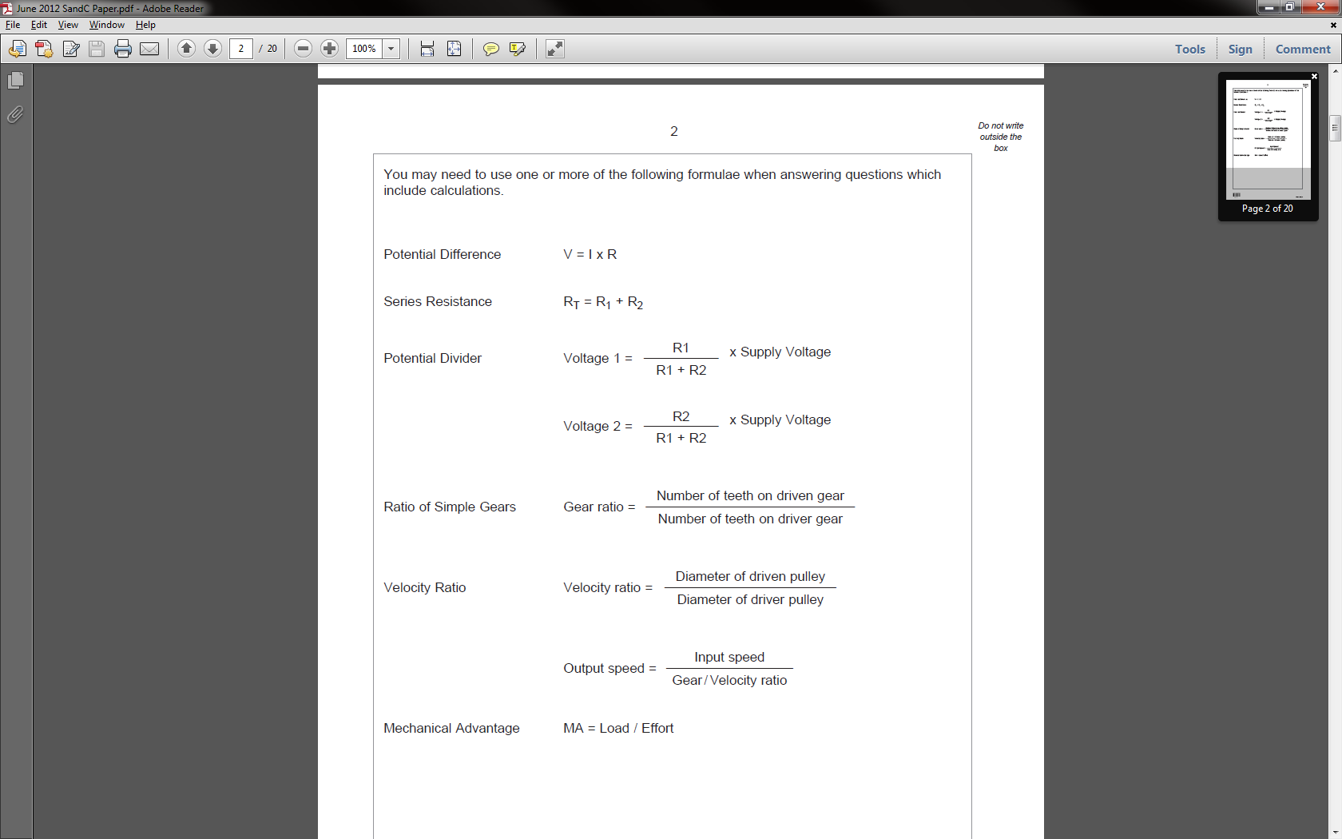6d. Formula: (*from formula page*)

Calc: V2 = 10000 / (5000+10000) * 9= (10000 / 15000) * 9 = (10/15) * 9 = **(2/3) * 9**

Answer: V2 = **6V**

*Note:* You should be able to recognise the potential divider in the circuit diagram. As the diagram labels V2 for you, you can then see that R2 is the 10000Ω resistor and that R1 is the 5kΩ LDR. All that remains is to plug these into the relevant formula to get the correct answer.

7a. The middle option is the correct one, as there is good solder contact between both the component leg and the PCB pad itself to allow a solid electrical connection.

7b. Continuity tester, multimeter or oscilloscope.

7c. Start with a visual inspection, which will highlight any obvious problems such as ripped tracks, under-etching (leading to tracks being merged), components inserted backwards or incorrectly, wrong resistor values being used, poorly soldered joints, missing components, incorrect ICs and battery terminals being soldered in backwards.

Next, use a multimeter to test continuity through all the tracks, then test each resistor. Use the voltage setting to ensure voltage levels are correct at the relevant areas on the PCB. Where ICs are used, these can be swapped to establish whether a defective chip has been used.

7d. i. Faulty goods may cause injury to customers. In addition to being undesirable, this will also tarnish the reputation of the company selling them.

ii. Issuing replacement products will be costly, as well as leading to reduced sales in the future.

**Teacher’s notes:** As with other written-answer questions, giving a correct answer gets you half the marks, and elaborating on it gets the other. Always look for opportunities to give that little bit extra to maximize your chances.

Closing thoughts

This paper follows the traditional layout for a S&C exam – questions on design, electronics, drive systems and programming all wrapped around a set of real-world problems. You can avoid the mistakes that other students will make by reading every question twice **slowly** before answering it. I almost made mistakes myself in the motor switching and cam question when writing these answers up.

Once you’ve finished the paper, go back over it yourself and pretend you are the examiner. If there are 6 marks available for a question, would you be able to award yourself all of them? Is there any other parts you could label? Would a paragraph of explanatory text make it clearer how your design works? Have you named the system you’ve designed (e.g. Rack and pinion)?