S&C June 2013 Model Answer

**NB:** With S&C papers, there are often multiple ways to answer a question and still achieve all the marks. This example shows the answers that I’d use if I was sitting the exam, sometimes with additional possible answers.

Key areas that attract marks are shown in bold where appropriate, to help you spot them, and teacher’s notes have been included. Note that where a question might ask for two examples, I’ve often given more to show some alternative answers you could consider.

1a. Specification points…

**Safety** – The system must have no sharp edges, so that birds are not injured.

**Power** – The system will need to run on batteries, as it will be used outdoors.

**Aesthetic** – The system should attempt to blend in with its surroundings, and should look attractive to encourage customers to buy it.

**Teacher’s notes:** As there are two marks for each of these, I made sure that I said what each requirement was, and then explained why it was important.

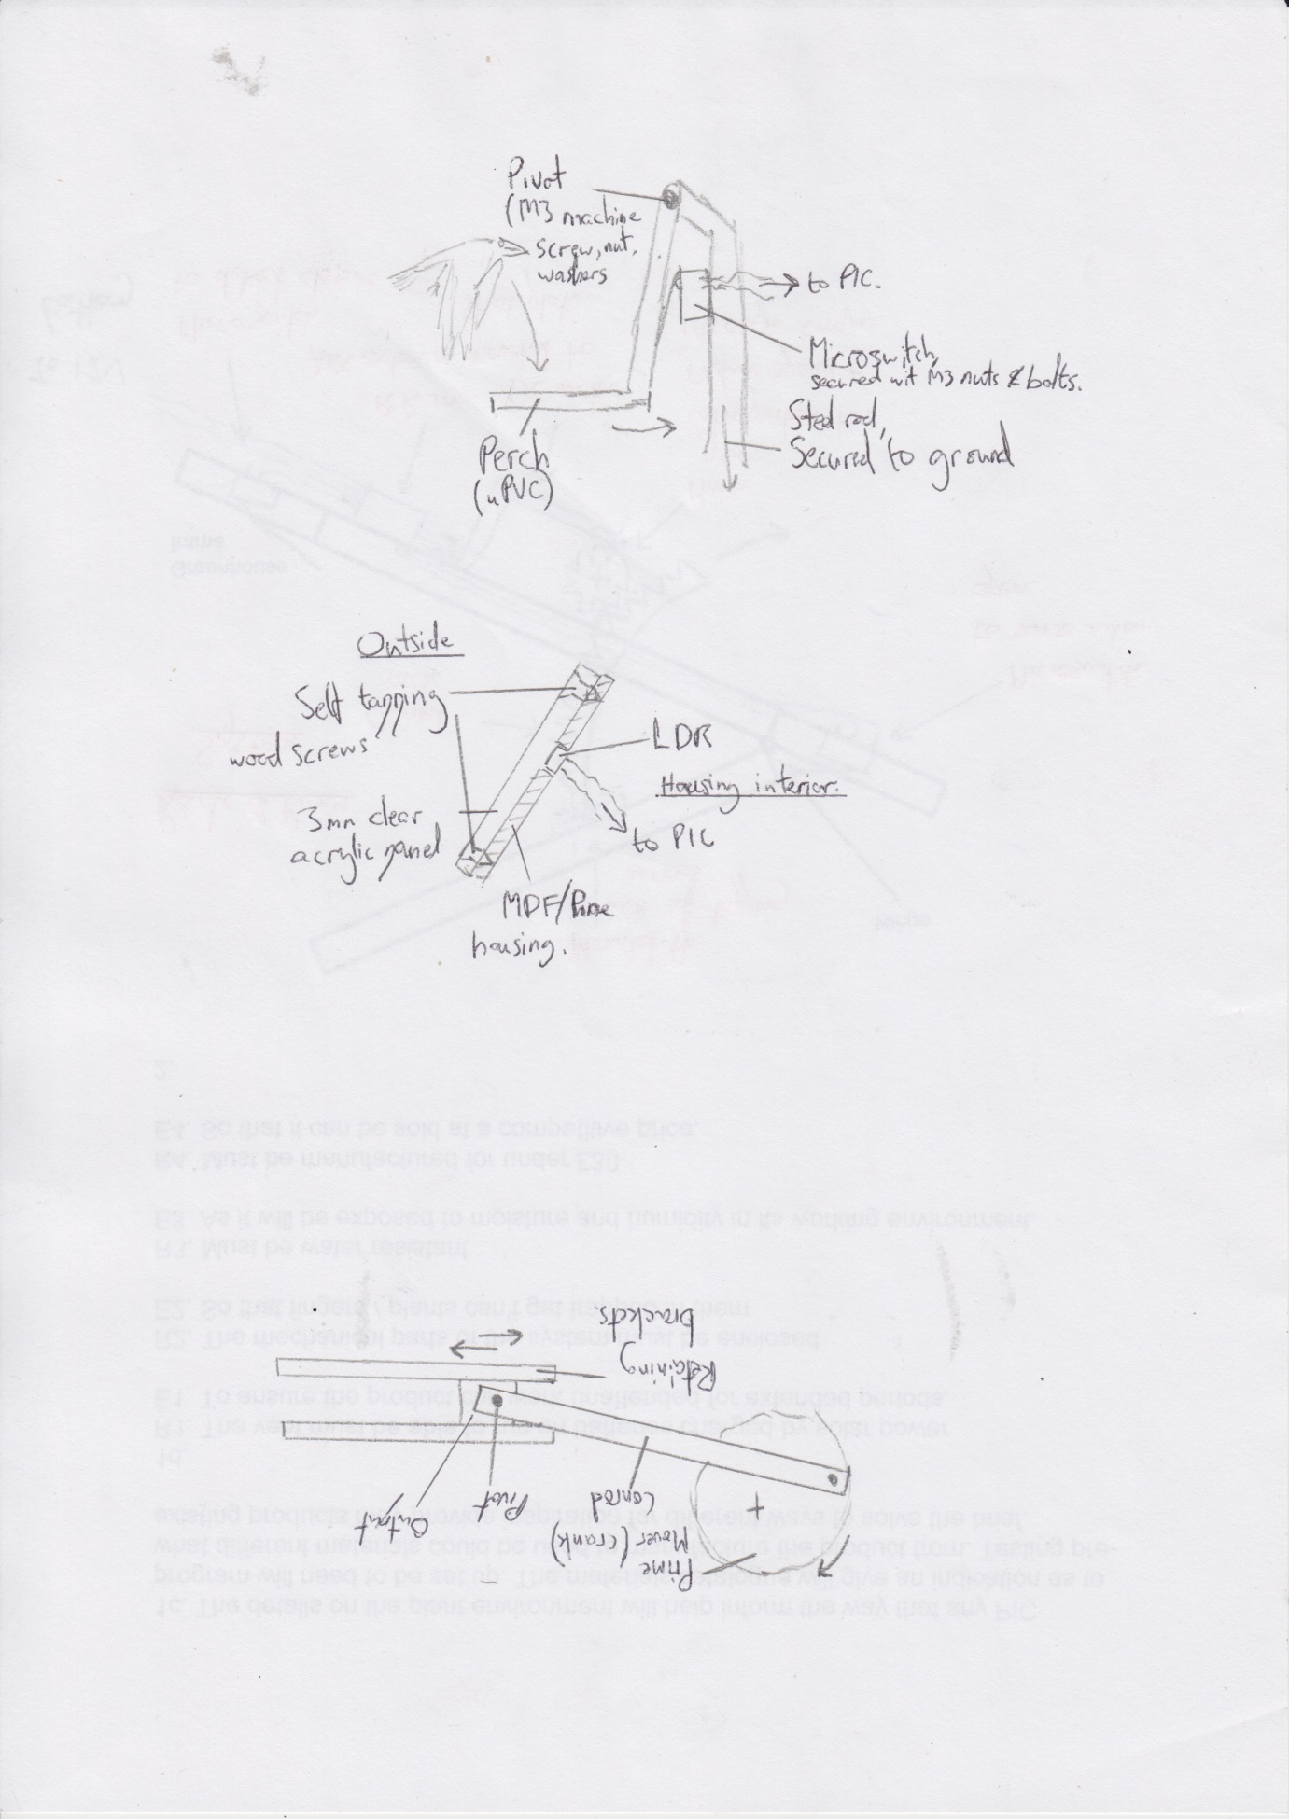1b i. My system uses a microswitch to sense the presence of the bird landing on a perch. This would be connected to a PIC, which could then go on to operate the camera unit.

**Teacher’s notes:** A large number of the input design scenarios can be solved with careful application of microswitches – this question is no exception. I could have used more exotic parts such as ultrasonic distance sensors, but I’m inclined to advise you keep things simple!

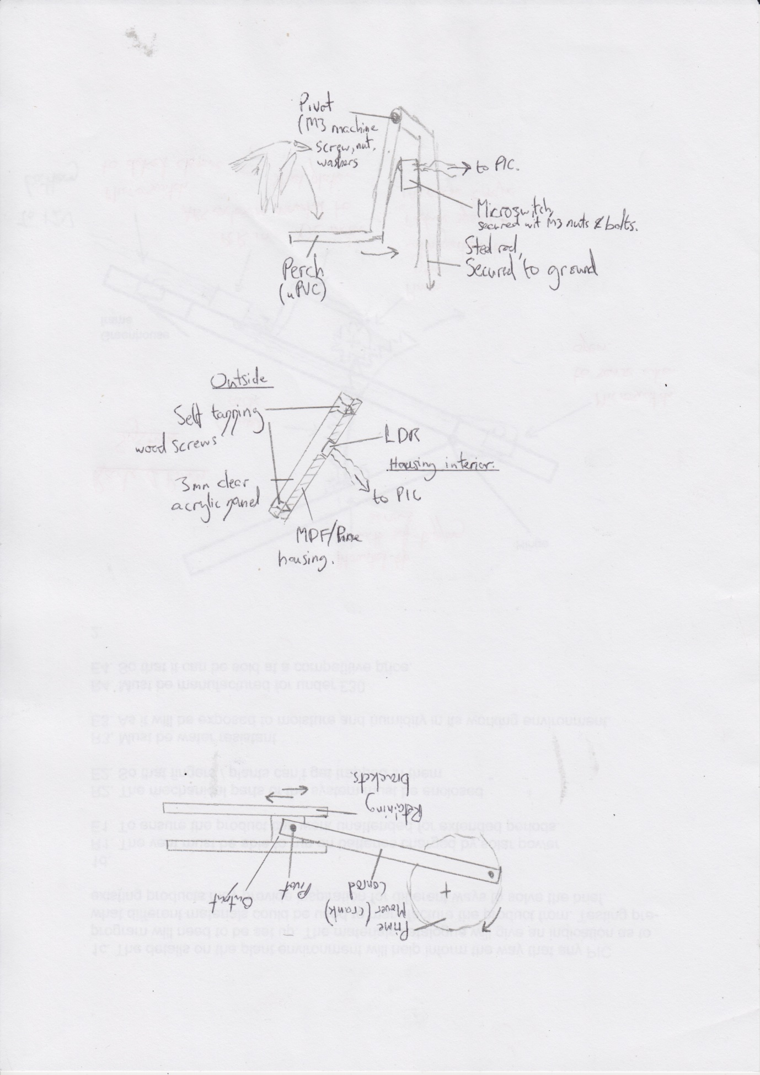1b ii. An LDR can detect changes in light level and can be connected to a PIC circuit. I’ve put a panel of clear acrylic (Perspex) over the top to protect it from rain. This has been secured by pre-drilling and counter-sinking the acrylic, then securing it to the wooden case with some short self-tapping screws.

**Teacher’s notes:** I’ve used a similar idea to the example in the mark scheme here, but added some weather-proofing for good measure. This allowed me to show another example of a material, and to talk about how I could secure it. Make sure you get lots of labels in as well as a good description!

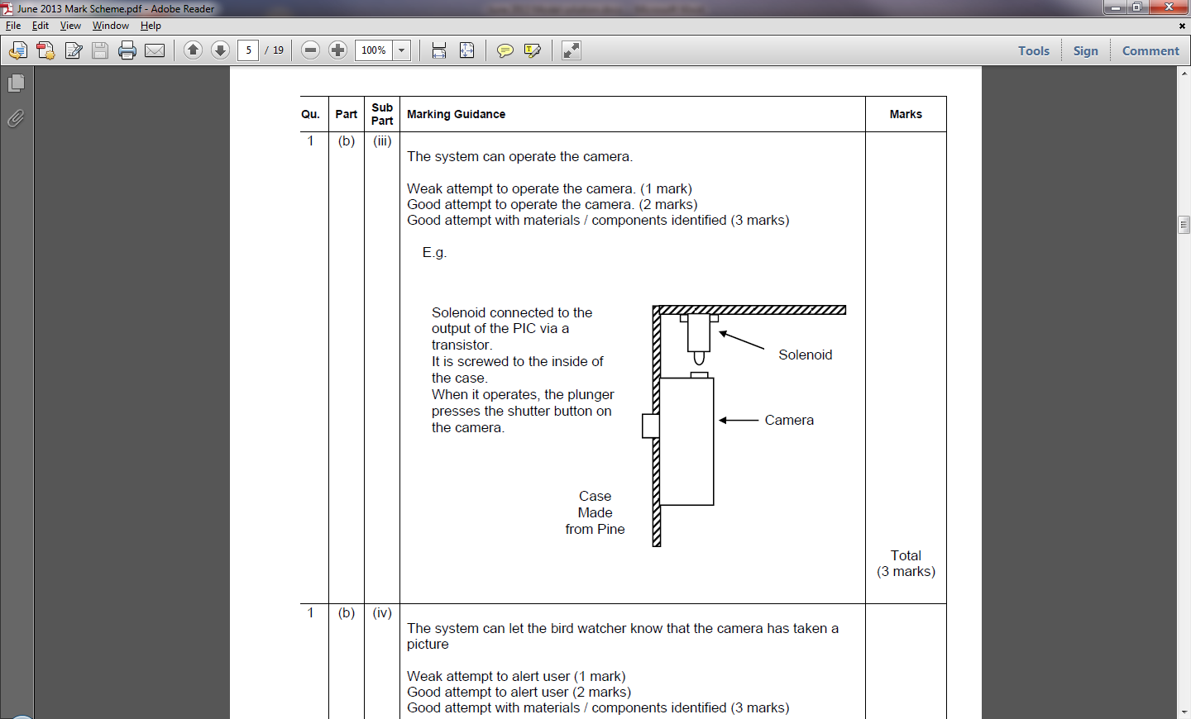1b iii. To activate the camera, I’d use a solenoid secured just above the shutter button, mounted in a pine housing. My PIC could activate it via a power transistor when the input is triggered. I’d need to remember to put a flyback diode facing backwards in the circuit in parallel to avoid blowing the transistor up.

**Teacher’s notes:** Another way I could have achieved the same idea would have been to use a servo with a “finger” on the end of it. I like the simplicity of the examiner’s model answer, but I’ve included a little more detail than they did on the mark scheme.

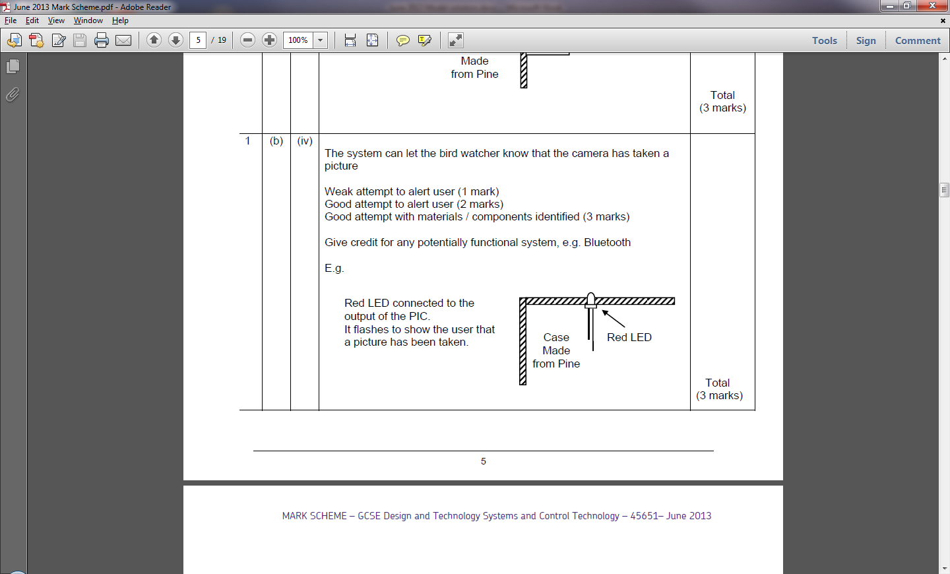1b iv. I’d use an LED connected to the output of my PIC to produce a visual indication that a picture has been taken. I also considered adding a piezo buzzer to provide audio notification, but felt it might be irritating for the user.

**Teacher’s notes:** Again, I’d have done exactly what the mark scheme shows. I included another idea in my write-up, just to make sure I got all the marks.

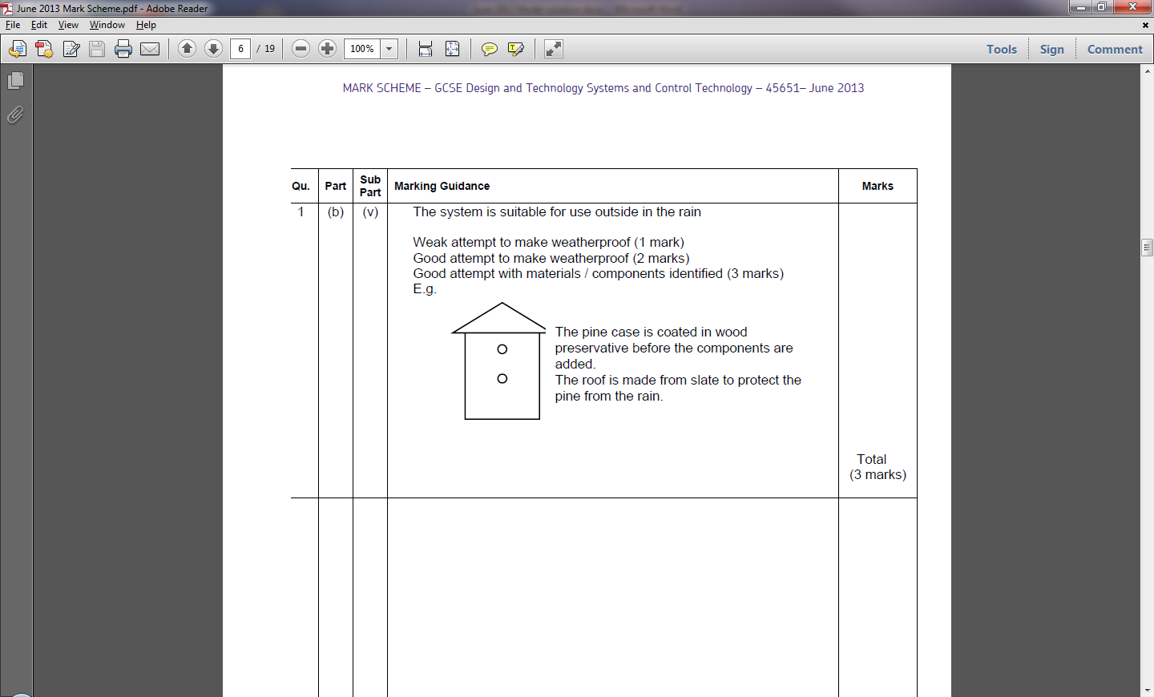1b v. I would package the system in something resembling a traditional birdhouse, to help it meet its aesthetic specification point. The whole housing could be built from pine and held together with self-tapping screws (or glued if desired), which could then be painted to improve weather resistance. The roof could be made from a thermoplastic sheet material (e.g. 3mm ABS) to reduce the amount of water the wooden parts are exposed to.

**Teacher’s notes:** The main consideration for this question is to build a design that won’t collect rain. As this problem has already been solved (houses have sloping roofs to stop water gathering), I used that.

**Teacher’s notes:** If you’ve managed the previous parts of the question, this part of the task is simple. You could just write, “Switch”, “PIC”, “Solenoid”.

1c. Input: Sense bird (microswitch)

Process: PIC (to transistor)

Output: Operate camera (solenoid)

1d.

Output device 1: 555 astable connected to an LED

Advantage: Low power consumption, and provides an unobtrusive visual signal.

Output device 2: Buzzer

Advantage: Low power consumption and no need to be looking at the device.

**Teacher’s notes:** I’d have gotten the first mark just by saying flashing LED. I think it looks better this way, though.

1e. Material: ABS

Process: Injection Moulding

Reason: High initial cost to produce moulds, but gives a high production rate and a consistent end product to a high degree of precision.

**Teacher’s notes:** Questions on mass production come up most years in the exam. There are extensive notes in the open drive on tackling these. Remember that if you need to make 20,000 of something, it’s better to reduce the amount of human interaction when manufacturing parts by using vacuum forming, injection moulding or laser cutting to ensure consistent levels of accuracy.

**Don’t** be tempted to talk about 3d printing as a mass production technique. It can take several hours to build a single part!

2a.

|  |  |  |  |
| --- | --- | --- | --- |
| Drive system | Advantage | Disadvantage | Example |
| Gears | Different ratios can produce different output speeds | Can be noisy,  Expensive compared to pulleys, | Car gearbox,  Desktop fan,  Sewing machine |
| Belt and Pulley | Can transmit drive over a distance  Easy to reverse direction | Belts can stretch  Belts can snap  Belts slip in the wet | Car fanbelt,  Wood lathe,  Steam engines, |
| Drive shaft | Steel shafts are strong, and can handle high amounts of torque. | Spin at fixed speed  Heavy | Trucks |

**Teacher’s notes:** Drive systems come up in some form every year (*usually asking you to sketch some different systems*). This table is worth a considerable number of marks; always try and write something in each box, even if you’re guessing!

2b. Friction is advantageous in braking systems, where it is used to reduce the speed of spinning wheels or gears. It is also advantageous in racing car tyres, where the maximum possible surface area is applied to the road surface in order to provide traction to the road and improve braking.

In a drill gearbox, friction causes heat and parts to wear, reducing the efficiency of the motor, and causing the gears to wear. In braking systems, the friction created when brake pads are pushed against brake disks causes the pads to wear away over time, until they need replacing.

**Teacher’s notes:** Make sure you give a practical example (e.g. car brakes, food mixer gearbox, bicycle tyres).

2c. Gear ratio…

Formula: ratio = driven gear / driver gear

Calculation: ratio = 32 / 16 = **2 / 1**.

Answer: 2:1 ratio.

**Teacher’s notes:** Ensure you show your working clearly to pick up the middle mark.

2d. Velocity ratio…

Formula: Velocity ratio = driven diameter / driver diameter

Calculation: VR = 45 / 15 = **3 / 1**

Ratio: 3:1 ratio

2e. Output speed…

Formula: Input speed / Velocity ratio

Calculation: OS = **1000 / 3**

Answer: Output Speed = 333.3rpm

3a. Reasons for using PCBs…

Reason 1: A PCB will have a smaller overall footprint than a stripboard circuit.

Reason 2: PCBs can have labels for where the components should go, making construction easier.

*Or…*

PCBs tend to be more reliable and will have a longer working life

PCBs can be made with surface mount components, making them smaller still

**Teacher’s notes:** Wrong answers include “better” and “smaller”. I’ve made sure I explained exactly what I meant with each of my examples.

3b. Hazards of soldering…

Hazard 1: Solder can spit

Precaution: Wear goggles

Hazard 2: Soldering irons can burn skin

Precaution: Holster soldering iron when not in use

Hazard 3: Solder fumes can be an irritant

Precaution: Avoid inhaling fumes, ensure adequate ventilation in work area.

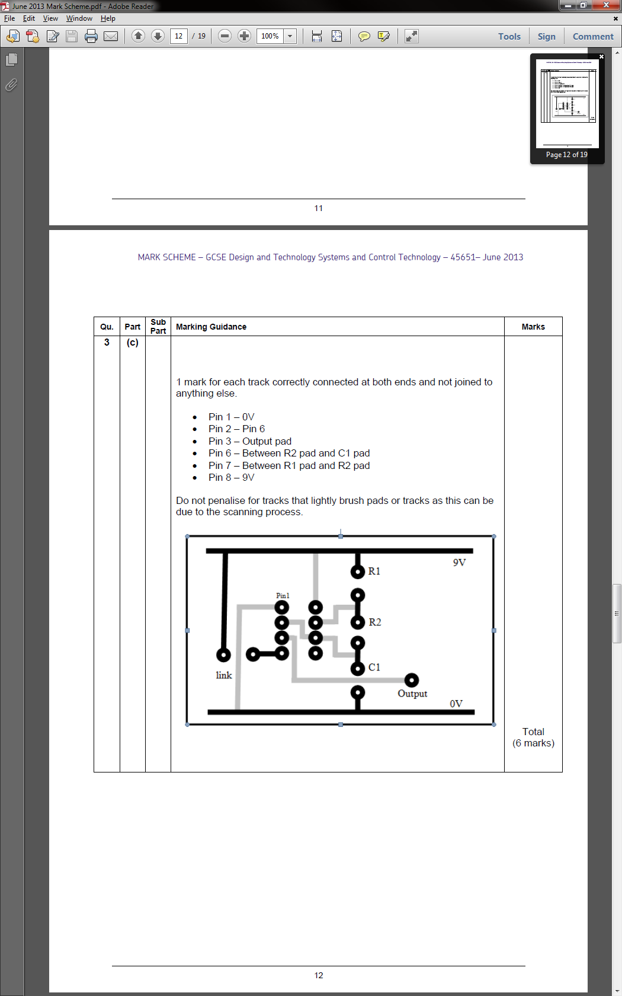

3c.

**Teacher’s notes:** Practice questions like this on scrap paper before putting them on your answer sheet, and use a ruler to make it look neat.

4a. Robots in manufacturing…

Advantage: Robots are able to manufacture parts 24/7, with the same degree of precision each time giving a consistent finish quality. In addition, they don’t lose concentration or require wages.

Disadvantage: Robots are unable to deal with unexpected situations that they are not programmed to deal with and can injure people if not operated correctly. The initial cost of automating production is very high, and the workforce will be required to up-skill in order to be able to operate them.

**Teacher’s notes:** With long-answer questions such as these (where advantages and disadvantages are asked for) I tend to split into two paragraphs, and then come up with about 3 things to talk about for each side of the debate. That way, if the examiner disagrees with something I said, I can still get the mark with my other “spare” point.

4b. Chinese manufacturing

The lower wages of Chinese employees and more relaxed approach to health and safety means that products can be manufactured more cheaply than in the UK. The Chinese economy is geared towards manufacturing, and as such production can usually start with short notice.

**Teacher’s notes:** Questions such as these are difficult to prepare for, as you have no idea what’s coming. Use your knowledge acquired in other areas (e.g. geography) combined with your S&C skill set to come up with a carefully considered answer.

4c. Illegal production process

If the company intends to sell the products in the UK, they should not use the process in question, as it is unethical to do so due to the unacceptable level of risk it places on those working in the factories. If the method was used and there was an accident, the negative press would have further impact on the company’s brand image and possibly the share price.

**Teacher’s notes:** With questions on ethics, the mark scheme doesn’t say this, but its sensible to assume you should take the moral high ground. Saying, “if I don’t do it, someone else will” and so forth will most likely fail to impress the examiner.

4d. Designing sustainability into a product…

Making it simple for the user to replace consumable parts such as any belts or filters would extend the working life of the product. A service manual could be provided with the machine, with clear instructions on how to replace these parts, and access panels or removable covers could be designed in to provide convenient, safe access to the machine. Internal parts could be secured using machine screws rather than hot glue, to make for more convenient servicing.

The manufacturer could ensure that the spare parts are easily identifiable and readily available to buy on the High Street or the Internet. They could make one part fit many models to make it simpler to stock and identify.

Another angle on sustainability is fashion. If the manufacturer did not regularly change the design of the product, the users would not feel the need to scrap their existing cleaner before the end of its working life, just to trade up to a newer, more fashionable model.

5a. 1: OR, 2: NOT, 3: AND

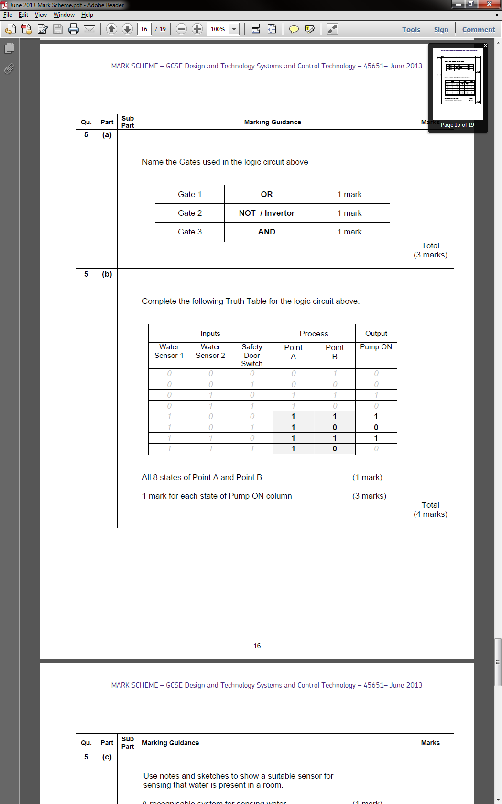

**Teacher’s notes:** Learn your logic gates ; there are lots of resources in the open drive and practice tasks that will help you become very confident at these, and they come up every year.

5b.

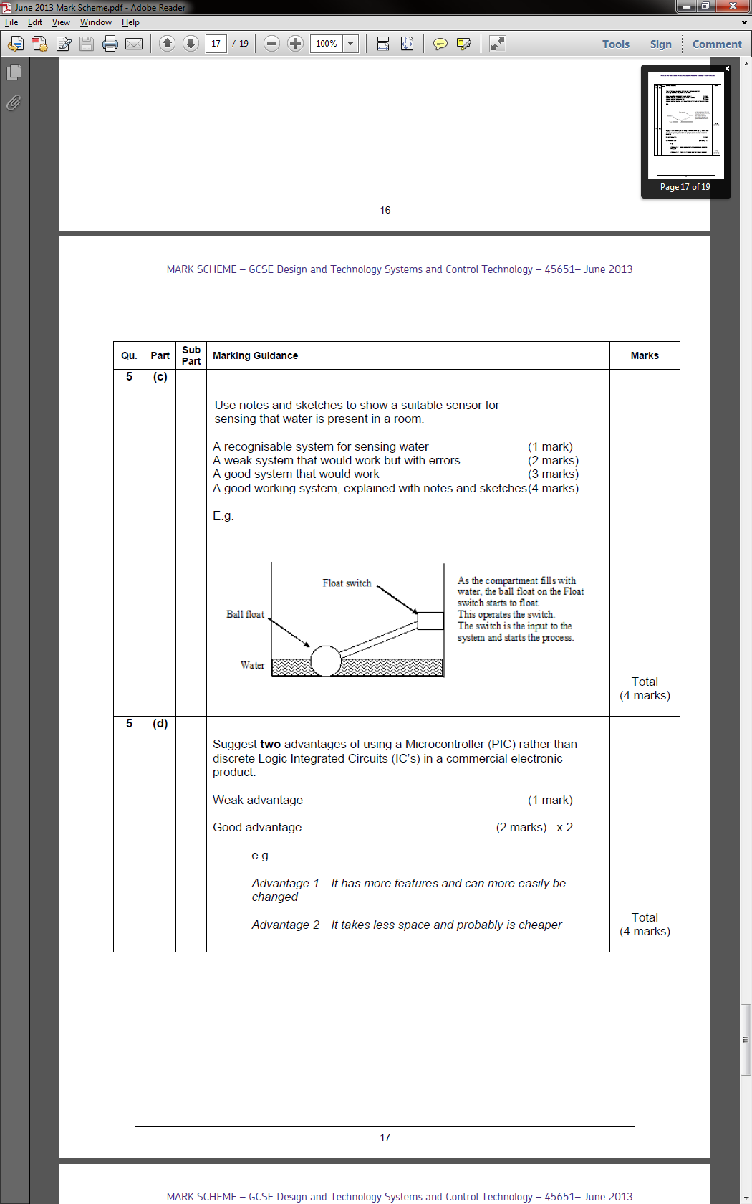

5c. Based on a toilet flush, this design has a hollow plastic ball (so it will float) attached to an arm, which is attached to the wiper on a potentiometer (*labelled float switch in the diagram*), which in turn feeds a PIC chip. As the water level rises, the potentiometer will be rotated, allowing an accurate indication of the height of the water by the microcontroller.

**Teacher’s notes:** It’s unlikely you’ll be asked to design something genuinely new in an exam question, even at AS level. If you think about the main part of the problem (i.e. How can I detect the water level going up), you can then try and consider situations in every day life where this happens. In my case, I looked at how toilets know when they’re full (a Victorian design, incidentally).

5d. PIC advantage over ICs…

1: PIC chips can be repeatedly re-programmed to allow for new features easily

2: A single PIC chip can take the place of several ICs.

3: PIC chips provide more flexibility for how a product can function than ICs.

**Teacher’s notes:** Examples of common ICs are decade counters, 555 timers, 7-segment display drivers, half H-bridge (L293D) and so on. The advantage of using ICs is that as their designs are well established and therefore they are normally very reliable and can often do things which PICs cannot (e.g. drive motors). Individually, they are usually cheaper than a PIC.

*Continued over…*

5e.

**Teacher’s notes:** The examiner was good enough to give you a reminder of the correct shapes to use. Common mistakes here are not looping up at the end, and also forgetting that once you turn an output (e.g. the red lamp) on, it will stay on until you tell it to turn off again.

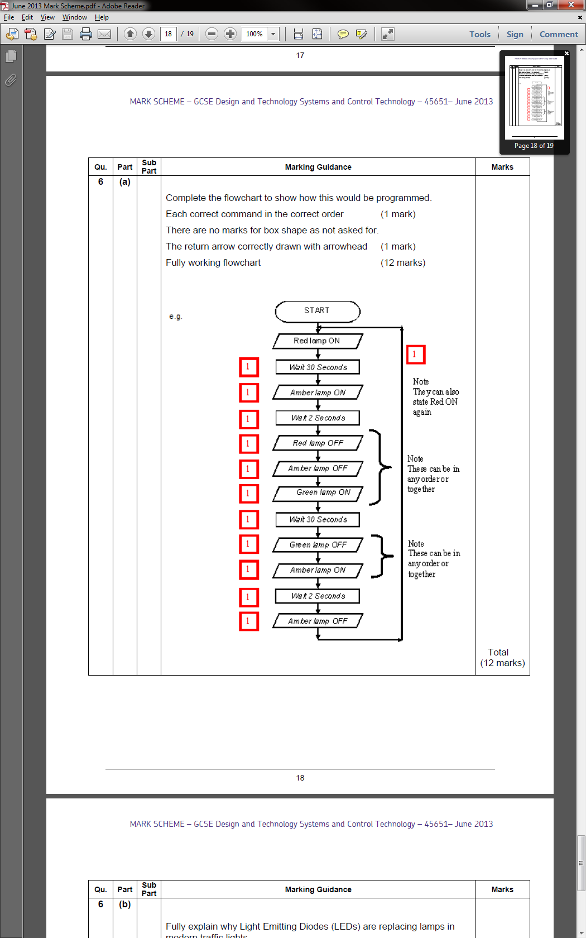

6b. LEDs replacing lamps…

LEDs draw less current than lamps, and so are considerably cheaper to run than lamps. They also have considerably longer life spans, and so will require less maintenance by engineers leading to a further cost saving. As they are dimmer than traditional lamps, they are usually configured in clusters – this has the advantage that if an LED blows, the others in the array will continue to function.

**Teacher’s notes:** On the flip side, bright LED lights are expensive, the light it casts is rather a “cold” shade of white and they brightest LED light is no-where near as bright as the brightest incandescent bulb.

Closing remarks

Another typical systems exam, combining questions on research, housing design, electromechanical design and circuit design (with programming) as well as some general questions on the social/moral/environmental aspects of the subject.