MIPS  Ops
User Guide
Table of Contents

1 Welcome to MIPS Ops! 2
2 Quick Start 2
3 The Multiplication Algorithm 3
4 SIM Settings 3
4.1 Operation 3
4.2 Operands 4
4.3 Mode 4
4.4 Speed 4
5 SIM VIEWER 5
5.1 Run 5
5.2 Stop 5
5.3 Log 6
5.4 Reset 6

Welcome to MIPS Ops!
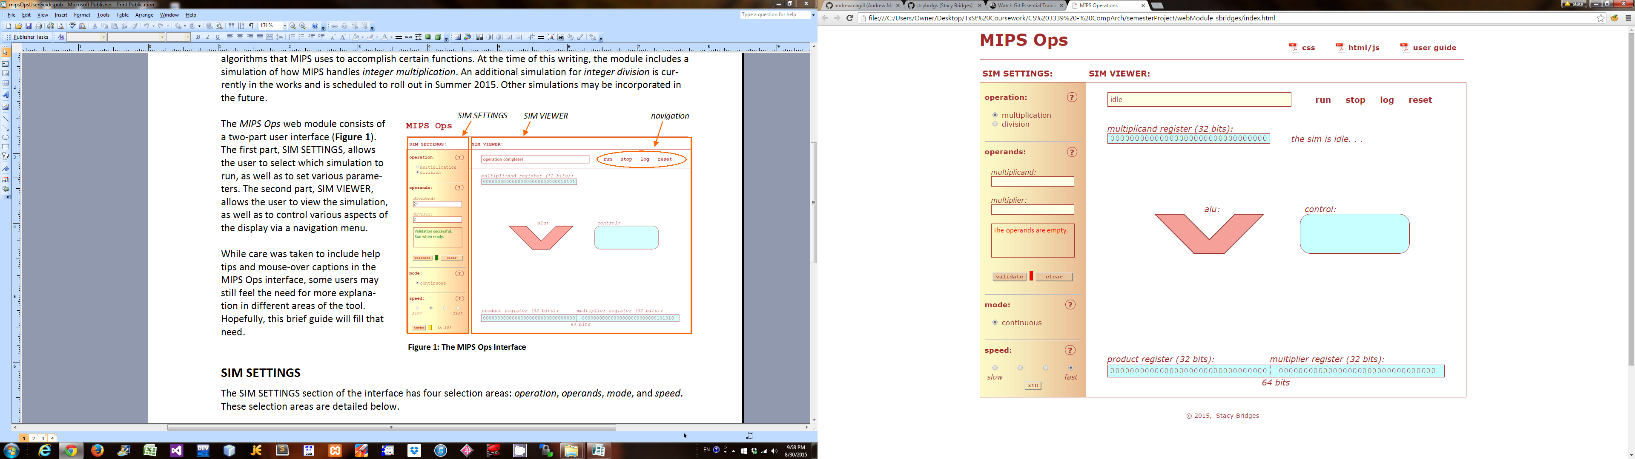
MIPS Ops is a JavaScript web application that is meant to help MIPS newcomers to conceptualize the algorithms that MIPS uses to accomplish certain functions. At the time of this writing, the application includes a simulation of how MIPS handles integer multiplication. An additional simulation for integer division is currently in the works. Other simulations may be incorporated thereafter.
Figure 1: The MIPS Ops Interface
SIM SETTINGS
SIM VIEWER
navigation menu

The MIPS Ops web module provides a User Interface that is divided into two sections (Figure 1). The first section, SIM SETTINGS, allows users to select which simulation to run (i.e., multiplication or division) and to set various parameters. The second section, SIM VIEWER, allows users to view the simulation and to interact with it through a navigation menu.

While care was taken to include help tips and mouse-over captions in the MIPS Ops interface, some users may still feel the need for more explanation in different areas of the tool. Hopefully, this brief guide will fill that need.

Quick Start
To begin using MIPS Ops, simply enter your preferred settings under SIM SETTINGS and then click 'run' under SIM VIEWER.

In order for the simulation to run, it must have valid operands, so be sure that your selected 'multiplicand' and 'multiplier' values are both integers before clicking 'run.' If you aren't sure if your operands are valid, you may check by clicking the 'validate' button under SIM SETTINGS.

At any time during the simulation, you may click 'stop' to pause it, or you may click 'log' to view the simulator's progress. If you want to re-run the simulation using different settings, click 'reset.'

Additional details on using the simulator are provided in the following sections.

The Multiplication Algorithm
The MIPS multiplication algorithm consists of three basic steps, which are described below. Before running the algorithm, the simulator will initialize the multiplicand, multiplier, and product registers by setting them equal to their binary equivalents. For the multiplicand and multiplier, the user operands are used, while the product is set to 0.

To run the algorithm, MIPS will execute the following steps:

- Determine if the Least Significant Bit (LSB) in the multiplier register is 0 or 1
- If it is 0, then do nothing; OR,
if it is 1, then add the multiplicand to the product and overwrite the sum to the product register
- Shift the contents of the product and multiplier registers to the right by one bit

Note that during Step 3, the bitwise shift will push the previous LSB of the multiplier register out of scope, and it will backfill the Most Significant Bit (MSB) of the product register with 0.

This algorithm is repeated 32 times, allowing one iteration of the algorithm to run per each bit in the multiplier register. When completed, the result of the operation will occupy all 64-bits of the combined product and multiplier registers, with the product register holding the high-order bits and the multiplier register holding the low-order bits.

SIM Settings
The SIM SETTINGS section of the interface is divided into four selection areas: operation, operands, mode, and speed. These selection areas are detailed below.

Operation
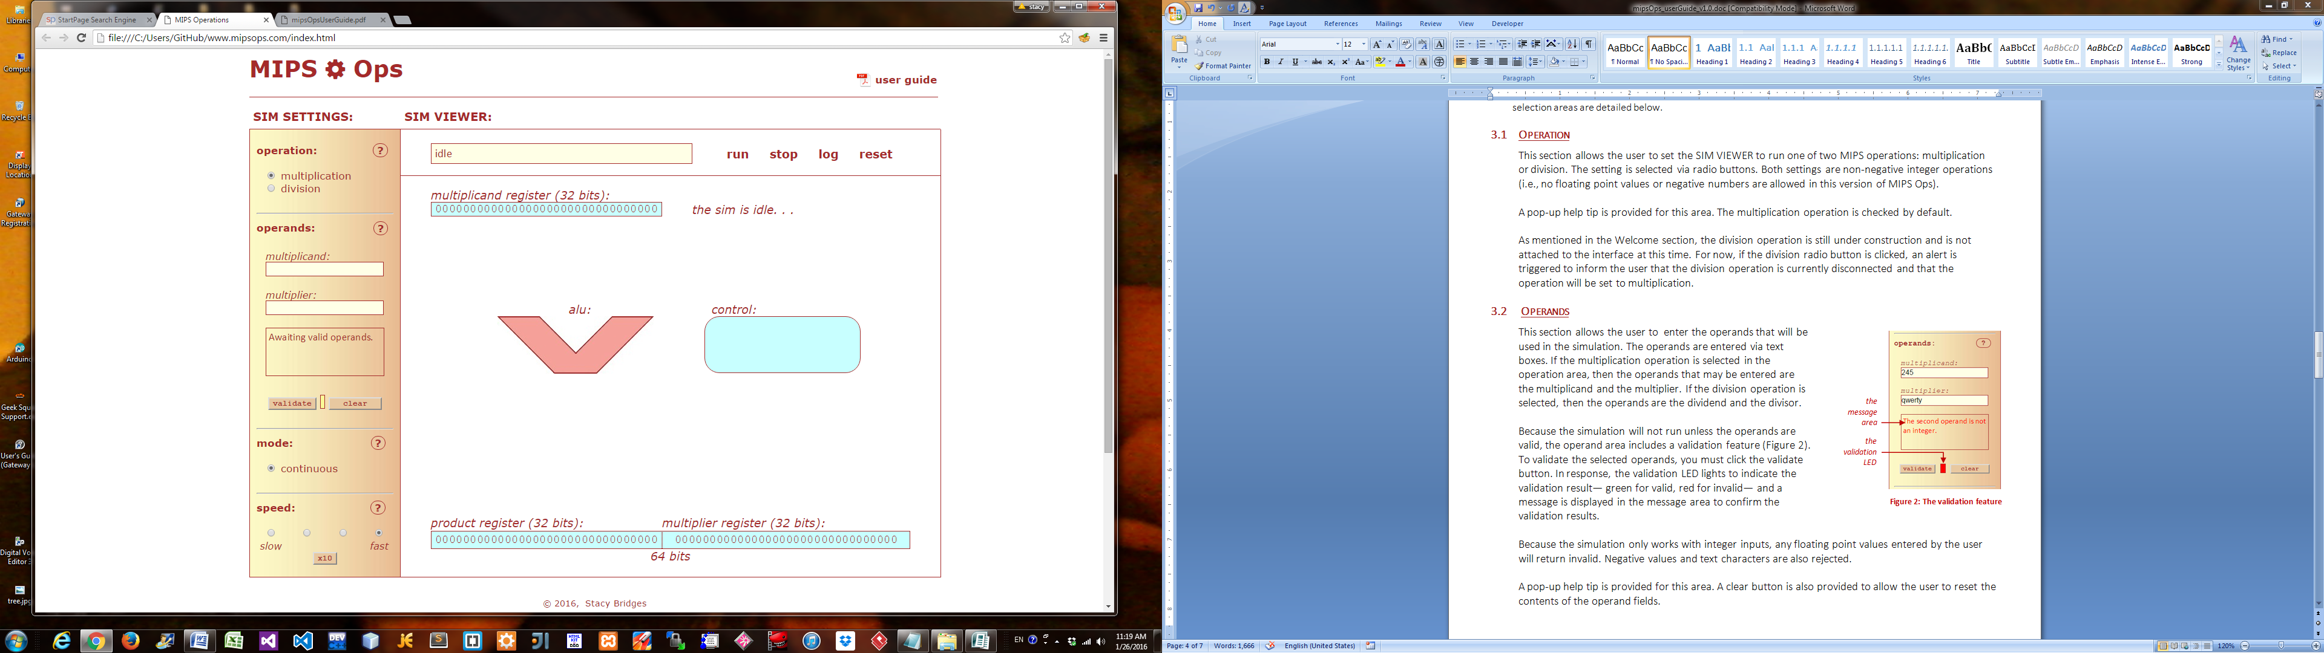
This selection area provides two radio buttons for selecting either multiplication or division (Figure 2).
Figure 2: The operation section

As mentioned in the Welcome section, the division operation is still under construction and is not attached to the interface at this time. For now, if the division radio button is clicked, an alert will indicate that the division operation is disconnected and that the operation will be set to multiplication by default.

A pop-up help tip is provided for this area. The multiplication operation is checked by default.

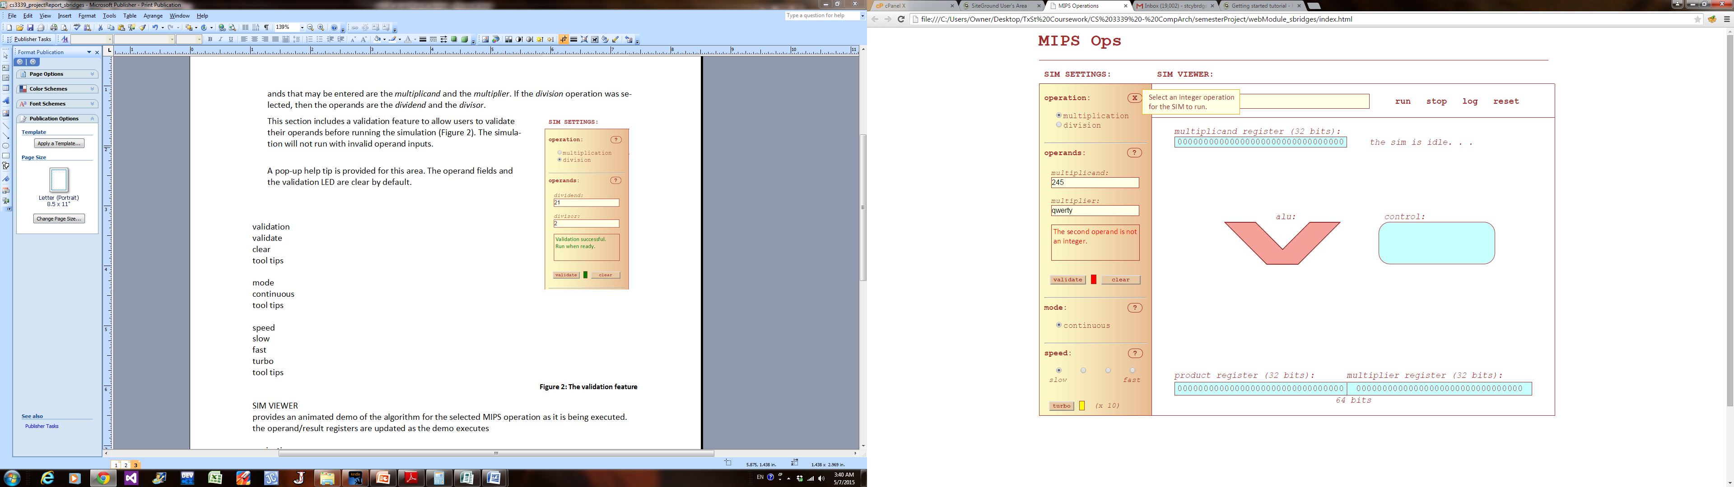
Operands
Figure 3: The validation feature

the
message
area
the
validation
LED
This section provides two text boxes for entering operands. If the multiplication operation has been selected, then the operands will be labeled 'multiplicand' and 'multiplier.' If the division operation has been selected, then the operands will be labeled 'dividend' and 'divisor.'

Because the simulation will not run without valid operands, a validation feature is available (Figure 3). To check the operands, simply click the 'validate.' If the operands are valid, the validation LED will turn green. If they are not valid, the LED will turn red, and the message area will provide a reason for the failure. Reasons for failure include empty operands, floating point values, negative values, and text characters.

Although the simulation will not run without valid operands, you do not have to validate your operands before running the simulation. The simulation will automatically perform the check at run time if the operands were not previously validated.

To reset the operands, click the 'clear' button.

This section provides a pop-up help tip.

Mode
Figure 4: The mode section
This section allows you to select the mode that will be used to run the simulation. For the current version of MIPS Ops, the only mode available is 'continuous,' so a lone radio button is provided and is set to 'continuous' by default (Figure 4).

The 'continuous' mode only allows the simulation to run continuously from beginning to end once it has been started. A 'step' mode is in the works that will allow future versions of MIPS Ops to run in a step-wise capacity.

This section also provides a pop-up help tip.


Speed
Figure 5: The speed section

the
x10
option
This section provides a set of radio buttons for selecting the simulation speed (Figure 5). Four speeds are available, ranging from slow to fast, with each increment providing a speed increase of approximately 25%. You may hover over each radio button to see its speed.

Once you are familiar with MIPS Ops, the speed settings may seem too slow, so a x10 option has been included to boost the selected speed setting by a factor of 10. To select this boost option, simply click on the x10 button, and it will turn green to confirm that the boost feature is active.

The current version of MIPS Ops does not allow the speed to be changed while the simulation is running. To change the speed, you must either click 'reset' or wait for the current run to be completed.

This section also provides a pop-up help tip.

the
viewing
pane
Figure 6: The SIM VIEWER
the navigation menu
the message box

SIM VIEWER
The SIM VIEWER section of the interface has three activity areas: the message box, the navigation menu, and the viewing pane (Figure 6). The message box describes the simulation step that is running at any point in time. The navigation menu provides four options to let you control the execution of the simulation: run, stop, log, and reset. These options are detailed below.

Run
This option allows the simulation to be started or resumed. If for some reason you choose to stop the simulation, then clicking 'start' will resume the simulation exactly where it left off.

Stop
This option allows the simulation to be stopped. When running a simulation for the first time, you may find it useful to stop the simulation from time to time in order to study the display more closely or to toggle the log. To resume the simulation, click 'start.'

Log
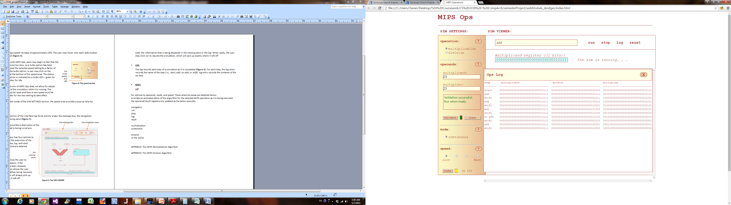
This option allows a log of the simulation to be opened and closed. The purpose of the log is to record each algorithm step as it is completed by the simulation (Figure 7). For each step, the log entry records the name of the step and the contents of each register.
Figure 7: The log

When multiplication is running, the log will display the contents of the multiplicand, the product, and the multiplier. When division is running, the log will display the contents of the divisor, the remainder, and the quotient.

Because the registers each contain 32-bits, the log has a large on-screen footprint. As a result, it has been implemented as a floating layer so that it may be moved around to optimize the viewing experience. Depending on the viewer’s monitor size, it may be possible to position the log in such a way that both the SIM VIEWER and the log may be viewed simultaneously.

The log may be opened and closed as needed while the simulation is running. When open, the log will update in synch with the simulation. When closed, the log will continue to update in the background.

Because the log has been implemented as a floating layer, it may not render optimally on mobile devices.

Reset
This option allows the simulation to be reset. Resetting the simulation restores it to the same default settings that prevailed upon the original page load. The simulation may be reset at any time, regardless of whether the simulation is currently running.

