|  |  |
| --- | --- |
|  | |
| **The role of robots in stock market** | |
|  | |
| MASTERS Murodov Shohjahon | |
|  | |
|  |  |
| Choose a type  20XX |  |
|  |  |
|  | |

*** Scanned submission page 1 ***

*** Scanned submission page 2 ***

*** Scanned Thesis Author’s Statement page 1 ***

*** Scanned Thesis Author’s Statement page 2 ***

ABSTRAKT

Czech abstract

Klíčová slova: klíčové slovo, klíčové slovo

ABSTRACT

Algorithmic trading defines set of specific rules and instructions using computer programs to execute trades with low latency and no human errors.

The goal of this thesis is to build a system containing set of robots that manages automated trading. As such retrieving live and historical stock data, analyze the data by applying ai models, backward and forward testing, choosing a strategy for analyzed data and execute the trades. In technical terms building the system is represented by developing a standalone application, the robots are represented by the application’s services, and these words are used interchangeably. The system is to be capable of extension that means new analysis tools or strategies can be added by implementing a new service/robot.

<<to be adjusted>>

Keywords: automated trading, algo trading

Acknowledgements, motto and a declaration of honour saying that the print version of the Bachelor's/Master's thesis and the electronic version of the thesis deposited in the IS/STAG system are identical, worded as follows:

I hereby declare that the print version of my Bachelor's/Master's thesis and the electronic version of my thesis deposited in the IS/STAG system are identical.

CONTENTS

Introduction 9

1. Theory 10

1 Heading 11

1.1 Subheading 11

1.2 Subheading 11

1.2.1 Sub-subheading 11

2 Heading 12

2.1 Subheading 12

1. Analysis 13

3 Heading 14

3.1 Subheading 14

3.1.1 Sub-subheading 14

3.2 Subheading 14

4 Heading 15

4.1 Subheading 15

Conclusion 16

Bibliography 17

List of abbreviations 18

List of figures 19

List of tables 20

appendices 21

Introduction

According to analysts, about 70% of US equities in 2013 were carried out via algorithmic trading, and the use of trading algorithms has continued to grow since then. But algorithmic trading didn’t just emerge out of nowhere. It’s good we look at the history. [1]

Algorithmic trading emerged with the advent of the internet in the late 1980s and early 1990s. However, it wasn’t until 1998 when the U.S Securities and Exchange Commission (SEC) authorized electronic exchanges that computerized high-frequency trading became mainstream.

Algorithmic trading witnessed a great boom in the late 2000s. In the early 2000s, algo trading accounted for less than 10% of equity orders, but it grew rapidly that by the end of 2009, algorithmic traders had captured 70% of the US securities markets. According to the NYSE, between 2005 and 2009 alone, algo trading volume grew by 164%.

The boom in algo trading was also accompanied by a significant decrease in trade execution time. For instance, in 2001, HFT trades had an execution time of several seconds, but by 2010, this had shrunk to milliseconds, even microseconds, and subsequently, nanoseconds in 2012.

<<<to be completed>>>

**Technical introduction**

The system application is to be implemented in Java using spring ecosystem framework.

Maven which is a project management tool is used to manage application dependencies, plugins and executions…

PostgreSQL

Flyway

DL4J Spark libs for ML

OpenAPI (swagger) api documentation

GUI with react.js (beyond the scope of the project ??)

|  |  |
| --- | --- |
|  | Short term trading … |

stock Pattern recognation

text

CNN

text

Most Common Repeated Patterns

text

Head-to-Shoulder Cups …..

text

Heading

text

Subheading

text

|  |  |
| --- | --- |
|  | Analysis |

Heading

text

Subheading

text

Sub-subheading

text

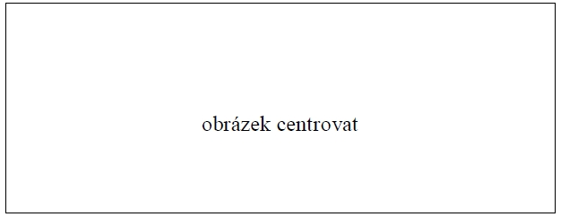

Figure 1 Caption of figure

text

Subheading

text

Table 1 Caption of table

|  |  |  |  |
| --- | --- | --- | --- |
| **Záhlaví tabulky 1** | **Záhlaví tabulky 2** | **Záhlaví tabulky 3** | **Záhlaví tabulky 4** |
| První řádek | 0,98 | 123,97 | 1258,58 |
| Druhý řádek | 1,5875 | 11,0334 | 251,005 |

Heading

text

Subheading

text

Conclusion

text

Bibliography

according to the citation style

List of abbreviations

ABC First abbreviation – meaning

B Second abbreviation – meaning

C Third abbreviation – meaning

List of figures

Figure 1 Caption of figure 2

List of tables

Table 1 Caption of table 2

appendices

Appendix P I: Appendix title

Appendix P II: Appendix title

Appendix P i: Appendix title

[1] Rejaul Karim. The History of Algorithmic Trading.