Draft for a new article 'ODE with Impulse load'

Extract:
- Balachandran
  - change IC
- Benchohra_Impulsive Differential Equations and Inclusions
- Corless
  - change IC
- De Silva
  - change IC ??
- Finan
  - solution ODE with Delta
- Genta
  - change IC
  - Dirac prop
- Kelly
  - change IC
- Nagy
  - solution ODE with Delta
- Ogata
  - solution ODE with Delta
- Rao
  - change IC
- Weber
  - change IC
  - Dirac prop
- Zill
  - solution ODE with Delta
  - Laplace transform

Balakumar Balachandran, Edward B. Magrab
VIBRATIONS
SECOND EDITION
©2009 Cengage Learning

ISBN-13: 978-0-534-55206-0
ISBN-10: 0-534-55206-4

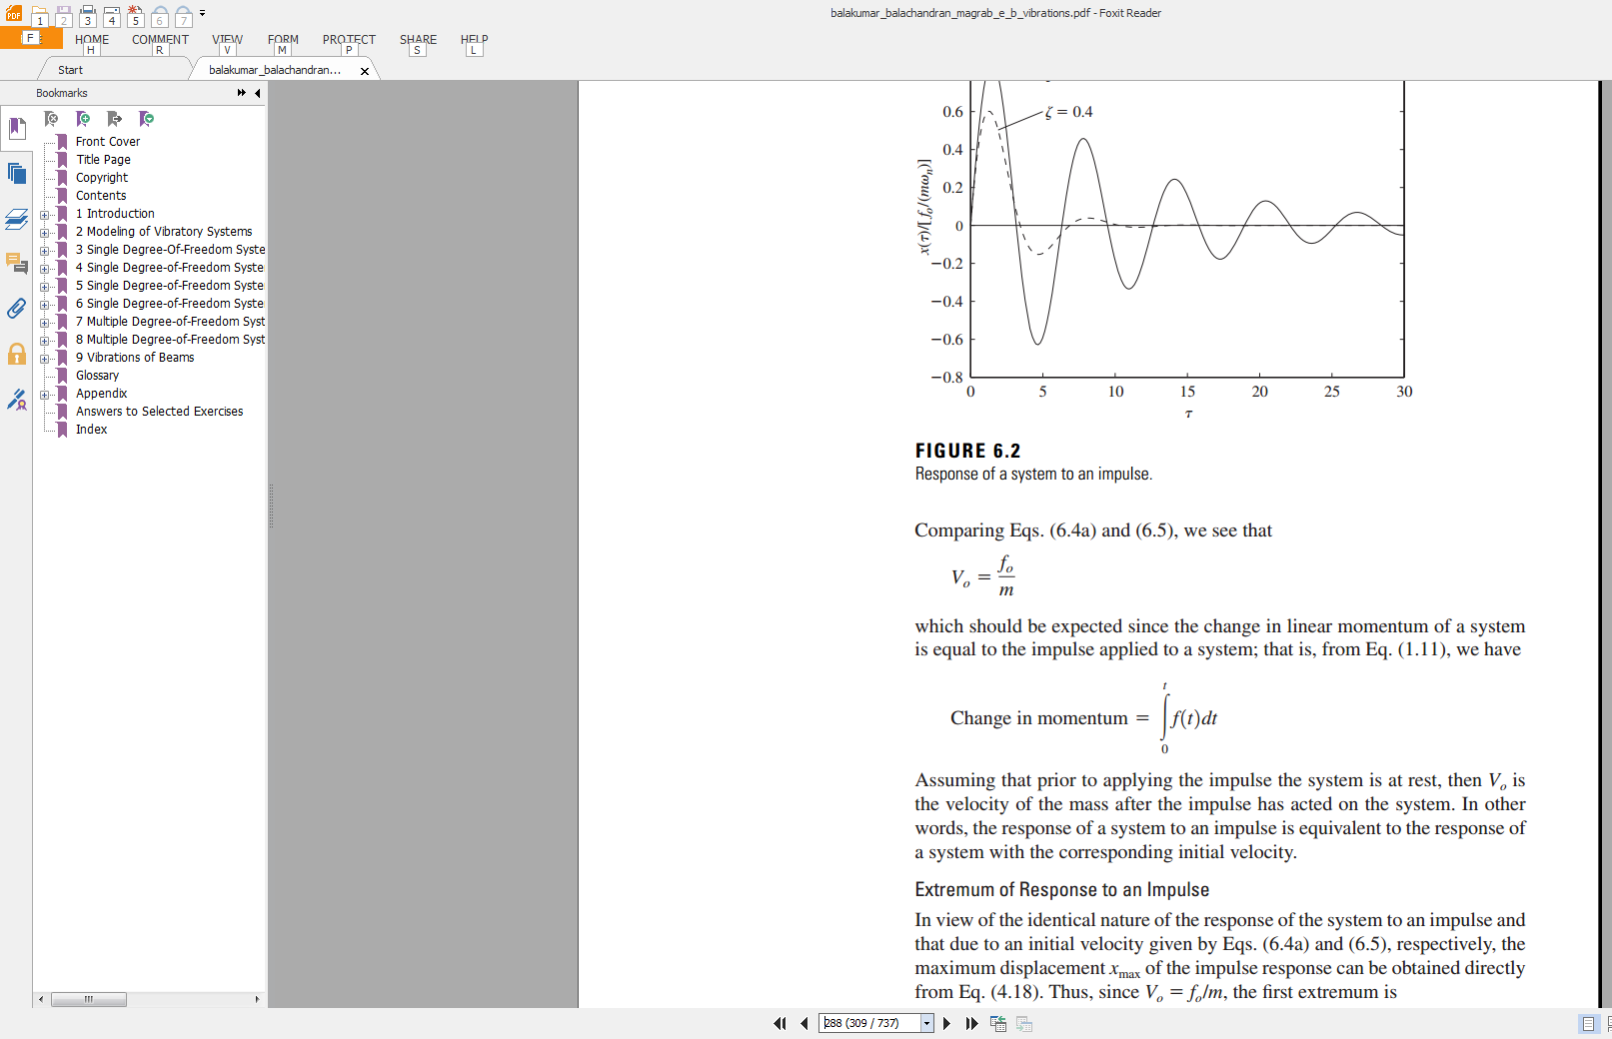
Benchohra_Impulsive Differential Equations and Inclusions.pdf

M. Benchohra, J. Henderson, and S. Ntouyas
Contemporary Mathematics and Its Applications, Volume 2
Impulsive Differential Equations and Inclusions
© 2006 Hindawi Publishing Corporation
ISBN 977-5945-50-X

William J. Bottega
Engineering Vibrations
© 2006 by Taylor & Francis Group, LLC
ISBN-13: 978-1-4200-2009-0

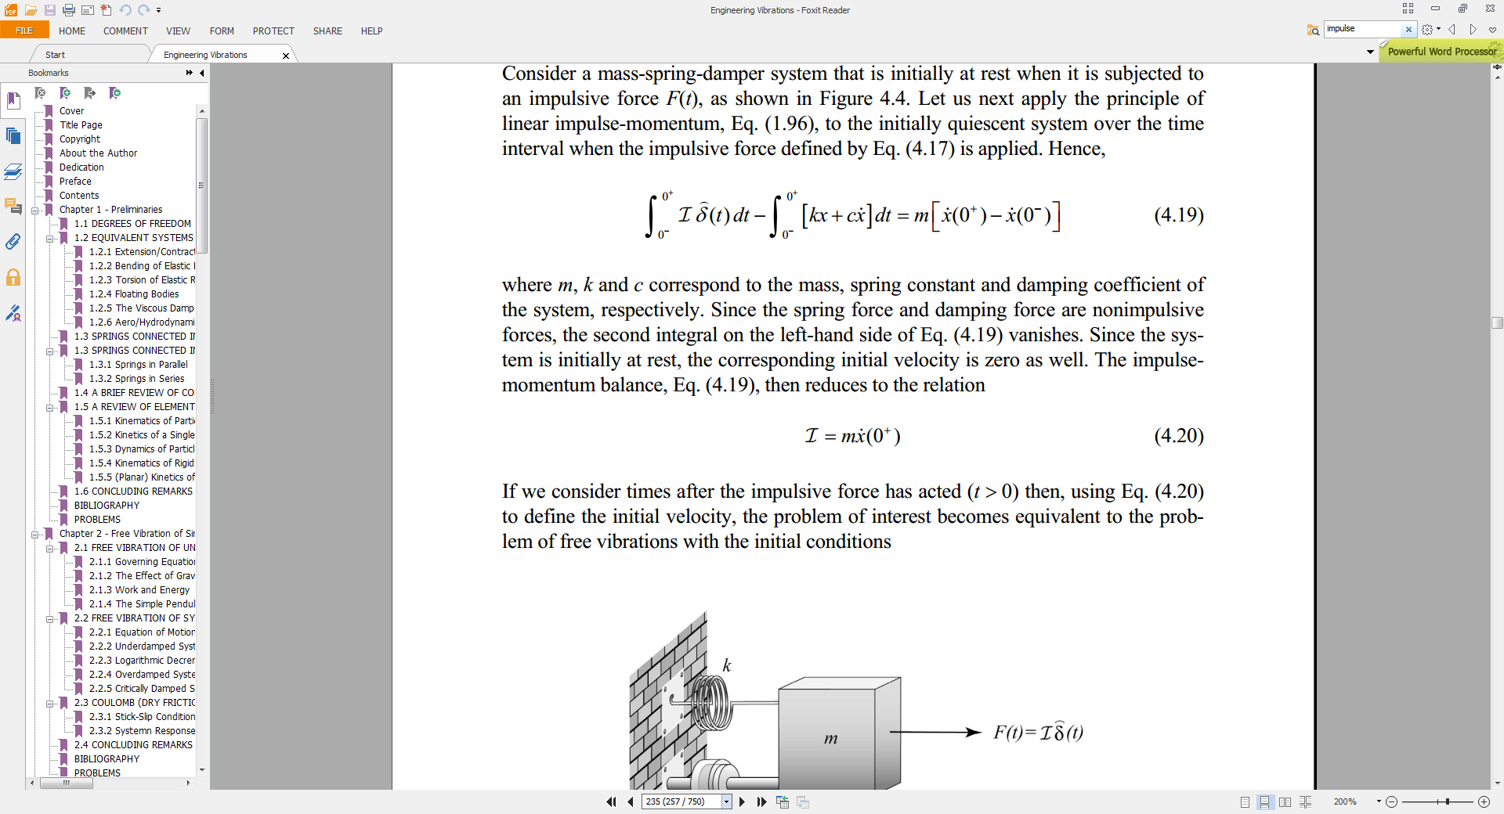

De Silva, Clarence W.
Vibration : fundamentals and practice
© 2000 by CRC Press LLC
ISBN 0-8493-1808-4

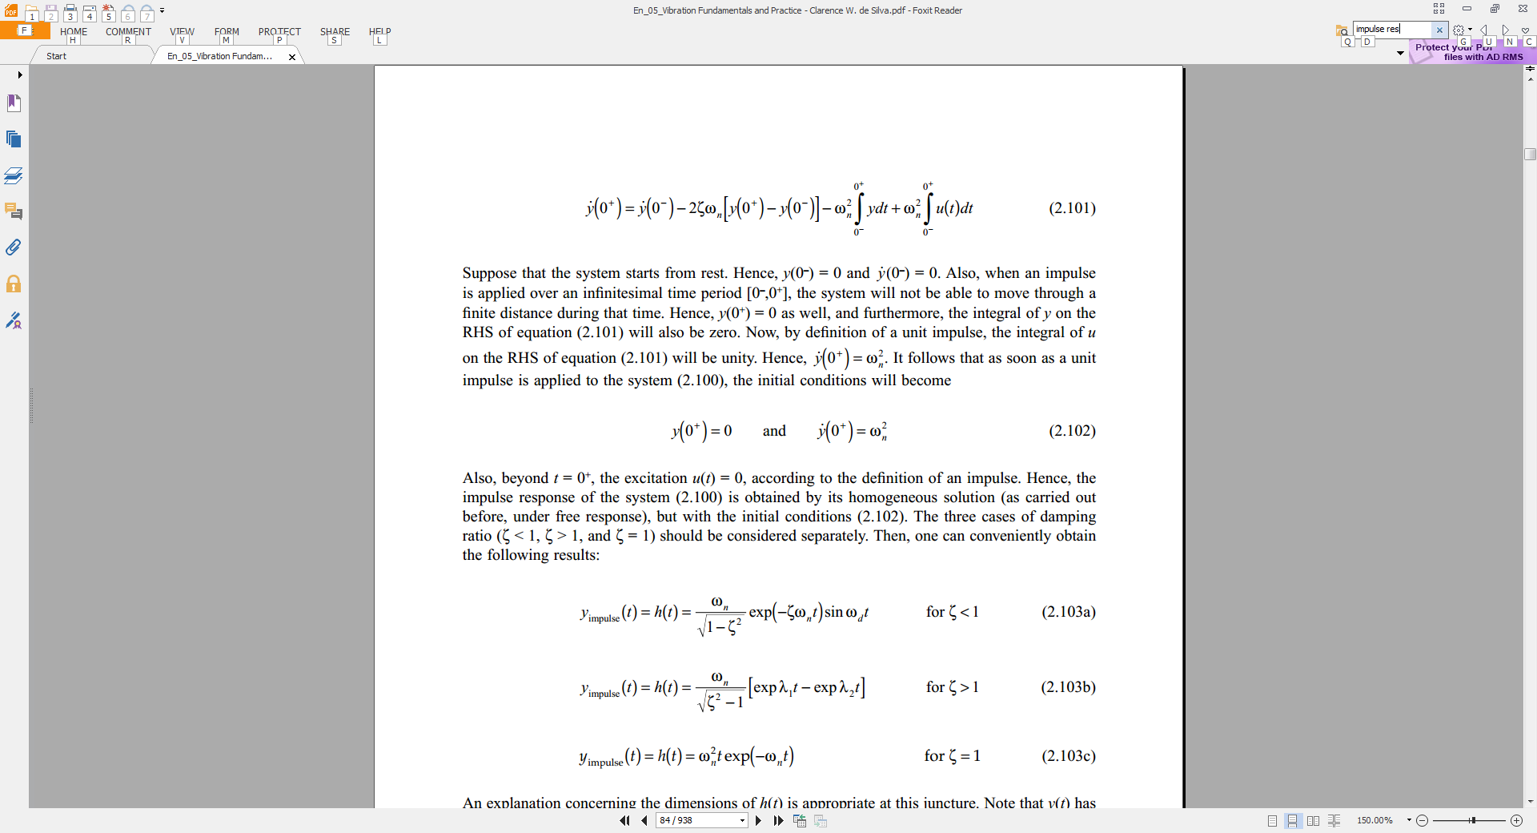
Finan_Laplace Transforms_TheoryProblems.pdf

Marcel B. Finan
Laplace Transforms: Theory, Problems, and Solutions
Arkansas Tech University

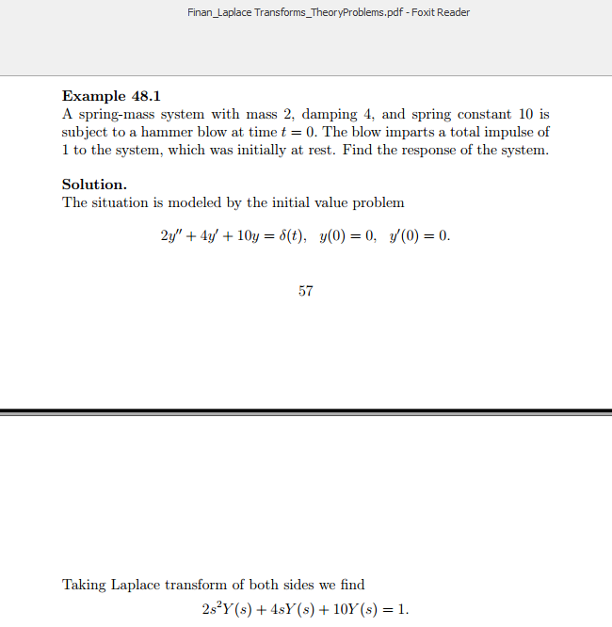

Genta - Vibration Dynamics and Control (Springer, 2009).pdf

Giancarlo Genta
Vibration Dynamics and Control
© Springer Science+Business Media, LLC 2009
ISBN: 978-0-387-79579-9

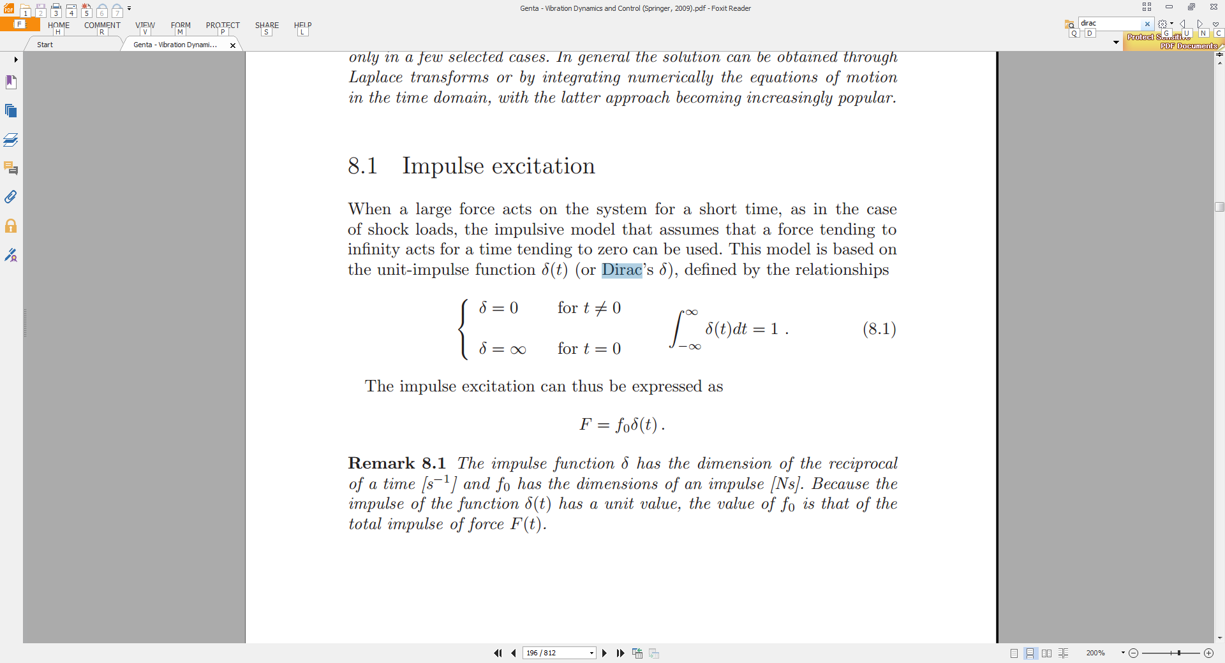
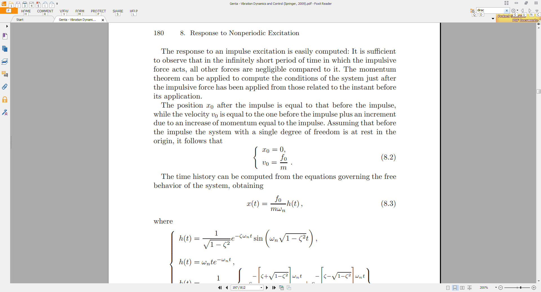

Kelly_Mechanical Vibrations- Theory and Applications_2012.pdf
S. GRAHAM KELLY
Mechanical Vibrations
THEORY AND APPLICATIONS
THE UNIVERSITY OF AKRON
© 2012Cengage Learning

ISBN-13: 978-1-4390-6212-8
ISBN-10: 1-4390-6212-9

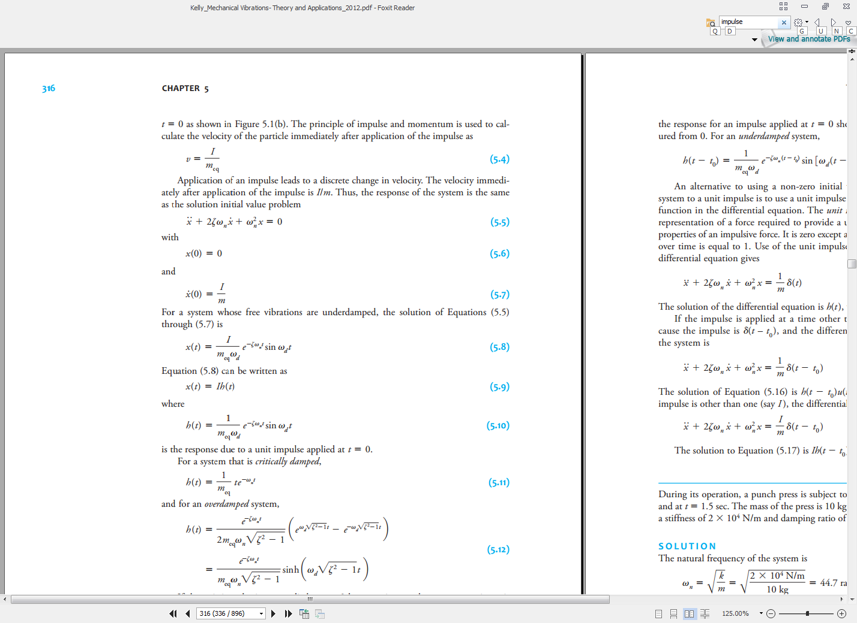

Nagy_ode.pdf
GABRIEL NAGY
ORDINARY DIFFERENTIAL EQUATIONS
AUGUST 15, 2016
Mathematics Department, Michigan State University,
East Lansing, MI, 48824.

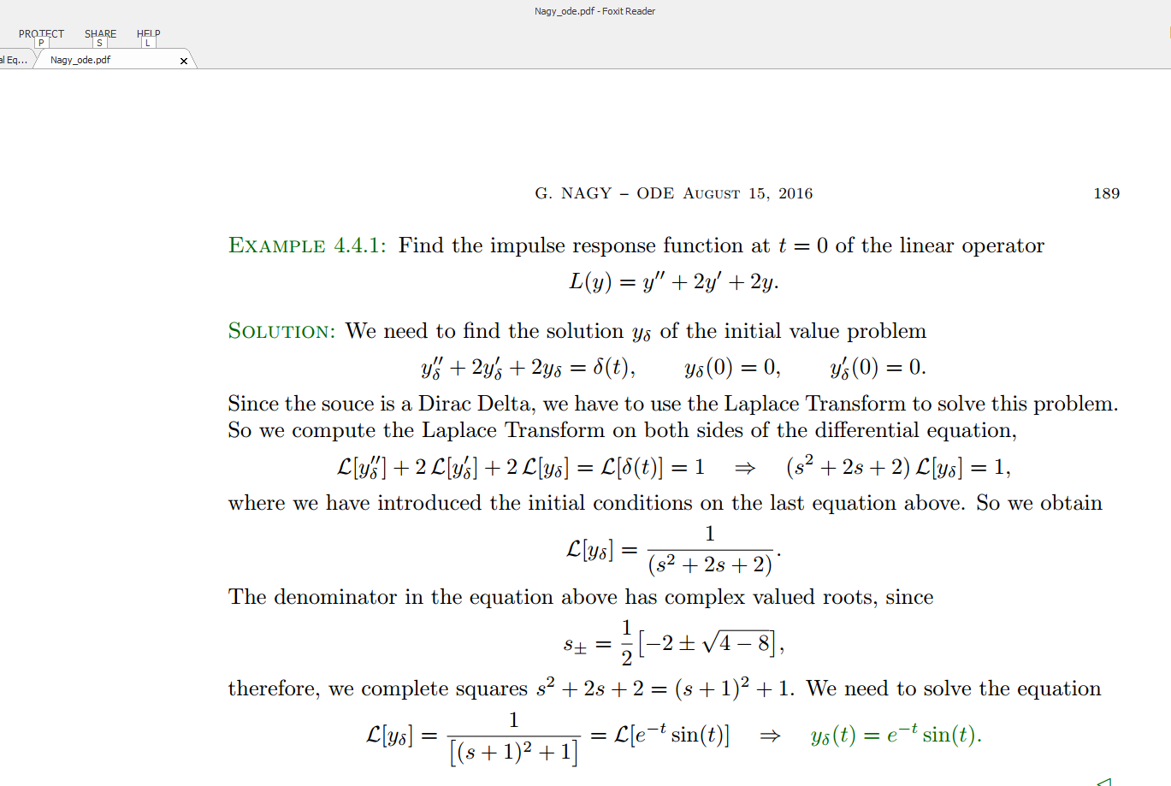

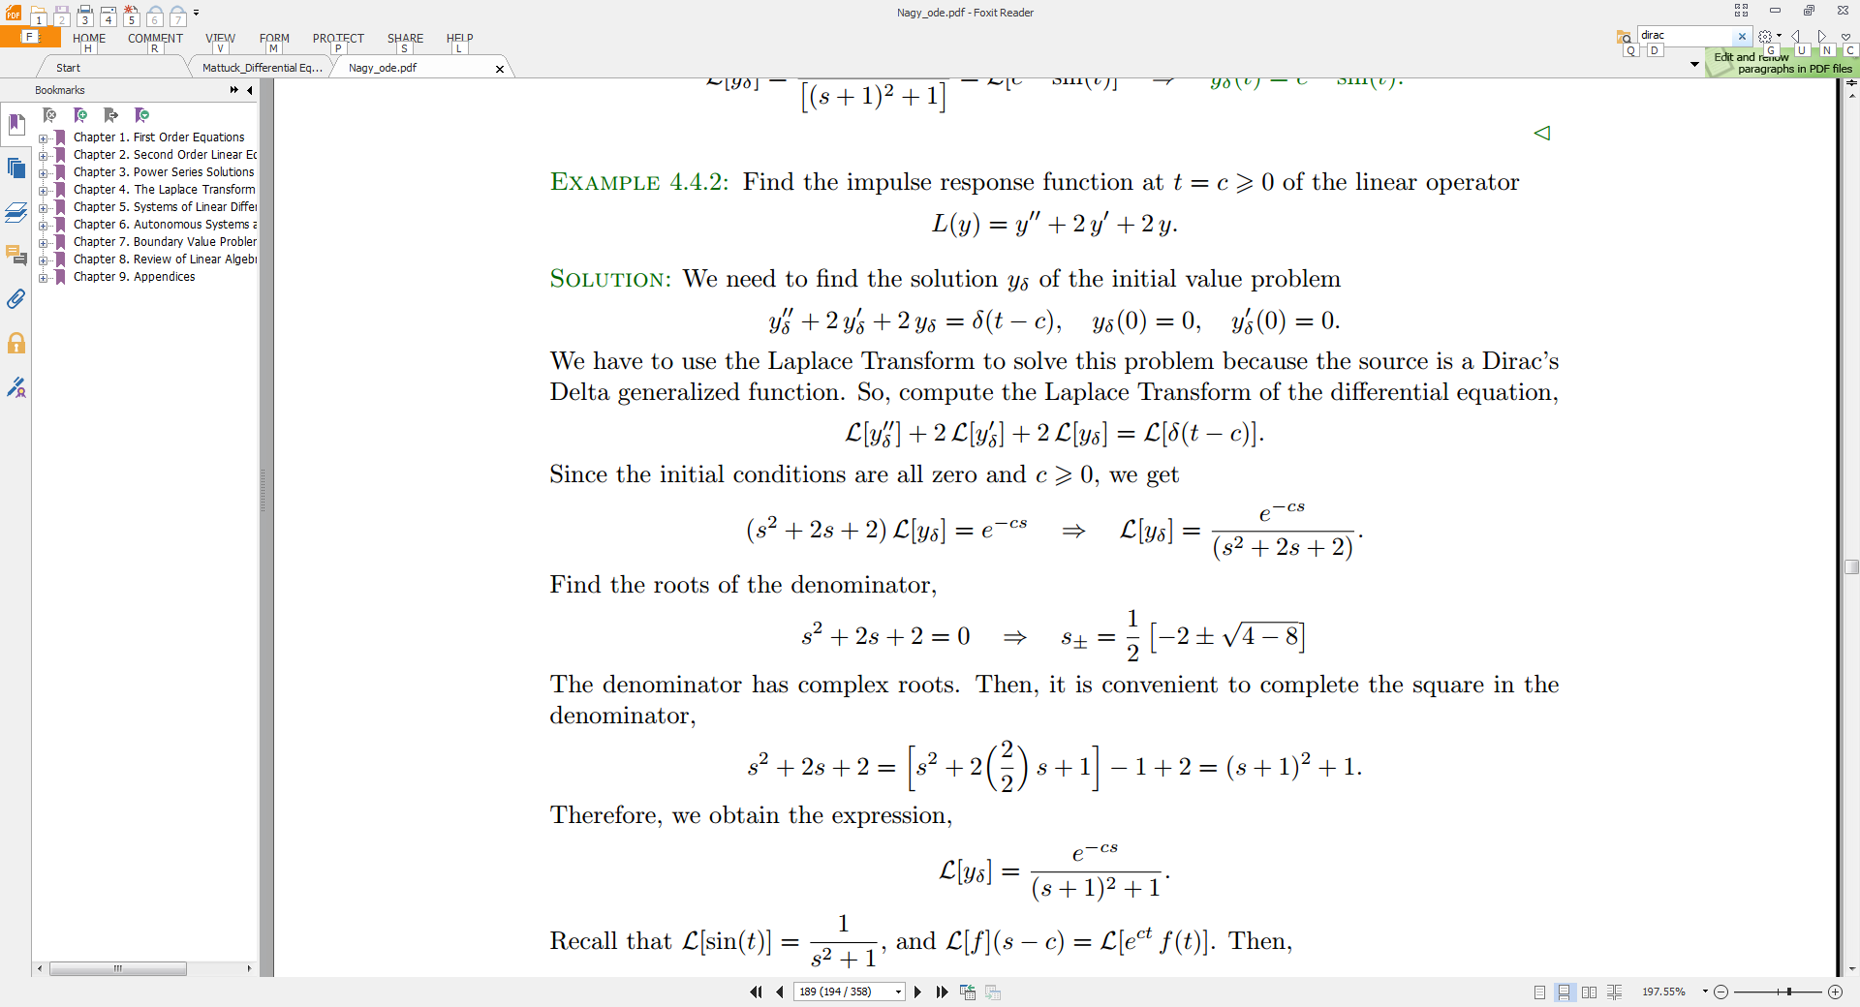
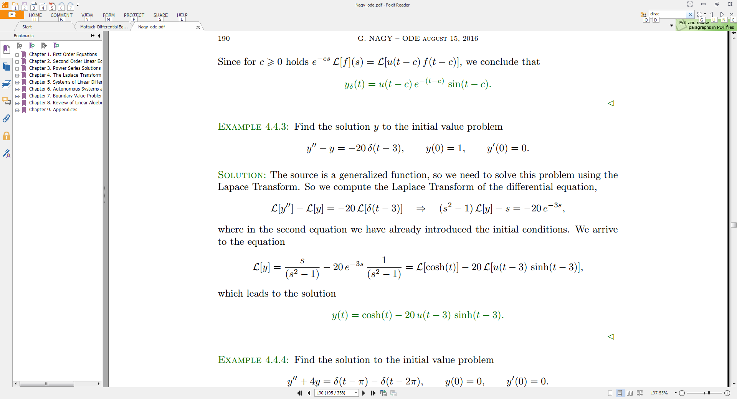

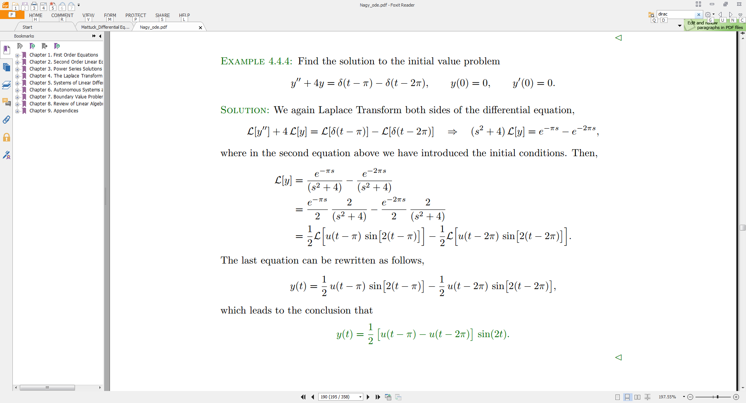

Ogata_Modern_Control_Engineering.pdf
Katsuhiko Ogata
Modern Control Engineering
Fifth Edition
Copyright © 2010, 2002, 1997, 1990, 1970 Pearson Education, Inc.
ISBN 10: 0-13-615673-8
ISBN 13: 978-0-13-615673-4

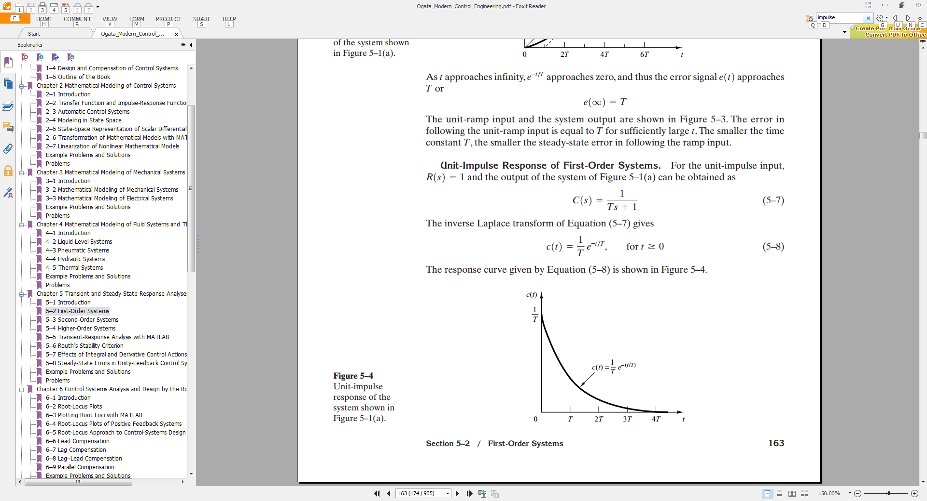

Rao_mechanical_vibrations_5th-edition_s-s-rao_scan.pdf

Singiresu S. Rao
Mechanical Vibrations (5th Edition)

ISBN-13: 978-0132128193
ISBN-10: 0132128195

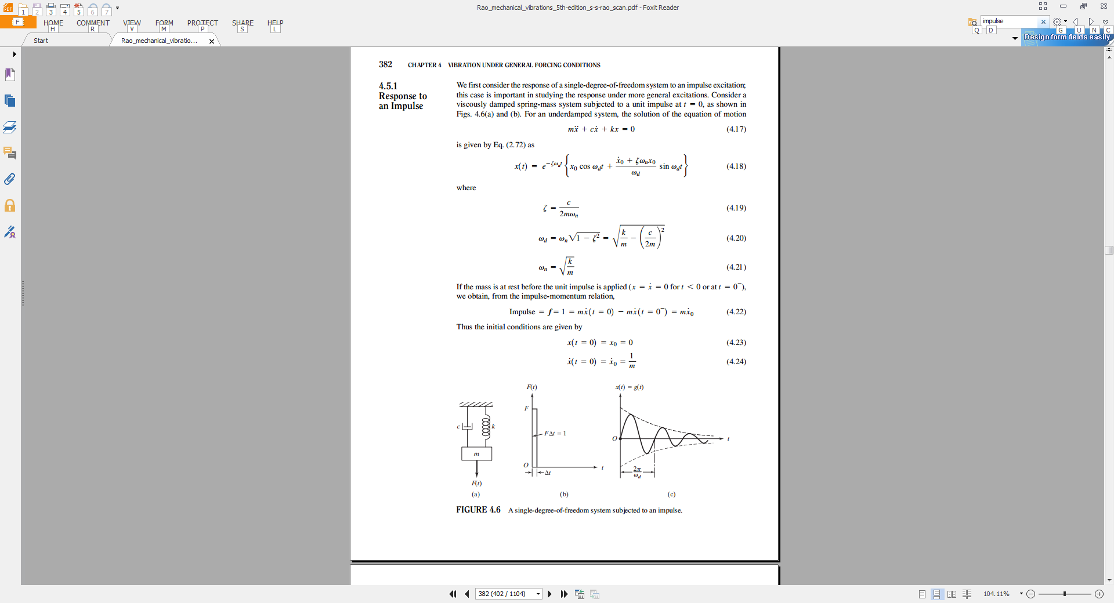

Weber, Arfken
Essential Mathematical Methods for Physicists
Academic Press, 2003
ISBN: 0-12-059877-9

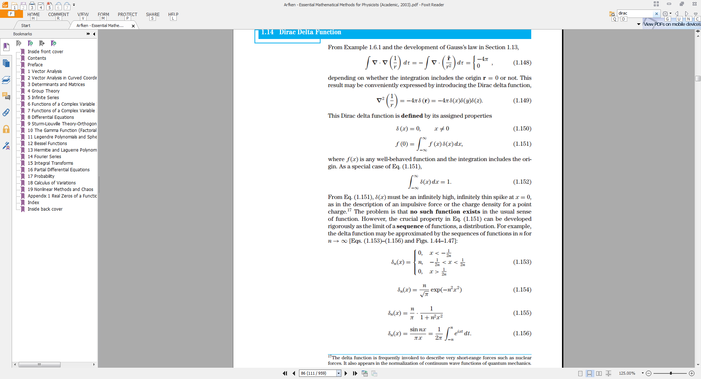

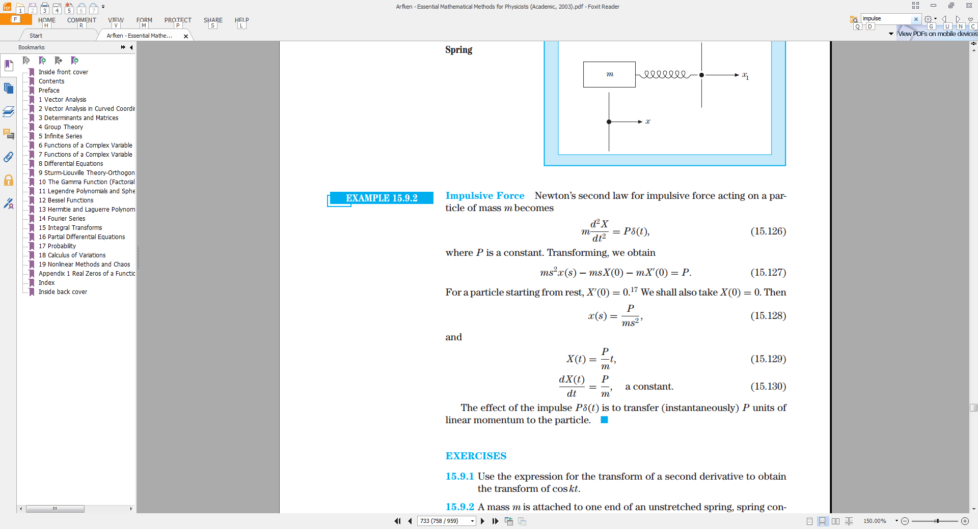

Zill_First Course in Differential Equations (Institutional), A - Dennis G. Zill.pdf

DENNIS G. ZILL
A FIRST COURSE IN DIFFERENTIAL EQUATIONS
with Modeling Applications (9th edition)
Loyola Marymount University
© 2009, 2005 Brooks/Cole, Cengage Learning
ISBN-13: 978-0-495-10824-5
ISBN-10: 0-495-10824-3

