人工智慧概論程式作業3報告
陳羿豐
實作決策樹
我使用Python語言來實作決策樹，因為我覺得Python是機器學習的標準語言。
程式碼放在附錄，使用方法是：
1. import cart 載入我的程式
2. tree = cart.trainCART(dataset, featureSet, numClasses, minSize) 會用輸入的資料來訓練，並把決策樹存到 tree 變數中
dataset 是二維陣列，dataset[i][j] 表示第i筆資料的第j個特徵，是浮點數，dataset[i][-1] 則是第i筆資料的分類結果，以整數表示，在Python中，第 -1項是最後一項。
featureSet 表示要作為分類用的特徵，是一個整數陣列，整數值是特徵編號
numClasses 是分類結果的種類數，至少是 2。要求0 ≤ dataset[i][-1] < numClasses
minSize 表示分支所需的最少資料數，如果沒有指定，則預設為 1，也就是不限最少資料數
3. tree.show() 顯示決策樹的結構
4. tree.predict(record) 對新的樣本作預測，回傳分類結果，以整數表示。record 是一維陣列，是一筆新資料。

執行圖中程式之前，請確認 cart.py、iris.py、iris.txt、cross200.py、cross200.txt、optical-digits.txt、opticaldigits.py都在目前的工作目錄
顯示iris.txt產生的決策樹
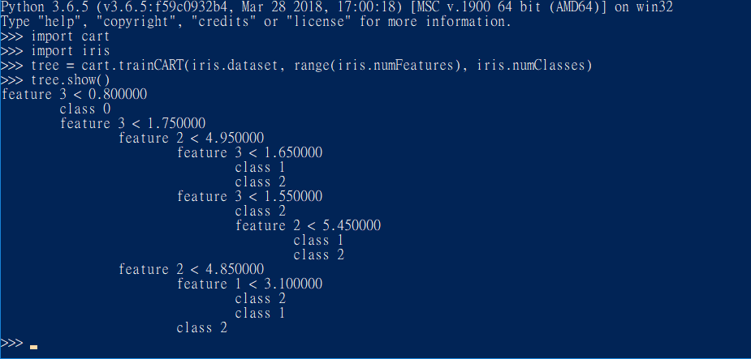
其中class 0 是Iris-setosa，class 1是Iris-versicolor，class 2是Iris-virginica

顯示cross200.txt產生的決策樹
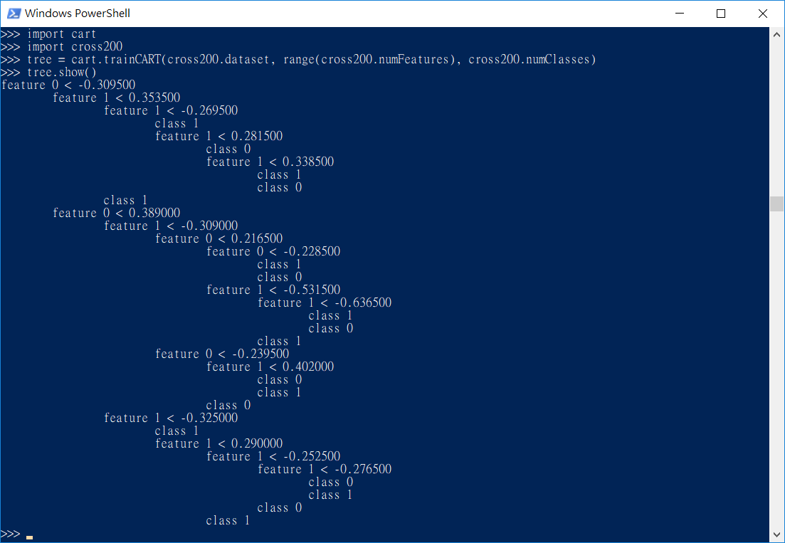
其中class 0 是1，class 1是2

optical-digits.txt 產生的決策樹太大了，無法在這裡呈現，不過可以用這個指令輸出
import cart
import opticaldigits
tree = cart.trainCART(opticaldigits.dataset, range(opticaldigits.numFeatures), opticaldigits.numClasses)
tree.show()

建立隨機森林 (Random Forest)
隨機森林的建立方法是建立好幾個決策樹，每個決策樹使用的特徵都是隨機指定的，大約有總共特徵數量的開根號個。
執行方法
請確認rf.py在目前作用中的資料夾
import iris
import rf
train, validate = rf.splitTrain(iris.dataset, 0.8) # train data 佔80%
numTrees = 10 # 樹的數量
forest = rf.randForest(train, iris.numClasses, iris.numFeatures, numTrees)
rf.validate(forest, validate, iris.numClasses)
如果要處理其他的資料，就把 iris 改成別的名字

結果
iris
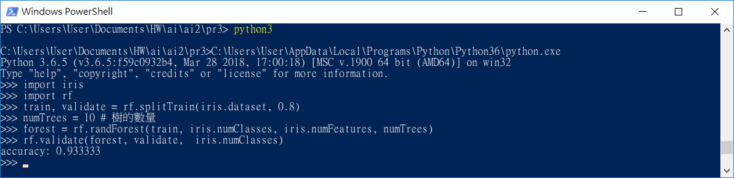
cross200
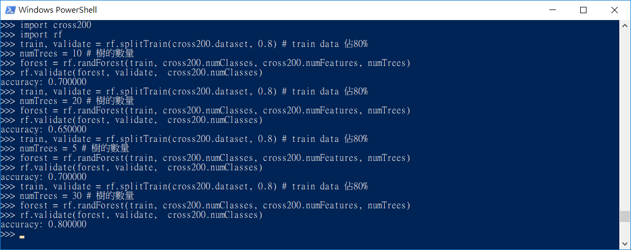
為什麼樹有 20 個的時候，準確度最糟？

optical-digits
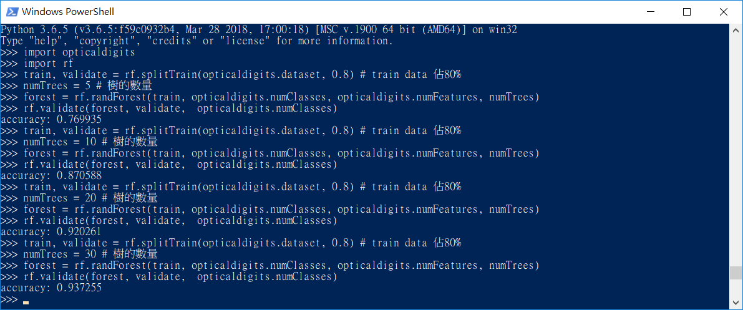
本來想說，optical-digits 是空間資料，決策樹應該會表現得很糟才是，不過在這裡，卻有90%以上的精準度，很神奇
附錄：
程式碼
cart.py
用 CART 演算法建立決策樹
class CART:
def __init__(self):
self.left = None
self.right = None
self.feature = 0
self.threshold = 0.0
self.classify = -1 # -1 means not leaf, >= 0 means output class
def leaf(self, output):
self.classify = output
return self
def branch(self, left, right, feature, threshold):
self.left = left
self.right = right
self.feature = feature
self.threshold = threshold
return self
def show(self, indent = 0):
if self.classify >= 0:
print ("%sclass %d" % ("\t" * indent, self.classify))
else:
print ("%sfeature %d < %f" % ("\t" * indent, self.feature, self.threshold))
self.left.show(indent+1)
self.right.show(indent+1)
def predict(self, record):
if self.classify >= 0:
return self.classify
if record[self.feature] < self.threshold:
return self.left.predict(record)
else:
return self.right.predict(record)

def trainCART(data, features, numClasses, minSize = 1):
n = len(data)
minGini = n + 1
featureToUse = None
threshold = 0.0
classCount = [0] * numClasses
# count number of each class
for rec in data:
output = rec[-1]
classCount[output] += 1
# if all data belong to one class, return a leaf node
for c in range(len(classCount)):
if classCount[c] == n:
return CART().leaf(c)
for f in features:
countSmall = [0] * len(classCount)
countBig = classCount[0:]
sortedData = sorted(data, key = lambda rec: rec[f])
# test each threshold
for i in range(1, len(data)):
# count each output class
output = sortedData[i-1][-1]
countSmall[output] += 1
countBig[output] -= 1
# check feature value
prev = sortedData[i-1][f]
current = sortedData[i][f]
# if previous value is the same, it cannot be a threshold
if prev == current:
continue
# calculate Gini index
gini = computeGini(countSmall, i) * i + computeGini(countBig, n-i) * (n-i)
if gini <= minGini:
minGini = gini
featureToUse = f
threshold = (prev + current) / 2.0
# no way to split
if featureToUse == None or len(data) < minSize:
m = 0
choose = 0
for c in range(numClasses):
if classCount[c] > m:
m = classCount[c]
choose = c
return CART().leaf(choose)
# split data
left = []
right = []
for rec in data:
if rec[featureToUse] < threshold:
left.append(rec)
else:
right.append(rec)
leftTree = trainCART(left, features, numClasses, minSize)
rightTree = trainCART(right, features, numClasses, minSize)
return CART().branch(leftTree, rightTree, featureToUse, threshold)

def computeGini(count, size):
return 1.0 - sum(nc * nc for nc in count) / float(size * size)

iris.py
處理iris.txt的資料
numFeatures = 4
numClasses = 3
def convertClassName(name):
classes = {
"Iris-setosa": 0 ,
"Iris-setosa*": 0, # I don't know why the dataset provided by teacher has this
"Iris-versicolor": 1,
"Iris-virginica": 2
}
return classes[name]

file = open("iris.txt", "r")
dataset = []
for line in file.readlines():
line = line.rstrip()
if line == "": continue # skip empty line
record = line.split(',')
out = record[-1]
record[-1] = convertClassName(out)
for i in range(numFeatures):
record[i] = float(record[i])
dataset.append(record)

cross200.py
處理cross200的資料
numFeatures = 2
numClasses = 2
def convertClassName(name):
classes = {
"1": 0,
"2": 1,
}
return classes[name]

file = open("cross200.txt", "r")
dataset = []
for line in file.readlines():
line = line.strip()
if line == "": continue # skip empty line
record = line.split()
out = record[-1]
record[-1] = convertClassName(out)
for i in range(numFeatures):
record[i] = float(record[i])
dataset.append(record)

opticaldigits.py
處理optical-digits.txt的資料
numFeatures = 64
numClasses = 10
def convertClassName(name):
classes = {
"0": 0,
"1": 1,
"2": 2,
"3": 3,
"4": 4,
"5": 5,
"6": 6,
"7": 7,
"8": 8,
"9": 9
}
return classes[name]

file = open("optical-digits.txt", "r")
dataset = []
for line in file.readlines():
line = line.strip()
if line == "": continue # skip empty line
record = line.split(',')
out = record[-1]
record[-1] = convertClassName(out)
for i in range(numFeatures):
record[i] = float(record[i])
dataset.append(record)

rf.py
Random Forest 的實作和計算成效的程式
import cart
import random
import math

# returns tuple (train data, validate data)
def splitTrain(dataset, trainRatio = 0.8):
n = len(dataset)
train = []
validate = list(range(n))
trainSize = int(len(dataset) * trainRatio)
for i in range(trainSize):
r = random.randint(0, n-1-i)
train.append(validate[r])
validate[r] = validate[n-1-i]
validate = validate[0 : n-trainSize]
train = [dataset[i] for i in train]
validate = [dataset[i] for i in validate]
return (train, validate)

def randForest(dataset, numClasses, numFeatures, numTrees):
forest = []
featCount = int(math.sqrt(numFeatures))
for i in range(numTrees):
attributes = random.sample(range(numFeatures), featCount)
tree = cart.trainCART(dataset, attributes, numClasses)
forest.append(tree)
return forest

def predict(forest, record, numClasses):
count = [0] * numClasses
for tree in forest:
ans = tree.predict(record)
count[ans] += 1
m = max(count)
for i in range(numClasses):
if count[i] == m:
return i

def validate(forest, validate, numClasses):
total = len(validate)
correct = 0
for record in validate:
ans = predict(forest, record, numClasses)
if ans == record[-1]:
correct += 1
print ("accuracy: %f" % (float(correct)/total))

