**Taxes Using the Turner Bands**

# **Long Story Short**

Statement from [Investopedia](https://www.investopedia.com/terms/c/capital_gains_tax.asp#:~:text=Capital%20gains%20taxes%20apply%20only,individual's%20regular%20income%20tax%20rate.):

*“…Short-term gains are taxed at the individual’s regular income tax rate.”*

Short-term capital gains tax applies to assets that are sold one year or less from the date they were purchased. This profit is taxed as ordinary income. For all but the wealthiest taxpayers, that is a higher tax rate than the capital gains rate.

By this definition, the Turner Bands strategy is designed to make short-term investments which are taxed as income and at your income brackets both federal and state.

# **Federal Tax Brackets**

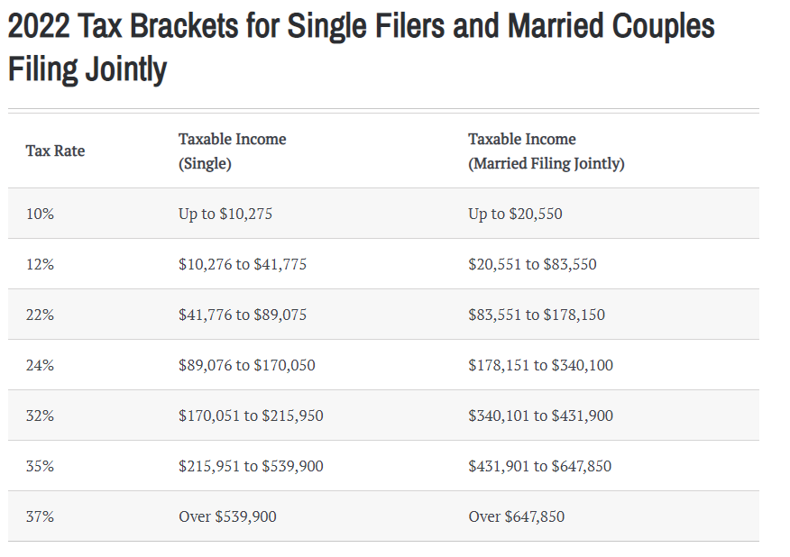

# **State Tax Brackets for Iowa**

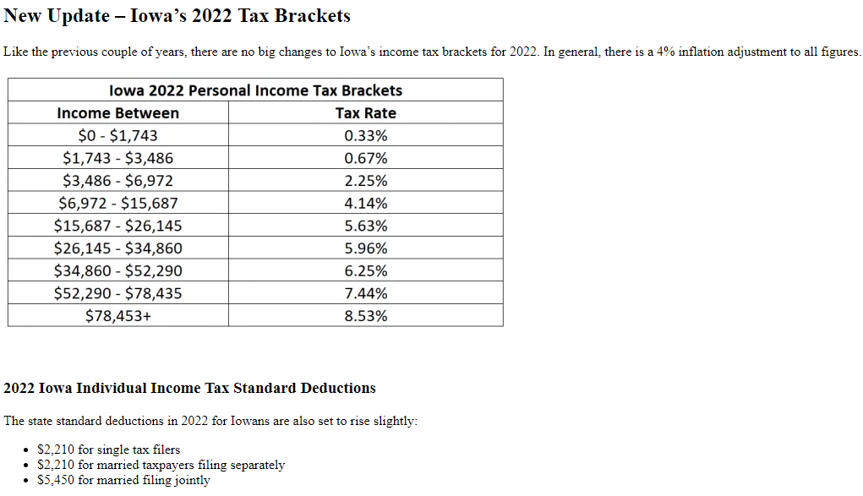

# **State Tax Brackets for Alabama**

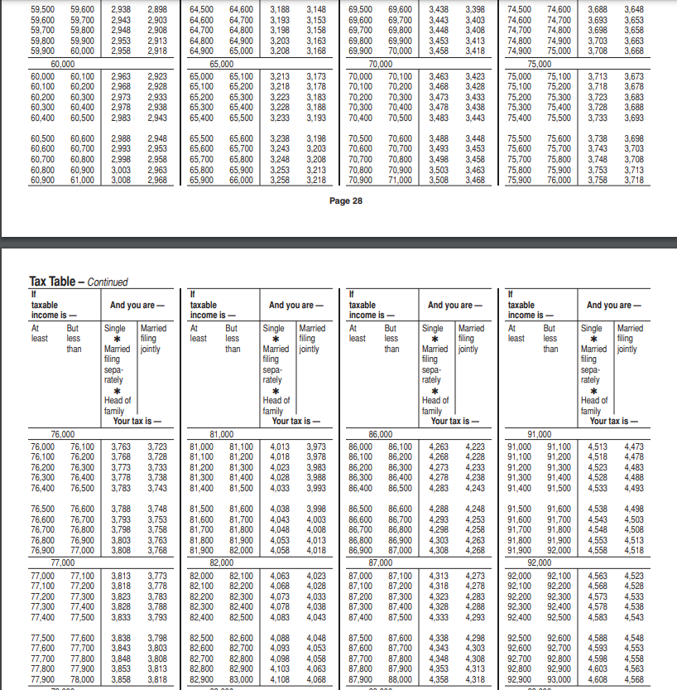

# **Sources**

Federal tax brackets - <https://www.kiplinger.com/taxes/tax-brackets/603738/irs-releases-income-tax-brackets-for-2022>

Iowa tax brackets - <https://arnoldmotewealthmanagement.com/iowans-new-tax-law-brackets/>

Alabama tax brackets - <https://revenue.alabama.gov/wp-content/uploads/2017/08/16f40taxtable.pdf>

Long Story Short section - <https://www.investopedia.com/terms/c/capital_gains_tax.asp#:~:text=Capital%20gains%20taxes%20apply%20only,individual's%20regular%20income%20tax%20rate>.