Steven Jones

08/17/22

Foundations of Programming - Python

Assignment 06

**Working with Functions and a Simple Class**

**Introduction**

In this sixth programming assignment we learned to automate our programming by using Functions.

**How I accomplished this task**

I obviously used the Python programming language and the PyCharm IDE to write the code for this assignment. I also used PyCharm & IDLE to run the code.

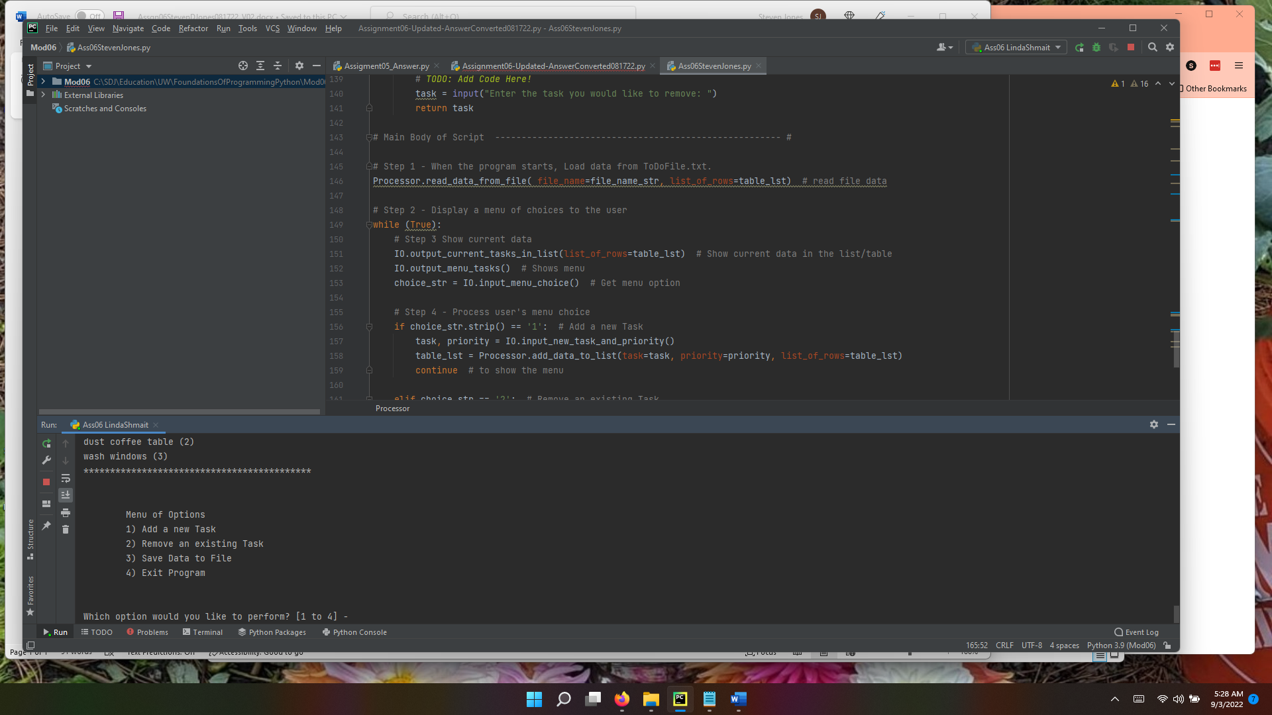

Figure Using PyCharm

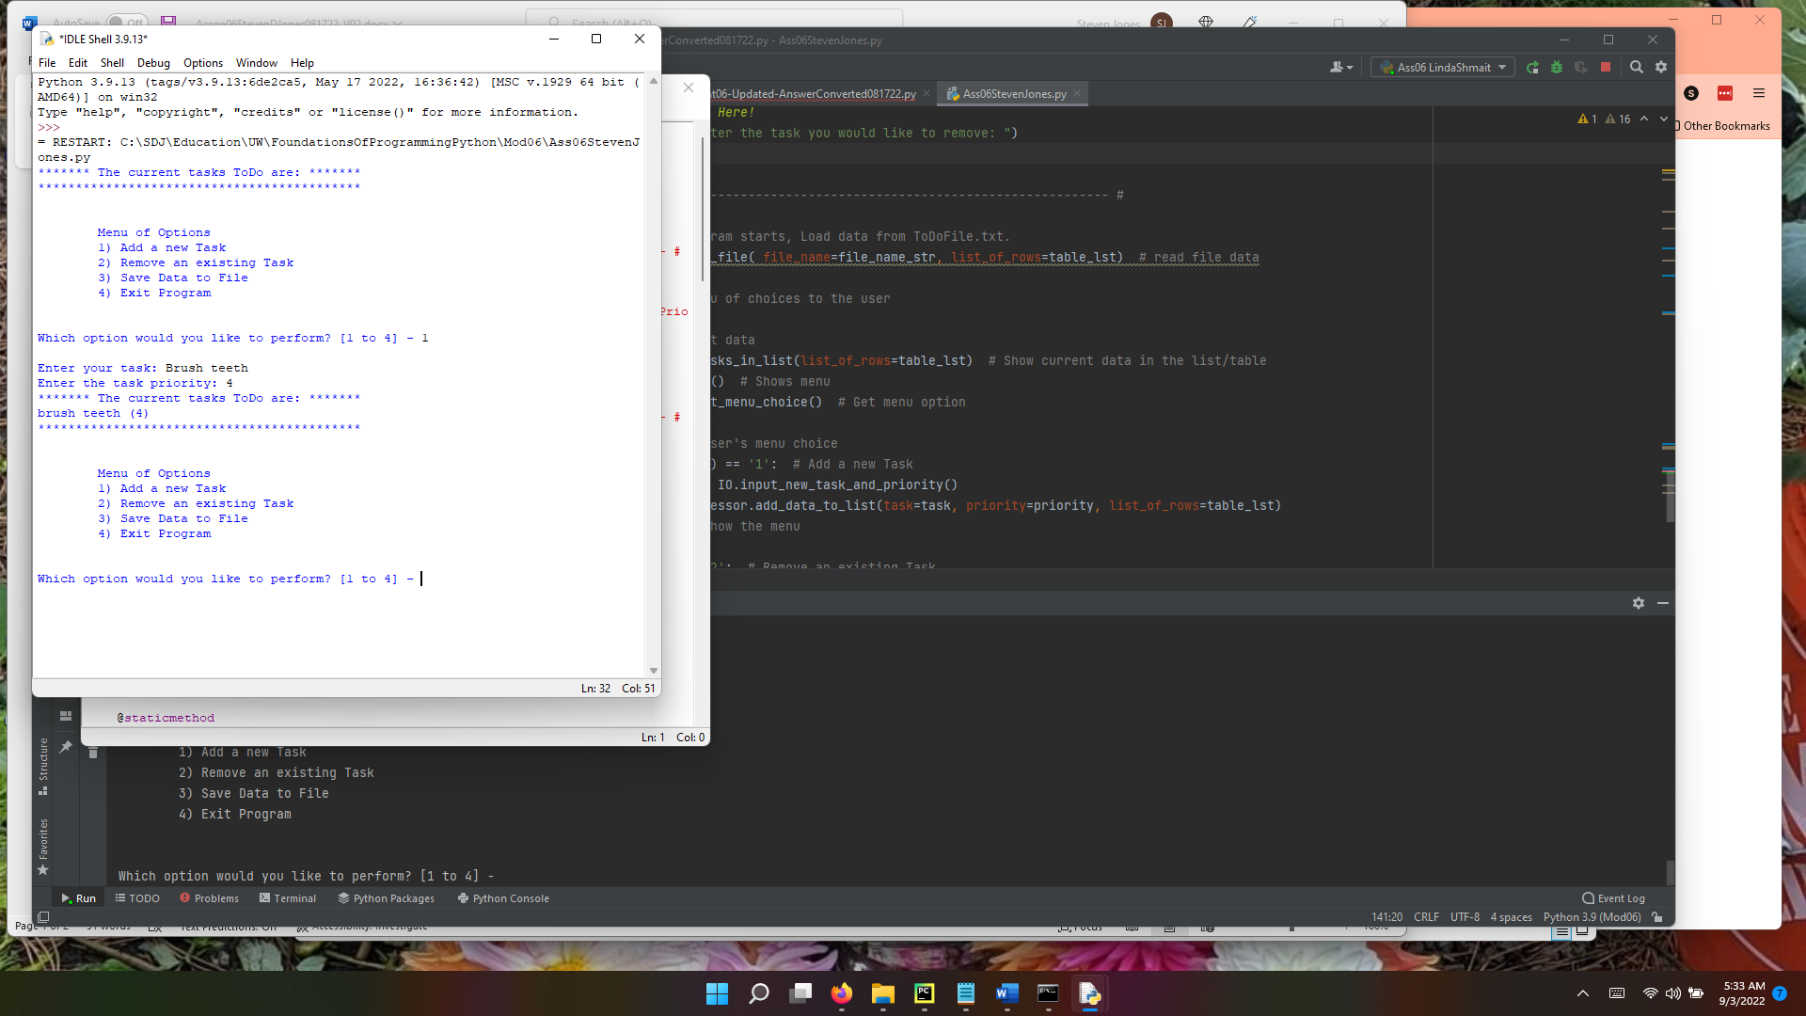

Figure Using IDLE

**Summary**

This sixth assignment was very challenging to me, I obviously relied on instructor provided help to complete this assignment.