Steven Jones

09/12/22

Foundations of Programming - Python

Assignment 07

**Exception handling and using Python’s pickling module**

**Introduction**

In this seventh programming assignment we learned about exception handling and the pickling module within Python.

**How I accomplished this task**

I obviously used the Python programming language and the PyCharm IDE to write the code for this assignment. I also used PyCharm & IDLE to run the code.

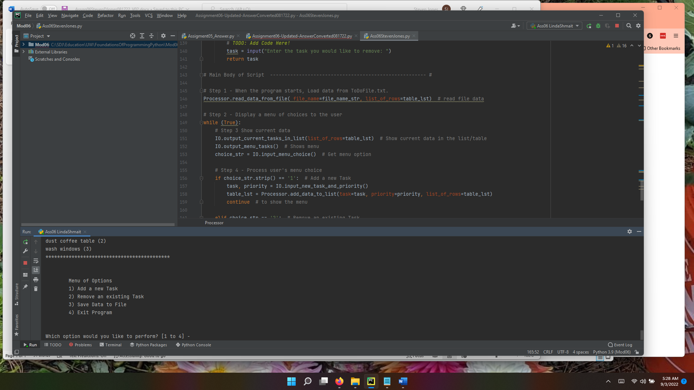

Figure Using PyCharm

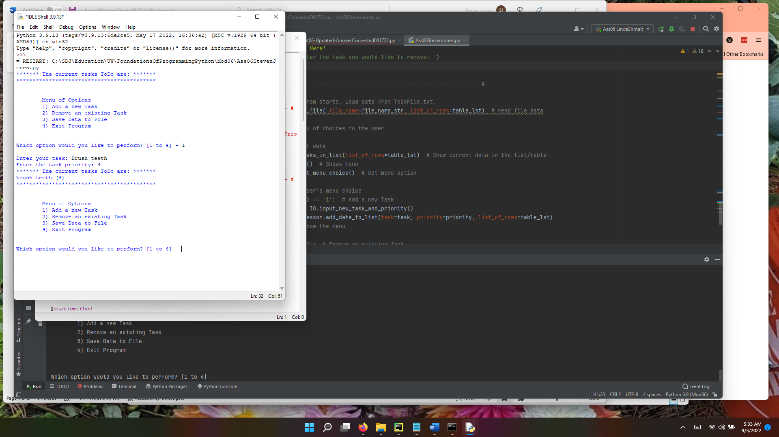

Figure Using IDLE

**Summary**

This seventh assignment was not a cake walk. I relied a great deal on instructor provided help to complete this assignment.