

FACULTY OF ICT

PERSONAL PROJECT

NAME: REG: No

BIYINZIKA FAITH BAIT/14D/U/A189

COURSE UNIT: PHP- PROGRAMING

YEAR: TWO

SEMESTER: ONE

LECTURER: Dr. KEVIN

PROJECT: VOTING MANAGEMENT SYSTEM

**REPORT**

**TABLE OF CONTENTS**

1. **Declaration**
2. **Introduction**
3. **Description**
4. **Technical Description**
5. **Source code**
6. **Conclusion**

# Declaration:

This is to certify that the work being presented in the project entitled “VOTING MANAGEMENT SYSTEM” submitted by a student of Second Year in BAIT in partial fulfillment of my End of first semester Exams of BAIT under guidance and supervision of Dr. KEVIN. In ICT Department and this work has not submitted elsewhere,

Thank you Dr. KEVIN.

**Name of student: BIYINZIKA FAITH.**

**Registration Number: BAIT/14D/U/A189.**

**Voting management system**

“ONLINE VOTING SYSTEM”

This system is dedicated to ST LAWRACE UNIVERSITY, for handling University’s **voting activities** , Uganda in particular.

Online voting Usage / technique. In this system students / people who are ST LAWRANCE’S members and above 18 years of age of any sex can vote online without going to any physical polling station. There is a database in which all the names of voters with complete information is stored.

In “ONLINE VOTING SYSTEM” a voter can use his\her voting right online without any difficulty. He\She has to be registered first for him/her to vote for security reasons.

After registration, the voter is assigned a secret Username / Email and Password with which he/she can use to log into the system and enjoy services provided by the system . If invalid/wrong details are submitted, then the citizen is not registered to vote.

**Voting sys it is all about choosing and selecting your Candidate by just clicking on the candidate name and the picture is also indicated above** .

**Voting system at the University** it has been existing factor for all years but in different styles (Manually done) , but with constant upgrading in terms of technology today here we are using Online PHP 5 language Voting system.

**Online Voting system is** very good because you can vote from any were , any time & without wasting time of lining up to vote , so everything is made soft for students / Ugandans .

**Technology used**

PHP (PHP 5 ) programing language is the language that is used to develop web scripts and other systems with the help of compilers such as wamp sever .

(MYSQL , HTML).

In this **Online Voting system** , I used PHP 5 (improved) just 2 simplify my work and to be different from others because we are many who did the same Project concerning Voting.

**About the system**

The system comprises of four (4) pages as (index , Home , Login , Registration pages) thus giving a variety of options for the users of the system as follows.

PART ONE:

LOGIN – PAGE IF I TEL YOU ARE OREADY RIGESTERED FOR E-VOTING

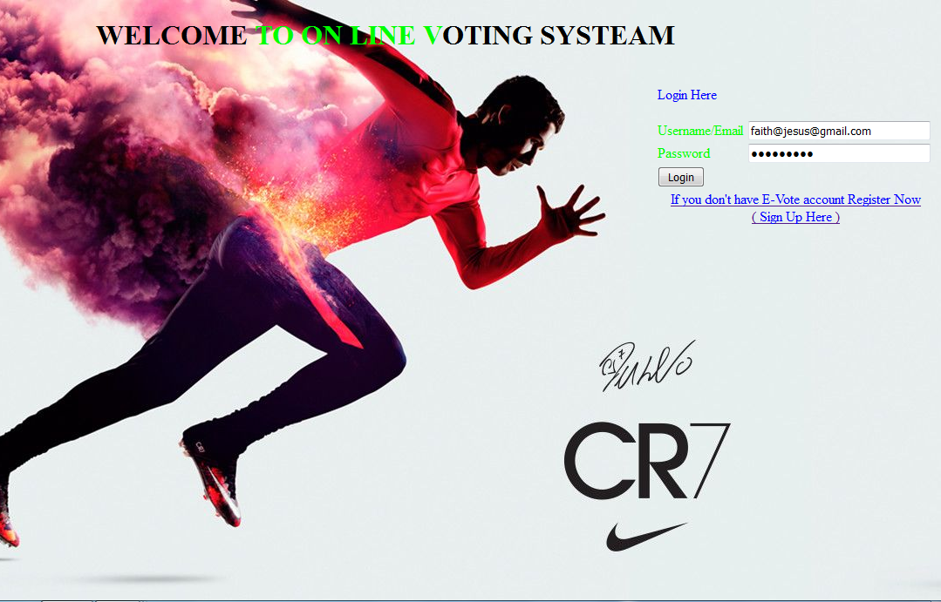

PART TWO: RIGESTER IF YOU DON’T HAVE E-VOTING ACCOUNT.

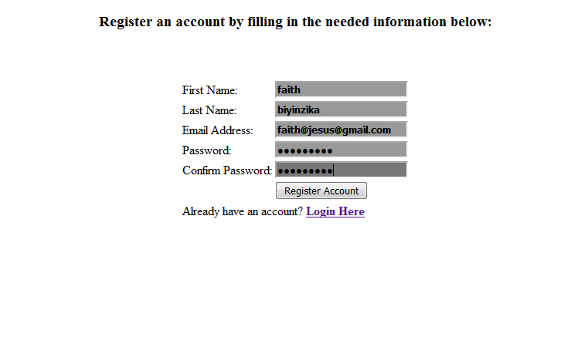

PART THREE , VOTE YOUR CANDIDATE.



THE ADMINISTRATION PART (OFFICIAL USE ONLY) RESULTS PAGE.

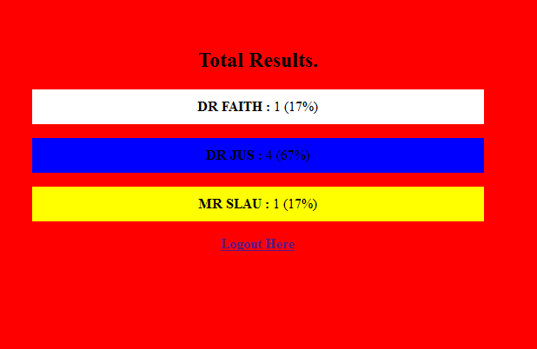

**CONCLUSION AND RECOMMENDATIONS**

**Conclusion:** Even though VOTING SYSTEM PHP/PHP 5 Project was full of challenges but also I recognize its value, it was worth the knowledge. It introduced me to professional working experience and good measure of IT, I leant that you have to be intelligent and work as if you have no need of the money. I enormously thank the management of ICT for the practical skills rendered to me / us.

**Recommendations**

The top administration at the college of computing and information technology should continue enforcing us / students to undergo Projects doing in order to translate their theory attained in class into practical experience.

The academic supervisor should be allocated more time and allowance to guide the students under project work.

Lastly, the government should procure more IT equipments to the Education sector so as to enhance and widen the ICT directorate.