Computer Vision HW#10

R08942125廖克允

1. Laplacian mask 1: 15

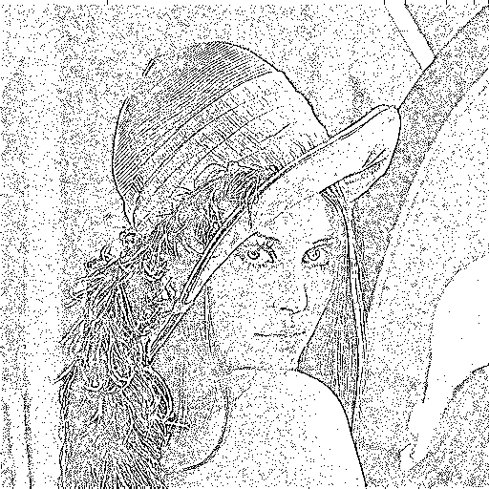

1. Laplacian mask 2: 15

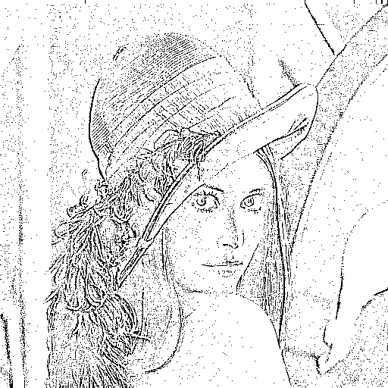

1. Minimum variance Laplacian : 20

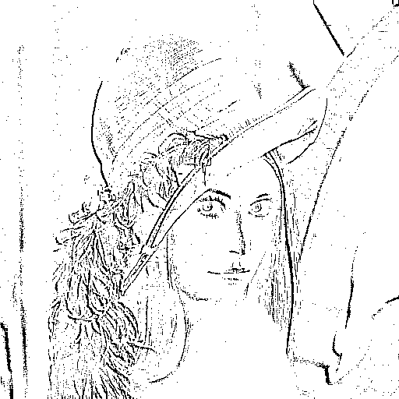

1. Laplacian of Gaussian : 3000

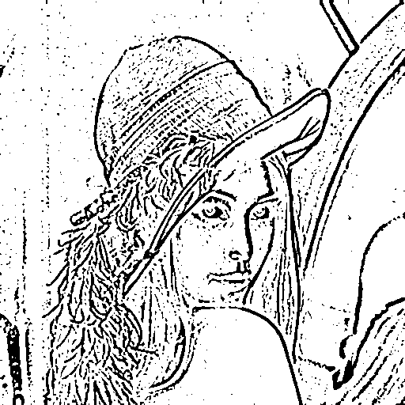

1. Difference of Gaussian : 1

