Computer Vision HW#3

R08942125廖克允

Part 1.

1. a binary image (threshold at 128)

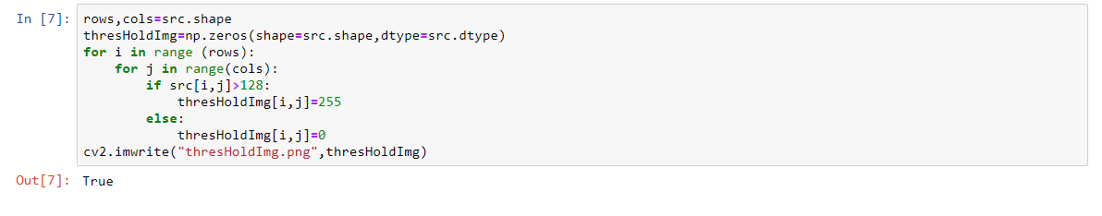

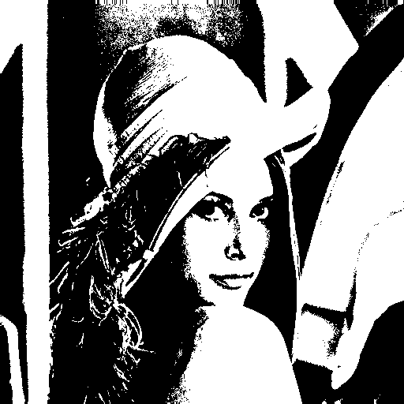

1. a histogram



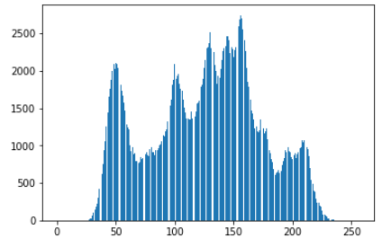

1. connected components(regions with + at centroid, bounding box)

By using 8-connected, set threshold to 500, push rectangle’s info into stack. And then draw the rectangles and crosses on new image

Push rectangle’s info into stack

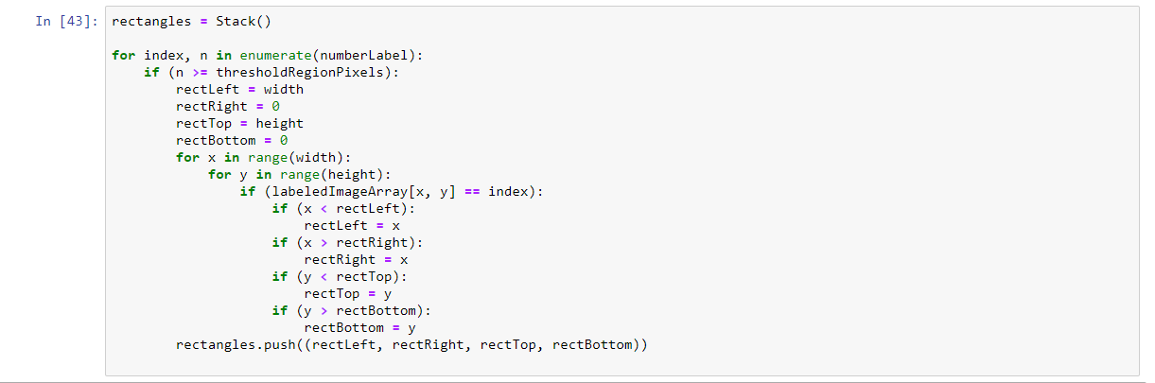

Draw the bounding box and centroids

