Computer Vision HW#3

R08942125廖克允

Part 1.

1. original image and its histogram

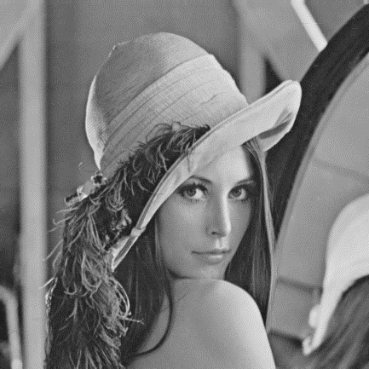 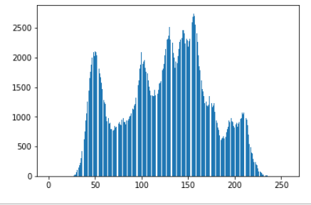

The figure below is how I get the histogram

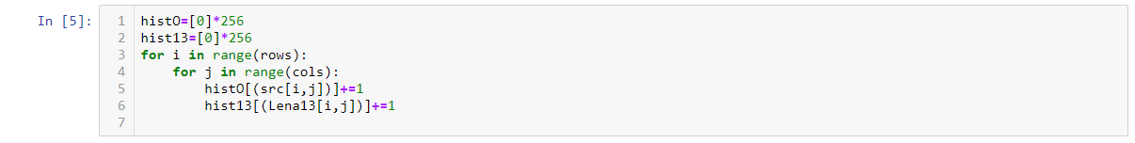

1. image with intensity divided by 3 and its histogram

divide the intensity by 3

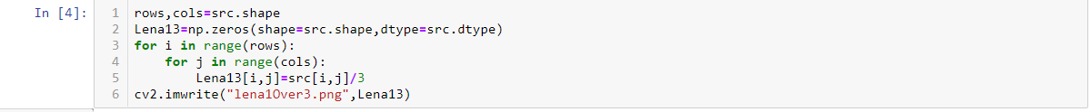

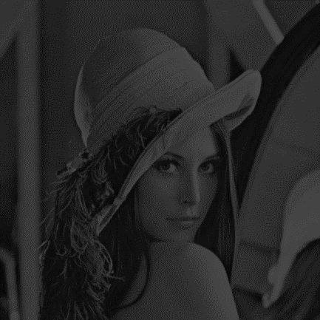 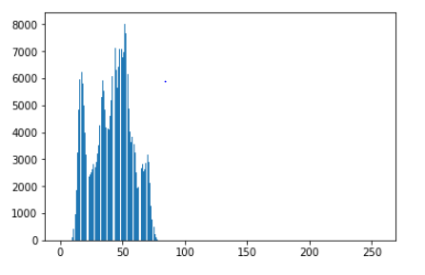

1. image after applying histogram equalization to (b) and its histogram

First, plot the cdf

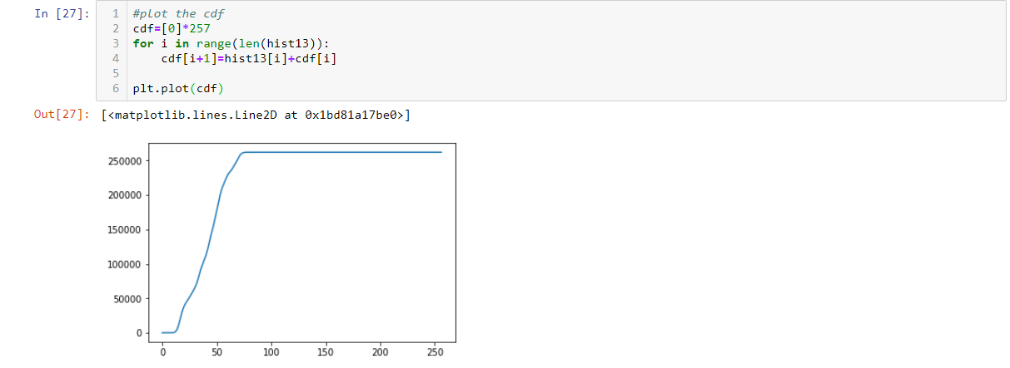

Second, renormalize the cdf



Get the value from cumulative sum for every index in “flat”, flat is a 1-D array which is reshape from the Lena in problem (b).

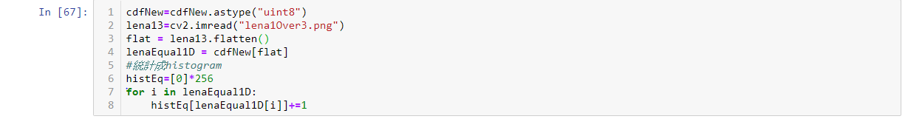

Now we just need to plot the histogram and reshape the 1-D array into 2-D image



