Computer Vision HW#4

R08942125廖克允

1. Binarize Lena and use the 3-5-5-5-3 kernel

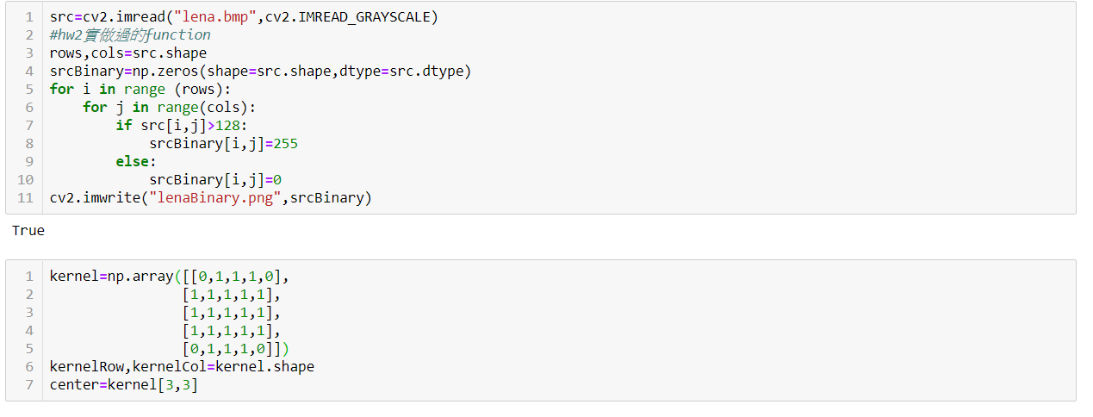

1. Start to do morphology operation on image
2. Dilation

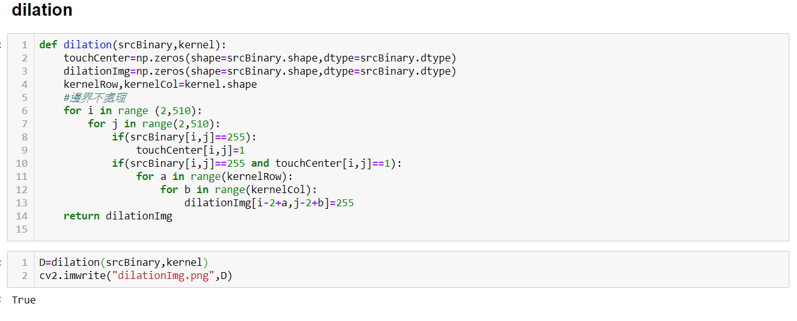

Result

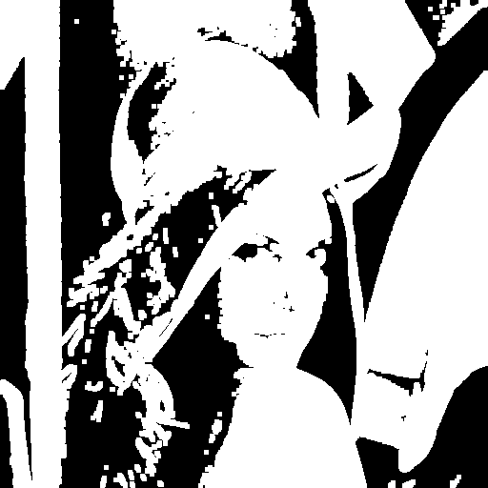

1. Erosion

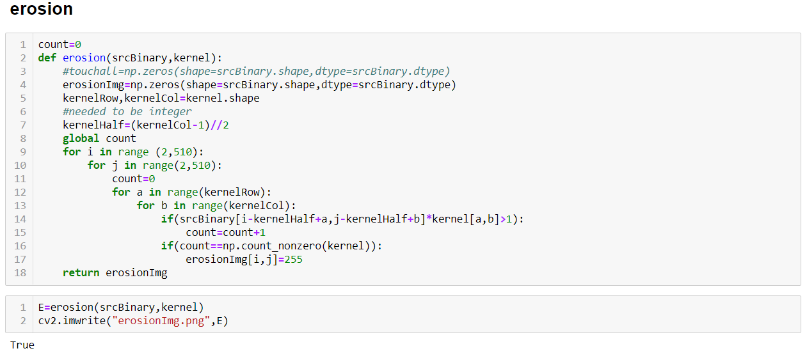

Result:

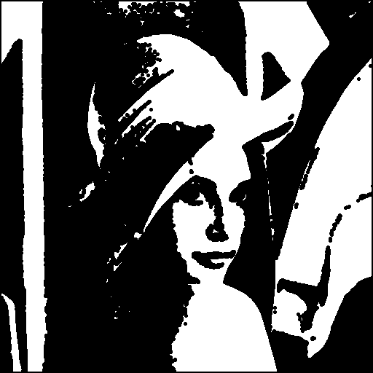

1. Opening

Opening是先對圖片做erosion再做dilation

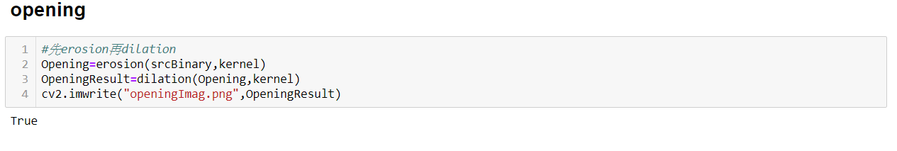

Result:

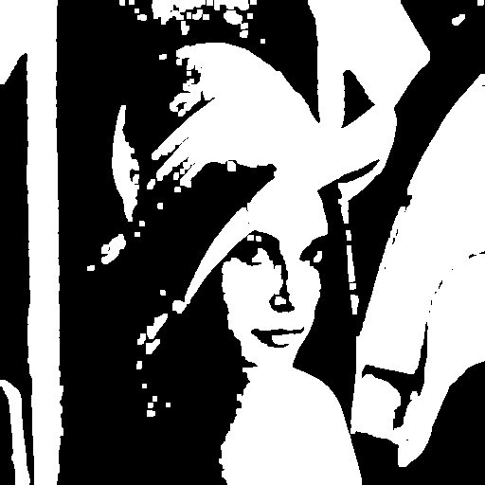

1. Closing

Closing 是先對圖片做dilation再做erosion

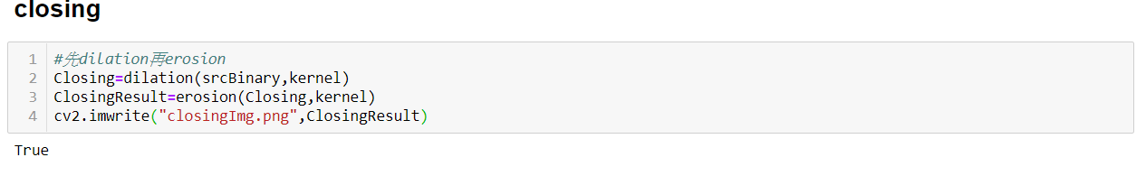

Result:

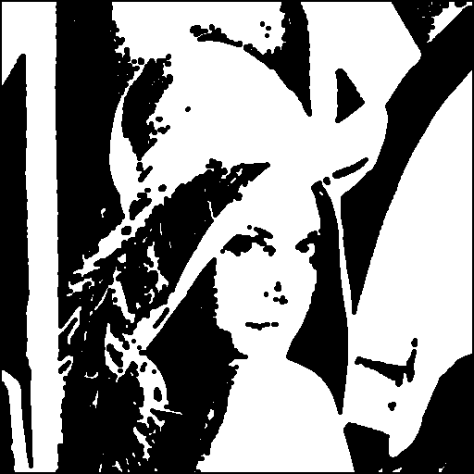

1. Hit-and-miss transform

Hit-and-miss的邏輯運算式:

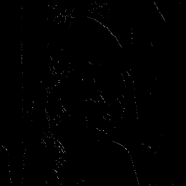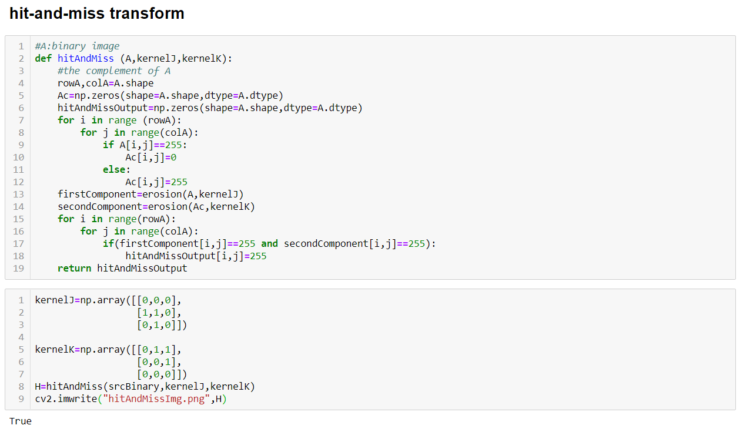Result: