Computer Vision HW#7

R08942125廖克允

1. Binarize Lena

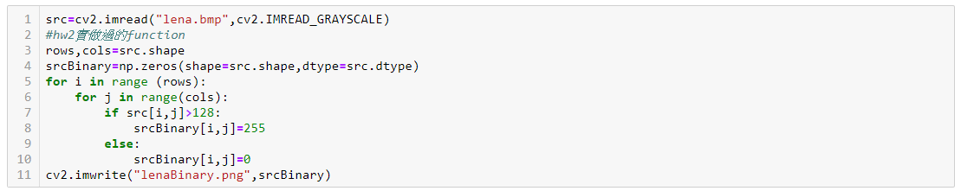

1. Down sampling

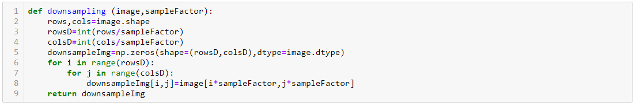

1. Get neighborhood pixels

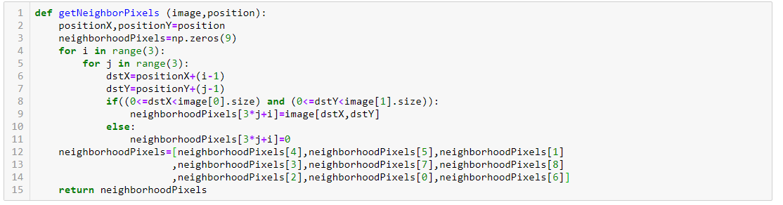

1. F function and h function of Yokoi

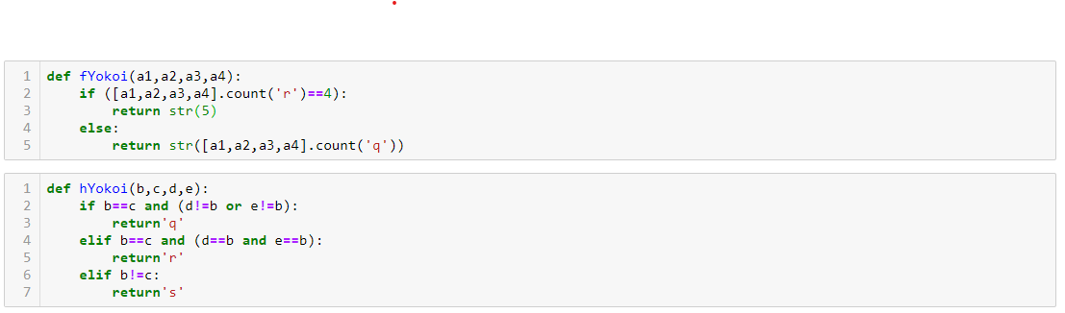

1. Count Yokoi connectivity number

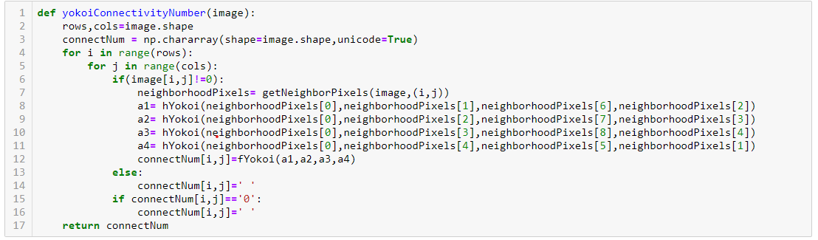

1. Pair relationship operator

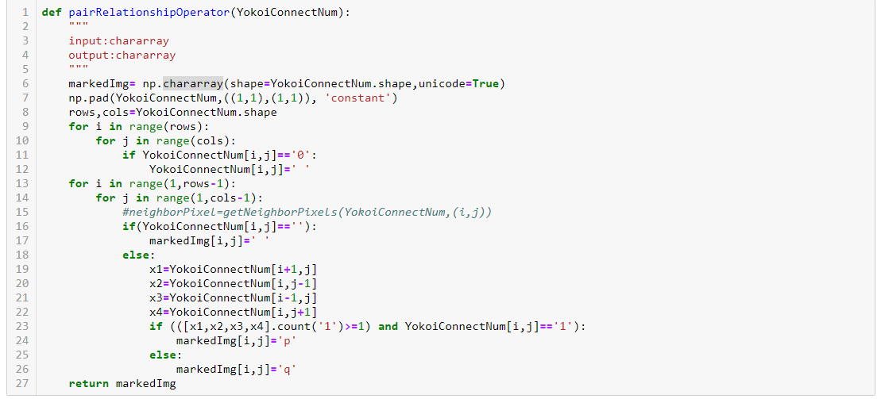

1. Connected shrink operator

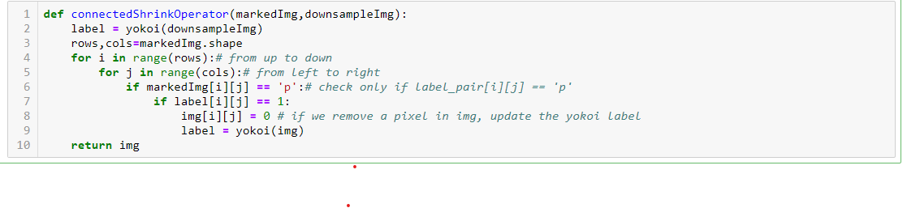

1. Result

