Computer Vision HW#9

R08942125廖克允

1. Robert's Operator: 12

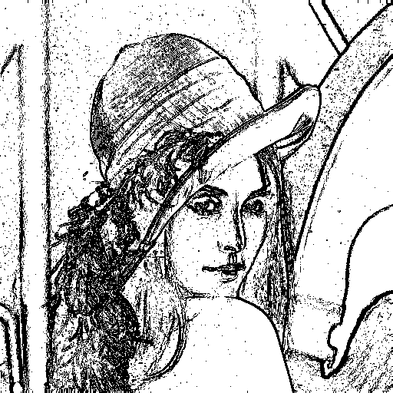

1. Prewitt's Edge Detector: 24

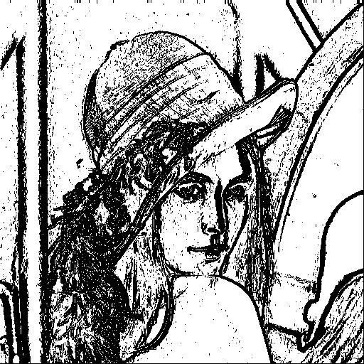

1. Sobel's Edge Detector: 38

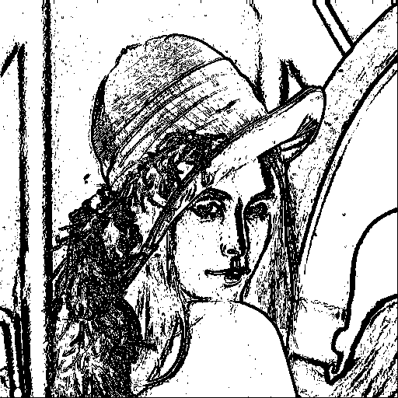

1. Frei and Chen's Gradient Operator: 30

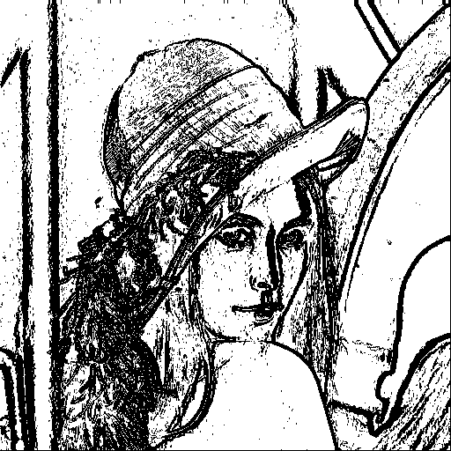

1. Kirsch's Compass Operator: 135

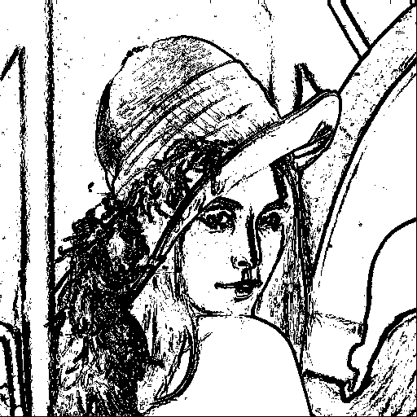

1. Robinson's Compass Operator: 43

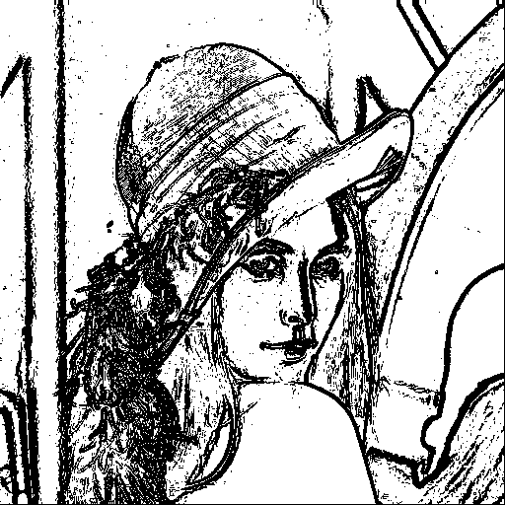

1. Nevatia-Babu 5x5 Operator: 12500

