Computer Vision HW#1

R08942125廖克允

Part 1.

Import cv2 and numpy for basic image I/O

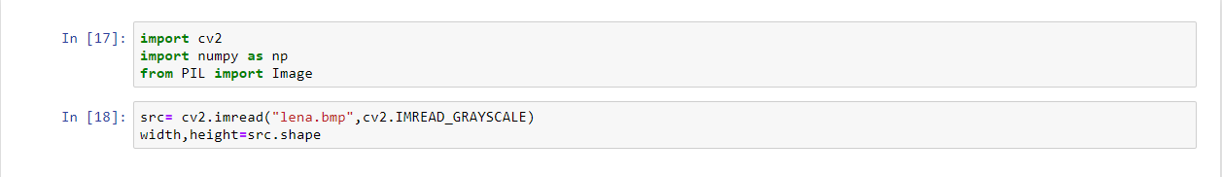

1. upside-down lena.bmp

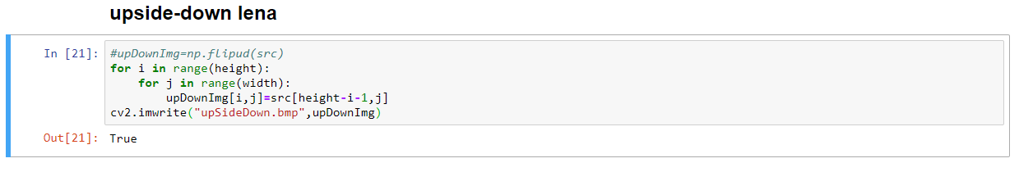

Result:

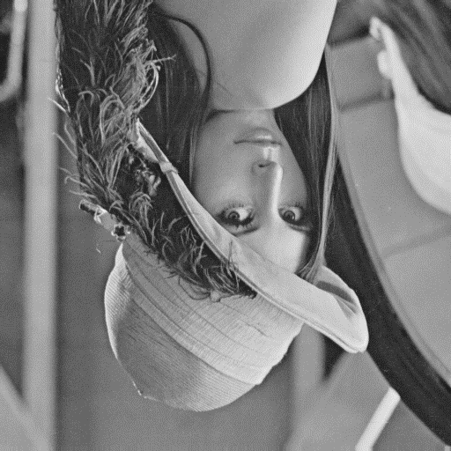

1. right-side-left lena.bmp

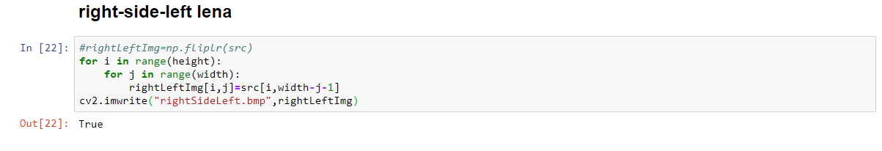

Result:

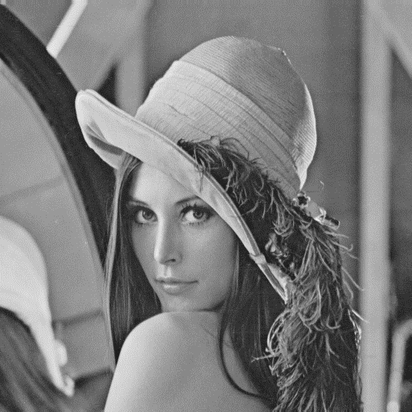

1. diagonally mirrored lena.bmp

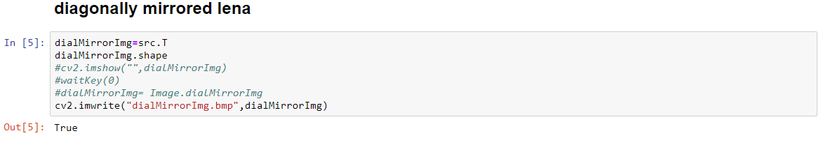

Result:

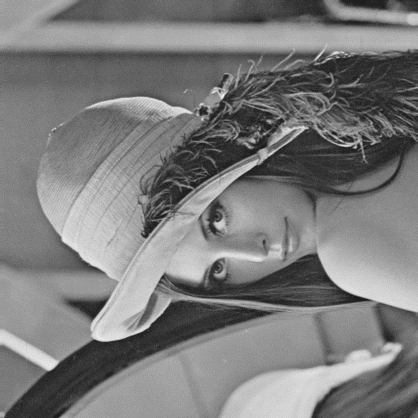

Part 2.

Use Photopea to get the requirement

1. rotate lena.bmp 45 degrees clockwise

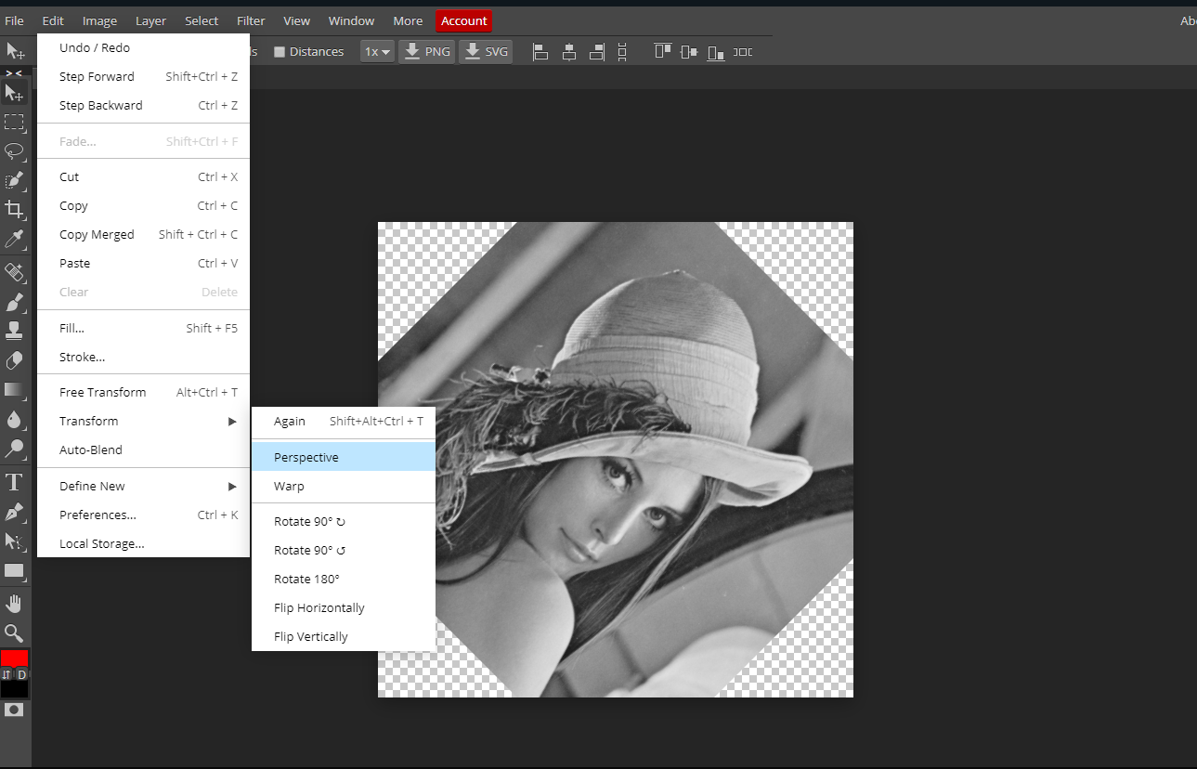

Result:

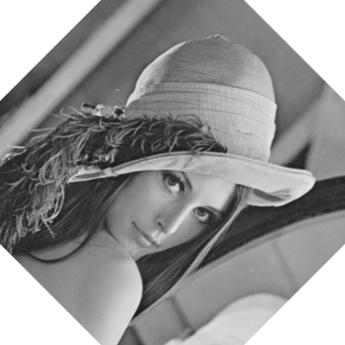

1. shrink lena.bmp in half

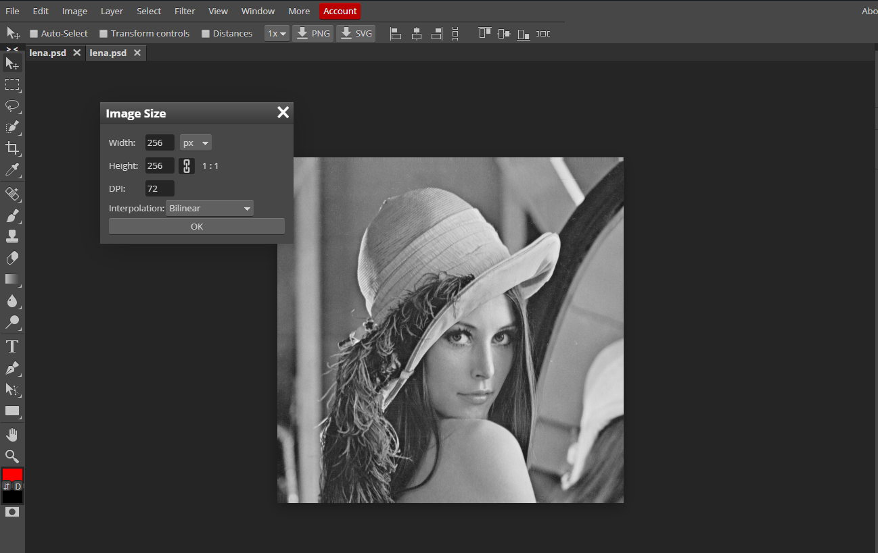

Result:

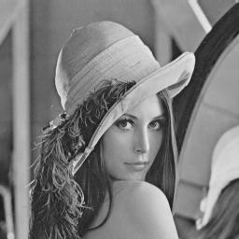

1. binarize lena.bmp at 128 to get a binary image

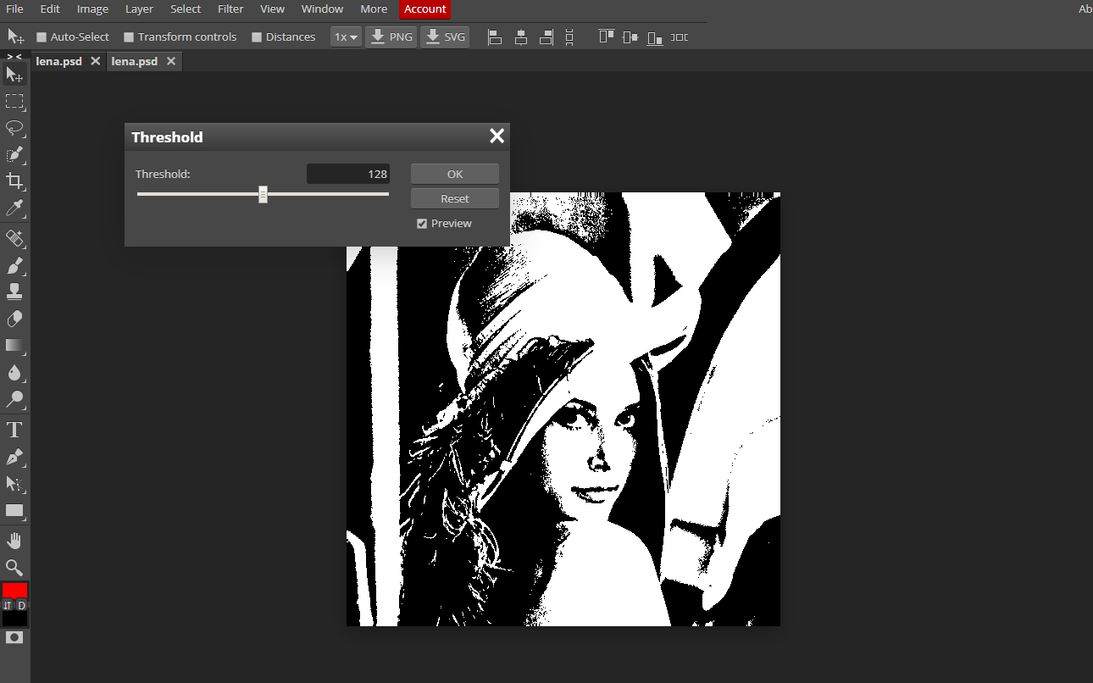

Result:

