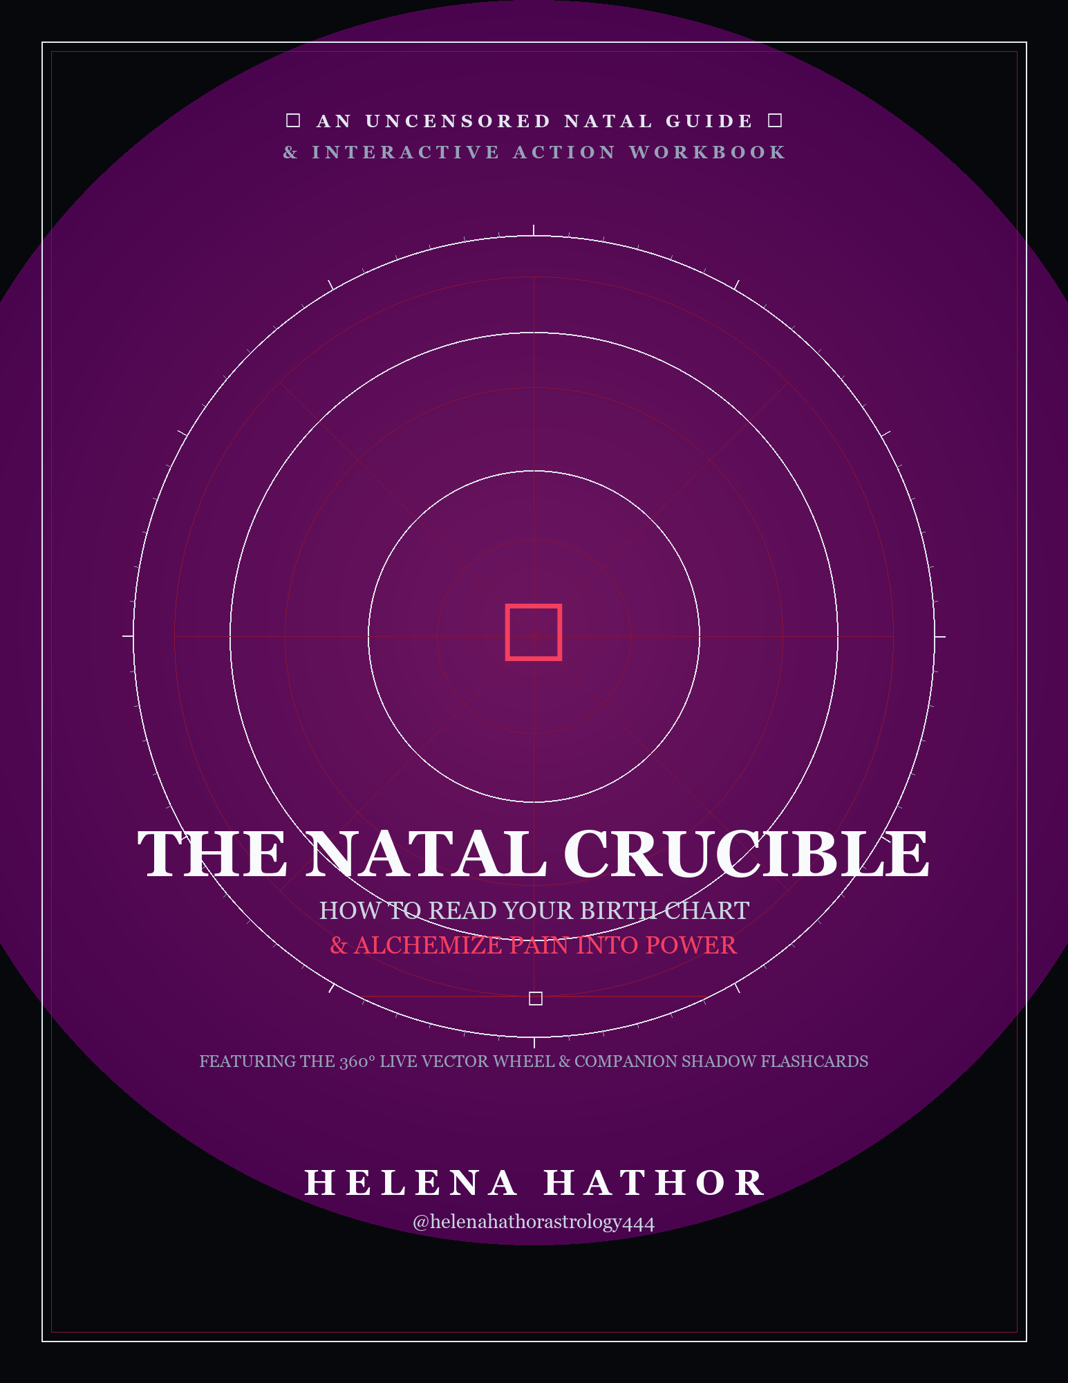

THE NATAL CRUCIBLE
How to Read Your Birth Chart & Alchemize Pain into Power
The Complete Guide, Visual Study Plates & Interactive Worksheets
✦ HELENA'S CLINICAL DIAGNOSTIC: WELCOME TO THE CRUCIBLE
Listen to me right now: this is not a dusty 1980s astrology textbook meant to collect dust on your coffee table. And this is definitely not a collection of generic, surface-level horoscopes telling you 'Geminis talk too much' or 'Scorpios are intense.' What we are doing here is putting your birth chart under the microscope.
Most people spend decades paralyzed in chronic guilt, relationship burnout, and financial anxiety simply because they are carrying 18-to-20-year structural karmic cycles that don't even belong to them. Suffering is not arbitrary misfortune—it is dense, valuable karmic lead waiting to be violently shed so that you can step into self-sovereignty, financial abundance, and raw personal power.
Open your chart, stop making excuses, and let's clean up your shit.
— Helena Hathor (@helenahathorastrology444)

TABLE OF CONTENTS
Click any chapter, study plate, or worksheet to jump directly to that section.
■ Introduction: How This Blueprint Works
■ Chapter 1: Understanding Your Birth Chart Basics
🖼️ Study Plate 1: The Cosmic Big Three & Natal Chart Architecture
📝 Worksheet 1.1: Your Birth Chart Data
📝 Worksheet 1.2: Planets, Signs & Houses
📝 Worksheet 1.3: Your Visual Birth Chart Map (The Centerpiece Wheel)
■ Chapter 2: Identifying Key Strengths & Challenges
📝 Worksheet 2.1: My Three Strengths
📝 Worksheet 2.2: My Three Challenges & Survival Adaptations
■ Chapter 3: Setting Astrological Intentions
📝 Worksheet 3.1: My Three Personal Intentions
■ Chapter 4: Daily Practices for Self-Awareness
🖼️ Study Plate 5: The Daily Grounding & Karmic Purge Lifeline
🖼️ Study Plate: 4-Step Somatic Emergency Triage Infographic
📝 Worksheet 4.1: My Daily Grounding Routine & Transit Crisis Baseline
📝 Worksheet 4.2: 7-Day Journal Tracker
■ Chapter 5: Navigating Relationships Through Astrology
📝 Worksheet 5.1: Chart Comparison (Synastry)
📝 Worksheet 5.2: Relationship Patterns, Triggers & Clean Boundaries
■ Chapter 6: Harnessing Career & Life Purpose Insights
🖼️ Study Plate 3: The Vocational Alchemical Refinery
📝 Worksheet 6.1: Career Indicators in My Chart
📝 Worksheet 6.2: Turning Wounds into Authority & Purpose Roadmap
■ Chapter 7: Creating a Personalized 14-Day Action Plan
🖼️ Study Plate 2: The Somatic Mirror & 6-Domain Life Audit
🖼️ Study Plate 4: The Daily Spiral Notepad Matrix & 14-Day Rebrand Season
📝 Worksheet 7.1: Synthesizing My Insights
📝 Worksheet 7.2: Setting Meaningful Standards
📝 Worksheet 7.3: 14-Day Action Plan (Weeks 1 & 2)
📝 Worksheet 7.4: Reflect, Adjust & Celebrate (Graduation Review)
■ Epilogue: At Peace with Understanding (The Great Exhale)

How This Interactive Blueprint Works
The Natal Crucible is engineered as a practical, hands-on self-discovery journey. Every single chapter is designed to guide you through a specific developmental threshold, giving you deep astrological theory paired with immediate, actionable exercises:
- 1. READ & ABSORB: Move through each chapter at your own pace. You will learn the exact astronomy and psychological archetypes behind your chart placements without overwhelming jargon.
- 2. STUDY PLATES: Look at the visual infographics embedded in each chapter. They map out the sacred geometry, the body-mind connection, and the vocational alembic in high-resolution detail.
- 3. COMPLETE YOUR INTERACTIVE WORKSHEETS: The 14 core typable worksheets are embedded directly in this book. Type your answers directly on the page or print them out.
- 4. CENTERPIECE WHEEL: In Chapter 1, you will build your very own visual 12-house birth chart map on Worksheet 1.3—dropping your Rising sign on the 9 o'clock line and populating your houses.
- 5. DAILY CARDS INTEGRATION: Use the companion spaced-repetition mobile flashcards (32 Morning and 32 Evening cards) to align your daily nervous system with your natal elements.

CHAPTER 1
UNDERSTANDING YOUR BIRTH CHART BASICS
“Your soul didn't pick this incarnation to play small. When you understand your chart, you stop asking the world for permission to exist.”
A birth chart—often called a natal chart—is a snapshot of the celestial sky at the exact minute and location of your first physical breath. Viewed from Earth, the planets, the Sun, and the Moon were positioned against the backdrop of the twelve zodiac constellations. In modern psychological astrology, this 360-degree wheel is not a deterministic fortune-telling tool that locks your fate in stone; rather, it is your personal energetic blueprint, outlining your core identity, emotional needs, relational dynamics, and evolutionary destiny.
The Core Requirement: Exact Birth Data
To calculate an accurate birth chart, you need three non-negotiable data points:
- 1. Your Birth Date: Day, month, and year.
- 2. Your Exact Birth Time: Down to the minute (from your birth certificate).
- 3. Your Birth Location: City, state or province, and country.
✦ HELENA'S CLINICAL DIAGNOSTIC: WHY EXACT BIRTH TIME IS NON-NEGOTIABLE
People tell me all the time: 'Helena, my mom thinks I was born around dinner time, can't we just wing it?' Absolutely not! Don't make me get violent. The Earth rotates on its axis at 1 degree every 4 minutes. In four minutes, your Ascendant shifts degree, and in two hours, an entirely new zodiac sign takes the wheel—completely rearranging your 12 houses, your second-house money ruler, and your eighth-house karmic debts.
If you want generic pop horoscopes, go look at a meme page. If you want to put your life under the microscope and uncover what the f*** you are actually supposed to be doing on Earth, get your birth certificate and find the exact minute.
— Helena Hathor

The Foundational Trinity: The Cosmic Big Three
While your chart contains ten planetary bodies across twelve houses, your core psychological identity is anchored by the Cosmic Big Three: your Sun Sign, your Moon Sign, and your Rising Sign (Ascendant).
The Sun represents your conscious ego, life purpose, vitality, and who you are actively evolving to become in this lifetime. It is the central hero's journey of your chart. When you operate in the high expression of your Sun sign, you feel energized, creative, generous, and purposeful.
The Moon represents your private emotional reality, subconscious instincts, and childhood conditioning. Your Moon sign reveals what you need to feel deeply safe, how you self-soothe when the world is overwhelming, and what you instinctively do under acute stress.
The Rising Sign (Ascendant) is the zodiac constellation that was rising on the eastern horizon at the exact minute of your birth. It defines your physical demeanor, first impressions, how you instinctively meet new environments, and the lens through which you view reality.
The 12 Zodiac Archetypes: Sun, Moon & Rising Expressions
Understanding how each sign expresses across the Big Three is the key to unlocking your unique complexity:
♈ Aries (The Pioneer / Fire / Cardinal / Ruled by Mars)
Sun: Courageous, independent leader who pioneers new trails.
Moon: Needs immediate emotional honesty and physical movement to process feelings.
Rising: Dynamic, direct, athletic presence with an unmistakable energetic spark.
♉ Taurus (The Builder / Earth / Fixed / Ruled by Venus)
Sun: Patient, grounded creator who builds lasting security and sensual beauty.
Moon: Needs physical comfort, routine, sensory luxury, and emotional stability to feel safe.
Rising: Calm, reassuring presence; embodies relaxed luxury and effortless magnetism.
♊ Gemini (The Polymath / Air / Mutable / Ruled by Mercury)
Sun: Curious seeker, brilliant communicator, and connector of people and ideas.
Moon: Needs mental stimulation, conversation, and journaling to process emotion.
Rising: Sparkling eyes, quick wit, youthful demeanor, highly adaptable.
♋ Cancer (The Sanctuary / Water / Cardinal / Ruled by the Moon)
Sun: Nurturing protector, intuitive guide, creator of emotional sanctuary.
Moon: Deeply intuitive, absorbs ambient emotional climates, fiercely loyal.
Rising: Soft, welcoming aura; people instantly feel safe opening up to them.
♌ Leo (The Sovereign / Fire / Fixed / Ruled by the Sun)
Sun: Generous luminary, heart-centered leader, radiant creative force.
Moon: Needs genuine appreciation, creative outlets, and loyalty to feel cherished.
Rising: Warm, magnetic presence; natural flair for style and dramatic authenticity.
♍ Virgo (The Sacred Healer / Earth / Mutable / Ruled by Mercury)
Sun: Devoted craftsman, systems optimizer, grounded problem-solver.
Moon: Needs cleanliness, functional routines, and acts of service to feel emotionally sound.
Rising: Polished, observant, composed demeanor; radiates understated competence.
♎ Libra (The Harmonizer / Air / Cardinal / Ruled by Venus)
Sun: Diplomatic champion of justice, aesthetic visionary, partnership builder.
Moon: Needs reciprocal harmony, calm environments, and mutual respect to feel safe.
Rising: Gracious, charming, beautifully balanced style; naturally disarms tension.
♏ Scorpio (The Alchemist / Water / Fixed / Ruled by Pluto & Mars)
Sun: Transformational truth-teller, unyielding researcher, phoenix rising from the ashes.
Moon: Needs raw emotional depth, psychological truth, and unwavering loyalty.
Rising: Piercing gaze, magnetic aura of mystery; reads the room with x-ray precision.
♐ Sagittarius (The Cosmic Seeker / Fire / Mutable / Ruled by Jupiter)
Sun: Philosophical explorer, freedom-lover, optimistic seeker of truth.
Moon: Needs autonomy, open horizons, humor, and intellectual expansion.
Rising: Joyful, expansive, enthusiastic energy; walks into a room like an adventure.
♑ Capricorn (The Master Architect / Earth / Cardinal / Ruled by Saturn)
Sun: Resilient leader, disciplined strategist, builder of generational legacy.
Moon: Needs order, self-sufficiency, and emotional containment; matures with age.
Rising: Authoritative, regal, highly capable presence; commands quiet respect.
♒ Aquarius (The Visionary Rebel / Air / Fixed / Ruled by Uranus & Saturn)
Sun: Innovative humanitarian, original thinker, breaker of obsolete paradigms.
Moon: Needs intellectual freedom, personal space, and community belonging.
Rising: Unique, avant-garde style; effortlessly magnetic because they refuse to conform.
♓ Pisces (The Mystic Channel / Water / Mutable / Ruled by Neptune & Jupiter)
Sun: Compassionate dreamer, artistic channel, intuitive healer.
Moon: Highly empathetic, absorbs psychic currents, needs artistic or spiritual retreat.
Rising: Ethereal, dreamy presence; gentle, soulful eyes that make others feel understood.

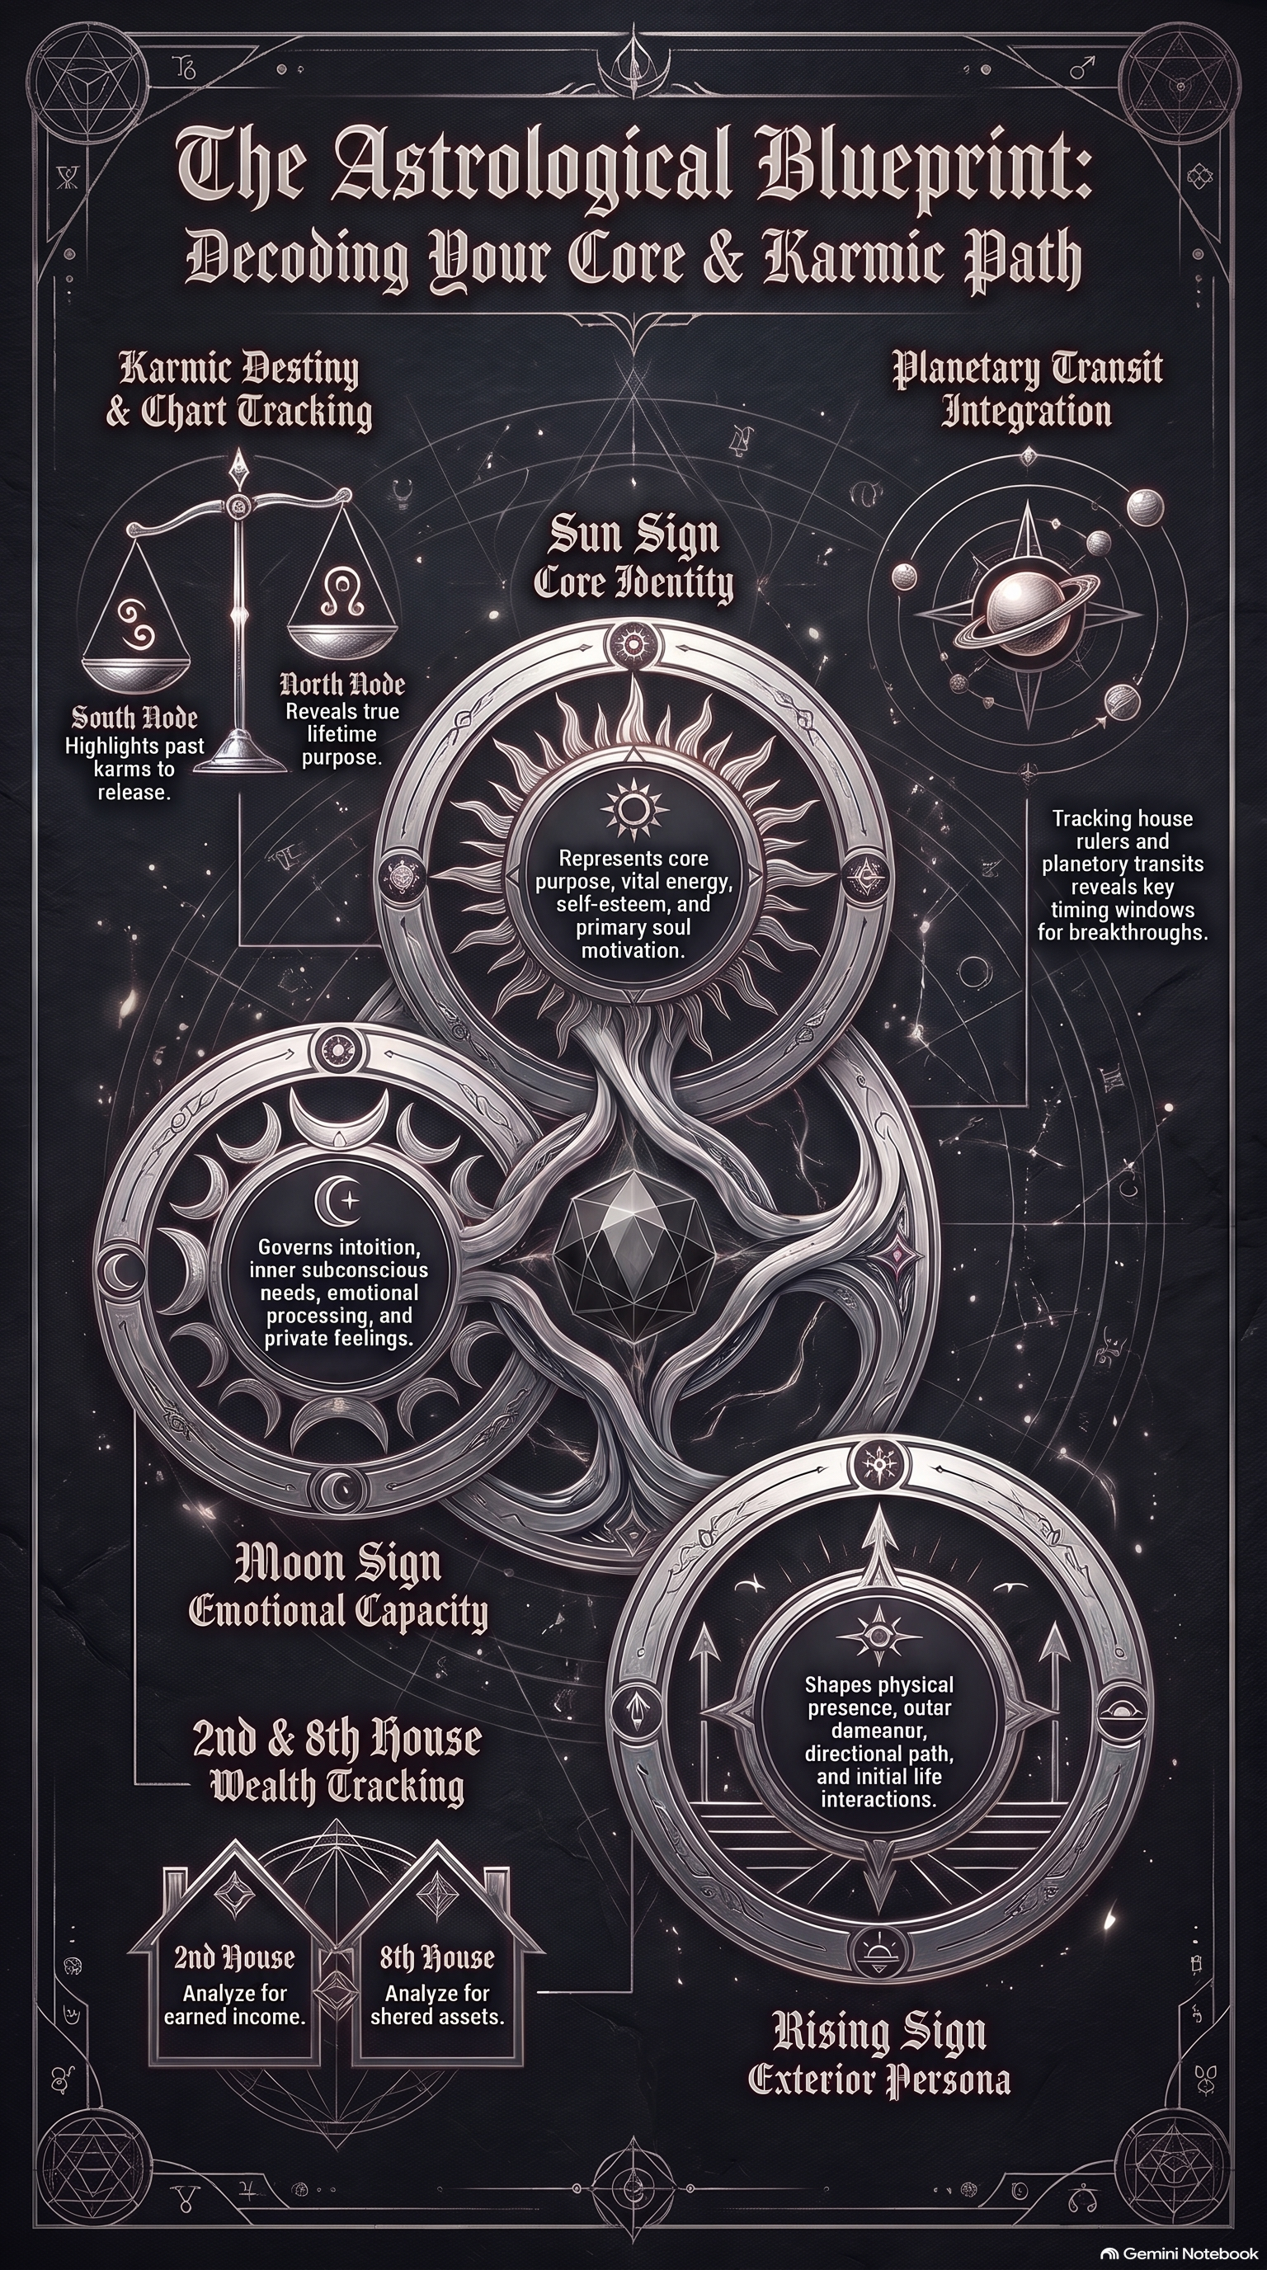
FIGURE · THE COSMIC BIG THREE & NATAL CHART ARCHITECTURE
Study Plate 1: The foundational trinity (Sun, Moon, Rising) anchored over the core celestial mechanics: the solar system, the 12-house wheel, and sacred aspect geometry.
The 12 Houses of Destiny: The Arenas of Lived Experience
- 1st House (Ascendant): Self, physical body, outward vitality, first impressions, personal identity.
- 2nd House: Personal income, material resources, financial management, self-worth, tangible talents.
- 3rd House: Everyday communication, local environment, siblings, short trips, mental processing speed.
- 4th House (Imum Coeli): Home, family roots, ancestral foundation, domestic sanctuary, private emotional core.
- 5th House: Creative self-expression, romance, joyful play, hobbies, children, authentic spotlight.
- 6th House: Daily routines, physical health, workplace skills, nervous system wellness, devoted service.
- 7th House (Descendant): Committed partnerships, marriage, contractual bonds, one-on-one relationships, soul mirrors.
- 8th House: Shared assets, intimacy, vulnerability, shadow psychology, debt/taxes, personal rebirth.
- 9th House: Higher learning, philosophy, worldview, long-distance travel, spiritual expansion, publishing.
- 10th House (Midheaven / MC): Public status, professional career, legacy, public reputation, societal calling.
- 11th House: Friendships, soul tribe, collective networks, community movements, long-term future goals.
- 12th House: The subconscious mind, solitude, dreams, karma, spiritual retreat, hidden strengths, surrender.
ACTION STEP CHECKLIST
☐ Obtain exact birth certificate time, date, and city.
☐ Generate natal chart wheel on Astro-Seek or Astro.com.
☐ Identify Sun, Moon, and Rising sign signs and degrees.
☐ Complete Worksheet 1.1 (Your Birth Chart Data).
☐ Complete Worksheet 1.2 (Planets, Signs & Houses).
☐ Complete Worksheet 1.3 (Your Visual Birth Chart Map wheel).

INTERACTIVE WORKSHEET 1.1
Your Birth Chart Data
✦ Gather the details your chart is built from.
Full Name & Birth Date
Prompt: Enter your full name and date of birth (Day, Month, Year).
[ Click or write your answer here ]

Exact Birth Time & Location
Prompt: Enter exact birth time (AM/PM) and birth city, state/province, country.
[ Click or write your answer here ]

My Big Three Signs
Prompt: ☉ Sun Sign: ______ | ☽ Moon Sign: ______ | ↑ Rising Sign: ______
[ Click or write your answer here ]

How My Big Three Interact
Prompt: How do your conscious drive (Sun), inner emotional needs (Moon), and outward persona (Rising) interact in your day-to-day life?
[ Click or write your answer here ]

INTERACTIVE WORKSHEET 1.2
Planets, Signs & Houses
✦ Catalog all 10 planetary directors living inside your psyche.
Personal Planets (Sun, Moon, Mercury, Venus, Mars)
Prompt: List the Sign, Degree, and House for each of your 5 personal planets.
[ Click or write your answer here ]

Social Planets (Jupiter, Saturn)
Prompt: List the Sign, Degree, and House for Jupiter (expansion) and Saturn (mastery).
[ Click or write your answer here ]

Transpersonal Planets (Uranus, Neptune, Pluto)
Prompt: List the Sign, Degree, and House for Uranus, Neptune, and Pluto.
[ Click or write your answer here ]

Planetary Concentration
Prompt: Which houses hold the most planets in your chart? What does that tell you about where your life energy concentrates?
[ Click or write your answer here ]

INTERACTIVE WORKSHEET 1.3
Your Visual Birth Chart Map
✦ The Centerpiece: Build your circular 12-house wheel.
The Ascendant (9 O'Clock Anchor)
Prompt: Write your Rising sign and exact degree on the Ascendant line on the far left.
[ Click or write your answer here ]

Populating the 12 House Cusps
Prompt: Moving counter-clockwise, write the zodiac signs on cusps 1 through 12.
[ Click or write your answer here ]

Placing the Planets into House Wedges
Prompt: Draw the planetary symbols (☉, ☽, ☿, ♀, ♂, ♃, ♄, ♅, ♆, ♇) inside their respective house wedges.
[ Click or write your answer here ]

Center Blueprint Snapshot
Prompt: Write your Big Three in the center of the wheel: Who are you becoming, what keeps you safe, and how do you meet the world?
[ Click or write your answer here ]

CHAPTER 2
IDENTIFYING KEY STRENGTHS & CHALLENGES
“Squares and oppositions are not character flaws; they are the intelligent survival armor that built your resilience.”
Your birth chart is not a flat drawing; it is a dynamic conversation between ten different planetary drives. Just like a company has a board of directors—a head of finance, a head of communications, an assertive CEO, and a long-range strategist—your psyche has an internal council. When these council members collaborate, you experience ease and flow. When they pull in opposite directions, you feel internal friction, self-doubt, or tension.
The 10 Planetary Energies: Your Internal Council
- Mercury (☿) — The Mental Operating System: Governs thought processes, perception, articulation, daily speech, and how your nervous system handles stimuli.
- Venus (♀) — The Magnetic Frequency & Value: Governs romantic attraction, what you find delicious, personal aesthetics, self-worth, and how you receive abundance.
- Mars (♂) — The Sacred Warrior & Physical Drive: Governs stamina, assertion, sexual energy, ambition, and the courage to uphold boundaries without guilt.
- Jupiter (♃) — The Cosmic Expander & Faith: Governs optimism, philosophical worldview, abundance mindset, luck, and where doors open effortlessly.
- Saturn (♄) — The Master Architect & Spine Builder: Governs discipline, time, boundaries, accountability, mature mastery, and long-term legacy.
- Uranus (♅) — The Electric Awakener: Governs sudden breakthroughs, unconventional originality, rebellion against obsolete dogma, and radical liberation.
- Neptune (♆) — The Mystical Channel & Dreamer: Governs intuition, psychic permeability, spiritual longing, artistic imagination, and dissolving ego barriers.
- Pluto (♇) — The Phoenix of Soul Rebirth: Governs psychological depth, shadow work, taboo truths, and the alchemical transformation of wounds into sovereignty.
Sacred Geometry: The Angles of Cosmic Conversation
- Conjunction (0°, Orb 0°–10°): Two planets in the same degree. Complete synthesis and fusion of drives into one powerhouse voice.
- Sextile (60°, Orb 6°–8°): Friendly angle between complementary elements (Fire/Air or Earth/Water). Gentle opportunity channels that require conscious activation.
- Square (90°, Orb 6°–8°): High-tension clash between signs of the same modality. Sharp internal friction, restlessness, and pressure that forces mature problem-solving.
- Trine (120°, Orb 6°–8°): Effortless golden flow between planets in the same element. Innate talents and luck, though it carries a risk of complacency without discipline.
- Opposition (180°, Orb 6°–8°): Direct confrontation across the zodiac wheel. Polar tug-of-war, often projected onto partners until integrated internally.
- Quincunx / Inconjunct (150°, Orb 2°–3°): Awkward, mismatched angle between incompatible elements. Requires continual micro-adjustments and adaptation.
✦ HELENA'S CLINICAL DIAGNOSTIC: STOP CRYING OVER YOUR SQUARES — ALCHEMIZE YOUR PAIN
I need you to hear this loud and clear: if you have a chart full of easy trines and sextiles, life might be comfortable, but you might also spend 30 years sitting on the couch doing nothing with your gifts. Easy aspects don't build empires or sovereign leaders. The masters, the disruptors, and the unapologetic powerhouses are built out of ferocious squares, brutal oppositions, and Mars-Pluto conjunctions.
Friction is the fuel of alchemy. Stop looking at your tough placements like a victim. Your suffering is valuable material meant to be transmuted. What do you need to release so you can be f***ing powerful, bitch?
— Helena Hathor

ACTION STEP CHECKLIST
☐ Catalog your harmonious aspects (trines and sextiles).
☐ Catalog your dynamic friction aspects (squares and oppositions).
☐ Complete Worksheet 2.1 (My Three Strengths).
☐ Complete Worksheet 2.2 (My Three Challenges & Survival Adaptations).

INTERACTIVE WORKSHEET 2.1
My Three Strengths
✦ Natural gifts and flowing energy channels.
Strength 1 (Trines & Sextiles)
Prompt: Identify your first natural strength. Which planetary aspect or element gives you effortless flow? How does it serve you?
[ Click or write your answer here ]

Strength 2 (Dominant Elements & Signs)
Prompt: Identify your second core strength. Where do you naturally excel without having to force outcomes?
[ Click or write your answer here ]

Strength 3 (Intuitive & Creative Gifts)
Prompt: Identify your third strength. How can you consciously cultivate and apply this gift rather than taking it for granted?
[ Click or write your answer here ]

INTERACTIVE WORKSHEET 2.2
My Three Challenges & Survival Adaptations
✦ Reframing friction as intelligent childhood armor.
Challenge 1 (Squares & Oppositions)
Prompt: Identify a high-friction aspect in your chart. What internal struggle or recurring trigger does this represent?
[ Click or write your answer here ]

The Childhood Survival Armor
Prompt: How did this tension serve you as a child? What was your young nervous system protecting you from?
[ Click or write your answer here ]

The Adult Conscious Upgrade
Prompt: How can you thank that old survival mechanism and consciously channel this friction into mature, grounded power today?
[ Click or write your answer here ]

CHAPTER 3
SETTING ASTROLOGICAL INTENTIONS
“You do not rise to the level of your goals; you fall to the level of your underlying self-concept.”
Most people set goals from a place of panic, deficiency, or societal pressure. They write frantic to-do lists in January, burn out by February, and wonder why their willpower failed. Astrological intention setting is entirely different. It aligns your desires with natural cosmic cycles—anchoring your actions to the four angular houses of your chart and the rhythmic phases of the Moon.
The Four Angular Houses: The Pillars of Manifestation
- 1st House (Ascendant): Your physical body, identity, and personal self-assertion.
- 4th House (Imum Coeli): Your home, inner sanctuary, ancestral roots, and emotional security.
- 7th House (Descendant): Committed partnerships, contracts, marriage, and reciprocal alliances.
- 10th House (Midheaven): Your career summit, public authority, reputation, and lasting legacy.
✦ HELENA'S CLINICAL DIAGNOSTIC: UNPLUG THE KARMIC LOOPS & CONFRONT YOUR NORTH NODE
Desperation and victimhood repel power! Clinging to obsolete relationships or repeating the same 9-month Mars retrograde holding patterns is a clear sign that you are stuck in your South Node baggage. Your South Node is where you've been comfy for multiple lifetimes—and it's rotting.
The North Node in astrology tells you what the f*** you're supposed to be doing on Earth right now. Unplug the karma, sever the cord to what is draining you, and execute your soul's purpose with surgical precision.
— Helena Hathor

ACTION STEP CHECKLIST
☐ Review your four angular houses (1st, 4th, 7th, 10th).
☐ Check the current moon phase in your calendar.
☐ Apply the 4 criteria (Specific, Positive, Present, Patient).
☐ Complete Worksheet 3.1 (My Three Personal Intentions).

INTERACTIVE WORKSHEET 3.1
My Three Personal Intentions
✦ Anchoring desires to angular pillars and lunar cycles.
Intention 1 (Self & Identity / 1st House)
Prompt: Write a specific, present-tense intention for your physical vitality and personal sovereignty.
[ Click or write your answer here ]

Intention 2 (Roots & Relationships / 4th & 7th Houses)
Prompt: Write a specific, present-tense intention for your emotional sanctuary and healthy boundaries.
[ Click or write your answer here ]

Intention 3 (Career & Calling / 10th House)
Prompt: Write a specific, present-tense intention for your vocational contribution and public legacy.
[ Click or write your answer here ]

Lunar Timing Anchor
Prompt: Which upcoming lunar phase (New Moon seed or Full Moon release) will you dedicate to these intentions?
[ Click or write your answer here ]

CHAPTER 4
DAILY PRACTICES FOR SELF-AWARENESS
“Astrology without somatic grounding is just intellectual self-torture. Your chart must be lived in your nervous system.”
You can know every degree of every planet in your chart, but if your physical nervous system is chronically stuck in fight-or-flight, that knowledge does you zero good. True transformation happens when cosmic awareness meets daily somatic devotion.

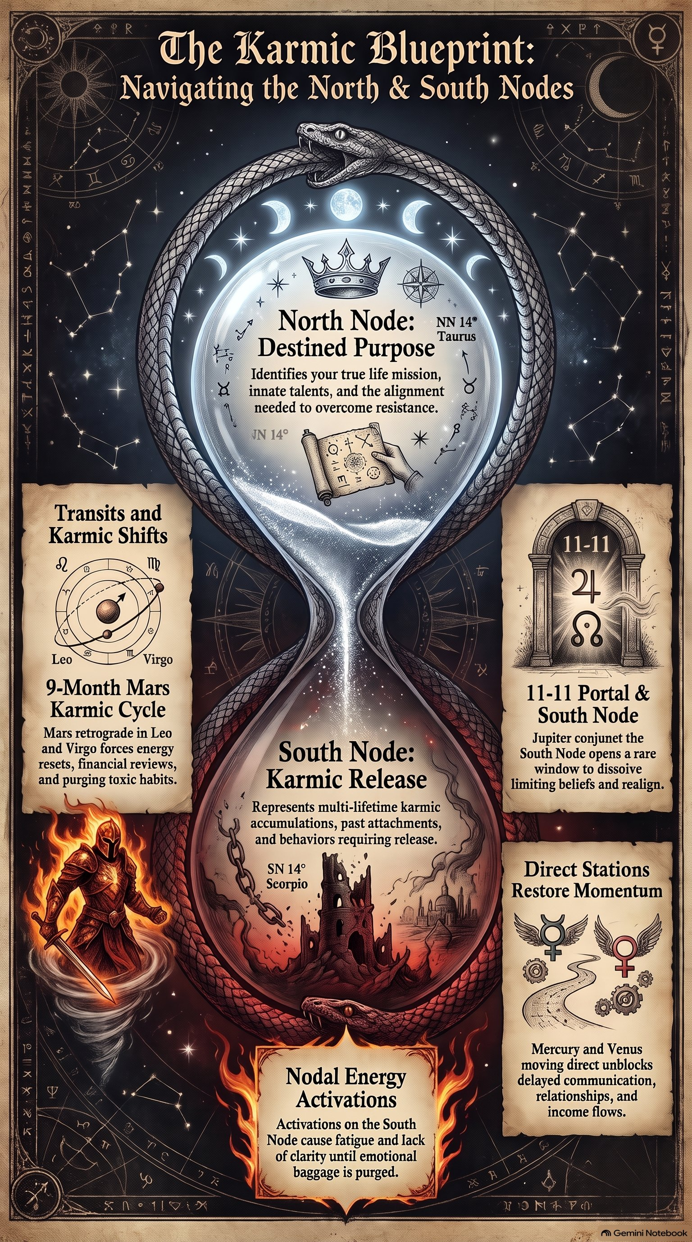
FIGURE · THE DAILY SOMATIC BASELINE & KARMIC PURGE LIFELINE
Study Plate 5: Somatic emergency triage—hands holding the golden mirror, cutting dopamine loops with golden shears, and the sealed permission scroll: Validate emotions while keeping commitment to business.
✦ HELENA'S CLINICAL DIAGNOSTIC: THE EMERGENCY KARMIC PURGE PROTOCOL (SOMATIC TRIAGE)
Life isn't always incense and calm meditations. When Mars retrogrades through Leo and squares your natal placements, or the South Node conjuncts your personal planets, your nervous system can feel like it's riddled with anxiety. Here is my rule for the bad days: You don't abandon yourself, and you don't blow up your life.
You engage the Karmic Purge Protocol. You strip down your demands to the absolute baseline, ground your physical body, drink water, take a salt bath, and refuse to make major structural decisions while dysregulated. Save the empire-building for when the celestial storm clears.
— Helena Hathor

ACTION STEP CHECKLIST
☐ Establish an elemental morning wake-up ritual.
☐ Establish an evening digital sunset and brain dump.
☐ Memorize your 4-step emergency Karmic Purge Protocol.
☐ Complete Worksheet 4.1 (My Daily Grounding Routine & Transit Crisis Baseline).
☐ Begin logging in Worksheet 4.2 (7-Day Journal Tracker).

INTERACTIVE WORKSHEET 4.1
My Daily Grounding Routine & Transit Crisis Baseline
✦ Nervous system protocols for high-vibe and worst-case days.
My Ideal Morning Somatic Sequence
Prompt: What 15-to-30 minute morning ritual grounds your body before you check your phone?
[ Click or write your answer here ]

My Evening Digital Sunset & Unwinding
Prompt: What ritual signals to your nervous system that work is complete and it is safe to sleep?
[ Click or write your answer here ]

My Emergency Transit Crisis Baseline Protocol
Prompt: When overwhelm strikes: What is your cry-it-out timer? What temperature reset will you use? What is your single bare-minimum non-negotiable task?
[ Click or write your answer here ]

INTERACTIVE WORKSHEET 4.2
7-Day Journal Tracker
✦ A simple, non-perfectionist 7-day reflection log.
Days 1 – 3 Daily Reflections
Prompt: Log your elemental check-in, dominant emotion, and power move executed for Days 1 through 3.
[ Click or write your answer here ]

Days 4 – 7 Daily Reflections
Prompt: Log your elemental check-in, dominant emotion, and power move executed for Days 4 through 7.
[ Click or write your answer here ]

7-Day Pattern Recognition
Prompt: Looking back over the week, what patterns did you notice? Where did you leak energy, and where did you feel most grounded?
[ Click or write your answer here ]

CHAPTER 5
NAVIGATING RELATIONSHIPS THROUGH ASTROLOGY
“Stop calling it 'peace' when you are swallowing your truth and abandoning yourself.”
Astrology shines its brightest light in interpersonal dynamics. Synastry—the art of comparing two birth charts—reveals where chemistry sparks, where childhood wounds are triggered, how communication flows, and what karmic contracts you share with partners, friends, and family.
The 7th House Descendant & The Chiron Wound
The sign on your 7th House cusp (the Descendant) sits directly opposite your Rising sign. Psychologically, whatever qualities we disown or repress in ourselves, we magnetically project onto others. Chiron, the 'Wounded Healer' asteroid, marks the spot in your chart where you carry an innate vulnerability. When handled with grace, Chiron becomes the very doorway through which unconditional love enters.
✦ HELENA'S CLINICAL DIAGNOSTIC: CLEAN UP YOUR SHIT, YOU MESSY BITCH (ENERGETIC BOUNDARIES)
Let's have an unfiltered diagnostic moment: how many times have you kept your mouth shut, smiled through disrespect, and called it 'being polite'—when in reality you were abandoning your own sovereignty? False peace is toxic rot. Speaking truth to power means lies and secrets will be exposed, starting with the lies you tell yourself to stay comfortable with people who drain you.
Clean up your shit, you messy bitch. Set ruthless boundaries around your time, your money, and your energetic field.
— Helena Hathor

ACTION STEP CHECKLIST
☐ Compare Mercury and Venus placements with your partner.
☐ Identify your 7th House Descendant sign and qualities.
☐ Locate Chiron in your natal chart and name your tender wound.
☐ Complete Worksheet 5.1 (Chart Comparison).
☐ Complete Worksheet 5.2 (Relationship Patterns, Triggers & Boundaries).

INTERACTIVE WORKSHEET 5.1
Chart Comparison (Synastry)
✦ Mapping interpersonal chemistry and communication styles.
My Placements vs. Partner / Loved One
Prompt: Compare your Big Three, Mercury, and Venus side-by-side with your chosen partner.
[ Click or write your answer here ]

Communication Synergy & Friction
Prompt: How do your Mercury styles interact? Where is communication effortless, and where do misunderstandings occur?
[ Click or write your answer here ]

Emotional Safety & Venus Needs
Prompt: What makes your partner feel loved (their Venus)? What makes you feel loved? How can you honor both?
[ Click or write your answer here ]

INTERACTIVE WORKSHEET 5.2
Relationship Patterns, Triggers & Clean Boundaries
✦ Identifying projection, Chiron wounds, and speaking clean boundaries.
My 7th House Descendant Projection
Prompt: What traits in your partner or friends trigger you the most? Could these be traits you repress in yourself?
[ Click or write your answer here ]

My Chiron Relational Wound
Prompt: Where does Chiron sit in your chart? How does fear of rejection or inadequacy emerge in intimate relationships?
[ Click or write your answer here ]

Writing the Clean 'No'
Prompt: Write down three clean, guilt-free boundary statements you will use when your personal space or standards are tested.
[ Click or write your answer here ]

CHAPTER 6
HARNESSING CAREER & LIFE PURPOSE INSIGHTS
“Your pain and past setbacks are not the end of the story; they are the raw material that goes into the refinery to forge your authority.”
You were not born to spend 40 years doing soul-crushing work just to pay bills and die. Your natal chart contains a specific 'Vocational Blueprint' that maps your natural income channels, your daily craftsmanship, your highest public reputation, and your soul's overarching evolutionary purpose.

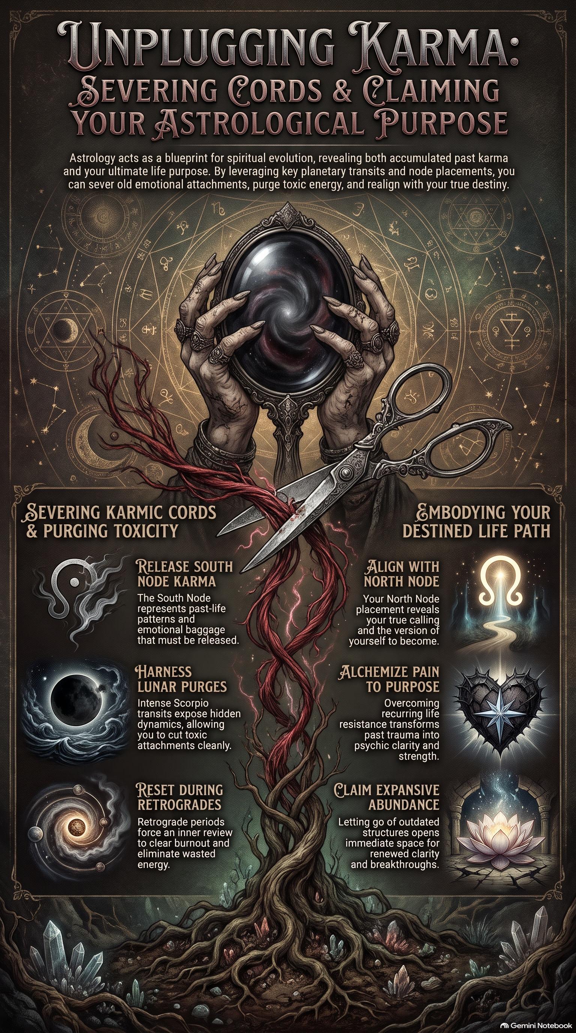
FIGURE · THE VOCATIONAL ALCHEMICAL REFINERY
Study Plate 3: Career, Midheaven & North Node—large alembic distillation flask turning past trials into the Crowned Star of recognized authority.
✦ HELENA'S CLINICAL DIAGNOSTIC: TURNING YOUR WOUNDS INTO UNDENIABLE SOVEREIGNTY
Every single betrayal, financial crash, failed venture, or karmic heartbreak you ever endured was not meaningless trauma. In true alchemy, heavy lead must enter the crucible before it turns into gold. Your 10th-house Midheaven calling and your 2nd/8th-house financial axis are forged directly in the fire of what you survived.
People don't follow gurus who lived in a glass castle; they follow leaders who went to the underworld, burned the dead weight, and walked back out crowned in sovereignty. Turn your pain into purpose.
— Helena Hathor

ACTION STEP CHECKLIST
☐ Locate your Midheaven (MC) sign and degree.
☐ Check planets in your 2nd, 6th, and 10th houses.
☐ Identify your North Node sign and house placement.
☐ Complete Worksheet 6.1 (Career Indicators in My Chart).
☐ Complete Worksheet 6.2 (Turning Wounds into Authority & Purpose Roadmap).

INTERACTIVE WORKSHEET 6.1
Career Indicators in My Chart
✦ The 4 pillars of vocational calling.
The Midheaven (MC) & 10th House
Prompt: What sign sits on your Midheaven? What planets occupy your 10th house? What public legacy is indicated?
[ Click or write your answer here ]

The 2nd House & 6th House Engines
Prompt: What generates earned income for you (2nd house)? What daily workflow environment keeps you thriving (6th house)?
[ Click or write your answer here ]

The North Node Growth Edge
Prompt: What is your North Node sign and house? What uncomfortable growth edge must you lean into to fulfill your soul purpose?
[ Click or write your answer here ]

INTERACTIVE WORKSHEET 6.2
Turning Wounds into Authority & Purpose Roadmap
✦ Transmuting past setbacks into professional leadership.
The Lead: Past Pain & Rejections
Prompt: What are 2 or 3 of your most painful career or personal setbacks? What did they feel like at the time?
[ Click or write your answer here ]

The Refinery: The Hard-Earned Wisdom
Prompt: What undeniable skills, resilience, and empathy did you develop by surviving those experiences?
[ Click or write your answer here ]

The Gold: My Sovereign Offering
Prompt: How can you package that hard-earned authority into your current work, business, or leadership to serve others?
[ Click or write your answer here ]

CHAPTER 7
CREATING A PERSONALIZED 14-DAY ACTION PLAN
“Transformation happens when you stop obsessively seeking and become at peace with understanding.”
Congratulations. You have navigated your Cosmic Big Three, mapped your 12-house wheel, reclaimed your internal council of planets, reframed your survival adaptations, and aligned your career and relationship standards. Now comes the final, sacred initiation: synthesizing everything you have learned into a focused 14-Day Action Plan that anchors your cosmic blueprint into daily physical reality.

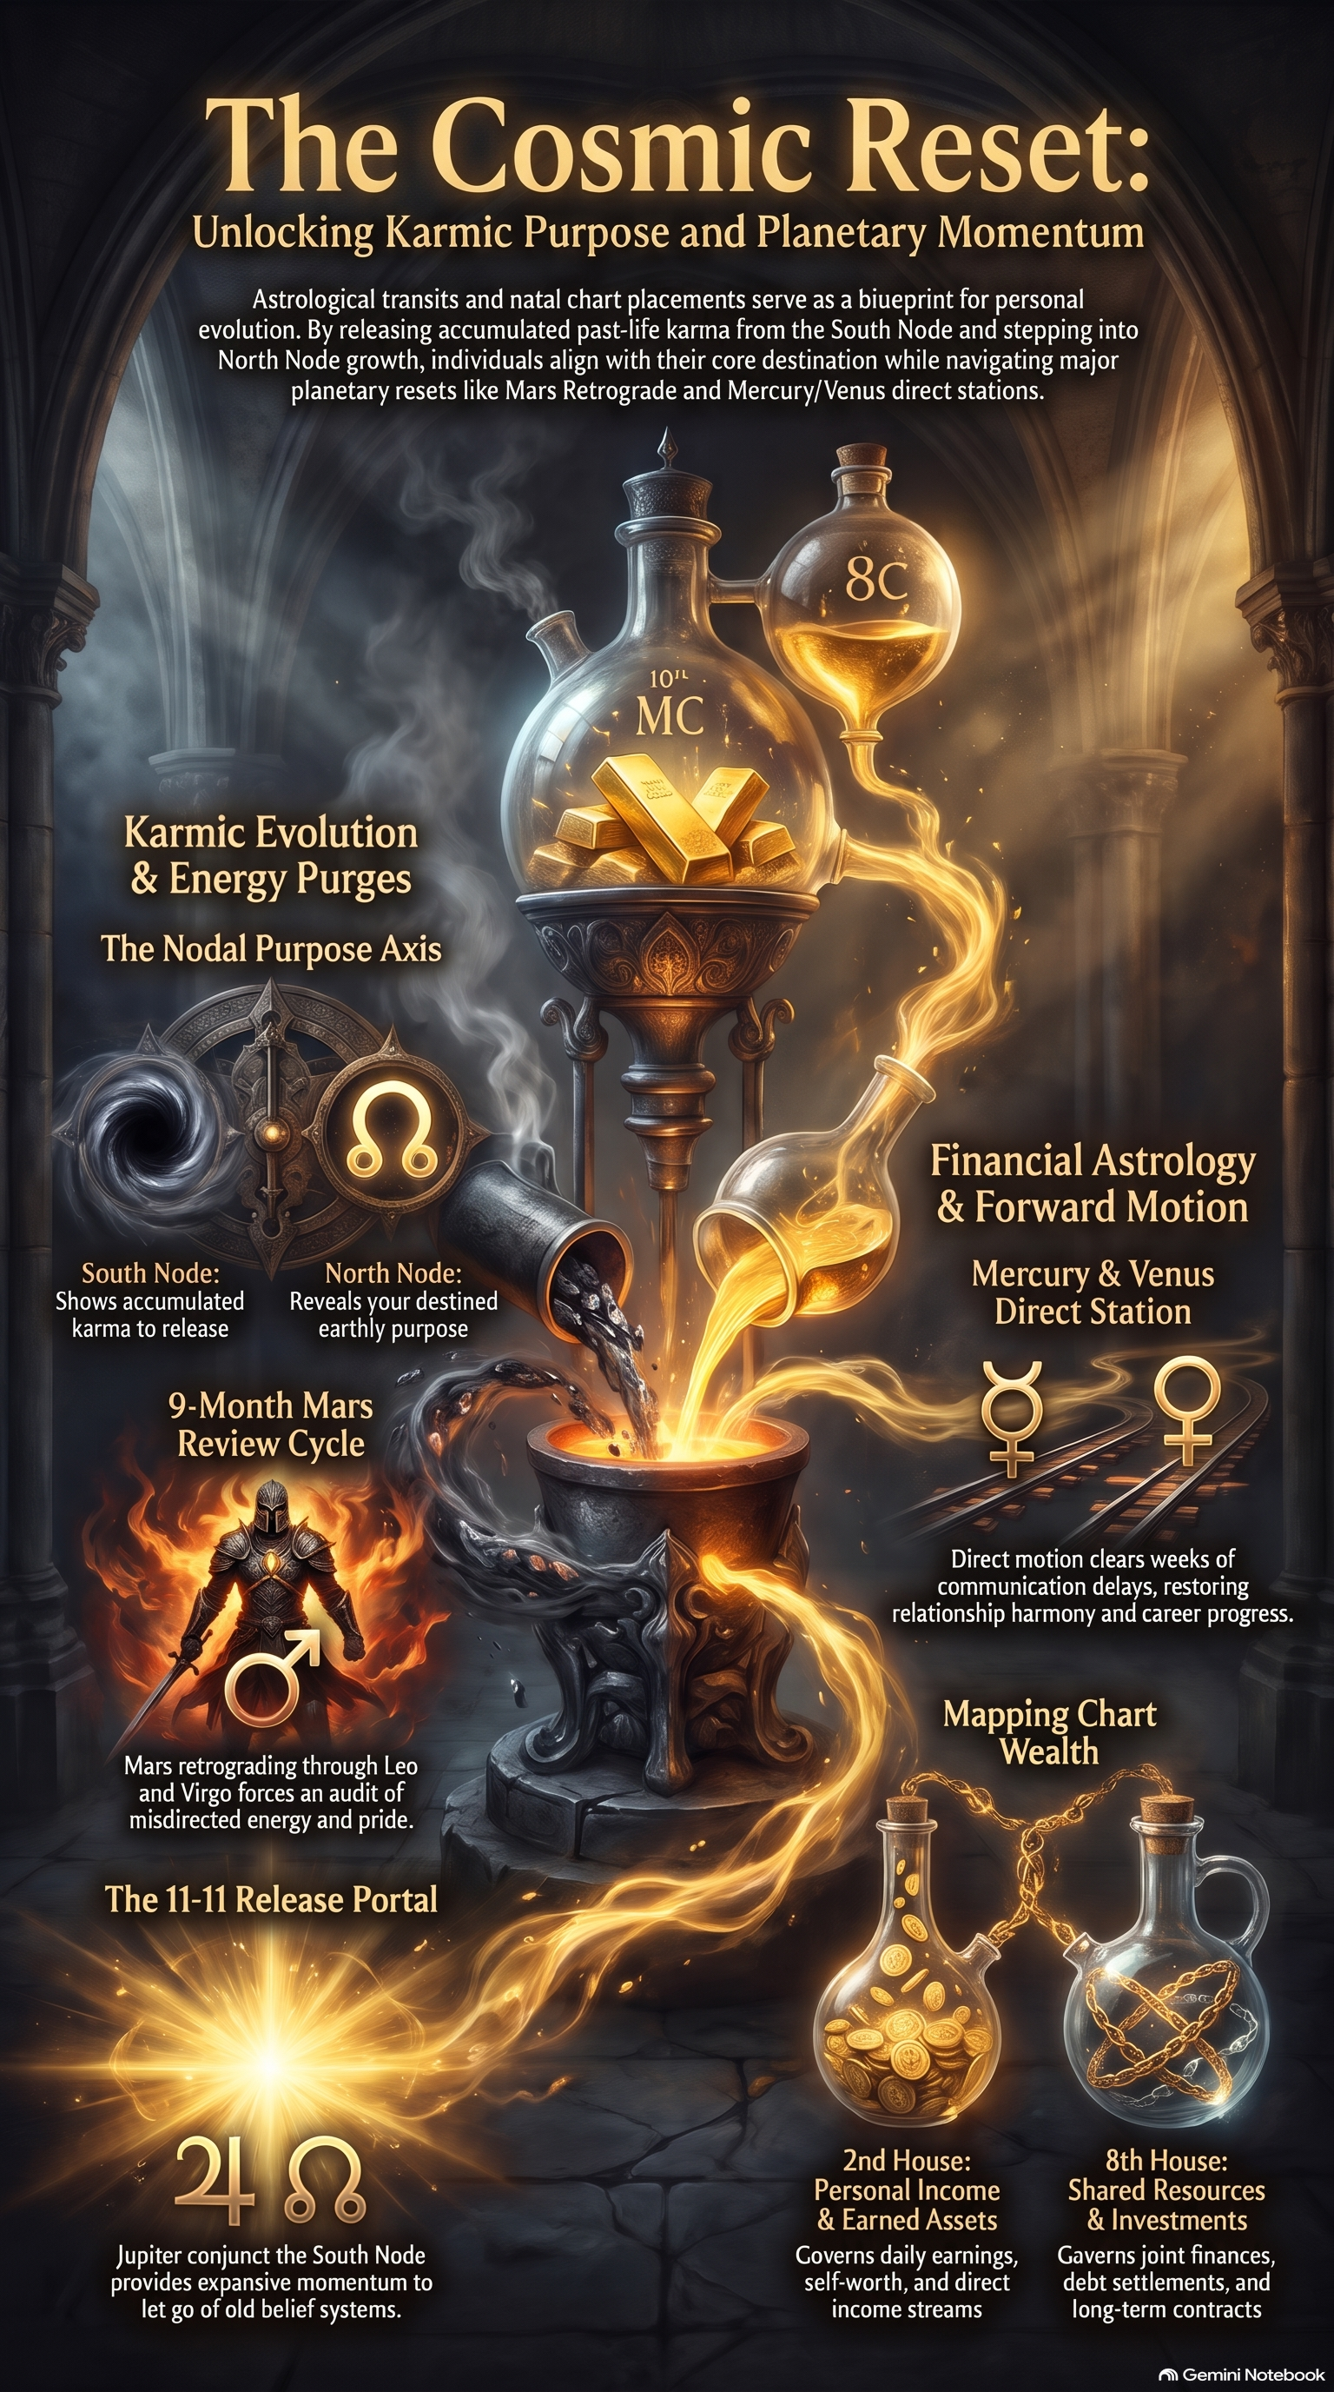
FIGURE · THE SOMATIC MIRROR & 6-DOMAIN LIFE AUDIT
Study Plate 2: Snapping the corporate ruler of outside expectation ➔ central golden vortex ➔ embodied truth across body, mind, relationships, wealth, career, and spirit.

FIGURE · THE DAILY SPIRAL NOTEPAD MATRIX & 14-DAY REBRAND SEASON
Study Plate 4: The 14-Day ascending spiral staircase, brain in glass alembic, and the sunset spiral notepad daily purge.
✦ HELENA'S CLINICAL DIAGNOSTIC: THE GREAT EXHALE & THE BALI SANCTUARY
Look at how far you've come. You were never broken; you were just navigating this chaotic world without your diagnostic blueprint. Now you have your chart in your hands. You know your Big Three, your karmic nodes, and your house rulers. But reading the blueprint is only phase one.
If you are ready to take this deep into somatic reality, put your chart under the microscope in private 1-on-1 sessions, and unplug multi-lifetime baggage in an opulent private sanctuary (flower baths, sound healing, zero shared rooms), come join me in Bali in April 2027. We are going to spoil you, recalibrate your nervous system, and launch you into your next 20-year cycle of unapologetic power.
— Helena Hathor (@helenahathorastrology444)

ACTION STEP CHECKLIST
☐ Complete the 6-Domain Life Audit.
☐ Lock in your 3 non-negotiable standards.
☐ Complete Worksheet 7.1 (Synthesizing My Insights).
☐ Complete Worksheet 7.2 (Setting Meaningful Standards).
☐ Execute Worksheet 7.3 (14-Day Action Plan).
☐ Graduation Review on Worksheet 7.4 (Reflect, Adjust & Celebrate)!

INTERACTIVE WORKSHEET 7.1
Synthesizing My Insights
✦ The master single-page natal dashboard.
My Core Identity Snapshot
Prompt: Sun Sign & Purpose: ______ | Moon Sign & Safe Haven: ______ | Rising Sign & Aura: ______
[ Click or write your answer here ]

My Superpowers & Transmuted Challenges
Prompt: Top 2 natural strengths: ______ | Top childhood adaptation turned into authority: ______
[ Click or write your answer here ]

My Vocational & Relational North Star
Prompt: Midheaven legacy summit: ______ | North Node evolutionary direction: ______ | Primary relationship standard: ______
[ Click or write your answer here ]

INTERACTIVE WORKSHEET 7.2
Setting Meaningful Standards
✦ Locking in 3 non-negotiable boundaries for the 14-day sprint.
Standard 1 (Physical Vessel / Somatic)
Prompt: My non-negotiable daily body/nervous system practice: ___________________________
[ Click or write your answer here ]

Standard 2 (Mental & Relational Peace)
Prompt: My clean boundary around time, people-pleasing, or mental chatter: ___________________________
[ Click or write your answer here ]

Standard 3 (Vocational Power Move)
Prompt: My needle-moving bold action toward career or creative legacy: ___________________________
[ Click or write your answer here ]

INTERACTIVE WORKSHEET 7.3
14-Day Action Plan (Weeks 1 & 2)
✦ Executing the daily elemental cadence.
Week 1 Focus & Daily Check-Ins
Prompt: Track your morning power move, midday somatic reset, and evening brain dump for Days 1 through 7.
[ Click or write your answer here ]

Week 2 Momentum & Breakthroughs
Prompt: Track your morning power move, midday somatic reset, and evening brain dump for Days 8 through 14.
[ Click or write your answer here ]

Mid-Sprint Recalibration
Prompt: On Day 7, where do you need to pivot? Where are you slipping into old survival habits?
[ Click or write your answer here ]

INTERACTIVE WORKSHEET 7.4
Reflect, Adjust & Celebrate
✦ Graduation review and claiming your rebirth.
The Transformation Audit
Prompt: How do you feel today compared to Day 1? What shifted in your nervous system and self-worth?
[ Click or write your answer here ]

Old Patterns Banished
Prompt: What obsolete beliefs, habits, or people-pleasing behaviors did you permanently leave behind?
[ Click or write your answer here ]

My Declaration of Sovereign Belonging
Prompt: Write a personal declaration to the cosmos claiming your identity, power, and future.
[ Click or write your answer here ]

EPILOGUE
At Peace with Understanding
There is a quiet, sacred moment that happens when you finish mapping your chart. You look down at the circle, the houses, the planetary glyphs, and the geometry, and for the first time in your life, you realize that nothing about you was an accident. Your deep sensitivity wasn't a flaw; it was your Moon preparing you for profound empathy. Your intense ambition wasn't unladylike; it was your Mars and Midheaven preparing you to lead. Your painful childhood lessons weren't punishment; they were Saturn forging your unshakeable integrity.
You don't need to spend the rest of your life desperately seeking answers, chasing every trend, or begging the world for validation. When you understand your cosmic architecture, you enter the era of the Great Exhale—at peace with understanding, standing tall in your power, and walking forward as the undeniable woman your soul came here to be.
With unyielding fire, truth, and alchemical sovereignty,
Helena Hathor ✦
@helenahathorastrology444

