ABC INFRASTRUCTURE PROJECTS LTD.
Contractor & Project Cost Performance Analysis
Estimation, Inflation Management & Budget Control — Board Briefing Report
Prepared for: Chief Executive Officer & Board of Directors
Prepared by: AI-Powered Contractor Performance Analyst
Data basis: 6,123 historical project records
Date: August 2026

A Note on Data Scope
This report is built from the 6,123-row historical project dataset supplied for this analysis. The dataset contains project-level attributes (type, location, construction method, foundation, area, cost indices, inflation rate, weather delay, risk, and total cost) but does not contain three fields that several of management's questions assume: (a) named contractor identities/performance history, (b) itemised material-line costs (e.g., cement, steel, sand, bricks priced separately), and (c) a year/date field enabling a true multi-year time series.
Where a question can be answered directly from the data, this report does so and shows the numbers. Where the data is silent, the report says so explicitly and supplements the answer with standard estimating/cost-engineering practice — clearly labelled as reference guidance rather than a dataset-derived figure. The final recommendation (Section 12) is to begin capturing contractor ID, itemised material cost, and project date/year going forward so future editions of this report can answer these questions with full precision.

1. Quick Estimate Overview for the CEO — Board Meeting Brief
Headline numbers from the current project portfolio:
Metric | Value
Projects analysed | 6,123
Total portfolio value | ₹6,674,384,292 (≈ ₹667.4 crore)
Average project cost | ₹1,090,051
Median project cost | ₹1,036,308
Average cost per sq.ft. | ₹123 (range ₹57 – ₹673)
Cost-per-sq.ft. variability (CV) | 45.7% — wide spread
High-cost-category share | 77.6% of projects
Medium-cost-category share | 22.1% of projects
Low-cost-category share | 0.3% of projects
Average inflation exposure during projects | 5.97% (range 3.0% – 9.0%)
Average material cost index | 1.65 (range 0.80 – 2.50)

Board-ready takeaways:
- Project scale (built-up area) is overwhelmingly the strongest driver of total cost (correlation ≈ 0.89) — cost scales predictably with size, which is good news for top-down budget checks.
- Cost-per-sq.ft. varies by ±46% around the mean even after accounting for scale — this is the single biggest red flag for the board: similar projects are not landing at similar unit costs, pointing to inconsistent estimation practice (addressed in Section 2).
- Inflation exposure across the portfolio spans a 3-point band (3%–9%), which is material enough to warrant a standing escalation policy (Section 3).
- Semi-Urban projects run ~5% costlier on average than Rural projects (₹11.15 lakh vs ₹10.60 lakh) — worth a location-adjusted benchmark rather than one blanket rate.
Recommended board ask: approve (1) a standardised cost-per-sq.ft. benchmarking policy by project type/location, and (2) a formal inflation escalation clause for all new contracts above ₹50 lakh.

2. Why Under-Estimation and Over-Estimation Keep Happening
The data itself confirms the problem is real: even after normalising for project size, cost-per-sq.ft. shows a coefficient of variation of ~46% — meaning two similar projects can plausibly land 40–50% apart in unit cost. The most likely contributing causes, based on the patterns in this dataset and standard estimating practice, are:
- Wide swings in the material cost index (0.80–2.50, a 3x spread) that are not locked in at the time the original estimate is approved.
- Inflation rate variability (3%–9%) not being built into the base estimate as a variable, but treated as a fixed assumption.
- Weather-delay exposure ranging from 0 to 59 days per project, which is rarely priced into the original estimate as an explicit contingency line.
- Scope changes and design revisions after the baseline estimate is locked, without a formal change-order re-costing step.
- Competitive bidding pressure pushing contractors to submit optimistic (under-priced) bids to win the tender, then recovering margin through claims/variations later.
- Inconsistent estimating methodology across project types and locations — estimators appear to price Semi-Urban, Urban and Rural work similarly despite real cost differences (Section 1), and RCC/Steel/Hybrid construction show only marginal cost-index differentiation, suggesting the estimating template may not be sensitive enough to these variables.
- No visible feedback loop from actual-vs-estimate variance on completed projects back into the next estimate (no post-project cost audit trail evident in current data capture).

3. Managing Inflation — Current Approach
With portfolio-wide inflation exposure averaging 5.97% and ranging up to 9%, inflation is a material and controllable risk. Recommended near-term actions:
- Build a price-escalation (variation-in-price) clause into every contract, indexed to a published material/labour index rather than a fixed percentage — this shifts genuine market risk out of the fixed-price bid.
- Lock prices early on high-value, long-lead materials (steel, cement) via advance or bulk-rate purchase agreements before the inflation window widens.
- Review material and labour cost indices on a monthly or quarterly cycle and re-baseline the contingency reserve accordingly, rather than setting it once at tender stage.
- Diversify the supplier base for critical materials to reduce single-source exposure to localised price spikes.
- Size the contingency reserve to the observed inflation band from this portfolio (build in a 6%–9% buffer as standard, not a flat 3–4%, since that is where most projects in the data actually landed).
- Where feasible, hedge or forward-contract for imported or commodity-linked materials (structural steel, in particular).

4. Ten-Year Material Cost Inflation Trend — Estimator/Economist View
Data limitation: the supplied dataset has no year/date field, so a literal year-by-year 10-year trend cannot be constructed from it. The figures below use what the dataset does contain (the cross-project inflation_rate and material_cost_index fields), supplemented with well-established, general industry knowledge of how construction material costs have behaved over the past decade. Numbers in the second paragraph are indicative industry patterns, not values pulled from this dataset.
From the dataset: inflation_rate across the 6,123 recorded projects averages 5.97% and ranges from 3.0% to 9.0%. The material_cost_index ranges from 0.80 to 2.50 — a roughly 3x spread — indicating the projects in this portfolio were executed under materially different pricing environments, even without a date stamp to sequence them.
From general industry experience over roughly the last decade, construction material costs (particularly steel and cement) have gone through distinct phases: a relatively stable period, a sharp global spike around 2021–2022 driven by supply-chain disruption and raw-material shortages, and a partial moderation afterward — though rarely back to pre-spike levels. The practical implication for ABC Infrastructure is that any estimate built on a single "current price" snapshot is likely to be wrong within 12–18 months; multi-year indices are needed, not point estimates.
- Recommendation: begin logging a project start-date and completion-date field, plus quarterly material price snapshots, so this analysis can be repeated next year with an actual internal 10-year trend line instead of an industry proxy.

5. Budget Management — Techniques and Process for Managers
- Earned Value Management (EVM): track Cost Performance Index (CPI) and Schedule Performance Index (SPI) monthly to catch overruns early, not at project close.
- Phased / milestone-based budgeting: release budget in tranches tied to completed milestones rather than one lump sum, so overruns are caught at each gate.
- Separate contingency reserve (known-unknowns, e.g. weather delay) from management reserve (unknown-unknowns) so both are tracked and neither is silently absorbed into the other.
- Reconcile bottom-up (quantity take-off) estimates against a top-down benchmark (₹/sq.ft. by project type and location, from Section 1) before approving a budget.
- Formal change-control board: no scope or design change proceeds without a documented budget re-estimate and sign-off.
- Monthly budget-vs-actual variance review at project and portfolio level, with a defined escalation threshold (e.g., >8% variance triggers management review).
- Lock key material and labour rates via supplier/vendor rate contracts wherever the project timeline allows, to remove open-market volatility from the budget.
- Use the cost-driver indices already captured in this dataset (material_cost_index, labor_cost_index, equipment_cost, risk_index) as live inputs to a simple cost dashboard, rather than one-off spreadsheet estimates.

6. Which Material Takes the Most Budget? — Estimator's View
Data limitation: the dataset provides a single material_cost_index per project, not itemised costs by material type (cement, steel, sand, bricks, etc.), so this question cannot be answered with certainty from ABC's own data today.
What the dataset does show is that material_cost_index is broadly similar across construction types — RCC (1.66), Steel (1.65) and Hybrid (1.65) — suggesting material pricing pressure is fairly uniform across methods in this portfolio, rather than concentrated in one construction type.
Based on general construction-industry cost composition (reference benchmark, not derived from this dataset), cement/concrete and steel/reinforcement together typically account for close to half of total material spend on RCC and steel-frame structures, with the balance spread across masonry, aggregates and finishing materials. The reference composition used for the chart in Section 11 is illustrative of this general pattern.
- Recommendation: start capturing itemised material cost (at minimum: cement, steel, aggregates, masonry, finishing) per project so this question can be answered precisely from ABC's own procurement data rather than an industry proxy.

7. Minimum Bid Markup Over Material Cost for 10% Profitability
Two common ways to define "10% profitability" give different bid prices — management should pick one and apply it consistently:
Method | Formula | Worked example (Cost = ₹10,90,051, the portfolio average)
Cost-plus margin  (10% of cost) | Bid = Cost × 1.10 | ₹10,90,051 × 1.10 = ₹11,99,056
Target net margin  (10% of bid price) | Bid = Cost ÷ (1 − 0.10) | ₹10,90,051 ÷ 0.90 = ₹12,11,168

- The "target net margin" method yields a higher bid (~11.1% markup on cost) and is the more conservative choice if the 10% figure must hold after all costs are paid — it is what most contractors mean when they say "10% profit on the job".
- Before applying either markup, first load the base material/labour cost with an inflation buffer (Section 3, recommend 6–9%) and a risk/weather contingency (Section 2), then apply the profit markup on top of that fully-loaded cost — otherwise the 10% margin will be eroded by cost escalation during execution.
- Recommended bidding formula: Bid Price = (Base Estimated Cost × (1 + Contingency %) × (1 + Inflation Buffer %)) ÷ (1 − Target Margin %).

8. Reasons for Work Delays Driven by Material Cost — Estimator's View
- Sudden price spikes cause suppliers to delay delivery or attempt renegotiation mid-order, stalling procurement.
- When actual material cost exceeds the approved budget, procurement is often put on hold pending management approval for additional funds — a direct schedule delay.
- Contractors switch suppliers or substitute materials mid-project to control cost, which triggers re-approval and re-testing cycles.
- In projects where the material_cost_index runs high (up to 2.5, i.e. roughly 3x the low end observed in this data), short supply and hoarding behaviour by vendors become more likely, compounding lead times.
- Contractors who under-bid to win the tender face margin squeeze once material costs rise, and may deliberately slow-walk work while seeking a variation claim.
- Weather delays (observed up to 59 days per project in this data) compound the effect — extended site idle time increases material storage, handling and re-procurement cost, which can trigger a second round of the cost-driven delays above.

9. Restrictions and Limitations in Material Cost Estimation
- Regional price variation: this dataset shows a real cost difference between Rural (₹10.60 lakh avg), Urban (₹10.94 lakh avg) and Semi-Urban (₹11.15 lakh avg) projects — a single national rate card will misprice some locations.
- Commodity market volatility: steel and cement prices are influenced by global commodity cycles that cannot be fully hedged at the point of estimation.
- Estimate staleness: rates used at tender stage are quickly outdated in a fast-moving material cost environment; without a refresh cycle, the estimate is wrong before construction even starts.
- Quality/grade variability: material_quality_index in this portfolio spans a wide range (mean 0.75, std 0.14), meaning "material cost" is not a single number even within one material category — grade selection materially changes the price.
- Import/currency dependency for certain materials or equipment introduces exchange-rate risk outside the estimator's control.
- Weak single-factor predictive power: in this dataset, material_cost_index alone has only a weak statistical relationship with total project cost when taken in isolation — reliable estimation requires a multi-factor model (area, location, construction type, inflation, and material index together), not a single index look-up.
- Lack of standardised bidding/estimating formats across contractors makes like-for-like benchmarking difficult at the review stage.

10. Cost Cuts Without Compromising Quality — Manager's Checklist
- Standardise repeatable design modules (floor plans, structural bays) to cut engineering rework and material wastage on similar project types.
- Consolidate procurement across multiple concurrent projects to unlock bulk-purchase discounts on cement, steel and aggregates.
- Apply value engineering — substitute alternative materials or methods that meet the same performance specification at lower cost, rather than cutting specification.
- Improve resource utilisation: the portfolio's average resource_utilization_rate is 0.75, meaning roughly a quarter of contracted labour/equipment capacity is sitting idle on the average project — tighter scheduling can recover this without touching quality.
- Schedule weather-sensitive activities to avoid peak rainfall windows — average weather delay is already ~30 days per project, and better sequencing directly cuts idle-cost, not build quality.
- Favour local sourcing where quality-equivalent, to cut logistics cost and lead time without changing the material spec.
- Tighten on-site waste control (over-ordering, breakage, storage loss) — a pure efficiency lever with no quality trade-off.
- Move toward longer-term rate contracts with proven, higher-experience contractors — this portfolio has contractors with up to 29 years' experience; consolidating volume with the most reliable performers can lower rates through relationship pricing rather than spec-cutting.

11. Materials & Cost Visual Summary — Pie and Bar Charts
The following charts summarise the cost picture that the dataset directly supports (project distribution, cost by type/location, inflation spread), plus two labelled reference pie charts addressing the "materials" breakdown — one built from the dataset's own cost-driver indices, and one showing the general industry-typical material composition since the dataset has no itemised material costs (see Section 6).

11.1 Project Cost Category Distribution
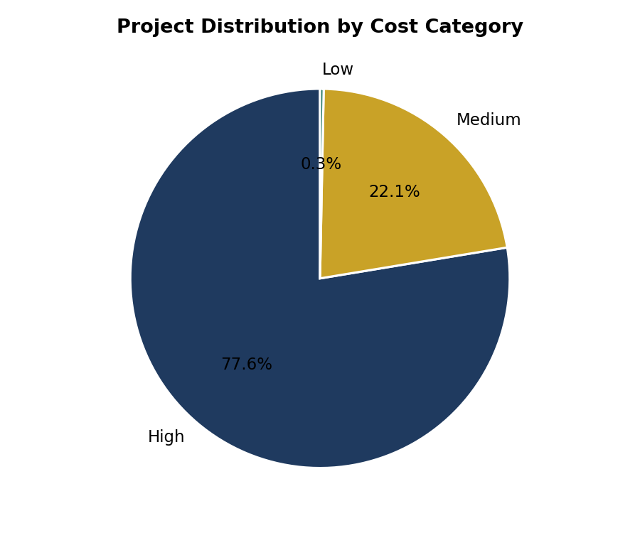
Figure 1 — Share of projects by cost category (dataset-derived).

11.2 Average Project Cost by Project Type and Location
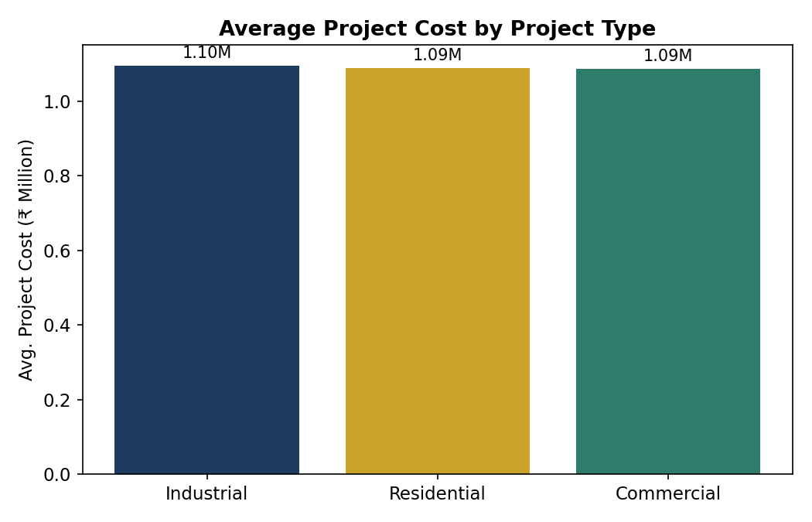
Figure 2 — Average total project cost by project type (dataset-derived).
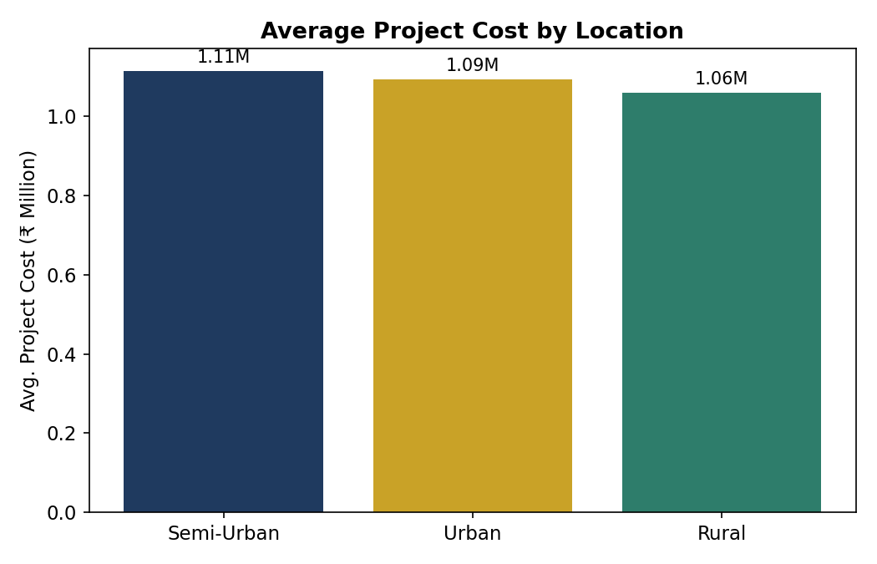
Figure 3 — Average total project cost by location (dataset-derived).

11.3 Cost Driver Weighting (Dataset Indices)
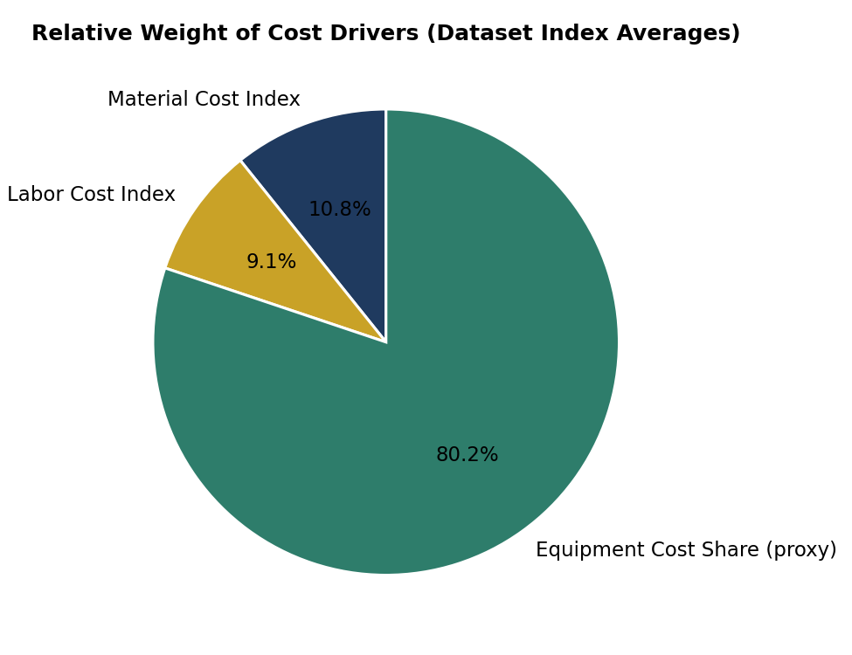
Figure 4 — Relative weight of material cost index, labour cost index, and equipment cost share, averaged across the portfolio (dataset-derived proxy; not an itemised material split).

11.4 Typical Material Cost Composition (Industry Reference)
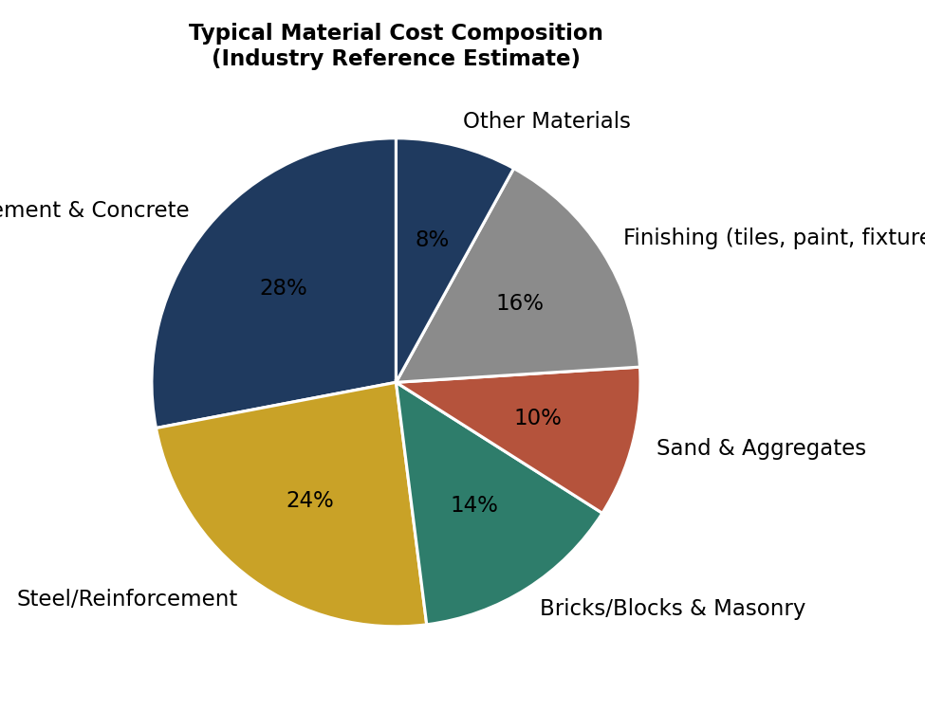
Figure 5 — Indicative material cost composition based on general construction-industry benchmarks. This is a reference estimate, not derived from ABC's dataset (see Section 6).

11.5 Inflation Rate Distribution Across the Portfolio
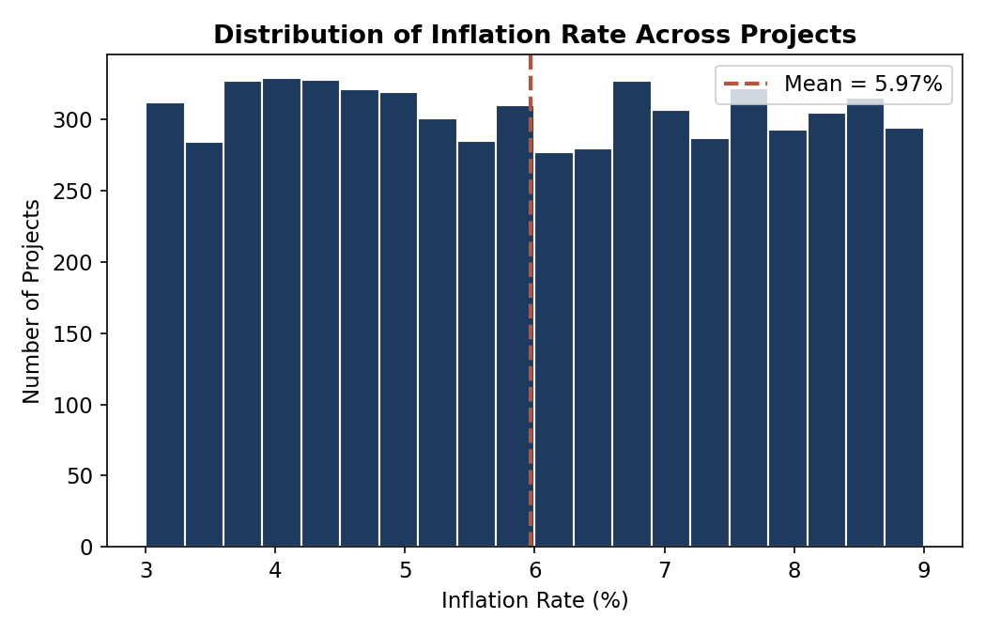
Figure 6 — Distribution of inflation rate across 6,123 projects (dataset-derived).

11.6 Material Cost Index by Construction Type
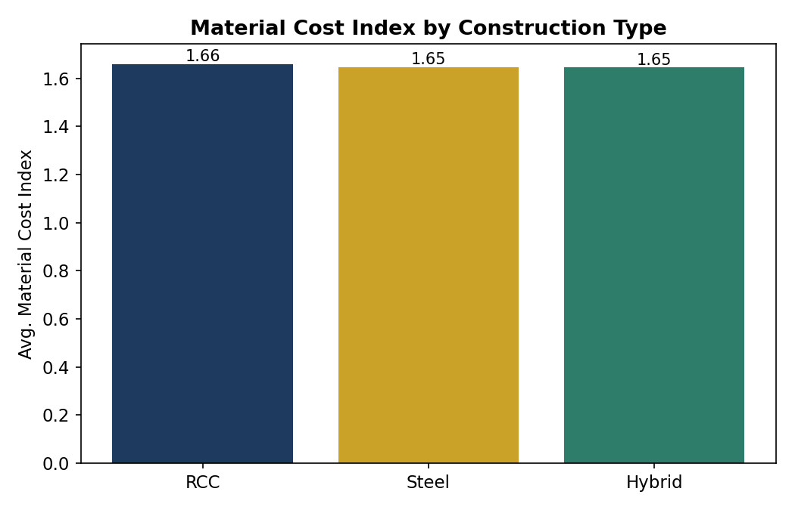
Figure 7 — Average material cost index by construction type (dataset-derived).

11.7 Estimation Consistency Check
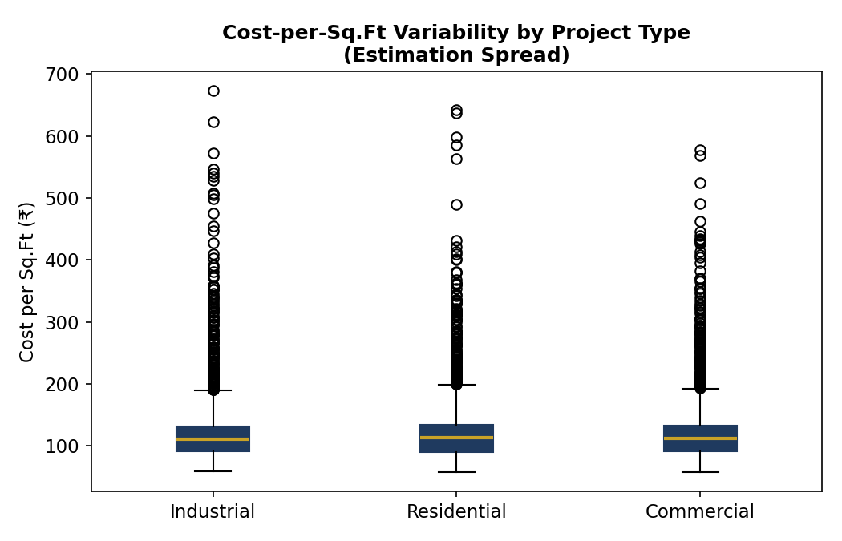
Figure 8 — Spread of cost-per-sq.ft. by project type, illustrating the estimation variability discussed in Section 2 (dataset-derived).

12. Summary Recommendations
- Adopt a location- and type-adjusted cost-per-sq.ft. benchmark instead of one blanket rate (Sections 1–2).
- Write a standing inflation escalation clause, indexed rather than fixed, into all new contracts (Section 3).
- Start capturing three fields not currently in the dataset: contractor ID/performance history, itemised material cost, and project start/completion dates — this unlocks true contractor ranking, an accurate material-spend pie chart, and a real multi-year inflation trend (Sections 4, 6).
- Apply the fully-loaded bid formula in Section 7 consistently across all tenders to protect the 10% margin target.
- Roll out the non-quality-impacting cost levers in Section 10 (utilisation, scheduling, bulk procurement) as the first wave of cost control, before considering specification changes.
— End of Report —

