**Website Programmer Manual**

Project structure

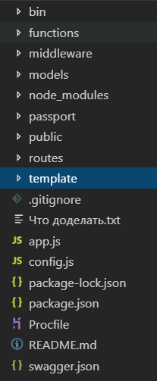

The “bin” folder contains one file with a description of the system. Work with him if you want to change the port.



In the folder “functions” there are several files with frequently used functions. You can write your functions here or use others.

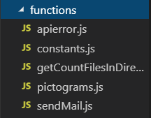

In the folder “middleware” there are several files with special functions - “middleware”. You can write your functions here or use others.

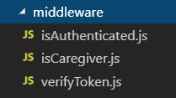

Folder "models" with files for the database. You can create a new collection here.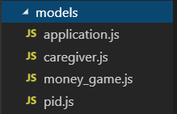

The folder "node_modules" that contains the modules of the nodes. It is not recommended to change manually.

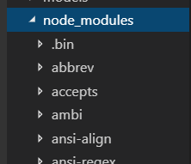

The folder “passport” that contains the authorization files. You can change the code or files.

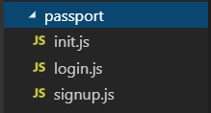

The folder “public” for public files that can be accessed from the outside.

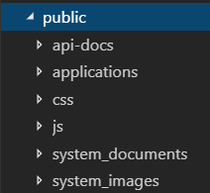

The folder “routes” that contains the routing files. You can change the code or files.

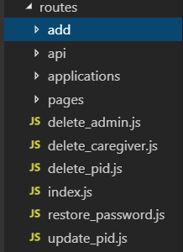

The folder “template” that contains the template files. You can change the code or files.

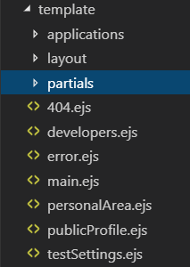

An example of adding your page:

1. Describe the routing file in index.js

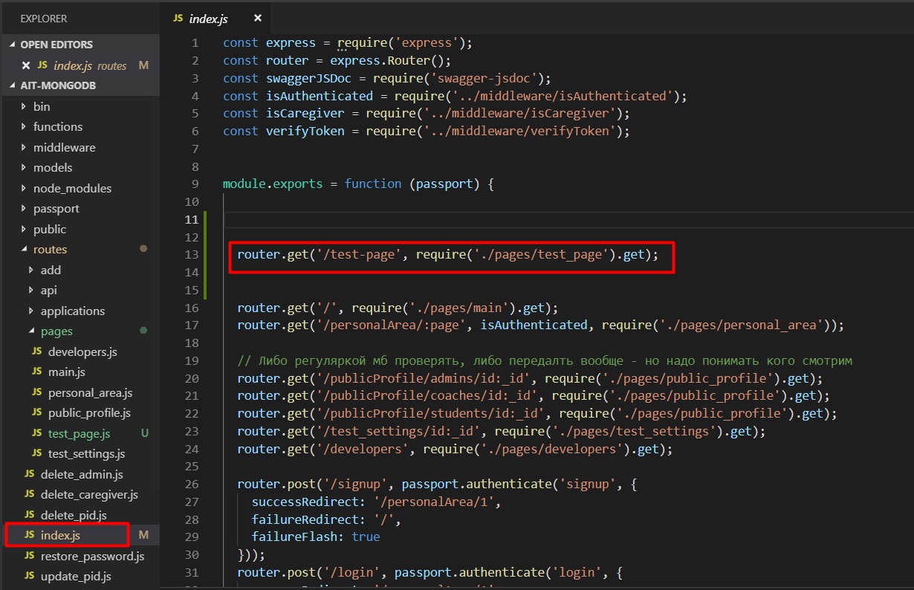

1. Create a file and write js code in it

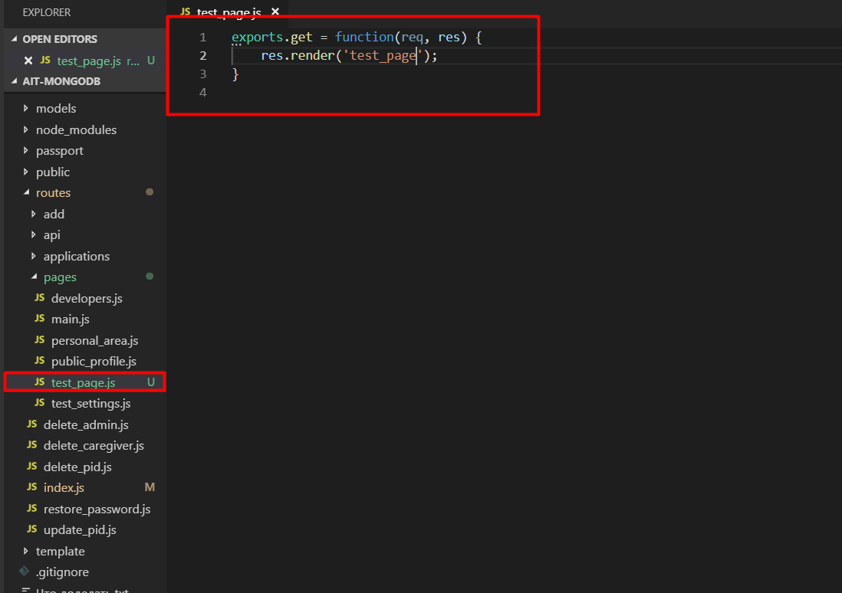

1. Create a file and write ejs code in it

