**Website User Manual**

1) Registration of the caregiver

If you don’t have an account in the system, you need to fill in the fields and click on “Sign up”:

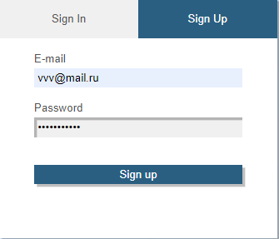

2) Authorization on the site

If you have an account in the system, you need to fill in the fields and click on “Sign in”:

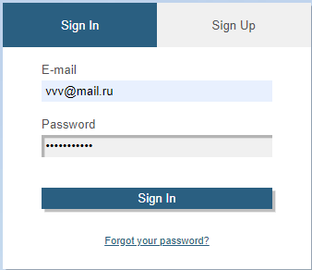

3) After registration or authorization you will be transferred to your personal account

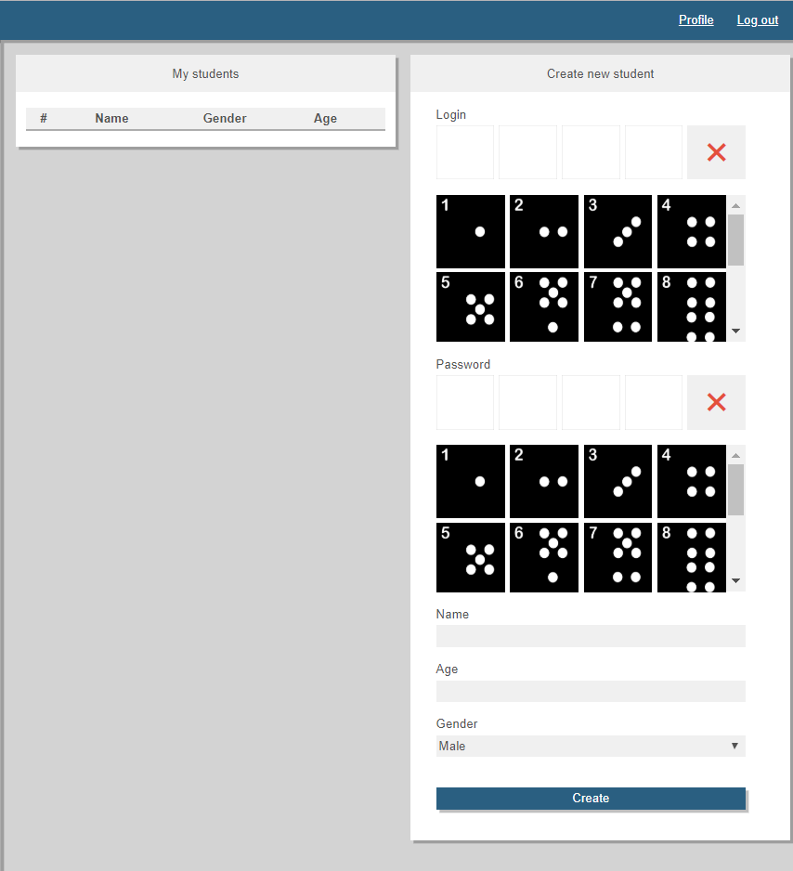

If you don't have students in the system, you need to create his profile. You need to enter student’s data: login, password, name, age, gender. And click on “Create”

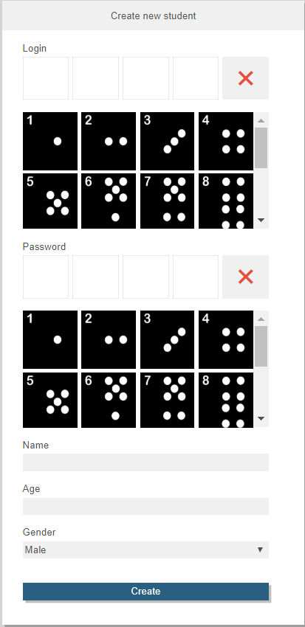

When you created the student’s profile you would see him in the left table

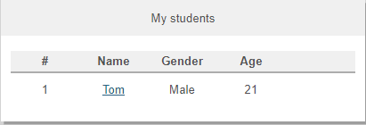

If you click on the name of some student, you will to come his public profile

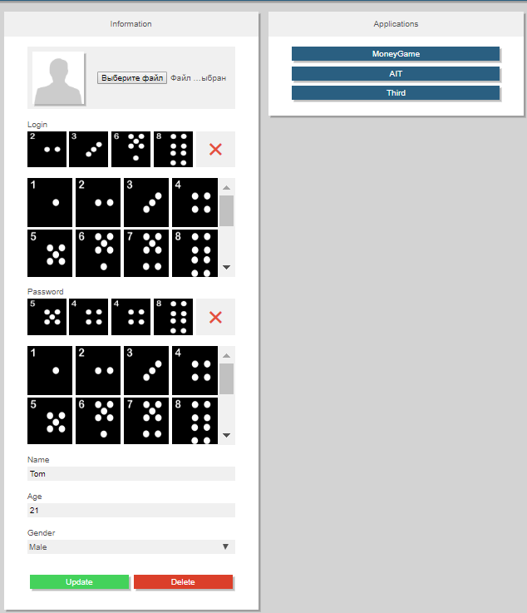

You can change his data or delete his profile

Also you can choose some application in the system and start to configure some application for this student. After that you will come to another page for further action

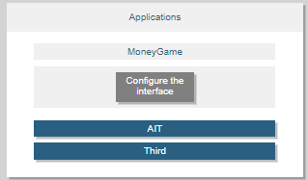

**Example configuration of the interface for MoneyGame**

The interface for MoneyGame includes 3 blocks:

1. Page of Android Application;
2. Block for configuration;
3. Visual similar interface for the android application (here you can see all the changes in the interface);

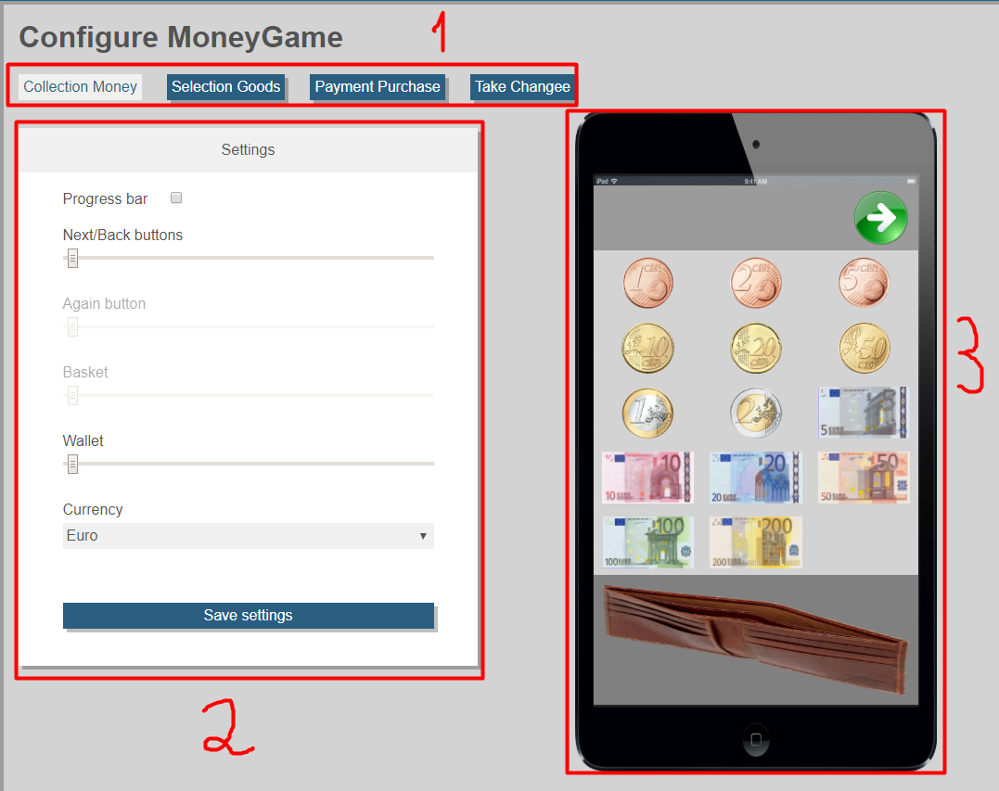

Example configuration on page “Collection Money”

1. The “Progress bar” turned off (it disappeared on the interface);
2. Changed “Next/Back buttons” (it changed on the interface);
3. Changed “Wallet” (it changed on the interface);
4. Clicked on “Save settings”;

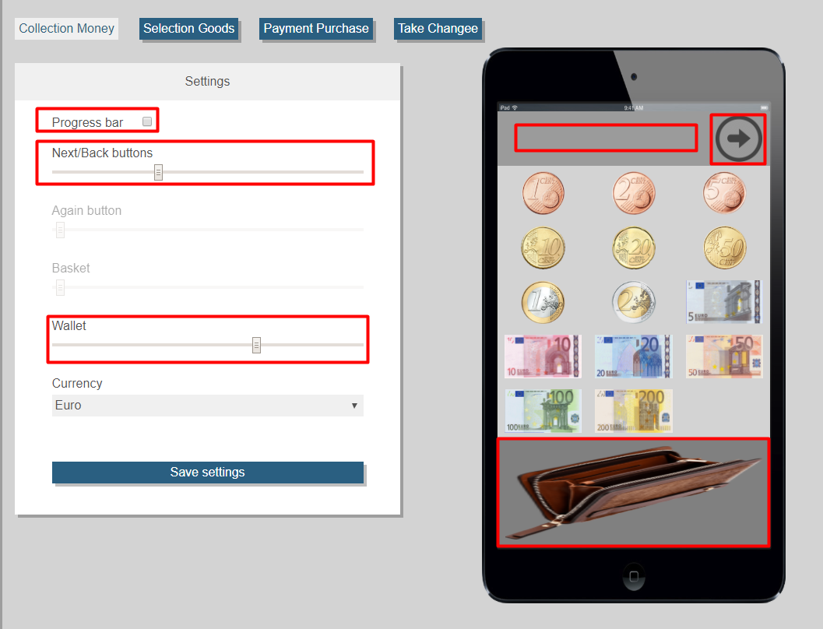

If you want transfer to your your personal account, you need click on “Profile” in the top menu



If you want logout, you need click on “Logout” in the top menu

