UCD3138 数 字 电 源 外 设
编 程 手 册

SLUU995A
April 2013 – Revised May 2013

目 录
1 引言.............................................................................................................................11
2 数字脉宽调制器（DPWM）………........................................................................12
2.1 DPWM 框图 ...........................................................................................................12
2.2 DPWM 介绍（DPWM 多模式， 开环）.............................................................13
2.3 DPWM 标准模式 ...................................................................................................15
2.4 DPWM 相移模式 ...................................................................................................17
2.5 DPWM 多输出模式 （多模）...............................................................................17
2.6 DPWM 谐振模式 ...................................................................................................18
2.7 三角模式 ..................................................................................................................20
2.8 DPWM 前导模式 ...................................................................................................20
2.9 同步FET斜坡和理想二极管仿真计算 ...................................................................21
2.10 自动模式切换 ..........................................................................................................22
2.10.1 谐振LLC例子 ...........................................................................................................22
2.10.2 自动模式切换机制 ...................................................................................................22
2.11 DPWMC、边沿发生、内部多路复用.....................................................................23
2.12 多种DPWM寄存器时间分辨率 ..............................................................................24
2.13 PWM 计数器和时钟 ...............................................................................................26
2.14 DPWM 寄存器 -概述...............................................................................................26
2.15 DPWM 控制寄存器 0 (DPWMCTRL0) .................................................................26
2.15.1 DPWM 自动配置中间和最大寄存器 ...................................................................26
2.15.2 内部多路复用 ..........................................................................................................26
2.15.3 逐周电流限制使能 ..................................................................................................26
2.15.4 多模 开/关.................................................................................................................28
2.15.5 最小占空比模式 ......................................................................................................28
2.15.6 主同步控制选择 ......................................................................................................29
2.15.7 主同步从使能 ..........................................................................................................29
2.15.8 D 使能.......................................................................................................................29
2.15.9 谐振模式固定占空比使能 ......................................................................................29
2.15.10 DPWM A and B 故障极性 ...................................................................................29
2.15.11 消隐使能 ................................................................................................................30
2.15.12 DPWM 模式 ..........................................................................................................30
2.15.13 DPWM 反相 ..........................................................................................................30
2.15.14 滤波器使能 (CLA_EN) .........................................................................................30
2.15.15 DPWM 使能 ..........................................................................................................30
2.16 DPWM 控制寄存器 1.............................................................................................30
2.16.1 周期计数器预置使能 ............................................................................................30
2.16.2 同步FET斜坡使能 .................................................................................................30
2.16.3 突发模式使能 ........................................................................................................31
2.16.4 电流/磁通量平衡占空比调整 ...............................................................................31.
2.16.5 同步输出分频因子选择 ........................................................................................31
2.16.6 滤波器标定 ............................................................................................................31
2.16.7 外部同步使能 ........................................................................................................31
2.16.8 逐周B侧激活使能 .................................................................................................31
2.16.9 自动模式切换使能 ................................................................................................31.
2.16.10 事件更新选择 ........................................................................................................31

2.16.11 检查闭锁 ..................................................................................................................32
2.16.12 全局周期使能 ..........................................................................................................32
2.16.13 DPWM管脚用作通用I/O .......................................................................................32
2.16.14 高分辨率使能/禁止 ...............................................................................................32
2.16.15 异步保护禁止 ........................................................................................................32
2.16.16 单帧使能 ................................................................................................................32
2.17 DPWM 控制寄存器 2.............................................................................................32
2.17.1 外部同步输入分频比 ..............................................................................................32
2.17.2 谐振死区补偿使能 ..................................................................................................32
2.17.3 滤波器占空比选择 ..................................................................................................33
2.17.4 DPWMB理想二极管仿真（IDE）使能 ................................................................33
2.17.5 采样触发 1 过采样 ................................................................................................33
2.17.6 采样触发 1 模式 ....................................................................................................33
2.17.7 采样触发使能位 ......................................................................................................33
2.18 周期和事件寄存器 ...................................................................................................33
2.19 相位触发寄存器 .......................................................................................................34
2.20 周期调整寄存器 .......................................................................................................34
2.21 谐振占空比寄存器 ...................................................................................................34
2.22 DPWM 故障控制寄存器 .........................................................................................34
2.23 DPWM 溢出寄存器 .................................................................................................34
2.24 DPWM 中断寄存器 .................................................................................................34
2.24.1 DPWM 周期中断位 ................................................................................................34
2.24.2 模式及切换中断位 ..................................................................................................34
2.24.3 中断位 ......................................................................................................................35
2.25 DPWM 计数器预置寄存器 .....................................................................................35
2.26 消隐寄存器 ...............................................................................................................35
2.27 DPWM 自适应采样寄存器 .....................................................................................35
2.28 DPWM 故障状态寄存器 .........................................................................................35
2.29 DPWM 自动切换寄存器 .........................................................................................35
2.30 DPWM 边沿 PWM 产生寄存器 ...........................................................................36
3 前端 ............................................................................................................................36
3.1 误差 ADC 和前端增益 .............................................................................................36
3.1.1 前端增益 ....................................................................................................................36
3.1.2 EADC 误差输出 .......................................................................................................37
3.1.3 EADC 触发、 EADC 输出到滤波器 ....................................................................38
3.1.4 EADC 时序 ...............................................................................................................38
3.1.5 EADC 平均 ...............................................................................................................38
3.1.6 使能 EADC 和 前端 ...............................................................................................39
3.2 前端 DAC ...................................................................................................................40
3.3 斜坡模块 .....................................................................................................................41
3.3.1 DAC 斜坡概述 ..........................................................................................................41
3.3.2 DAC 斜坡启动和结束点 ..........................................................................................42
3.3.3 DAC 斜坡步长 ..........................................................................................................42
3.3.4 DAC 斜坡启动、中断、启动延时 ..........................................................................43
3.3.5 斜坡启动寄存器 ........................................................................................................43
3.3.6 当EADC饱和时DAC斜坡 .....................................................................................43

3.3.7 斜坡模块用于峰值电流模式 ....................................................................................43
3.3.8 同步FET软启动/关闭使用斜坡模块 ........................................................................43
3.4 逐次逼近模式 ...........................................................................................................44
3.4.1 逐次逼近控制参数......................................................................................................44
3.4.2 逐次逼近算法概述 ....................................................................................................44
3.4.3 非连续逐次逼近模式 ................................................................................................44
3.4.4 连续逐次逼近模式 ....................................................................................................44
3.5 绝对值没有逐次逼近 ...............................................................................................45
3.6 EADC模式 ................................................................................................................45
4 滤波器 ........................................................................................................................45
4.1 滤波器数学细节.........................................................................................................45
4.1.1 滤波器输入和分支计算 ............................................................................................45
4.1.2 比例分支 ....................................................................................................................46
4.1.3 积分分支 ....................................................................................................................46
4.1.4 微分分支 ....................................................................................................................46
4.1.5 相加、饱和、尺度和钳位 ........................................................................................47
4.1.6 滤波器输出级 ............................................................................................................47
4.2 滤波器状态寄存器 .....................................................................................................48
4.3 滤波器控制寄存器 .....................................................................................................48
4.3.1 滤波器使能 ................................................................................................................49
4.3.2 使用CPU采样 ............................................................................................................49
4.3.3 强制启动 ....................................................................................................................49
4.3.4 Kp关闭、Kd关闭、Ki关闭 ......................................................................................49
4.3.5 Kd 冻结, Ki 冻结l .....................................................................................................49
4.3.6 非线性模式 ................................................................................................................49
4.3.7 输出标定 ........ ...........................................................................................................49
4.3.8 输出乘数选择 ............................................................................................................49
4.3.9 开关周期作为输出乘数 ............................................................................................50
4.3.10 KComp作为输出乘数 .............................................................................................50
4.3.11 前馈作为输出乘数 ..................................................................................................50
4.3.12 周期乘数选择 ..........................................................................................................50
4.3.13 Ki 加法器模式 ........................................................................................................50
4.4 XN、YN读写寄存器 ................................................................................................51
4.4.1 CPU Xn 寄存器...........................................................................................................51
4.4.2 滤波器 XN 读寄存器.................................................................................................51
4.4.3 滤波器 YN 读寄存器 ...............................................................................................51
4.5 系数配置寄存器 .........................................................................................................51
4.6 Kp、Ki、和Kd 寄存器 ............................................................................................52
4.7 Alpha 寄存器 ............................................................................................................53
4.8 滤波器非线性限制寄存器 ..........................................................................................53
4.9 钳位寄存器 ..................................................................................................................53
4.10 滤波器预置寄存器 ......................................................................................................53
5 环路复用 .......................................................................................................................54
5.1 前端控制复用 (FECTRL0MUX, FECTRL1MUX, FECTRL2MUX) ..........................54
5.2 采样触发控制 (SAMPTRIGCTRL) ..............................................................................55
5.3 外部DAC 控制 (EXTDACCTRL) ..............................................................................55

5.4 滤波器复用寄存器 (FILTERMUX) ..............................................................................55
5.5 滤波器 KComp 寄存器 (FILTERKCOMPx) ..............................................................55
5.6 DPWM 复用寄存器 (DPWMMUX) .............................................................................55
5.7 全局使能寄存器 (GLBEN) ...........................................................................................56
5.8 PWM 全局周期寄存器 (PWMGLBPRD) ...................................................................56
5.9 同步控制 (SYNCCTRL) ...............................................................................................56
5.10 轻负载（突发）模式 ..................................................................................................56
5.11 恒流/恒功率 .................................................................................................................56
5.12 模拟峰值电流模式 ........................................................................................................56
5.13 自动周期调整 ..............................................................................................................57
5.13.1 计算 ...........................................................................................................................57
5.13.2 配置 ...........................................................................................................................57
5.13.3 标定 ...........................................................................................................................58
6 故障复用 ...................................................................................................................58
6.1 模拟比较器配置 ....................................................................................................59
6.1.1 模拟比较器使能 .....................................................................................................59
6.1.2 模拟比较器门槛 .....................................................................................................59
6.1.3 模拟比较器极性 .....................................................................................................59
6.1.4 模拟比较器中断使能 .............................................................................................59
6.1.5 模拟比较器输出使能 .............................................................................................59
6.1.6 模拟比较器选择.......................................................................................................59
6.1.7 模拟比较器F参考电压选择.....................................................................................59
6.1.8 模拟比较器控制寄存器排列 .................................................................................59
6.2 模拟比较器斜坡 ....................................................................................................59
6.3 数字比较器配置 ....................................................................................................60
6.4 故障管脚配置 ........................................................................................................60
6.5 模拟峰值电流 ........................................................................................................60
6.6 故障状态寄存器 ....................................................................................................60
6.7 故障复用控制寄存器 ............................................................................................61
6.8 DPWM 故障动作 ..................................................................................................61
6.9 理想二极管仿真/非连续电流模式 检测控制.......................................................62
6.10 振荡器失效检测 ....................................................................................................63
6.10.1 高频振荡器失效检测 .............................................................................................63
6.10.2 低频振荡器失效检测 .............................................................................................64
7 通用IO模式...............................................................................................................65
8 DPWM 0-3 Registers Reference ..................................................................................91
8.1 DPWM Control Register 0 (DPWMCTRL0) ............................................................... 91
8.2 DPWM Control Register 1 (DPWMCTRL1) ............................................................... 95
8.3 DPWM Control Register 2 (DPWMCTRL2) ............................................................... 98
8.4 DPWM Period Register (DPWMPRD) ........................................................................ 99
8.5 DPWM Event 1 Register (DPWMEV1) ....................................................................... 99
8.6 DPWM Event 2 Register (DPWMEV2) ..................................................................... 100
8.7 DPWM Event 3 Register (DPWMEV3) ..................................................................... 100
8.8 DPWM Event 4 Register (DPWMEV4) ..................................................................... 100
8.9 DPWM Sample Trigger 1 Register (DPWMSAMPTRIG1) ...................................... 101
8.10 DPWM Sample Trigger 2 Register (DPWMSAMPTRIG2) ...................................... 101

8.11 DPWM Phase Trigger Register (DPWMPHASETRIG) ............................................ 101
8.12 DPWM Cycle Adjust A Register (DPWMCYCADJA) ............................................. 102
8.13 DPWM Cycle Adjust B Register (DPWMCYCADJB) .............................................. 102
8.14 DPWM Resonant Duty Register (DPWMRESDUTY) .............................................. 102
8.15 DPWM Fault Control Register (DPWMFLTCTRL) .................................................. 102
8.16 DPWM Overflow Register (DPWMOVERFLOW) ................................................... 104
8.17 DPWM Interrupt Register (DPWMINT) .................................................................... 105
8.18 DPWM Counter Preset Register (DPWMCNTPRE) .................................................. 107
8.19 DPWM Blanking A Begin Register (DPWMBLKABEG) ......................................... 107
8.20 DPWM Blanking A End Register (DPWMBLKAEND)............................................. 107
8.21 DPWM Blanking B Begin Register (DPWMBLKBBEG) ......................................... 108
8.22 DPWM Blanking B End Register (DPWMBLKBEND) ............................................ 108
8.23 DPWM Minimum Duty Cycle High Register (DPWMMINDUTYHI) ..................... 108
8.24 DPWM Minimum Duty Cycle Low Register (DPWMMINDUTYLO) ..................... 109
8.25 DPWM Adaptive Sample Register (DPWMADAPTIVE) ......................................... 109
8.26 DPWM Fault Status (DPWMFLTSTAT) ................................................................... 109
8.27 DPWM Auto Switch High Upper Thresh Register (DPWMAUTOSWHIUPTHRESH) ……….110
8.28 DPWM Auto Switch High Lower Thresh Register (DPWMAUTOSWHILOWTHRESH) .........111
8.29 DPWM Auto Switch Low Upper Thresh Register (DPWMAUTOSWLOUPTHRESH) …….….111
8.30 DPWM Auto Switch Low Lower Thresh Register (DPWMAUTOSWLOLOWTHRESH) ……..112
8.31 DPWM Auto Config Max Register (DPWMAUTOMAX) ........................................ 113
8.32 DPWM Auto Config Mid Register (DPWMAUTOMID) .......................................... 114
8.33 DPWM Edge PWM Generation Control Register (DPWMEDGEGEN) ................... 116
8.34 DPWM Filter Duty Read Register (DPWMFILTERDUTYREAD) .......................... 117
8.35 DPWM BIST Status Register (DPWMBISTSTAT) .................................................. 119
9 Front End Control Registers ........................................................................................ 119
9.1 Ramp Control Register (RAMPCTRL) ...................................................................... 119
9.2 Ramp Status Register (RAMPSTAT) ......................................................................... 121
9.3 Ramp Cycle Register (RAMPCYCLE) ...................................................................... 122
9.4 EADC DAC Value Register (EADCDAC) ................................................................ 123
9.5 Ramp DAC Ending Value Register (RAMPDACEND) ............................................ 123
9.6 DAC Step Register (DACSTEP) ................................................................................ 123
9.7 DAC Saturation Step Register (DACSATSTEP) ....................................................... 124
9.8 EADC Trim Register (EADCTRIM) – (For Factory Test Use Only) ........................ 124
9.9 EADC Control Register (EADCCTRL) ..................................................................... 125
9.10 Analog Control Register (ACTRL) (For Test Use Only) ........................................... 128
9.11 Pre-Bias Control Register 0 (PREBIASCTRL0) ........................................................ 128
9.12 Pre-Bias Control Register 1 (PREBIASCTRL1) ........................................................ 129
9.13 SAR Control Register (SARCTRL)............................................................................. 129
9.14 SAR Timing Register (SARTIMING) ........................................................................ 131
9.15 EADC Value Register (EADCVALUE) ..................................................................... 131
9.16 EADC Raw Value Register (EADCRAWVALUE) ................................................... 132
9.17 DAC Status Register (DACSTAT) ............................................................................. 132
10 Filter Registers Reference ............................................................................................ 132
10.1 Filter Status Register (FILTERSTATUS) ................................................................... 132
10.2 Filter Control Register (FILTERCTRL) ..................................................................... 134
10.3 CPU XN Register (CPUXN) ...................................................................................... 135
10.4 Filter XN Read Register (FILTERXNREAD) ............................................................ 136
10.5 Filter KI_YN Read Register (FILTERKIYNREAD) ................................................. 136
10.6 Filter KD_YN Read Register (FILTERKDYNREAD) .............................................. 136
10.7 Filter YN Read Register (FILTERYNREAD) ............................................................ 137
10.8 Coefficient Configuration Register (COEFCONFIG) ................................................ 137
10.9 Filter KP Coefficient 0 Register (FILTERKPCOEF0) ............................................... 139
10.10 Filter KP Coefficient 1 Register (FILTERKPCOEF1) ............................................. 139
10.11 Filter KI Coefficient 0 Register (FILTERKICOEF0) ............................................... 140
10.12 Filter KI Coefficient 1 Register (FILTERKICOEF1) ............................................... 141
10.13 Filter KD Coefficient 0 Register (FILTERKDCOEF0)............................................ 141
10.14 Filter KD Coefficient 1 Register (FILTERKDCOEF1)............................................ 141
10.15 Filter KD Alpha Register (FILTERKDALPHA) ..................................................... 142
10.16 Filter Nonlinear Limit Register 0 (FILTERNL0) .................................................... 142
10.17 Filter Nonlinear Limit Register 1 (FILTERNL1) .................................................... 142
10.18 Filter Nonlinear Limit Register 2 (FILTERNL2) .................................................... 142
10.19 Filter KI Feedback Clamp High Register (FILTERKICLPHI) ............................... 143
10.20 Filter KI Feedback Clamp Low Register (FILTERKICLPLO) ............................... 143
10.21 Filter YN Clamp High Register (FILTERYNCLPHI) ............................................ 144
10.22 Filter YN Clamp Low Register (FILTERYNCLPLO) ............................................ 144
10.23 Filter Output Clamp High Register (FILTEROCLPHI) .......................................... 144
10.24 Filter Output Clamp Low Register (FILTEROCLPLO) .......................................... 145
10.25 Filter Preset Register (FILTERPRESET) ................................................................ 145
11 Loop Mux Registers Reference .............................................................................. 145
11.1 Front End Control 0 Mux Register (FECTRL0MUX) ............................................ 145
11.2 Front End Control 1 Mux Register (FECTRL1MUX) ............................................ 148
11.3 Front End Control 2 Mux Register (FECTRL2MUX) ............................................ 150
11.4 Sample Trigger Control Register (SAMPTRIGCTRL) ........................................... 152
11.5 External DAC Control Register (EXTDACCTRL) ................................................. 153
11.6 Filter Mux Register (FILTERMUX) ........................................................................ 155
11.7 Filter KComp A Register (FILTERKCOMPA) ....................................................... 157
11.8 Filter KComp B Register (FILTERKCOMPB) ........................................................ 157
11.9 DPWM Mux Register (DPWMMUX) ..................................................................... 158
11.10 Constant Power Control Register (CPCTRL) .......................................................... 159
11.11 Constant Power Nominal Threshold Register (CPNOM) ........................................ 161
11.12 Constant Power Max Threshold Register (CPMAX) .............................................. 161
11.13 Constant Power Configuration Register (CPCONFIG) ........................................... 161
11.14 Constant Power Max Power Register (CPMAXPWR) ........................................... 163
11.15 Constant Power Integrator Threshold Register (CPINTTHRESH) ......................... 163
11.16 Constant Power Firmware Divisor Register (CPFWDIVISOR) ............................. 163
11.17 Constant Power Status Register (CPSTAT) ............................................................ 164
11.18 Cycle Adjustment Control Register (CYCADJCTRL)............................................ 165
11.19 Cycle Adjustment Limit Register (CYCADJLIM) ................................................. 165
11.20 Cycle Adjustment Status Register (CYCADJSTAT) ............................................. 166
11.21 Global Enable Register (GLBEN) ........................................................................... 167
11.22 PWM Global Period Register (PWMGLBPRD) ..................................................... 168
11.23 Sync Control Register (SYNCCTRL) ..................................................................... 168
11.24 Light Load Control Register (LLCTRL) ................................................................. 169
11.25 Light Load Enable Threshold Register (LLENTHRESH)....................................... 169
11.26 Light Load Disable Threshold Register (LLDISTHRESH) .................................... 170
11.27 Peak Current Mode Control Register (PCMCTRL) ................................................ 170
11.28 Analog Peak Current Mode Control Register (APCMCTRL) ................................ 170
11.29 Loop Mux Test Register (LOOPMUXTEST) (Test Use Only)............................... 171
12 Fault Mux Registers Reference ................................................................................ 172
12.1 Analog Comparator Control 0 Register (ACOMPCTRL0) .................................... 172
12.2 Analog Comparator Control 1 Register (ACOMPCTRL1) .................................... 173
12.3 Analog Comparator Control 2 Register (ACOMPCTRL2) .................................... 175
12.4 Analog Comparator Control 3 Register (ACOMPCTRL3) .................................... 176
12.5 External Fault Control Register (EXTFAULTCTRL) ............................................ 177
12.6 Fault Mux Interrupt Status Register (FAULTMUXINTSTAT) ............................. 178
12.7 Fault Mux Raw Status Register (FAULTMUXRAWSTAT) ................................. 179
12.8 Comparator Ramp Control 0 Register (COMPRAMP0) ........................................ 181
12.9 Digital Comparator Control 0 Register (DCOMPCTRL0) ..................................... 182
12.10 Digital Comparator Control 1 Register (DCOMPCTRL1) ..................................... 183
12.11 Digital Comparator Control 2 Register (DCOMPCTRL2) ..................................... 183
12.12 Digital Comparator Control 3 Register (DCOMPCTRL3) ..................................... 184
12.13 Digital Comparator Counter Status Register (DCOMPCNTSTAT) ...................... 185
12.14 DPWM 0 Current Limit Control Register (DPWM0CLIM) .................................. 185
12.15 DPWM 0 Fault AB Detection Register (DPWM0FLTABDET) ............................ 187
12.16 DPWM 0 Fault Detection Register (DPWM0FAULTDET) .................................. 189
12.17 DPWM 1 Current Limit Control Register (DPWM1CLIM) .................................. 193
12.17 DPWM 1 Current Limit Control Register (DPWM1CLIM) .................................. 193
12.18 DPWM 1 Fault AB Detection Register (DPWM1FLTABDET) ............................ 195
12.19 DPWM 1 Fault Detection Register (DPWM1FAULTDET) .................................. 197
12.20 DPWM 2 Current Limit Control Register (DPWM2CLIM) .................................. 201
12.21 DPWM 2 Fault AB Detection Register (DPWM2FLTABDET) ............................ 203
12.22 DPWM 2 Fault Detection Register (DPWM2FAULTDET) .................................. 205
12.23 DPWM 3 Current Limit Control Register (DPWM3CLIM) .................................. 209
12.24 DPWM 3 Fault AB Detection Register (DPWM3FLTABDET) ............................ 211
12.25 DPWM 3 Fault Detection Register (DPWM3FAULTDET) .................................. 213
12.26 HFO Fail Detect Register (HFOFAILDET) ........................................................... 216
12.27 LFO Fail Detect Register (LFOFAILDET) ............................................................ 216
12.28 IDE Control Register (IDECTRL) .......................................................................... 217
13 GIO – General Purpose Input/Output Module ........................................................ 218
13.1 Fault IO Direction Register (FAULTDIR) ............................................................. 218
13.2 Fault Input Register (FAULTIN) ........................................................................... 219
13.3 Fault Output Register (FAULTOUT) .................................................................... 219
13.4 Fault Interrupt Enable Register (FAULTINTENA) .............................................. 220
13.5 Fault Interrupt Polarity Register (FAULTINTPOL).............................................. 220
13.6 Fault Interrupt Pending Register (FAULTINTPEND) ......................................... 222
13.7 External Interrupt Direction Register (EXTINTDIR) ............................................ 223
13.8 External Interrupt Input Register (EXTINTIN) ..................................................... 223
13.9 External Interrupt Output Register (EXTINTOUT) .............................................. 223
13.10 External Interrupt Enable Register (EXTINTENA) .............................................. 223
13.11 External Interrupt Polarity Register (EXTTINTPOL) .......................................... 223
13.12 External Interrupt Pending Register (EXTINTPEND) ......................................... 224

本文档的适用范围
以下主题均包含在UCD3138数字电源外设编程手册中
▪ 数字脉宽调制器 (DPWM)
▪ 运行模式 (标准/多路/相移/谐振 等)
▪ 自动模式切换
▪ DPWMC、边沿产生及内部复用
▪ 前端
▪ 模拟前端
▪ 误差 ADC 或 EADC
▪ 前端 DAC
▪ 斜坡模块
▪ 逐次逼近寄存器模块
▪ 滤波器
▪ 滤波器数学
▪ 环路复用
▪ 模拟峰值电流模式
▪ 恒流/恒功率 (CCCP)
▪ 自动周期调整
▪ 故障复用
▪ 模拟比较器
▪ 数字比较器
▪ 故障管脚功能
▪ DPWM故障动作
▪ 理想二极管仿真 (IDE)、非连续电流模式检测
▪ 振荡器失效检测
▪  UCD3138中的以上所有外设寄存器映射与UCD3138相关的其它主题包含在以下列出的另外文件中：
UCD3138 ARM and Digital System Programmer’s Manual
▪ 自举 ROM 及自举 Flash
▪ 自举 ROM 功能
▪ 存储器读/写功能
▪ 累加和功能
▪ Flash 功能
▪ 避免编程的 Flash 空间自锁
▪ ARM7 构架
▪ 操作模式
▪ 硬件/软件中断
▪ 指令系统
▪ 双模状态工作 (Thumb 16-bit 模式/ARM 32-bit 模式)
▪ 存储器和系统模块
▪ 地址译码器、 DEC (存储空间映射)
▪ 存储控制器 (MMC)
▪ 中央中断模块
▪ 以上外设在UCD3138中的寄存器映射
UCD3138 Monitoring and Communications Programmer’s Manual
▪ ADC12
▪ 控制、转换、顺序和平均
▪ 数字比较器
▪ 温度传感器
▪ PMBUS 寻址
▪ 双采样和保持
▪ 模拟控制 (电流分享、掉电、时钟门控)
▪ PMBUS 接口
▪ 通用输入输出 (GPIO)
▪ 定时器模块
▪ PMBus
▪ 以上外设在UCD3138中的寄存器映射
For the most up to date product specifications please consult the UCD3138 Device datasheet (Lit #
SLUSAP2) available at www.ti.com.

1 引言
UCD3138是TI的数字电源控制器，提供了一流水平的针对高性能隔离电源的应用的单芯片高集成
度解决方案。其核心是数字控制环路的外设，也被称为数字电源外设（DPP）用于控制电源回路中的高速
电压/电流环，一个ARM7TDMI-S微控制器/处理器执行实时监控，配置和外部管理通信。该器件还包​​含一个12位，265ksps通用ADC，具有高达14个通道，定时器，中断控制，JTAG调试和PMBus和UART
通信接口。在内存方面，UCD3138提供32KB程序闪存，2kB的数据闪存，4KB RAM和4kB ROM。
数字电源外设（DPPS）是UCD3138控制器中的元件块，通过特殊架构构成数字电源的控制。他们
被设计用于取代基于模拟电源管理控制芯片中的模拟补偿网络和PWM波形发生器系统，并加入增强的数字功能的系统。在许多情况下，通过固件初始化后，DPPS可以完全控制电源自动运行，不再需要固件的参与。这使得处理器留出资源​​以提升监视、通讯、及其它功能。
高亮显示的关键参与模块的数字电源外设控制环路见下图：
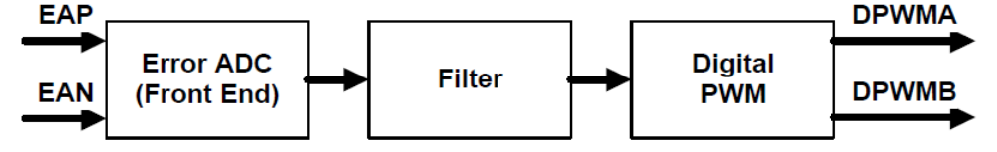
误差ADC（​​前端）接受一个差分电压信号作为输入。它测量该输入和一个数字控制的参考电压之间的差异并产生一个数字误差输出。它通过这个数字误差信息给滤波器。误差ADC（​​或EADC）是一个特殊的高速、高分辨率的ADC并带有一个很小的动态范围，对电源误差测量并进行优化。
该滤波器采用的误差信号通过一个基于补偿其外部环路传递特性的数字滤波器PID调节。该滤波器可以对电源负载、输入、电路特性的变化进行动态可编程补偿。同时它也为电源处理暂态瞬变提供了更好的非线性响应。
滤波器的输出被传递给一个数字PWM（DPWM）发生器。该DPWM有两路输出，可用于许多不同的场合。有同步整流、多种桥拓扑的多相控制，以及LLC控制。除了2路 DPWM输出外，DPWM还具供外部和内部使用的其他信号。这些信号包括：
* 帧 开 始 --------- 一个开关周期的开始
* 采样触发 --------- 信号前端、尾端采样
* 同步输出 --------- 信号触发另一路DPWM起始
* 同步输入 --------- 一个外部同步信号触发DPWM启动
* 故障信号 --------- 提醒DPWM采取各种故障应对
这些信号将被包括在更详细的本文档的DPWM章节中。
外围设备可如上所述一起运行，也可以通过不同的组合在内部互联运行，并未在上面的图例中显示。如：DPWM可用于触发误差ADC启动，并在采样转换结束时触发滤波器。
UCD3138芯片具有支持多套数字电源外设的能力并可控制高达3路反馈回路（电压或电流），并同时驱动8路输出。有一个叫作LOOP MUX的大型模块用来内部控制所有的DPPS，这对DPP的设置提供了一个了高度的灵活性。任意的前端可以连接到任意的滤波器，并且任意的滤波器输出可以连接到任意的DPWM。此外，信息可以在外围设备之间传递。例如，一个滤波器的输出（如控制一个慢速电压环路）可以向另外前端提供参考（如监视一个快速电流环）以便实现嵌套循环（像平均电流模式控制）。
另外，UCD3138中的DPPS为其它模块或功能块提供用于电源输入及控制的（信号）。
这些包括：
―― 故障处理
―― 逐周电流限制
―― 恒功率/恒流
―― 斜坡上升/下降
―― 峰值电流模式控制
等等……..
还有一种称为FAULT MUX模块，连接故障检测电路的输出来控制输入、DPWMs主回路，及针对用户定制的故障处理和恢复。
本文档提供了UCD3138的DPP模块的信息，首先是详细说明，其次为一些配置范例，最后列出了各DPP模块每个位字段的参考章节。
- 数字脉冲宽度模块（DPWM）
DPWM模块大概是最复杂的并且是DPPS的中心。它读取滤波器的输出并转化为许多电源拓扑相对应的正确PWM输出。每一个DPWM模块有2个输出引脚――DPWMXB（x＝0，1，2，3）。DPWM也可为各相间的电流平衡提供可编程的死区时间和周期调整。它也控制误差信号（测量启动）的触发。它也能与其它的DPWMs或外部源同步。另外，它也可为其它DPWMs或外部接收端提供同步信息。DPWM也能被外部设备用于作为输入，也可用作为输出的SYNC管脚来（实现与其它电源的）同步。此外，它联接到多个故障检测电路。这些故障的响应是DPWM功能的一部分。
  - DPWM 框图
下图是单一DPWM块的总体示例，是由不同的单独的模块构成并通过它们进行信号传递：
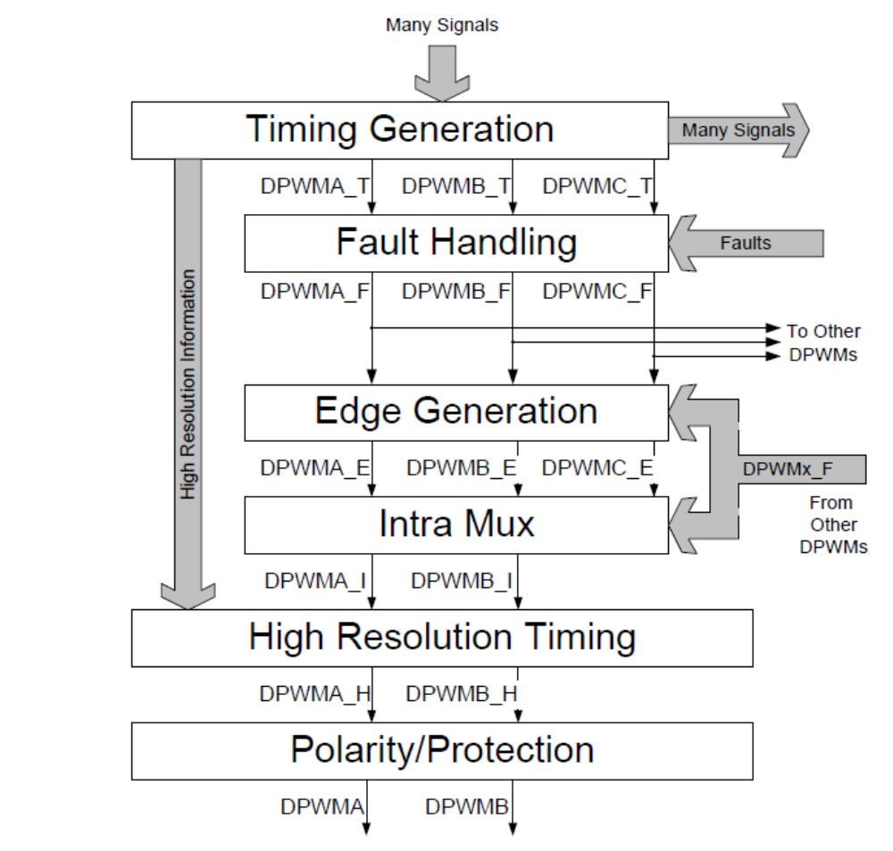
DPWM模块框图
* 时序发生器模块输出3 个DPWM信号（DPWMx_T，X = A，B，C），以应用于其它模块的许多其它信号。它是滤波器输出(信号)被转换成脉冲的宽度、有时为周期的一部分。
* 下一个是故障处理模块。当故障产生时其关闭DPWM的信号。从故障模块出来的DPWM信号（DPWMx_F, x=A, B, C）输送到其它DPWM模块。
* Edge Generation(边沿产生) Intra Mux （内部复用）模块可以组合来自其它DPWMs的信号产生新的信号（DPWMx_E, DPWMx_I, x=A, B, C）
DPWMx_T, DPWMx_F (这里 x=A, B, C) 等注释在这儿对于理解其来历和信号之间的关系是非常有用
的。例如DPWM2A_F与DPWMM2A_F也许没有任何一点关系。
许多拓扑既不使用DPWMC信号也不使用（Edge Generation）边沿发生器和（Intra Mux）内部复用模
块。缺省情况下对于这些模块来说，信号仅是无改变地通过。然而某些拓扑像全桥相移（PSFB）使用以上2个模块（Edge Generation and Intra Mux modules）及DPWMC信号。
这些图表仅仅说明了信号在不同的DPWM模块中的传递，并没有给出那些控制每个模块如何工作和那些在DPWM开关周期中可动态设置的配置逻辑。
下图为（Timing Module）时序模块图表，解释了涉及的数据、信号和主元件（再次说明，时序模块的实
际逻辑没有在这里标明）
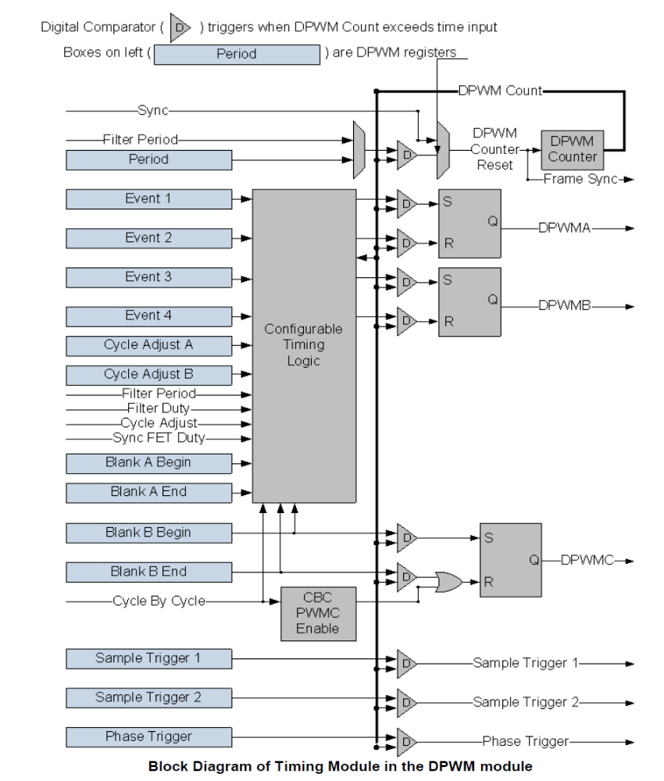
2.2 DPWM介绍（DPWM Multi-Mode, Open Loop 多路模式，开环）
DPWM是基于1个DPWM计数器，该计数器从0开始计时一直到其周期值然后再复位并且重新开始。该计数器可被来自于SYNC引脚或其它DPWM的同步信号复位。
当周期计数器碰到信号触发值时QPWM逻辑将引起许多数字信号之间的传递。在以上时序模块图解中，是通过数字比较器来象征性地描述这些功能。
DPWM具有一个250MHz、4nS分辨率的基本时钟。250MHz时钟16分频后产生250pS的间隔。输出脉冲宽度和脉冲间距是由这些250pS分辨率时钟信号控制的。由这些时钟产生的边沿在因而图表部分中被称为“高分辨率”。
DPWM输出的大多数信号是非常简单的。仅DPWMA和DPWMB是复杂信号。这些变化依赖于电源的拓扑并且这些来自于DPWM的信号是最为重要的。
DPWM有很多方式来支持不同的拓扑。这些方式由DPWM控制寄存器的方式位字段来选择。Multi mode, Open loop（多模，开环）方式在这儿用于DPWM的介绍，其它DPWM方式在下面部分介绍。
下图说明了大部分的信号参与的DPWM模式被称为“多模，开环”。开环的意思是DPWM的控制完全于其自身的寄存器控制，而非通过滤波器输出来控制。换句话说，电源的控制环路不是闭合的。这种模式被用来介绍DPWM是因为DPWM寄存器的数值与信号的时序是一个非常简单联系。
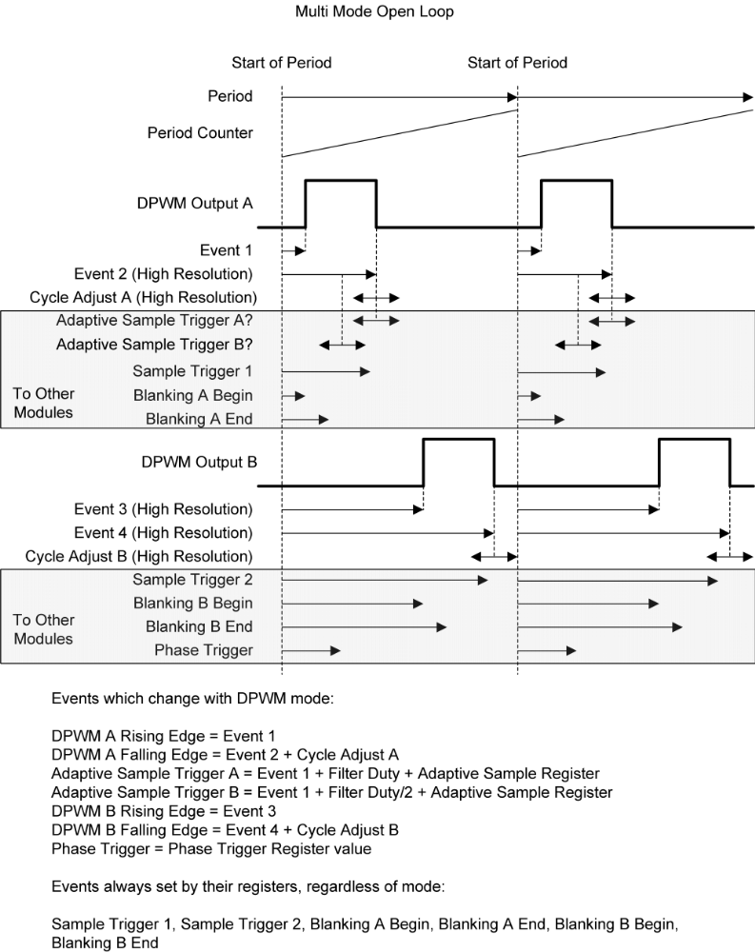
采样触发信号用于触发前端开始采样输入信号。消隐信号用于消除在噪声期间的错误测量，如在场效应管开通和关闭过程时。这种做法防止了因噪声引起的错误检测。它们仅影响（CBC）逐周模块。其它故障检测不消隐。
注意针对特殊模式如采样触发1和2、消隐A和B及相位触发已示意在本逻辑中，其可放置于周期的任意点。

2.3 标准模式（区别于介绍模式）
在标准模式下，滤波器的输出决定DPWMA、DPWMB的脉冲宽度适应开关周期的剩余时间（脉冲占空比），及与DPWMA的开通时间（保证一定间隔）的死区时间。这在使用（占空比）D与1－D型波形拓扑中是很有用的，例如，BUCK和BOOST派生的拓扑可使用标准模式来驱动。这里画出了标准模式下波形：

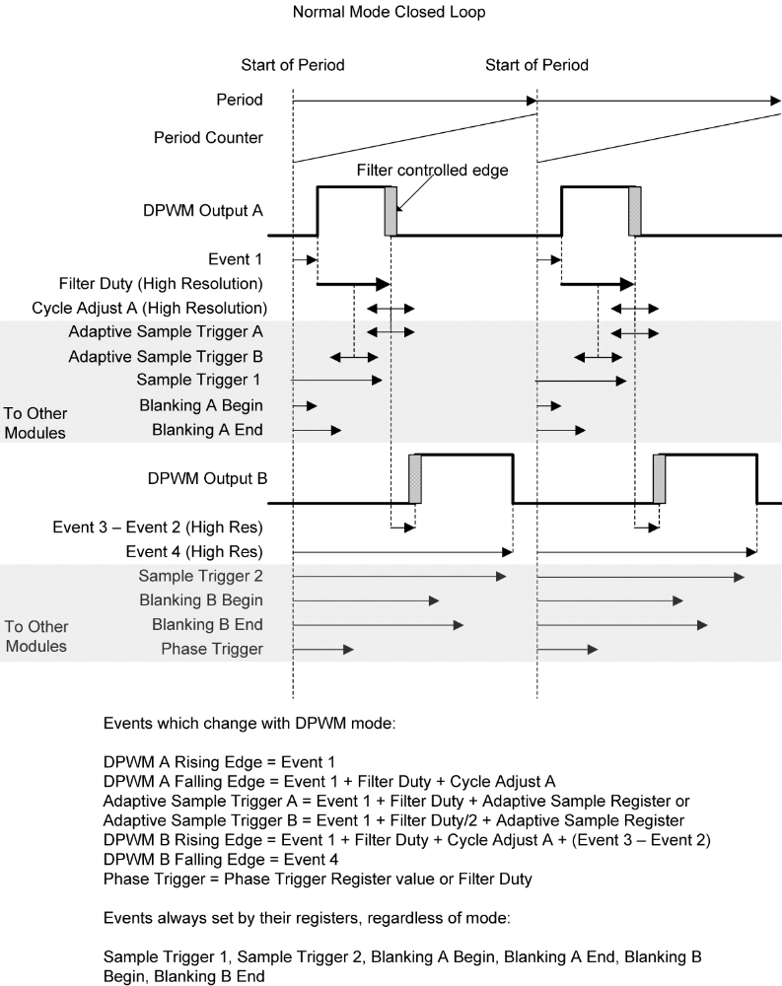
Cycle Adjust A可用于多相系统中的单相脉冲宽度的调节。这可用于某些场合例如需要电流平衡。自适应采样触发可用于开通时间中间的采样（自适应采样触发B－运用于开通期间的平均输出），或在开通时间的尾端（自适应采样A－最小化相位延时）。自适应采样寄存器对芯片输出的DPWM信号提供一个在开通期间的中心点或尾部的偏移量。这能够补偿外部延时，如场效应管和门驱动的开通时间。
消隐信号可用于禁止噪声期间的CBC故障信号的检测。通常噪声是由DPWM的边沿（开通或截止）引起的。消隐寄存器设有一个固定的延时，因而它们相比于动态变化边沿来说更容易地运用于固定边沿。所以在这种情况下，DPWMA的上升沿和DPWMB的下降沿更容易提供消隐。在这个模式里，2个消隐时间均作用于A的下降沿，因为该时刻是CBC逻辑的工作点。
Cycle Adjust B在标准模式下无效。
注意：在标准模式下，DPWMB的上升沿计算值不允许超过DPWM事件4的计数设定值。这既可通过滤波器输出钳位也可使用一个在滤波器输出时乘上一个合适的KCOMP值来操作。假如不这样做，DPWMB导通时间也许会与DPWMA的导通时间相重叠，导致短路。
  - DPWM相移模式
在相当多的模式下，有可能要同步多个使用相移信号的DPWM模块。相移信号有2种可能来源，
来源于相移寄存器或滤波器占空比值。
相移寄存器提供一个固定的计数值，对于像交错式PFC（功率因数校准）简单多相系统是非常有用的。
当滤波器占空比作为源时，滤波器输出变化将引起2个DPWM模块间相关相位变化。假如考虑采用电压反馈模式而不是峰值电流反馈模式时，对于相移全桥拓扑来说是有用
下图显示了相移的机理：
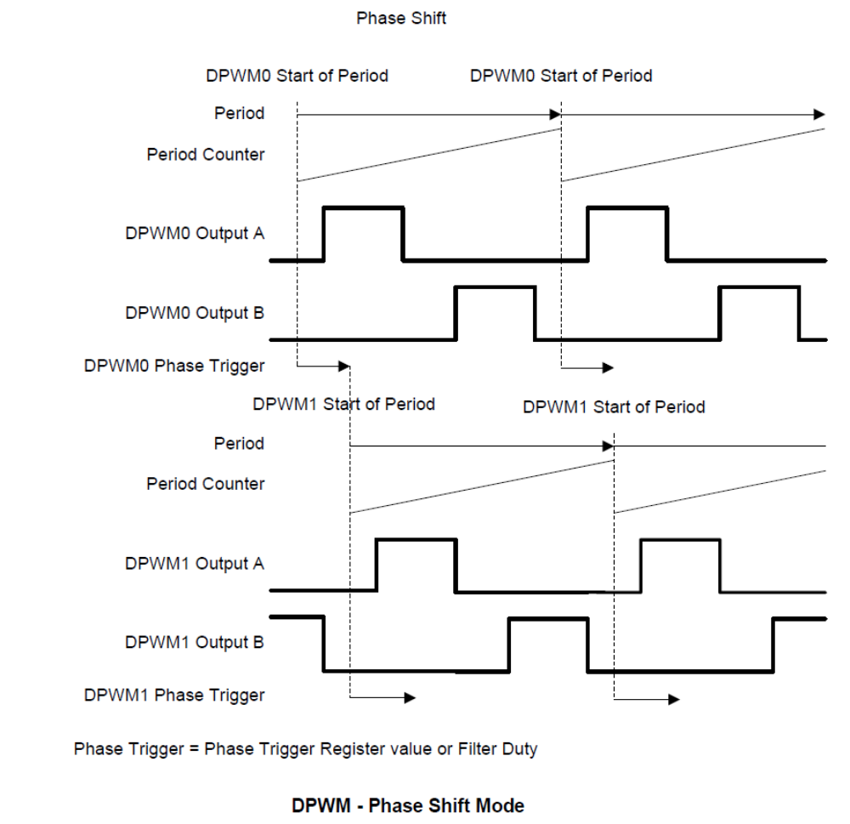
2.5 DPWM多个输出模式（多模）
多模常用于每个相位仅需要一个驱动信号的系统中。在这种模式下，每个DPWM外设可驱动2相具有相同脉冲宽度但相位之间有一个时间偏移，每相之间带有不同的周期调整。
下图为多模方式：

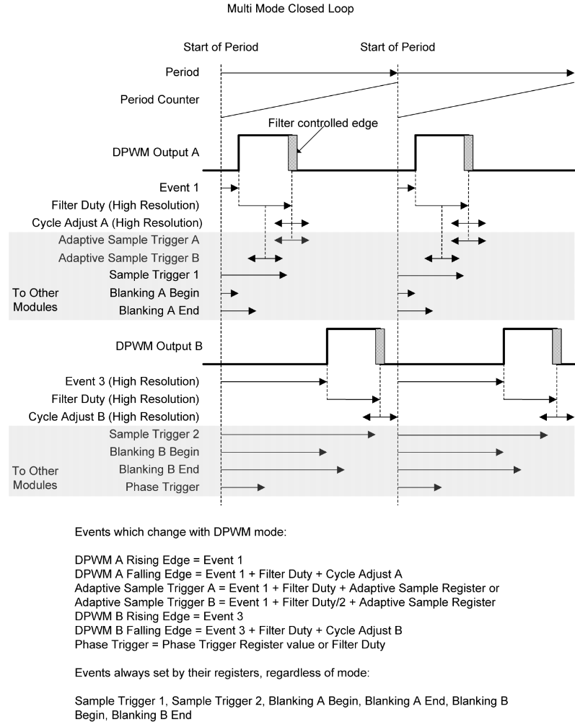
DPWM – Multiple Output Mode (Multi Mode)
在多模方式下事件2与时间4不相关的。
图标所示，DPWMA设计成开通时接近周期的起始点。它能在周期结束前的任意点关闭，达到接近100%的开通时间（占空比）。DPWMB设计成周期启动后用于支持多相系统。因而DPWMB设计成跨越周期边界安全型，只要它不进入或超出事件更新窗口。这使得DPWMB同样可实现100%脉冲宽度（占空比）的操作。
因为DPWMB的上升沿也是固定的，消隐B的开始和结束可用于消除这个上升沿（的噪声）。在这个模式中，消隐A仅工作在DPWMA的下降沿上，消隐B仅工作在DPWMB的下降沿上。
当然Cycle Adjust B用于DPWMB上。
没有限制（功能来）防止2个信号相互重叠。图中显示2个相位差为180度的信号，但这不是必需的。它们之间可以90度、60度或任意需要的偏移（相位）。
2.6 DPWM谐振模式
谐振模式操作取决于RESON_DEADTIME_COMP_EN bit位的状态。设置RESON_DEADTIME_COMP_EN
使能位可提供DPWMA和DPWMB具有相同脉冲宽度的对称波形。当开关频率变化时，在2个脉冲之间的死区时间还得保持与原来一样。这种模式对LLC谐振拓扑是非常理想的。
清除RESON_DEADTIME_COMP_EN使能位可提供脉冲宽度相同及在周期变化时其占空比为常数（不变）的模式。也就是意味着当频率提高时，死区时间等比例缩小。
这种模式的应用是为从PWM模式平滑过渡到谐振模式而设计的，第27页的2.10.1章节的谐振LLC例子有描述。下面是这种模式的图例：
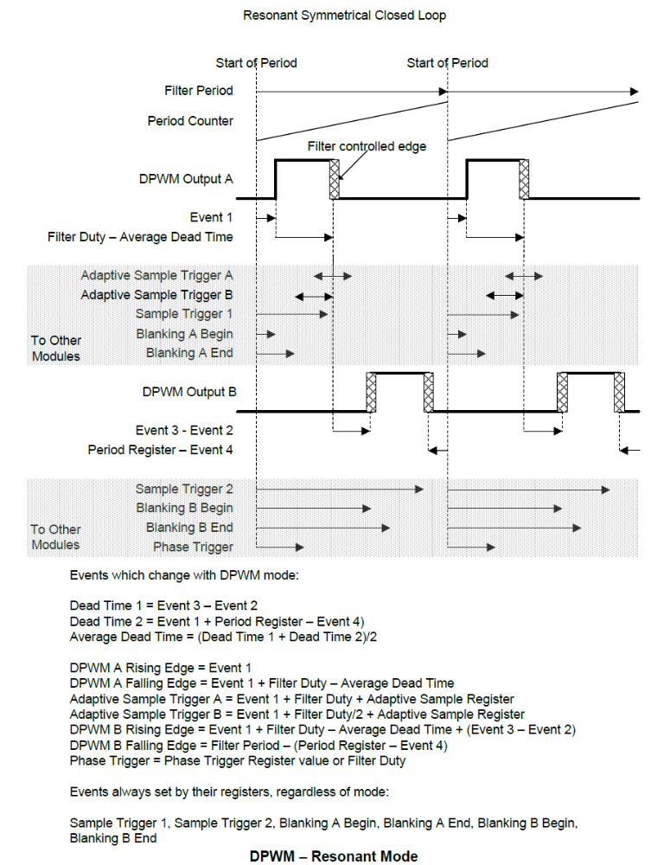
在后面可以看到，滤波器模块有2个输出，滤波器占空比和滤波器周期。在谐振模式，滤波器被配置成滤波器周期为2倍于滤波器占空比。零死区时间，每个DPWM引脚导通时间是周期的一半。对于死区时间的处理，2个DPWM引脚的滤波器占空比减去2个死区时间的平均值。因而2引脚将具有同样的导通时间，并且死区时间固定不变与周期无关。仅与周期开始相关的DPWMA的上升沿是固定的。消隐A和消隐B均仅工作在DPWMA上。
2.7 三角波模式
三角模式可为交错PFC及其相似拓扑提供非常稳定的相移。在这种情况下，PWM脉冲集中在周期的中间，而不是起始在这一端或另一端。在本模式下，仅DPWMB有效。以下是三角模式的示意图：
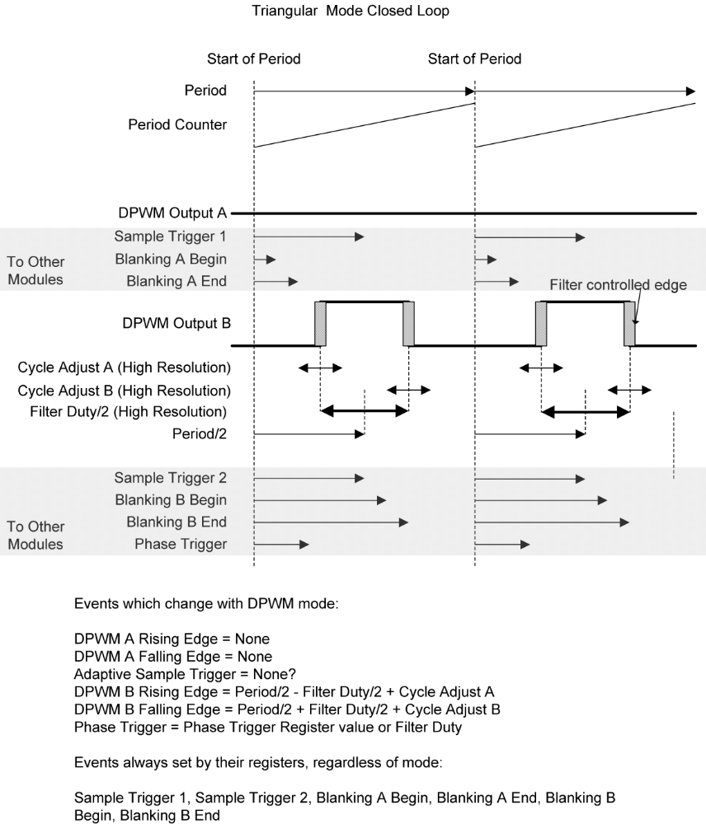
DPWM – Triangular Mode

三角模式下所有的脉冲边沿都是动态的，所以固定消隐是没用的。自适应采样触发也是不需要的。在开通期间的中点可很容易地固定一个精确采样触发点，因为在这种模式下，开通时间的中心点是不移动的。消隐A和B应用于DPWMB。

  - DPWM前导沿模式
前导沿模式与标准模式非常相似，时序上相反。DPWM A的下降沿是固定的，当滤波器的输出增加时其
上升沿是往左移动的或向时间段回退。DPWM B下降沿超前DPWM A一个固定的死区时间。以下为前导沿模式的图例：
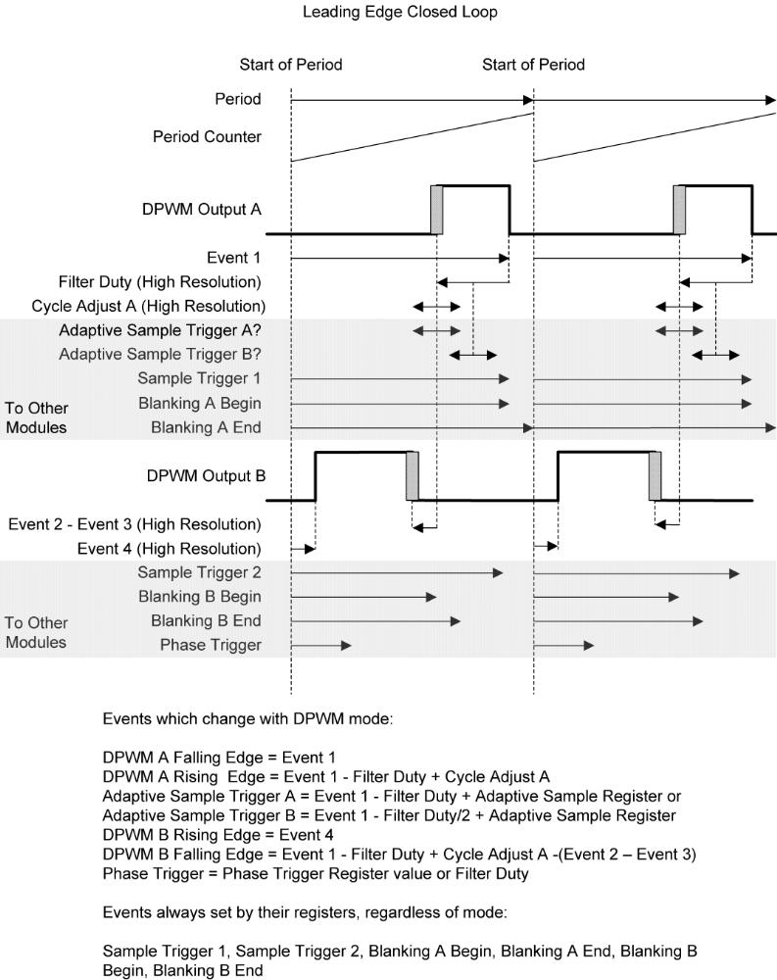

DPWM – Leading Edge Mode
与标准模式一样，周期中间的2个边沿（指DPWMA上升沿和DPWMB下降沿）是动态变化的，因而固定的消隐间隔主要用在周期开始或结束侧的2个边沿上（指DPWMA或B）。
2.9 同步FET的斜坡和理想二极管仿真计算
对于许多拓扑来说，用同步整流（SR）来代替二极管（整流）是有益的，一个熟知的概念是理想二极管仿真。在连续导电模式下，整流FET的控制是很简单的，因为其只要在主开关管整个关断时间内减去一个死区时间后均可开通。用标准模式可很完美处理好。同步FET的斜坡和理想二极管仿真计算仅在标准模式下有效。它与逐周期故障模块不兼容。（两功能不可得兼）。
然而，在非连续模式下，SR FET（整流开关管）需要在周期结束前关闭。UCD3138硬件提供了自动功能使其实现更轻松。在此情况下，DPWM B的下降沿是可调节的，见下图：
Normal Mode with Sync FET IDE and/or Ramp
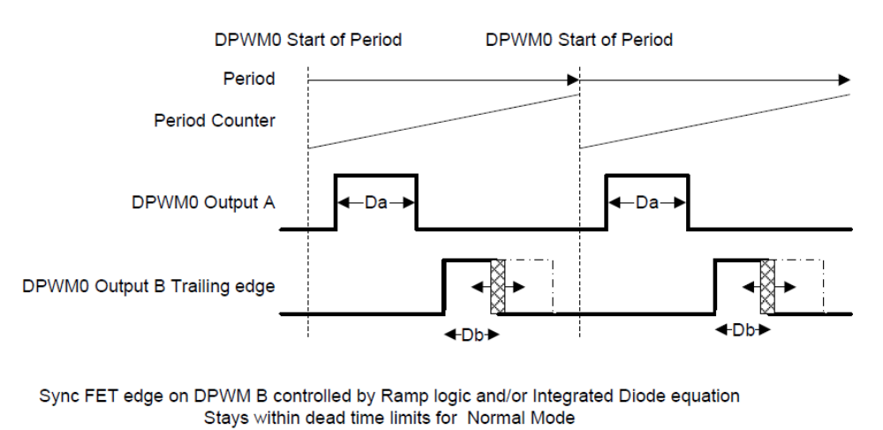
SyncFET IDE (Normal Mode)
数字硬件实现了算式 D_{b} = D_{a} ∗K_{d}。硬件测量Vin和Vout并计算Kd。例如对于Buck拓扑，（其算式为）
K_{d} = (V_{in} −V_{out})/ V_{out}，此处Da是控制主开关管的工作周期，Db是整流开关管的工作周期，Vin 是输入电压、 Vout 是输出电压。硬件定期测量缓慢变化的Vin和Vout，并将计算结果放入Kd寄存器中。DPWM硬件在每一个开关周期内调节Db（时间），甚至在引起Da快速变化的瞬变期间仍保持适当的理想二极管仿真。
当在prebias模式启动时也即在输出端仍存在电压时，完全精确二极管仿真就很难实现了。这个问题的一个解决办法是一个斜坡电压加在没有同步整流的目标上？，在电压稳定后再开通同步整流。当开通或关闭同步整流时，为了避免短时干扰脉冲进入稳定电压上，最好逐步地增加/减少同步开关管的开通时间。UCD3138提供了一个被称为Sync FET Soft-On/Soft-Off （斜坡）逻辑来完成这项工作。在章节3.3.8 Sync FET Soft
On/Off using Ramp Module（使用Ramp模块实现同步开关管的软启动和关闭）中有说明。前端中的Ramp模块就是实现这功能的。它既在标准模式实现斜坡限制功能，也在IDE逻辑中实现限制功能。
数字IDE使能后，因为系统是从非连续模式转变到连续导通模式（同步开关管在周期结束前都是导通的）IDE将停止减少同步开关管的脉冲宽度。这是因为通过同步开关管的反向导通将使Da和Db相同。在IDE通路中检测DCM（非连续导通模式）电流水平是很有必要的。一旦这个电平检测到后，同步开关管将斜坡降低，再通过IDE的使能返回斜坡。

2.10 Automatic Mode switching 自动模式切换
自动模式切换能使DPWM模块在没有任何固件干预下，模式之间自动切换。这有利于在某些拓扑中提高效率和电源工作范围及实现平滑系统性能（如单调启动）。下面提供一个在LLC拓扑中进行模式切换的例子。
2.10.1 谐振LLC例子
在谐振LLC拓扑中，使用了3种模式。在低功率情况下，使用了脉冲宽度调制方式（多模式中）。当（输出）功率增加和频率降低时，使用谐振模式。当频率仍较低时，仍采用谐振模式，但同步开关管的驱动变成固定导通时间并且不再提高（SR的脉宽钳位），下面是LLC的波形：
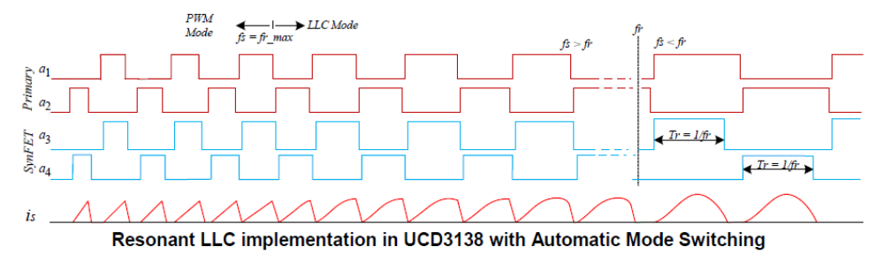
2.10.2 自动模式切换机制
许多DPWM的参数配置包括模式是在DPWM Control Register 1（控制寄存器1）中。因自动模式切换，有一些参数在Auto Config Mid 和Auto Config High registers中是重复的。
如自动模式切换功能允许，滤波器的Duty信号被用来选择这3个寄存器中的哪一个来使用。有4个寄存器（的数值）被用来选择模式切换发生点，以下显示它们的使用：
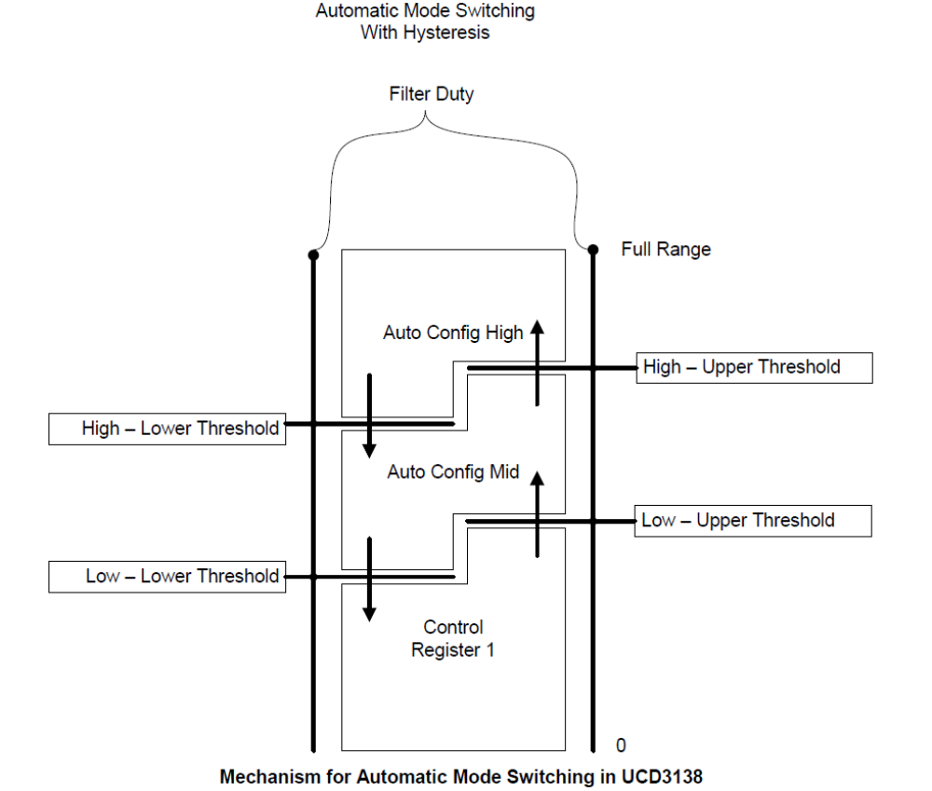
图中可看到，寄存器成对使用形成磁滞效应。从Control Register 1 转换到Auto Config Mid仅发生在当滤波器的Duty值大于Low Upper门槛值。直到其低于Low Lower门槛值时才返回到Control Register 1。这可防止在滤波器Duty靠近模式切换点时在模式间产生振荡。在某些应用中使得两个值相等以取消磁滞效应。这样做使得从2种模式过来的信号在模式切换点匹配正确。

2.11 DPWMC，Edge Generation，IntraMux （DPWMC、边沿生成、内部多路复选）
UCD3138还具有富有创建的硬件来产生更复杂的波形，其远超前面讨论的简单DPWMA和DPWMB波形。DPWMC、边沿产生及内部多路复选器在提供该能力时起到了关键的作用。
DPWMC是DPWM逻辑中的一个信号。其在消隐B开始变高，在消隐B结束时变低。
边沿产生模块需要取之于其自身的DPWM模块中的DPWMA和DPWMB信号，下一步使用他们来为2个输出产生边沿（脉冲）。对于DPWM3来说DPWM0被认为是它的下一个DPWM。每一个边沿（DPWMA和DPWMB的上升沿和下降沿）有8个影响它的选择。其选择是：
0 = DPWM(n) A Rising edge
1 = DPWM(n) A Falling edge
2 = DPWM(n) B Rising edge
3 = DPWM(n) B Falling edge
4 = DPWM(n+1) A Rising edge
5 = DPWM(n+1) A Falling edge
6 = DPWM(n+1) B Rising edge
7 = DPWM(n+1) B Falling edge
边沿产生由DPWMEDGEGEN寄存器控制。同样它具有使能/取消位。IntraMux由Auto Config寄存器控制。IntraMux从多路DPWMs及边沿产生器中获取信号。它可设置这些信号指向DPWMA和DPWMB输出。特别是对于像采用了全自动模式切换控制的全桥移相这样复杂的拓扑来说是很有用的。可通过对IntraMux为每一个DPWM A和B信号设置为Pass Through mode可取消该功能。如IntraMux置为允许那么高分辨率必须取消。
以下为Edge Gen/Intra Mux的图示：
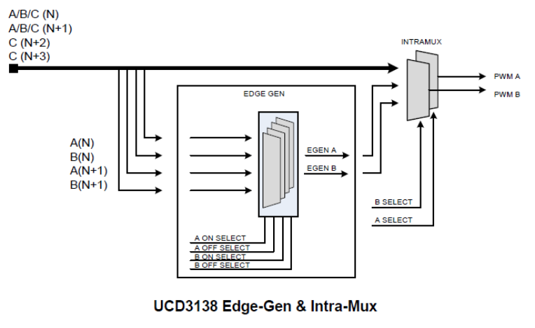
以下是IntraMux模式对DPWMA选项的列表：
0 = DPWMA(n) pass through (default) 缺省为直通
1 = Edge-gen output, DPWMA(n)
2 = DPWNC(n)
3 = DPWMB(n) (Crossover) 交叉
4 = DPWMA(n+1)
5 = DPWMB(n+1)
6 = DPWMC(n+1)
7 = DPWMC(n+2)
8 = DPWMC(n+3)
以下是IntraMux模式对DPWMB选项的列表：
0 = DPWMB(n) pass through (default)
1 = Edge-gen output, DPWMB(n)
2 = DPWNC(n)
3 = DPWMA(n) (Crossover)
4 = DPWMA(n+1)
5 = DPWMB(n+1)
6 = DPWMC(n+1)
7 = DPWMC(n+2)
8 = DPWMC(n+3)
DPWM的数字循环与Edge Gen单元一样。对于DPWM4（应该该值就是n+1），DPWM(n+1)是DPWM0，DPWM(n+2)是DPWM1，等等。
注意在Edge Gen和IntraMux单元前的Fault logic影响Fault module模块（参见2.1章节的DPWM块图表）。故障的影响必需计算考虑进Edge Gen 和 IntraMux单元的影响（因素）。

2.12 不同DPWM寄存器的时间分辨率
DPWM块中不同寄存器具有不同的时间分辨率。脉冲宽度通常以250pS的步长调节，而周期和相移以4nS的步长调节。采样触发以16nS的步长来调节。

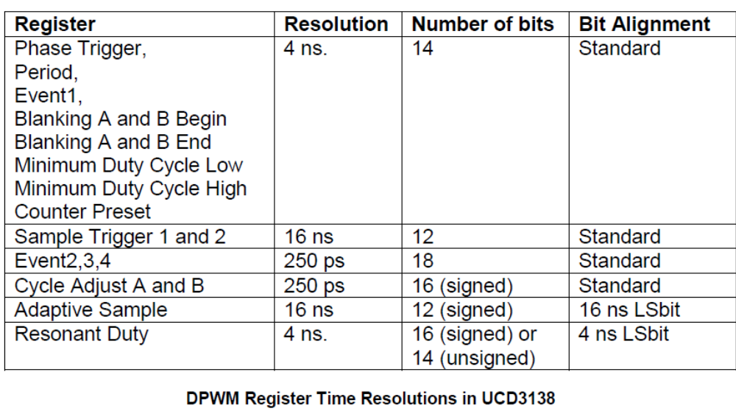
在UCD3138里，除Resonant Duty 和 Adaptive Sample register外，所有寄存器以符合其范围的位字段排列。允许正负调节带符号的寄存器除了：2 adjust registers、Resonant Duty 及 Adaptive Sample register外，其余寄存器值均为无符号数。
Resonant Duty register用于UCD3138 LLC 参考固件（用于UCD3138LLCEVM-028 EVM）是作为无符号14位寄存器。它也能用作为16位带符号寄存器。参见第34页2.21章节的Resonant Duty Register。
也就是说，Phase Trigger、Period 及 Event1 registers省略最后4位有效位，见下图：
DPWM Period Register (DPWMPRD) – 其它所有带有标准排列的 4 ns 寄存器都是一样的。
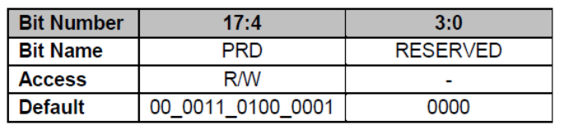

Sample Trigger registers省略最后6位有效位，见下图：
DPWM Sample Trigger 1 Register (DPWMSAMPTRIG1)
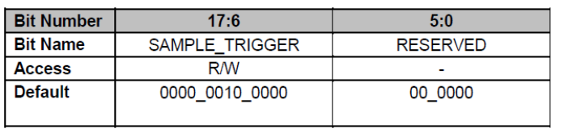
仅Event 2, 3, and 4 registers使用了18位字段，见下图。
DPWM Event 2 Register (DPWMEV2) – Event 3、4 相同， Cycle Adjust registers仅到15位。
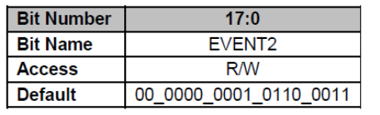
在所有寄存器中，每一位在时间段中占有相同的权重。这使得配置简单，因为所有寄存器的装载能使用相同的时间基准。
要使用这一特点，可使用寄存器结构的 .all 扩展符。位字段中不包括寄存器的省略位。
这些C语句都是将100uS放入相应寄存器中。注意“低”分辨率时钟是4nS，“高”分辨率为250pS,因而写入相应的寄存器的数值分别为2500和40000。
Dpwm0Regs.DPWMPRD.all = 40000; //包含4个未使用的最低有效位
Dpwm0Regs.DPWMPRD.bit.PRD = 2500; //仅放入PRD的位字段 = 40000/16
Dpwm0Regs.DPWMEV1.all = 40000; //包含4个未用位
Dpwm0Regs.DPWMEV1.bit.EVENT1 = 2500; //EV1 是仅有的低分辨率事件寄存器
Dpwm0Regs.DPWMEV2.all = 40000; //EV2 是高分辨率，因而
Dpwm0Regs.DPWMEV2.bit.EVENT2 = 40000; //与上一个相同
Dpwm0Regs.DPWMSAMPTRIG1.all = 40000; //包含6个未用的最低有效位
Dpwm0Regs.DPWMSAMPTRIG1.bit.SAMPLE_TRIGGER = 625; //对于6位来说需除以2⁶＝64
adaptive sample 和 resonant duty registers未按照标准位排列。它们的最低有效位分别代表16nS和4nS。

2.13 PWM计数器和时钟
PWM计数器是DPWM逻辑的中心。没有那个寄存器可以用来读出PWM计数器的值，而大多数的事件都需要它来触发。在所有的模式中均允许计数至整个周期值，然后再清零重启动。因其从零开始重启，故其周期从技术上来说应该是PERIOD+1。因此在以上的例子中，实际数值应为2499.通常这个误差不重要。除了谐振模式外的所有模式，周期是固定的值。在谐振模式周期的数值来自于滤波器的输出。
PWM计数器在收到同步信号时也可重启（假如同步使能），像以上第17页章节2.4 DPWM移相模式。
精确在周期末端接受到的同步信号运行非常平稳。在周期其它点上接收到同步信号将重新启动计数器和周
期计数。这样做应该为每一个应用考虑其产生的结果。
虽然周期寄存器只有14位，PWM计数器的有效位有18位。每个4nS周期被细分成16个名义上的250pS的间隔长度。附加的4位代表这些被称作为“高分辨率位”间隔。

2.14 DPWM 寄存器—概述
这个章节讨论每一个寄存器，带有他们恰当使用的例子。同时附带了与其相关的许多其它外设，他们中的部分在下面也有描述。

2.15 DPWM Control Register 0 (DPWMCTRL0)
DPWM Control Register 0是配置DPWM的3个DPWM控制寄存器之一。所有3个寄存器控制了各种DPWM的功能。在3个寄存器之间不可能画出一个明确的分界线。
2.15.1 DPWM Auto Config Mid 和 Max 寄存器
有2个其它寄存器—DPWMAUTOMAX和DPWMAUTOMID，它们和Control Register0有许多相同的位。
这两个自动模式切换寄存器（AMS）被用于当滤波器输出变化时自动改变DPWM模式的拓扑中，如谐振和全桥相移。参见第22页章节2.10.2的自动切换模式机制，在模式切换中获得更多的自动切换电平寄存器信息。
不是所有的DPWMCTRL0位和Auto寄存器位重复。仅DPWMCTRL0中的位值被用于所有模式。基于LLC和PSFB拓扑需要切换模式的位被选中。随后的位字段描述判断是否每个字段在自动模式切换寄存器都存在。
2.15.2 Intra Mux （内部多路复用）
Intra Mux 位字段，PWM_A_INTRA_MUX 和 PWM_B_INTRA_MUX 允许从不同源来的信号复用成DPWMA和DPWMB2个输出。此功能用于全桥和半桥拓扑中。该位字段的缺省值为0，代表正常功能，具有如上章节描述的模式介绍，在DPWMA和DPWMB引脚上产生标准的DPWM波形。Intra Mux更详细的介绍见第23页2.11章节的 DPWMC, Edge Generation, IntraMux
这些字段在AMS寄存器里同样存在。
    - Cycle by Cycle Current Limit 使能
有几个使能位与逐周电流限制相关：
DPWMCTRL0 包含：
CBC_PWM_C_EN
CBC_PWM_AB_EN
CBC_ADV_CNT_EN
CBC_SYNC_CUR_LIMIT_EN
CBC_BSIDE_ACTIVE_EN
除了CBC_BSIDE_ACTIVE_EN，所有其它位在AMS寄存器中都存在。
前2个，CBC_PWM_C_EN 和 CBC_PWM_AB_EN简单的对相应信号使能逐周电流限制。在所有模式里，CBC_PWM_EN对DPWMC有独立的影响。其它位对DPWMC无影响。
其它3个位在不同的模式下有不同的影响。下面为其影响：

标准模式
在标准模式下，一个CBC事件将在由CLA(滤波器以前的称呼)决定时间前引起DPWMA变低。DPWMB的死区时间将保持，因此DPWMB的上升沿将向前移动一个跟DPWMA下降沿（距离）相同的时间（应该是死区时间）。
在标准模式设置CBC位只有2个选择：
- 全部清零，没有CBC功能。
- 设置CBC_PWM_AB_EN 和 CBC_ADV_CNT_EN位得到CBC功能。
CBC_BSIDE_ACTIVE_EN没有影响。标准模式对负死区时间也有一些支撑如在CBC逻辑。甚至负死区时间的保持。在下图可以看到，假如有个负死区时间，在DPWMA上的最小脉冲宽度将等于死区时间。保持负死区时间，CBC将触发DPWMB的上升沿。当死区时间到后，DPWMA变低。
当然，对于正死区时间DPWMA将随CBC时间下降，DPWMB在死区时间到后再上升。
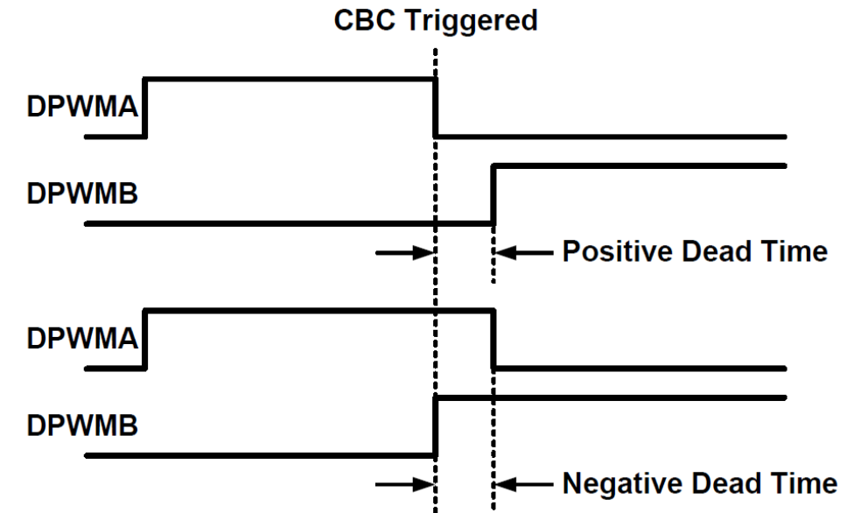
即使DPWMB被用作为GPIO。对Event 3为CBC编程死区时间是很重要的。

谐振/多模模式
在谐振/多模模式，系统通常是对称的。在这种情况下，DPWMB可能需要通过外带CBC故障逻辑来控制。有时在一个DPWM针输出一个很短的开通时间需要在另一个DPWM针上随后也产生一个等长的开通时间用以防止在电容或电感上建立偏置（电压）。对于这种情况，可以通过使能该2种模式的duty cycle matching（占空比匹配）位实现。如果DPWMA或DPWMB被CBC事件打断，在下一个脉冲另一个DPWM针将被缩短至相同的长度。

下面为谐振和多模模式状态：
- 全部清零---无CBC功能
- 仅CBC_PWM_AB_EN置1--- CBC on A，无占空比匹配
- 仅CBC_PWM_AB_EN 和 CBC_BSIDE_ACTIVE_EN置1---CBC on A、B，无匹配
- 三个位都置1 --- CBC on A、B，占空比匹配
- CBC_PWM_AB_EN 和 CBC_ADV_CNT_EN 置1，CBC_BSIDE_ACTIVE_EN 不设置
------------------------ CBC on A，B占空比匹配到A

真值表
CBC_PWM_AB_EN | CBC_ADV_CNT_EN | CBC_BSIDE_ACTIVE_EN | CBC A | CBC B | Duty match
0 | X | X | 0 | 0 | 0
1 | 0 | 0 | 1 | 0 | 0
1 | 1 | 0 | 1 | 0 | B matches A
1 | 1 | 1 | 1 | 1 | 1
CBC_SYNC_CUR_LIM_EN位用于控制从同步。假如该位设置，在电流限制期间从同步是先进的。这种设置任何拓扑配置都不在这个期间使用。假如该位设置，如CBC故障发生，从DPWM中就会出现同步输出脉冲。如在周期期间CBC故障未发生，同步脉冲将依据同步控制位字段的正常设置输出。
对CBC电流限制的更多信息，参见第58页第6章 Fault Mux
2.15.4 多模方式的开/关
MULTI_MODE_CLA_A_OFF 和 MULTI_MODE_CLA_B_OFF位仅表示多模方式下各个DPWM针哪一个被用来计算。在其它模式它们不能设置。假如该位被清零，DPWM针的开通时间由滤波器输出控制。卢设置该位，时间寄存器控制其开通时间。
AMS（自动模式切换）寄存器只有MULTI_MODE_CLA_B_OFF位，没有MULTI_MODE_CLA_A_OFF位。
2.15.5 最小占空比模式
MIN_DUTY_MODE位选择DPWM如何处理最小占空比限制。
a: 0缺省――滤波器输出直通到DPWM
b: 1 ――输出在最小值以上，滤波器值直通。假如低于最小值，DPWM无脉冲输出
c: 2 ――输出在最小值以上，滤波器值直通。假如低于最小值，DPWM脉冲宽度＝最小值
有2个寄存器设定最小占空比和滞延：
DPWMMINDUTYLOW
DPWMMINDUTYHI
低位寄存器设置了当占空比下降时哪一个最小占空比模式起作用的点（值）。在MIN_DUTY_MODE为2时，它也设置了最小占空比。
高位寄存器设置了当占空比升高时哪一个最小占空比模式退出的点。
在AMS registers中这些位是不重复的。
下面2张图显示了在MIN_DUTY_MODE位为1和2时，DPMMINDUTYLOW=30, DPWMMINDUTYHI =70。
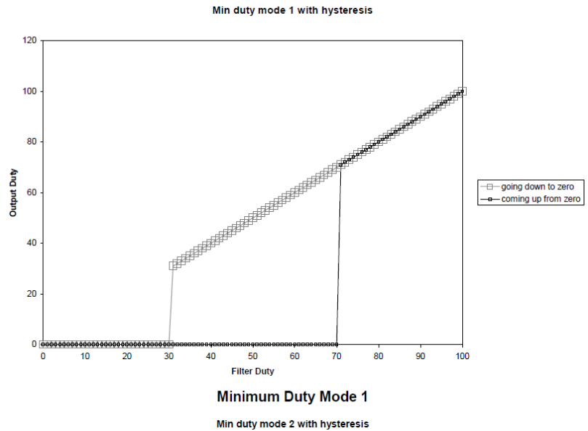
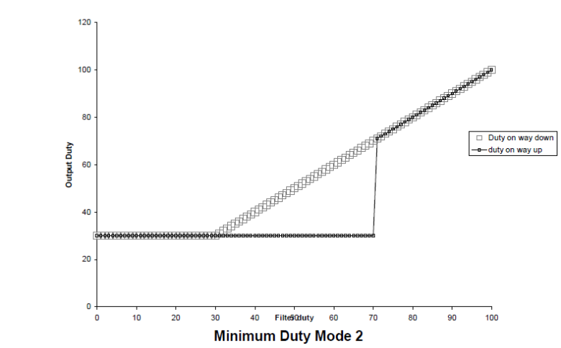
2.15.6 主同步控制选择
MASTER_SYNC_CNTL_SEL位选择DPWM通道的同步输出来自哪儿。缺省值为0，使得从相位触发寄存器来的同步信号延时。这对于两相之间有固定间隔的系统很有用，如像交叉PFC和全桥硬开关。见19页2.4节的DPWM Phase Shift Mode。
对该位置1使得滤波器的输出控制主同步输出。
该位在AMS 寄存器（自动模式切换）中是重复的。

2.15.7 主同步被动使能
设置MSYNC_SLAVE_EN位使能DPWM通道相对于其它DPWM通道的同步输出为从（模式）。这个位在章节Loop Mux中与DPWMMUX寄存器中的DPWMx_SYNC_SEL位一起工作。下面的例子代码是使DPWM1为DPWM0的从模式：
LoopMuxRegs.DPWMMUX.bit.DPWM1_SYNC_SEL = 0; //DPWM1 is slave to DPWM0
Dpwm1Regs.DPWMCTRL0.bit.MSYNC_SLAVE_EN = 1; //enable slave mode for DPWM1
这个位在AMS寄存器中不重复

2.15.8 D使能
一般的，滤波器D被用于直接设置DPWM针的开通时间。换句话说，OnTime =D。D_ENABLE位也可用来使OnTime = 1-D 来替代。
缺省设置（0）使滤波器的输出直接用于DPWM输出的计算。因而在多模模式下，例如，当滤波器D增加时DPWMA和DPWMB的开通时间增加。
然而，假如D_ENABLE位置1，滤波器D从周期寄存器中减去。在这种情况下，当滤波器D从0增加到满量程。开通时间将从周期的100％减少到周期的0％。
该位在AMS寄存器中是不重复的。

2.15.9 谐振模式固定占空比使能
RESON_MODE_FIXED_DUTY_EN位仅控制谐振模式下的占空比宽度。在缺省值（0）时，占空比直接从滤波器输出。这种用于上述的低谐振频率，Fmin（最小频率），提供一个1/2周期减去一个最小的固定死区时间的占空比。设置该位时，脉冲宽度将由Auto Switch High Upper Threshold Register产生。该位通常仅用于设置输出频率低于电路的最低谐振频率模式下的LLC的同步整流。在这种点上，任何的脉宽上升都是无益的，
因而其停止增加。在第22页的2.10.1节有这种模式的波形显示。
该位在AMS寄存器中是重复的。

2.15.10 DPWMA和B的故障极性
PWM_A_FLT_POL 和 PWM_B_FLT_POL位可提升DPWM的灵活性，通过（设置）允许在故障情况下使DPWM针输出任意状态。当DPWM禁止时，这些位值仍将会出现这些管脚上。这些值会精确地出现在DPWM的故障模块的输出上。因此，假如IntraMux 或 Edge Generation units使用的话，同样的数值就不会出现在DPWM的输出上。
当芯片复位后，这些位不再影响DPWM的状态。复位后，所有的DPWM管脚被配置成输出及有效驱动为低电平。
这些位在AMS寄存器中不重复。

2.15.11 消隐使能
BLANK_A_EN 和 BLANK_B_EN位用于故障检测。它们工作于消隐寄存器（blanking registers）--见35页2.26节的Blanking Registers—为电流限制检测使能消隐，噪声可能会使CBC故障检测出错。
这些位在AMS寄存器中不重复。

2.15.12 DPWM 模式
PWM_MODE位选择DPWM的模式。请参见DPWM引用部分的模式数字，以及上面章节对不同模式的描述。
这些位在AMS寄存器中重复。

2.15.13 DPWM 输出倒置（反相）
PWM_A_INV 和 PWM_B_INV位翻转DPWMA和DPWMB引脚的输出。
然而当芯片复位后，这些位不影响DPWM的状态，复位后，所有的DPWM管脚配制成有效驱动为低电平的输出。
这些位在AMS寄存器中不重复。

2.15.14 滤波器使能（CLA_EN）
在以往，滤波器被称作为Control Law Accelerator（控制律加速器），因而因历史原因，滤波器使能位被叫成CLA_EN。当该位置1时，DPWM把滤波器作为输入。否则，DPWM的输出仅来自于DPWM的寄存器。
这些位在AMS寄存器中重复。
由Loop Mux中的DPWMMUX寄存器中的DPWMx_FILTER_SEL位选择哪个滤波器控制每个DPWM。

    - DPWM 使能
PWM_EN位置1时将使能DPWM通道。如置0（缺省值）DPWM的输出由DPWM 故障极性位的值决定（29页2.15.10 DPWM A and B Fault Polarity章节）。
该位仅在Control 0 register出现，不在AMS registers中。
2.16 DPWM Control Register 1
像DPWMCTRL0一样，DPWMCTRL1寄存器包含了许多DPWM的控制位。

2.16.1 Period Counter Preset Enable 周期计数器预置使能
PRESET_EN位为多个具有不同的周期启动时间的DPWM模块系统增加了灵活性。它可用于同时启动所有的DPWM，甚至它们的周期不在同个时间启动。它也可用于这些DPWMs间的同步。
一般地，周期计数器由3种事件复位：
1：DPWM 使能
2：接收到同步信号（被动模式使能）
3：计数器到达周期寄存器的值
假如PRESET_EN允许，这就变成：
1：DPWM 使能 －周期计数器置为预设值
2：接收到同步信号（被动模式使能）－周期计数器置为预设值
3：计数器到达周期寄存器的值－周期计数器置0
2.16.2 Sync FET Ramp Enable 同步场效应管斜坡使能
SYNC_FET_EN位可使同步FET斜坡逻辑来控制DPWMB。更多的斜坡逻辑请参见第43页3.3.8节的Sync FET Soft On/Off using Ramp。提供斜坡数据前端由Loop Mux的DPWMMUX寄存器来选择。下面的代码是使能DPWM0的同步FET斜坡，可设置前端0（FE0）斜坡引擎提供斜坡源。
LoopMuxRegs.DPWMMUX.bit.DPWM0_SYNC_FET_SEL = 0; // FE0使用斜坡引擎
Dpwm0Regs.DPWMCTRL1.bit.SYNC_FET_EN = 1; // 使能同步FET斜坡
同步FET斜坡逻辑把DPWMB的脉冲宽度从一个起始点到宽度斜性变化，其由标准模式控制或由IDE 功能实现（需使能）。它只能工作在标准模式。

2.16.3 Burst Mode Enable 突发模式使能
设置BURST_EN位允许该DPWM具有突发（轻负载）模式。更多的轻负载模式信息，见the light load章节。

2.16.4 Current/Flux Balancing Duty Adjust 电流/磁通量平衡调节
设置CLA_DUTY_ADJ_EN位允许电流平衡逻辑来修改DPWM的输入，因而该DPWM控制的电流能被由同个UCD3138的另一个DPWM控制的电流平衡。更多信息。见电流平衡章节。

2.16.5 Sync Out Divisor Selection 同步输出分频选择
SYNC_OUT_DIV_SEL位字段选择一个除法因子产生同步输出脉冲到在外部同步输出管脚上。该位仅对同步输出有效，不针对输送至其它DPWMs的内部芯片同步信号。该因子由4位，范围位1到16。
因子= SYNC_OUT_DIV_SEL + 1。位字段为0将给出因子为1，1给出因子2，等等……

2.16.6 Filter Scale 滤波器标定
CLA_SCALE位段控制滤波器Duty输出移位在被DPWM使用前。有效移动范围为右移3位到左移3位。这些位不改变滤波器周期。缺省值为0不引起移位。移位表格，参见95页DPWM Control Register 1 (DPWMCTRL1)8.2节的DPWM reference。
这能用于同一滤波器输出需要不同频率点的不同电路的复杂拓扑中。它也可用于改变所有滤波器的增益。

2.16.7 External Sync Enable 外部同步使能
设置EXT_SYNC_EN位使得DPWM的Sync in引脚作为同步源输出。
2.16.8 Cycle By Cycle Bside Active Enable
更多的CBC_BSIDE_ACTIVE_EN位，见以上26页2.15.3章节的 Cycle by Cycle Current Limit Enable。
2.16.9 Auto Mode Switching Enable 自动模式切换使能
AUTO_MODE_SEL位，当设置时，使能自动模式切换。
2.16.10 Event Update Select 事件更新选择
EVENT_UP_SEL使能4个不同DPWM的事件更新模式。DPWM需要一个72nS(名义上的)的时间去更新它的下一个时间周期。在此期间，它接受最终的滤波器输出、任意固件改变寄存器值及重新计算DPWM信号的时间。选择更新的时间不应该有任何的DPWN边沿的进出窗口。
注意：假如DPWM边沿进出事件更新窗口，这些传输有可能丢失，导致DPWM脉冲比期望值更长或更短。
更新模式为：
0---当滤波器计算完成时
1---在周期结束（在周期结束时启动，并且延伸72nS到新周期开始后）
2---在采样触发2设定的时间
3---在周期结束和采样触发2设定的时间
注意除模式1外，其它所有模式使得事件更新时间依据于采样触发的位置。对于大多数拓扑来说，使用模式1时死区时间或最小脉冲宽度被用于保证边沿移出DPWM周期的最初72nS。请参见由ucd3138 EVMs提供的固件代码参考得到每个拓扑的具体指导。

2.16.11 Check Override 检查闭锁
CHECK_OVERRIDE位，当置1时，闭锁DPWM的内部检查。DPWM检查将防止事件设置/周期设置无效放置或无效配置。
设置该位对某些拓扑是有必要的。
2.16.12 Global Period Enable 全局周期使能
GLOBAL_PERIOD_EN位，如置1，允许使用全局周期寄存器来提供DPWM的周期。它用于多路DPWMs和需要频率抖动的系统中。可用于在某点改变多路DPWMs的频率。更多信息见56页5.8节的PWM Global Period Register (PWMGLBPRD)。
2.16.13 Using DPWM Pins as General Purpose I/O 采用DPWM引脚用作通用I/ O
在DPWMCTRL1中有6位可用来使得DPWM引脚作为通用I/O引脚使用：
这些位可立即起作用。
PWM_A_OE ---当DPWMA作为GPIO时 0为输出；1位输入
PWM_B_OE ---当DPWMB作为GPIO时 0为输出；1位输入
GPIO_A_VAL ---当DPWMA作为输出时，其引脚的输出值
GPIO_B_VAL ---当DPWMB作为输出时，其引脚的输出值
GPIO_A_EN ---当置1时，DPWMA作为GPIO使用
GPIO_B_EN ---当置1时，DPWMB作为GPIO使用
此外，在DPWMOVERFLOW register中有2位也用于GPIO的设置
GPIO_A_IN ---DPWMA作为输入时，代表其引脚的电位高低
GPIO_B_IN ---DPWMB作为输入时，代表其引脚的电位高低
2.16.14 高分辨率允许/禁止
所有以这样或那样方式来允许/禁止高分辨率模式的有5个位（控制）
PWM_HR_MULT_OUT_EN ---仅为多模方式设置
HIRES_SCALE (2 bits) ----设置DPWM high res block的分辨率
ALL_PHASE_CLK_ENA ----使能所有相或仅需要的相
HIRES_DIS ----------------------禁止high res logic高分辨率逻辑
通常规则是，当高分辨率不可能时所有位被禁止，当高分辨率可能和需要时所有位应允许。
2.16.15 Asynchronous Protection Disable 异步保护禁止
PWM_A_PROT_DIS 和 PWM_B_PROT_DIS该2位用于禁止它们对应管脚上的异步保护。请请教具体提供UCD3138 EVM的参考固件代码中关于是否在所需的拓扑设置这些位的指导。
2.16.16 Single Frame Enable 单帧使能
SFRAME_EN位使能从DPWM输出一个单帧（信号）。这是很有用的从DPWM上输出一个单帧脉冲、触发一个单独前端和滤波器周期。它可用来例如测量一个隔离电源的输入电压时，使用单帧使能，初始化DPWM模件并设置SFRAME_EN位及使能DPWM全局寄存器。其实启动单帧脉冲是设置PWM_EN位。这将触发单帧信号。

2.17 DPWM Control Register 2 DPWM控制寄存器2
DPWMCTRL2寄存器，象其它2个控制寄存器具有位字段的宽泛选择。
2.17.1 External Synchronization Input Divide Ratio 外同步输入分频比率
SYNC_IN_DIV_RATIO位字段有4位，在复位时初始化为0。它们为从外部和另外DPWM来的同步（信号）设置分频比率。分频比率为位字段的值加上1。因此0代表除以1，1为除以2，等等……。
2.17.2 Resonant Deadtime Compensation Enable 谐振死区补偿允许
设置RESON_DEADTIME_COMP_EN位允许对从滤波器来的CLA Duty信号进行死区调节。这个仅对谐振模式起作用的补偿使得全频率范围内的谐振模式具有固定不变、对称的死区时间。通常这是LLC最好的配置。假如该位不设置，CLA Duty信号不调节使用。这使得DPWMA输出为50% Duty + Cycle Adjust A，DPWMB输出50%Duty - dead time +Cycle Adjust B，此不能为全频率范围的LLC（回路提供）对称的DPWMA和DPWMB信号。
2.17.3 Filter Duty Select 滤波器占空比选择
FILTER_DUTY_SEL位字段有2位，从3个模式中选择。这些值所选择的模式被送至Filter Duty multiplicand multiplexer（滤波器占空比被乘数多路复用器）的Resonant Duty input输入端。例如，假如LoopMux.FILTERMUX.FILTER0_PER_SEL设置为0，滤波器0的OUTPUT_MULT_SEL位设置位3，那么FILTER_DUTY_SEL将选择滤波器占空比被乘数。这个值将与滤波器的输出相乘并使其适合DPWM的范围。
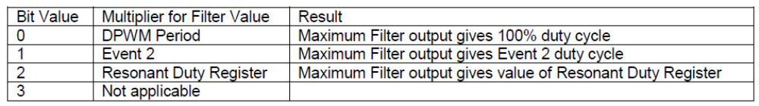
模式2用于LLC的谐振模式。
2.17.4 为DPWMB设置的理想二极管仿真（IDE）允许
设置IDE_DUTY_B_EN位使得数字IDE逻辑用于DPWNM的控制。使用IDE逻辑可使同步FET在合适的时间关闭，仿真一个理想的二极管（具有低压降的二极管）。参见21页2.9节更详细的描述：Sync FET Ramp and IDE Calculation。
2.17.5 Sample Trigger 1 Oversampling 采样触发1过采样
很早提及过，DPWM模块产生的信号生成一个在前端误差ADC上的采样触发。DPWMs也能提供过采样功能用于采样触发的协调。SAMP_TRIG1_OVERSAMPLE位字段可实现前端2、4、8次过采样。采样点均匀地分布在时间段，在周期的起始点启动，最后一个采样点在采样触发1点。
其位字段选择为：
0--- 1个采样值在采样触发时间（点）
1--- 1个采样值在1/2采样触发点，另一个值在采样触发点
2--- 4个采样值在采样触发点的1/4、2/4、3/4和4/4
3--- 8个采样值在采样触发点的1/8、2/8、3/8、4/8、5/8、6/8、7/8、8/8
采样触发1既能用于触发前端和滤波器的完整周期，也可用于空间平均的采样，见前端章节，特别是38页的3.1.5 的误差AD转换平均。
2.17.6 Sample Trigger 1 Mode 采样触发1模式
另外在过采样中，采样触发1提供几个计算模式。SAMPLE_TRIG1_MODE位字段有4个选择：
0---采样触发设置为使用采样触发寄存器（DPWMSAMPTRIG1）
1---采样触发= Event 1 + (DUTY/2) + Adaptive Offset where Duty is most recent Filter Duty（本周期）
2---采样触发= Event 1 + (DUTY/2) + Adaptive Offset where Duty is Filter Duty from last cycle（上周期）
3---采样触发= Event 1 + DUTY + Adaptive Offset + Fixed Offset where Filter Duty is from last cycle
在本章前的图中，选择1被称作为Adaptive Sample Trigger B，选择3被称为Adaptive Sample Trigger A
Adaptive Offset（自适应偏置）来自于DPWMADAPTIVE registe，是一个11位带符号的寄存器。如没有自适应偏置，在标准模式及多模模式下采样触发将位于DPWMA导通波形的中间。自适应偏置用于门驱、FET导通时间和电压电流传感电路系统的正确延时。正确使用自适应偏置可使采样触发设置在电压或电流导通时间的中间。自适应偏置寄存器和采样触发寄存器有相同的分辨率（16nS）。自适应寄存器虽然没有相同的映射。位0是第一个可用位。参见DPWM参考章节获得更多的信息。
注意：在占空比变化引起某些变化时，使用自适应偏置将引起控制环路的相位延时。
模式3中的固定偏移值为4。这个值被加在DPWMADAPTIVE Register、Event 1 and Duty Terms。
2.17.7 采样触发使能位
采样触发2仅由Sample Trigger 2 Register驱动-- DPWMSAMPTRIG2.设置SAMPLE_TRIG_2_EN位使能Sample Trigger 2。
SAMPLE_TRIG_1_EN使能Sample Trigger 1。

2.18 Period and Event Registers 周期和事件寄存器
周期和事件寄存器DPWMPRD、DPWMEV1、DPWMEV2、DPWMEV3和 DPWMEV4在不同的模式下有不同的影响。见以下DPWM模式获得更多关于各个模式的更多信息。一般寄存器工作如上所述在页面13第2.2节介绍的DPWM。通常脉冲宽度是由滤波器来控制的，在事件寄存器中的不同是用于死区时间。

2.19 Phase Trigger Register 相位触发寄存器
DPWMPHASETRIG寄存器是个低分辨率（4nS）寄存器。以4nS为基数，在周期的起始到为一个从模式的DPWM同步输出一个同步脉冲之间提供步长。见17页2.4节DPWM Phase Shift Mode。

2.20 Cycle Adjust Registers 周期调节寄存器
DPWMCYCADJA 和 DPWMCYCADJB是附加在DPWM脉冲宽度计算之前的滤波器占空比上的寄存器。它们在不同的模式有不同的响应，参见以上的DPWM模式章节。它们是带符号的高分辨率寄存器，因而占空比能被从滤波器来的值增加或减少。它们仅有16位，因而不能调节DPWM的18位全量程。但它们的范围是在±8mS,其通常超过整个开关周期。
高分辨率是250pS，16位带符号值为±2¹⁵。所以2¹⁵×250pS=8.192mS。

2.21 Resonant Duty Register 谐振占空比寄存器
这寄存器用于LLC拓扑来产生正确的滤波器占空比输出。滤波器输出是乘以这个寄存器来计算滤波器的占空比。在LLC参考固件中（UCD3138LLCEVM-028）它被设置成1/2最大需要周期。在这种情况下，位13-0被用于带符号的数值。使能这种模式。DPWM必定是谐振模式，DPWMCTRL2中的FILTER_DUTY_SEL字段必须设置为2。
如果FILTER_DUTY_SEL位设置为0或1并且DPWM在谐振模式，寄存器内的16位带符号内容加上滤波器周期值，其结果用于DPWM的周期。这是另一个选项调整谐振模式的时机来匹配一个其他模式的转变。这种模式在所有拓扑中很少用（不流行的）。

2.22 DPWM Fault Control Register DPWM故障控制寄存器
参见Fault Mux节的DPWMFLTCTRL register信息。

2.23 DPWM Overflow Register DPWM溢出寄存器
DPWMOVERFLOW寄存器（已经提及）当DPWM用于通用I/O功能是，有2个位给出了DPWM针的输入状态。
它还有6位表示DPWM故障逻辑检测到的溢出位。

2.24 DPWM Interrupt Register DPWM中断寄存器
DPWMINT寄存器具有中断使能位、中断标志、一个中断标志清除位和一个中断范围寄存器。
更多关于故障（中断）使能位和标志，参见Fault Mux Reference章节。
2.24.1 DPWM Period Interrupt Bits DPWM周期中断位字段
与周期中断相关的有3个位字段。
PRD是个代表一个周期中断产生的标志。它仅是个选通信号，所以它不象那种一旦置位永远可读一样。假如中断位被置位并且没有其它位被置位，这就意味着周期中断位已经被置位。
PRD_INT_EN使能周期中断。
PRD_INT_SCALE为周期中断编程一个因子。中断的选择范围为每一个周期到256个周期一次中断，见DPWM Reference章节的表图。
注意假如DPWM禁用，而周期中断使能，大多数情况下，它将连续不断地产生周期中断。
2.24.2 Mode Switching Interrupt Bits. 模式切换中断位字段
与模式切换相关的位字段有3个。
见35页的2.29节DPWM Auto Switch Registers获取更多关于模式切换的信息。
当DPWM已经切换模式时，MODE_SWITCH变高。
MODE_SWITCH_INT_EN使能该中断。
在上升沿时MODE_SWITCH_FLAG_CLR清除MODE_SWITCH位。该位不是自动清除的，因此采用固件来清除时一定要在下个上升沿前。
2.24.3 INT bit
INT位表示了一个或更多个中断标志被设置和使能，DPWM被发送一个中断到Central Interrupt Module (CIM中断模块中心)。当中断位被清除时，INT位仍可显示。

2.25 DPWM Counter Preset Register DPWM计数器预置寄存器
假如使能的话，DPWMCNTPRE寄存器内容在DPWM启动或同步沿上升时下载到Period Counter周期计数器中。这种方式应用于需要在DPWMs之间复杂同步和相移操作。见30页2.16.1节的Period Counter Preset Enable获取更多信息。

2.26 Blanking Registers 消隐寄存器
在每个DPWM中有4个消隐寄存器：
DPWMBLKABEG DPWMA 消隐起始
DPWMBLKBBEG DPWMB 消隐起始
DPWMBLKAEND DPWMA 消隐结束
DPWMBLKBEND DPWMB 消隐结束
DPWM A和B有2个消隐周期，每个有起始和结束2个周期，以4nS步长测量周期计数器。
这些寄存器用于消隐CBC信号中的噪声时段的信号，例如围绕着硬件切换期间。更多信息见Fault Mux节。也可用于具有不同死区时间的多个DPWMs间的电流限制响应时间的对齐（达到同一时刻采样目的）。
消隐B的值也可用于产生DPWMC信号以实现内部多路的复杂拓扑。见26页2.15.2,章节的Intra Mux。

2.27 DPWM Adaptive Sample Register DPWM自适应采样寄存器
DPWMADAPTIVE寄存器用于自适应采样触发模式，见33页2.17.6 Sample Trigger 1 Mode得到更多信息。

2.28 DPWM Fault Status Register DPWM 故障状态寄存器
DPWMFLTSTAT寄存器中的某些位可指示故障：IDE探测、突发模式（轻载）探测。见Fault 章节关于故障、IDE 章节关于IDE以及Light Load mode 章节关于Burst mode。

  - DPWM Auto Switch Registers DPWM自动切换寄存器
请参见第22页自动模式切换第2.10节关于这些寄存器的作用概述。其有14个自动切换门槛寄存器：
DPWMAUTOSWIHIUPTHRESH DPWM自动切换高位高门槛
DPWMAUTOSWIHILOWTHRESH DPWM自动切换高位低门槛
DPWMAUTOSWILOUPTHRESH DPWM自动切换低位高门槛
DPWMAUTOSWILOLOWTHRESH DPWM自动切换低位低门槛
这些寄存器用于DPWM从一个模式动态切换至另一个模式的拓扑中，如像全桥移相和LLC。它们控制着设置DPWM许多控制位的3个寄存器中的一个。4个寄存器中的各2个组成具有磁滞效应的分割线。
3个寄存器是：
DPWMCTRL0
AUTOCONFIGMID
AUTOCONFIGMAX
假如滤波器输入到DPWM的值高于DPWMAUTOSWIHIUPTHRESH（高位高门槛），那么AUTOCONFIGMAX寄存器中的值被使用直到滤波器输入低于DPWMAUTOSWIHILOWTHRESH（高位低门槛）寄存器的值。当低于（高位低门槛）的值时，AUTOCINFIGMID的控制位起作用直到滤波器的值低于DPWMAUTOSWILOLOWTHRESH（低位低门槛）。再低于低位低门槛时，使用DPWMCTRL0的值。
模式切换使能通过设置DPWMCTRL1 中的 AUTO_MODE_SEL位。使得波形平稳过渡模式切换的边界是复杂的。
2.30 DPWM Edge PWM Generation Register DPWM边沿PWM发生器寄存器
DPWMEDGEGEN用于象全桥相移与IntraMux相结合的复杂的系统。它以非常灵活的方式选择多种来源来产生各个边沿。选项的详细描述在第23页的2.11节DPWMC, Edge Generation, IntraMux。
DPWM参考部分显示了特定的位分配。
假如边沿发生器允许的话，高分辨率应禁止。

- Front End 前端
在UCD3138中有3个有效的前端模块（Front End 0,1,2）。下图为前端准确显示所有功能块的简化方框图：
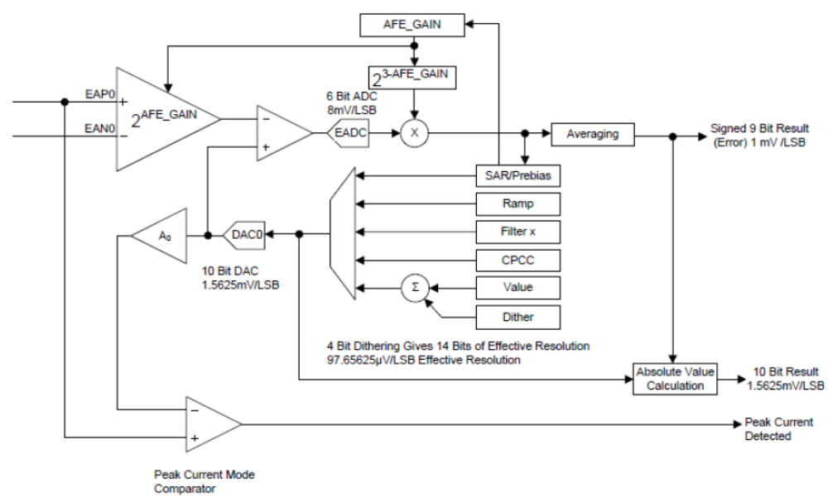
Simplified Block Diagram of Front End in UCD3138 (Front End 2 recommended for Peak Current Mode Control)
前端的输入是UCD3138芯片上2输入针（EANx, EAPx, x=0, 1, 2）的差分信号。一个差分放大器处理该差分输入并输出一个表示两针之间差分（电压）的单端信号。通常该信号代表电源或一些其它通过反馈回路调整或测量的电压或电流值。
该信号流进另一个差分放大器。另一个输入这个差分放大器的信号是来自于有效范围从0~1.6V的数模转换器。该DAC的输出通常代表目标调整值（参考值）。
在DAC输出和前端输入之间是一个可编增益的差分放大器。该模拟信号通常代表调整值（参考值）和目标值之间的误差。这个信号被误差模数转换器（EADC）转变为数字值。这个数字值虽然可用于其它方面但其通常供给一个或多个滤波器的输入。UCD3138前端的其它块是辅助实现的通常电源供给功能。逐次逼近控制
快速打开前端、限制EADC在1.6V范围、较慢地逐次逼近AD转换。
斜坡控制前端参考电压值的坡度，通过已编程速率及简单地软启动和软停止功能（实现）上升或下降（来实现）。斜坡引擎同样能用于其它的斜坡（控制）。
预偏置控制增加了预偏置处理支持。
连接在EAP针和DAC之间的单端比较器用于象全桥相移拓扑的峰值电流模式控制。前端2推荐用于峰值电流模式控制。
所有这些在后续的章节中有更详细的描述。

3.1 Error ADC and Front End Gain 误差ADC和前端增益
误差ADC（EADC）是一个高速的6位ADC转换器。
3.1.1 Front End Gain 前端增益
前端增益（EADC前增益）可以调整为1倍、2倍、4倍和8倍。给出的EADC的分辨率分别为：8mV、4mV、2mV和1mV。
设置一个固定的前端增益值是通过写入EADC控制寄存器的AFE_GAIN的位实现的。
FeCtrl0Regs.EADCCTRL.bit.AFE_GAIN = 2; //set AFE gain 为4倍
另外，在前端0（仅此有效）有2个自动增益设置模式。其通过设置EADC控制寄存器中的AUTO_GAIN_SHIFT_ENABLE位来允许。
FeCtrl0Regs.EADCCTRL.bit.AUTO_GAIN_SHIFT_EN = 1; //enable auto gain shift mode.
在简单模式下，无论EADC溢出或下溢，增益都转入下个较低一级的模式。假如EADC的输出在当前增益下低于±1/4位的范围时，增益被提升。
第二种自动增益模式使能是通过对EADCCTRL寄存器中的AUTO_GAIN_SHIFT_MODE位的设置。在该模式中，转变点是通过滤波器非线性模式阀值来设定的。这些阀值在第49页的4.3.6节的Nonlinear Mode中描述。4个滤波器带有非线性阀值。在Loop Mux中的FECTRLxMUX寄存器为每个前端选择使用哪一个非线性阀值。
3.1.2 EADC Error Output EADC误差输出
内部EADC输出是6位2进制补码数。依据AFE（前端放大器）增益，EADC的最低有效位为1~8mV。为简化自动AFE增益变化，EADC输出依据AFE增益进行移位（相乘计算，目的是使其实际输出与输入值对应）并向滤波器给出一个9位输出。
这样无论AFE的增益为多少，最低有效位将始终具有1mV的分辨率。
依据AFE增益，输出的位和范围实际使用将变化：
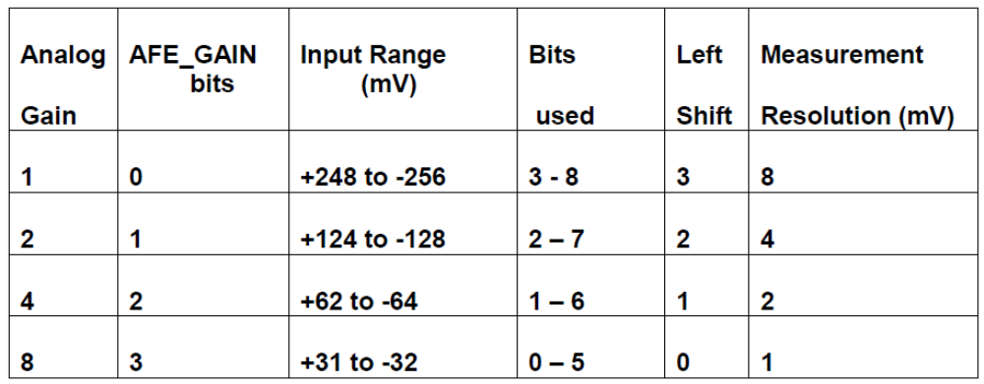
这里是EADC输出的图形表示：
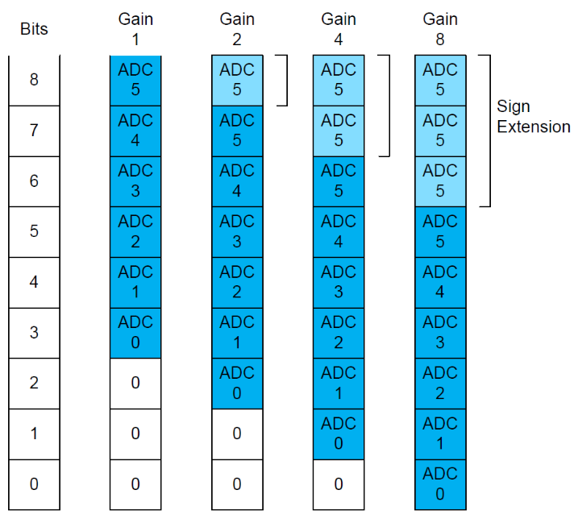
以上描述的EADC的误差输出通过EADC原始值寄存器可读出：
eadc_error = FeCtrl0Regs.EADCRAWVALUE.bit.RAW_ERROR_VALUE ;
它也被送至滤波器，并且也是由Fault Mux控制的数字比较器使用的输入值之一。
    - EADC Triggering, EADC Output to Filter EADC触发、EADC输出至滤波器
EADC通常由DPWM模块的采样触发信号来触发。触发后假如平均（功能）允许，平均模块也会发出另外的触发。Successive Approximation (SAR逐次逼近)模块触发EADC。多个DPWMs可以在同一个周期、不同的时间来触发单个EADC。
每个DPWM模块有2个采样触发寄存器来设置采样触发时序。DPWMs也能提供2、4、8样本的过采样，通过协调2个采样触发选取一个。见33页2.17.5节Sample Trigger 1 Oversampling得到更多信息。
在Loop Mux 模块中的采样触发控制寄存器控制着从DPWMs至EADCs的采样触发信号的路径。在该寄存器中有一位针对DPWM/前端的每一种可能组合。假如某位设置了，那么特定的DPWM的采样触发将被指定到特定前端。如使用DPWM3去触发前端2，代码为：
LoopMuxRegs.SAMPTRIGCTRL.bit.FE2_TRIG_DPWM3_EN = 1;
参见本书Loop Mux Reference节获取更多信息。
假如EADC正在驱动一个滤波器，该滤波器将在EADC转换结果（的基础上）计算它的输出。在Loop Mux中的Filter Mux寄存器选择哪个前端输送数据到哪个滤波器。例如输送前端2的输出到滤波器1：
LoopMuxRegs.FILTERMUX.bit.FILTER1_FE_SEL = 2; //use Front end 2 for filter 1.
参见Loop Mux Reference节获取更多信息。
采样触发也可被划分（间隔采样）因而EADC可以每隔1~16个采样触发（脉冲）触发一次：
FeCtrl0Regs.EADCCTRL.bit.SAMP_TRIG_SCALE = 4; //trigger every 5 sample triggers.

3.1.4 EADC Timing EADC 时序
EADC需要250MHz高速时钟的任一16或32个周期完成一个模拟到数字的转换。时序逻辑连续运行，每64或128nS产生一个采样值。这是分别在16MHz和8MHz下的最大采样速率。采样触发，当其发生时，得到的是最近的采样值。在转换开始它不再触发。
设置EADC速度，使用EADC控制寄存器中的Switched Cap Front End (SCFE) Divide by 2 (SCFE_DIV_2)位：
FeCtrl0Regs.EADCCTRL.bit.SCFE_CLK_DIV_2 = 0; //clear for 16X clock divide.
默认情况下EADC开关电容滤波器运行在一个连续的固定速率上。假如周期不是这个速率的整数倍，采样时间能在一个64nS的窗口里循环移动。
为避免该种情况，设置Frame Sync Enable（帧同步允许位）：
FeCtrl0Regs.EADCCTRL.bit.FRAME_SYNC_EN = 1; 在每帧开始的帧边缘重同步EADC采样
//resync EADC sampling to frame boundary at start of each frame.
帧启动来自一个或多个DPWMs的信号。DPWM选择在Loop Mux下的Front End Control Mux Registers中完成。每一个前端有一个前端控制多路寄存器，该寄存器控制许多输入至前端，包含EADC采样复位帧同步。例如，使用DPWM3帧同步前端2：
LoopMuxRegs.FECTRL2MUX.bit.DPWM3_FRAME_SYNC_EN = 1;
有一位为前端初始化状态机计数器为非零值的状态位。该位应保留为0，否则其它的数值将会引起不希望的结果。
FeCtrl0Regs.EADCCTRL.bit.SCFE_CNT_INIT = 0; //leave at 0.

3.1.5 EADC Averaging EADC的平均
该芯片可以平均2、4、8个EADC的值。EADC平均有2种方式－连续的和空间性的。它是真实的平均－采样值相加后除以采样个数。还是一个可用的加权平均。
连续模式提取在采样触发后立即以16或8MHz的EADC采样速率采样的指定数目值。然后触发滤波器和提供采样值的平均数作为滤波器的输入。

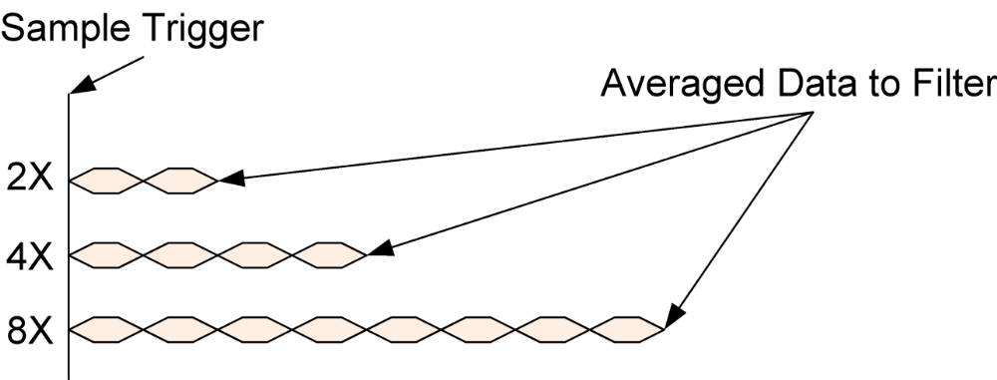
Consecutive Mode of Averaging by EADC
空间模式每次采样触发提取一个采样值，到采样触发至指定数目后再输送平均数据到滤波器。
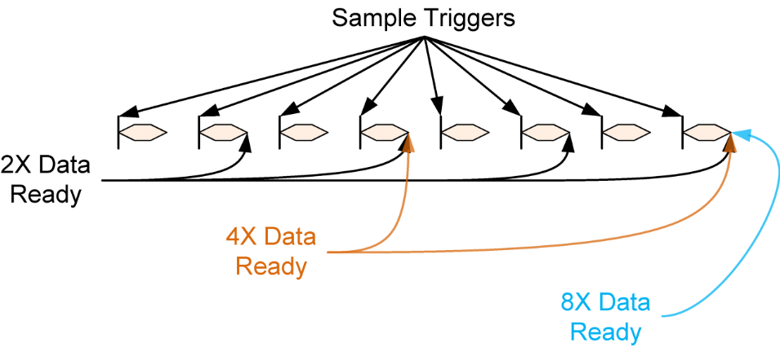
Spatial Mode of Averaging by EADC
平均误差值可在EADC Value寄存器读到：
eadc_error = FeCtrl0Regs.EADCVALUE.bit.ERROR_VALUE;
如果平均使能的话，该值将反映平均值。否则它将与前面提到的原始EADC值相同。
平均是由EADC控制寄存器控制的。在EADC_MODE位中写入1选择平均模式：
FeCtrl0Regs.EADCCTRL.bit.EADC_MODE = 1; //averaging mode
有3位一共可提供8个模式，所有模式在后续本章中都会讨论。
最简单模式是模式0－1个采样，没有平均。
选择空间模式，写1到AVG_SPATIAL_EN位：
FeCtrl0Regs.EADCCTRL.bit.AVG_SPATIAL_EN = 1; //spatial averaging mode
该位写入0选择连续模式。
选择哪些采样值来平均，使用AVG_MODE_SEL位。他们的工作情况如下：
0 = 2x Averaging (Default)
1 = 4x Averaging
2 = 8x Averaging
FeCtrl0Regs.EADCCTRL.bit.AVG_MODE_SEL = 2; //select 8X averaging
还有个可用的加权平均控制位，给出了对当前采样值更多的加权。详细见本文件的Front End reference节。
3.1.6 Enabling the EADC and Front End. 使能EADC和前端
有几个位必须都要设置来使能EADC和整个前端。它们中的大多数已被缺省值使能。为了节省功耗和减少噪声，假如EADC未被使用这些缺省位可以清除（禁止）。
EADC0的使能位为：
FeCtrl0Regs.EADCCTRL.bit.EADC_ENA = 1; //1 is default
FeCtrl0Regs.EADCCTRL.bit.SCFE_ENA = 1; //1 is default
前端中的一些模块可以使用，不需要使能EADC。
在Loop Mux中也有一位必须被置位来启动前端0。
LoopMuxRegs.GLBEN.bit.FE_CTRL0_EN = 1; //0 is default
GLBEN寄存器特殊寄存器在相同寄存器中带有使能所有前端和所有DPWMs（的控制位）。它被设计用于通过立即写入整个寄存器来允许所有前端和DPWMs同时启动。对于所有FET的控制波形需要防止误动作及同时启动的复杂拓扑是非常有用的。
union GLBEN_REG glben_temp; // 使用一个临时变量堆积（存放）需要的配置glben_temp.bit.FE_CTRL0_EN = 1;
glben_temp.bit.FE_CTRL2_EN = 1;
glben_temp.bit.DPWM0_EN = 1;
glben_temp.bit.DPWM1_EN = 1;
LoopMuxRegs.GLBEN = glben_temp; //enable FE0, FE2, DPWM0, DPWM1
以上代码设置了一个叫glben_temp的临时变量，初始化后立即将其全部写入GLBEN寄存器中。它也可以这样写入：
LoopMuxRegs.GLBEN.all = 0x53; //enable FE0, FE2, DPWM0, DPWM1
这样做更有效一点，但几乎没有可读性。最好的方法是：
#define FE_CTRL0_EN_BIT 0x100
#define FE_CTRL2_EN_BIT 0x400
#define DPWM0_EN_BIT 1
#define DPWM1_EN_BIT 2
LoopMuxRegs.GLBEN.all = FECTRL0_EN_BIT + FE+CTRL2_EN_BIT + DPWM0_EN_BIT + DPWM1_EN_BIT;
当然，直接将寄存器的各位写入将不能完成同时启动。这可能会导致电源故障。对于DPWM和前端这两种外设必须设置局部、全局位两种使能。如要同时启动，在写入全局寄存器之前必须先设置局部位。

3.2 Front End DAC 前端DAC
前端的参考电压通过DAC来设置，有时也被称作为EADC DAC。这是一个10位的数模转换器，具有每比特（bit）1.5625mV标称步长。DAC的输入是一个无符号的10位数，给出0～1.6V的电压值。（2¹⁰×1.5625＝1600mV＝1.6V）。
DAC最简单的配置是对EADCDAC寄存器写入设定值：
FeCtrl0Regs.EADCDAC.bit.DAC_VALUE = 100 * 16;//set 10 bit DAC to 100 (.15625 Volts)
16倍的乘法是必要的，因为DAC逻辑还支持一个4位抖动功能。
DAC_VALUE一共有14位――10位是实际DAC的值，4位用于抖动功能：
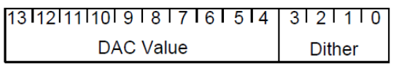
抖动有一个4位计数器，由选择的DPWM信号驱动，其将在2个DAC数值之间来回切换。例如，如DAC的值设置成100.75 *16，那么100将在DAC位中、4在dither位中。
For example, if the DAC value is set to 100.75 *16, there will be a 1100 in the 10 DAC bits, and a 4 in the dither bits.
抖动逻辑将输出100的值为4次、101的值为12次。这将给出一个100.75的平均值。
波形如下：
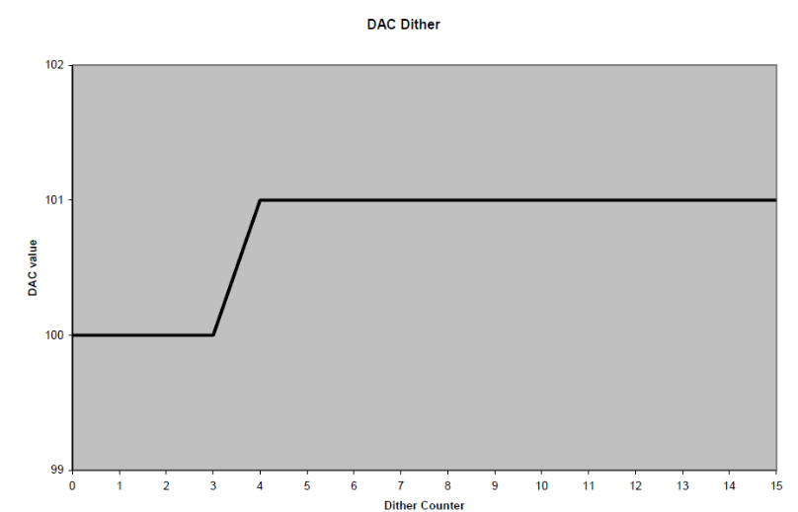
抖动计数器在DPWMA和/或DPWMB脉冲起始时增加。特定的DPWM针的使用（方式）在Loop Mux中的FECTRLxMUX寄存器中选择。
例如，设定DPWM3B的上升沿触发前端2的DAC抖动：
LoopMuxRegs.FECTRL2MUX.bit.DPWM3_B_TRIG_EN = 1; //set DPWM3B up to trigger dither.
注意：假如DPWM管脚不活跃（指无脉冲输出），因从滤波器输出0会引起故障，抖动计数器将不会增加（指开始计数）。
要允许抖动，DAC_DITHER_EN位必须设置：
FeCtrl0Regs.EADCDAC.bit.DAC_VALUE = (int)(100.25 * 16);
//set 10 bit DAC to 100.25 (0.156640625 Volts)
FeCtrl0Regs.EADCDAC.bit.DAC_DITHER_EN = 1; //enable dither
DAC也可被其它的DACs、滤波器的输出、恒功率模块控制。
在Loop Mux 中的External DAC Control寄存器可用来选择使用哪一个DAC源。
有几个选择：
0 = DAC 0 Setpoint Selected
1 = DAC 1 Setpoint Selected
2 = DAC 2 Setpoint Selected
3 = Output of Constant Power Module Selected
4 = Filter 0 Output Selected
5 = Filter 1 Output Selected
6 = Filter 2 Output Selected
LoopMuxRegs.EXTDACCTRL.bit.DAC0_SEL = 5; //control DAC 0 with Filter 1
如允许外部DAC控制，那么设定特定的DAC位是必要的：
LoopMuxRegs.EXTDACCTRL.bit.EXT_DAC0_EN = 1; //enable external DAC for DAC 0
滤波器被用于控制DAC时，当2个滤波器一起使用时通常用于平均电流模式控制，电压误差进入电压环滤波器并且电压环滤波器的输出控制电流环滤波器的DAC。
用于DAC的实际值在任意给定时间都能通过DAC状态寄存器来读取－DACSTAT。
dac_value = FeCtrl0Regs.DACSTAT.bit.DAC_VALUE;

3.3 Ramp Module 斜坡模块
斜坡模块用于控制EADCDAC（前端参考电压）以使电流和电压斜坡上升和斜坡下降。它也用于同步整流FET脉冲宽度的斜坡升或降以避免在同步整流使能和关闭（开或闭）时的毛刺。斜坡模块的部份也可用于预偏置处理。斜坡模块也用于峰值电流模式下的斜坡补偿。斜坡模块只可用于一个目的（在一定的时间内）。有3种斜坡模块，每一种对应每一个前端，因而有3种斜坡功能可同时运行。
3.3.1 DAC Ramp Overview DAC斜坡概述
UCD3138中的前端控制模块提供经硬件产生一个硬件设定DAC点的自动斜坡的能力。固件具有配置以下斜坡参数能力：
1：配置DAC在软启动或软停止斜坡完成时的DAC终值
2：配置DAC步长（8.10格式10位小数）
3：固件可编程每个DAC步长的开关周期数量（配置从1～128个）
4：在斜坡启动前可配置延时的周期数（可配置从0~65535）
5：斜坡可被以下事件之一初始化：固件的启动位、PMBus Control管脚、从其它前端控制模块来的斜坡延时补偿脉冲或从其它前端控制模块来的斜坡补偿脉冲的。
6：固件可配置DAC的饱和步长（假如EADC在DAC更新时饱和，硬件将通过DAC饱和步长增加/减少DAC值）
3.3.2 DAC Ramp Start and End points DAC斜坡开始和结束点
DAC斜坡开始点取自前端参考电压（EADC DAC）值寄存器：
FeCtrl0Regs.EADCDAC.bit.DAC_VALUE = 0; //start ramp at 0
DAC斜坡结束点取自Ramp DAC Ending Value寄存器：
FeCtrl0Regs.RAMPDACEND.bit.RAMP_DAC_VALUE = 100 * 16;
//set 10 bit DAC to 100 (.15625 Volts)
以上2个值将导致斜坡下降（缓降）。这2个寄存器都是14位，所以在斜坡的起始和结束点支持抖动值。
DAC将保持在结束值直至有别的要求。在另一个斜坡工作前该结束值需写入到DAC_VALUE寄存器以便斜
坡从相同的地方启动。
3.3.3 DAC Ramp steps DAC 斜坡步长
DAC斜坡步长由2个位字段控制，Switch Cycles per Step（开关周期数/每步）字段和DAC步长寄存器。
开关周期数/每步位决定产生一步之前需多少个DPWM（脉冲）输入。它有7位，因而该寄存器可存储数值从0~127，对应于1~128个周期数。
开关周期信号是DPWM的输出。用于斜坡模块的DPWM输出同以上的抖动使用是一样的：
LoopMuxRegs.FECTRL2MUX.bit.DPWM3_B_TRIG_EN = 1;
// 设置DPWM3上升沿触发抖动和斜坡模块。
步长长度是一个无符号值。斜坡模块逻辑检查起始和结束值。如起始值低于结束值，步长长度与DAC值相加。假如起始值高于结束值，步长长度与DAC值相减。
步长长度有10位小数部分，允许非常精准和非常慢速的斜坡。10个小数位低于DAC的抖动部分。有8位与DAC匹配的值，包括抖动。
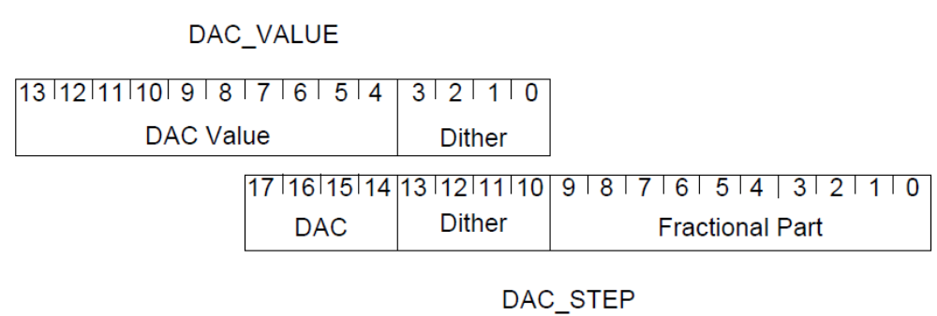
有个对编程者不可见的寄存器，它保留了步长间的小数位的总和。
举例来说，假设位8（第8位）是唯一在DAC步长寄存器中的设置位：
FeCtrl0Regs.DACSTEP.bit.DAC_STEP = 0x100; //set bit 8 in DAC_STEP
每一步，0x100将被加入到步长寄存器。其顺序将如下：
Hidden step register DAC register
0x000100 0x0000
0x000200 0x0000
0x000300 0x0000
0x000400 0x0001
0x000500 0x0001
0x000600 0x0001
0x000700 0x0001
0x000800 0x0002
0x000900 0x0002
0x000A00 0x0002
3.3.4 DAC Ramp Start, interrupts, Start Delay DAC斜坡启动、中断、启动延时
DAC启动由Ramp Control Register (RAMPCTRL)寄存器的位控制。DAC斜坡由上面列出几个事件启动。这些均清晰地在本文件的Front End Reference节中描述了。同样的寄存器也包含预斜坡延时的设置和斜坡事件的控制中断位。
允许斜坡，设置RAMPCTRL寄存器中的RAMP_EN位是必须的。
3.3.5 RAMPSTAT Register 斜坡状态寄存器
RAMPSTAT寄存器具有表明斜坡完成和其它斜坡状态事件的位。RAMPCTRL寄存器也能用于斜坡状态事件的中断使能。
3.3.6 DAC RAMP when EADC is saturated 当EADC饱和时的DAC斜坡
当EADC在自动斜坡期间饱和时，DACSATSTEP配置DAC的递增/递减值。
假如EADC是高值饱和（Verror = Vref – Vsense），DAC设置点通过DACSATSTEP值递减。递减将持续到EADC退出饱和状态。在斜坡期间新的DAC值将更新DAC，当EADC饱和时递减的发生是周期性的。
假如EADC是低值饱和，DAC设置点通过DACSATSTEP的值递增。递增将持续到EADC退出饱和状态。在斜坡期间新的DAC值将更新DAC，当EADC饱和时递增的发生是周期性的。
假如步长值是仔细选择的，这种模式可能有助于防止EADC在斜坡（升）期间饱和。然而它可能使斜坡时序非确定和非单调的。
3.3.7 Using Ramp Module for Peak Current Mode 峰值电流模式中使用斜坡模块
斜坡模块也可用于Analog Peak Current Mode (APCM)模拟峰值电流模块。通常PCM_START_SEL位被置位，因而滤波器的输出用于驱动斜坡的起始点。斜坡的结束点被置成一个低值因而斜坡总是向下的。
在这个模式，斜坡触发简单的斜坡启动。步长一32nS的速率来自于前端。在前端有一个比较器。该比较器比较斜坡的值（DAC中）和EADC的输入值。当EADC的输入值超过斜坡值，则前端的APCM（模拟峰值电流模块）故障输出变位有效。该故障位可通过Loop Mux和Fault Mux送至DPWM管脚。
为简单化前端的图中忽略它，但DAC（和输入至EADC放大器）是真正的差分。然而峰值电流模块比较器是单端的。所以在DAC和峰值电流模块比较器之间有一个差分到单端的转换器。该比较器必须使能以使峰值电流模块工作。EADCCTRL寄存器中的D2S_COMP_EN位执行此功能。
有关更多信息，请参阅UCD3138PSFBEVM-029 EVM随附参考固件和TI相移全桥（峰值电流模式控制）实施应用笔记.
3.3.8 Sync FET Soft On/Off using Ramp Module 使用斜坡模块的同步FET软启/停
同步FET软启/停可用于控制标准模式下的DPWMB的开通时间。DPWMB可被斜坡升和降。它可结合使用于数字或模拟IDE（理想二极管仿真）。
这些双模块控制DPWMB宽度见下图：
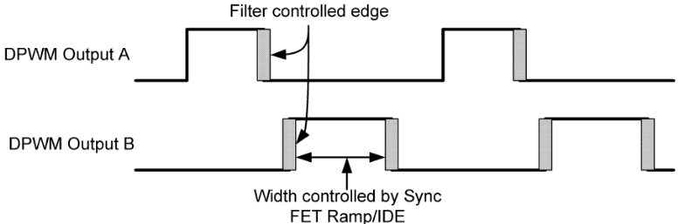
Ideal Diode Emulation (IDE) Module in UCD3138
同步FET斜坡相似于DAC斜坡，使用同样的硬件，但它需要一个由RAMPCTRL斜坡控制寄存器中的SYNC_FET_RAMP_START位提供的起始点。这些位的比例是：每位代表1个高速时钟周期（标称为4nS）。RAMPDACEND.RAMP_DAC_VALUE寄存器同样用于同步FET斜坡的结束值，与起始寄存器相同的比例。
步长寄存器的小数位置是相同的，也即意味着步长寄存器中的0~10位代表4nS/每位。
所有相同的启动条件可用于同步FET斜坡。不同之处是在RAMPCTRL寄存器中的SYNC_FET_EN位替代RAMP_EN位。
同步FET斜坡只可工作在标准模式。它不能用于逐周电流限制或任何峰值电流模式形式。为使同步FET正确工作，DPWMB的上升沿必须由滤波器控制。DPWMB的下降沿在更新窗期间由DPWM逻辑计算。
任何DPWM可被任意的斜坡发生器驱动，也可参见DPWM文件的斜坡章节。
斜坡模块也可用于DAC斜坡和预偏置中，因而每一个斜坡模块同一时间内只能工作于这些功能中的一个。
注意：即使斜坡模块可用于同步FET软启/停，但当斜坡模块被使用于该功能后，其不能用于对前端的参考电压的写入。

3.4 Successive Approximation Mode 逐次逼近模式
EADC和DAC一起可放入逐次逼近模式。逐次逼近模块需控制DAC和EADC。它起始于一个低增益并试图正确测量全量程在EADC上的输入电压。其方式类似于逐次逼近ADC。注意：假如输入信号变化很快时，应采用多次采样，逐次逼近模块可能不会会聚于一点。
3.4.1 SAR Control Parameters 逐次逼近控制参数
固件可采用逐次逼近控制算法编程下列参数：
1：初始逐次逼近分辨---—控制AFE增益用于逐次逼近处理的开始
2：最终逐次逼近分辨---—控制AFE最终增益设置用于逐次逼近处理完成时
3：逐次逼近窗口1范围 –--假如误差落在+/-逐次逼近窗口1范围内，只要最终逐次逼近分解不等于0X0，那么AFE增益递增为0X1。
4：逐次逼近窗口2范围 –--假如误差落在+/-窗口2范围内，只要最终逐次逼近分解不等于0X1，那么AFE增益递增为0X2。
5：逐次逼近范围 ----------假如误差落在+/- 本范围内，只要最终逐次逼近分解不等于0X2，那么AFE增益递增为0X3。
6：逐次逼近模式 ----------配置在非连续模式或连续模式下的逐次逼近算法
3.4.2 SAR Algorithm Overview 逐次逼近算法概述
在逐次逼近处理初始化的基础上，逐次逼近控制模块通过固件编程设置AFE增益启动逐次逼近分辨。最初，10位DAC值的最高位设置为1或DAC的设置点放在其范围的中点。一个EADC样本被捕获和比较。基于EADC误差的极性和幅值，调整AFE增益和DAC（参考值）的设置点。
3.4.3 Non-Continuous SAR Mode 非连续逐次逼近模式
UCD3138具有两种模式，当它试图使用一个SAR的算法来确定一个绝对电压时。第一个模式是非连续SAR模式。在该模式下，SAR控制模块在每个DPWM模块的采样触发时重启SAR算法。在收到来自DPWM模块的采样触发时，新EADC样本要求在0X0的AFE增益和DAC的设定值重置为中点（重新开始其算法）（可参见8.2.3节的描述）。
非连续SAR模式在新的测量开始时，通过仅运行模拟前端来减小功率损耗。SAR控制模块在每次采样触发时均重新运行整个SAR算法，相比于连续模式，这可能会增加延时获取绝对电压值。
3.4.4 Continuous SAR Mode 连续逐次逼近模式
连续SAR模式配置SAR控制模块从模拟前端连续地获取新的EADC采样值。在收到来自DPWM模块的新的采样触发时，假如误差在最后的SAR窗中，新的绝对电压可快速产生因为算法不需要去复位DAC的设置点到中点和降低AFE增益到0X0。
SAR计算结果可从EADC value寄存器读取。检查EADC溢出，在相同的寄存器里读取EADC_SAT_HIGH和EADC_SAT_LOW位：
if((FeCtrl0Regs.EADCVALUE.bit.EADC_SAT_HIGH
&& FeCtrl0Regs.EADCVALUE.bit.EADC_SAT_LOW) == 0)
{ eadc_absolute = FeCtrl0Regs.EADCVALUE.bit.ABS_VALUE; }
else
{ //adjust EADCDAC and try again }

3.5 Absolute Value Without SAR 无逐次逼近的绝对值测量
不使用SAR模式也可从EADC得到绝对值数据。为在该种情况下得到精确数据，误差ADC必须在设定的前端参考值范围内。
Vabs = Veadcdac + Veadc V_{绝对} = V_{参考} + V_{误差}
假如EADC平均值使用，EADC平均值将被用于计算绝对值。

3.6 EADC Modes
这有几个其它前端模式的不同应用。
全部例举如下：
1：0= 标准模式，EADC采样基于从DPWM模块的采样触发（缺省）
2：1= 平均模式，通过AVG_MODE_SEL配置
3：2= 非连续逐次逼近模式
4：3= 连续逐次逼近模式
5：4= 保留
6：5= 数字峰值电流模式
7：6= 恒功率/恒电流控制模式 （CPCC模块控制标准模式和非连续SAR模式之间的开关）
8：7= 恒功率/恒电流控制模式2 （CPCC模块控制标准模式和连续SAR模式之间的开关 ）

4 Filter 滤波器
UCD3138滤波器是一个具有许多电源增强控制的PID滤波器。它的一些特性包括：
1：PID 架构 （P—比例 I—积分 D—微分）
2：在微分回路中附加了α系数和历史（数据）
3：可编程的非线性限制是基于接收到的EADC误差进行调整并用于滤波器系数的自动修正
4：多系数可由固件完全配置设定
5：整个滤波器计算全24位精度
6：积分回路和滤波器输出具有可编程钳位
7：系统运行时能加载数据至内部滤波器寄存器
8：具有冻结计算任意单独滤波器分支能力
9：具有清除和冻结计算任意单独滤波器分支能力
10：基于滤波器输出的占空比、谐振周期、相移产生
11：通量平衡
12：电压前馈 （正激？）

4.1 Filter Math Details 滤波器数学细节
滤波器使用二进制算法。在大多数情况下，结果的精度保持在最高的水平直到在滤波器的输出端舍入/钳位。其主要的例外在额外的极点、使用Kα系数，其需立即舍入到一个低分辨率的值。滤波器是一个相对复杂的，因而本节讨论其缩放。滤波器数学细节描述完后，那些控制滤波器的寄存器也将被记录（描述）。
4.1.1 Filter Input and Branch Calculations 滤波器输入和（PID）分支计算
这是滤波器第一部分的框图，带有位宽信息：
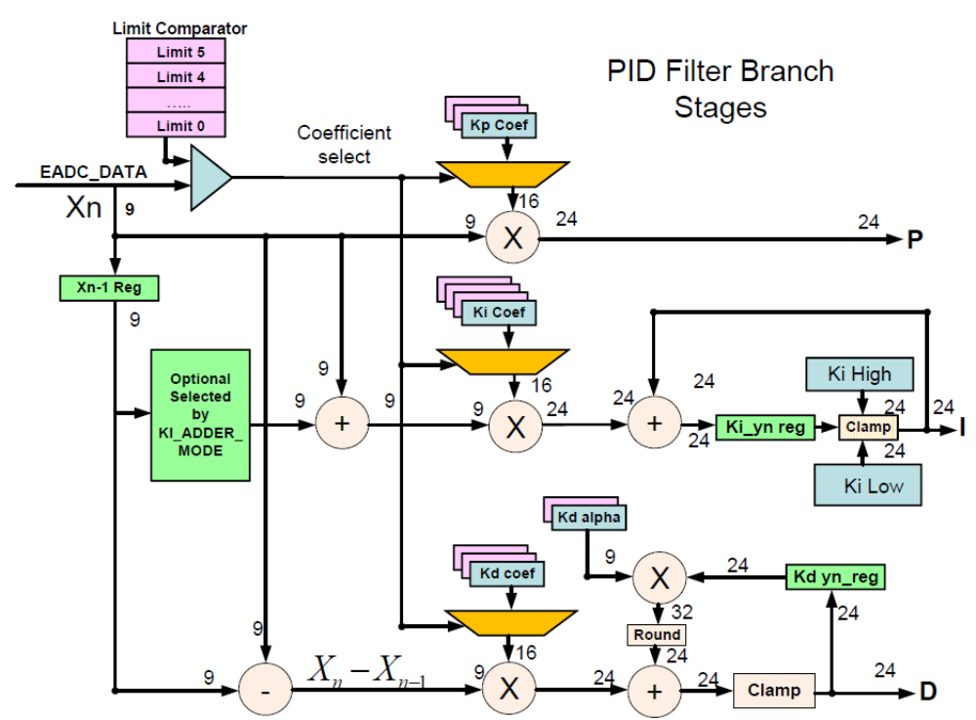
在滤波器里显示的所有值都是带符号数字，其最高有效位是符号位。所有数均被规范化为1。
滤波器的主输入是一个来自于误差ADC的9位带符号值。其（Xn）示意在图的左上方。它进入输入端用于滤波器计算，同时它也进入到数字比较器。滤波器提供非线性计算，带有高至7个不同系数设置并通过Xn值来选择。这可用于修正不同输入误差范围的滤波器的补偿。对于此功能的完整讨论，请参见第49页第4.3.6节的非线性模式。
4.1.2 Proportional Branch 比例分支
Xn值用于直接作为一个输入至滤波器的比例（P）分支。它被乘以一个16位带符号的Kp系数，得到的24位的结果作为P分支的输出。当乘以两个带符号数的二进制算术时，会产生一个额外的符号位。因此，9位乘以16位得出一个24位有效位而不是25位。
在比例分支中是不需要钳位的。它是自限制的，因为它没有存储器。它永远不会超过24位。如果需要从比例分支中输出一个较低的最大值，可以通过减小Kp的值来实现。
4.1.3 Integral Branch 积分分支
在积分（I）输入中对于Xn的使用有两种选择。当前的Xn可以自己单独使用，或者当前的Xn被加到前一个Xn-1。做加法时可提供一个梯形近似，有时会被理论上认为优于单点。然而，既然加法器的输出也是9位，如果Xn和Xn-1的值相加超过255或小于-256，加法的输出就会在那些值上被钳位。
这只会发生在误差ADC的最低增益设置时。因此如果使用EADC的最低增益设置，梯形近似可能会导致输入的过早饱和。
Xn值或Xn+Xn-1之和乘以Ki系数。注意在梯形模式中通常会有简单Xn值的两倍输出。这将会被两个因素改变I阶段的总增益。如果在Xn相加模式下，这个变化必须被考虑进去。
这个乘法的输出将始终符合在24位内。这个值然后被加到现有的I值中。硬件将自动钳位其为一个24位带符号数，并且通过有效的高和低钳位寄存器将其钳位至较低值。如果输入值超出了钳位，还有状态寄存器位将被设置。
被钳位值被馈送到滤波器的下一级，并且也被反馈加入到下一个计算的Xn*K值。
4.1.4 Differential Branch 微分分支
在微分（D）分支中，Xn-1从Xn中减去。两个最近的X值的差然后被Kd相乘，给出一个24位的带符号数。
微分分支在乘法之后添加了一个另外的极点，给出了更多的滤波器响应控制允许为电源提供更好的匹配。在D阶段的输出中，Dalpha分支作为一个积分器运行。经过每个滤波器的计算，之前D和Dalpha计算的24位结果被乘以一个9位的Kalpha (Kα)。给出一个32位的带符号结果。为了匹配24位数据路径，这必须舍入回降到24位。在滤波器输出之前，这是一个实际发生在滤波器中的一次舍入。
也有一个简单的钳位，以防止K的输出超出一个24位带符号数。由于alpha阶段中的积分元件，有可能使其超出这个范围。
4.1.5 Add, Saturate, Scale and Clamp 相加、饱和、尺度和钳位
这是滤波器下部分的图：
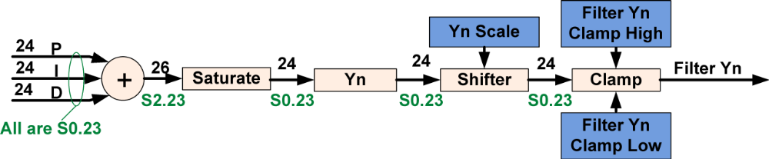
该S0.23表示法表示一个24位的数，带有1个位于二进制点左侧的符号位和位于点的右侧23位，意味着范围从1-2⁻²³到-1（近似为1~-1范围）。2.23意味着一个数带有1个符号位和2个有效位位于二进制点的左侧，23有效位位于点的右侧。
滤波器部分将P、I、D相加一起输出，得到一个潜在的26位结果。饱和逻辑钳位该值回降到24位。假如该值高于24位的最大值，饱和逻辑输出将设置到最大值（0x7ffff or 524287），负值超出范围将被钳位到最负的值。
饱和部分的输出至一个可编程的移位器，其有8种不同的移位编程，包括完全无移位。这可用于补偿滤波器系数的标度。
标度后，（输出至）带有独立的可通过写寄存器设置值的钳位高和钳位低的钳位。该钳位也有在超出钳位限制时设置的状态位。然而注意：到达这一点才算饱和。位数超过24位只是简单地截断和忽略。假如移位器设置移位0，或向右移位，所有输入数据将给出期望的结果。假如使用左移，编程者必须注意其结果总是适合于24位里，否则其结果也许是非期望
4.1.6 Filter Output Stage 滤波器输出级
这是滤波器的最后一级：
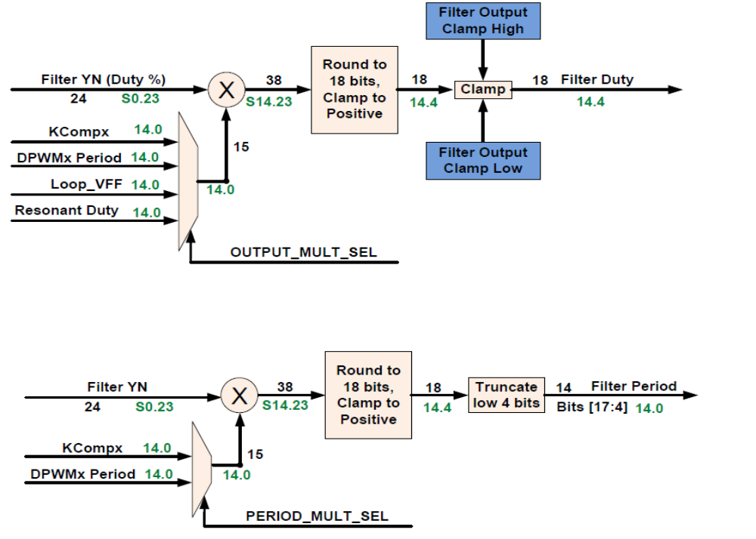
该阶段转换滤波器的输出去匹配DPWM的输入要求。2个不同的计算顺序执行，使用同样的乘法器但带有不同的设置。一种计算提供一个DPWM的占空比值，另一种提供一个DPWM的周期值。在许多拓扑中，仅占空比值被使用。在LLC中，2个值均使用。
这级的初始，PID输出与几个14位无符号数中之一相乘，得到一个38位的输出。对于滤波器占空比计算，有4个数据能使用。见49页4.3.8节Output Multiplier Select这些数据的讨论。对于滤波器周期计算，仅2个数据可选择。
乘法计算后，是一个38位带符号结果。负值被钳位到0并且符号位被移除。这给出一个37位正结果。这数据被圆整到18个最高有效位。这部分对于2种计算来说是一样的。
经过圆整和钳位后，2种输出被不同地处理。滤波器占空比值被钳位，使用Filter Output Clamp High Register (FILTEROCLPHI) 和 Filter Output Clamp Low Register (FILTEROCLPLO)2个值来钳位。这以后，滤波器占空比值被用于DPWM作为一个时间值。它被认为是一个14.4位值，低4位进入DPWM的高分辨率部分。所以滤波器占空比数值的分辨率是250 psec。
滤波器周期值获得没有钳位。DPWM周期不支持高分辨率，所以18位结果的低4位被截断。去DPWM的滤波器周期仅代表高14位，给出一个标准的4nS分辨率。
这有一个典型的使用滤波器输出级的例子：
Filter YN (50% Duty) 0x400000（或 4194304） X DPWM Period (100 kHz) 0x9C4（或2500）＝0x271000000 （或10485760000）
右移19位并圆整（舍入）：
0x4E20或20000
该结果为带有高分辨率的去DPWM值。
转换该值至周期范围并检查该结果，我们可以除以16，其相当于右移4位，得到：
0x4e2或1250，其为周期的一半，所以我们得到了50％的占空比。

  - Filter Status Register 滤波器状态寄存器
滤波器状态寄存器有5位。
FILTER_BUSY 滤波器忙位
YN_LOW_CLAMP YN低钳位位
YN_HIGH_CLAMP YN高钳位位
KI_YN_LOW_CLAMP KI_YN低钳位位
KI_YN_HIGH_CLAMP KI_YN高钳位位
当滤波器正在计算时，FILTER_BUSY位为高。该计算时间非常短，仅很少几个指令周期。滤波器忙位变高时间是很难实际检测到的。
其它位在每次滤波器计算完成后被写入（置位）。它们反映了当前滤波器计算的结果。

4.3 Filter Control Register 滤波器控制寄存器
滤波器控制寄存器（FILTERCTRL）有13个字段。它们用于配置滤波器的操作。滤波器的源和目标源在Loop Mux寄存器中设置。
The Filter Control Register (FILTERCTRL) has 13 fields. They are used to configure the filter operation.
Filter sources and destinations are set in the Loop Mux registers
1：KI_ADDER_MODE 位：＝1为梯形计算 ＝0为Xn
2：PERIOD_MULT_SEL 周期乘数选择
3：OUTPUT_MULT_SEL 输出乘数选择
4：YN_SCALE（OUTPUT_SCALE） 3个位：输出移位数选择
5：NL_MODE 位：非线性模式选择
6：KD_STALL 位：KD分支冻结
7：KI_STALL 位：KI分支冻结
8：KP_OFF 位：KP分支关闭
9：KD_OFF 位：KD分支关闭
10：KI_OFF 位：KI分支关闭
11：FORCE_START 位：触发一个单一的滤波器计算
12：USE_CPU_SAMPLE 位：允许开环测试
13：FILTER_EN 位：滤波器允许
4.3.1 Filter Enable 滤波器允许
滤波器允许（FILTER_EN）位使能滤波器。其不像DPWM和前端，在Loop Mux寄存器中的GLBEN (Global Enable)寄存器中没有滤波器的全局使能位。对滤波器来说没必要设置这些位，因为当它仅被前端或一些其它的外部事件触发时其才运行。缺省时滤波器的使能位是1，其允许滤波器运行。如果滤波器至少运行一个周期后停用，发送到DPWM的数值将继续控制DPWM。另外最后的Filter Status状态依然存在。
4.3.2 Use CPU Sample 使用CPU采样
USE_CPU_SAMPLE位用于滤波器和DPWM配置或有需要由固件输入至滤波器的其它场合下的开环测试。假如USE_CPU_SAMPLE设置，滤波器的输入来自于CPUXN寄存器的CPU_SAMPLE位字段。
以下是使用CPU_SAMPLE的例子：
Filter1Regs.FILTERCTRL.bit.USE_CPU_SAMPLE = 1; //enable CPU sample
Filter1Regs.CPUXN.bit.CPU_SAMPLE = -34; //put negative value into CPU sample
4.3.3 Force Start 强制启动
FORCE_START位触发一个单一的滤波器计算。和CPU_SAMPLE值一起用于运行和控制滤波器的计算。假如CPU Sample禁止的话，那么它可以为滤波器选择任意的输入。
4.3.4 Kp Off, Kd Off, Ki Off KP、KD、KI分支关闭
KP_OFF、KD_OFF、KI_OFF位禁止滤波器中的该部分，并将它们的值替换成0.它们也清除各自代表的任意的历史数据（积分和微分分支）为0。
4.3.5 Kd Stall, Ki Stall Kd冻结、Ki冻结
KD_STALL 和 KI_STALL寄存器冻结这些滤波器元件的当前值。它们不对它们复位。他们对于抑制瞬变响应非常有用，当这样的相应是不需要的。
4.3.6 Nonlinear Mode 非线性模式
NL_MODE位选择用于非线性模式的选择。0为不对称方式，选1为对称模式。参见4.5~4.8节模式选择获得更多的信息。
4.3.7 Output Scaling 输出标定
3 个OUTPUT_SCALE位允许滤波器输出的移位。其对滤波器外设的标定提供了灵活性。它为2的补码数，0表示没有移位、1代表右移1位、2代表右移2位，-1代表左移1位等等……。
Filter1Regs.FILTERCTRL.bit.OUTPUT_SCALE = -3; //shift filter output left by 3（扩大2³）
4.3.8 Output Multiplier Select 输出乘数选择
OUTPUT_MULT_SEL位选择什么值乘以滤波器的输出来决定DPWM脉冲的宽度。请参阅Filter Reference部分中具体位功能分配。其选择为：
1：Kcomp—这使得输出的特殊的缩放到DPWM独立的周期。
2：Switching Period—（开关周期）滤波器输出的结果直接转变为DPWM导通百分比（占空比）。滤波器输出的全量程等同于100%导通时间。
3：Feed Forward value—前馈值。允许滤波器输出由另外滤波器输出控制。这可能是，例如，一个电压前馈值。
4：Resonant Duty value received from the DPWM module—（从DPWM模块接收到的谐振占空比值）这用于谐振模式，例如用于LLC构架。
注意：缺省值是KComp。这是不直观的，尤其是对UCD3000系列数字电源控制器的用户。他们UCD3000没有这方面的选择，周期是通常使用的。当设置一个简单的基于周期的系统时，这是很容易忽视的位字段。OUTPUT_MULT_SEL寄存器与Loop Mux中的FILTERMUX寄存器协同选择数值。FILTERMUX选择使用哪一个KComp、使用哪个DPWM周期和使用哪个滤波器输出作为前馈。谐振占空比也来自于一个DPWM模块并且也由FILTERMUX选择。见55页5.4节Filter Mux Register (FILTERMUX)。
开关周期由DPWM提供。缺省值其值来自于DPWM周期寄存器，并用于大多数的拓扑中。然而，有2种其它的DPWM寄存器也可将这个值送给滤波器。见33页2.17.3 Filter Duty Select有更详细的描述。
4.3.9 Switching Period as Output multiplier 开关周期作为乘数
使用开关周期作为一个输出乘数使得DPWM的占空比正比于滤波器的输出，全量程的输出等同于100％的周期。这是乘法的位模式：
滤波器输出是一个带符号的24位数，范围从0x7fffff （8388607） to 0x800000 （-8388608）。所有的输出乘数是一个范围从0X3FFF（16383）0无符号14位数字。
这两个数字的乘积是一个38位的数。这个乘积然后缩放和向下舍入至18位数并用作为DPWM中高分辨率事件。
因而假设滤波器的输出约为50％或4194304。假如周期与以上例子相同为：2500，两数的乘积将是10485760000。从一个38位有符号数减少到一个18位的无符号数，我们去掉符号位的顶部并除以2¹⁹。负的滤波器输出在DPWM的时序方面无意义，所以将其钳位到零。
除以2¹⁹将得到20000的结果。对于4 GHz的DPWM时钟，其是一个高分辨率值。转换其为低分辨率，250 MHz时钟用于周期，需要除以16。给出1250的结果，或周期的一半。其它滤波器输出值遵循完全相同的比例。在Loop Mux中有FILTERMUX寄存器，其为每一个滤波器选择周期源。
参见Loop Mux reference section获得更多关于该寄存器的信息。此有其使用的一个例子：
LoopMuxRegs.FILTERMUX.bit.FILTER0_PER_SEL = 2; //use DPWM2 period for filter 0
4.3.10 KComp as Output Multiplier KComp作为输出乘数
使用KComp作为输出乘数对于DPWM输出限制低于100％的场合是很有用的。这对允许使用整个动态范围的滤波器来说具有更为有限的范围，并可移除输出钳位。缩放的工作原理完全一样，除了14位KCOMP值代替了14位的周期值。
该选择可实现动态改变滤波器的增益而不改变极点和零点的位置。它也可以被用来增加超出标准滤波器结构支持的滤波器增益。它也可用于匹配PWM和配置LLC的谐振模式的波形。
Loop Mux中包含KCOMP值和为每个滤波器选择3个KCOMP值中哪一个的寄存器。
这儿有一个提供50％最大输出的代码例子：
#define SWITCHING_PERIOD 2500 // 250 MHz clock divided by period of 100 KHZ
Dpwm0Regs.DPWMPRD.bit.PRD = SWITCHING_PERIOD;
LoopMuxRegs.FILTERKCOMPA.bit.KCOMP0 = SWITCHING_PERIOD >> 1; //KCOMP = period/2
LoopMuxRegs.FILTERMUX.bit.FILTER0_KCOMP_SEL = 0; //select KCOMP0 for filter 0
Filter1Regs.FILTERCTRL.bit.OUTPUT_MULT_SEL = 0; //Multiply output by KCOMP
这种产生1位多点的滤波器分辨率比钳位滤波器输出至50％方法减少了任何限制周期的（大小还是空间？）。
4.3.11 Feed Forward as Output Multiplier 前馈作为输出乘数
当前馈被选为输出乘数时，乘数值是来自于不同的滤波器的最高有效位为14位的滤波器输出。Loop Mux中的FILTERMUX寄存器也用于选择该滤波器。在2个滤波器之间配置连接是很简单并在下面演示。前馈的实际滤波器的设置和运行在TI公司的Hard Switching Full Bridge EVM(UCD3138HSFBEVM-029) reference code中已提供。
这是滤波器之间的连接代码：
LoopMuxRegs.FILTERMUX.bit.FILTER0_FFWD_SEL = 0; //select Filter 1 as ffwd input
Filter0Regs.FILTERCTRL.bit.OUTPUT_MULT_SEL = 2; //select feed forward as output multiplier
参见FILTERCTRL寄存器参考部分得到更多的这些位字段的信息。
4.3.12 Period Multiplier Select 周期乘数的选择
滤波器有第二种输出，除了滤波器占空比外，还有滤波器周期输出。
PERIOD_MULT_SEL位用于选择滤波器周期的乘数。
仅有DPWM周期和KCOMP两种选择。滤波器周期用于LLC拓扑因而该滤波器可控制电源的开关频率
4.3.13 Ki Adder Mode KI加法器模式
KI_ADDER_MODE位从2种模式中选择计算KI的输入。
KI_ADDER_MODE=1，选择Xn+Xn-1梯形模式。采用最低的AFE增益设置，这有可能引起计算的饱和。
KI_ADDER_MODE=0，仅Xn用于作为积分I的输入。不提供梯形计算，但它可避免任何的饱和问题。参见46页4.1.3积分分支获得更全的描述。
4.4 XN, YN Read and Write Registers Xn、Yn读写寄存器
有几个寄存器允许存取滤波器内的动态值。寄存器的格式，请参阅下列滤波器参考章节。
4.4.1 CPU Xn Register CPU Xn寄存器
CPUXN寄存器用于以上所述的CPU采样模式。该处是固件在CPU采样模式下写CPU控制值。见49页4.3.2节的Use CPU Sample。
4.4.2 Filter XN Read Register 滤波器 Xn读寄存器
该寄存器提供Xn 和 Xn-1用于固件读取。
4.4.3 Filter YN Read Registers 滤波器 Yn读寄存器
用于内部滤波器结果的3个可读寄存器：
FILTERKIYNREAD 滤波器KI Yn读寄存器
FILTERKDYNREAD 滤波器KD Yn读寄存器
FILTERYNREAD 滤波器Yn读寄存器
该寄存器提供积分输出、微分输出和滤波器的总输出。
比例输出没提供。它通过Xn乘以KP决定或通过Yn-KiYn-KdYn得到。
4.5 Coefficient Configuration Register 系数配置寄存器
COECONFIG寄存器用于非线性模式下配置滤波器系数。每个滤波器系数有2到4个可通过滤波器寄存器可编程的值。下图显示Kp、Ki 和 Kd被排列成7个系数集
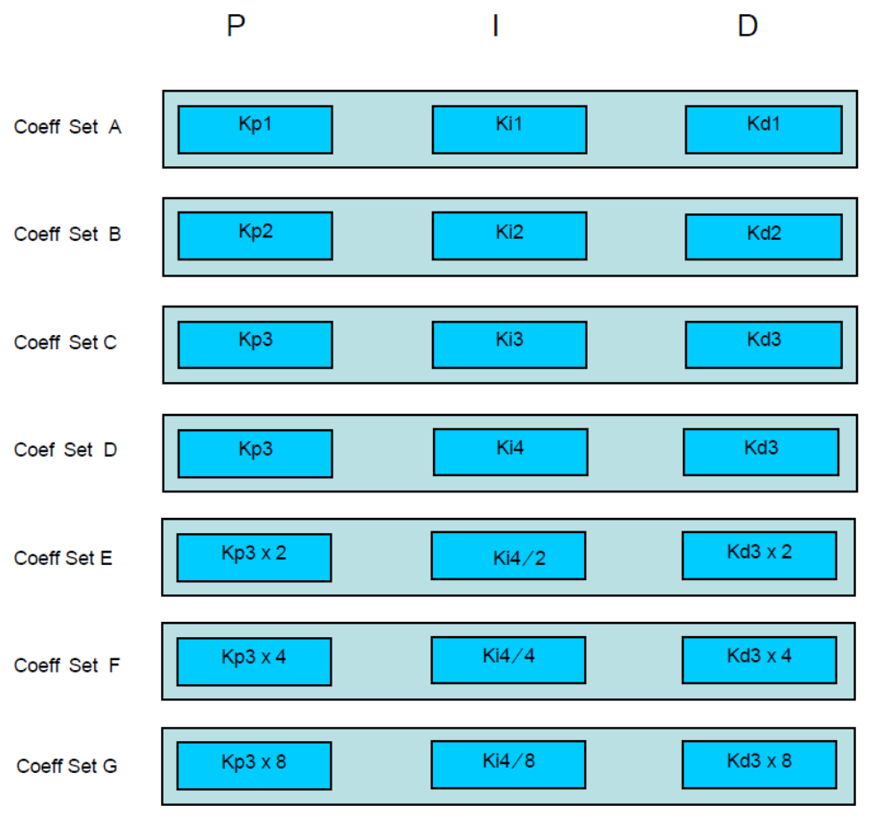

这些集如此设计使得从A到G带宽逐渐增加。这些设置可以映射至任何可能组合成7个bins,从Bin0到Bin6。
这些bins的选择基于非线性限制寄存器内容和到滤波器的Xn的值。有2种选择---对称和不对称。这儿给出了bins(系数屉)的2种模式：
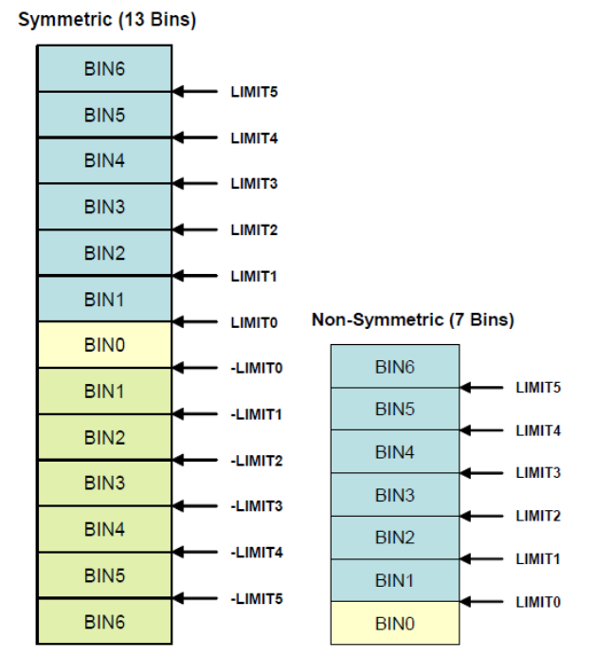
这有许多中组合。在对称模式，如果带宽随着误差的增加而增加，那么Bin0可置入Coefficient Set A，Bin1可置入Coefficient Set B……。假如采用较少的bins，那么Bin0和1都置入Coefficient Set A，Bin2和3置入Coefficient Set B……。
缺省设置是不对称模式，所有的bins（系数屉）置入Coefficient Set A。
限制值必须是递增的，限制0为尽可能低的值，限制1相对于限制0较高点……。在对称模式下，所有的限制值必须是正数。
每一个bin有一个独立位用于选择2个alpha值中的一个。
以下为一个代码例子关于使用所有的系数用于带宽随着误差增大而增大的设置：
Filter0Regs.COEFCONFIG.bit.BIN0_CONFIG = 0; //coefficient set A
Filter0Regs.COEFCONFIG.bit.BIN1_CONFIG = 1; //coefficient set B
Filter0Regs.COEFCONFIG.bit.BIN2_CONFIG = 2; //coefficient set C
Filter0Regs.COEFCONFIG.bit.BIN3_CONFIG = 3; //coefficient set D
Filter0Regs.COEFCONFIG.bit.BIN4_CONFIG = 4; //coefficient set E
Filter0Regs.COEFCONFIG.bit.BIN5_CONFIG = 5; //coefficient set F
Filter0Regs.COEFCONFIG.bit.BIN6_CONFIG = 6; //coefficient set G
Filter0Regs.COEFCONFIG.bit.BIN0_ALPHA = 0; //alpha 0
Filter0Regs.COEFCONFIG.bit.BIN1_ALPHA = 0; //alpha 0
Filter0Regs.COEFCONFIG.bit.BIN2_ALPHA = 0; //alpha 0
Filter0Regs.COEFCONFIG.bit.BIN3_ALPHA = 0; //alpha 0
Filter0Regs.COEFCONFIG.bit.BIN4_ALPHA = 1; //alpha 1
Filter0Regs.COEFCONFIG.bit.BIN5_ALPHA = 1; //alpha 1
Filter0Regs.COEFCONFIG.bit.BIN6_ALPHA = 1; //alpha 1
4.6 Kp, Ki, and Kd Registers Kp、Ki、Kd寄存器
有几个寄存器存储Kp、Ki 和 Kd系数：
FILTERKPCOEF0 KP系数0
FILTERKPCOEF1 KP系数1
FILTERKICOEF0 KI系数0
FILTERKICOEF1 KI系数1
FILTERKDCOEF0 KD系数0
FILTERKDCOEF1 KD系数1
这些寄存器包含了所有以上描述的PID涉及的不同coefficient sets的系数。对于具体的细节，请参阅下面的滤波器参考章节。所有的K系数为16位带符号数。每个寄存器存储1或2个数。不使用非线性模式的系统仅需上载Coefficient Set A。下面是例子：
Filter1Regs.FILTERKPCOEF0.bit.KP_COEF_0 = 500;
Filter1Regs.FILTERKICOEF0.bit.KI_COEF_0 = 150;
Filter1Regs.FILTERKDCOEF0.bit.KD_COEF_0 = 250;
4.7 Alpha Register α寄存器
FILTERKDALPHA寄存器存有2个可被COEFCONFIG寄存器中的BINx_ALPHA位选择的alpha系数。Alpha系数是个9位带符号数。这有一个仅上载KD_ALPHA_0的例子：
Filter1Regs.FILTERKDALPHA.bit.KD_ALPHA_0 = 134;
4.8 Filter Nonlinear Limit Registers 滤波器非线性限制寄存器
有6个非线性限制控制值，示于以上51页4.5节Coefficient Configuration Register。它们都是9位有符号数，虽然对称模式下它们必须为正数。三个寄存器中每个寄存器存储2个值：
FILTERNL0 滤波器非线性限制值0
FILTERNL1 滤波器非线性限制值1
FILTERNL2 滤波器非线性限制值2
对称模式下，代码示例上载：
Filter1Regs.FILTERNL2.bit.LIMIT5 = 218; //symmetric values
Filter1Regs.FILTERNL2.bit.LIMIT4 = 182;
Filter1Regs.FILTERNL1.bit.LIMIT3 = 145;
Filter1Regs.FILTERNL1.bit.LIMIT2 = 109;
Filter1Regs.FILTERNL0.bit.LIMIT1 = 72;
Filter1Regs.FILTERNL0.bit.LIMIT0 = 36;
4.9 Clamp Registers 钳位寄存器
在滤波器构架中有3个钳位，积分器、PID滤波器输出和前馈乘法后输出。积分器和滤波器的钳位是有符号24位数，像积分器和滤波器的输出一样？。所有输出的钳位是一个18位无符号数，像所有的输出？。
这里是钳位所有的，范围为10％~50％满刻度的一个例子。
Filter2Regs.FILTERYNCLPHI.bit.YN_CLAMP_HIGH = 0x400000; //50% of full scale
Filter2Regs.FILTERYNCLPLO.bit.YN_CLAMP_LOW = (int)(((float)0x800000) *.1);
//10% of full scale
Filter2Regs.FILTERKICLPHI.bit.KI_CLAMP_HIGH = 0x400000; //50% of full scale
Filter2Regs.FILTERKICLPLO.bit.KI_CLAMP_LOW = (int)(((float)0x800000) *.1);
//10% of full scale
Filter2Regs.FILTEROCLPHI.bit.OUTPUT_CLAMP_HIGH = 0x20000; //50% of full scale
Filter2Regs.FILTEROCLPLO.bit.OUTPUT_CLAMP_LOW = (int)(((float)0x40000) *.1);
//10% of full scale
4.10 Filter Preset Register 滤波器预置寄存器
FILTERPRESET寄存器用于滤波器中一些计算的寄存器预置值。预置寄存器工作于滤波器计算之间。假如滤波器正在计算中滤波器预置有效时，滤波器中的目标寄存器不是立即写入。硬件等待滤波器停止计算然后再写入到目标寄存器。
假如滤波器不运行，滤波器预置立即生效。
滤波器的预置寄存器有3个位字段。
PRESET_EN位置1使能预置并能被拉低时说明已完成或生效。
3个PRESET_REG_SEL位选择哪个寄存器将被预置，参见Filter Reference Section的关于其确切的值。
最后，数值被预置和上载至PRESET_VALUE位空间。
以下为用于预置寄存器的代码例子：
while(Filter0Regs.FILTERPRESET.bit.PRESET_EN == 1)
{
; //wait for previous preset to take effect
}
Filter0Regs.FILTERPRESET.bit.PRESET_VALUE = 15; //put a 15
Filter0Regs.FILTERPRESET.bit.PRESET_REG_SEL = 1; //into I holding register
Filter0Regs.FILTERPRESET.bit.PRESET_EN = 1; //set bit to make it happen

5 Loop Mux 环路复用
环路复用控制着控制环路不同部分之间的连接—前端、滤波器和DPWM:
• Front End Control Mux 0, 1, 2--控制DPWMs如何触发前端斜坡模块和DAC抖动。
• Sample Trigger Control Register – 控制DPWMs如何触发EADC。
• External DAC control Register – 控制DAC的什么设置被用于每个前端
• Filter Mux – 选择滤波器的数据源
• DPWM Mux Register – 选择DPWM的输入
环路复用也有几个在一个寄存器中控制多个模块的寄存器：
• Global Enable Register (GLBEN) – 使能多个前端和多个DPWMs同时启动
• PWM Global Period Register (PWMGLBPRD) – 允许同时改变多个周期
• Sync Control Register (SYNCCTRL) – 配置同步引脚
另外，环路复用控制几个将多个部分捆绑一起并有其自身逻辑的模块：
• Constant Power/Constant Current (CPCC) Module 恒功率/恒流模式
• Cycle Adjustment Module (used for balancing current and flux) 周期调整模式（用于平衡电流和磁通量）
• Light Load Module 轻负载模式
• Analog Peak Current Mode (PCM) Module 模拟峰值电流模式（PCM）模块
下面的表格示出了Loop Mux的连接，“I”表示Loop Mux寄存器或模块的输入，“O”代表输出。
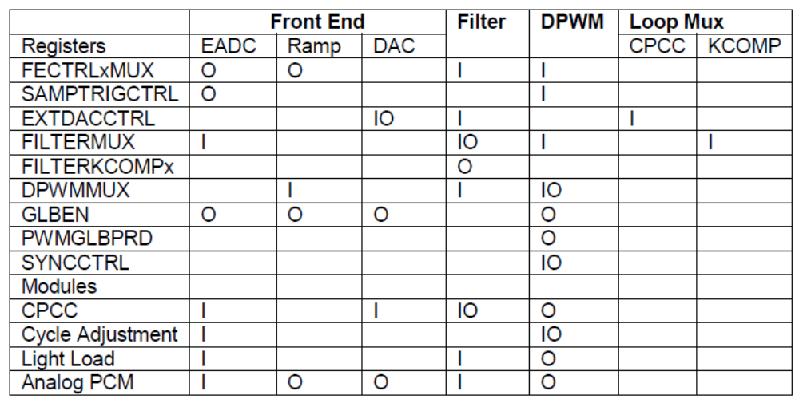

本章包含了Loop Mux寄存器。模块有其本身的章节。

5.1 Front End Control Muxes (FECTRL0MUX, FECTRL1MUX,FECTRL2MUX) 前端控制复用
这些寄存器选择DPWM的什么信号被用来触发在前端、斜坡和抖动中的DAC控制功能。被选择的信号也用于斜坡模块何时用于同步FET斜坡。2个信号可使用：
1：从所有DPWM模块来的DPWMA和DPWMB的上升沿
2：从所有DPWM模块来的帧同步
帧同步发生在DPWM周期的起始。在DPWM任何运行时间，帧同步信号总是存在的。DPWMA和DPWMB依据于DPWMA和DPWMB的实际上升沿。假如没有DPWM脉冲产生，那么其触发也不可能产生。DPWMA_F和DPWMB_F被运用。来自于故障块的信号，参见12页2.1节DPWM Block Diagram。为阻止DPWMA和DPWMB在变高时产生在时序或故障模块上的任何信号将防止该些信号触发前端。在信号链中任何进一步下降，像Intra Mux或Edge Generator将不起任何影响。
这些触发与采样触发不冲突，其触发EADC转换。理想情况下，仅在EADC转换结束后触发DAC控制功能用以允许DAC有最大的设置时间。关于DAC设置时间，请参照UCD3138芯片的数据手册。
FECTRLxMUX寄存器也允许使用滤波器中的非线性选择寄存器来为前端的自动增益移位设置步点。
关于FECTRLxMUX位的精确分配，参见：第145页11.1节，Front End Control 0 Mux寄存器(FECTRL0MUX)。

5.2 Sample Trigger Control (SAMPTRIGCTRL) 采样触发控制（(SAMPTRIGCTRL）
SAMPTRIGCTRL寄存器有一个控制位用于每一个前端和DPWM模块的组合。缺省情况下，这些位均不设置，所以没有采样从触发被允许。任意DPWM能触发任意的前端。多个触发能用于任意前端，多个前端能使用相同的触发。DPWMs能产生2个触发（A和B）。它们可产生多个触发—过采样。如在SAMPTRIGCTRL中的位被设置，那么所有这些都是自动传输到前端的。见152页的11.4节的Sample Trigger Control Register (SAMPTRIGCTRL)获得更多关于寄存器的详细信息。

5.3 External DAC Control (EXTDACCTRL) 外部DAC控制(EXTDACCTRL)
EXTDACCTRL寄存器允许来自不同源的每一个前端的参考电压的控制。假如EXT_DACx_EN位为0，前端控制其自己的DAC。假如EXT_DACx_EN是1，其它源将（用于其）控制。
1：Other EADCDACs（其它前端参考电压）--其可用来驱动2个连接在一起的前端。
2：Output of Constant Power Module（恒功率模块输出）--其用于恒功率控制。
3：Filter x Output—其用于放置串联环路中，例如，一个电压环路能控制一个电流回路，通过使用电压环路输出来控制电流环路的前端参考电压。
参见第153页的11.5节External DAC Control Register (EXTDACCTRL)中详细的位字段。

5.4 Filter Mux Register (FILTERMUX) 滤波器多路寄存器
FILTERMUX控制一些输入到滤波器。它选择哪一个前端提供误差信号到每个滤波器。
FILTERMUX也选择滤波器输出级的乘数值（47页，4.1.6节Filter Output Stage）。对于该功能，FILTERMUX与FILTERCTRL寄存器中的 PERIOD_MULT_SEL和OUTPUT_MUL_SEL字段一起工作。
对于每个滤波器，FILTERMUX选择以下之一：
--- FILTERx_KCOMPSEL从KCOMP0、 KCOMP1 或 KCOMP2中选择
--- FILTERx_FFWD_SEL从其它2滤波器之一选择前馈值
--- FILTERx_PER_SEL从DPWM0、1、2 或 3中选择周期
--- FILTERx_PER_SEL也为谐振占空比选择源
然后OUTPUT_MULT_SEL位从这些预选择值中选择。OUTPUT_MULT_SEL能选择任意4个输入。PER_MULT_SEL仅可从Period 或 KComp中选择。

5.5 Filter KComp Registers (FILTERKCOMPx) 滤波器KComp寄存器
这有2个寄存器，FILTERKCOMPA 和 FILTERKCOMPB。FILTER KCOMPA存放KCOMP0和KCOMP1两个值。FILTERKCOMPB仅存放KCOMP3。所有的KComp值是个14位无符号数。

5.6 DPWM Mux Register (DPWMMUX) DPWM 多路寄存器
DPWMMUX选择输入（源）到DPWM模块。它选择
--- 控制同步FET斜坡的斜坡模块
--- 如DPWM模块为从时提供同步脉冲的主控DPWM
--- 控制DPWM占空比周期/谐振周期的源。该源可以为一个滤波器、恒功率模块或轻负载控制模块。

5.7 Global Enable Register (GLBEN) 全局使能寄存器（GLBEN）
GLBEN有个可使能每个DPWM和每个前端的位。这些位与其在每个DPWM和前端中单独的使能位相与。全局和本地位两者必需被设置用于模块启动。为了同时、同步启动，首先设置所有的本地使能位，然后写一个单独的时间去全局寄存器。该同时写的操作至少有2种方法：
1：定义一个与GLBEN同样结构的临时变量
union GLBEN_REG glben_store; //collect global enable bits for simultaneous use
glben_store.all = 0;
glben_store.bit.DPWM0_EN = 1;
glben_store.bit.DPWM1_EN = 1;
glben_store.bit.FE_CTRL0_EN = 1;
LoopMuxRegs.GLBEN = glben_store;
2：简单地写值到GLBEN：
LoopMuxRegs.GLBEN = 0x13;
5.8 PWM Global Period Register (PWMGLBPRD) PWM全局周期寄存器（PWMGLBPRD）
假如Global Period Enable (GLOBAL_PERIOD_EN)位在DPWM模块的DPWMCTRL1中被置1，那么将使用PWMGLBPRD的值作为其周期。这可用于通过一句C声明改变多个DPWMs的周期。这对于频率抖动来说是非常有用的。注意：周期的改变点在前个周期的尾端生效。如DPWMs超出其相位，那么每个DPWM的频率改变将发生在不同的时间点上。
还需注意的是：假如滤波器采用DPWM的周期用来计算，那么它将仍使用DPWM Period Register计算即使全局周期被使能。所以使用全局周期时，使用KCOMP寄存器作为乘数并在同一时间改变Global Period Register 和KCOMP register两寄存器是很有必要的。实际上，一个需小心处理的顺序如下：
假如周期是增加的--- 首先改变Global Period寄存器，然后等待1个周期、再改变KCOMP。该序列防范死区冲突。
为了同样的原因，当周期降低时，首先改变KCOMP。
对于任何频率变化，变化的顺序应该基于实际的拓扑和芯片的配置基础上精心设计。
5.9 Sync Control (SYNCCTRL) 同步控制（SYNCCTRL）
SYNCTRL控制同步引脚。同步引脚可作为输入或输出。其可输出来自于任何DPWM的同步脉冲，或其可用作为一个通用的输出。也可输出一些用于调试目的的内部处理时钟。
作为一个输入，其可用作为各DPWMs的同步输入，可作为一个通用输入。用于DPWMs的同步输入，设置DPWMCTRL1寄存器中的EXT_SYNC_EN位。
5.10 Light Load (Burst) Mode 轻负载（突发）模式
在Loop Mux中与突发模式/轻负载模式相关的有几个寄存器。该模式工作基于一个选择的滤波器的输出上。其最简单的模式，当滤波器的输出低于一个门槛（LoopMuxRegs.LLDISTHRESH）时禁止DPWM输出脉冲。当滤波器（输出）高于另一个门槛（LoopMuxRegs.LLENTHRESH.bit.TURN_ON_THRESH）时重新启用它们（指DPWM脉冲）。在LLCTRL寄存器有允许轻负载模式的位，并选择哪个滤波器输出用于驱动轻负载控制。
为了使单个轻负载模块来控制DPWM模块，在DPWMCTRL1寄存器中的BURST_EN位必须置1。
在标准模式，假如PWM脉冲变得非常短，它们将完全停止。输出电压将有少量的下降，并且滤波器输出将再次上升，其将重新启动（输出脉冲）。另外还具有允许在突发模式下固定大小脉冲输出的附加功能。该功能是非常具体的应用。咨询参考随UCD3138EVM提供的固件代码为所需的拓扑获得更详细的信息。
例如：作为Vin的一个功能调节其门槛是必须的（应该是输入过压关闭功能）。
5.11 Constant Current / Constant Power 恒电流/恒功率
恒流/恒功率是非常依赖于拓扑结构的配置和运用的。请查阅相应的EVM固件适当的恒流/恒功率设置。
5.12 Analog Peak Current Mode 模拟峰值电流模式（PCM=峰值电流模式）
在Loop Mux中，有2个简单的寄存器---- PCMCTRL 和 APCMCTRL。
PCMCTRL只有一个位字段：
• PCM_FILTER_SEL 该字段选择一个滤波器输出。该滤波器输出用于斜坡补偿的开始。
ADPCMCTRL有 3 个位字段：
• PCM_FE_SEL 选择哪个前端用于电源电流的斜坡补偿
• PCM_LATCH_EN 使能峰值电流检测锁存至PCM帧的尾端
• PCM_EN 使能PCM模式
参见随UCD3138PSFBEVM-027提供的固件代码和TI采用UCD3138实现移相全桥峰值电流模式控制的应用笔记。
5.13 Automatic Cycle Adjustment 自动周期调整
Loop Mux包含控制和监视自动周期调整的寄存器。它可用于平衡并联拓扑两端之间的电流，如多相PFC。其也可用于桥拓扑结构中的磁通平衡。下图说明了它被用在桥拓扑结构中的例子。周期调整示于图底侧左手边，联结着EADC2的输出至D_{adj}。电流测量在每个半周中，所以2个采样值来自于同一个EADC。其输出被用于调节DPWM3的占空比以保持磁通平衡。
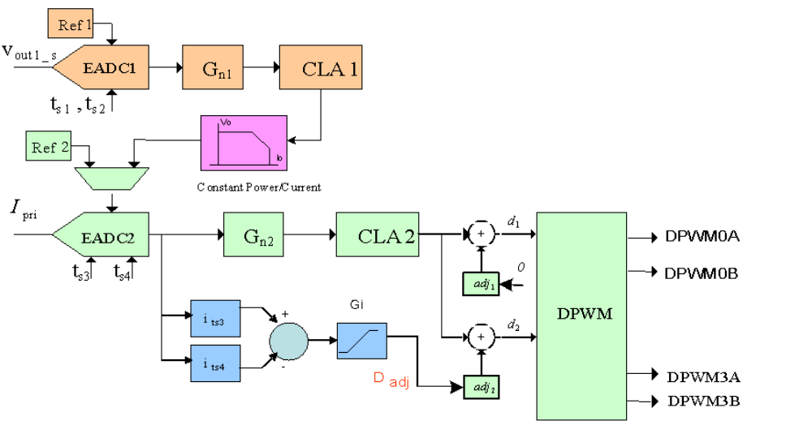
UCD3138 Flux Balancing Approach （UCD3138流量平衡法）
5.13.1 Calculation 计算
该逻辑输出是一个提供给DPWM的周期调整数，该数为基于来自于一个或2个前端EADCs的两采样值之间的差值。其等式为：
D_{adj} =（E₁-E₂）*2^{CYC}_{ADJGAIN}
D_{adj} = Duty Cycle Adjust 占空比周期调整
E₁、E₂ = EADC误差值 ( i_{ts3} 和 i_{ts4} ) 示于图中
CYC_ADJ_GAIN = CYCADJCTRL寄存器中的位字段值
5.13.2 Configuration 配置
控制的大多数位于CYCADJCTRL寄存器中。
测量启动在一个DPWMxA的上升沿后，其由CYC_ADJ_SYNC选择。
上升沿后，逻辑等待前端一个采样由FIRST_SAMPLE_SEL选择。
第一次采样后，逻辑等待前端一个采样由SECOND_SAMPLE_SEL选择。完成后，其计算并将结果呈现给DPWM模块。
以上提及的所有位字段均在寄存器中。也有一个CYC_ADJ_EN位允许自动周期调整。
使能DPWM接受调整，置位DPWMCTRL1寄存器中的CLA_DUTY_ADJ_EN位是必需的。
当然为EADC提供采样触发也是必要的。
为防止在测量错误事件中过度调节，周期调整限制寄存器（CYCADJLIM）提供高位和低位限制的调解量。
5.13.3 Scaling 标定
EADC误差信号以标称值1 mV进行标定。自动周期调整模块的输出以标准分辨率1步（LSB）=4nS来标定。
所以假如（E₁-E₂）是1 mV，且CYC_ADJ_GAIN是0，那么周期调整将为4nS。这将使CLA_DUTY_ADJ_EN位设置的任意DPWM上的占空比为4nS步长。

6 Fault Mux 故障复用
Fault Mux寄存器控制着一个连接电源故障信号至DPWMs的多路转换器。它们还执行其他几个功能：
-- 配置模拟和数字比较器及故障引脚的故障检测
-- 故障状态监视
-- 同步整流FETs数字理想二极管仿真电路
-- 处理器时钟故障检测
-- 支持模拟峰值电流模式控制
Fault Mux负责故障检测和连接，而DPWM是负责处理已故障的动作。尽管故障响应动作控制的大多数是基于DPWM寄存器，其在本节中讨论（以这种方式与故障信息有关的所有信息可以在一个地方）。
这里是UCD3138故障处理系统的概述:
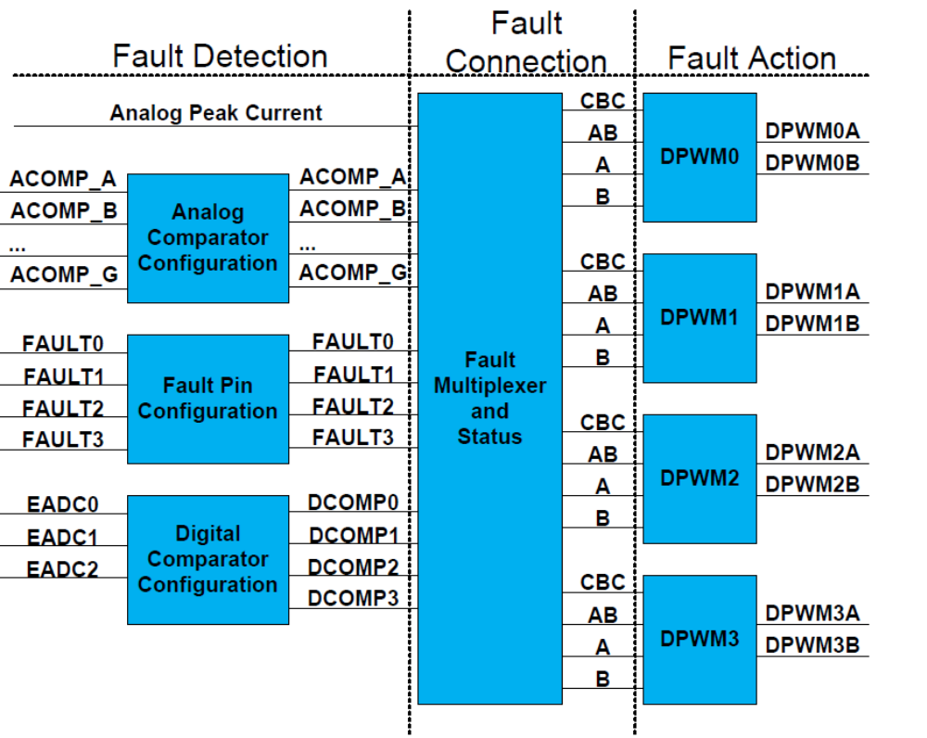
UCD3138 Fault Handling System 故障处理系统

该系统是非常灵活和强大的。有7个模拟比较器、4个故障引脚和4个数字比较器。每个DPWM有4个以不同方式影响其输出的故障输入（通道）。故障探测输出的任意组合可连接并驱动DPWM故障输入的任意组合。
这有3个例子：
1：许多故障输出映射到一个单独的故障输入－一个模拟比较器的过电压保护、一个数字比较器的过电流
保护和一个外部数字故障引脚可均映射到一个连接到单一DPWM故障输入并关闭DPWM1-A的fault-A信号。
2：单一故障输出映射作为多个DPWM模块内的多个故障输入－一个模拟比较器的过电流保护通过几个故障模块映射到所有DPWM0~DPWM3。
3： 许多故障源映射到多个DPWM模块内的多个故障模块。上述提及的2个备选方案的灵活组合。
6.1 Analog Comparator Configuration 模拟比较器配置
该模拟比较器通过ACOMPCTRL0 到 ACOMPCTRL3寄存器控制。该图示出控制是如何工作的：

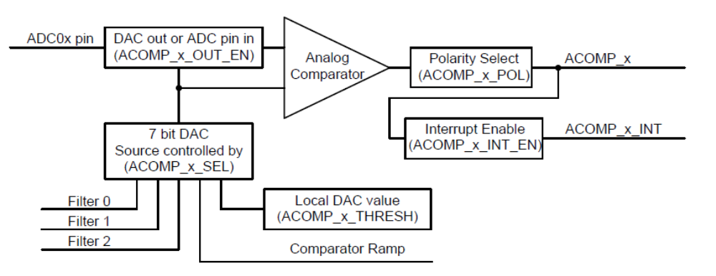
UCD3138 Analog Comparator Control 模拟比较器控制
以上在括号中画出的所有名字是ACOMPCTRL寄存器中的位字段名称。模拟比较器在HFO（标称250MHz）速率下采样。模拟比较器上的任何故障将被传输到Fault Mux上而不论DPWM时序。
6.1.1 ACOMP_EN 比较器的使能
模拟比较器启动的第一步是设置ACOMPCTRL0中的ACOMP_EN位。
FaultMuxRegs.ACOMPCTRL0.bit.ACOMP_EN = 1;
该位使能所有的模拟比较器。
6.1.2 ACOMP_x_THRESH 比较器的门槛寄存器
对于典型操作――检测一个过流或过压故障仅需写入ACOMP_x_THRESH寄存器。写入对应于输入引脚上故障水平的值。
FaultMuxRegs.ACOMPCTRL1.bit.ACOMP_C_THRESH = OVER_VOLTAGE_THRESH;
所有其它寄存器被设置到该应用程序工作的默认值。
6.1.3 ACOMP_x_POL 比较器的极性位
检测所引起的电压低于一个阈值而不是高于该阀值的故障，清除ACOMP_x_POL位。当ADC引脚低于比较器阀值时，该位为0将引发ACOMP_x信号激活
6.1.4 ACOMP_x_INT_EN 比较器的中断使能
ACOMP_x_INT_EN位，当设置使能后，来自于模拟比较器中断允许。
6.1.5 ACOMP_x_OUT_EN 比较器的DAC输出允许
当ACOMP_x_OUT_EN位设置时，DAC值输出至ADC引脚，其可用于一个外部的参考电压。咨询UCD3138芯片数据手册获得附加信息。当该位使能时，明显地，比较器的输出信号是无效的。
6.1.6 ACOMP_x_SEL 比较器的源选择
比较器DAC也可被其它数据驱动――滤波器输出和比较器斜坡引擎。ACOMP_x_SEL寄存器选择使用哪一个源。
6.1.7 ACOMP_F_REF_SEL 比较器F参考电压选择
模拟比较器F是一个特殊情况。其可被配置用于AD07作为参考电压来替代DAC（参考电压）。使能该位，设置ACOMPCTRL2的ACOMP_F_REF_SEL位。
6.1.8 ACOMPCTRL Register Arrangement ACOMPCTR寄存器的分配
由7个模拟比较器，但仅4个ACOMPCTRL寄存器。2个比较器组合至一个寄存器。

6.2 Analog Comparator Ramp 模拟比较器斜坡
模拟比较器斜坡逻辑是一个可提供一个斜坡值到比较器参考DACs的数字回路。它是一个简单的、低分辨率版本在前端的斜坡引擎（请参见第41页第3.3节匝道了解有关前端斜坡引擎的信息）。模拟比较器斜坡的主要区别特征如下：
― 仅7位分辨率
― 斜坡步长由MCLK(标称31.25MHz)触发
－ 由DPWMx_TRIG_EN位选择DPWMx帧启动触发斜坡启动
－ 斜坡总是上升的，斜坡结束值总是为0x7f（DAC最大值）

6.3 Digital Comparator Configuration 数字比较器配置
数字比较器是另一种故障检测机制。替代一个直接的模拟输入，它用于前端EADC测量结果的故障检测。
有3个数字比较器由DCOMPCTRL0、1和2寄存器控制。
它们使用FE_SEL位字段来选择哪个前端用作为源以及是否使用前端的绝对电压或误差数据。
象模拟比较器一样，它们可编程来检测一个故障高于或低于门槛值。COMP_POL位用于选择高于或低于。
也有INT_EN用于使能中断。
每个数字比较器具有它自己的COMP_EN位来使能。
比较器的参考门槛值是非常简单的，其仅来自于THRESH位字段。其有11位分辨率，比模拟比较器高很多。
数字比较器增加了一个计数器用于在（故障）信号传递到Fault Mux之前需要几个连续的故障检测。
CNT_THRESH位字段控制故障检测需要的次数。写入1到CNT_CLR位将清除计数器及相关的故障。
假如计数器达到CNT_THRESH中值，它（计数器）将被锁存并且DCOMP_x信号将被送至Fault Mux。
数字比较器执行它的比较在每个被选前端的每次采样。
故障检测仅发生在前端的每次采样后。
CNT_CONFIG位控制处理其中包含一些故障样本和一些无故障样本的采样顺序。在缺省模式下―――（CNT_CONFIG = 0）一个无故障样本将清除该计数器（假定它没有达到CNT_THRESH值）。
假如CNT_CONFIG = 1，一个无故障事件将递减该计数器，除非该计数器已经为0。该种设置下，假如故
障发生超过50%的时间，最终计数器将达到阈值。
还有一个DCOMPCNTSTAT寄存器给出了每个计数器的值。该寄存器仅为读。
6.4 Fault Pin Configuration 故障引脚配置
有4个故障引脚，Fault 0 到 Fault 3。它们的配置非常简单。
－ FAULTx_POL 设置极性
－ FAULTx_INT_EN 使能中断
－ FAULTx_DET_EN 使能故障检测
所有这些位均在EXTFAULTCTRL寄存器中。象模拟比较器一样，故障引脚在MCLK速率下采样。
6.5 Analog Peak Current 模拟峰值电流
模拟峰值电流是Fault Mux的另一个输入。它不是技术上的故障，因为它是基于峰值电流模式控制电源的正常工作控制。来自于前端的模拟峰值电流信号仅可被引入DPWM的CBC（逐周）输入。更多附加信息咨询由UCD3138PSFBEVM-029 EVM和TI移相全桥（峰值电流模式控制）实施的应用笔记提供的参考固件。
6.6 Fault Status Registers 故障状态寄存器
有2个寄存器给出了故障检测状态：FAULTMUXINTSTAT和FAULTMUXRAWSTAT。
它们有相同的位，但它们有不同的意思。
FAULTMUXRAWSTAT示出了每个故障的即时状态。
FAULTMUXINTSTAT示出了任意故障
－ 自上次读取FAULTMUXINTSTAT后发生的
－ 有中断使能的
这对于检测那些在一个周期内仅产生很短时间的故障是特别有用的。从这寄存器读取将清除来自于故障检测中断逻辑的故障。该中断逻辑依赖于信号传输到Fault Mux 和 DPWM。这些信号仅锁存在DPWM逻辑单元中，而不是其它任意位置。
寄存器还有LFO_FAIL（低频震荡故障）和DCM_DETECT（非连续模式探测）2个位。这些源在其它地方已描述。这些信号不用于Fault Mux的输入。

6.7 Fault Mux Control Registers 故障复用控制寄存器
有4个DPWM模块，DPWM0~DPWM3。每个DPWM模块有4个故障输入：CLIM、AB、A和B。
每个DPWM有3个故障复用寄存器：
• DPWMxCLIM – 控制CLIM，也就是大家熟知的CBC
• DPWMxFLTABDET – 控制AB故障输入
• DPWMxFAULTDET – 控制A和B故障输入。
编程这些寄存器是非常简单的。在每个寄存器中每个故障检测源有一个位对应。设置该位连接故障探测源到故障输入和DPWM（相关的）寄存器，此处为一个例子：
FaultMuxRegs.DPWM0FLTABDET.bit.ACOMP_B_EN = 1;
// 连接模拟比较器B到DPWM0故障输入AB。
在同样的寄存器中控制A和B故障输入工作如下：
FaultMuxRegs.DPWM0FAULTDET.bit.PWMA_ACOMP_B_EN = 1;
//连接模拟比较器B到DPWM0故障A
FaultMuxRegs.DPWM0FAULTDET.bit.PWMB_ACOMP_B_EN = 1;
//连接模拟比较器B到DPWM0故障B
几乎任何故障检测电路可被连接到的任意故障输入的任意DPWM上。仅有的例外是模拟峰值电流模式，其仅可被连接到CLIM故障输入：
FaultMuxRegs.DPWM0CLIM.bit.ANALOG_PCM_EN = 1;
6.8 DPWM Fault Action DPWM故障动作
故障链中的最后一节是故障动作行为，其发生在DPWM模块中。
下图画出了故障行为的要点：
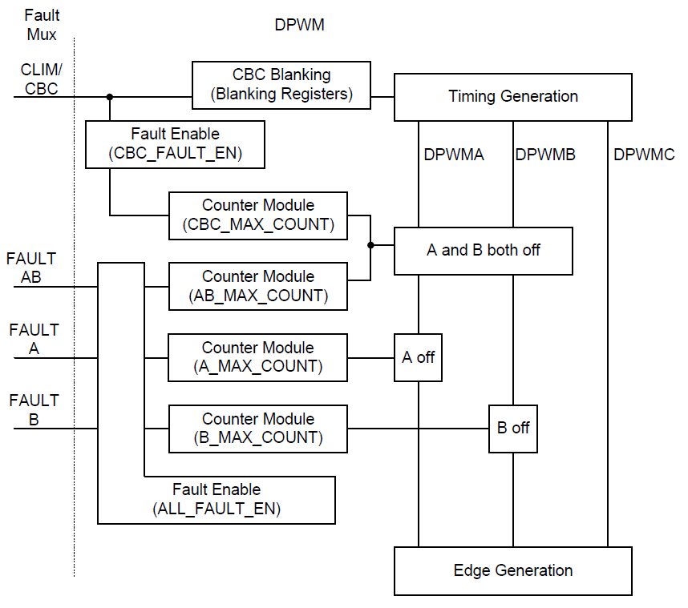
UCD3138 DPWM Fault Action UCD3138 DPWM故障动作
该图纸符合第12页2.1节的DPWM概述中的DPWM框图。这里部分扩展是故障处理部分。CLIM/CBC信号到时序产生模块的连接也示于图中。
关于在时序模块中CLIM/CBC的影响的信息，参见第26页2.15.3节逐周电流限制使能。在那节中描述的位影响送到时序发生器的CLIM/CBC信号。DPWM章节也描述了在DPWM中的消隐寄存器，其允许CLIM/CBC信号到时序产生部分的消隐。这些寄存器用于防止开关噪声引起的CBC逻辑的错误触发。它们也可用于两DPWM不同导通时间之间的同步CBC触发。消隐寄存器依赖拓扑而影响不同的边沿。其影响如下：
- 对于标准和谐振模式，消隐A和B的窗口仅应用于PWM-A
- 对于三角模式，消隐A和B的窗口仅运用于PWM-B
- 对于所有其它模式，消隐A和B的窗口，分别适用于PWM-A和PWM-B
CLIM/CBC也可用于故障处理，其在下面描述。2个机制是完全相互独立的，除非它们有相同的输入信号。消隐寄存器不影响去故障处理的CLIM/CBC信号。
本节将描述DPWM的故障处理部分中的逻辑。
所有4个信号：CLIM/CBC、AB、A和B可用作为故障信号，并且所有的（信号）可以完全相同的方式使用,除了他们关闭不同的DPWM信号。
如图示，有2个使能位：CBC_FAULT_EN对应CLIM/CBC，ALL_FAULT_EN对应其它3个。每个故障有其自己的5位计数器，由一个专用的x_MAX_COUNT位字段设置为最大值。故障门槛不停地检测，但每个DPWM周期仅一个事件被计数。假如该x_MAX_COUNT值设置为0，那么第一个故障事件将关闭相应的DPWM管脚。连续故障周期的最大计数值是31，假如该x_MAX_COUNT字段装载了0x1f（16＋15＝31）。
故障必须是连续产生的。如任意一个完整周期没有一个故障，计数器将被复位。
故障处理相对于时序发生器里的CLIM/CBC来说是非常简单的。它们简单地闭锁1个或2个DPWM管脚。重启DPWM，必须使用全局使能寄存器来禁止取消它：
void global_enable(void)
{
//Enable DPWM0, DPWM1, DPWM2, DPWM3, FE_CTRL0 AND FE_CTRL1 simultaneously.
LoopMuxRegs.GLBEN.all = 0x30F;
}
global_disable(void)
{
//Disable DPWM0, DPMW1, DPWM2 and DPWM3 simultaneously.
LoopMuxRegs.GLBEN.all = 0x300;
}
或者局部DPWM使能寄存器：
Dpwm0Regs.DPWMCTRL0.bit.PWM_EN = 0;
Dpwm0Regs.DPWMCTRL0.bit.PWM_EN = 1;
DPWMINT寄存器可用于配置故障中断，正如其它中断一样。其也可用于这些中断状态的读取。中断位读取后清0。DPWMFLTSTAT寄存器示出了故障的状态。这些位也是读位后清除（0）的。参见关于这些寄存器位映射的参考章节。
如通过ALL_FAULT_EN位使能的故障，并且当其产生故障时，FLT_A、 FLT_B、 FLT_AB的标志位将置位。假如响应的INT_EN位置位，DPWM将发送和中断至中央中断模块（CIM）。如DPWM的中断在CIM中使能，那么一个中断将给到处理器。
6.9 IDE /DCM Detection Control 理想二极管仿真/非连续模式检测控制
除了上面描述的故障检测和连接，在Fault Mux寄存器中有些其它的寄存器控制着其它的功能。这些功能之一是IDE/DCM检测。IDE代表理想二极管仿真。DCM代表不连续模式。他们都是由Fault Mux寄存器中的IDECTRL寄存器设置控制的。
一些隔离电源拓扑在二次侧简单地运用整流二极管。在理想二极管仿真中，FETs（场效应管）用于替代二极管。它们在二极管将导通时开通，在二极管将反向偏置时关闭。这种方法将提升效率因为经过FET的电压降低于经过二极管的压降。这被称作同步整流，所以FETs是同步FETs的简称。
在连续模式下，电流是一直流通的，同步FET在主侧关闭及死区期间可一直导通。这个功能可在DPWM模块的标准模式下完美处理。注意：该IDE/DCM检测仅工作于标准模式。
然而，在非连续模式下，电流不是连续流动的，因而同步FET必须在模拟二极管周期结束前关闭。否则能量将从二次侧流回到一次侧。
在非连续模式，同步FET(Db)导通时间正比于DPWMA的导通时间(Da)。乘数因子取决于拓扑、电路结构和Vin及Vout。该乘数因子需通过固件不停地计算和放入IDE_KD寄存器。
FaultMuxRegs.IDECTRL.bit.IDE_KD = kd_value;
IDE还必须在DPWM模块中使能：
Dpwm1Regs.DPWMCTRL2.bit.IDE_DUTY_B_EN = 1; //enable ide
Db通过Da（滤波器占空比）乘以IDE_KD。KD是一个是个无符号值带有4个整数位和9个小数位（bit）。例如：一个0b0001.000000000将等同于1的乘法器（“0b”代表二进制，“.”用于从整数划分小数部份）。这将对应于为0x200十六进制值。对于Kd的这个值，Db将完全等于Da。仅有一个IDE_KD寄存器，但每个滤波器都能使用KD计算。IDE值的每个滤波器的输出是由DPWM模块的IDE_EN位控制。DPWM模块由
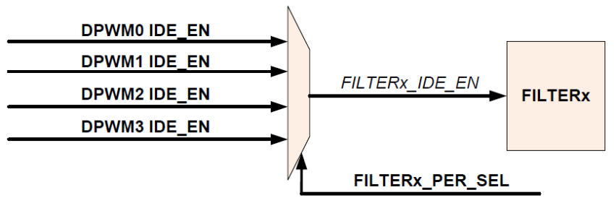
通常FILTERx_PER_SEL就已经指向了正确的滤波器，因为其也用于提供滤波器的周期来计算占空比的值。
然而在一些情况下，例如KCOMP用于替换周期的场合，仍有必要设置FILTERx_PER_SEL以便IDE_EN能被正确地复用。
注意：使用IDE的任何DPWM仍需设置，尽管该DPWM也许不提供IDE_EN到滤波器。如IDE_EN不设置，通常的死区时间将被使用到控制DPWMB。
IDECTRL寄存器还包含检测DCM的一种手段。如前提到在连续模式下，DPWMA关闭时同步FET在该整个时间里是导通的。所以Db=1-Da。在非连续模式下，Db < 1-Da。所以当Db< 1-Da时该DCM检测逻辑触发一个中断。提供迟滞以防在稳态接近连续和非连续边界时重复触发中断。用DCM_LIMIT_H和DCM_LIMIT_L寄存器来实现。
DCM_DETECT位被置位当：
Db < ((1-Da) – DCIM_LIMIT_L
其被清0当：
Db > ((1-Da) + DCIM_LIMIT_H
DCM_DETECT位在FAULTMUXRAWSTAT寄存器中可监视。中断位的状态在FAULTMUXINTSTAT寄存器可读取。中断由IDECTRL寄存器中的DCM_INT_EN位使能。
6.10 Oscillator Failure Detection 振荡器失效检测
Fault Mux模块提供高频和低频振荡器模块的检测失效的能力。高频振荡器失效检测可配置成产生一个芯片复位。当检测到低频振荡器失效时，固件可配置Fault Mux产生一个中断。
6.10.1 High Frequency Oscillator Failure Detection 高频振荡器失效检测
2个计数器用于高频振荡器模块的失效检测。一个计数器实现高频振荡器时钟范围，同时另一个计数器实现低频振荡器时钟范围。一旦计数器达到一个固件可编程的17位门槛，该高频振荡器计数器产生一个明确的信号。这个明确的信号清除自由运行的低频振荡器计数器。在高频振荡器失效的情况下，无明确的信号产生并且低频振荡器将溢出，产生一个振荡器失效标识到SYS（系统）模块。基于系统模块设置，一个芯片复位从振荡器失效产生。
在HFO失效检测寄存器HFOFAILDET中有2个位字段。
HFO_FAIL_THRESH―― 配置门槛，一个明确的标志用于清除低频振荡器范围内的计数器（假如LFO计数器溢出，一个复位将产生），门槛分辨率等于高频振荡器周期。
Bit 0: HFO_DETECT_EN－ 置1使能高频振荡器失效检测逻辑，当一个振荡器失效检测到后芯片将复位。
HFO失效没有中断或状态位。是因为HFO失效时，处理器将不工作。
6.10.2 Low Frequency Oscillator Failure Detection 低频振荡器失效检测
低频振荡器用于看门狗定时器，并且测试HFO的功能以上已描述。当高频振荡器失效检测时，2个计数器用于检测低频振荡器模块的失效。在低频振荡器失效检测中计数器作用互换，一旦计数器达到一个固件可编程的5位门槛时，低频振荡器时钟产生一个明确的信号。该明确信号清除自由运行的高频振荡器计数器。在该种低频振荡器失效的情况下，无明确的信号产生并且高频振荡器计数器将溢出。通过Fault Mux中断或通过轮询Fault Mux寄存器中的状态寄存器，固件可检测低频振荡器失效。
在LFOFAILDET寄存器中有3个位字段：
• LFO_FAIL_THRESH – 配置门槛，一个确定的标志用于清除在高频振荡器范围内的计数器（假如HFO计数器溢出，一个复位将产生），门槛的分辨率等于低频振荡器周期。
• LFO_FAIL_INT_EN – 置1使能中断，其建立在LFO失效检测上
• LFO_DETECT_EN - 置1使能LFO失效检测电路。
在FAULTMUXRAWSTAT 和 FAULTMUXINTSTAT寄存器中有LFO_FAIL位，给出了LFO失效检测和中断状态。
7 GIO Module 通用IO模块
GIO模块提供通用输入/输出管脚。这些管脚也可用于至以上失效逻辑作为输入。也可用于失效中断。GIO寄存器也控制和监视外部中断管脚。它们相似于许多微处理器的GPIO功能。更多信息，参见218页第13节的GIO – General Purpose Input/Output Module。

