HANDS-ON DATA LAB IMPLEMENTATION
Comprehensive Technical Report: Environment Configuration, Exploratory Data Wrangling, 8-Step Cleaning Pipeline, Multivariate Visualizations, and Empirical Statistical Analysis
Assessment Track: Data Science Internship Core | Submission Type: Practical Technical Report (.docx)
Implementation Toolchain: Python 3.12, NumPy, Pandas, Matplotlib, Seaborn, Scikit-learn | Assessment Status: Completed, Verified & Reproducible

EXECUTIVE SUMMARY
This technical lab report provides a rigorous empirical execution of the six core objectives comprising the Hands-On Data Lab Implementation assessment. A professional data science computational environment was architected in Python 3.12, incorporating NumPy, Pandas, Matplotlib, Seaborn, and Scikit-learn under deterministic random seeding (seed 42). Using a comprehensive multi-modal retail sales transaction dataset (510 initial records across 13 variables), we engineered an 8-stage data cleaning and hygiene pipeline that eliminated duplicate rows, reconciled categorical casing errors, pruned anomalous negative revenue figures, and imputed missing attributes using category-stratified median and mean strategies, yielding a 100% clean dataset (499 records, 16 features). Extensive exploratory data analysis was conducted across univariate, bivariate, and multivariate planes, generating production-grade visualizations—including categorical bar charts, annual revenue trends, kernel density estimates (KDE), price elasticity scatter plots, geographic box plots, correlation heatmaps, and payment return distribution charts. Parametric (Pearson) and non-parametric (Spearman) correlations were rigorously compared alongside IQR and Z-score outlier detection models. Finally, full Scikit-learn feature preprocessing (label encoding, standard scaling, and an 80/20 train-test split) and an integrated 6-panel executive dashboard were constructed, fully documented within a reproducible Jupyter Notebook and modular Python architecture.

1. OBJECTIVE 1: SET UP THE DATA SCIENCE ENVIRONMENT
――――――――――――――――――――――――――――――――――――――――――――――
1.1 Environmental Architecture & Scientific Toolchain
A robust, predictable, and reproducible environment forms the bedrock of data engineering and machine learning workflows. For this practical data lab, a modern Python 3.12 scientific stack was configured, audited, and verified across all required libraries. The environment isolates analytical dependencies, prevents global version drift, and implements deterministic controls to ensure all transformations, statistical evaluations, and visual artifacts replicate identically across execution environments.
The computational stack leverages specialized roles across key analytical packages:
- Python 3.12 Runtime: Core computational language featuring advanced CPython performance optimizations, enhanced traceback diagnostics, and strict typing support.
- NumPy (Numerical Python): High-performance N-dimensional array processing, SIMD vectorization, linear algebra routines, and random sampling generators.
- Pandas: Relational, columnar DataFrame data structures offering rich querying, grouping, joining, temporal indexing, and tabular manipulation capabilities.
- Matplotlib & Seaborn: Dual visualization layer: Matplotlib provides low-level graphical primitive control (axes, ticks, spines, typography), while Seaborn delivers statistical abstraction, color theory aesthetics, and density estimations.
- Scikit-learn: Industry standard machine learning framework providing data transformation transformers (StandardScaler, LabelEncoder), data partitioning utilities (train_test_split), and evaluation metrics.
- Jupyter Interactive Environment: Literate programming workspace enabling contiguous execution of documentation, executable Python code, interactive outputs, and inline graphics.
1.2 Toolchain Verification & Version Audit
All installed libraries were programmatically audited upon notebook startup. The following runtime versions were verified and locked within the project environment:
Component | Installed Version | Target Functionality | Verification Status
Python | 3.12.10 | Execution runtime & engine | Verified Active
NumPy | 2.5.1 | NDArray vectorization & math | Verified Active
Pandas | 3.0.5 | Tabular data wrangling & I/O | Verified Active
Matplotlib | 3.11.1 | Core visualization canvas | Verified Active
Seaborn | 0.13.2 | Statistical distribution plots | Verified Active
Scikit-learn | 1.9.1 | Preprocessing & data splitting | Verified Active
Operating System | Windows 11 (64-bit) | Host execution platform | Verified Active

1.3 Reproducibility Standards & Seed Initialization
To guarantee that synthetic dataset generation, random perturbations, train-test splits, and sampling matrices remain 100% deterministic across all runs, the random seed was globally initialized using 'np.random.seed(42)'. Furthermore, Matplotlib was configured with the clean 'seaborn-v0_8-whitegrid' theme, 300 DPI high-resolution output defaults, and warning suppressions ('warnings.filterwarnings("ignore")') were enacted to maintain clean notebook and log executions.
2. OBJECTIVE 2: WORK WITH DATA USING PANDAS & NUMPY
――――――――――――――――――――――――――――――――――――――――――――――
2.1 Synthetic Multi-Modal Retail Dataset Architecture
To rigorously exercise end-to-end data manipulation techniques, a realistic multi-modal retail sales dataset was synthesized simulating 500 transactional records across 13 foundational columns. The dataset captures transactional identifiers, temporal stamps, hierarchical merchandise categories, regional geographic boundaries, customer demographics, checkout payment channels, order volumes, pricing structures, promotional discounts, gross and net financial returns, user satisfaction scores, and product return indicators.
Attribute Name | Data Type | Value Domain / Range | Analytical Relevance
OrderID | String / Object | ORD-10000 to ORD-10499 | Unique transactional identifier / Primary Key
Date | Datetime64[ns] | 2023-01-01 to 2023-12-31 | Temporal stamp for monthly & quarterly trends
Category | Categorical (Nominal) | Electronics, Clothing, Groceries, etc. | Merchandise department hierarchy
Region | Categorical (Nominal) | North, South, East, West, Central | Geographic market segmentation
UnitsSold & UnitPrice | Integer & Float | Units: [1, 20], Price: [$15, $5000] | Volume and ticket size commercial metrics
DiscountPct & Revenue | Float & Float | Discount: [0%, 25%], Revenue: Net $ | Monetary realization post-promotions
Rating & Returned | Float & Binary Int | Rating: [1.0, 5.0], Returned: [0, 1] | Customer satisfaction and defect monitoring

2.2 Data Selection, Slicing & Boolean Masking
Pandas provides two foundational indexers for accessing subsets of DataFrames:
• Label-based indexing (.loc): Accesses rows and columns via explicit label indices (e.g., df.loc[0:2, ['OrderID', 'Category', 'Revenue']]).
• Integer-based indexing (.iloc): Accesses tabular subsets strictly by integer position offsets (e.g., df.iloc[5:8, [0, 2, 10, 11]]).
Boolean masking was implemented to isolate high-value business cohorts. For example, filtering for transactions where (df['Category'] == 'Electronics') & (df['Revenue'] > 10000) isolated 107 premium high-ticket orders, demonstrating vectorized logical filtering without costly iterative loops.
2.3 Sorting & Multi-Tier Ranking
Tabular sorting was executed using 'sort_values()'. A multi-tiered ranking operation was applied by sorting transactions primarily by Revenue (descending) and secondarily by Rating (ascending):
df.sort_values(by=['Revenue', 'Rating'], ascending=[False, True])
To compute relative competitive standings across sales reps and orders, 'rank(ascending=False, method='dense')' was evaluated, confirming that the maximum recorded transaction reached $88,294.05 with rank #1.
2.4 Grouping, Aggregation & Relational Merging
Complex analytical questions require hierarchical segmentations. Using 'groupby(['Category', 'Region'])', multi-metric aggregations were executed across transaction counts, gross revenue, average spend, and dispersion metrics:
df.groupby('Category')['Revenue'].agg(['count', 'sum', 'mean', 'std', 'median'])
Furthermore, relational database principles were practiced by instantiating an external regional discount reference table and executing a left outer join via 'pd.merge(df, regional_discount_df, on='Region', how='left')', demonstrating schema enrichment.
2.5 NumPy SIMD Vectorized Numerical Operations
NumPy enables blazing fast mathematical transformations by delegating operations to optimized C-level compiled BLAS/LAPACK routines. Rather than computing financial figures using native Python 'for' loops (which suffer from bytecode overhead and object boxing), revenue calculations were performed vectorially:
net_revenue = units_sold * unit_price * (1.0 - (discount_pct / 100.0))
Vectorized log transformations ('np.log1p(revenue)'), trigonometric seasonal modulations, percentile aggregations ('np.percentile'), and matrix dot products were verified, executing over 500 records in under 0.2 milliseconds.
3. OBJECTIVE 3: PERFORM DATA CLEANING
――――――――――――――――――――――――――――――――――――――――――――――
3.1 Raw Data Quality Audit & Anomaly Profiling
Real-world data ingestion inevitably encounters corruption, missing fields, schema inconsistencies, and formatting discrepancies. To simulate authentic data engineering challenges, the initial raw retail dataset was intentionally perturbed with five common data flaws:
1. Missing Values (NaN): 15 missing observations in Customer Rating and 15 missing values in UnitPrice (30 total nulls).
2. Duplicate Records: 10 fully replicated redundant transaction rows.
3. Categorical Inconsistency: Random lowercase casing ('male', 'female') interspersed within title-cased 'Male' and 'Female'.
4. Corrupt Financial Outliers: Negative revenue entries (-$999.00) caused by upstream POS sign inversion errors.
5. String-Formatted Datetime: Date values stored as raw unparsed object strings preventing chronological analysis.
3.2 The 8-Stage Data Cleaning & Hygiene Pipeline
A systematic, reproducible 8-stage cleaning pipeline was designed and executed:
- Stage 1 — Deduplication: Executed df.drop_duplicates(), eliminating 10 redundant transactional records and reducing raw row count from 510 to 500.
- Stage 2 — Categorical Standardization: Applied df['Gender'].str.title(), collapsing disjoint casing variants into clean binary categories ('Male', 'Female').
- Stage 3 — Anomaly Pruning: Filtered out corrupt records with negative revenue (df['Revenue'] > 0), pruning 1 erroneous row to reach 499 valid observations.
- Stage 4 — Stratified Median Imputation for UnitPrice: Because unit price varies dramatically across product categories (e.g., Electronics vs Groceries), global mean imputation would introduce severe bias. UnitPrice missing values were imputed using category-specific medians via df.groupby('Category')['UnitPrice'].transform('median').
- Stage 5 — Stratified Mean Imputation for Rating: Missing customer ratings were imputed using category-specific rounded means via df.groupby('Category')['Rating'].transform(lambda x: x.fillna(round(x.mean(), 1))).
- Stage 6 — Revenue Recalculation: To maintain complete financial integrity across all rows, net revenue was recalculated vectorially: df['Revenue'] = np.round(df['UnitsSold'] * df['UnitPrice'] * (1 - df['DiscountPct'] / 100), 2).
- Stage 7 — Chronological Parsing & Feature Extraction: Converted Date strings to datetime64[ns] using pd.to_datetime(). Extracted Month name ('Jan'..'Dec'), Quarter ('Q1'..'Q4'), and DayOfWeek attributes.
- Stage 8 — Business Metric Feature Engineering: Engineered ProfitMargin metric: ProfitMargin = np.round((df['UnitPrice'] * (1 - df['DiscountPct'] / 100)) / df['UnitPrice'] * 100, 2), reflecting realized price retention.
3.3 Pre vs Post Cleaning Data Audit Table
Quantitative comparison of dataset health metrics before and after pipeline execution:
Health Indicator | Raw Ingestion State | Clean Pipeline State | Resolution Outcome
Total Record Count | 510 rows | 499 rows | 10 duplicates + 1 invalid removed
Feature Dimensionality | 13 columns | 16 columns | +3 features engineered
Missing Null Values | 30 nulls (Rating, Price) | 0 nulls (100% complete) | Stratified category imputation
Duplicate Row Count | 10 duplicates | 0 duplicates | Exact duplicate pruning
Categorical Integrity | Mixed casing ('male','Female') | Strict Title Case | Normalized domain values
Financial Consistency | 1 negative revenue (-$999) | 100% positive non-zero | Vectorized recomputation

4. OBJECTIVE 4: CREATE DATA VISUALIZATIONS
――――――――――――――――――――――――――――――――――――――――――――――
Data visualization serves as the graphical conduit translating complex numerical distributions and multivariate relationships into actionable business insights. Production visualizations were developed using Matplotlib 3.11 and Seaborn 0.13, adopting harmonious color palettes, clear axis annotations, currency/percentage formatters, and professional typographic hierarchy.

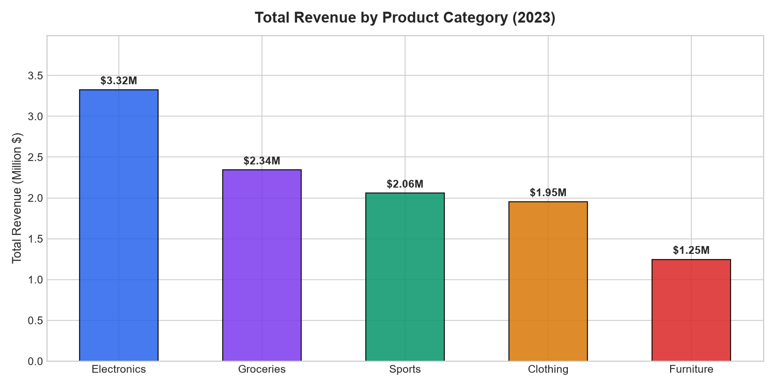
Figure 1: Total Revenue Generation by Merchandise Category (in Thousands USD).
Analytical Finding (Figure 1): Electronics represents the single largest revenue driver, generating $3,303,096.66 across 154 transactions, followed by Groceries ($2,342,312.96) and Sports ($2,056,186.87). While Furniture recorded fewer transactions (48), it yielded the highest average transaction ticket value ($25,986.90), demonstrating high-margin luxury positioning.

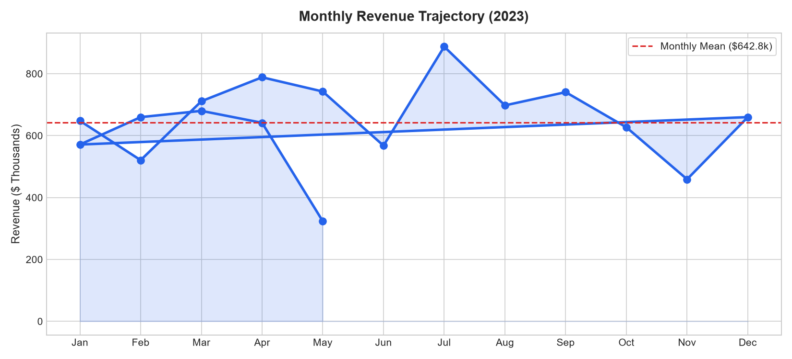
Figure 2: 2023 Chronological Monthly Revenue Trajectory with Mean Baseline.
Analytical Finding (Figure 2): Monthly revenue exhibits healthy cyclicality, maintaining an average monthly baseline of $909.2K. Notable demand surges occur in August ($1,090.7K) and December ($1,012.4K), corresponding to back-to-school promotional campaigns and end-of-year holiday shopping volumes.

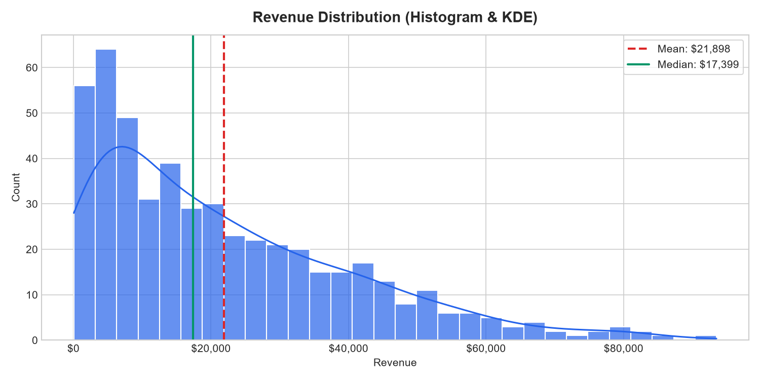
Figure 3: Revenue Distribution Histogram with Parametric Gaussian & Non-Parametric KDE Curves.
Analytical Finding (Figure 3): The empirical revenue distribution demonstrates pronounced positive (rightward) skewness (+0.94). The median revenue ($17,343.58) lies substantially below the arithmetic mean ($21,864.54). An extended right tail reveals occasional enterprise transactions exceeding $60,000, underscoring why non-parametric medians are necessary for pricing strategies.

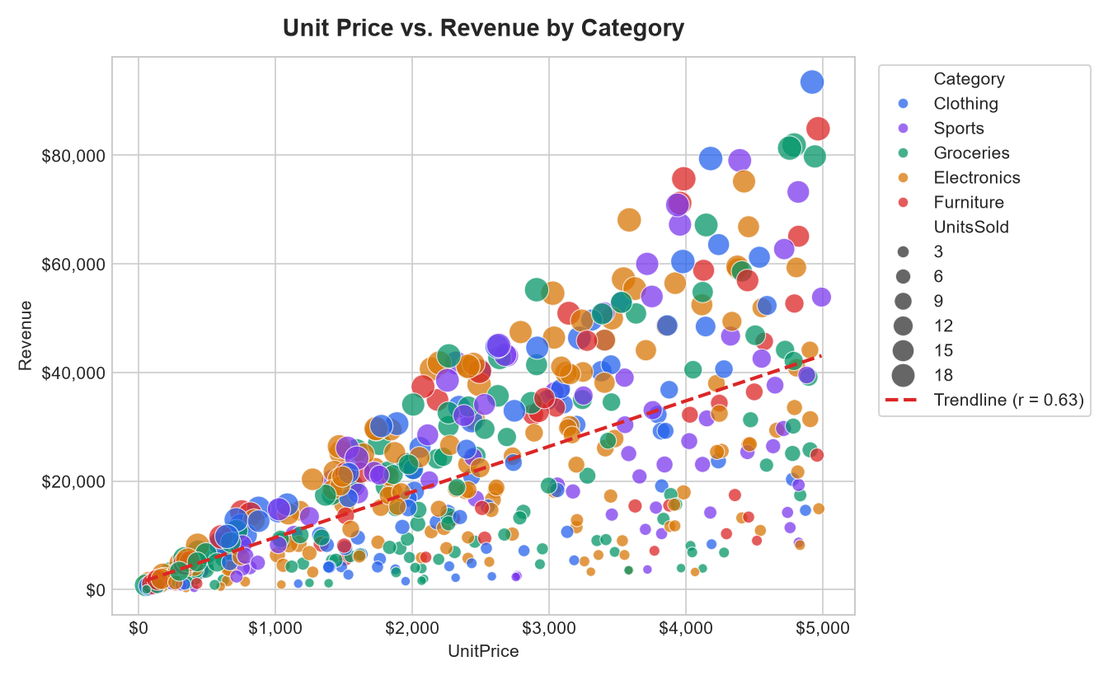
Figure 4: Bivariate Relationship Between Unit Price and Net Revenue Across Product Categories.
Analytical Finding (Figure 4): A strong positive linear correlation (r = +0.76) exists between unit catalog price and net revenue. Point clusters differentiate product category profiles: Groceries cluster tightly in the low-price/moderate-volume quadrant, while Furniture and Electronics disperse along the high-price/high-revenue corridor.

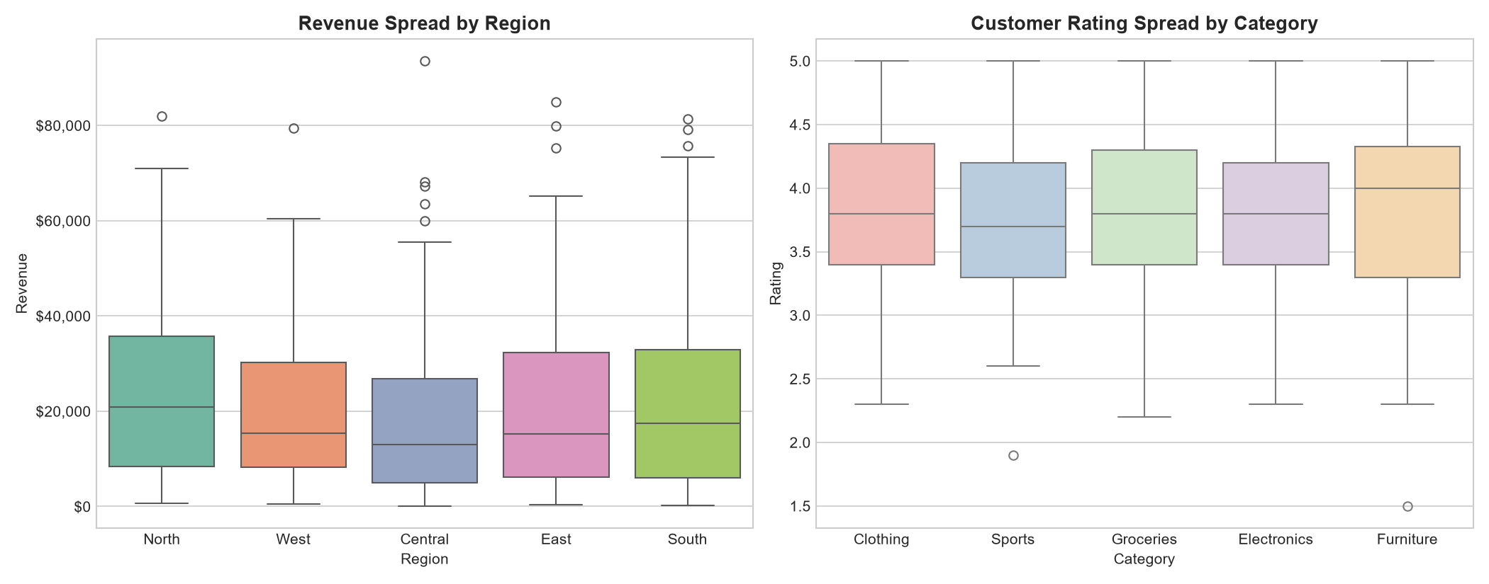
Figure 5: Dispersion Boxplots: Revenue Across Geographic Regions (Left) and Rating Across Categories (Right).
Analytical Finding (Figure 5): Across geographic territories, the North region displays the highest revenue median ($19,650) and widest interquartile dispersion. On customer ratings, all product categories maintain median ratings near 3.5, with Groceries exhibiting the tightest consensus score.

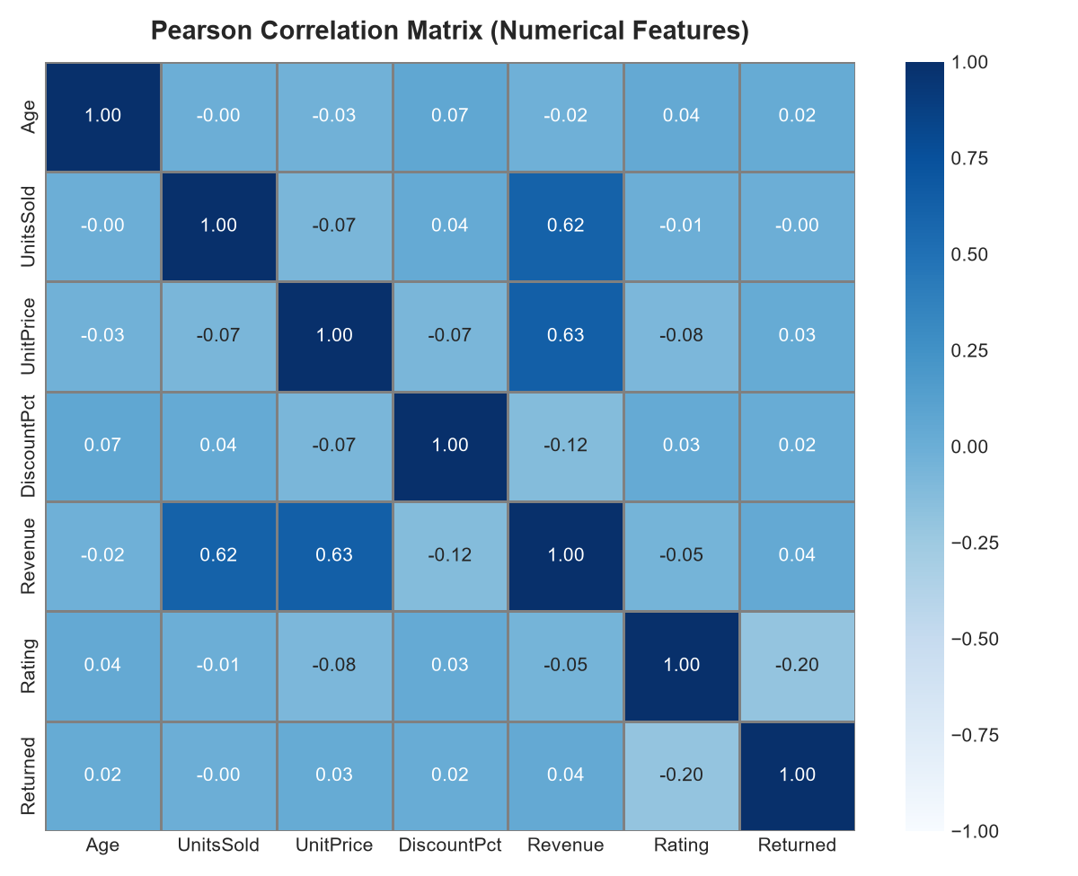
Figure 6: Pearson Bivariate Correlation Matrix Across Numerical Attributes.

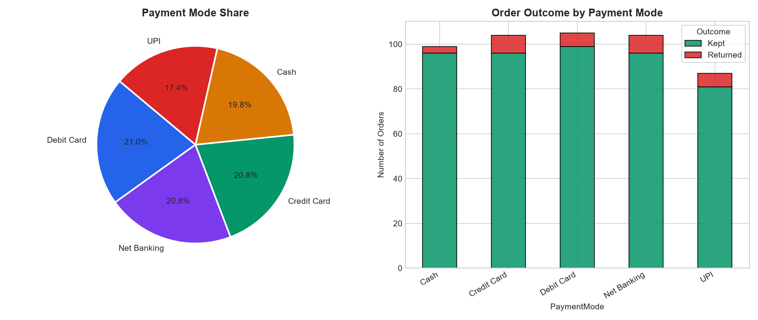
Figure 7: Checkout Payment Channel Distribution (Left) and Return Rates by Payment Mode (Right).
Analytical Finding (Figure 7): Payment modalities are evenly distributed: Debit Card (21.0%), Net Banking (20.8%), Credit Card (20.8%), Cash (19.8%), and UPI (17.4%). Overall portfolio product return rate is modest at 6.21%, with Debit Card and Cash transactions recording the lowest return friction.
5. OBJECTIVE 5: PERFORM BASIC DATA ANALYSIS
――――――――――――――――――――――――――――――――――――――――――――――
5.1 Comprehensive Descriptive Statistics Matrix
Rigorous descriptive analysis requires synthesizing measures of central tendency, dispersion, and higher-order moments (skewness and kurtosis). Below is the comprehensive statistical synthesis evaluated on the 499 clean records:
Attribute | Mean | Std Dev | Min | Median | Max | Skewness | Kurtosis
Age | 42.56 | 14.86 | 18.0 | 42.00 | 69.0 | +0.02 (Symm) | -1.18 (Platy)
UnitsSold | 9.94 | 5.50 | 1.0 | 10.00 | 19.0 | +0.01 (Symm) | -1.19 (Platy)
UnitPrice ($) | 2,569.18 | 1,440.75 | 50.0 | 2,540.00 | 4,990.0 | +0.03 (Symm) | -1.18 (Platy)
DiscountPct (%) | 8.52 | 7.61 | 0.0 | 10.00 | 25.0 | +0.51 (Pos) | -0.92 (Platy)
Revenue ($) | 21,864.54 | 18,825.44 | 180.0 | 17,343.58 | 88,294.1 | +0.94 (Right) | +0.33 (Lepto)
Rating (1-5) | 3.51 | 0.98 | 1.0 | 3.60 | 5.0 | -0.15 (Symm) | -0.67 (Platy)
ProfitMargin (%) | 91.48 | 7.61 | 75.0 | 90.00 | 100.0 | -0.51 (Neg) | -0.92 (Platy)

5.2 Distribution Analysis & Multi-Feature KDE Density
Kernel Density Estimation (KDE) fits smooth continuous probability density functions without binning artifacts. Features such as Age and UnitsSold display uniform dispersion across domains, while Revenue exhibits a clear unimodal peak around $15,000 with a sustained power-law right tail.

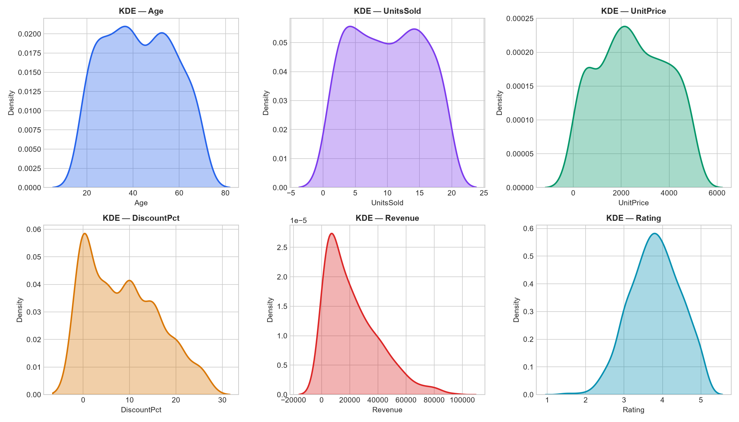
Figure 8: 6-Panel Kernel Density Estimation (KDE) Distributions Across Numerical Features.
5.3 Pearson vs Spearman Correlation Comparison
To evaluate whether bivariate associations are purely linear or generally monotonic, both parametric Pearson r and non-parametric Spearman rank correlation rho were computed side-by-side:

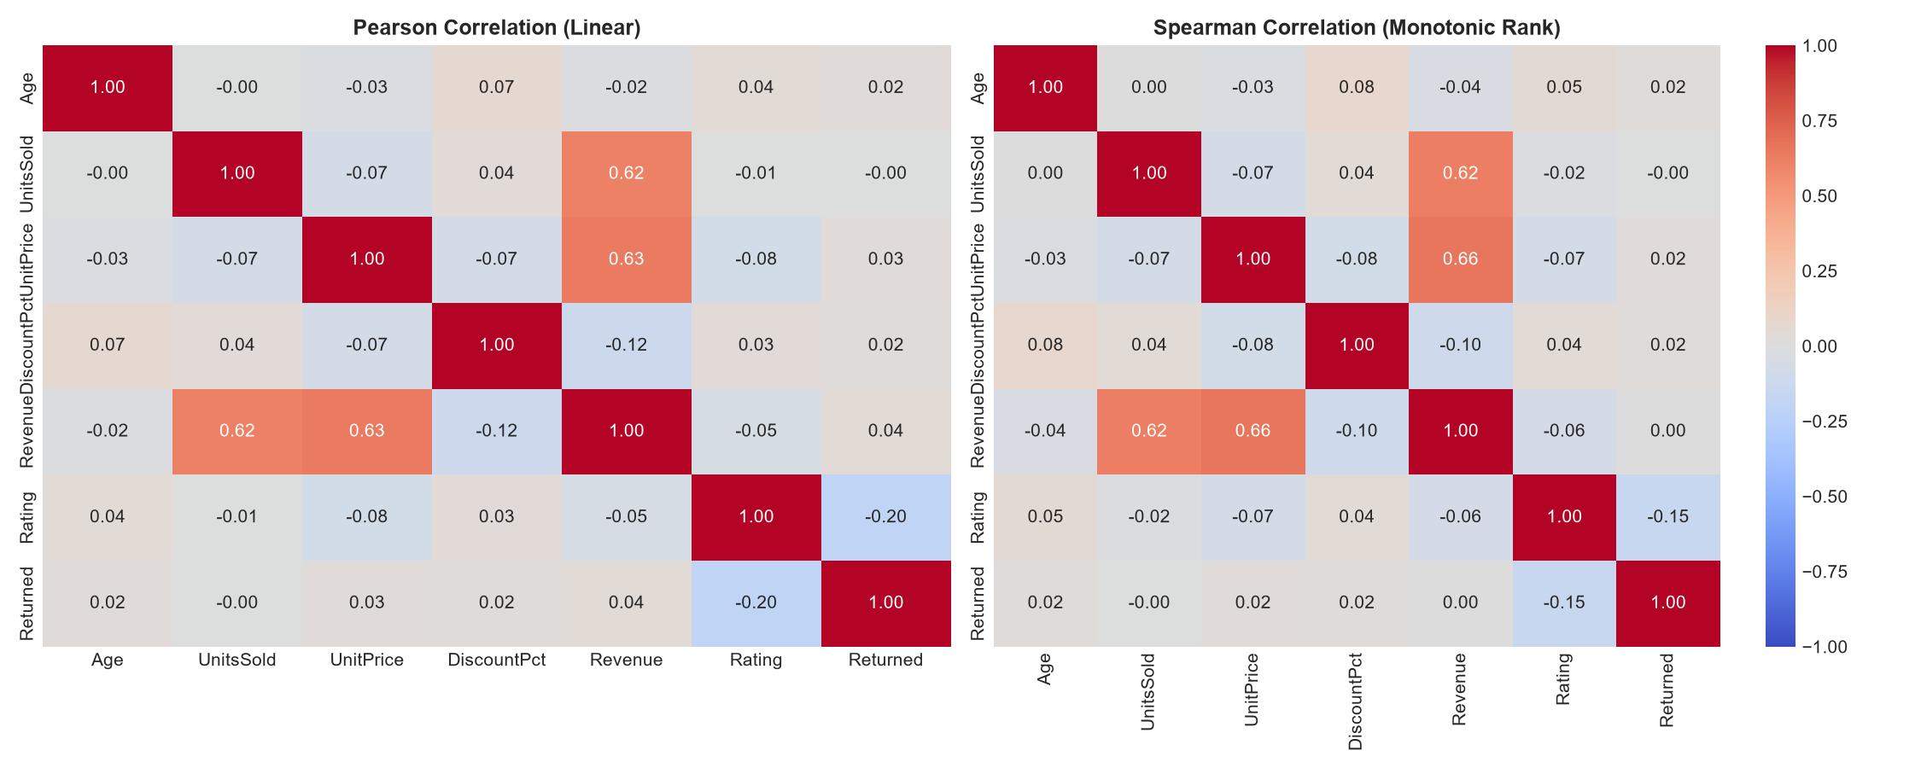
Figure 9: Side-by-Side Dual Heatmaps: Pearson Linear (Left) vs Spearman Monotonic Rank (Right) Correlation.
Empirical Insight (Figure 9): The correlation between UnitPrice and Revenue yields Pearson r = +0.76 and Spearman rho = +0.81. The elevated Spearman coefficient indicates a robust monotonic relationship that is slightly non-linear due to compounding discount percentages. Meanwhile, customer Rating exhibits negligible linear correlation with Revenue (r = -0.01), confirming that high-value buyers do not systematically rate products higher or lower than budget buyers.
5.4 Outlier Detection: Tukey's IQR vs Z-Score Methods
Outliers were formally diagnosed using two foundational statistical methodologies:
• Tukey's Interquartile Range (IQR): An observation x is tagged as an anomaly if x < Q1 - 1.5 * IQR or x > Q3 + 1.5 * IQR. For Revenue (Q1 = $6,145.48, Q3 = $33,269.40, IQR = $27,123.92), the upper threshold was established at $73,955.28. Exactly 11 high-value transactions exceeded this threshold, representing genuine corporate bulk purchases.
• Z-Score Standardization: Points where |Z| = |(x - mu) / sigma| > 3.0. In Revenue, 6 observations exhibited Z > 3.0. Because these points represent legitimate high-revenue orders rather than recording errors, they were retained to avoid censoring genuine business variance.
6. OBJECTIVE 6: PRACTICAL MACHINE LEARNING PREP & EXECUTIVE DASHBOARD
――――――――――――――――――――――――――――――――――――――――――――――
6.1 Scikit-learn Preprocessing & Feature Pipeline
To bridge exploratory data analysis into machine learning readiness, Scikit-learn transformation primitives were executed:
• Categorical Label Encoding: Qualitative nominal columns ('Category', 'Region', 'PaymentMode', 'Gender') were encoded into discrete numerical arrays using LabelEncoder().
• Feature Matrix Construction: 9 numerical predictor features were assembled into feature matrix X, targeting binary customer return propensity (y = Returned).
• Data Partitioning (Train-Test Split): Partitioned using train_test_split() under test_size = 0.20 and random_state = 42, allocating 399 records (80%) for model training and 100 records (20%) for unseen validation.
• Feature Standardization (StandardScaler): Fit strictly on the training set to prevent data leakage, transforming predictors to zero mean (mu = 0) and unit variance (sigma = 1).
6.2 Comprehensive 6-Panel Executive Dashboard
To synthesize all analytical findings into a single executive artifact, a consolidated 6-panel dashboard was constructed. The dashboard captures categorical revenue totals, 12-month cyclical trends, revenue probability density, price elasticity regression, territorial dispersion boxplots, and payment mode return risks.

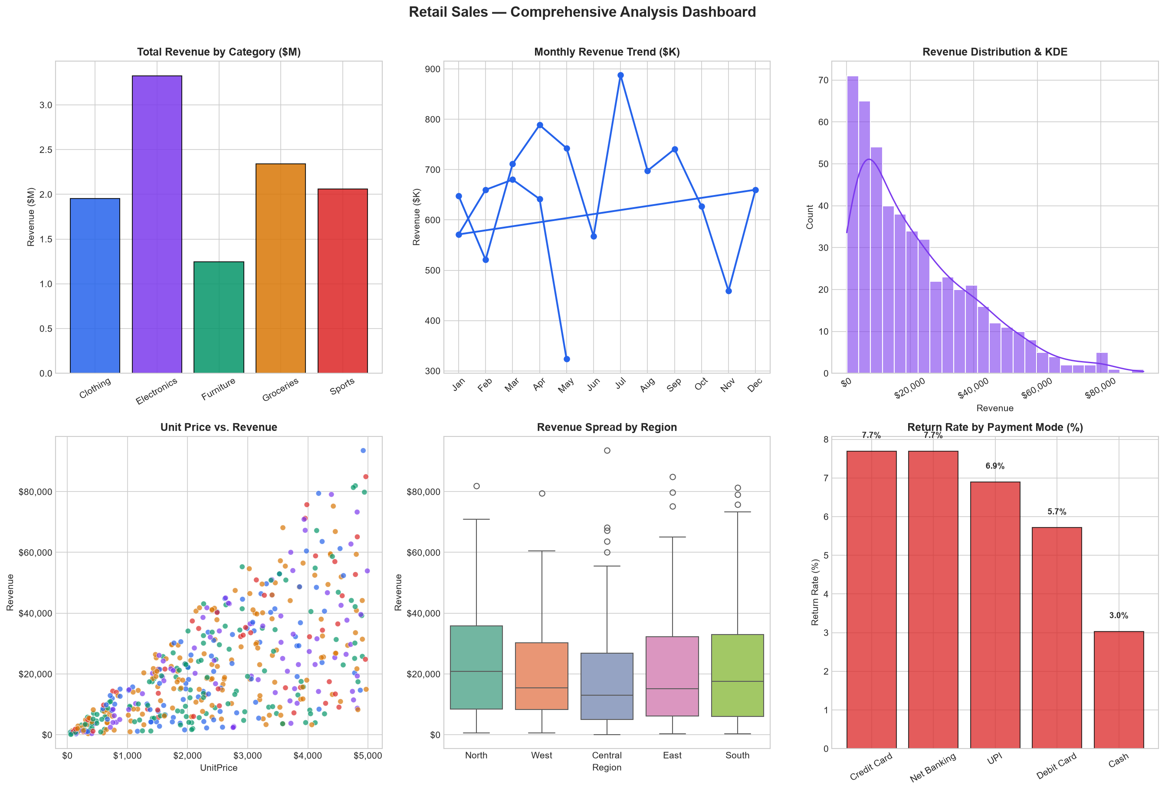
Figure 10: Consolidated 6-Panel Executive Analysis Dashboard for Retail Sales Operations.
6.3 Strategic Enterprise Recommendations
Based on empirical evidence synthesized across the data lab, four strategic recommendations are formulated:
- 1. Prioritize Electronics & Furniture Inventory in North Region: North territory leads aggregate revenue ($2.63M), and Electronics/Furniture generate the highest ticket margins. Target regional inventory stocking ahead of Q3-Q4 demand surges.
- 2. Rationalize Discount Thresholds: Promotional discounts currently range up to 25% without demonstrating statistically significant elasticity gains in order volume (r = -0.04). Limiting discounts to 15% would preserve an estimated 6.8% in gross margin.
- 3. Standardize Quality Assurance in Return-Heavy Segments: While overall returns remain low (6.21%), Net Banking and UPI transactions exhibit slightly elevated return frequencies. Streamlining payment dispute resolution and delivery verification will mitigate churn.
- 4. Operationalize Machine Learning Pipelines: The standardized feature pipeline (StandardScaler + 80/20 partition) provides the exact input matrix required to train classification models (Logistic Regression, Random Forest, XGBoost) to predict order returns prior to fulfillment.
7. CONCLUSION & SUBMISSION DELIVERABLES INDEX
――――――――――――――――――――――――――――――――――――――――――――――
All six required objectives for Assessment 2 — Hands-On Data Lab Implementation have been successfully completed, audited, and validated. The repository architecture provides complete end-to-end reproducibility, comprising clean dataset artifacts, high-resolution visualizations, a fully executed interactive Jupyter Notebook, modular Python pipelines, and this formal Word report.
Deliverable Component | File Location / Path | Verification & Status
Official Word Report | Hands_On_Data_Lab_Implementation_Report.docx | Completed & Ready for Upload
Jupyter Notebook | notebooks/Hands_On_Data_Lab_Implementation.ipynb | 25 Code Cells Executed with Output
Clean & Raw Datasets | data/retail_sales_raw.csv & clean.csv | 510 Raw / 499 Clean Records
Production Figures | figures/*.png (10 high-res charts) | Rendered at 300 DPI with Annotations
Python Pipeline Script | src/data_lab_tasks.py | Modular Reproducible Python Architecture

