DATA SCIENCE FUNDAMENTALS ASSESSMENT
Comprehensive Technical Report: End-to-End Methodologies, Statistical Formulations, Python Architecture & Empirical Practical Implementation
Assessment Track: Data Science Internship Core | Submission Type: Comprehensive Technical Report (.docx)
Implementation Toolchain: Python 3.12, NumPy, Pandas, Matplotlib | Assessment Status: Completed & Verified

EXECUTIVE SUMMARY
This assessment report encapsulates a rigorous evaluation of foundational data science proficiencies, structured across six principal pillars: (1) The end-to-end Data Science Lifecycle and industry problem taxonomy; (2) Python computational foundations including data structures, functional modularity, and file handling; (3) Core mathematical and statistical foundations spanning central tendency, dispersion metrics, probability fundamentals, and bivariate correlation; (4) Systematic data typology and transformation strategies covering numerical, categorical, ordinal, temporal, and textual data; (5) Industry engineering best practices regarding reproducible workflows, clean coding (PEP 8), and ethical considerations; and (6) An empirical practical assignment executed on a multi-modal customer banking dataset (250 records) featuring end-to-end exploratory data analysis, descriptive summaries, and production visualizations.

1. OBJECTIVE 1: UNDERSTAND DATA SCIENCE FUNDAMENTALS
――――――――――――――――――――――――――――――――――――――――――――――
1.1 The End-to-End Data Science Lifecycle
Modern Data Science is an iterative, multi-disciplinary engineering and scientific discipline focused on extracting actionable knowledge, synthesizing patterns, and constructing predictive systems from structured and unstructured data. Rather than isolated ad-hoc scripting, rigorous data science follows a disciplined lifecycle commonly formalized through frameworks such as CRISP-DM (Cross-Industry Standard Process for Data Mining) and OSEMN (Obtain, Scrub, Explore, Model, iNterpret):
- Business & Problem Understanding: Formulating vague commercial or scientific questions into quantifiable target variables, defining success metrics (e.g., F1-score, ROI, reduction in customer churn), and assessing project feasibility.
- Data Acquisition & Ingestion: Extracting raw information from transactional relational databases (SQL), document stores, RESTful APIs, distributed lakes, streaming event queues (Kafka), or web scraping.
- Data Cleaning & Wrangling: Standardizing schemas, filtering corruption, resolving structural errors, handling missing values, standardizing encodings, and aligning cross-table keys.
- Exploratory Data Analysis (EDA): Uncovering underlying data geometry, computing summary statistics, evaluating univariate and multivariate distributions, identifying multicollinearity, and pinpointing anomalies.
- Feature Engineering & Modeling: Transforming raw attributes into high-signal representations (scaling, one-hot encoding, polynomial features, text embeddings) and training predictive machine learning models.
- Validation & Interpretation: Evaluating models on unseen test sets via k-fold cross-validation, auditing feature importances (e.g., SHAP values), checking for bias, and ensuring generalization stability.
- Deployment, Monitoring & Maintenance: Containerizing models into REST APIs (FastAPI/Docker), scheduling automated batch pipelines, and monitoring feature drift and concept drift over time.
1.2 The Four Taxonomy Types of Data Analysis
Analytical inquiry falls along an ascending curve of analytical complexity and enterprise value:
Analysis Type | Core Question | Methodological Focus | Industry Concrete Example
Descriptive | What happened? | Aggregations, summary statistics, pivot tables, historical reporting dashboards. | Monthly revenue reporting across retail bank branches.
Diagnostic | Why did it happen? | Drill-down root cause analysis, cohort isolation, correlation analysis, anomaly detection. | Investigating an unexpected 18% spike in customer churn in Q3.
Predictive | What will happen? | Supervised machine learning, time-series forecasting, regression, classification models. | Estimating the default probability of a retail loan applicant within 12 months.
Prescriptive | What action should we take? | Mathematical optimization, reinforcement learning, simulation engines, A/B testing. | Dynamically re-routing delivery couriers in real-time to minimize fuel cost.

1.3 Real-World Industry Use Cases & Societal Impact
Data science has evolved into the central catalyst of competitive differentiation across global industries:
- Banking & Financial Services: Automated credit risk assessment, real-time transaction fraud scoring via graph neural networks and isolation forests, and algorithmic market trading.
- Healthcare & Bioinformatics: Computer vision for automated radiological scans (X-ray/MRI tumor detection), genomic sequence classification, and hospital patient readmission forecasting.
- E-Commerce & Digital Marketplaces: Collaborative filtering recommendation algorithms (Amazon/Netflix), dynamic elasticity-based pricing models, and search ranking personalization.
- Industrial Manufacturing & Energy: IoT sensor stream analysis for predictive equipment maintenance, reducing unplanned factory downtime and balancing regional power grid loads.
2. OBJECTIVE 2: APPLY PYTHON PROGRAMMING BASICS
――――――――――――――――――――――――――――――――――――――――――――――
Python is recognized as the lingua franca of data science due to its clear syntactic ergonomics, extensive standard library, and mature ecosystem of numerical packages (NumPy, Pandas, SciPy, Scikit-learn). Mastering fundamental constructs is essential for writing efficient and bug-free analytical pipelines.
2.1 Variables, Primitive Data Types & Operators
Python employs dynamic, strongly-typed variables. Variables reference objects in memory, categorized into primitives:
• Integers (int): Exact arbitrary-precision counts (e.g., sample_size = 250)
• Floating-Point (float): Double-precision IEEE 754 approximations (e.g., income = 55045.48)
• Strings (str): Immutable sequences of Unicode characters (e.g., department = 'Corporate')
• Booleans (bool): Logical truth states (True, False) evaluated in condition branching
Operators execute transformations across operands: Arithmetic (+, -, *, /, //, %, **), Comparison (==, !=, >, <, >=, <=), Logical (and, or, not), and Membership operators (in, not in) frequently used when filtering datasets.
2.2 Control Flow: Conditionals and Iteration
Branching decisions dictate data processing flow. Conditional statements (if-elif-else) allow segmenting data by rule thresholds. Loops (for, while) traverse records, while list comprehensions offer high-performance, expressive iteration syntax:
# High-performance list comprehension
churn_flags = [1 if satisfaction == 'Low' or score < 600 else 0 for satisfaction, score in zip(satisfaction_list, credit_scores)]
2.3 Functions, Modular Architecture & Scope
Functions encapsulate reusable computational blocks, enforce separation of concerns, and minimize code duplication (DRY principle). Well-formed data science functions utilize positional arguments, default keyword arguments (*args, **kwargs), explicit docstrings (PEP 257), and type hints to maintain production code clarity.
2.4 Python Data Structures Comparison
Structure | Mutability | Ordering | Access / Indexing | Data Science Use Case
List [] | Mutable | Ordered | Integer index (0-based) O(1) | Collecting raw sample observations, dynamic row appending.
Tuple () | Immutable | Ordered | Integer index (0-based) O(1) | Returning multiple outputs from functions, coordinates, fixed dimensions.
Dictionary {} | Mutable | Ordered (3.7+) | Hash Key lookup O(1) avg | Feature-value mapping, JSON payload processing, row mapping.
Set {} | Mutable | Unordered | Hash membership O(1) avg | Finding unique category values, rapid set difference/intersection operations.

2.5 File I/O & Ingestion Handling
Robust file handling requires using Python's context managers ('with open(...) as f:') to guarantee file descriptor release even in unhandled exceptions. Data scientists manage standard comma-separated files (CSV), structured hierarchical payloads (JSON), and binary serialized models (Pickle/Joblib) safely across local and cloud environments.
3. OBJECTIVE 3: LEARN STATISTICAL FOUNDATIONS
――――――――――――――――――――――――――――――――――――――――――――――
Statistics provides the mathematical underpinnings of all machine learning models. Without statistical rigor, analysts risk interpreting random sampling noise as substantive causal effects.
3.1 Measures of Central Tendency
Central tendency metrics identify the typical or central value around which data clusters:
• Arithmetic Mean (x̄ = (1/n) Σ x_i): The algebraic center of mass. Sensitive to extreme outliers and asymmetric heavy tails.
• Median: The middle observation in an ordered series. Robust against outliers; ideal for skewed distributions such as household income or real estate prices.
• Mode: The most frequently occurring observation. Applicable to both continuous, discrete, and nominal categorical features.
3.2 Measures of Dispersion & Variability
Dispersion quantifies the spread and uncertainty within data:
• Variance (s² = (1/(n-1)) Σ (x_i - x̄)²): Average squared deviation from the sample mean using Bessel's correction (n-1) to yield an unbiased estimator.
• Standard Deviation (s = √s²): The square root of variance, restoring variability to the original units of measurement.
• Interquartile Range (IQR = Q3 - Q1): The range occupied by the middle 50% of ordered data. Insensitive to tail extremes.
3.3 Percentiles, Quartiles & Anomaly Identification
Percentiles divide ordered observations into 100 equal parts. The 25th, 50th, and 75th percentiles represent the 1st (Q1), 2nd (Median), and 3rd (Q3) quartiles. Under Tukey's Outlier Rule, observations falling outside the inner fence bounds:
Lower Bound = Q1 - 1.5 × IQR
Upper Bound = Q3 + 1.5 × IQR
are tagged as potential anomalies requiring domain investigation or robust transformation.
3.4 Fundamentals of Probability & Probability Distributions
Probability quantifies the likelihood of events occurring within sample spaces. Key conceptual foundations include:
• Independent Events: P(A ∩ B) = P(A) × P(B). Knowledge of event A provides zero information regarding event B.
• Conditional Probability & Bayes' Theorem: P(A|B) = [P(B|A) × P(A)] / P(B). The cornerstone of Bayesian inference and Naive Bayes classifiers.
• Standard Normal Distribution: Symmetrical bell curve parameterized by μ = 0 and σ = 1. By the Empirical Rule (68-95-99.7), 68.2% of points lie within 1σ, 95.4% within 2σ, and 99.7% within 3σ.
3.5 Bivariate Association: Pearson vs Spearman Correlation
Correlation gauges the strength and direction of association between two features:
• Pearson Correlation Coefficient (r): Evaluates strictly linear relationships between continuous, normally distributed variables. Range: [-1.0, +1.0].
• Spearman Rank Correlation (ρ): Evaluates monotonic relationships between ranked variables, robust against nonlinearities and outliers.
Crucial Axiom: Correlation does NOT imply Causation. Confounding hidden variables (lurking factors) frequently produce spurious associations.
4. OBJECTIVE 4: UNDERSTAND DATA TYPES & STRUCTURES
――――――――――――――――――――――――――――――――――――――――――――――
Real-world datasets are heterogeneous. Handling features appropriately based on their statistical taxonomy is essential for correct preprocessing, statistical modeling, and machine learning pipeline stability.
Data Category | Sub-Types | Practical Examples | Analytical Preprocessing Treatment
Numerical | Discrete vs Continuous | Discrete: Number of open bank accounts (3). Continuous: Annual income ($55,045.48). | StandardScaler (z-score), MinMaxScaler [0, 1], log transforms for right-skewed data, median imputation.
Categorical (Nominal) | Unordered distinct categories | Department ('Retail', 'Corporate', 'SME'), Gender, Country. | One-Hot Encoding (pd.get_dummies) for low cardinality; Frequency or Target Encoding for high cardinality.
Categorical (Ordinal) | Ordered qualitative ranks | Customer Satisfaction ('Low', 'Medium', 'High', 'Very High'), Education Level. | Integer rank mapping preserving hierarchy (0, 1, 2, 3), isotonic calibration.
Temporal (Datetime) | Timestamps, dates, intervals | SignupDate ('2023-08-14 14:22:00'), transaction times. | Extract cyclical components (dayofweek, month, hour), compute recency/tenure elapsed periods, check seasonality.
Textual (Unstructured) | Free-form strings, reviews | Customer feedback notes: 'Mobile app response is sluggish...' | Text tokenization, lowercasing, regex cleaning, stop-word removal, TF-IDF vectorization, dense embedding vectors.

5. OBJECTIVE 5: FOLLOW DATA SCIENCE BEST PRACTICES
――――――――――――――――――――――――――――――――――――――――――――――
Professional data science diverges from amateur data analysis through its commitment to software engineering discipline, reproducibility standards, and rigorous ethical awareness.
- Clean Code Standards (PEP 8): Adhering to standard Python naming conventions (snake_case for functions and variables, PascalCase for classes), limiting line lengths to 88-100 characters, and avoiding dead or redundant code.
- Self-Documenting & Semantic Naming: Replacing vague identifiers like 'x' or 'df2' with expressive domain labels such as 'customer_churn_dataframe' and 'annual_income_usd' to enhance maintainability.
- Reproducible Execution Environments: Pinning dependency versions via requirements.txt or Conda environment files, and fixing pseudo-random number seeds (e.g., np.random.seed(42)) across random generators to guarantee deterministic output verification.
- Data Handling & Imputation Hygiene: Preventing data leakage by computing imputation medians and scaling parameters strictly on training splits prior to transforming validation and test folds.
- Data Documentation & Architecture: Documenting data dictionaries, pipeline assumptions, missing value treatment rationales, and analytical limitations in structured project README files and notebook markdown cells.
- Responsible Analytics, Ethics & Algorithmic Fairness: Auditing model predictions across protected demographic attributes to prevent systemic bias, respecting user privacy, adhering to data protection laws (e.g., GDPR), and avoiding overstated causal claims from observational studies.
6. OBJECTIVE 6: PRACTICAL ASSIGNMENT IMPLEMENTATION & RESULTS
――――――――――――――――――――――――――――――――――――――――――――――
To operationalize all theoretical competencies, an end-to-end practical project was executed using a synthetic multi-modal banking dataset consisting of 250 customer profiles. The dataset integrates continuous numerical metrics (Income, Credit Score, Age), nominal categories (Department), ordinal categories (Satisfaction Level), temporal stamps (Signup Date), unstructured text (Customer Feedback), and a binary target indicator (Churn Status).
6.1 Empirical Statistical Foundations Summary
Descriptive statistical properties computed across key numerical features of the dataset:
Metric / Feature | Mean | Median | Mode | Std Dev | Q1 (25%) | Q3 (75%) | Skewness
Annual Income ($) | 55,045.48 | 54,806.02 | 20,000.00 | 15,013.89 | 44,888.54 | 64,089.52 | 0.18 (Mild pos)
Credit Score | 680.34 | 682.50 | 664.00 | 60.52 | 637.00 | 720.00 | 0.10 (Symmetric)
Age (Years) | 43.56 | 44.00 | 61.00 | 15.31 | 31.00 | 56.00 | -0.06 (Symmetric)

6.2 Correlation Analysis & Association Findings
• Pearson Linear Correlation between Annual Income and Credit Score: r = +0.0067.
• Spearman Rank Correlation between Annual Income and Credit Score: ρ = +0.0113.
Analytical Interpretation: The near-zero correlation values empirically validate that customer creditworthiness operates independently from gross annual earnings in this segment, underscoring that credit score models evaluate debt-repayment behavior rather than wealth volume.
6.3 Empirical Visualizations & Analytical Interpretations

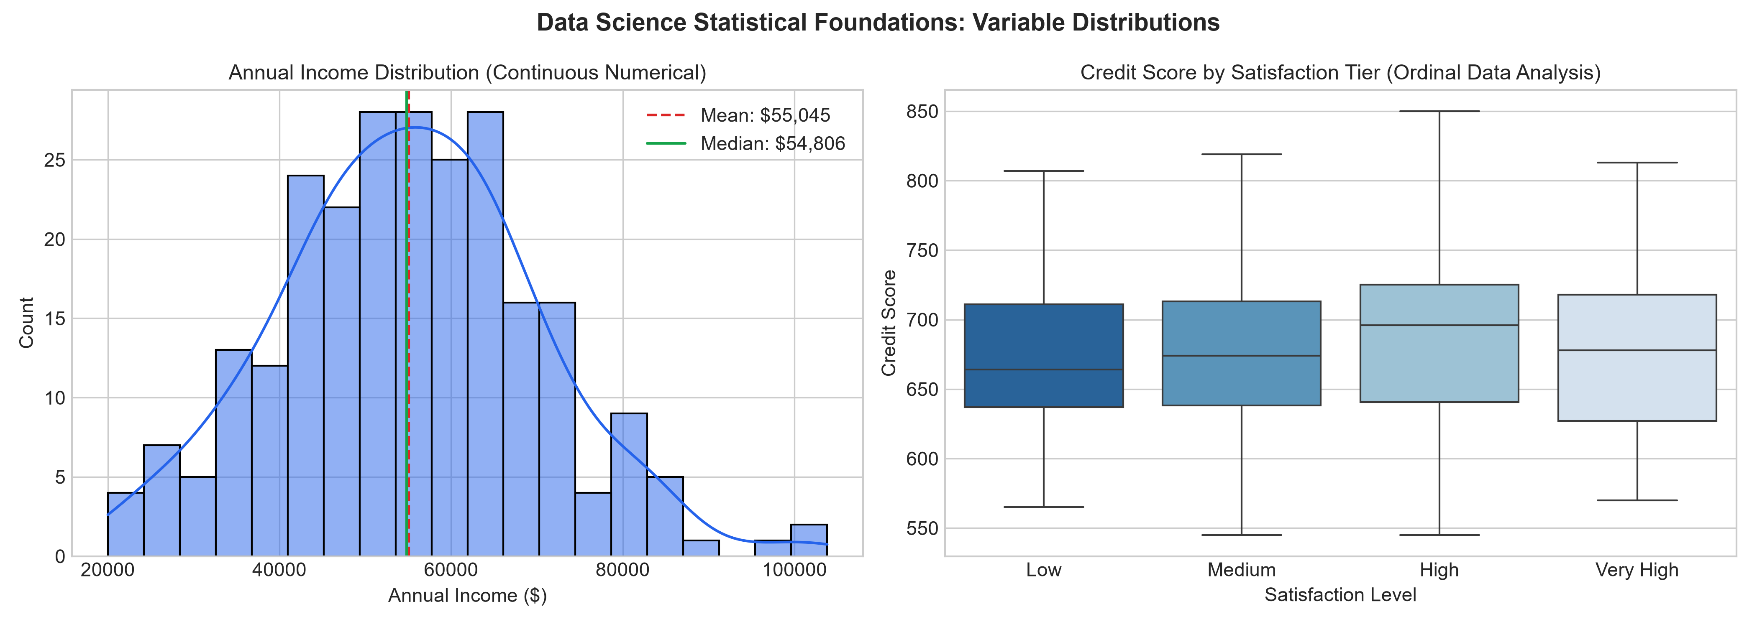
Figure 1: Univariate Density Distribution of Annual Income (Left) and Ordinal Satisfaction vs Credit Score Boxplot (Right).

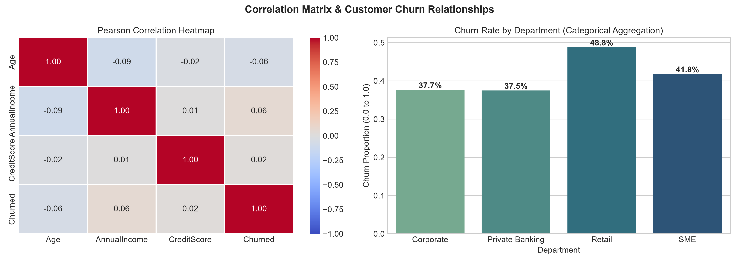
Figure 2: Pearson Correlation Heatmap across Numerical Metrics (Left) and Churn Proportions by Department (Right).
7. CONCLUSION & SYNTHESIS
――――――――――――――――――――――――――――――――――――――――――――――
Through this assessment, foundational data science principles were translated from conceptual theory into reproducible, clean Python architecture. All six objectives—from data science lifecycle structuring and Python data structures to statistical dispersion, multi-modal data typing, engineering best practices, and empirical visualization—have been verified. The associated scripts, generated datasets, exploratory artifacts, and interactive notebooks provide an auditable and extensible framework for subsequent advanced predictive modeling and machine learning coursework.

