Operations Intelligence Platform — Project Overview
Read this first. It gives the big picture: what the platform does, why it exists, how the pieces fit together, and where to find the detail for each part.

1. What this project is, in one paragraph
This is an industry-agnostic data intelligence platform. A business — a factory, a telecom operator, a hospital, a movie studio — uploads its raw CSV data. The platform automatically inspects every column, suggests how each maps onto a fixed set of universal business domains (Assets, Operations, Quality, Maintenance, Inventory, Workforce, Finance, Customers), lets the user confirm or correct those suggestions, and then loads the data into a single centralized hub. From there the user sees what was collected, what was skipped, can pull in anything that was missed, and explores the data through charts. The same code works for any industry because we never model industries — we model the universal functions every operation shares, and onboard new data through configuration, not new code.

2. The problem it solves
Real organizations keep data in many disconnected systems (ERP, MES, billing, spreadsheets, IoT). Answering a simple question like "why did output drop last week?" means manually pulling from four or five different places. This platform unifies all of that into one consistent hub so the data can be analyzed in one place — turning scattered, siloed data into usable intelligence.
The hard part is that every business names things differently: a factory has machine_id and units_produced, a telecom has tower_id and active_subscribers. We solve this with a universal domain model plus a thin mapping layer: the hub shape is fixed, and each business’s columns are mapped onto it once, at upload time.

3. The core idea — universal domains
We do NOT build a separate schema for each industry. Instead, every operation, regardless of sector, is modeled with eight universal domains:
Domain | What it captures | Factory example | Telecom example
Assets | Physical/logical resources | machines | cell towers
Operations | The core work done | units produced | calls handled
Quality | Defects, failures, SLA breaches | defect count | dropped calls
Maintenance | Repairs, downtime, servicing | downtime minutes | outage minutes
Inventory | Stock, materials, parts | spare parts | SIM stock
Workforce | Staff, shifts, crew | operators | field engineers
Finance | Revenue, cost, billing | operating cost | bill amount
Customers | Subscribers, clients, patients | — | subscribers
This is the stable backbone. Whatever industry’s data arrives, it gets mapped into these eight domains. Adding a new industry means adding a mapping, not rewriting code.

4. How the pieces connect
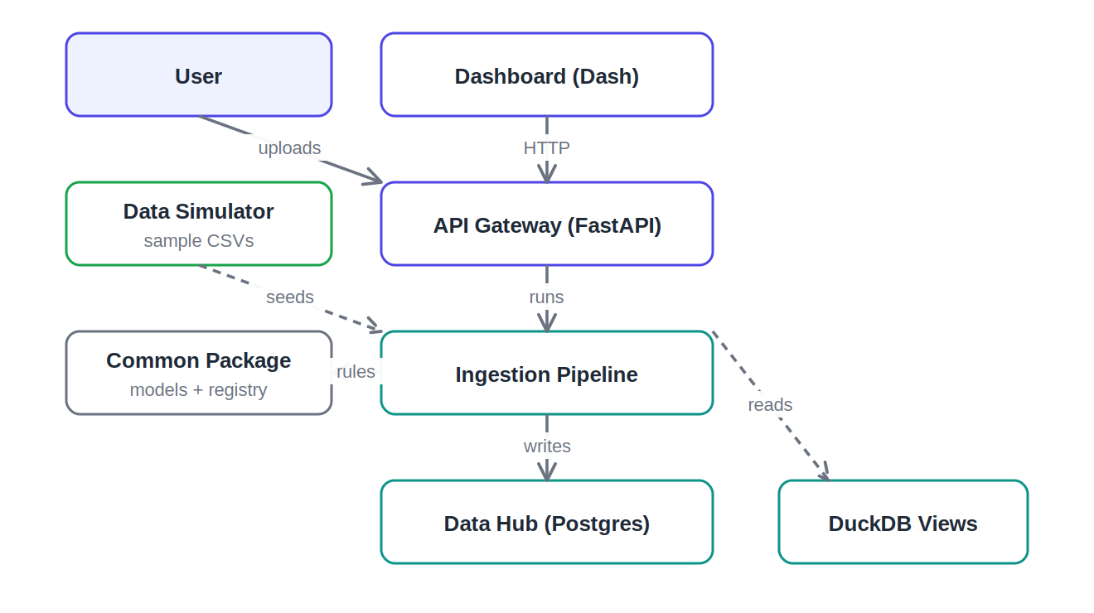
Simple overview — how the modules connect
In words: the user works in the dashboard, which only ever talks to the API. The API runs the ingestion pipeline, which uses the common package for the domain rules and writes into the hub (Postgres). The API reads analytics back through DuckDB views that attach to the same hub. The simulator just provides ready-made sample data to upload.

5. The end-to-end journey
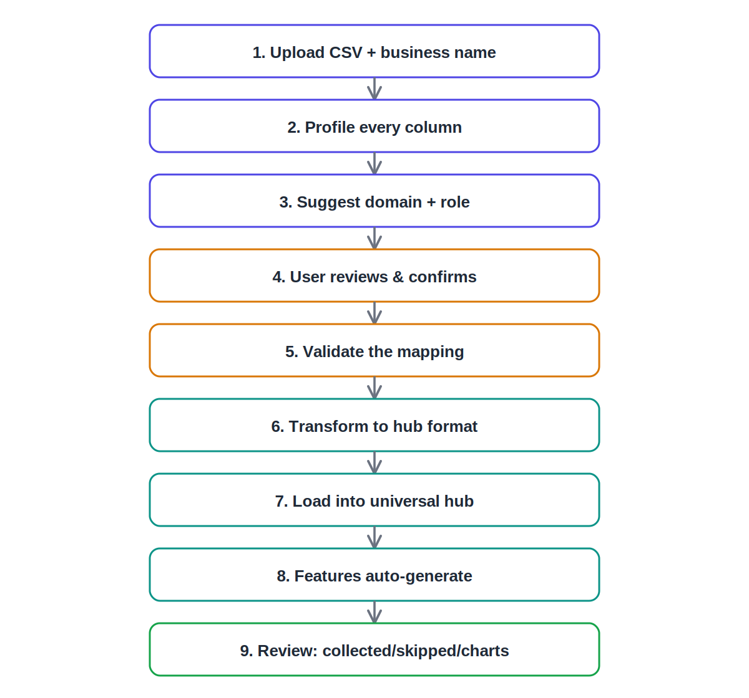
What happens on one upload, end to end
Each step is owned by a specific file. The detail of every step lives in the per-module documents.

6. Key design decisions (and why)
- Universal domains, not per-industry schemas — one codebase serves every industry. New industries need configuration (a mapping), not new code.
- Postgres for storage, DuckDB for analytics — Postgres is the reliable system of record; DuckDB attaches read-only and serves fast analytical queries without copying data.
- Human-in-the-loop mapping — the system suggests, the user confirms. This keeps the hub trustworthy instead of a black box.
- The dashboard never touches the database — it only calls the API. Clean separation: the API owns all data access.
- Everything runs in Docker with one command — make up brings up the whole stack and self-seeds data, so it is reproducible and demo-safe.

7. One-line summary
I built the universal pipe that any business’s data flows through to become usable intelligence: upload any industry’s CSV, the system maps it onto eight universal business domains through a confirm-once step, loads it into a single Postgres + DuckDB hub, and surfaces what it collected, what it missed, and lets the user fill the gaps — all running in Docker with one command.

