01 — The Common Package
packages/common/ops_common
What this module is: the shared foundation every other service depends on. Configuration, database connections, logging, the universal domain model, and the feature registry all live here, installed as a proper Python package.

Why this module exists
Three services (API, ingestion, simulator) all need the same things: how to read settings, how to connect to the database, how to log, and what the universal domains are. Rather than copy that into each service, it lives once here and is installed everywhere. This is the single source of truth for the shared plumbing and the domain model.

Files at a glance
File | Purpose
config.py | All settings, read from environment variables
db.py | Postgres engine + DuckDB connection (and the ATTACH that links them)
logging.py | Structured, environment-aware logging
domain/models.py | The universal domain tables, defined as ORM classes
domain/registry.py | Each domain's ready-made features + keyword hints
pyproject.toml | Makes this folder an installable package

Simple module flow
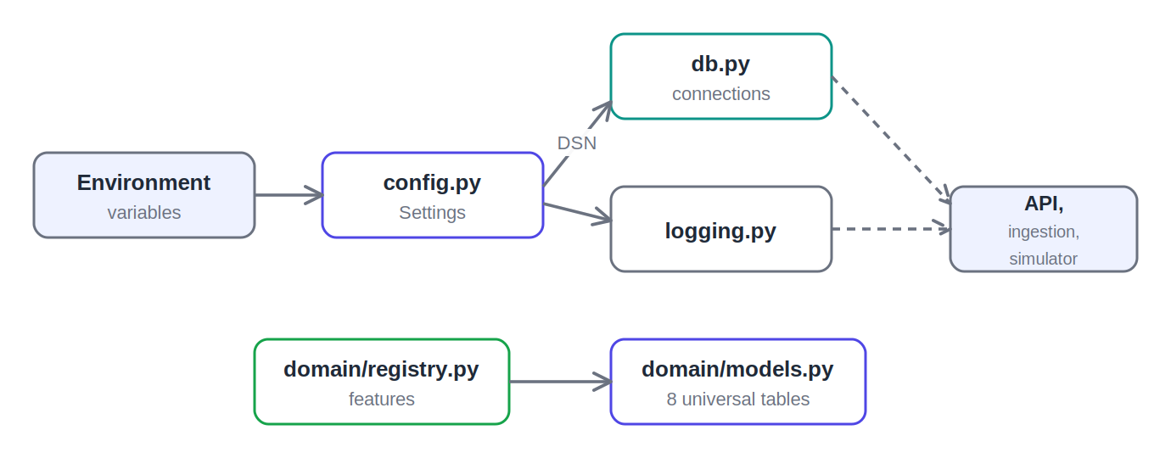
How the common package pieces relate

File-by-file detail

config.py — the settings hub
Purpose: one place that defines every configurable value (database host, ports, LLM key, file paths) and reads them from environment variables.
- Settings — a pydantic-settings class. Each field maps to an env variable with the OPS_ prefix. The same code runs with different config in Docker vs local, just by changing env values.
- Computed connection strings — the Postgres and DuckDB connection strings are derived from the individual fields, so the format is defined once and reused.
- get_settings() — returns a single cached Settings instance, so every part of the app shares the exact same configuration.

db.py — database connections
Purpose: create and manage the two database connections — Postgres (the hub) and DuckDB (the analytics layer).
- get_engine() — a lazy, thread-safe singleton SQLAlchemy engine for Postgres.
- session_scope() / get_db() — give callers a database session; commit on success, roll back on error.
- wait_for_postgres() — retries the connection on startup until Postgres is ready. This is what makes the stack boot reliably.
- get_duckdb() + _attach_postgres() — open DuckDB and attach Postgres read-only, so DuckDB can query the live hub without copying it.
Why it matters: this is the seam between the two databases. Postgres handles writes; DuckDB attaches and serves fast analytical reads. The ATTACH is what links them.

logging.py — structured logging
Purpose: give every part of the app a consistent logger — plain readable lines in development, structured JSON in production. Any extra data passed to a log call is merged into the output automatically.

domain/models.py — the universal domain model
Purpose: define, as ORM classes, the tables that make up the hub — both the metadata tables and the eight universal domain tables.
- Metadata tables — Dataset, ColumnProfile, MappingConfig, FeatureRecord.
- Eight hub tables — Assets, Operations, Quality, Maintenance, Inventory, Workforce, Finance, Customers — all sharing an identical shape via a mixin.
- model_for_domain() — maps a domain name to its table class, so the loader routes rows with no per-industry branching.
Why it matters: the identical shape across all eight tables is the whole portability trick. One definition, eight tables, and any industry’s data fits.

domain/registry.py — the feature registry
Purpose: define, for each universal domain, the ready-made features that auto-generate whenever data lands in that domain — plus the keyword hints used to guess a column’s domain.
- DOMAIN_REGISTRY — the catalog. The moment any column maps to, say, Finance, its features (total_revenue, total_cost, etc.) are generated.
- match_domain_by_keyword() — the deterministic fallback when the LLM is off, so onboarding still works offline.
Why it matters: features are defined per universal domain, never per industry. This is what makes the platform truly industry-agnostic.

Detailed flow — how a service uses this module
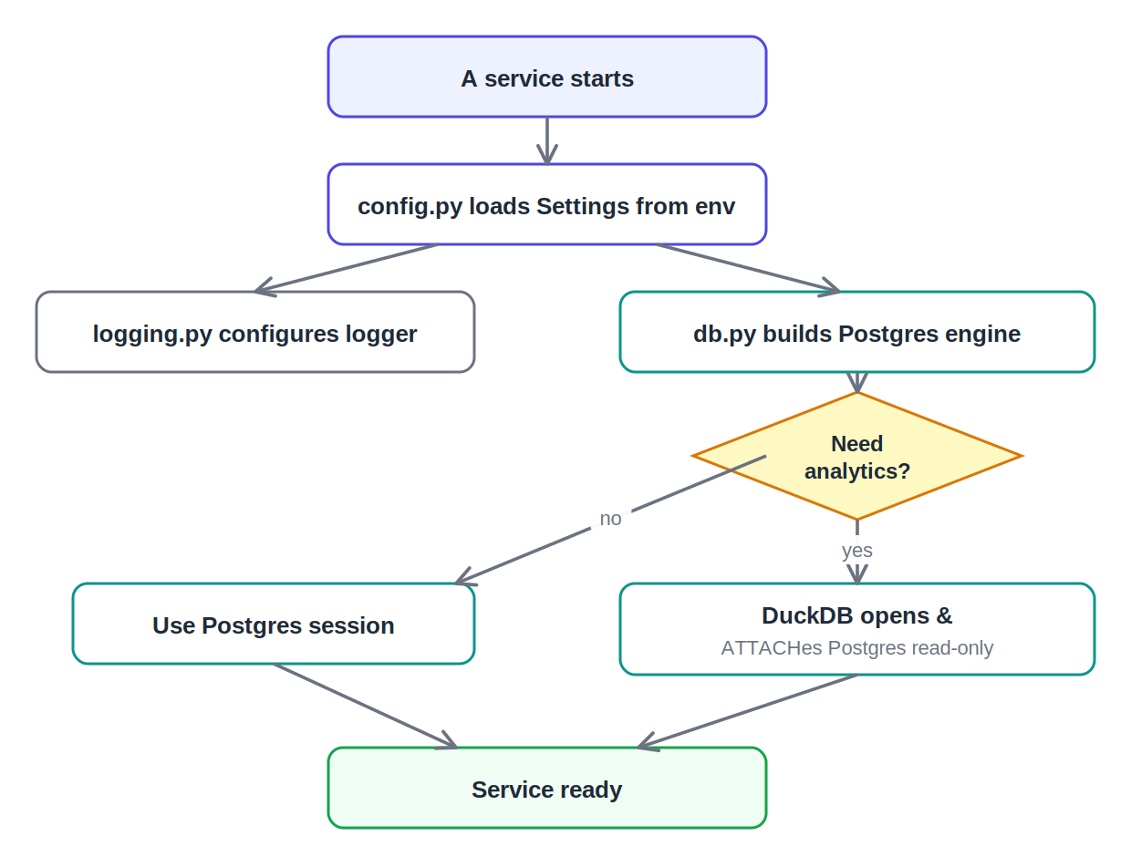
A service startup using the common package

What to say in the review
This is the shared foundation, installed as a package so every service uses the same code. config.py centralizes all settings. db.py manages both databases — Postgres for storage and DuckDB attached read-only for analytics. models.py defines the eight universal domain tables, all with an identical shape, which is what lets any industry’s data fit. And registry.py defines the ready-made features per domain. That’s the core of how the platform stays industry-agnostic without rewriting code.

