02 — The Data Hub
data-hub/
What this module is: the heart of the platform — where all data lives. Postgres holds the data (the system of record), and DuckDB attaches to it read-only to serve fast analytical queries for the dashboard charts.

Why this module exists
After the pipeline maps and reshapes a business’s data, it has to land somewhere consistent. The hub is that place. Its key property: the shape is fixed and universal — it never changes per industry. Telecom data, factory data, and movie data all land in the same eight tables, in the same format. That fixed shape is exactly what makes the rest of the system industry-agnostic.

The two-database design (and why)
Database | Role | Why
Postgres | Stores all data; handles writes | Reliable, transactional system of record
DuckDB | Reads from Postgres for analytics | Fast analytical queries without copying data
DuckDB does not hold its own copy of the data. It attaches to Postgres read-only and runs queries against the live hub tables. So there is never any sync or drift — DuckDB always reads exactly what Postgres holds.

Simple module flow
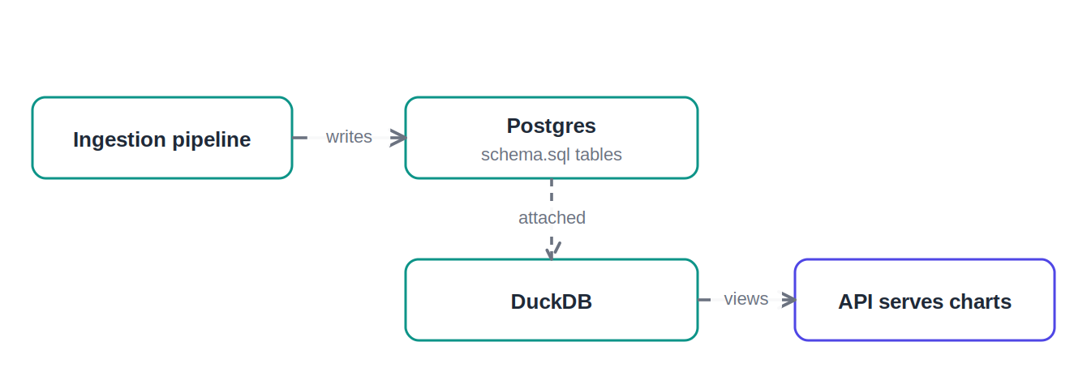
Data written to Postgres, read through DuckDB views

File-by-file detail

postgres/schema.sql — the hub tables
Purpose: define every table in the hub. It is split into two schemas (namespaces): meta for tracking, and hub for the actual data.
The meta schema — tracking the onboarding process:
Table | What it holds
meta.dataset | One row per uploaded file (business, filename, row count, time)
meta.column_profile | One row per column: its type, samples, and mapping status
meta.mapping_config | The saved, versioned mapping config per business
meta.feature_record | Every feature generated (collected) or skipped
The hub schema — the eight universal domain tables. Every one has the identical column shape:
Column | Meaning
id | Primary key
dataset_id | Which uploaded dataset this row belongs to
entity_ref | The thing being measured (a machine, a tower, a movie)
metric_name | What is measured (e.g. units_sold, bill_amount)
metric_value | The numeric value
attributes | Extra context as flexible JSON
recorded_at | Timestamp, if the data had one
Why identical shape matters: because every domain table is the same, any metric from any industry fits — it just becomes a metric_name to metric_value pair under the right domain. This is the structural core of the universal model.
Other details: indexes on dataset_id for fast reads; foreign keys with ON DELETE CASCADE for clean deletes; and CREATE TABLE IF NOT EXISTS so the schema is idempotent and safe to run on every startup (this was a real fix — without it, the second startup crashed with "table already exists").

duckdb/analytics.sql — the analytics views
Purpose: define read-only views on top of the Postgres hub. A view is a saved query — it computes results live from the hub each time it’s read; it stores no data of its own.
View | What it does | Powers
v_column_review | Every column with its mapping state | The collected/skipped table
v_domain_coverage | Collected vs skipped per domain | The coverage chart
v_generated_features | The collected features list | The "collected" panel
v_missed_columns | Skipped columns with context | The "skipped" panel
v_hub_metrics | All 8 tables stacked into one | Cross-domain analytics
v_domain_metric_summary | Per-domain aggregates | The hub-data charts
Why views (not more tables): the analytics layer is purely derived from the hub. Keeping it as views means one source of truth and analytics that are always current — no second copy to keep in sync.

Detailed flow — data entering and leaving the hub
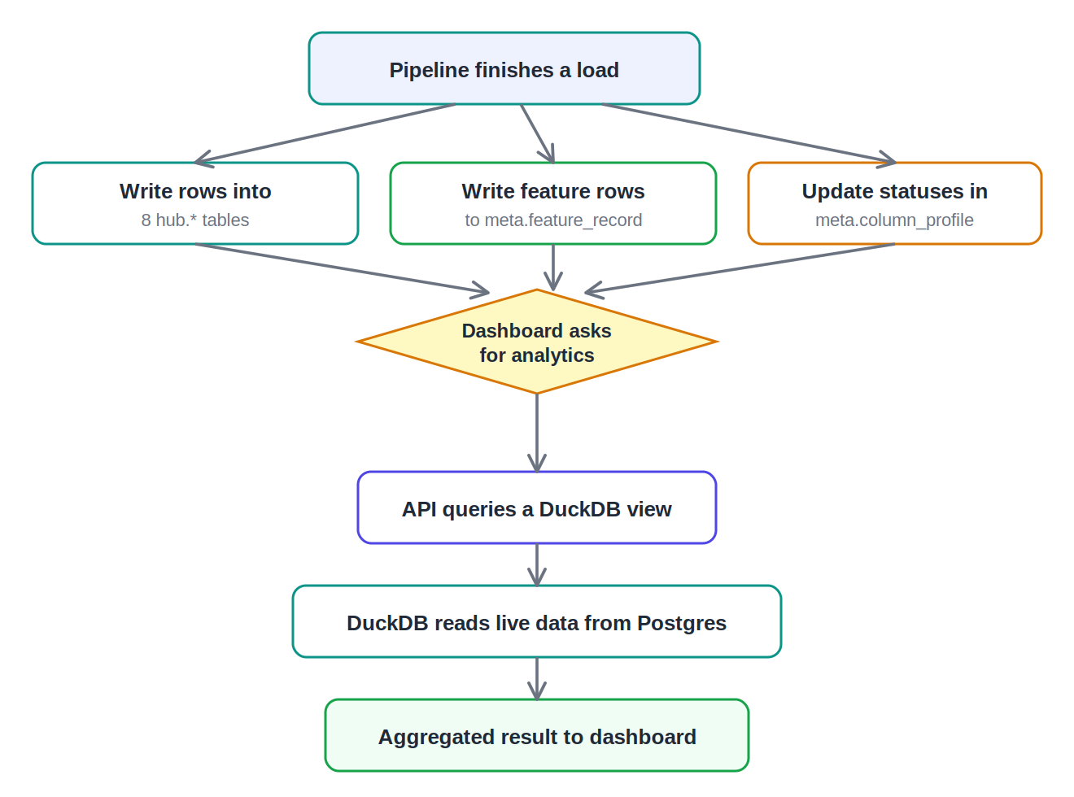
Writes go to Postgres; reads come back through DuckDB views

What to say in the review
The hub is where all data lives, and it’s two databases working together. Postgres is the system of record — the pipeline writes data into eight universal domain tables that all share the exact same shape, which is what lets any industry’s data fit. DuckDB attaches to Postgres read-only and exposes a set of views — the dashboard’s charts and panels all read from those, so analytics are always live and there’s no second copy. The schema is also idempotent, so the stack can restart safely.

