03 — The Ingestion Pipeline
services/ingestion
What this module is: the engine of the platform. It takes a raw uploaded CSV and turns it into clean, mapped, universal data in the hub. The largest module, because it does the most work — eight files, each one stage of the journey.

Why this module exists
A raw CSV is messy and industry-specific. Before its data is useful, the system must read it safely, understand each column, decide which universal domain each belongs to, let the user confirm, check the result is valid, reshape it into the hub’s universal format, and write it in. Each of those is one file. The pipeline ties them together.

The two-stage design (important)
The pipeline is deliberately split into two stages because a human sits in the middle:
- Stage 1 — start_onboarding: upload → profile → suggest. Then it stops and returns the suggestions for the user to review.
- Stage 2 — complete_onboarding: after the user confirms → validate → transform → load into the hub.

Files at a glance
Stage | File | Job
read | connectors/base.py | The connector interface (reusability seam)
read | connectors/csv_connector.py | Reads a CSV into a clean dataframe
profile | profiling/profiler.py | Inspects every column
suggest | mapping/suggester.py | Proposes domain + role (LLM or keyword)
confirm | mapping/confirm.py | Saves the user's confirmed mapping
validate | validation.py | Checks the mapping is loadable
transform | transforms.py | Reshapes rows to the universal format
load | loaders.py | Writes rows + generates features
orchestrate | pipeline.py | Ties it all into the two-stage flow

Simple module flow
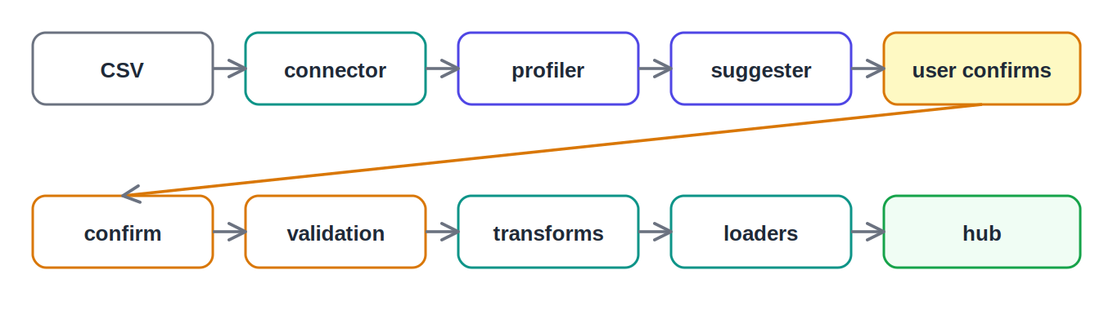
The pipeline stages, left to right

File-by-file detail

connectors/base.py — the reusability seam
Defines BaseConnector, the abstract interface every data source must implement (read_dataframe and validate_source). It also normalizes column names so "Bill Amount", "bill-amount" and "bill_amount" all become the same. Everything downstream only ever sees a clean dataframe — it never knows the source was telecom, aerospace, or a future feed. Adding a new data source = one new subclass. This is the reusability story.

connectors/csv_connector.py — the CSV reader
The concrete CSV connector: auto-detects the delimiter, falls back from UTF-8 to latin-1 on bad encoding, caches the read, and drops junk columns. Makes messy real-world CSVs load reliably.

profiling/profiler.py — column inspection
Looks at every column and describes it — type, sample values, distinct/null counts, and whether it looks like an identifier. It re-checks the real type even when pandas reads everything as text (numeric if 90%+ parseable, datetime by name hint + parse rate). The suggester and dashboard both need this before anything can be mapped.

mapping/suggester.py — the domain mapper
For each column, proposes a universal domain, a role (metric/entity/skip), and a metric name. Tries the LLM first (sending the domain catalog so suggestions stay valid), and falls back to keyword matching if the LLM is disabled, has no key, errors, or returns bad JSON. Fail-safe by design — onboarding never hard-fails. This is also where the offline switch (OPS_LLM_ENABLED=false) applies.

mapping/confirm.py — saving the confirmation
Takes the user’s confirmed mappings, validates each before any DB write, updates each column’s status, and saves a versioned mapping config. It deliberately does not load data yet — keeping "decide the mapping" and "load the data" separate.
Note for the demo: the rule here — anything not "skip" needs a domain — is what produced the "Invalid domain None" message during testing. It’s correct behavior, but the rough edge worth smoothing before a live demo.

validation.py — pre-load checks
Before writing anything, checks the confirmed mapping against the data. Errors (missing column, invalid domain, non-numeric metric, metric with no name) block the load; warnings (no entity column, partly-numeric metric) allow but flag. If there are errors, the pipeline writes nothing — so bad data never lands.

transforms.py — reshaping to universal format
Converts a wide, industry-specific table into the hub’s narrow universal HubRow format. Each mapped metric becomes one row (domain, entity_ref, metric_name, metric_value). The first entity column becomes entity_ref; extras fold into the attributes JSON. After this step the data no longer looks like telecom or factory data — it’s just universal metrics.

loaders.py — writing to the hub
Takes the transformed rows and bulk-inserts each domain’s group into its table. For every metric’s domain it generates that domain’s ready-made features (collected), and records every skipped column (skipped). Idempotent — clears prior data for the dataset first, so re-running never double-counts. This is where the registry pays off and what powers the review dashboard.

pipeline.py — the orchestrator
Ties every file above into the two-stage flow: start_onboarding (connector → profiler → suggester → return suggestions) and complete_onboarding (confirm → validate → transform → load). The whole thing runs in one database session so any failure rolls back atomically.

Detailed flow — the full pipeline
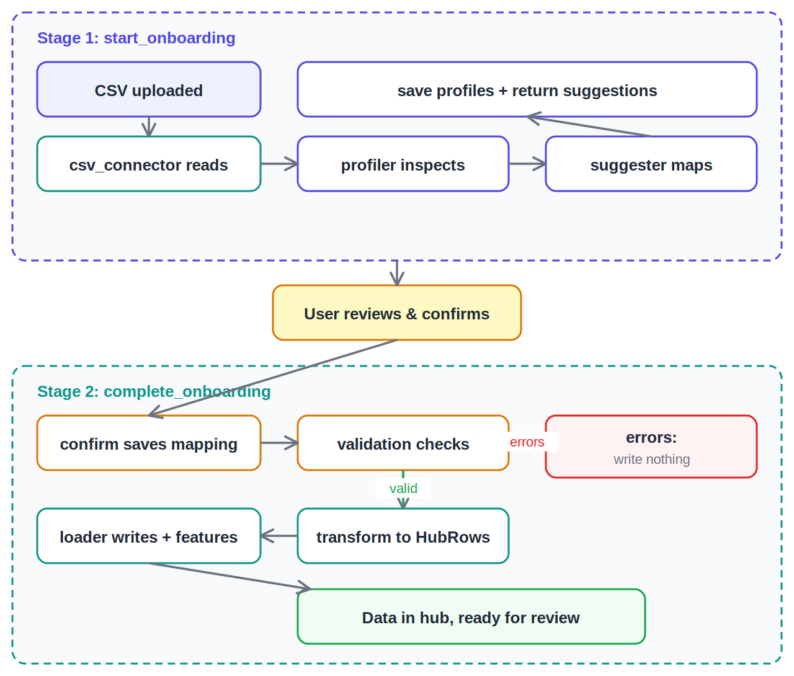
Two stages with the human confirmation and the validation gate

What to say in the review
This is the engine — eight files, each one stage of turning a raw CSV into universal hub data. It’s split into two stages because a human confirms in the middle. The connector interface is the reusability seam — a new data source is just one new subclass. The suggester uses an LLM but falls back to keyword matching if anything fails. And the loader auto-generates each domain’s features and records skipped columns, which powers the review dashboard.

