04 — The API Gateway
services/api-gateway
What this module is: the backend. It is the only thing that talks to the database and runs the pipeline. The dashboard always goes through this API — clean separation: the API owns all data access.

Why this module exists
Something has to expose the pipeline and the hub over HTTP, handle uploads, manage database sessions, and apply the schema on startup. That’s the API gateway, built with FastAPI — a modern Python web framework that auto-generates interactive docs at /docs.

Files at a glance
File | Purpose
api_app/main.py | The app: startup logic, middleware, health checks, wiring
routers/v1/onboard.py | Upload + the two onboarding stages
routers/v1/features.py | The feature review data + add-missing-feature
routers/v1/domains.py | Domain info, hub-data charts, and the datasets list

A note on the folder name
This service’s code lives in api_app/ (not app/). That’s deliberate: the ingestion pipeline is installed as a package called app, so the API’s own code uses a different name to avoid a clash. The API imports the pipeline as app.pipeline and its own routers as api_app.routers.

Simple module flow
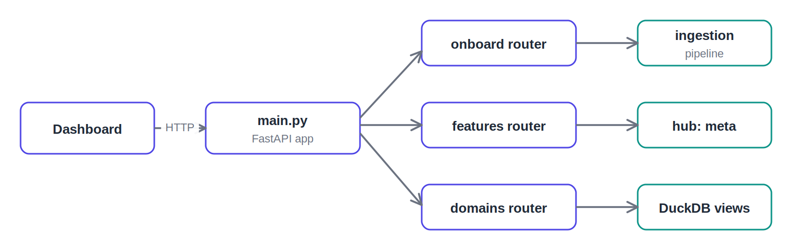
The app routes requests to three routers, each reading/writing the right place

File-by-file detail

api_app/main.py — the application
Creates the FastAPI app and runs startup setup in order: wait for Postgres, apply the schema (idempotent), load the DuckDB views. This order is what makes the stack boot reliably. It also adds CORS (so the dashboard on another port can call it), exception handlers (turning pipeline errors into clean 400/404 responses), and health endpoints (Docker uses /health to know when the API is ready).

routers/v1/onboard.py — onboarding endpoints
- POST /onboard/start — accepts the upload + business name, saves the file, runs stage 1 (profile + suggest), returns the suggestions plus a stored_path token.
- POST /onboard/confirm — accepts the confirmed columns + stored_path, runs stage 2 (validate + transform + load), returns how many rows and features landed.
Uploads get a unique filename to avoid collisions. Each endpoint manages its own commit/rollback, so a failure leaves no partial dataset.

routers/v1/features.py — the review + gap-filling
- GET /features/{id}/review — returns everything the review screen needs in one call: collected features, skipped columns, and per-domain coverage.
- POST /features/add — re-ingests one skipped column into the hub, generates its features as added_later, and flips the column’s status. Only skipped columns can be added (no double-loading).

routers/v1/domains.py — domain info, charts, and the dataset list
- GET /domains — the catalog of universal domains and their features (used by the confirm screen’s dropdowns).
- GET /datasets/{id}/summary — per-domain aggregates from a DuckDB view; powers the hub-data chart.
- GET /datasets — lists every onboarded dataset with collected/skipped counts; powers the Datasets browse page. This is what lets the user see all previously loaded files.
The chart endpoints read DuckDB views, so aggregation happens in the analytics layer, not in Python. DuckDB failures return 503, so the dashboard can tell "analytics down" from a real bug.

Detailed flow — a request through the API
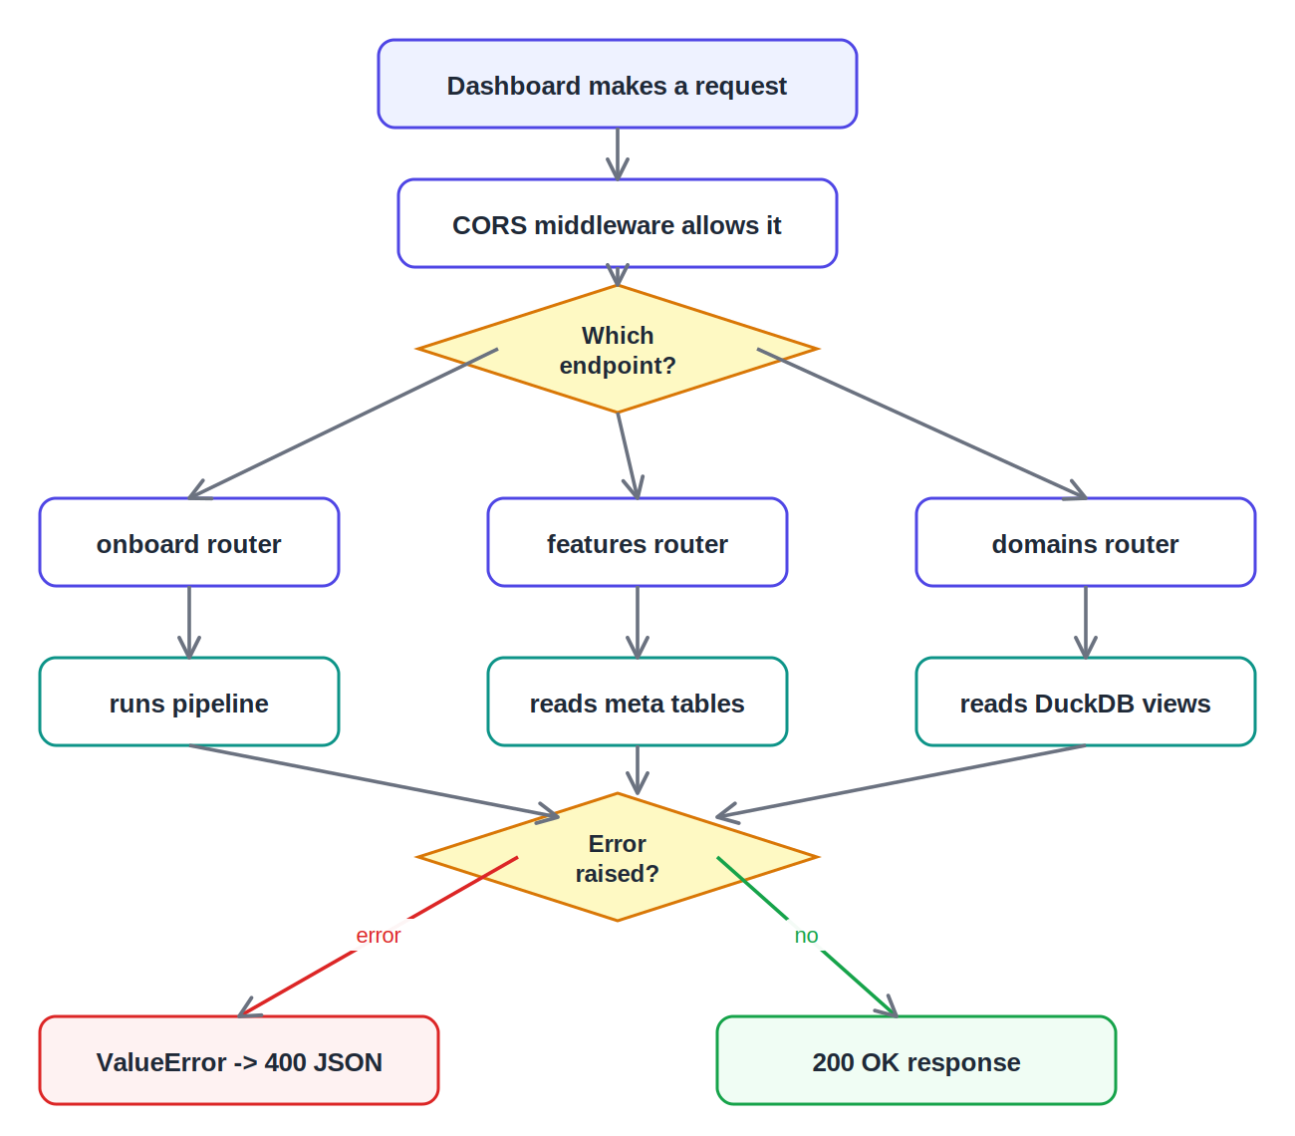
Request routing, data access, and error handling

What to say in the review
This is the backend, built with FastAPI. It’s the only thing that touches the database — the dashboard always goes through it. main.py handles startup: it waits for Postgres, applies the schema, and loads the analytics views in a careful order so the stack boots reliably. Three routers: onboard drives the two-stage pipeline, features serves the review screen and add-missing-feature, and domains serves the charts and the list of all datasets.

