05 — The Data Simulator
services/data-simulator
What this module is: a generator of realistic, correlated, multi-industry sample data. It produces believable CSVs for several different industries — which is what proves the platform is truly industry-agnostic.

Why this module exists
A data platform needs data to demonstrate it. We have no live industrial systems, so we simulate them. This isn’t a shortcut — by generating four genuinely different industries, it proves that the same pipeline, hub, and dashboard handle any of them without code changes. The data is also correlated and seasonal — output dips on weekends, downtime rises when output drops — so the dashboard shows believable patterns.

Files at a glance
File | Purpose
app/generators.py | The actual data generators for each industry
app/cli.py | Command-line interface to generate and seed data

Simple module flow
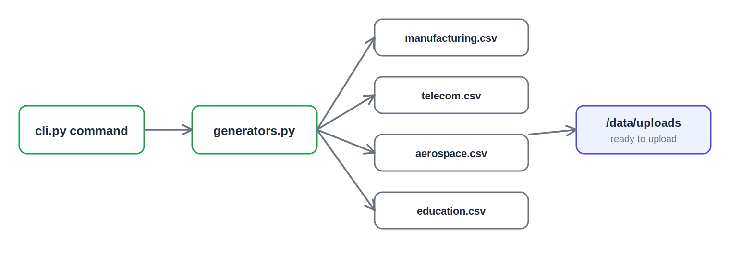
One command generates four industries into the shared upload folder

File-by-file detail

app/generators.py — the data generators
Generates a realistic dataset for each supported industry, with columns that look like that industry’s real data:
Industry | Sample columns | Spans which domains
Manufacturing | machine_id, units_produced, downtime_minutes, defect_count, operating_cost | Assets, Operations, Maintenance, Quality, Finance
Telecom | tower_id, active_subscribers, data_usage_gb, dropped_calls, bill_amount | Assets, Operations, Customers, Quality, Finance
Aerospace | aircraft_id, flight_hours, inspection_failures, service_cycles, maintenance_cost | Assets, Operations, Quality, Maintenance, Finance
Education | classroom_id, students_enrolled, attendance_count, average_grade, fee_paid | Assets, Customers, Operations, Quality, Finance
It uses a fixed seed, so every run produces the same data (reproducible demos), and builds in correlation and seasonality so the charts look real. The different column names across industries are the whole point — when you upload each one, the platform maps its unique columns onto the same universal domains with no code changes. This module is the proof of portability.

app/cli.py — the command-line interface
Provides the seed command, which generates all four industries’ CSVs into the shared upload directory. This is the command Docker Compose runs at startup, so a fresh stack has demo data ready. Other commands (generate, generate-all, list) are for development.

Detailed flow — how seeding fits the startup
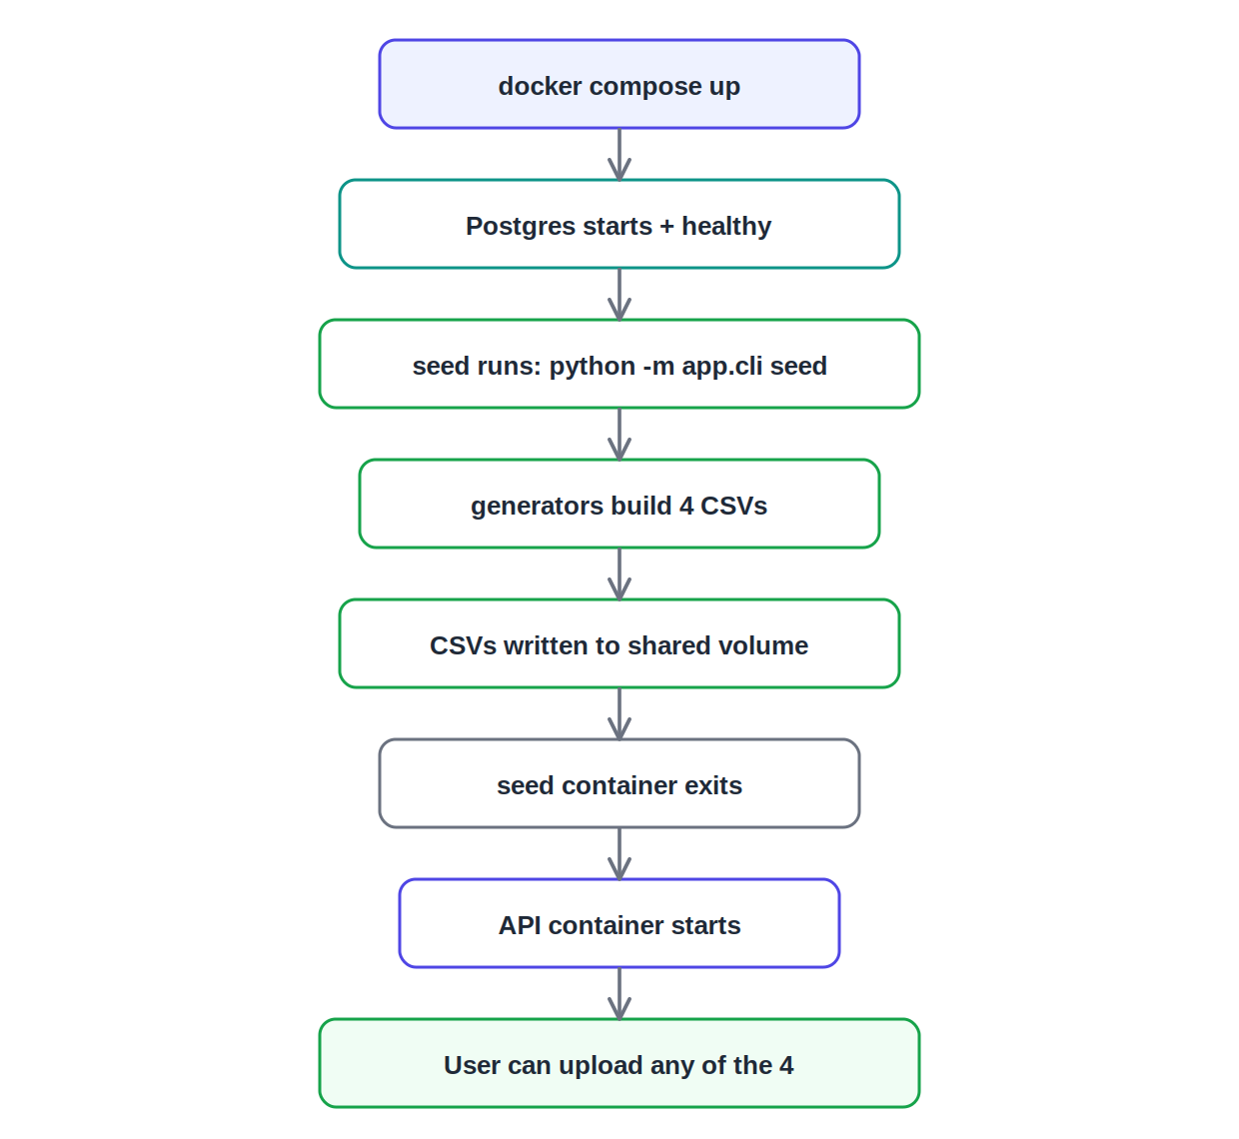
The seed container runs once and exits before the API starts

What to say in the review
Since there’s no real factory or telecom feeding the platform, this module simulates data sources — a legitimate engineering component. The key point is that it generates four genuinely different industries, each with its own column names. That’s what proves the platform is industry-agnostic — I can upload any of them and the same pipeline maps each one’s columns onto the universal domains with no code changes. The data is seeded so every demo is reproducible, and the seed command runs automatically at startup.

