06 — The Dashboard
services/dashboard
What this module is: the user interface, built with Plotly Dash (pure Python). Everything the user sees and clicks: upload, confirm mappings, review features, browse datasets. It never touches the database — it only calls the API.

Why this module exists
The platform needs a screen a person can actually use. Built with Dash because it is Python-native (a strong fit for a data-science project), gives interactive Plotly charts for free, and handles multi-page apps cleanly.

Files at a glance
File | Purpose
app/api_client.py | The single layer that calls the API over HTTP
app/theme.py | Shared colors and styles for a consistent look
app/main.py | The Dash app: registers pages, shared state, navigation
app/pages/upload.py | Screen 1 — upload a CSV + business name
app/pages/mapping_confirm.py | Screen 2 — review and confirm mappings
app/pages/feature_review.py | Screen 3 — the main dashboard
app/pages/datasets.py | Screen 4 — browse all onboarded datasets

Simple module flow
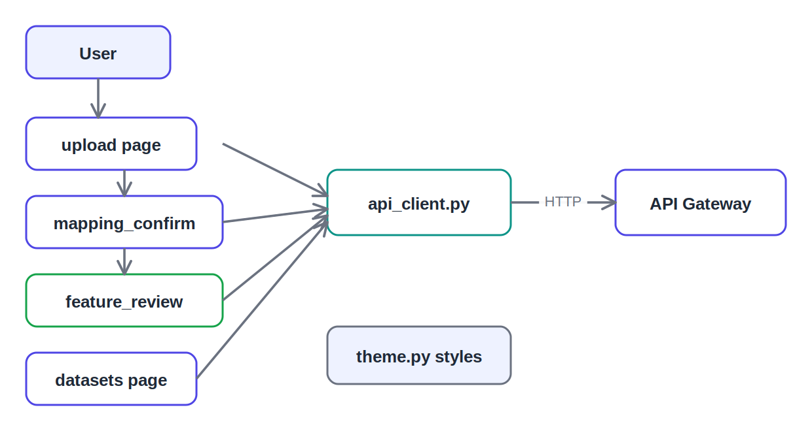
Pages call one api_client; theme styles them all

File-by-file detail

app/api_client.py — the API boundary
The single place that calls the backend. One function per endpoint; every page imports from here and never calls HTTP directly. Wraps failures into a friendly APIError. If an endpoint changes, you fix it here once.

app/theme.py — shared styling
Centralizes every color and reusable style. Includes the collected (green) and skipped (amber) colors that map to the two feature states, and a fixed color per domain so charts are consistent.

app/main.py — the app shell
Creates the Dash app with use_pages=True (multi-page system), defines the shared state stores (onboarding-store carries data across screens; review-refresh re-triggers the review after an add; url drives navigation), and builds the top nav. This is what makes the separate pages behave as one app.

app/pages/upload.py — Screen 1
Lets the user enter a business name and drop in a CSV. Decodes the file, calls start_onboarding, stores the result, and navigates to Confirm.

app/pages/mapping_confirm.py — Screen 2
Shows the suggested mapping for every column and lets the user adjust role/domain/metric, then confirm. Uses pattern-matching component IDs so one callback handles any number of columns.
Note for the demo: this screen enforces "anything not Skip needs a domain", which is what produced the Invalid domain None message in testing — the rough edge worth smoothing before a live demo.

app/pages/feature_review.py — Screen 3 (the dashboard)
The main screen. Shows collected features (grouped by domain), skipped columns (each with a domain dropdown, metric box, and Add button), a coverage chart, and a hub-data chart. The Add action calls add_feature then bumps review-refresh so the screen reloads live. This is where the platform’s core idea becomes visible and interactive.

app/pages/datasets.py — Screen 4
Lists every dataset ever onboarded with its collected/skipped counts, and an Open review button to revisit any one. This is what makes the "upload many files one by one" workflow visible.

Detailed flow — the dashboard journey
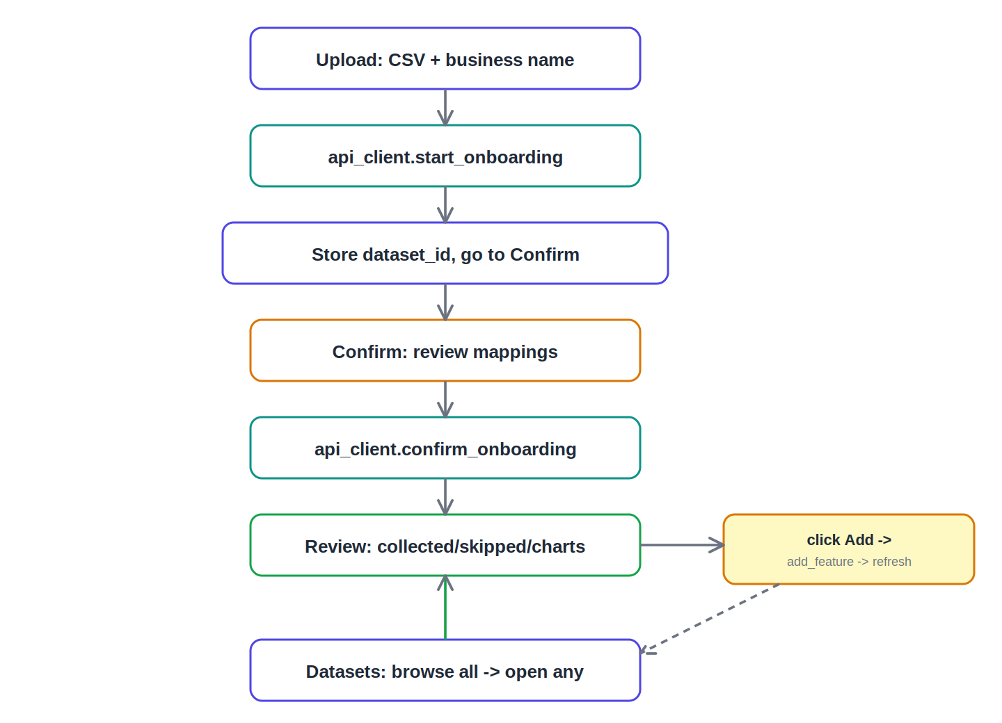
Upload to confirm to review, with the add-and-refresh loop

What to say in the review
This is the user interface, built with Plotly Dash — pure Python, which fits a data-science project and gives interactive charts for free. Four screens: upload, confirm, feature review, and a datasets browser. Every page goes through one api_client, so the dashboard never touches the database — it only calls the API. The feature review screen is the heart: it shows what was collected and skipped, with charts, and lets the user add a missed column and see it update live.

