07 — Docker & Infrastructure
What this module is: the wiring that turns a folder of code into a running system with one command. Docker Compose, the per-service Dockerfiles, dependency lists, the Makefile, and the environment template.

Why this module exists
The platform is five services (Postgres, simulator, API, dashboard, plus the shared package). Starting them by hand in the right order would be error-prone. Docker Compose packages each into a container and starts them in the correct order with one command — the reproducible, production-shaped layer.

Files at a glance
File | Purpose
docker-compose.yml | Defines all services and their startup order
services/*/Dockerfile | How to build each service's image
services/*/requirements.txt | Each service's Python dependencies
packages/common/pyproject.toml | Makes the shared package installable
.env.example | The environment-variable template
Makefile | Convenience commands (make up, make down, ...)

Simple module flow
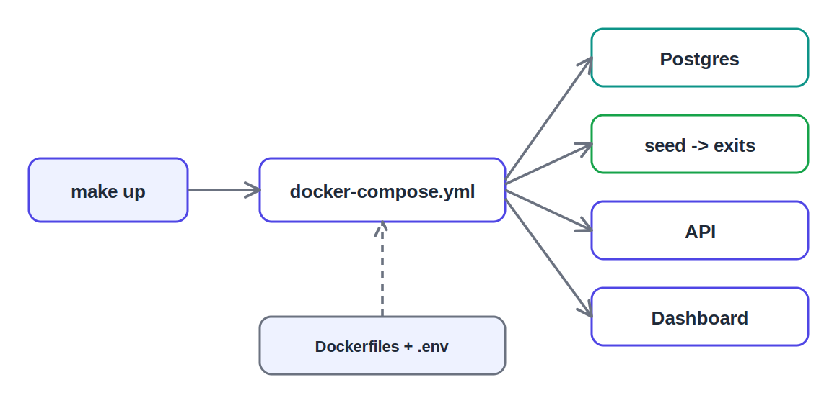
make up drives compose, which starts the services in order

File-by-file detail

docker-compose.yml — the orchestrator
Defines every service and the order they start in:
- postgres starts and must pass its healthcheck.
- seed runs to completion (generates the sample CSVs, then exits).
- api starts (applies the schema, loads the views) and must pass its healthcheck.
- dashboard starts last, once the API is healthy.
A shared volume lets the simulator write CSVs the API can read. All config comes from .env with sane defaults. The dashboard reaches the API by its service name (http://api:8000) on the internal Docker network.
Note: the Postgres host-port mapping was removed during setup because a local PostgreSQL was already using port 5432. The API still reaches Postgres over the internal Docker network, so nothing broke — a common, clean fix.

Dockerfiles — building each image
Each service has a Dockerfile. The API installs the common + ingestion packages, its requirements, copies the code and schema, and runs uvicorn. The simulator runs the seed command once. The dashboard installs only dash/plotly/requests and runs under gunicorn. Layer order is deliberate so Docker caches the slow steps.

requirements.txt + pyproject.toml — dependencies & packaging
Each service lists its dependencies; the common and ingestion folders are installable packages so the API can import them cleanly. The installable packages are the production-grade packaging signal.

.env.example — the config template
Documents every environment variable. Includes OPS_LLM_ENABLED=false — the switch to run fully offline on the keyword fallback, for data that can’t be sent to a cloud LLM.

Makefile — convenience commands
make up (build + start, prints the URLs), make down (stop, keep data), make clean (wipe volumes), make logs-api / logs-dash (debugging), make db-shell (psql shell). make up makes the demo one word.

Detailed flow — what make up does
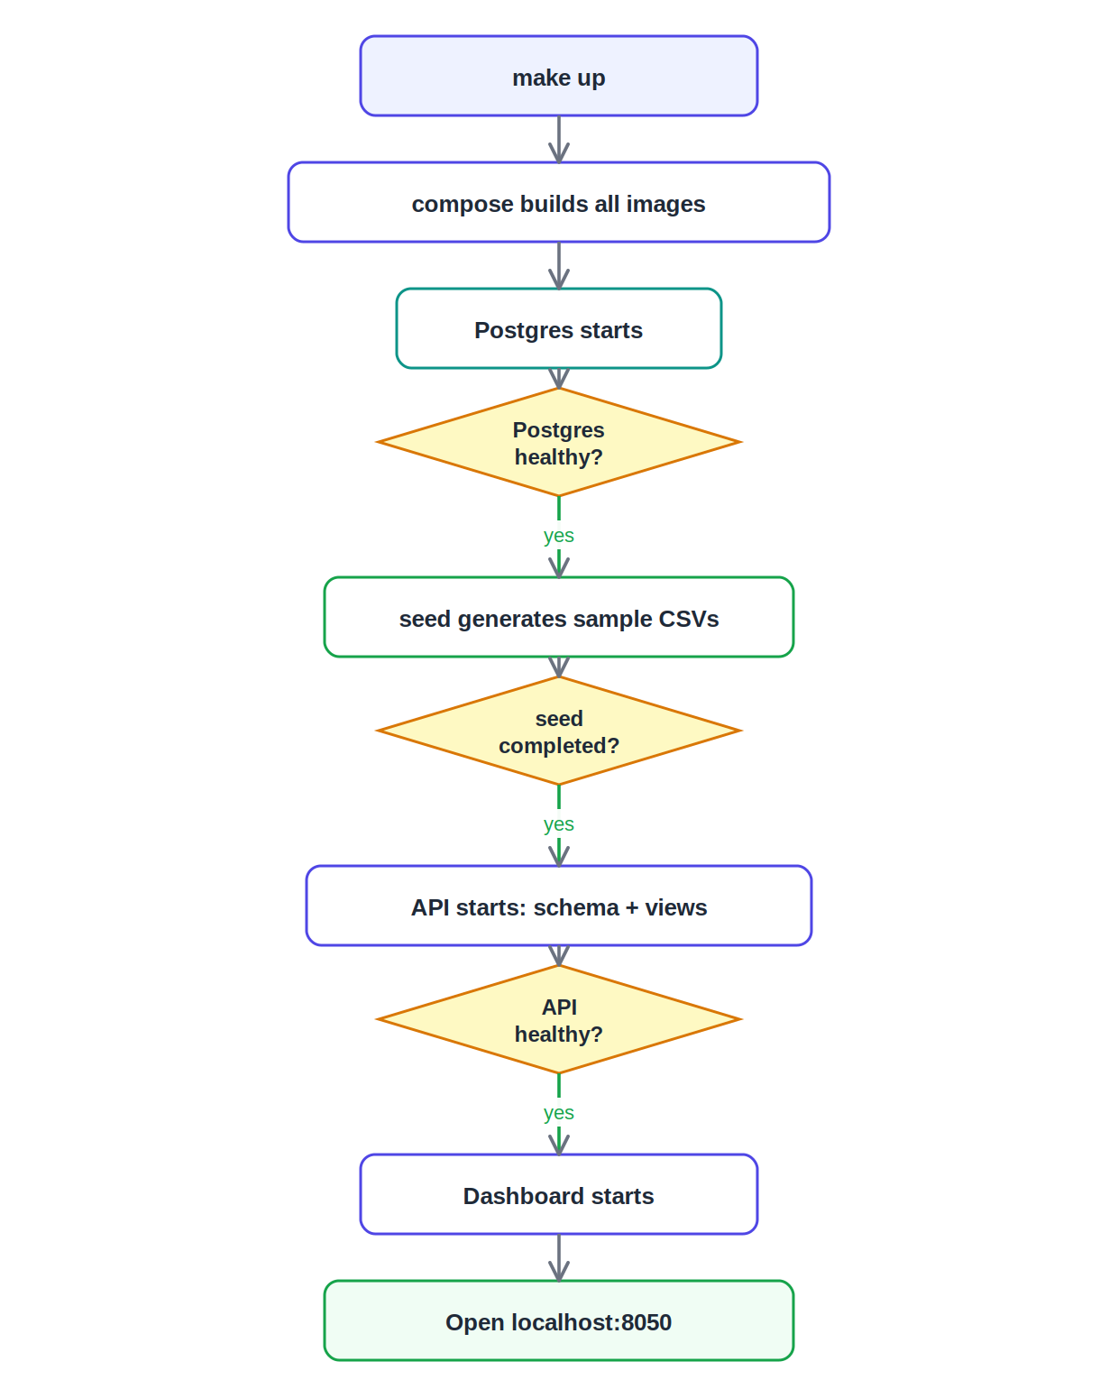
The enforced startup chain

What to say in the review
This is the wiring that makes everything run with one command. Docker Compose defines the five services and the order they start in: Postgres becomes healthy, then the seed container generates sample data and exits, then the API applies the schema and starts, then the dashboard. Each service has its own Dockerfile, and the shared code is installed as real Python packages. The Makefile wraps it so make up brings up the whole data-seeded stack.

