08 — The End-to-End Flow
What this document is: the full journey of one upload traced across every module, so you can explain how the whole system works as one story — not just file by file.

The one-sentence version
A user uploads any industry’s CSV → the system profiles and maps it onto universal domains → the user confirms → it loads into the hub → the user reviews what was collected, sees what was missed, and fills the gaps.

The complete flow as one diagram
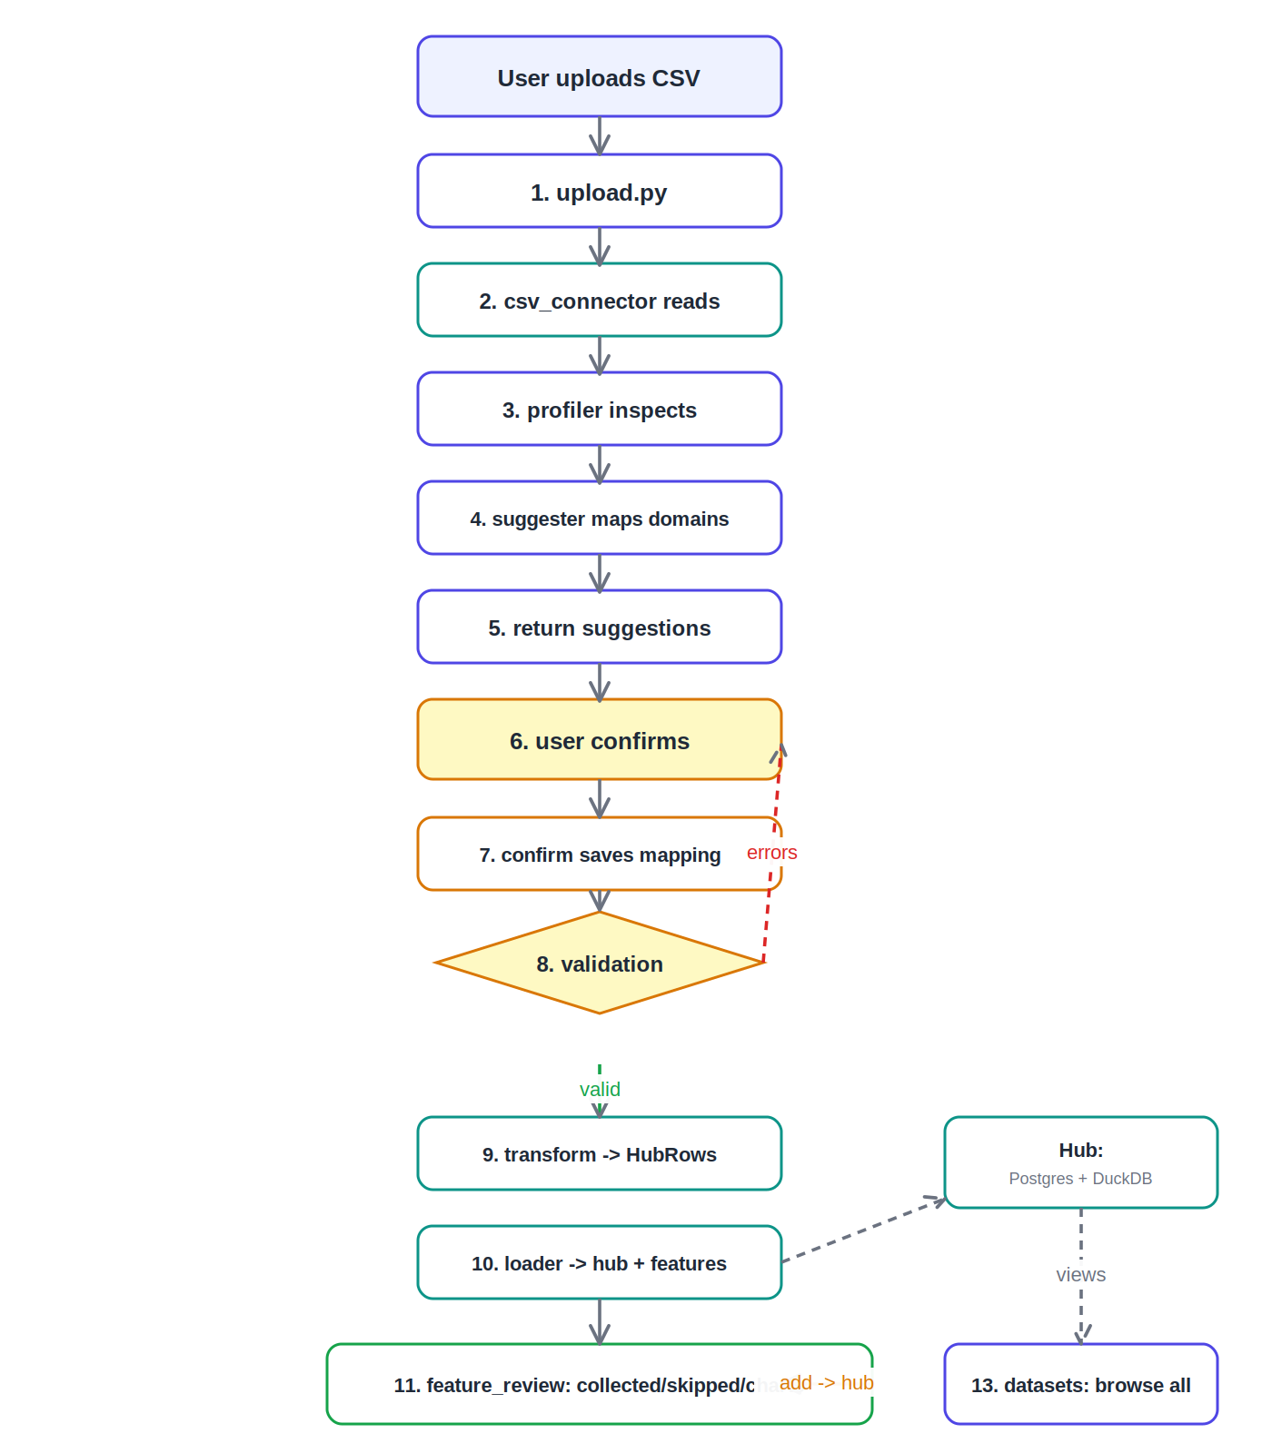
The full journey, with the module/file that owns each step

The full journey, step by step
- Upload a CSV — Dashboard / upload.py. The user enters a business name and drops in a CSV; the page calls /onboard/start.
- The file is read — Ingestion / csv_connector.py. Read into a clean dataframe — delimiter and encoding handled.
- Every column is profiled — Ingestion / profiler.py. Type, samples, distinct/null counts, identifier flag.
- Domains are suggested — Ingestion / suggester.py (using registry.py). Domain, role, metric name per column.
- Suggestions return — API / onboard.py → Dashboard / mapping_confirm.py. Profiles saved, suggestions shown.
- The user confirms — Dashboard / mapping_confirm.py → /onboard/confirm.
- The mapping is saved — Ingestion / confirm.py. Statuses updated, versioned config saved.
- The mapping is validated — Ingestion / validation.py. Errors block the load; nothing is written.
- The data is reshaped — Ingestion / transforms.py. Each metric becomes a universal HubRow.
- The data is loaded — Ingestion / loaders.py → hub tables. Features generated; skipped columns recorded.
- The review screen loads — Dashboard / feature_review.py → /features/{id}/review. Collected, skipped, and charts (from DuckDB views).
- The user fills a gap — Dashboard / feature_review.py → /features/add. Re-ingests one column; the screen refreshes live.
- Browse all datasets — Dashboard / datasets.py → /datasets. Every dataset listed; reopen any one’s review.

Why this design is good (talking points)
- Industry-agnostic: steps 2–10 never contain industry-specific code. Only the mapping (a configuration) differs.
- Human-in-the-loop: the user confirms and can fill gaps, so the hub is trustworthy, not a black box.
- Safe: validation blocks bad loads; the whole thing runs in one transaction, so failures roll back cleanly.
- Separated cleanly: the dashboard only calls the API; the API owns the database; the pipeline does the work; the common package holds shared rules.
- Reproducible: the whole stack starts with one command and self-seeds data.

How this maps to the reviewer’s four required items
Reviewer's item | Where it lives in this flow
1. Data ingestion pipeline | Steps 2–10 (connector → profiler → suggester → confirm → validate → transform → load)
2. Database design & modeling | The hub schema + universal domain model (steps 9–10)
3. Industrial data hub setup | Postgres + DuckDB (step 10 write, step 11 read)
4. Dashboard development | Steps 1, 6, 11, 12, 13 (the four screens)
Plus the upgrade beyond the four items: universal auto-onboarding for any industry (steps 3–4) and multi-dataset browsing (step 13).

The closing line for your review
So the whole system is one pipe: any business’s data goes in at the top, gets mapped onto eight universal domains through a confirm-once step, lands in a single Postgres + DuckDB hub, and comes back out as a dashboard showing what was collected, what was missed, and letting the user fill the gaps — all running in Docker with one command, and all industry-agnostic because we model universal business functions, not industries.

