GeostatisticsLab
A geostatistics plugin for QGIS
User Guide
Stefano Bonduà
stefano.bondua@unibo.it

DICAM – University of Bologna
Document version: 1.0

Table of Contents
Table of Contents 2
1. Introduction 4
1.1 Who this guide is for 4
1.2 Plugin structure 4
1.3 Example datasets used in this guide 4
1.4 Requirements 5
2. Installation and Startup 6
2.1 Plugin installation 6
2.2 Loading the example data 6
2.3 Opening the plugin window 6
3. Statistics Tab 8
3.1 Layer and variable selection 8
3.2 Statistical results and histogram 8
3.3 Histogram sub-tab 9
3.4 Q-Q plot sub-tab 9
3.5 Data Declustering sub-tab 10
3.6 Normal Score Transform 11
4. Variogram Tab 13
4.1 Variogram sub-tab – computation parameters 13
4.2 Theoretical variogram modeling 14
4.3 Automatic fitting (Autofit) 14
4.4 Settings sub-tab (model selection for Autofit) 15
4.5 Exporting the model in GSLIB format 16
4.6 Variogram Map sub-tab 16
4.7 3D Variogram sub-tab 17
5. Kriging Tab 18
5.1 Kriging type 18
5.2 Search neighborhood geometry (Neighboring) 18
5.3 Estimation on a regular grid (Estimation grid) 18
5.4 Estimation on a point layer (Estimation point) 19
5.5 Output and starting the estimation 20
5.6 Cross-Validation 20
5.7 Cross Kriging Plot 21
5.8 Cross kriging map 22
5.9 Cross-kriging neighbourhood 23
5.10 Back Transform 24
6. Probability Maps Tab 26
6.1 Input parameters 26
6.2 Notes on the computation 27
7. Recommended Workflow 28
8. Appendix: Interface Controls Summary 29
8.1 Statistics Tab 29
8.2 Variogram Tab 29
8.3 Kriging Tab 29
8.4 Probability Maps Tab 30
8.5 References on the example datasets 30

1. Introduction
GeostatisticsLab is a QGIS plugin developed at DICAM – University of Bologna, bringing together a complete geostatistical workflow in a single interface: from exploratory data analysis to probability mapping, passing through variography, model fitting, kriging and cross-validation.
The plugin was built starting from the skeleton generated by QGIS Plugin Builder and is written entirely in Python, using QGIS native libraries (PyQt, QgsVectorLayer, QgsRasterLayer) together with NumPy, SciPy and Matplotlib for numerical computation and graphical visualization.

1.1 Who this guide is for
This guide is intended for users who are already familiar with the basic concepts of geostatistics (variogram, kriging, normal-score transformation) and with the use of QGIS as a GIS environment. No programming experience is required: all functionality is accessible through the plugin's graphical interface.

1.2 Plugin structure
The plugin interface is organized into four main tabs, each dedicated to a stage of the geostatistical workflow:
- Statistics – data loading, descriptive statistics, histogram, Q-Q plot, declustering and Normal Score Transform
- Variogram – experimental variogram computation, theoretical modeling (including automatic fitting), 2D/3D variogram map
- Kriging – Simple/Ordinary/Universal Kriging estimation on a regular grid or on points, cross-validation and back-transform
- Probability Maps – computation of threshold exceedance/non-exceedance probability maps from a kriging estimate and its variance
Each tab is described in detail in the following chapters, including the meaning of every parameter and of the resulting outputs.

1.3 Example datasets used in this guide
To illustrate the plugin's functionality in a concrete way, this guide refers to two reference geostatistical datasets, widely used in the literature and typically included in GSLIB-style distributions:
- sic97.dat – the dataset from the “Spatial Interpolation Comparison 1997” (SIC97) contest, containing radioactivity deposition measurements (Caesium-137) collected after the Chernobyl accident over a portion of German territory. It is a classic dataset for testing spatial interpolation and kriging methods.
- walker_lake_samples_.dat – a sampled subset of the well-known Walker Lake dataset (Isaaks & Srivastava), reporting values of two variables (typically denoted V and U) at a set of locations in the Walker Lake region of Nevada. It is one of the most widely used teaching datasets in geostatistics textbooks for demonstrating variography, kriging and cross-validation.
Note: The .dat files are typically delimited text files (columns X, Y, value) and can be loaded into QGIS as a Delimited Text Layer, then used directly in the various tools of the plugin described in this guide.

1.4 Requirements
- QGIS 3.x with Python 3 support
- Python libraries: NumPy, SciPy, Matplotlib (required for variography, autofit, normality tests and plots)
- GDAL with Python bindings (osgeo.gdal), already included in most QGIS installations, required for back-transform and probability maps

2. Installation and Startup

2.1 Plugin installation
- Copy the GeostatisticsLab plugin folder into the QGIS plugins directory (typically ~/.local/share/QGIS/QGIS3/profiles/default/python/plugins/ on Linux/Mac, or %APPDATA%\QGIS\QGIS3\profiles\default\python\plugins\ on Windows).
- Start QGIS and open the Plugins → Manage and Install Plugins menu.
- In the Installed tab, locate GeostatisticsLab and make sure its checkbox is enabled.
- A new plugin icon will appear in the toolbar (or in the Plugins menu), from which the plugin's main window can be opened.

2.2 Loading the example data
Before using the plugin, a point layer containing the data to be analyzed must be loaded into QGIS. For the example datasets sic97.dat and walker_lake_samples_.dat, proceed as follows:
- From the Layer menu, choose Add Layer → Add Delimited Text Layer…
- Select the .dat file, setting the correct delimiter (space or comma, depending on the file formatting).
- Specify which columns represent the X and Y coordinates (typically the first two columns of the file).
- Confirm with OK: the point layer will appear in the Layers panel and will be usable by all the plugin's tools.
Tip: For the sic97.dat dataset the main field of interest is generally the Caesium-137 deposition value; for walker_lake_samples_.dat the typical variables are V (primary value) and U (correlated secondary variable).

2.3 Opening the plugin window
Once the layer is loaded, click the GeostatisticsLab icon in the QGIS toolbar. The plugin's main window will open, organized into the four tabs described in the introduction.
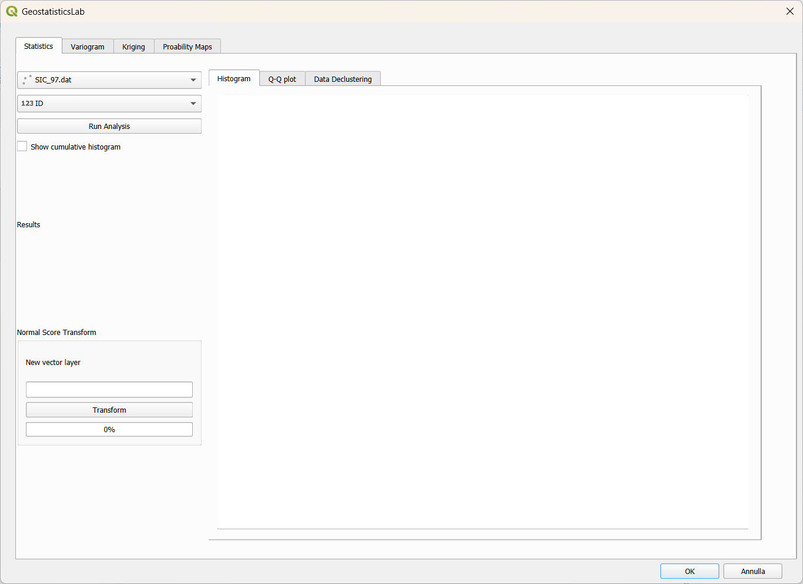
Figure 2.1 – Main plugin window, Statistics tab on startup.

3. Statistics Tab
The Statistics tab is the starting point of the analysis: here the layer and variable of interest are selected, basic descriptive statistics are computed, the shape of the distribution is examined through a histogram and a Q-Q plot, the effect of spatial sample clustering is evaluated via declustering, and the Normal Score Transform can optionally be applied.

3.1 Layer and variable selection
The top-left panel of the tab contains:
- Point layer (Map Layer combo box) – lists all point layers present in the QGIS project; select sic97.dat or walker_lake_samples_.dat here after loading them.
- Field (variable) (Field combo box) – automatically updates based on the selected layer and allows the numeric column to be analyzed to be chosen (e.g. the Caesium-137 value in sic97.dat, or V or U in walker_lake_samples_.dat).
- Run Analysis button – starts the computation of descriptive statistics and draws the histogram.
- Show cumulative histogram (checkbox) – when enabled, overlays a cumulative percentage frequency curve on the histogram, on a secondary Y axis.
When the selected layer is changed, the plugin automatically recomputes, in the background, default values for the variogram, the kriging grid and the declustering parameters, based on the spatial extent and the number of points in the layer.

3.2 Statistical results and histogram
Pressing Run Analysis, the Results panel shows: sample count (Data Count), mean, median, minimum, maximum and standard deviation of the selected variable. At the same time, the panel on the right draws the frequency histogram (in percentage) using 15 classes.
The computed mean value is automatically proposed as the “mean” parameter for Simple Kriging in the Kriging tab, so the user does not need to copy it manually.
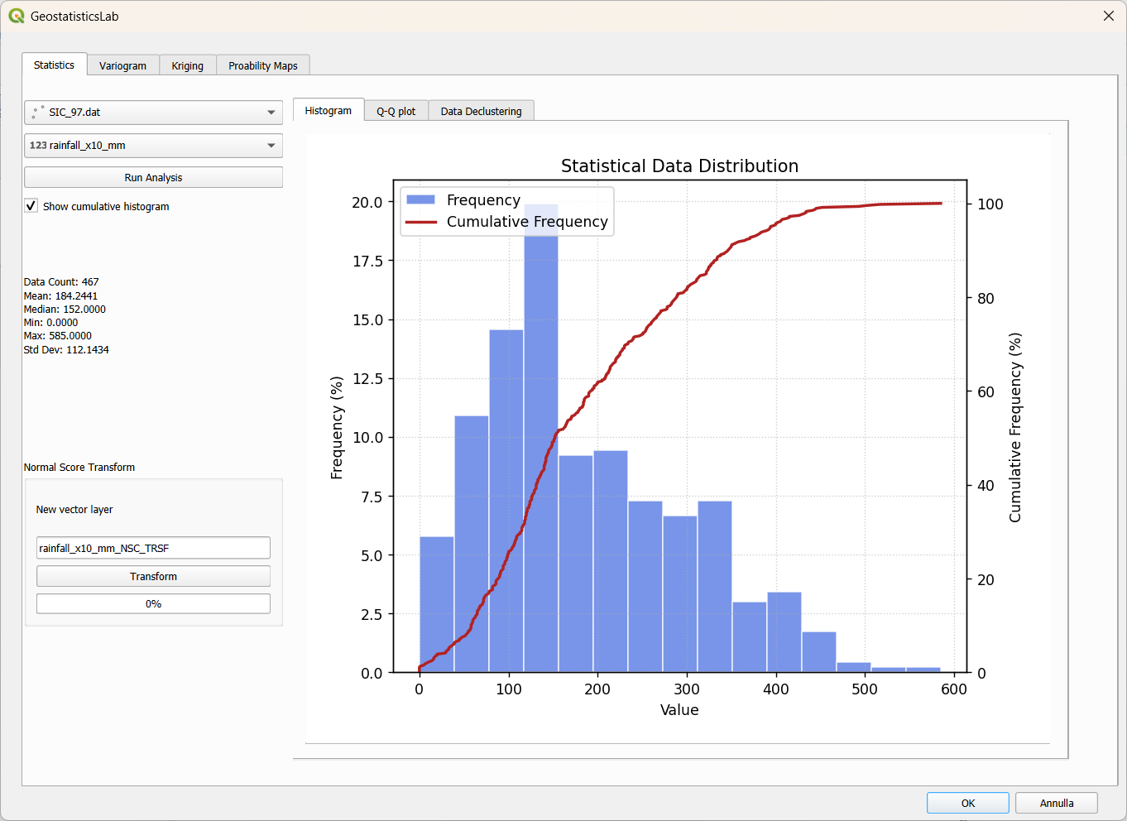
Figure 3.1 – Statistics tab: layer/variable selection, histogram and Normal Score Transform group.

3.3 Histogram sub-tab
The central panel of the Statistics tab in turn contains three sub-tabs: Histogram, Q-Q plot and Data Declustering.
The Histogram sub-tab shows the bar chart of the frequency distribution described above; if the Show cumulative histogram checkbox is enabled, the cumulative frequency curve is added in red, useful for quickly reading the percentiles of the distribution.

3.4 Q-Q plot sub-tab
This sub-tab allows the normality of the original variable to be visually and statistically compared with that of its possible transformation via Normal Score (see section 3.6), placing two quantile-quantile plots side by side.
To run the comparison:
- Make sure the original layer and field are selected in the main panel on the upper-left of the Statistics tab (mFieldComboBox).
- In the Transformed variable drop-down menu, choose the field already transformed with Normal Score (created previously with the Transform button, see 3.6).
- Press Calculate: two Q-Q plots are drawn side by side (original variable on the left, transformed variable on the right), each with the theoretical normal reference line.
Below the plots, the text panel reports, for both variables, the results of two normality tests:
- Shapiro-Wilk test (W statistic and p-value): a p-value greater than 0.05 indicates a distribution compatible with normality.
- Anderson-Darling test (A² statistic compared with the critical value at the 5% level): if the statistic exceeds the critical value, the distribution deviates significantly from normality.
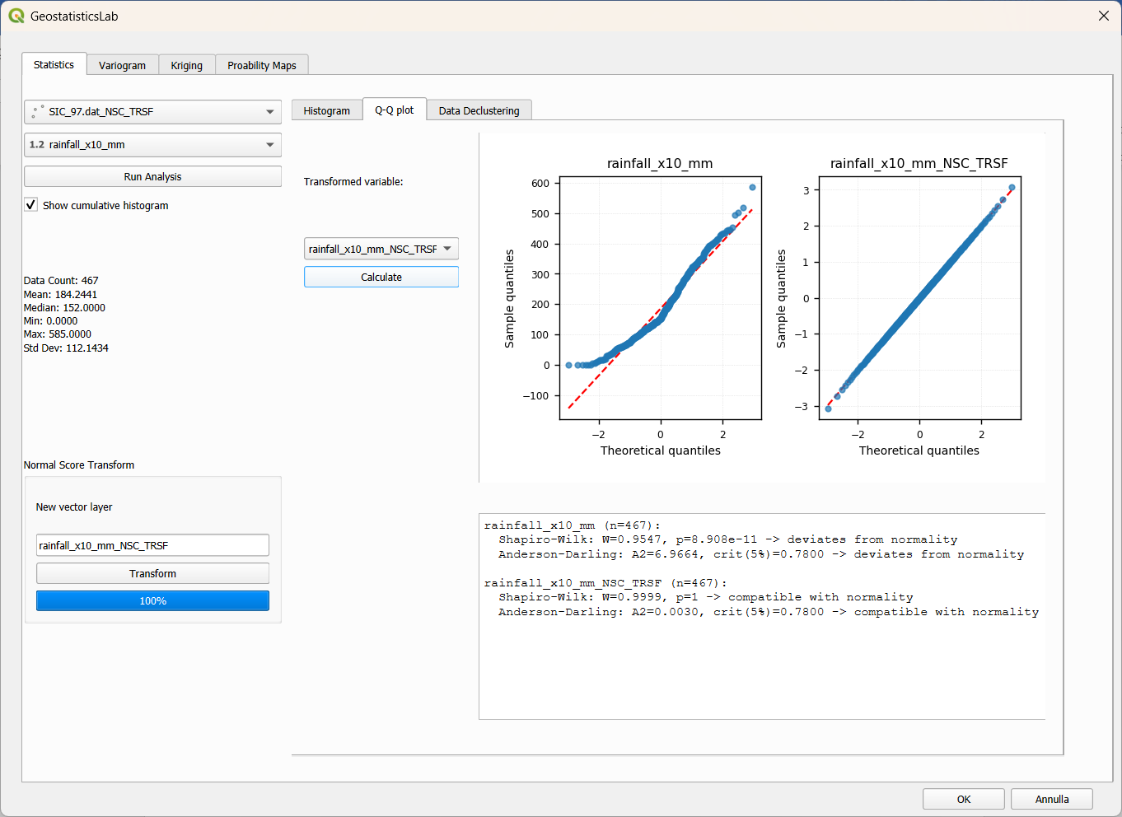
Figure 3.2 – Q-Q plot sub-tab: normality comparison between the original variable and its Normal Score transform.
Note: At least 8 valid values per variable are required for the normality tests to be computed; with smaller samples the result would not be statistically reliable.

3.5 Data Declustering sub-tab
When samples are not uniformly distributed in space (for example with densely sampled zones and others that are sparsely sampled), the simple arithmetic mean can be biased. The Cell Declustering tool (standard GSLIB method) corrects this effect by assigning weights that are inversely proportional to the local density of points.
The parameters available in this sub-tab are:
- Cell Size – the cell size used for the final computation of the declustering weights, applied to the layer.
- cell_size_min / cell_size_max / cell_size_steps – the range and number of steps used to build the diagnostic curve “weighted mean vs. cell size”, which helps select the optimal cell size (typically the one corresponding to the minimum or to a plateau of the curve).
Pressing Decluster, the plugin:
- Computes the diagnostic curve (weighted mean as a function of cell size) and draws it on the plot, comparing it against the naive (unweighted) mean, shown as a dashed red line.
- Computes the final declustering weights for the cell size specified in Cell Size.
- Creates a NEW in-memory layer (named <layer_name>_decluster), containing all the original columns plus a new decluster_weight column with the computed weight for each point.
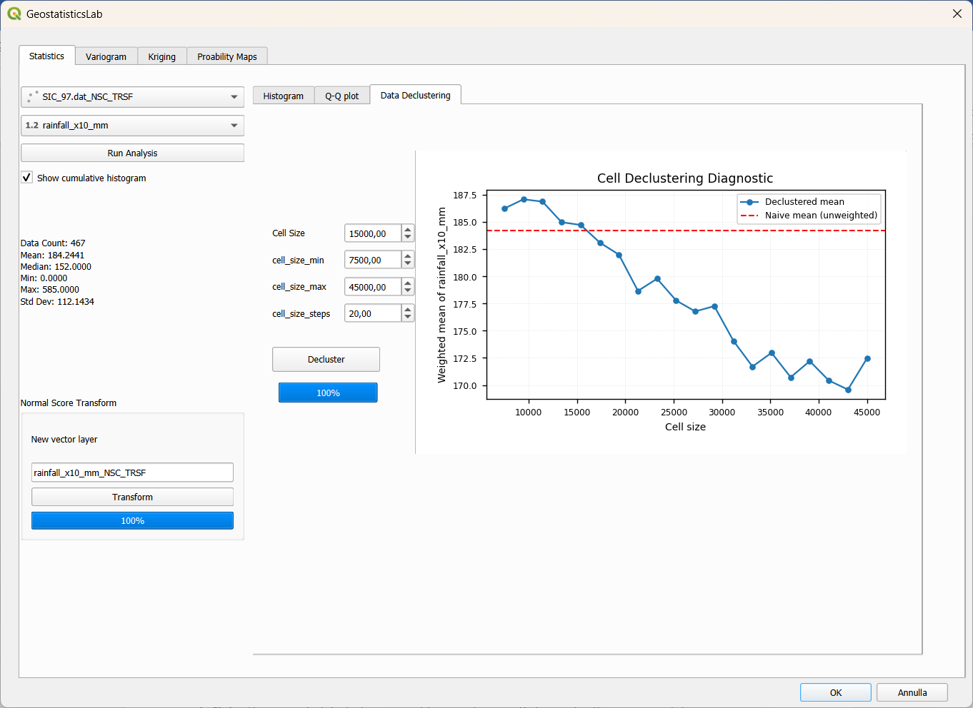
Figure 3.3 – Data Declustering sub-tab: cell parameters and the weighted-mean-vs-cell-size diagnostic curve.
Tip: The plugin always creates a new in-memory layer for declustering, never modifying the original layer: this makes it easy to compare results with/without declustering, and also works with read-only data sources (e.g. CSV files).
Note: The generated declustering weights can subsequently be used in the experimental variogram computation by enabling the use_decl.weights checkbox in the Variogram tab (section 4.2), provided that the new <layer_name>_decluster layer is selected as the active layer.
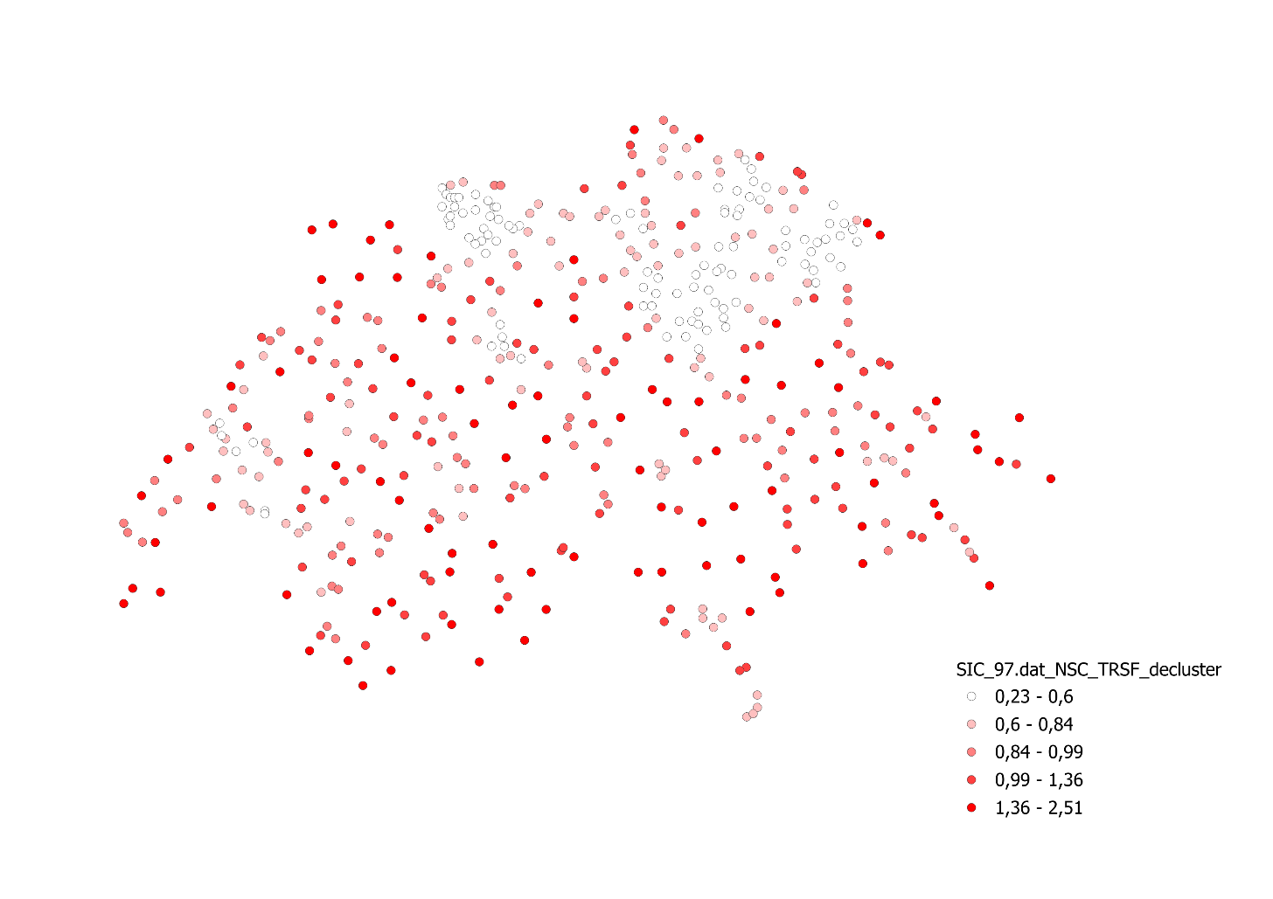
Figure 3.4 – Data Declustering results

3.6 Normal Score Transform
The Normal Score Transform group, located in the lower-left part of the Statistics tab, applies the standard Gaussian transformation (Normal Score Transform, NST) to the selected variable: each original value is converted into the corresponding quantile of a standard normal distribution, a common practice in geostatistics to make methods (such as Simple Kriging) that assume Gaussian data applicable.
To run the transformation:
- Select the layer and the field to be transformed in the main panel above.
- In the New vector layer field, optionally specify the desired name for the new transformed column; if left empty, the name <field>_NSC_TRSF is proposed automatically.
- Press Transform.
The result is a new in-memory point layer, whose rows are sorted in ascending order with respect to the original value: this choice is not arbitrary, since the layer itself directly constitutes the GSLIB-style transformation table (original sorted value column + corresponding normal score column), subsequently used by the back-transform tool in the Kriging tab (section 5.10).
Note: Since the transformation always generates a new layer, the original layer and data table remain untouched: this makes it easy to go back to the non-transformed variable at any time.

4. Variogram Tab
The Variogram tab is dedicated to computing the experimental variogram, building and fitting the theoretical model (possibly with several nested structures), the 2D and 3D variogram map, and exporting the model in GSLIB format. It is organized into three sub-tabs: Variogram, Variogram Map and 3D Variogram.

4.1 Variogram sub-tab – computation parameters
The left panel collects all the parameters of the directional experimental variogram computation:
- fixed lag / adaptive_lag – two alternative lag-spacing modes. With fixed lag, the user sets lag and number of lags directly; with adaptive_lag, the plugin automatically computes the optimal spacing replicating the AutoVar routine algorithm (based on the average distance to the k-th nearest neighbour), updating lag, lag_tolerance and num_lags accordingly.
- MaxDistance – maximum distance within which point pairs are considered; it is automatically proposed as half of the minimum diagonal of the layer extent, rounded to a “round” value.
- num_lags – number of distance bins. GSLIB/AutoVar convention: bin centers are at h = 0, lag, 2·lag…, so MaxDistance = (num_lags − 1) × lag.
- lag – width of each distance bin; changing this value automatically updates lag_tolerance (always equal to lag/2) and MaxDistance.
- lag_tolerance – distance tolerance used to assign a pair to a bin; in the plugin it is always automatically derived as lag/2, and the field is disabled to avoid inconsistencies with the adopted GSLIB convention.
- azimuth – reference direction (in geographic degrees, 0° = North, clockwise) from which the equally spaced directions are generated.
- Number of directions – number of directions computed, equally spaced over a 180° arc (because of variogram symmetry). Automatically updates angular_tolerance.
- angular_tolerance – half-aperture angle of each directional sector; by default computed as 90° / Number of directions, but it can be modified manually to allow sector overlap or narrowing.
- bandwidth – maximum lateral width (perpendicular to the direction) within which a pair is still considered to belong to the directional sector; if set to 0, the filter is disabled and only the angular tolerance applies.
- use_decl.weights – if enabled and the selected layer has a decluster_weight column (generated in 3.5), weights each pair by the product of the declustering weights of its two points, following GSLIB convention.
- Show num pairs – displays the number of pairs used for each point on the plot (useful to assess the statistical reliability of each bin).
- Show box plot – overlays box plots of the semivariogram distribution within each bin, in addition to the mean value.
- show theoretical model – overlays the theoretical model curve currently defined in the structures table (section 4.2) onto the plot.
- Normalize by variance – divides each semivariance value by the global sample variance, so that the sill tends to 1 (relative variogram), useful for comparing variables or datasets on different scales.
- Effective distance – when enabled, each point on the plot is positioned at the actual average distance of the pairs falling within that bin (AutoVar style), instead of at the theoretical bin center.
Pressing Calculate, the plugin computes the experimental variogram for all directions and draws the multi-directional plot in the right-hand panel, simultaneously enabling Autofit and the structures table.
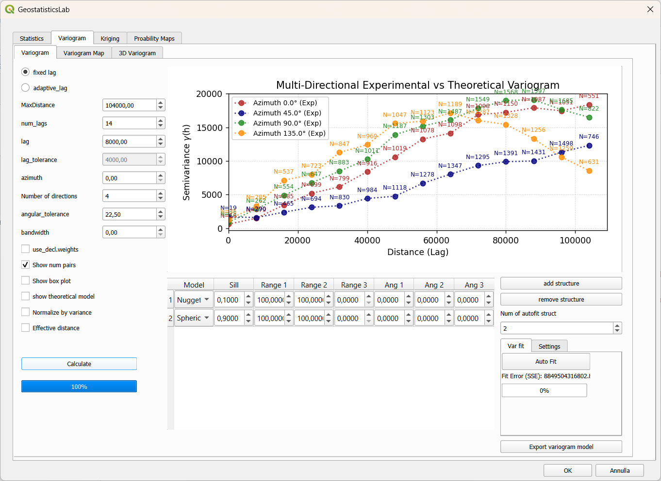
Figure 4.1 – Variogram sub-tab: computation parameters, multi-directional experimental plot and model structures table.

4.2 Theoretical variogram modeling
Below the plot is the table of nested structures of the theoretical model (Model, Sill, Range 1, Range 2, Range 3, Ang 1, Ang 2, Ang 3), representing the sum of one or more basic structures (Nugget, Spherical, Exponential, Gaussian, Linear, Cubic), each with its own sill, range (possibly anisotropic, with Range 1/2/3 along the principal directions) and rotation angles of the anisotropy ellipsoid. As this plugin is working in 2D coordinate system, just Ang 1 is used in this plugin.
To edit the model manually:
- add structure button – adds a new row (spherical structure by default) to the table.
- remove structure button – removes the currently selected structure (at least one structure is always required).
- Every table cell is directly editable (combo box for the type, numeric spin boxes for the other parameters); each change instantly updates the plot and the fit error value, without needing to recompute the experimental variogram.

4.3 Automatic fitting (Autofit)
The Var fit panel (sub-tab of the structures table) automates the search for the best theoretical model through numerical optimization (scipy.optimize, L-BFGS-B method), using a multi-start approach on azimuth to avoid getting stuck in local minima.
- Num of autofit struct – number of spatial structures to combine in the model being searched for (in addition to any nugget).
- Auto Fit button – starts the automatic search: several combinations of models (among those enabled in the Settings sub-tab) and several azimuth starting points are tried, keeping the combination with the lowest weighted squared error (SSE).
- Fit Error (SSE) label – shows the current weighted squared error between the theoretical model and the experimental data, automatically updated with every change to the structures table.
- Progress bar – shows the progress of the search, which systematically explores all model combinations and the different angular starting points.
Upon completion, if the search is successful, the structures table is automatically replaced with the best combination found, and the show theoretical model checkbox is enabled to immediately display the result on the plot.
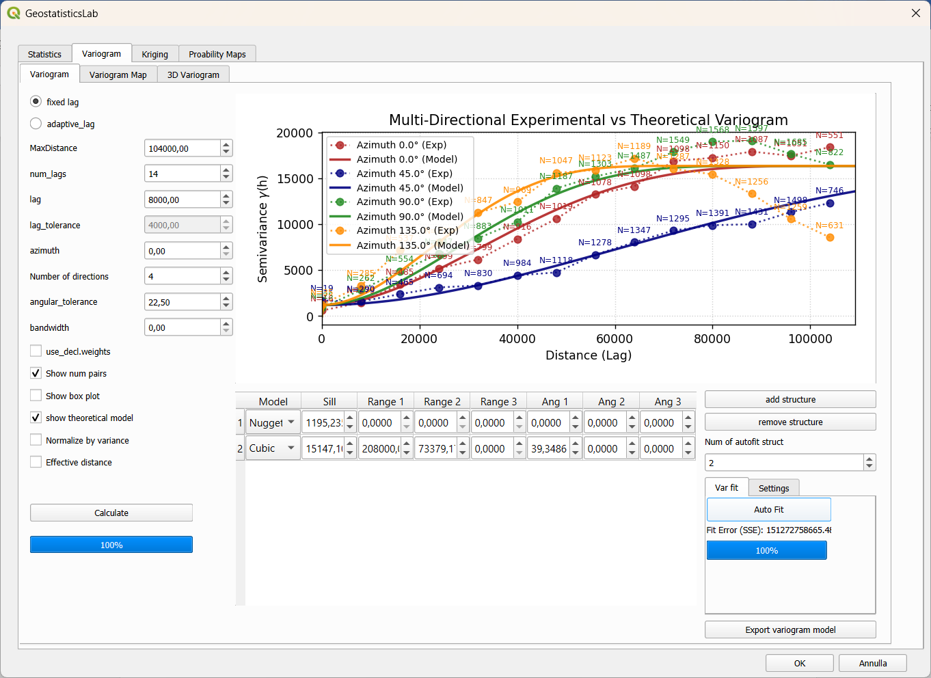
Figure 4.2 – Variogram sub-tab: Autofit resutls.

4.4 Settings sub-tab (model selection for Autofit)
This sub-tab contains a table listing all available theoretical models (Nugget, Spherical, Exponential, Gaussian, Linear, Cubic), each with a Use in autofit checkbox. Deselecting a model excludes it from the combinations tested by Autofit (useful, for example, to exclude the Linear model if it is not physically plausible for the phenomenon being analyzed).

4.5 Exporting the model in GSLIB format
The Export variogram model button saves the theoretical model currently defined in the structures table to disk, in a text file following GSLIB convention: the first line gives the number of spatial structures and the nugget sill, the following lines give the model type, sill and range/angle parameters for each spatial structure. This file can be reused in other GSLIB-compatible software.

4.6 Variogram Map sub-tab
The variogram map provides an overall view of the spatial anisotropy of the phenomenon, computing the experimental semivariance on a polar grid (distance rings x angular sectors) covering the full 360° circle, even if the variogram is symmetric over 180°.
The available parameters are similar to those of the Variogram sub-tab (MaxDistance, num_lags, lag, lag_tolerance, azimuth, Number of directions, angular_tolerance, bandwidth, Use declus. weights), but with specific default values: 18 sectors by default and an angular tolerance halved with respect to the standard case, since here the sectors cover the entire circle.
- Camp. princ. directions (checkbox, enabled by default) – when selected, the plugin identifies and draws the principal anisotropy directions on the map, computed via the inertia tensor of the semivariance surface.
- Calculate button – computes the variogram map and draws it as a colored polar plot in the right-hand panel.
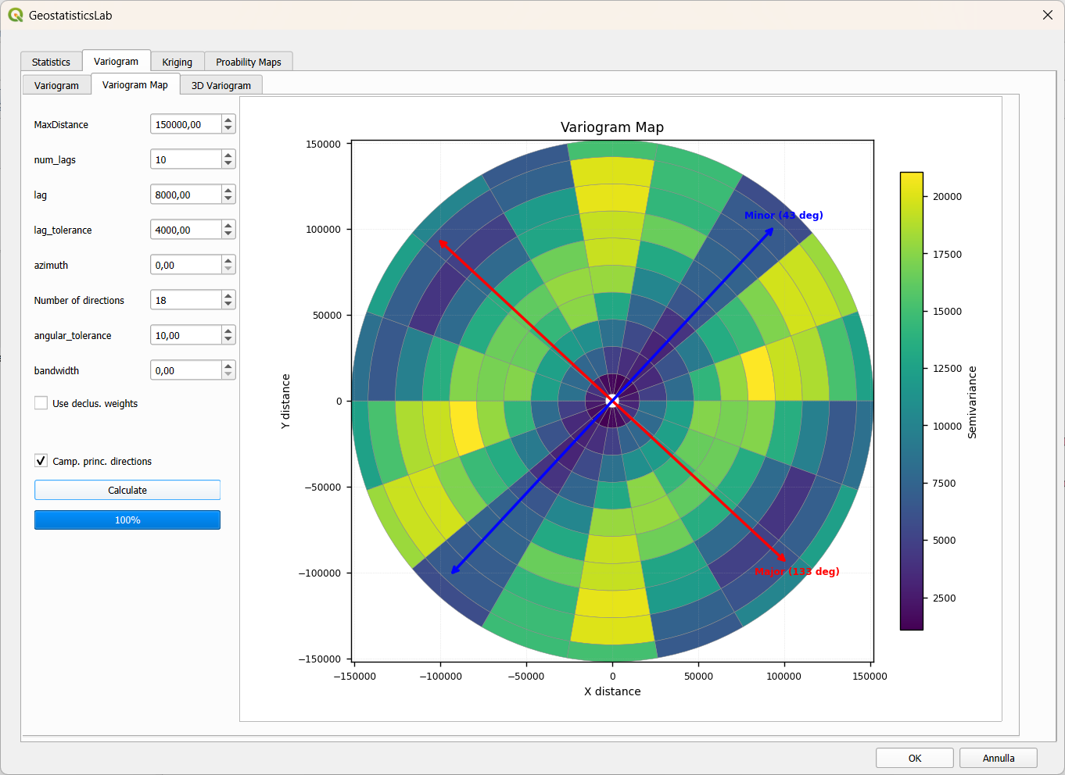
Figure 4.3 – Variogram Map sub-tab: 2D polar map of the semivariance with arrows showing the principal anisotropy directions.
Tip: The variogram map is particularly useful as a preliminary step before directional modeling: the elongation (ellipticity) of the semivariance surface indicates the direction and intensity of anisotropy, to be later set as the azimuth in the Variogram sub-tab.

4.7 3D Variogram sub-tab
This sub-tab offers a three-dimensional surface representation of the same variogram map described above, useful for visually appreciating the behaviour of semivariance as a function of both distance and direction simultaneously.
- Variogram Model (checkbox) – when enabled, overlays the surface corresponding to the currently defined theoretical model onto the experimental surface, for direct visual comparison.
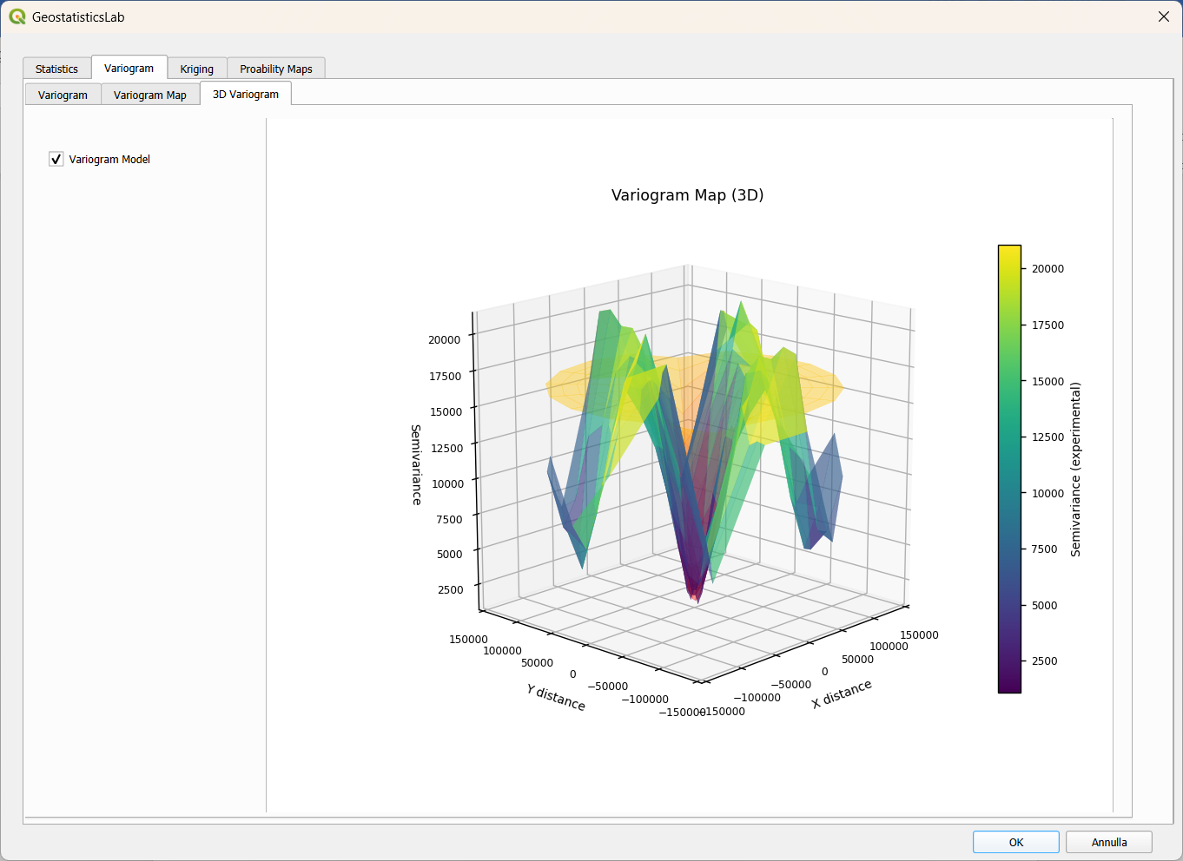
Figure 4.4 – 3D Variogram sub-tab: three-dimensional surface of semivariance as a function of distance and direction.

5. Kriging Tab
The Kriging tab is the operational core of the plugin: it allows spatial interpolation to be performed via Simple, Ordinary or Universal Kriging, on a regular grid or on a point layer of estimation locations, lets the user define the search neighborhood geometry, validate the model through cross-validation, and apply the back-transform to bring results back to the original variable's space after a Normal Score Transform.

5.1 Kriging type
The Kriging type group (top left) allows the user to choose between three variants:
- Simple (Simple Kriging, SK) – assumes the mean of the variable over the whole domain is known and constant, entered in the mean field (automatically proposed based on the mean computed in the Statistics tab, section 3.2, but manually editable).
- Ordinary (Ordinary Kriging, OK) – the default option; does not require a known mean, instead estimating it locally within each search neighborhood through the unbiasedness constraint on the weights.
- Universal (Universal Kriging, UK) – extends Ordinary Kriging by including a deterministic trend (drift) in the estimation, useful when the phenomenon exhibits a systematic, non-stationary spatial trend.

5.2 Search neighborhood geometry (Neighboring)
The Neighboring group defines which points are actually used to estimate each grid node or estimation point:
- Num. Points Min / Num. Points Max – minimum and maximum number of data points required within the search ellipse; if the number of available neighbors is below the minimum, the node is not estimated.
- Range max / Range min – major and minor semi-axes of the search ellipse, automatically proposed as half of the shortest side of the data bounding box, but customizable (for example to align them with the variogram model ranges).
- Azimuth – orientation of the search ellipse, in geographic degrees; typically aligned with the direction of maximum spatial continuity identified during variography.
- Octant search (checkbox) – when enabled, divides the search ellipse into eight octants and enforces a minimum number of points per octant (Min points per octant), ensuring a more even distribution of the neighbors used around the node being estimated and reducing the effect of directional data clustering.

5.3 Estimation on a regular grid (Estimation grid)
The Estimation grid sub-tab (selected by default via the Grid radio button) defines the output grid parameters:
- X Min/Max, Y Min/Max – geographic extent of the grid, automatically proposed based on the layer's data extent with a “rounded” margin, but freely editable.
- Nx, Ny – number of grid cells along X and Y.
- dx, dy – cell size along X and Y.
These six parameters are linked interactively: changing the geographic bounds (X/Y Min/Max) automatically recomputes dx and dy keeping Nx/Ny fixed; changing Nx, Ny, dx or dy instead automatically recomputes X Max and Y Max, keeping the grid geometrically consistent at all times without requiring manual calculations by the user.
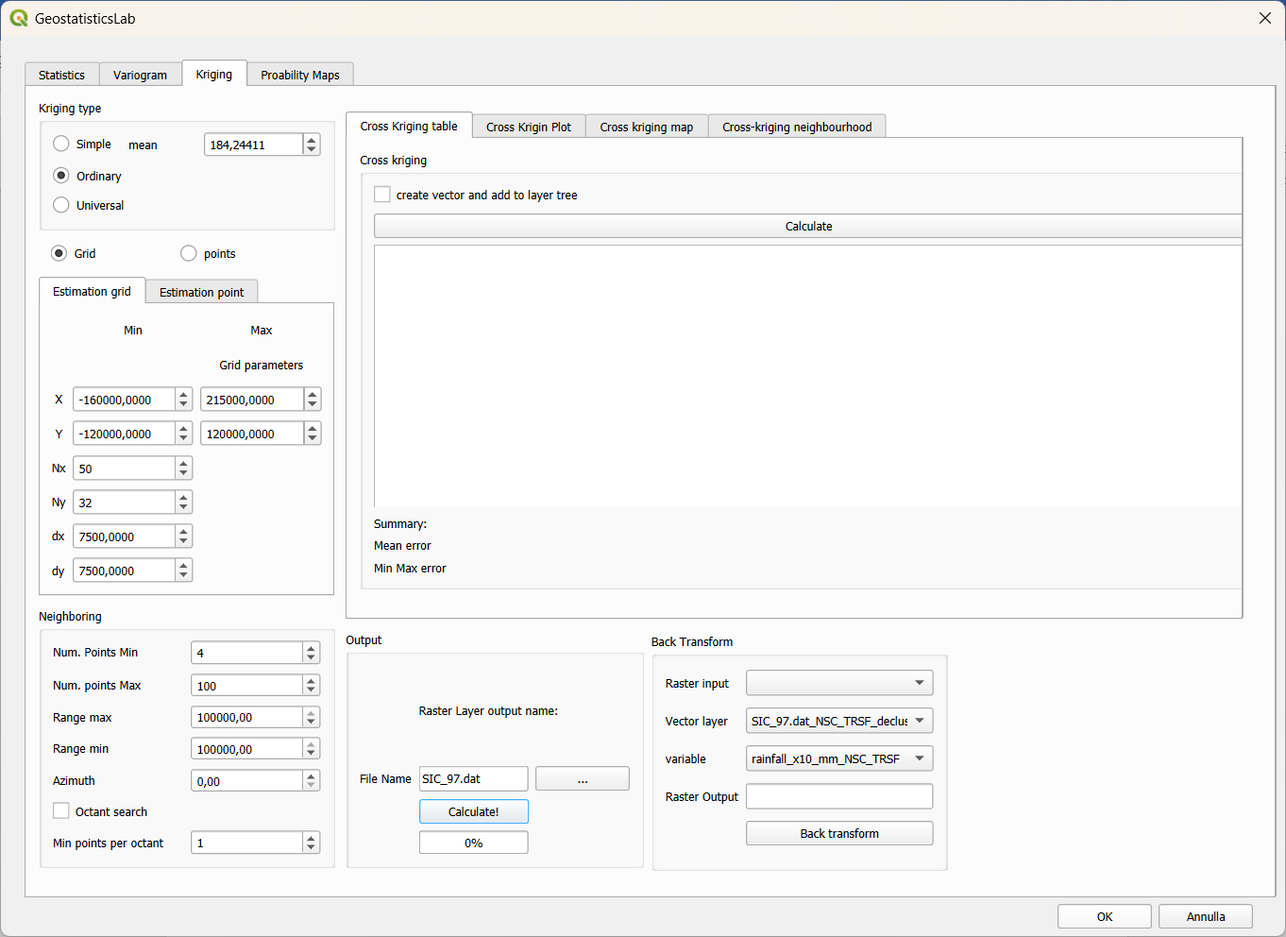
Figure 5.1 – Kriging tab: kriging type, search neighborhood, estimation grid and Output group.

5.4 Estimation on a point layer (Estimation point)
As an alternative to a regular grid, selecting the points radio button activates the Estimation point sub-tab, which allows the variable to be estimated exclusively at the locations of an existing point layer (for example, verification points, wells, or sample locations not yet measured):
- Select layer with points – combo box for choosing the point layer that defines the estimation locations.
- output vector layer – proposed name for the new output vector layer, containing for each point the estimated value and the corresponding kriging variance.
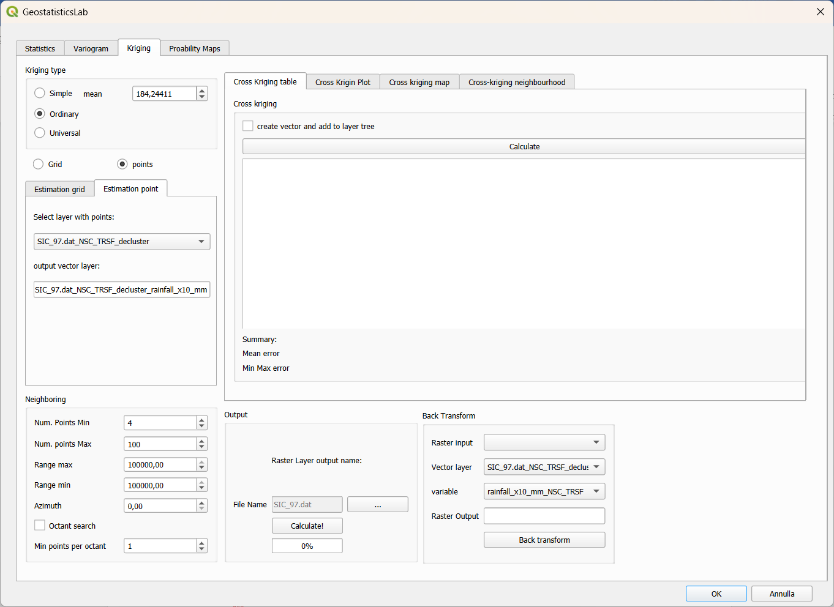
Figure 5.2 – Estimation point sub-tab: point-wise estimation on an existing point layer.

5.5 Output and starting the estimation
The Output group, at the bottom right, manages the name and path of the raster (or vector, in the case of point estimation) produced by the estimation:
- Raster Layer output name / File Name – name automatically proposed as <variable>_<kriging type>.tif (e.g. Cs137_ok.tif), editable by the user.
- … button – opens a dialog box to manually choose the path and name of the output file.
- Calculate! button – starts the kriging computation, showing progress in the progress bar below.
Before starting the estimation, the plugin performs a few automatic safety checks:
- If the theoretical variogram has never been computed or manually adjusted by the user, a warning is shown inviting completion of the variogram modeling first (Variogram tab), to avoid estimates based on meaningless default parameters.
- If duplicate coordinates are present in the data layer (same XY position for multiple points), the issue is reported with the list of affected locations, since exact duplicates produce a singular kriging matrix; the user can choose to proceed by keeping only the first occurrence of each duplicate.
- If the output file already exists on disk, the user is asked whether to overwrite it or automatically generate a new indexed name (e.g. name_1.tif).
Upon completion of the computation, the plugin produces a two-band GeoTIFF raster: the estimate and the corresponding kriging variance, automatically added to the QGIS project.

5.6 Cross-Validation
The Cross kriging sub-panel, contained in the Cross Kriging table sub-tab, allows the kriging model to be validated through leave-one-out cross-validation: each data point is temporarily removed from the dataset and re-estimated using all the other points, then comparing the estimated value with the actually observed one.
- create vector and add to layer tree (checkbox) – if enabled, in addition to the results table, a point vector layer with the cross-validation outcomes is created and added to the QGIS project for further spatial analysis.
- Calculate button – starts the cross-validation over all points in the active layer, using the variogram model and neighborhood parameters currently set.
The table reports, for each point, the observed value, the estimated value, the error (estimated − observed) and any additional metrics; at the bottom, a Summary section reports the mean error (Mean error) and the minimum/maximum error range (Min Max error) over all points, summary indicators of the overall quality of the adopted model.
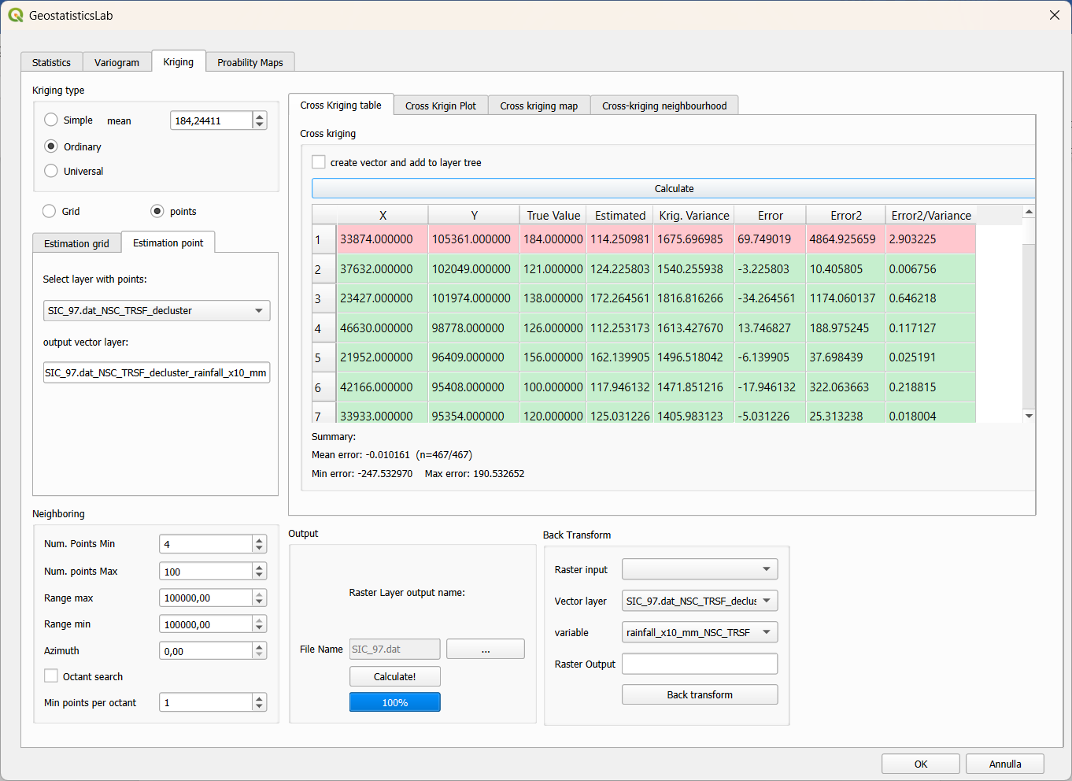
Figure 5.3 – Cross Kriging table sub-tab: results table of the leave-one-out cross-validation.

5.7 Cross Kriging Plot
The Cross Krigin Plot sub-tab shows a scatter plot of the estimated values against the observed values for all cross-validation points: a good model produces points aligned along the bisector (estimate = observation); systematic deviations from the bisector indicate model bias, while excessive scatter indicates poor predictive capability.
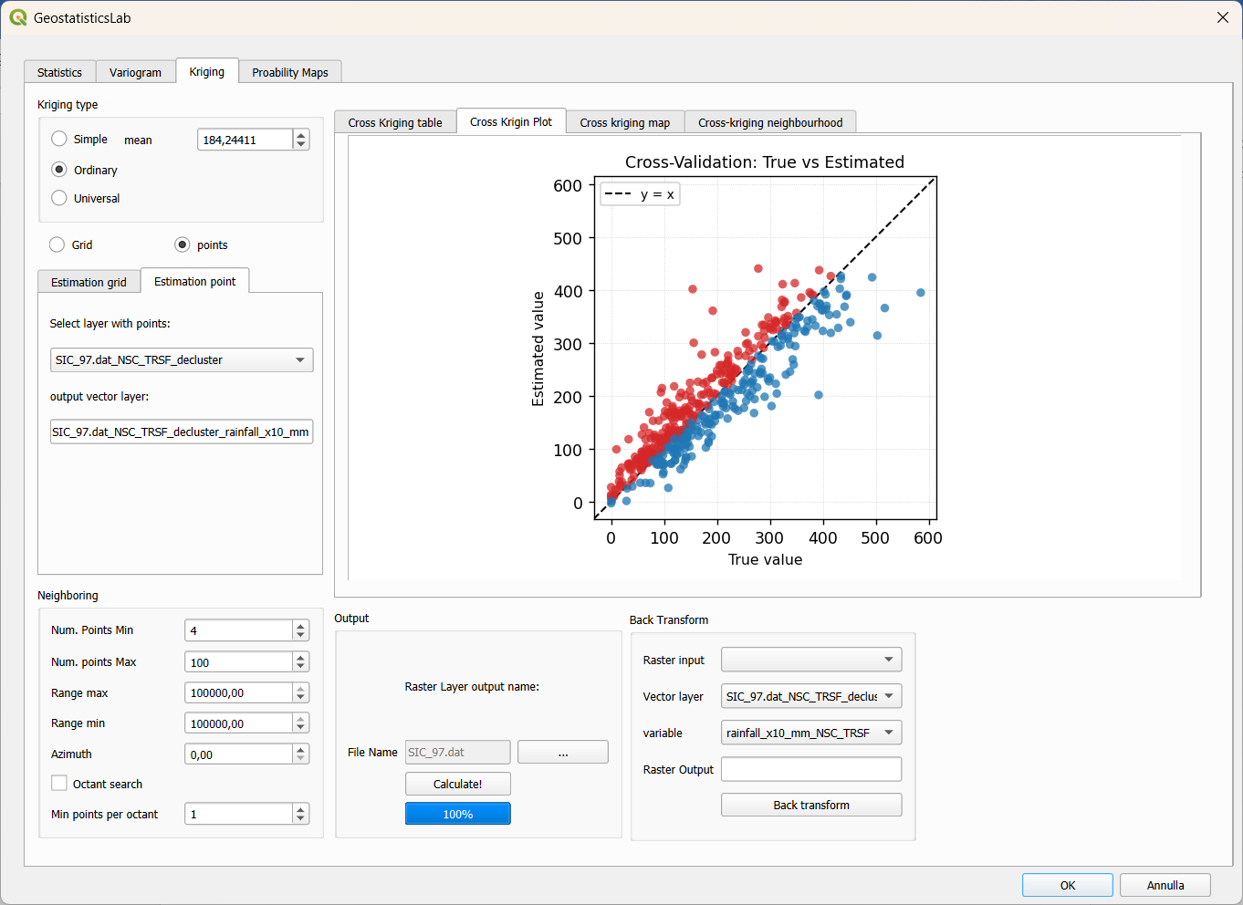
Figure 5.4 – Cross Krigin Plot sub-tab: estimated vs. observed for all cross-validation points.

5.8 Cross kriging map
The Cross kriging map sub-tab displays the spatial distribution of cross-validation errors, coloring each layer point according to the magnitude and sign of the estimation error. This representation is particularly useful for identifying areas of the domain where the model systematically over- or under-estimates, suggesting possible corrections to the neighborhood geometry or to the variogram model.
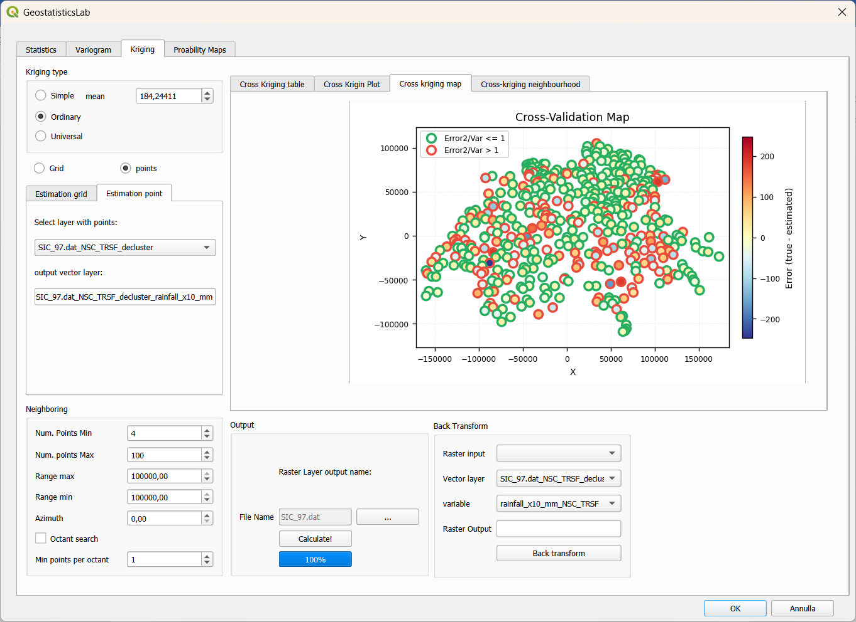
Figure 5.5 – Cross kriging map sub-tab: spatial distribution of cross-validation errors.

5.9 Cross-kriging neighbourhood
This sub-tab allows a detailed, point-by-point inspection of which neighbors were actually used by the cross-validation and with which weight, through:
- Weights table (on the left) – lists the neighboring points used for the estimation of the currently selected point, with their corresponding kriging weight.
- Neighbor map (center/right) – graphically represents the selected point (solid red circle), the neighbors actually used (colored according to their weight on a color scale, with a black border), the unused points (gray border, white fill) and the applied search ellipse, with axes at a 1:1 scale so as not to distort the geometry.
- <-Previous and Next-> buttons – allow scrolling through the cross-validation results point by point, updating both the weights table and the neighbor map at the same time; it is also possible to directly select a table row to jump to that specific point.
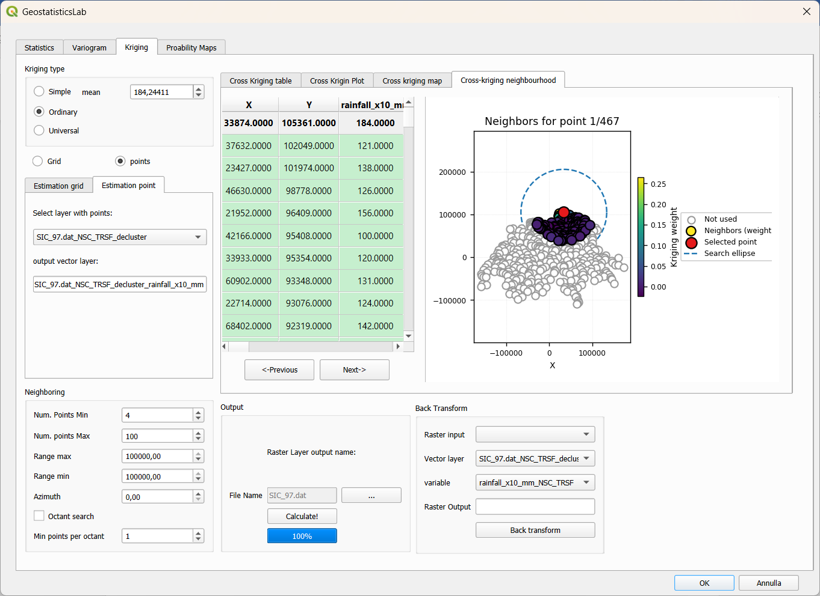
Figure 5.6 – Cross-kriging neighbourhood sub-tab: neighbors, kriging weights and search ellipse for the selected point.

5.10 Back Transform
The Back Transform group, at the bottom right of the Kriging tab, allows an estimated raster in normal space (i.e. obtained by performing kriging on a variable previously transformed via Normal Score, section 3.6) to be brought back into the original variable's space, applying the inverse transformation based on the correspondence table generated during the transformation.
- Raster input – a raster (already loaded in the project) obtained from kriging performed on the Normal Score-transformed variable.
- Vector layer – layer containing the Normal Score transformation table generated previously (section 3.6); automatically lists all compatible layers present in the project.
- variable – the normal score field (with suffix _NSC_TRSF) within the selected layer, from which the plugin automatically also retrieves the corresponding original-value column.
- Raster Output – path/name of the resulting GeoTIFF file from the back-transform.
- Back transform button – applies the inverse transformation pixel by pixel (via interpolation on the sorted original/normal-score correspondence table) and loads the resulting raster into the QGIS project.
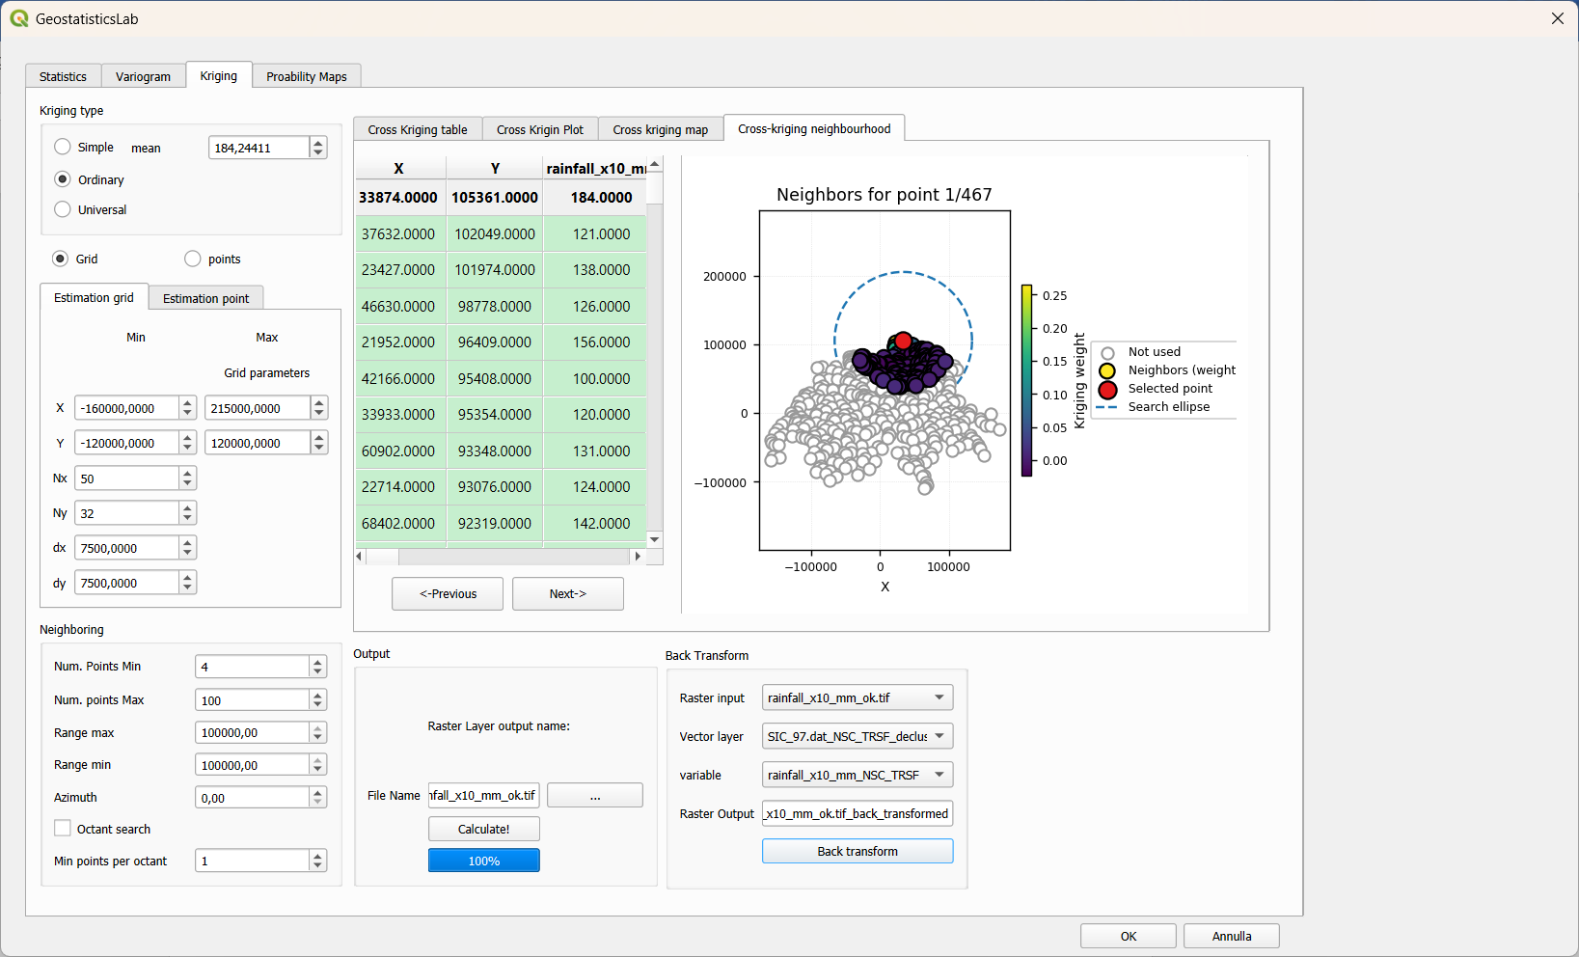
Figure 5.7 – Back Transform group: converting a raster estimated in normal space back to the original variable's space.
Note: The back-transform requires the transformation table layer to have been generated exactly by the Normal Score Transform tool described in section 3.6, since the plugin relies on the column naming convention (<variable>, <variable>_NSC_TRSF) to automatically reconstruct the sorted correspondence table.

6. Probability Maps Tab
The Probability Maps tab allows computation, starting from a pair of estimate/variance rasters produced by kriging (section 5.5), of a map of the probability of exceeding (or not exceeding) a critical threshold of the variable, assuming the estimation error follows a Gaussian distribution with variance equal to the kriging variance at each pixel.
This type of output is particularly useful in environmental and risk-management applications (for example, mapping the probability that a contaminant concentration exceeds a regulatory limit, as in the case of the sic97.dat dataset related to Caesium-137 deposition).

6.1 Input parameters
- Estimated data – the estimate raster (first band of the kriging result), selected among the rasters already present in the project.
- Variance data – the corresponding kriging variance raster (second band of the same kriging result), which must have the same dimensions as the estimate raster.
- threshold value – threshold value of the variable with respect to which the probability is computed.
- Output: higher / Lower – choice of the type of probability to compute: higher returns the probability that the real value exceeds the threshold (P(Z > threshold)), Lower returns the probability of non-exceedance (P(Z ≤ threshold)).
- Output name text field – name of the new probability raster; if left empty, it is automatically proposed as <variable>_prob_<threshold>.
- Run! button – computes the probability map pixel by pixel and adds it to the QGIS project as a new raster layer.
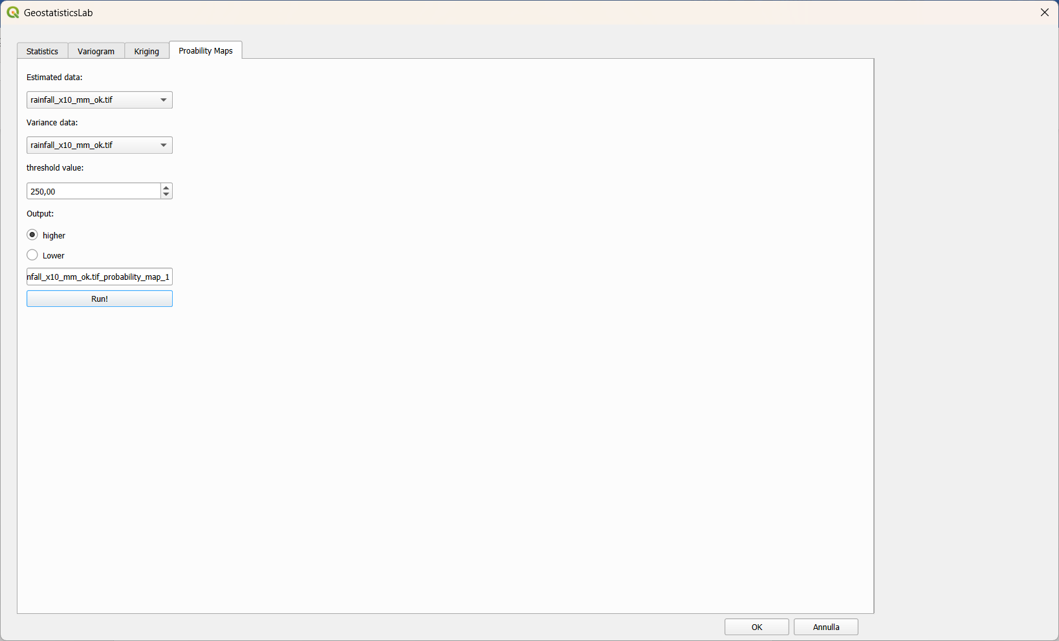
Figure 6.1 – Probability Maps tab: selection of estimate/variance rasters, threshold and direction of the probability calculation.
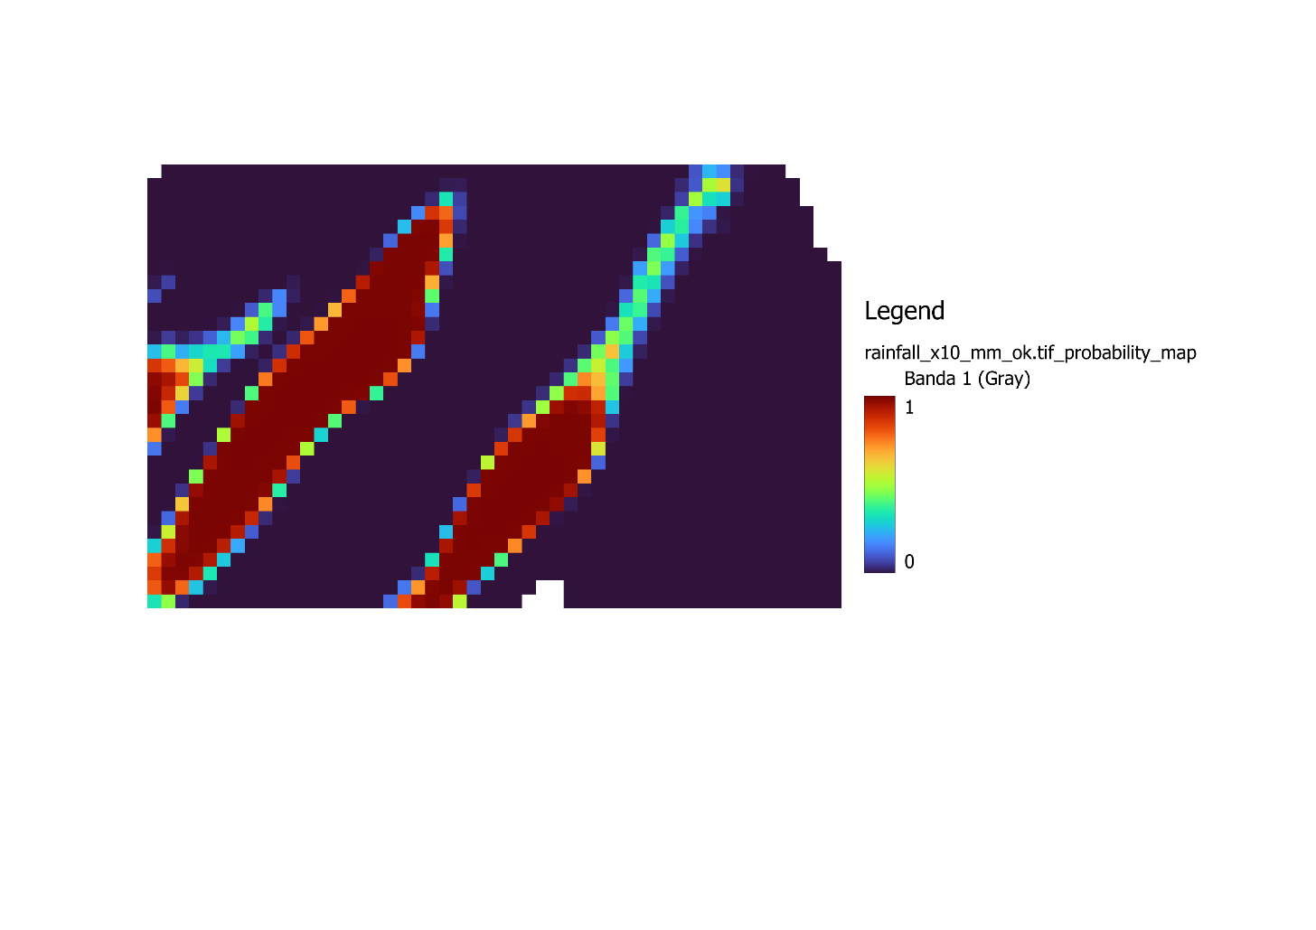
Figure 6.2 – Probability Maps result example (sic97.dat, OK, threshold 250 mm).

6.2 Notes on the computation
The computation is based on the Gaussian probability formula, applied to each valid pixel (where both the estimate and the variance are finite numbers and the variance is positive):
P(Z > threshold) = 1 − Φ((threshold − estimate) / σ) [higher option]
P(Z ≤ threshold) = Φ((threshold − estimate) / σ) [Lower option]
where Φ is the cumulative distribution function of the standard normal distribution and σ is the square root of the kriging variance at the pixel under consideration.
The resulting raster is generated entirely in memory (via the GDAL /vsimem/ driver) and is never automatically written to disk: this allows the result to be displayed immediately in QGIS without creating unnecessary temporary files; if the user wants to keep the raster permanently, it can be manually exported from QGIS (for example via Raster Layer → Save As…).
Note: Pixels where the estimate or the variance are not valid (NoData, non-finite values, or zero/negative variance) are set to the NoData value (−9999) in the resulting probability raster as well.

7. Recommended Workflow
Although the individual tabs of the plugin can be used independently, the typical workflow for a complete geostatistical analysis, applicable to both the sic97.dat and walker_lake_samples_.dat datasets, is as follows:
- Load the .dat file as a delimited text layer in QGIS (section 2.2).
- In the Statistics tab, select the layer and the variable of interest and press Run Analysis to review descriptive statistics and the histogram.
- Inspect the Data Declustering sub-tab if the samples are not uniformly distributed in space, generating a layer with declustering weights.
- If needed (e.g. for Simple Kriging or for strongly skewed data), apply the Normal Score Transform and verify its effect via the Q-Q plot sub-tab.
- In the Variogram tab, compute the variogram map (Variogram Map sub-tab) to identify the anisotropy direction, then compute the directional experimental variogram setting the identified azimuth.
- Build the theoretical model manually, or via Autofit, checking the Fit Error (SSE) and the visual appearance of the curve overlaid on the experimental data.
- In the Kriging tab, set the desired kriging type, the search neighborhood geometry (ideally consistent with the variogram model ranges) and the estimation grid parameters.
- Run Cross-Validation to validate the model before proceeding to the final estimation, examining the table, the scatter plot and the error map.
- Once satisfied with the model, press Calculate! to produce the estimate and variance rasters.
- If the estimation was performed on a Normal Score-transformed variable, apply Back Transform to bring the results back to the original variable's space.
- Finally, use the Probability Maps tab to derive exceedance/non-exceedance probability maps for thresholds of interest, starting from the estimate and variance rasters obtained.
Tip: For the sic97.dat dataset, this workflow is particularly suited to producing a probability map of exceeding rainfall threshold; for walker_lake_samples_.dat it is useful for comparing the behaviour of Ordinary and Universal Kriging on the V variable, validated through cross-validation.

8. Appendix: Interface Controls Summary
The following table summarizes, for each tab, the main interface controls described in this guide, as a quick reference.

8.1 Statistics Tab
Control | Function
Point layer / Field | Selects the layer and the variable to analyze
Run Analysis | Computes descriptive statistics and draws the histogram
Show cumulative histogram | Overlays the cumulative frequency curve
Transformed variable / Calculate (Q-Q plot) | Compares normality of the original variable vs its NS transform
Cell Size, min/max/steps / Decluster | Computes declustering weights and the diagnostic curve
New vector layer / Transform | Applies the Normal Score Transform

8.2 Variogram Tab
Control | Function
fixed lag / adaptive_lag | Lag spacing mode (manual or automatic)
MaxDistance, num_lags, lag | Distance parameters of the experimental variogram
azimuth, Number of directions | Directions analyzed and corresponding angular tolerance
Bandwidth | Maximum lateral width of the directional sector
Calculate (Variogram) | Computes the multi-directional experimental variogram
add/remove structure | Manages the theoretical model structures
Auto Fit | Automatic search for the optimal theoretical model
Export variogram model | Exports the model as a GSLIB text file
Calculate (Variogram Map) | Computes the 2D polar variogram map
Varigram Model (3D) | Overlays the theoretical model onto the 3D surface

8.3 Kriging Tab
Control | Function
Simple / Ordinary / Universal | Selects the kriging type
Num. Points Min/Max, Range max/min, Azimuth | Search ellipse neighborhood geometry
Octant search | Octant-based neighbor search
Grid / points | Estimation on a regular grid or on a point layer
Calculate! | Starts the kriging computation and produces the output raster
Calculate (Cross kriging) | Starts the leave-one-out cross-validation
<-Previous / Next-> | Navigates the cross-validation results point by point
Back transform | Brings a raster from normal space back to original space

8.4 Probability Maps Tab
Control | Function
Estimated data / Variance data | Estimate and variance rasters used as input
threshold value | Threshold used in the probability calculation
higher / Lower | Direction of the calculation (exceedance / non-exceedance)
Run! | Computes and adds the probability map to the project

8.5 References on the example datasets
- sic97.dat – Dubois, G. (ed.), “Spatial Interpolation Comparison 1997: Dataset description”; a Caesium-137 deposition dataset used as a benchmark for spatial interpolation methods.
- walker_lake_samples_.dat – Isaaks, E. H. & Srivastava, R. M., “An Introduction to Applied Geostatistics”, Oxford University Press, 1989; a teaching dataset sampled from the original Walker Lake dataset.

