GeostatisticsLab
A geostatistics plugin for QGIS
User Guide
Stefano Bonduà
stefano.bondua@unibo.it

DICAM – University of Bologna
Document version: 2.0

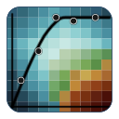

Table of Contents
1. Introduction 4
1.1 Who this guide is for 4
1.2 Plugin structure 4
1.3 What is new in version 2.0 of the guide 4
1.4 Example datasets used in this guide 5
1.5 Requirements 5
2. Installation and Startup 6
2.1 Plugin installation 6
2.2 Loading the example data 6
2.3 Opening the plugin window 6
2.4 Files written by the plugin 7
3. Statistics Tab 8
3.1 Layer and variable selection 8
3.2 Statistical results and histogram 8
3.3 Histogram sub-tab 9
3.4 Q-Q plot sub-tab 9
3.5 Data Declustering sub-tab 10
3.6 Normal Score Transform 12
3.7 Exporting the plots 12
4. Variogram Tab 13
4.1 Variogram sub-tab – computation parameters 13
4.2 Theoretical variogram modeling 15
4.3 Automatic fitting (Autofit) 15
4.4 Settings and advanced options of Autofit 16
4.5 AutoVar 17
4.6 Exporting the variogram and the model 19
4.7 Variogram Map sub-tab 19
4.8 3D Variogram sub-tab 20
5. Kriging Tab 22
5.1 Kriging type 22
5.2 Search neighborhood geometry (Neighboring) 22
5.3 Estimation on a regular grid (Estimation grid) 22
5.4 Estimation on a point layer (Estimation point) 23
5.5 Output and starting the estimation 24
5.6 Saving and loading the kriging parameters 25
5.7 Cross-Validation 25
5.8 Cross Kriging Plot 26
5.9 Cross kriging map 27
5.10 Cross-kriging neighbourhood 28
5.11 Neighboring Optimization 29
5.12 Back Transform 30
6. Probability Maps Tab 32
6.1 Input parameters 32
6.2 Notes on the computation 33
7. Benchmark Tab 35
7.1 Variogram benchmark 35
7.2 Kriging benchmark 37
7.3 Optimisation benchmark 37
8. Settings Tab 39
8.1 How it works 39
8.2 Properties that can be customised 39
8.3 Buttons 40
8.4 Where the settings are stored 40
9. Recommended Workflow 41
10. Appendix: Interface Controls Summary 42
10.1 Statistics Tab 42
10.2 Variogram Tab 42
10.3 Kriging Tab 43
10.4 Probability Maps Tab 43
10.5 Benchmark and Settings Tabs 44
10.6 References on the example datasets 44

1. Introduction
GeostatisticsLab is a QGIS plugin developed at DICAM – University of Bologna, bringing together a complete geostatistical workflow in a single interface: from exploratory data analysis to probability mapping, passing through variography, automatic model fitting, kriging, cross-validation and the optimisation of the search neighbourhood.
The plugin was built starting from the skeleton generated by QGIS Plugin Builder and is written entirely in Python, using the QGIS native libraries (PyQt, QgsVectorLayer, QgsRasterLayer) together with NumPy, SciPy and Matplotlib for numerical computation and graphical visualisation.

1.1 Who this guide is for
This guide is intended for users who are already familiar with the basic concepts of geostatistics (variogram, kriging, normal-score transformation) and with the use of QGIS as a GIS environment. No programming experience is required: all functionality is accessible through the graphical interface of the plugin.

1.2 Plugin structure
The plugin window is organised into six main tabs. The first four follow the stages of the geostatistical workflow; the last two are service tabs:
- Statistics – descriptive statistics, histogram, Q-Q plot, declustering and Normal Score Transform.
- Variogram – experimental variogram, manual and automatic modelling of the theoretical variogram (Autofit and AutoVar), 2D and 3D variogram map.
- Kriging – Simple, Ordinary and Universal Kriging on a regular grid or at the points of a layer, saving and loading of the kriging parameters, leave-one-out cross-validation, optimisation of the search neighbourhood and back-transform.
- Probability Maps – maps of the probability of exceeding (or not exceeding) a threshold, from an estimate and its variance.
- Benchmark – measurement of the computing time of the most demanding routines of the plugin.
- Settings – customisation of the appearance of all the plots (fonts, ticks, grid, lines, colours, axis limits).

Each tab is described in detail in the following chapters, including the meaning of every parameter and of the resulting outputs.

1.3 What is new in version 2.0 of the guide
This version of the guide describes the current version of the plugin. With respect to version 1.0 the following functions have been added or changed:
- AutoVar (section 4.5): automatic calculation of the experimental variograms in the two principal directions and fitting of a spherical model, a Python implementation of the AutoVar algorithm.
- Advanced options of Autofit (section 4.4): weights of the least-squares objective function (number of pairs, inverse distance) and constraint on the total sill.
- Auto lag spacing and further display options of the variogram (box plots of the distances and of the semivariances), export of the experimental variogram to CSV, indication of the computing times (section 4.1).
- Kriging parameter files (section 5.6): the parameters of the Kriging tab and the variogram model can be saved and loaded.
- Neighbouring Optimization (section 5.11): search of the best neighbourhood parameters by Latin Hypercube sampling and leave-one-out cross-validation.
- Cross-validation: new columns in the results table (kriging variance, squared error, squared error divided by the variance), summary with the sum of squared errors, export to CSV (sections 5.7 to 5.10).
- Benchmark tab (chapter 7) and Settings tab (chapter 8).
- The type of the declustering cell size (Auto or user defined) and the export of every plot to PNG (chapter 3).

1.4 Example datasets used in this guide
To illustrate the functionality of the plugin in a concrete way, this guide refers to two reference geostatistical datasets, widely used in the literature and typically distributed in GSLIB-style text files:
- sic97.dat – the dataset of the “Spatial Interpolation Comparison 1997” (SIC97) exercise: daily rainfall measured at 467 monitoring stations in Switzerland (values in tenths of a millimetre). It is a classic dataset to test interpolation and kriging methods.
- walker_lake_samples_.dat – a sampled subset of the well-known Walker Lake dataset (Isaaks & Srivastava), reporting two variables (typically denoted V and U) at a set of locations in the Walker Lake area of Nevada. It is one of the most widely used teaching datasets in geostatistics for demonstrating variography, kriging and cross-validation.

Note: The .dat files are delimited text files (columns X, Y, value) and can be loaded into QGIS as a Delimited Text Layer, then used directly in the tools of the plugin described in this guide.

1.5 Requirements
- QGIS 3.x with Python 3 support.
- Python libraries: NumPy, SciPy, Matplotlib (required for variography, autofit, normality tests and plots). They are included in the standard QGIS installation.
- GDAL with Python bindings (osgeo.gdal), already included in most QGIS installations, required for kriging rasters, back-transform and probability maps.
- The file autovar_core.py in the plugin folder, required by the AutoVar function (section 4.5). It is part of the plugin distribution.

2. Installation and Startup

2.1 Plugin installation
- Copy the GeostatisticsLab plugin folder into the QGIS plugins directory (typically ~/.local/share/QGIS/QGIS3/profiles/default/python/plugins/ on Linux/Mac, or %APPDATA%\QGIS\QGIS3\profiles\default\python\plugins\ on Windows).
- Start QGIS and open the Plugins → Manage and Install Plugins menu.
- In the Installed tab, locate GeostatisticsLab and make sure its checkbox is enabled.
- A new plugin icon will appear in the toolbar (or in the Plugins menu), from which the main window of the plugin can be opened.

Note: When the plugin is updated, replace the whole plugin folder (including autovar_core.py) and restart QGIS, or reload the plugin with the Plugin Reloader.

2.2 Loading the example data
Before using the plugin, a point layer containing the data to be analysed must be loaded into QGIS. For the example datasets sic97.dat and walker_lake_samples_.dat, proceed as follows:
- From the Layer menu, choose Add Layer → Add Delimited Text Layer…
- Select the .dat file, setting the correct delimiter (space or comma, depending on the file).
- Specify which columns represent the X and Y coordinates (typically the first two columns of the file).
- Confirm with OK: the point layer appears in the Layers panel and can be used by all the tools of the plugin.

Tip: For sic97.dat the variable of interest is the rainfall value; for walker_lake_samples_.dat the typical variables are V (primary value) and U (correlated secondary variable).

2.3 Opening the plugin window
Once the layer is loaded, click the GeostatisticsLab icon in the QGIS toolbar. The main window of the plugin opens, organised in the tabs described in the introduction.
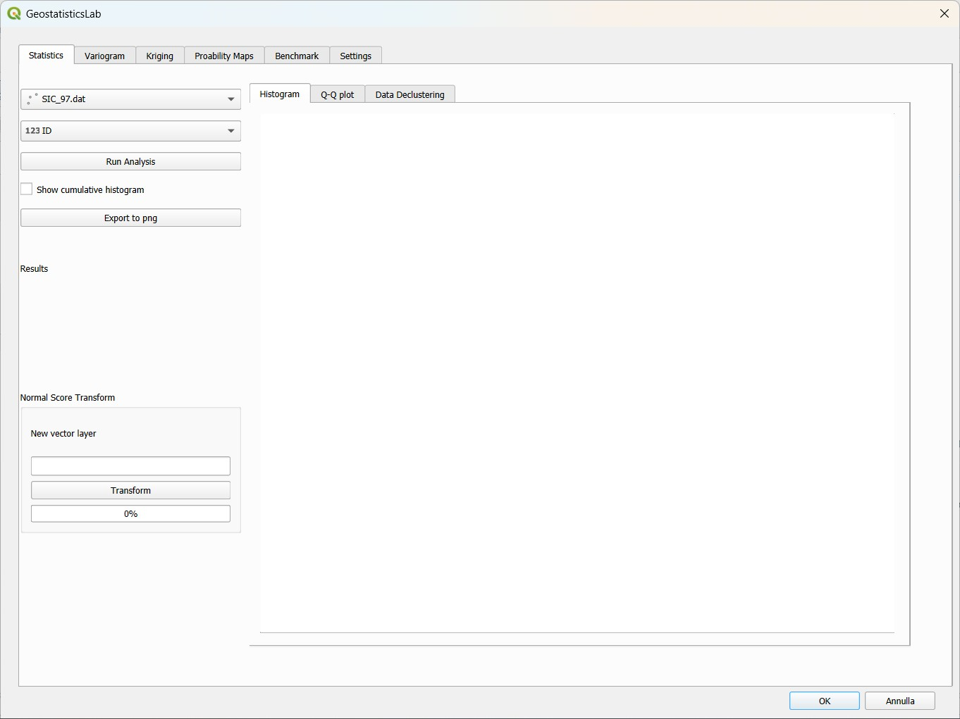
Figure 2.1 – Main plugin window, Statistics tab on start-up.

2.4 Files written by the plugin
The plugin never modifies the original layers. The files that it can write on disk are the following; all of them are produced only on explicit request of the user, except the settings file of the Settings tab, which is updated automatically:
- rasters of the kriging estimate and variance (GeoTIFF), section 5.5;
- kriging parameter files (.kriging_par), section 5.6;
- variogram model files in GSLIB format and CSV files of the experimental variogram, section 4.6;
- PNG images of the plots and CSV tables of the cross-validation and of the benchmarks;
- the three text files written by AutoVar, section 4.5;
- the file plot_settings.json with the appearance of the plots, section 8.

3. Statistics Tab
The Statistics tab is the starting point of the analysis: here the layer and the variable of interest are selected, basic descriptive statistics are computed, the shape of the distribution is examined through a histogram and a Q-Q plot, the effect of spatial clustering of the samples is evaluated via declustering, and the Normal Score Transform can optionally be applied.

3.1 Layer and variable selection
The top-left panel of the tab contains:
- Point layer (map layer combo box) – lists all the point layers of the QGIS project; select here sic97.dat or walker_lake_samples_.dat after loading it. The layer and the field selected here are used by all the other tabs.
- Field (field combo box) – updated according to the selected layer; it allows to choose the numeric column to analyse.
- Run Analysis – computes the descriptive statistics and draws the histogram.
- Show cumulative histogram (checkbox) – overlays a cumulative frequency curve on the histogram, on a secondary Y axis.

When the selected layer is changed, the plugin automatically recomputes, in the background, the default values of the variogram parameters, of the kriging grid and of the declustering parameters, based on the spatial extent and on the number of points of the layer.

3.2 Statistical results and histogram
After pressing Run Analysis, the Results panel shows the number of data, the mean, the median, the minimum, the maximum and the standard deviation of the selected variable. At the same time the frequency histogram (in percentage, 15 classes) is drawn in the Histogram sub-tab.
The computed mean is automatically proposed as the “mean” parameter of Simple Kriging in the Kriging tab, so the user does not need to copy it manually.
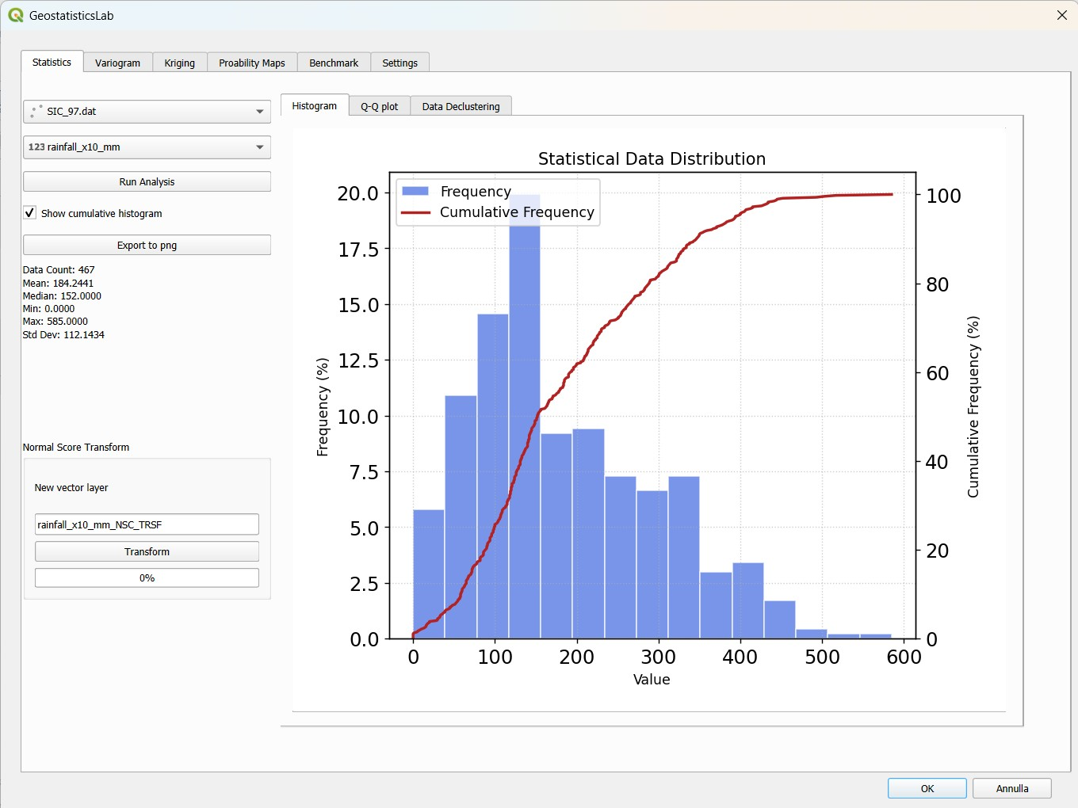
Figure 3.1 – Statistics tab: layer and variable selection, results, histogram and Normal Score Transform group.

3.3 Histogram sub-tab
The central panel of the Statistics tab contains three sub-tabs: Histogram, Q-Q plot and Data Declustering. The Histogram sub-tab shows the bar chart of the frequency distribution; if Show cumulative histogram is enabled, the cumulative frequency curve is added in red, useful to read the percentiles of the distribution. The Export to png button saves the plot as an image (section 3.7).

3.4 Q-Q plot sub-tab
This sub-tab compares the normality of the original variable with that of its Normal Score transform (section 3.6), placing two quantile-quantile plots side by side. To run the comparison:
- Make sure the original layer and field are selected in the main panel at the top-left of the Statistics tab.
- In the Transformed variable drop-down menu, choose the field transformed with the Normal Score (created previously with the Transform button, section 3.6).
- Press Calculate: two Q-Q plots are drawn (original variable on the left, transformed variable on the right), each with the theoretical normal reference line.

Below the plots, a text panel reports, for both variables, the results of two normality tests:
- Shapiro–Wilk test (W statistic and p-value): a p-value greater than 0.05 indicates a distribution compatible with normality.
- Anderson–Darling test (A² statistic and critical value at the 5% level): if the statistic exceeds the critical value, the distribution deviates significantly from normality.

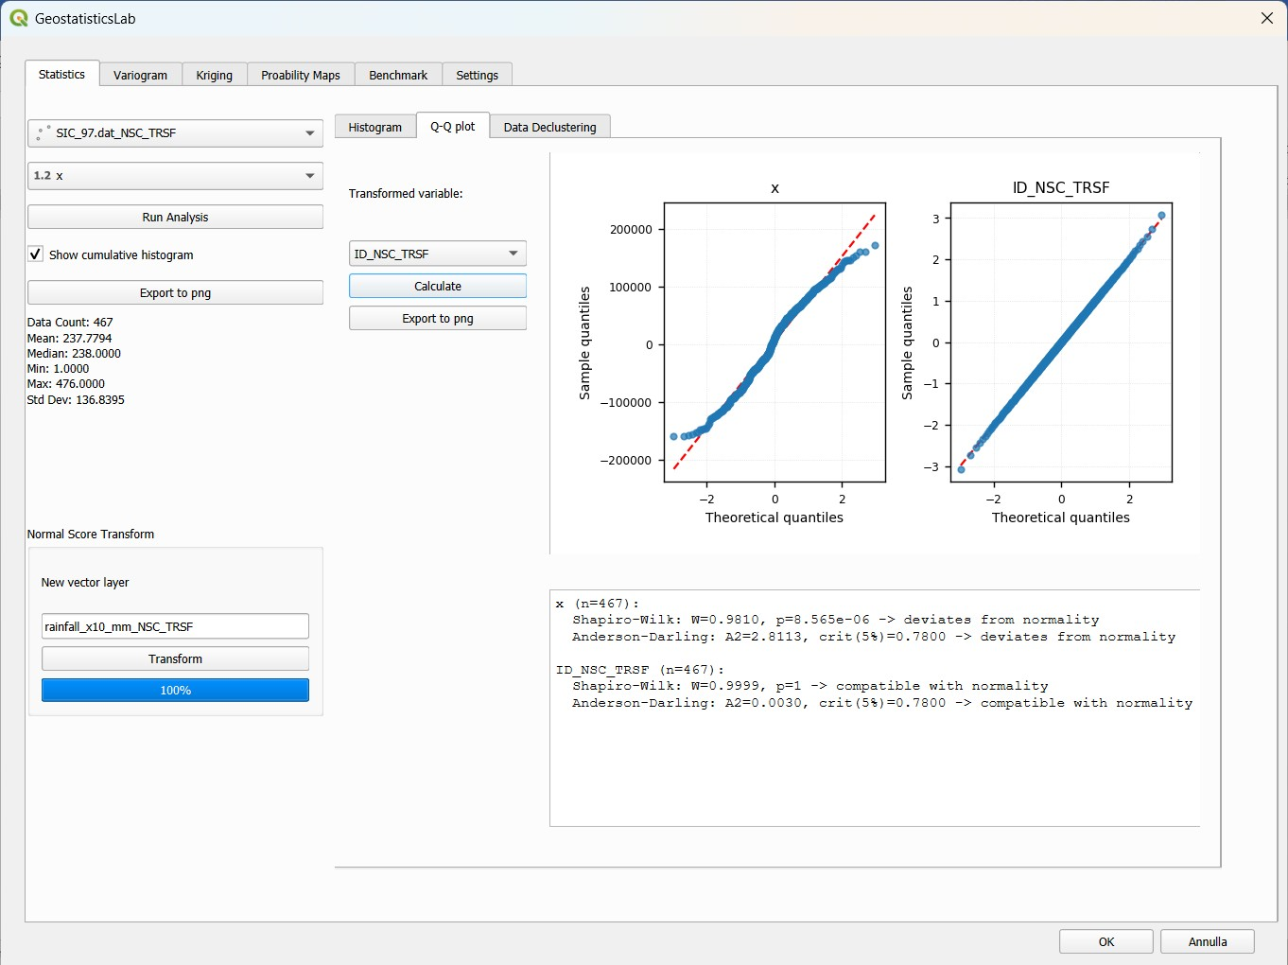
Figure 3.2 – Q-Q plot sub-tab: normality of the original variable and of its Normal Score transform.
Note: At least 8 valid values per variable are required to compute the normality tests; with fewer data the result would not be reliable.

3.5 Data Declustering sub-tab
When the samples are not uniformly distributed in space (for example with densely sampled zones and sparsely sampled ones), the arithmetic mean can be biased. The cell declustering tool (standard GSLIB method) corrects this effect by assigning to each datum a weight inversely proportional to the local density of points. For each cell size the grid of square cells is shifted by several random offsets and the weights are averaged, so that the result does not depend on the arbitrary origin of the grid; the weights are normalised so that their mean is 1.
The parameters of the sub-tab are:
- Auto / user defined (radio buttons) – in Auto mode the cell size is selected by the plugin as the minimum of the diagnostic curve and is shown in the Cell Size field, which cannot be edited; in user defined mode the user sets Cell Size after inspecting the curve.
- Cell Size – the cell size used for the final computation of the declustering weights.
- cell_size_min / cell_size_max / num. steps – range and number of steps used to build the diagnostic curve “weighted mean vs. cell size”, which helps to select the cell size.

After pressing Decluster, the plugin:
- computes the diagnostic curve (declustered mean as a function of the cell size) and draws it, together with the naive mean of the data shown as a dashed red line;
- determines the cell size (Auto mode) or reads the one set by the user, and computes the final declustering weights;
- creates a NEW in-memory layer (named <layer_name>_decluster) containing all the original columns plus a new column decluster_weight with the weight of each point.

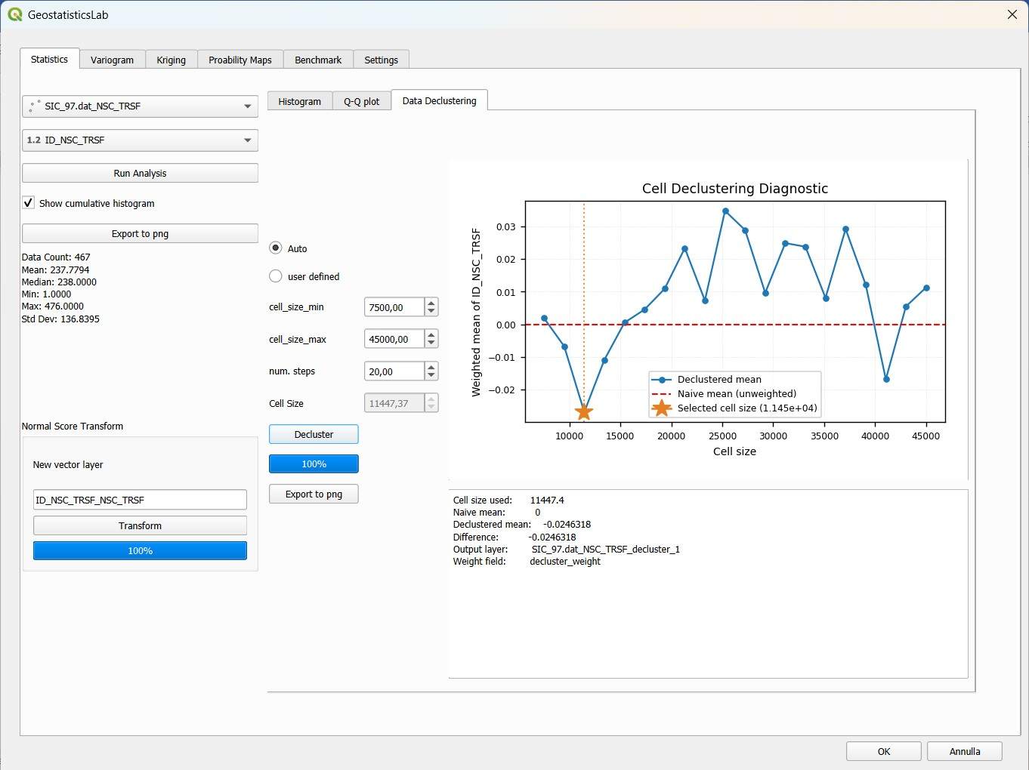
Figure 3.3 – Data Declustering sub-tab: cell parameters and diagnostic curve (declustered mean vs. cell size).
Tip: The plugin always creates a new in-memory layer for declustering and never modifies the original layer: this makes it easy to compare the results with and without declustering, and also works with read-only data sources (for example CSV files).
Note: The weights can be used in the computation of the experimental variogram by enabling the use_decl.weights checkbox of the Variogram tab (section 4.1), provided that the new <layer_name>_decluster layer is the active layer.
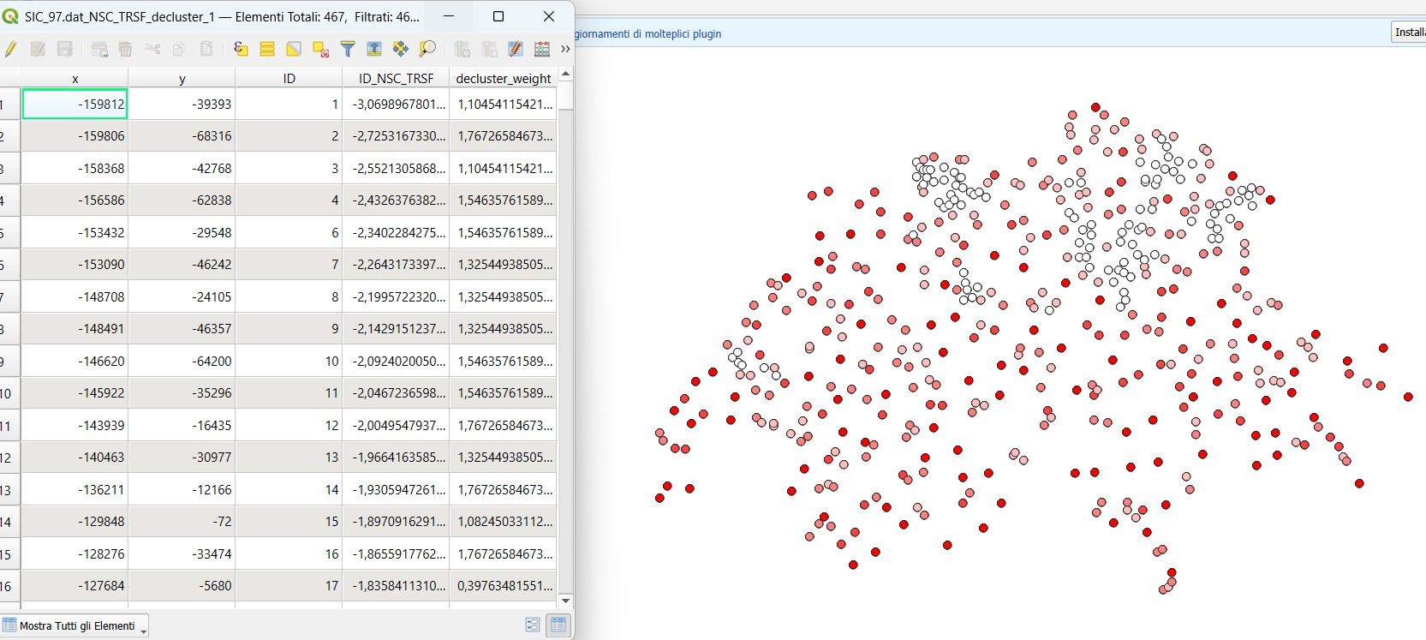
Figure 3.4 – Declustering results: the new layer and the weights column.

3.6 Normal Score Transform
The Normal Score Transform group, in the lower-left part of the tab, applies the standard Gaussian transformation to the selected variable: each value is converted into the corresponding quantile of a standard normal distribution. It is a common practice in geostatistics to make methods that assume Gaussian data applicable.
To run the transformation:
- Select the layer and the field to be transformed in the main panel.
- In the New vector layer field, optionally write the name of the new transformed column; if left empty, the name <field>_NSC_TRSF is proposed.
- Press Transform (a progress bar shows the advancement).

The result is a new in-memory point layer whose rows are sorted in ascending order of the original value: this choice is not arbitrary, since the layer itself is the GSLIB-style transformation table (sorted original value and corresponding normal score), used later by the back-transform tool of the Kriging tab (section 5.12).
Note: The transformation always generates a new layer: the original layer and its table remain untouched, and it is easy to return to the non-transformed variable at any time.

3.7 Exporting the plots
Every plot of the Statistics tab has an Export to png button (histogram, Q-Q plot and declustering curve). A save dialog proposes a file name with a timestamp, the name of the layer and of the field and the type of plot (for example 2026_10_19_10_30_00_sic97_value_histogram.png) and asks the resolution of the image (from 72 to 1200 DPI). The last used folder is remembered between sessions. The same export function is available in all the other tabs. The appearance of the plots can be customised in the Settings tab (chapter 8) and is kept in the exported images.

4. Variogram Tab
The Variogram tab is dedicated to the computation of the experimental variogram, to the construction and fitting of the theoretical model (possibly with several nested structures, manually, with Autofit or with AutoVar), to the 2D and 3D variogram map and to the export of the results. It is organised in three sub-tabs: Variogram, Variogram Map and 3D Variogram.

4.1 Variogram sub-tab – computation parameters
The left panel collects the parameters of the computation of the directional experimental variogram:
- fixed lag / auto lag spacing – two alternative modes for the lag spacing. With fixed lag, the user sets the lag and the number of lags. With auto lag spacing the plugin computes the lag with the algorithm of the AutoVar program: for each sample the distances to the nearest neighbours are averaged, and the lag is the mean of these local spacings over the whole dataset; lag, lag tolerance and number of lags are updated accordingly. In this mode the lag tolerance cannot be edited.
- MaxDistance – maximum distance considered; it is proposed as half of the shorter side of the extent of the layer, rounded to a round value.
- num_lags – number of distance classes. As in GSLIB and AutoVar, the centres of the classes are at h = 0, lag, 2·lag, … so that MaxDistance = (num_lags − 1) × lag.
- lag – width of each class; changing it updates lag_tolerance (lag/2) and MaxDistance.
- lag_tolerance – distance tolerance used to assign a pair to a class; it is lag/2 by default and can be edited in fixed lag mode.
- azimuth – first direction (in geographical degrees, 0° = North, clockwise) from which the equally spaced directions are generated.
- Number of directions – number of directions computed, equally spaced over 180° (the variogram is symmetric). It updates angular_tolerance.
- angular_tolerance – half-aperture of the angular sector of each direction; by default 90° / Number of directions, but it can be edited to widen or narrow the sectors.
- bandwidth – maximum lateral width (perpendicular to the direction) of the sector; if set to 0, the filter is disabled and only the angular tolerance applies.
- use_decl.weights – if enabled and the layer has a decluster_weight column (section 3.5), each pair is weighted by the product of the declustering weights of its two points.
- Show num pairs – shows on the plot the number of pairs of each point (useful to judge the reliability of each class).
- Show h box plot – draws, for each class, a horizontal box plot of the distances of the pairs, to check how the pairs are distributed inside the class.
- Show var box plot – draws, for each class, the box plot of the semivariance values in addition to their mean.
- show theoretical model – overlays the curve of the theoretical model defined in the structures table (section 4.2).
- Normalize by variance – divides the semivariances by the sample variance, so that the sill tends to 1; useful to compare variables or datasets on different scales.
- Effective distance – each point is plotted at the mean distance of the pairs of the class (AutoVar style) instead of at the centre of the class.

When Calculate is pressed, the plugin computes the experimental variogram of all the directions, draws the multi-directional plot, enables Autofit and the structures table, and shows in the Computing time label the time spent for the calculation. The result can be exported with the Export variogram to png button and with the Export Variogram to csv button (section 4.6).
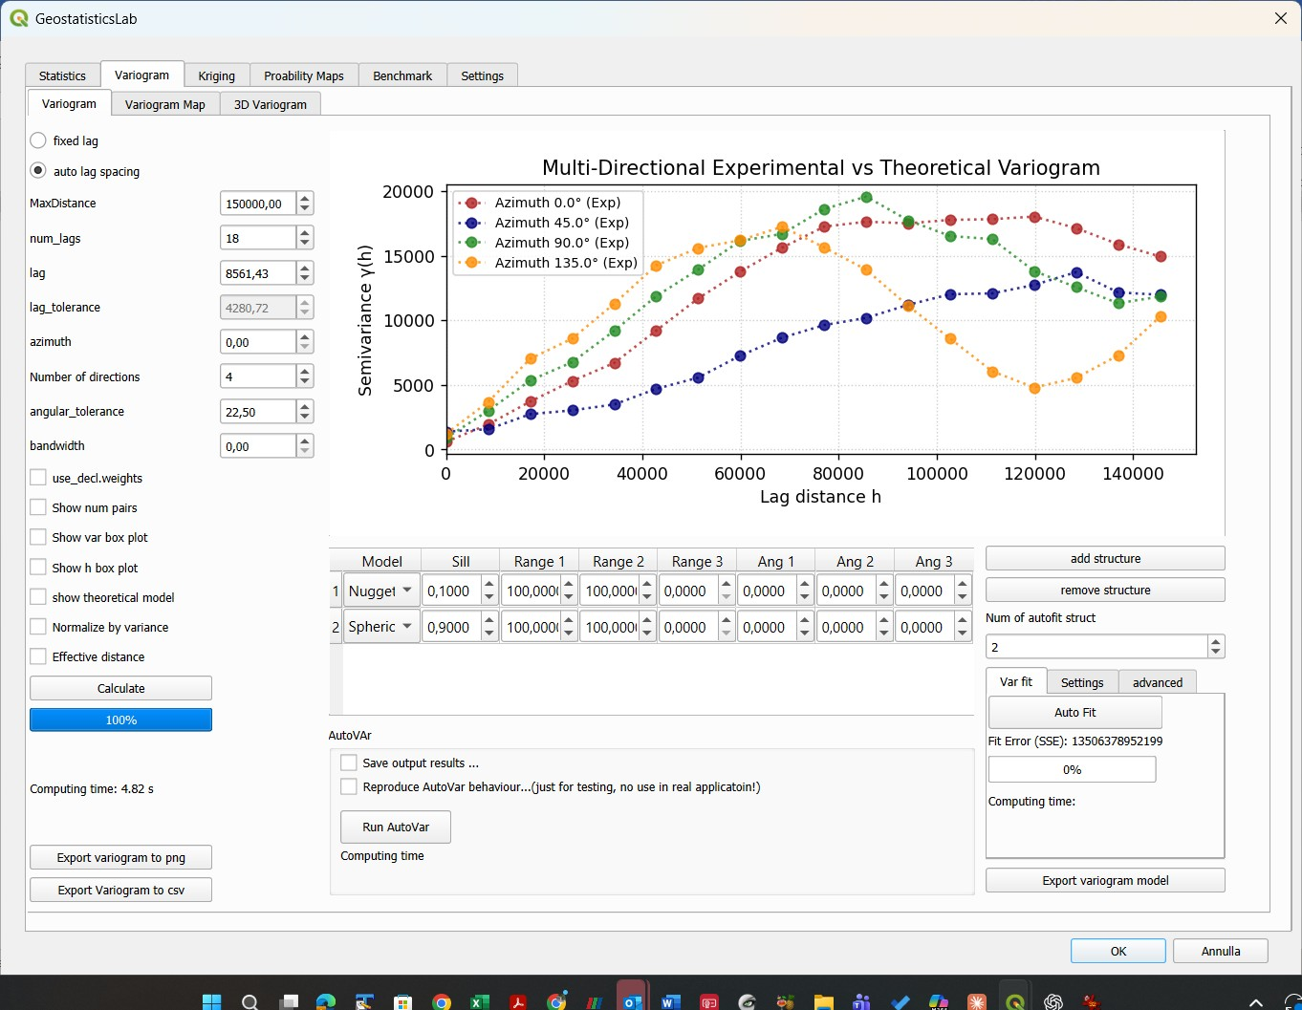
Figure 4.1 – Variogram sub-tab: computation parameters, multi-directional experimental plot and model structures table.
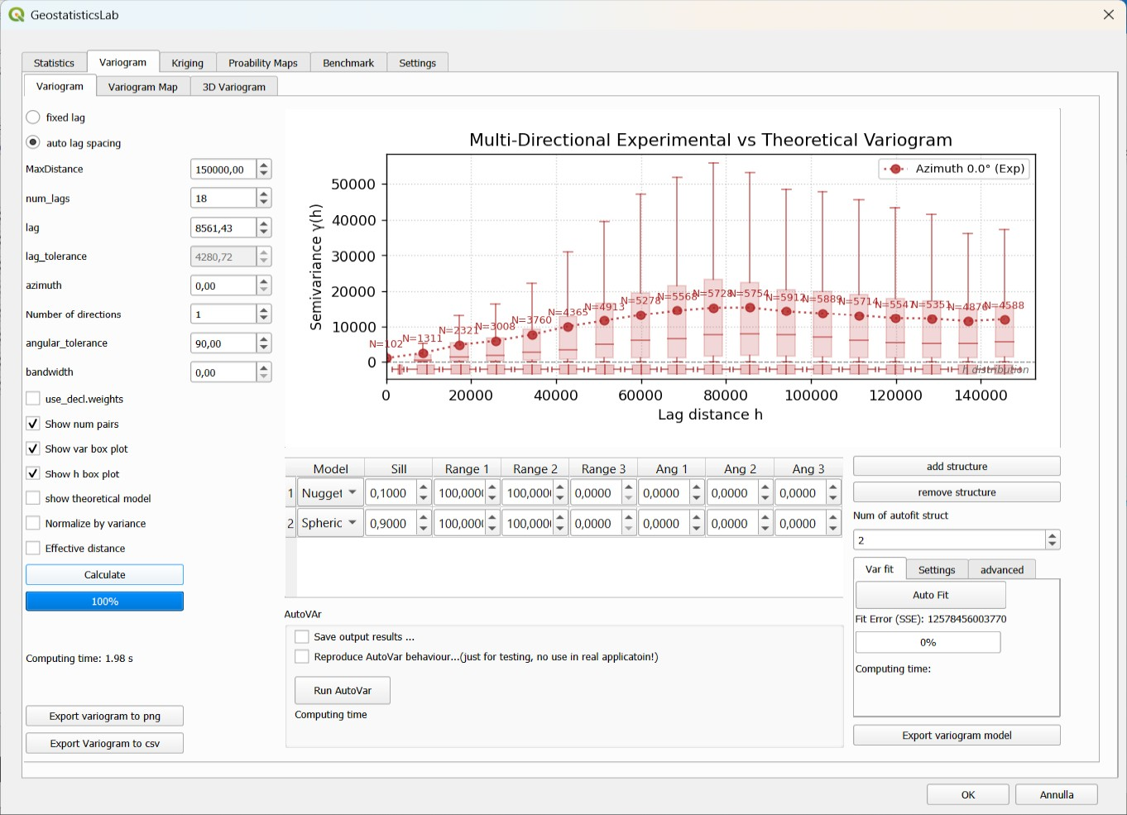
Figure 4.2 – Display options of the experimental variogram: number of pairs and box plots.

4.2 Theoretical variogram modeling
Below the plot is the table of the nested structures of the theoretical model (columns Model, Sill, Range 1, Range 2, Range 3, Ang 1, Ang 2, Ang 3). The model is the sum of one or more basic structures (Nugget, Spherical, Exponential, Gaussian, Linear, Cubic), each with its own sill, range (possibly anisotropic, with Range 1/2/3 along the principal directions) and rotation angles of the anisotropy ellipsoid. As the plugin works in a two-dimensional coordinate system, only Range 1, Range 2 and Ang 1 are used.
To edit the model manually:
- add structure – adds a row (a spherical structure by default) to the table.
- remove structure – removes the selected structure (at least one structure is always required).
- Every cell of the table can be edited directly (a combo box for the type, spin boxes for the other parameters); each change immediately updates the plot and the fit error, without recomputing the experimental variogram.

4.3 Automatic fitting (Autofit)
The Var fit sub-tab automates the search of the theoretical model by numerical optimisation (scipy.optimize), with a multi-start strategy on the azimuth to avoid local minima:
- Num of autofit struct – number of spatial structures of the model to be searched (in addition to the nugget, if enabled).
- Auto Fit – starts the search: several combinations of models (among those enabled in the Settings sub-tab, section 4.4) and several starting azimuths are tried, and the combination with the lowest weighted sum of squared errors (SSE) is kept.
- Fit error label – weighted squared error between the model and the experimental data, updated at every change of the table.
- Progress bar and Computing time – advancement of the search and time elapsed at the end.

At the end of a successful search the structures table is replaced with the best combination found, and the show theoretical model checkbox is enabled to display the result on the plot.
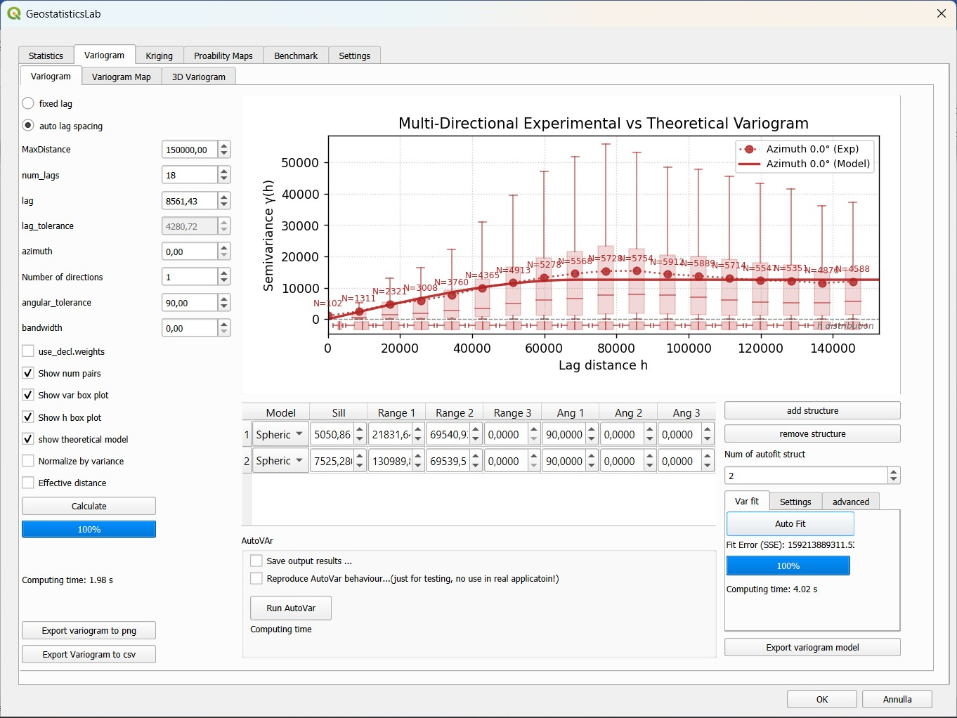
Figure 4.3 – Result of Autofit: fitted model, structures table and fit error.

4.4 Settings and advanced options of Autofit
The Settings sub-tab contains the table of the available models (Nugget, Spherical, Exponential, Gaussian, Linear, Cubic), each with a “Use in autofit” checkbox. A model that is deselected is excluded from the combinations tested by Autofit (for example, to exclude the Linear model when it is not physically plausible).
New in version 2.0: the advanced sub-tab controls how the least-squares objective function is built and constrains the sill:
- Weights with N pairs (on by default) – every experimental point is weighted by the number of pairs of its class; if off, all the points have the same weight.
- use inv. dist weights and Exponent a (1/d^a) – the weight is also divided by d^a, where d is the distance at which the point is plotted, so that the short-distance classes count more. With a = 1 the emphasis is mild; a = 2 gives the usual N/h² weights; a = 0 means no distance weighting. The default exponent is 1.
- Force sill=variance or 1.0 (on by default) – the sum of the nugget and of the sills of the structures cannot exceed the sample variance (or 1.0 if the variogram is normalised). This inequality constraint is handled with a constrained optimiser (SLSQP) instead of L-BFGS-B.

Tip: For a first fit leave the default options. Use the distance weights when the behaviour near the origin is the most important, for example if the kriging uses a small neighbourhood.

4.5 AutoVar
New in version 2.0: the AutoVar group runs a Python implementation of the AutoVar algorithm for the automatic calculation and modelling of the variogram.
AutoVar works on the standardised variable and does not need any parameter: it determines the two principal directions of anisotropy (major and minor axis) and the lag size of each direction, computes the experimental variogram in the two directions as a pseudo-correlogram, 1 − ρ(h), and fits a model of nested spherical structures, with nugget 0 and total sill 1, by a random-search optimisation. It requires at least 30 valid data and takes of the order of one minute on the larger datasets: a progress window shows the objective function and can be used to cancel the run.
- Run AutoVar – runs the algorithm on the selected layer and field.
- Save output results … – if enabled, at the end of the run a folder is requested and three text files are written, with the same format of the Fortran program: autovar_<layer>_<field>.out (experimental variograms of the two directions), autovarmod_<layer>_<field>.out (points of the model curves) and varfit_<layer>_<field>.out (model in GSLIB format).
- Reproduce AutoVar behaviour … – reproduces the original Fortran program, including its known errors and the single precision of its input. It is only meant to compare the results with the Fortran program and must not be used in real applications.
- Computing time – time of the last run.

When the run is finished the plugin draws the experimental variograms of the two principal directions together with the model, shows a summary (number of data, mean, variance, azimuth of the major and minor axes, lag sizes, structures of the model and value of the objective function) and copies the model into the structures table, ready to be used for kriging. The sills of the table are multiplied by the sample variance, unless Normalize by variance is enabled: in this case the standardised sills are kept.
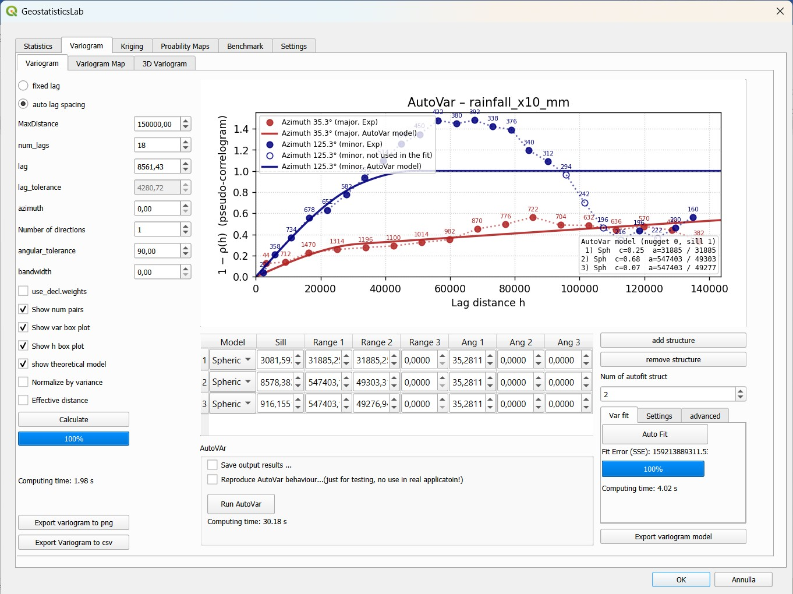
Figure 4.4 – Result of AutoVar: experimental variograms in the major and minor directions and fitted spherical model.
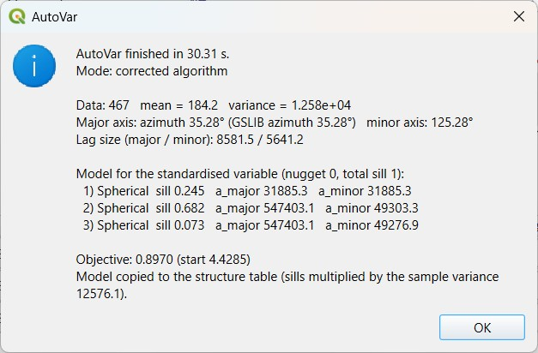
Figure 4.5 – AutoVar summary window.

4.6 Exporting the variogram and the model
The Export variogram model button saves the theoretical model defined in the structures table in a text file in GSLIB style: the first line gives the number of spatial structures and the nugget, and the following lines give the type, the sill and the range and angle parameters of each structure. The file can be reused in other GSLIB-compatible software.
The Export Variogram to csv button writes the experimental variogram currently in memory in “long” format, one row for every direction and distance class, so that it can be plotted in a spreadsheet or compared with other software. The columns are:
Column | Meaning
azimuth_deg | Direction, in degrees clockwise from North
lag_index | Index of the distance class (starting from 0)
lag_center | Nominal centre of the class (index × lag)
h | Distance at which the point is plotted (mean distance of the pairs if Effective distance was enabled)
gamma | Experimental semivariance (empty if the class has no pairs)
num_pairs | Number of pairs of the class

The delimiter is the comma and the decimal separator is the dot.

4.7 Variogram Map sub-tab
The variogram map gives an overall view of the spatial anisotropy of the phenomenon: the experimental semivariance is computed on a polar grid (distance rings × angular sectors) that covers the whole circle of 360°, even if the variogram is symmetric over 180°.
The parameters are similar to those of the Variogram sub-tab (MaxDistance, num_lags, lag, lag_tolerance, azimuth, Number of directions, angular_tolerance, bandwidth, Use declus. weights), with different default values: 10 distance classes and 18 sectors. Since the sectors cover 360°, each one spans 360° / Number of directions and the angular tolerance is 180° / Number of directions.
- Camp. princ. directions (checkbox, on by default) – identifies and draws on the map the principal directions of anisotropy, computed from the inertia tensor of the semivariance surface. The labels Major direction and Minor direction show their azimuths in degrees.
- Calculate – computes the variogram map and draws it as a coloured polar plot.
- Export plot to png – saves the plot as an image.

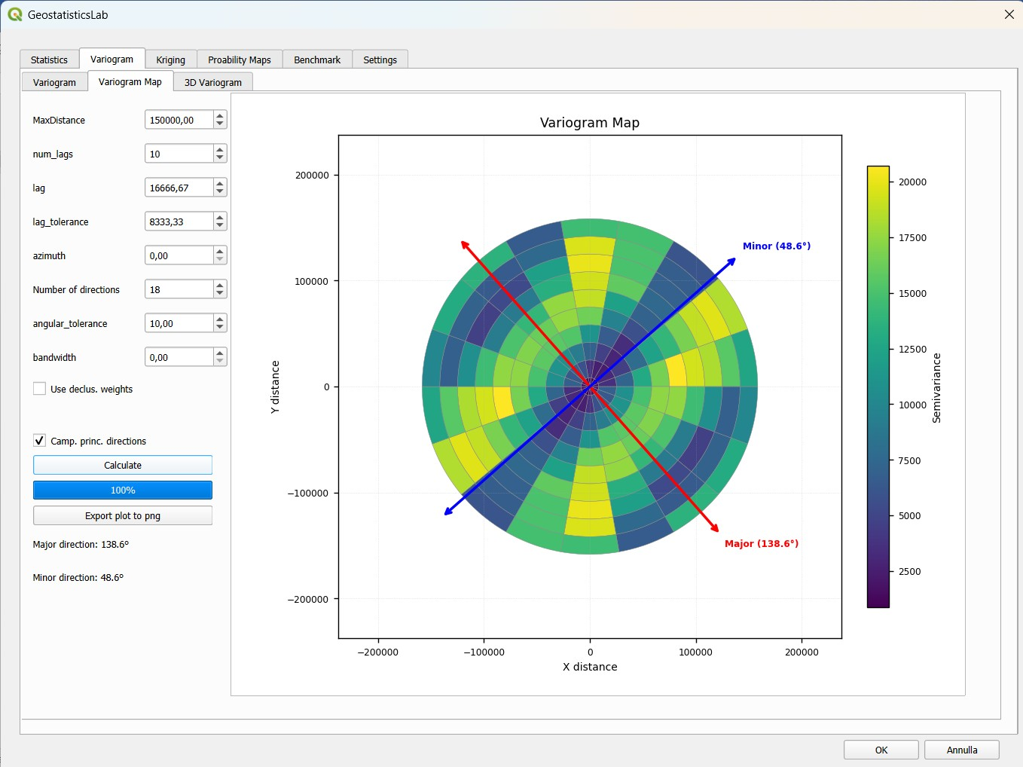
Figure 4.6 – Variogram Map sub-tab: 2D polar map of the semivariance with the principal directions of anisotropy.
Tip: The variogram map is a useful preliminary step before the directional modelling: the elongation of the semivariance surface indicates direction and intensity of the anisotropy, to be set afterwards as the azimuth of the Variogram sub-tab.

4.8 3D Variogram sub-tab
This sub-tab shows the same variogram map as a three-dimensional surface, to appreciate the behaviour of the semivariance as a function of both distance and direction.
- Variogram Model (checkbox) – overlays on the experimental surface the surface of the theoretical model currently defined, for a direct visual comparison.

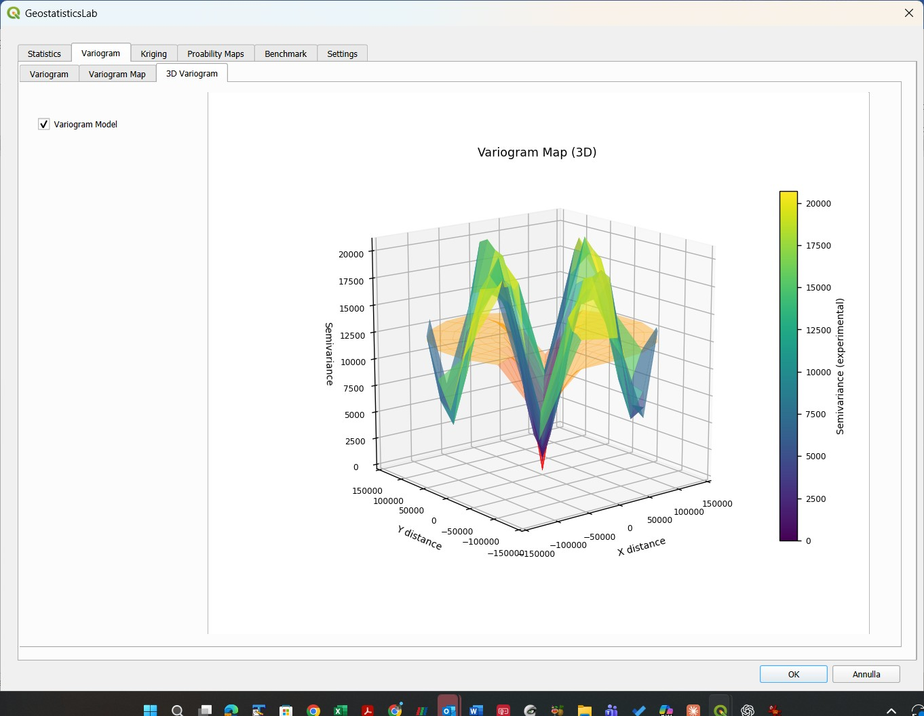
Figure 4.7 – 3D Variogram sub-tab: semivariance as a function of distance and direction.

5. Kriging Tab
The Kriging tab is the operational core of the plugin: it performs the spatial interpolation by Simple, Ordinary or Universal Kriging on a regular grid or at the points of a layer, defines the geometry of the search neighbourhood, validates the model by cross-validation, searches the best neighbourhood parameters and brings the results back to the original space after a Normal Score Transform.

5.1 Kriging type
The Kriging type group offers three variants:
- Simple (SK) – assumes that the mean of the variable is known and constant over the domain; it is entered in the mean field (proposed from the mean computed in the Statistics tab, but editable).
- Ordinary (OK) – the default; does not require the mean, which is implicitly estimated in each neighbourhood through the unbiasedness constraint on the weights.
- Universal (UK) – extends Ordinary Kriging with a linear drift in the coordinates (constraints 1, X and Y); useful when the phenomenon has a systematic trend.

5.2 Search neighborhood geometry (Neighboring)
The Neighboring group defines which data are used to estimate each node or point:
- Num. Points Min / Num. Points Max – minimum and maximum number of data in the search ellipse; if fewer data than the minimum are found, the node is not estimated.
- Range max / Range min – major and minor semi-axes of the search ellipse, proposed as half of the shorter side of the data bounding box, and editable (for example to match the ranges of the model).
- Azimuth – orientation of the search ellipse, in geographical degrees; typically the direction of maximum continuity found in the variography.
- Octant search (checkbox) – divides the search ellipse into eight octants and requires a minimum number of data in each of them (Min points per octant), for a more even distribution of the data around the node.

Tip: The parameters of this group can also be found automatically with the Neighboring Optimization (section 5.11).

5.3 Estimation on a regular grid (Estimation grid)
The Estimation grid sub-tab (selected when the Grid radio button is on, the default) defines the grid of the output:
- X Min/Max, Y Min/Max – extent of the grid, proposed from the extent of the data with a rounded margin, and editable.
- Nx, Ny – number of cells along X and Y.
- dx, dy – size of the cells along X and Y.

The six parameters are linked: changing the bounds recomputes dx and dy keeping Nx and Ny; changing Nx, Ny, dx or dy recomputes X Max and Y Max, so the grid is always consistent.
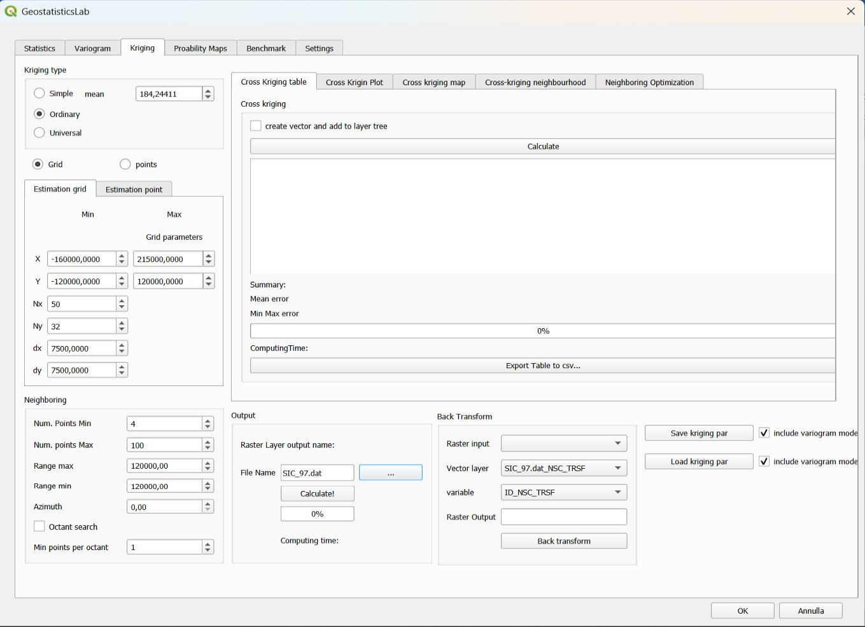
Figure 5.1 – Kriging tab: kriging type, search neighbourhood, estimation grid and output.

5.4 Estimation on a point layer (Estimation point)
Selecting the points radio button activates the Estimation point sub-tab: the variable is estimated only at the locations of an existing point layer (for example check points or wells).
- Select layer with points – layer that defines the estimation locations.
- output vector layer – name of the new in-memory point layer, which contains for each point the estimate and the kriging variance (fields <field>_estimated and <field>_est_var).

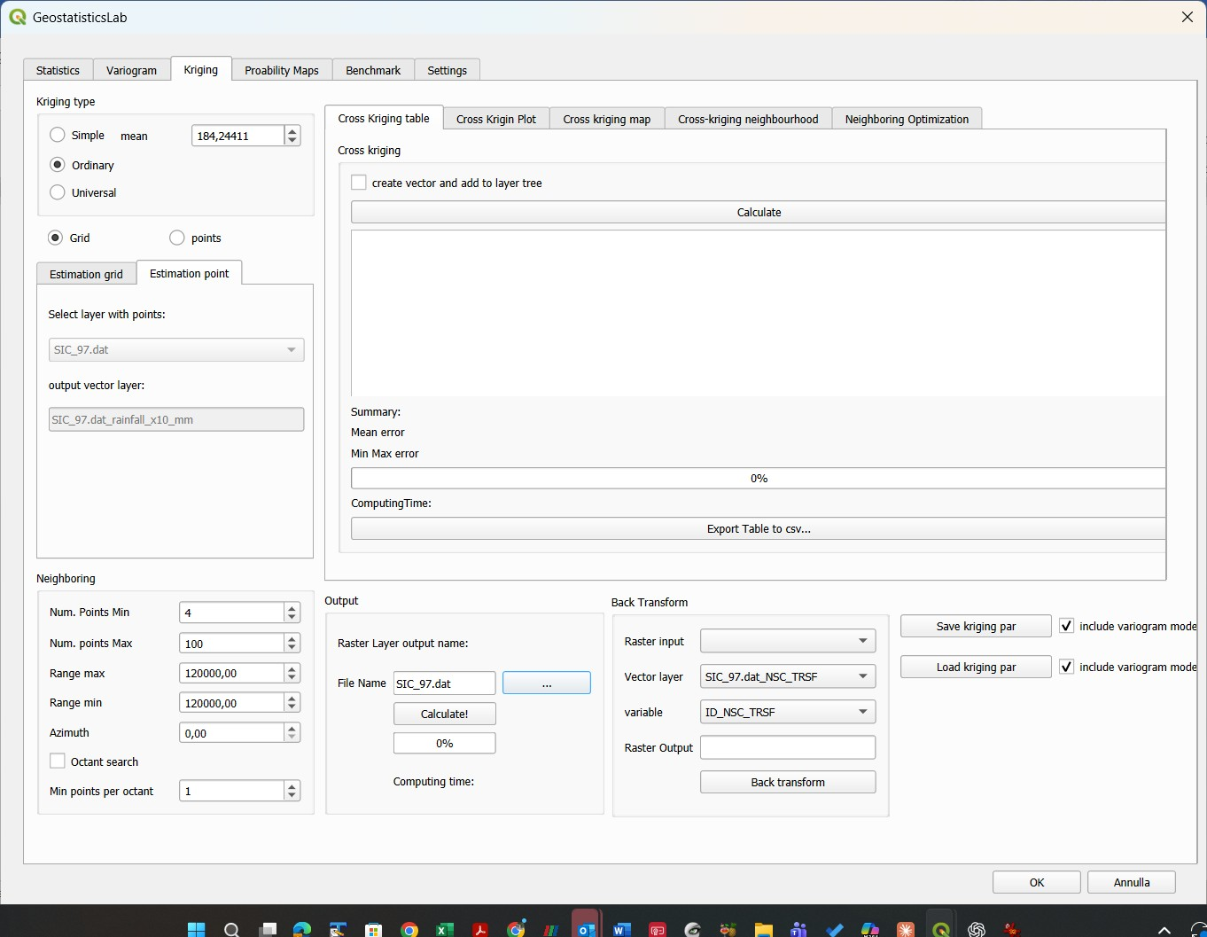
Figure 5.2 – Estimation point sub-tab: estimation at the points of an existing layer.

5.5 Output and starting the estimation
The Output group manages the name and the path of the raster (or of the vector, for the point estimation) produced:
- Raster Layer output name / File Name – name proposed as <variable>_<kriging type>.tif (for example rainfall_ok.tif), editable.
- … button – opens a dialog to choose the path and the name of the output file.
- Calculate! – starts the kriging; a progress bar shows the advancement and the Computing time label reports the time spent.

Before starting, the plugin performs some automatic checks:
- if the theoretical variogram has never been computed or adjusted, a warning invites to complete the variogram modelling first, to avoid estimates based on meaningless default parameters;
- if the layer contains duplicate coordinates, they are listed, because exact duplicates produce a singular kriging matrix; the user can proceed keeping only the first occurrence of each duplicate;
- if the output file already exists, the user can overwrite it or let the plugin generate a new indexed name (for example name_1.tif).

At the end the plugin produces a two-band GeoTIFF: the estimate and the kriging variance, added to the QGIS project.

5.6 Saving and loading the kriging parameters
New in version 2.0: the parameters of the Kriging tab can be saved in a file and loaded again, so that an analysis can be repeated or shared.
- Save kriging par – writes a .kriging_par file, a text file in the style of the GSLIB parameter files (one value or group of values per line, followed by a description after a backslash). It contains the kriging type and the mean, the choice grid/points, the grid parameters, the neighbourhood parameters, the names of the layer, of the field and of the outputs. If include variogram model is checked, the structures of the variogram model are written too.
- Load kriging par – reads a .kriging_par file and sets the widgets of the tab. The variogram model is loaded only if the include variogram model checkbox next to the button is checked. If the file cannot be read nothing is changed.

The proposed file name contains the date and time, the layer and the field; the last used folder is remembered.
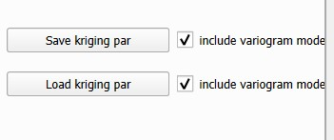
Figure 5.3 – Saving and loading the kriging parameters.

5.7 Cross-Validation
The Cross kriging group of the Cross Kriging table sub-tab validates the kriging model by leave-one-out cross-validation: each datum is removed in turn from the dataset and re-estimated with all the others, and the estimate is compared with the observed value. The variogram model, the kriging type and the neighbourhood parameters currently set are used.
- create vector and add to layer tree (checkbox) – in addition to the table, creates a point layer with the results (fields x, y, true_val, estimated, krig_var, error, error2, err2_var) and adds it to the project.
- Calculate – starts the cross-validation on all the points of the active layer; a progress bar and the computing time are shown.
- Export Table to csv… – saves the table in a CSV file.

The table has one row per point and the following columns:
Column | Meaning
X, Y | Coordinates of the point
True Value | Observed value
Estimated | Value estimated without the point itself
Krig. Variance | Kriging variance of the estimate
Error | True value − estimated value
Error2 | Squared error
Error2/Variance | Squared error divided by the kriging variance (close to 1 on average if the model is consistent)

Below the table the Summary reports the mean error (with the number of points estimated), the minimum and maximum error and the sum of the squared errors (SSE), which are synthetic indicators of the quality of the model. Points that cannot be estimated with the neighbourhood set (fewer data than the minimum) are marked and excluded from the statistics.
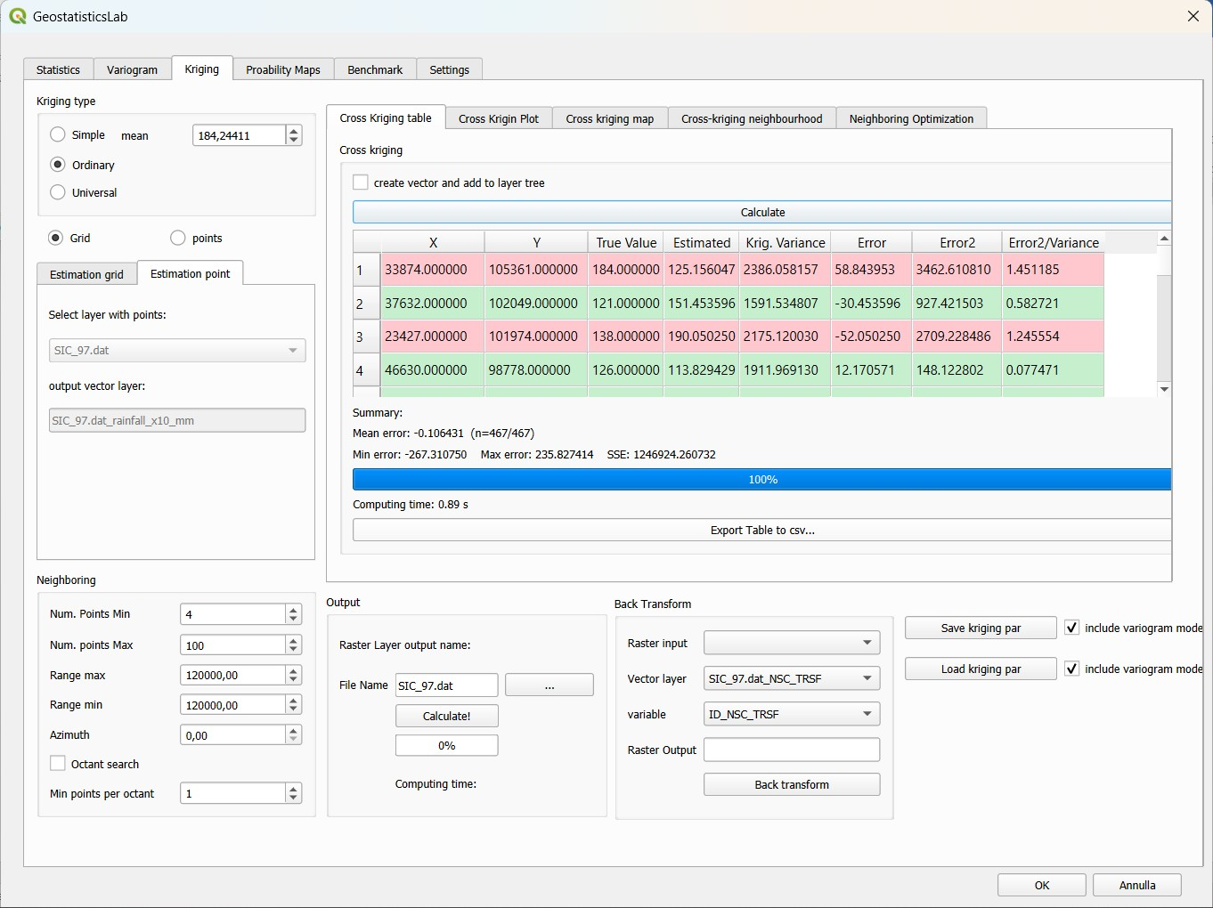
Figure 5.4 – Cross Kriging table sub-tab: results of the leave-one-out cross-validation.

5.8 Cross Kriging Plot
The Cross Krigin Plot sub-tab shows the scatter plot of the estimated values against the observed values: a good model gives points close to the bisector (estimate = observation); systematic deviations indicate bias, a large scatter a poor predictive capacity. Points above the bisector (overestimated) and below it (underestimated) have different colours. The Export plot to png button saves the plot.
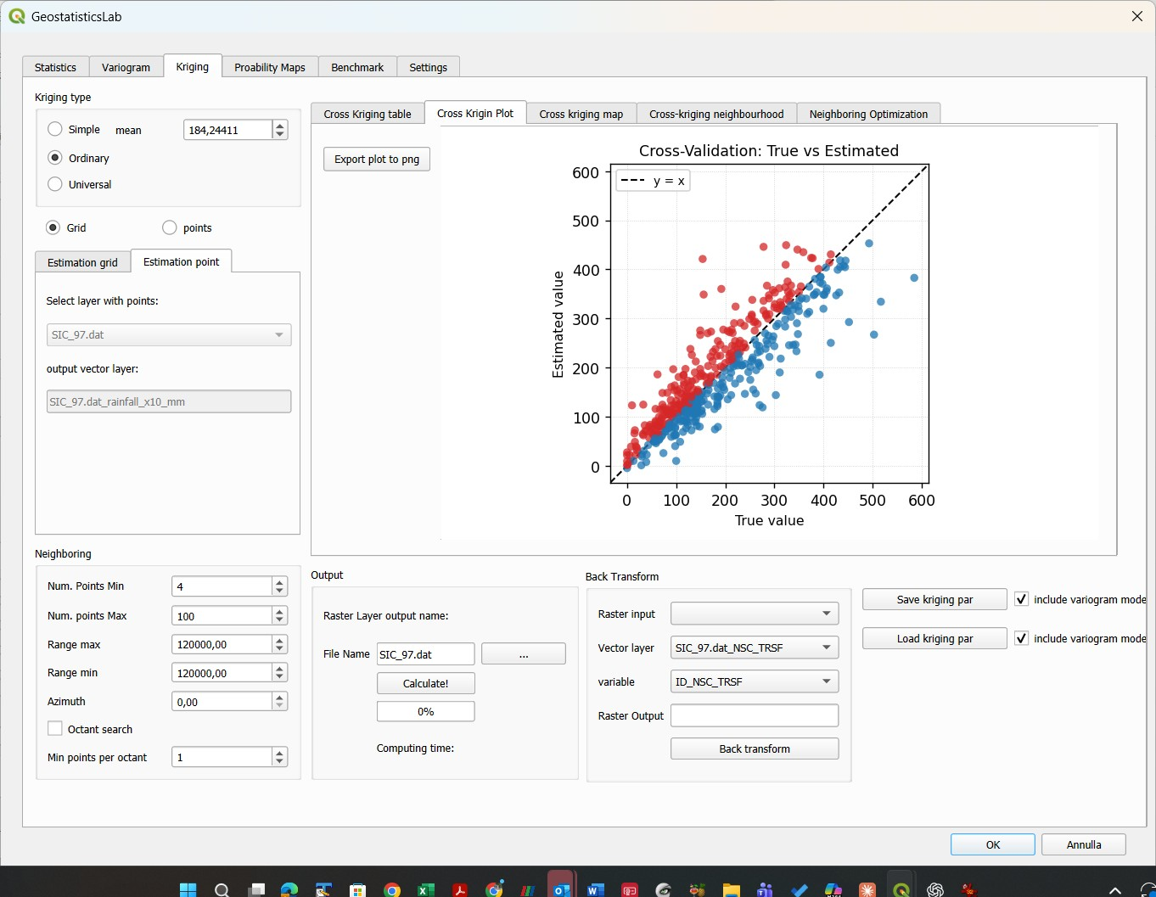
Figure 5.5 – Cross Kriging Plot sub-tab: estimated vs. observed values.

5.9 Cross kriging map
The Cross kriging map sub-tab displays the spatial distribution of the errors, colouring each point according to the sign and the size of the error (true − estimated). It is useful to find the areas where the model systematically over- or under-estimates, which suggests corrections to the neighbourhood or to the variogram model. The plot can be exported to png.
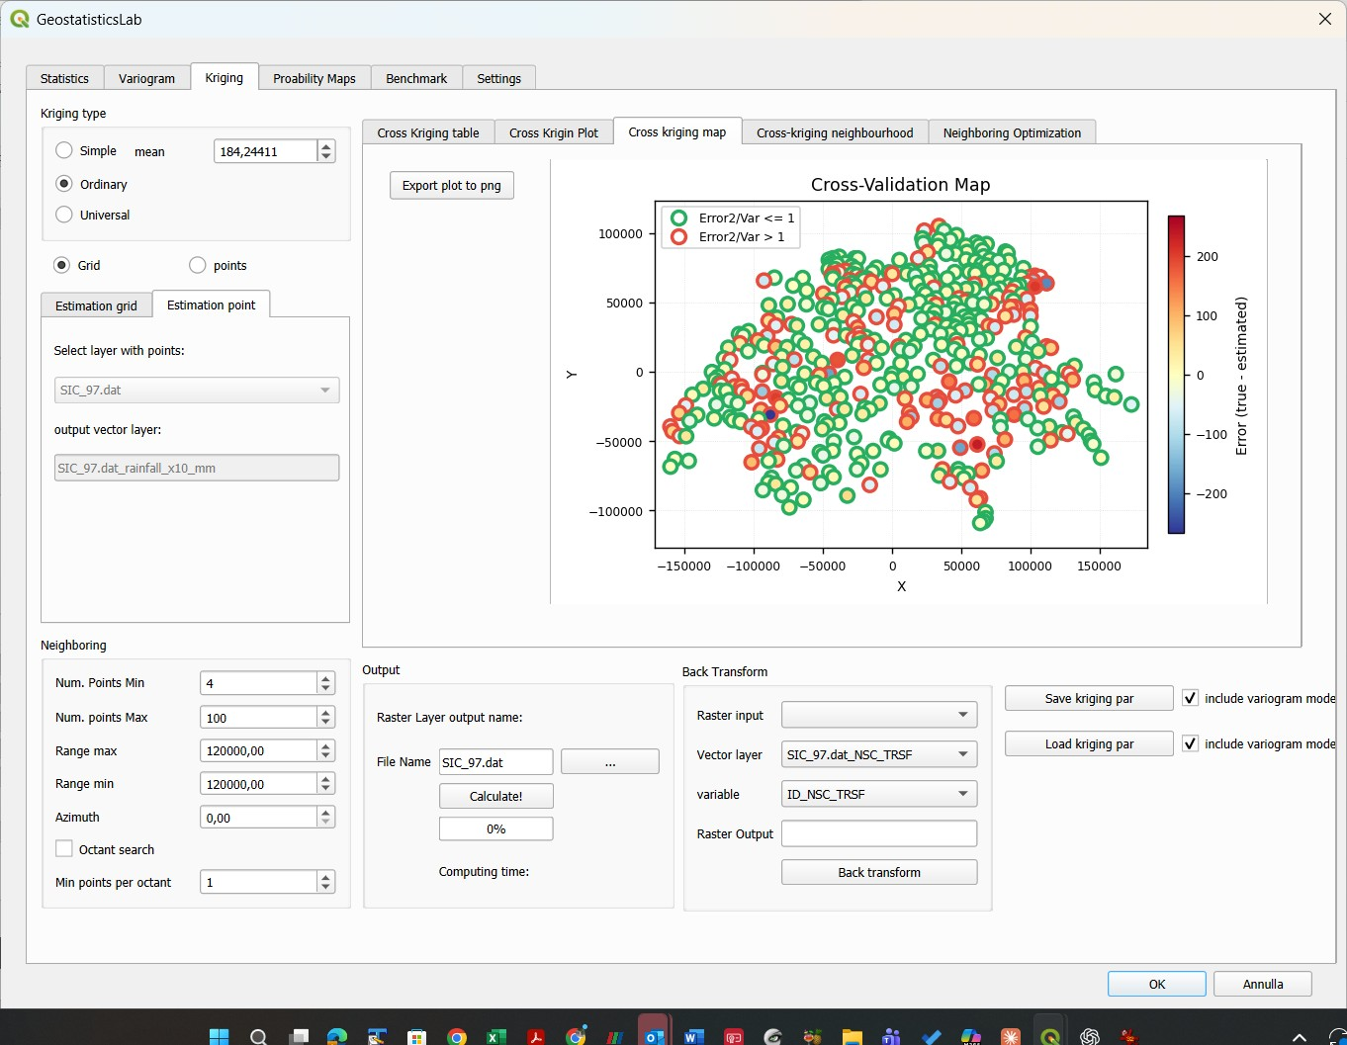
Figure 5.6 – Cross kriging map sub-tab: spatial distribution of the errors.

5.10 Cross-kriging neighbourhood
This sub-tab allows to inspect, point by point, which neighbours were used by the cross-validation and with which weight:
- Weights table (left) – the neighbours used for the selected point with their kriging weights.
- Neighbour map – the selected point (solid red circle), the neighbours used (coloured by weight, black edge), the data not used (grey edge, white fill) and the search ellipse, with equal scale on the two axes.
- <-Previous and Next-> – scroll the results point by point, updating the table and the map; a row of the results table can also be selected to jump to that point.

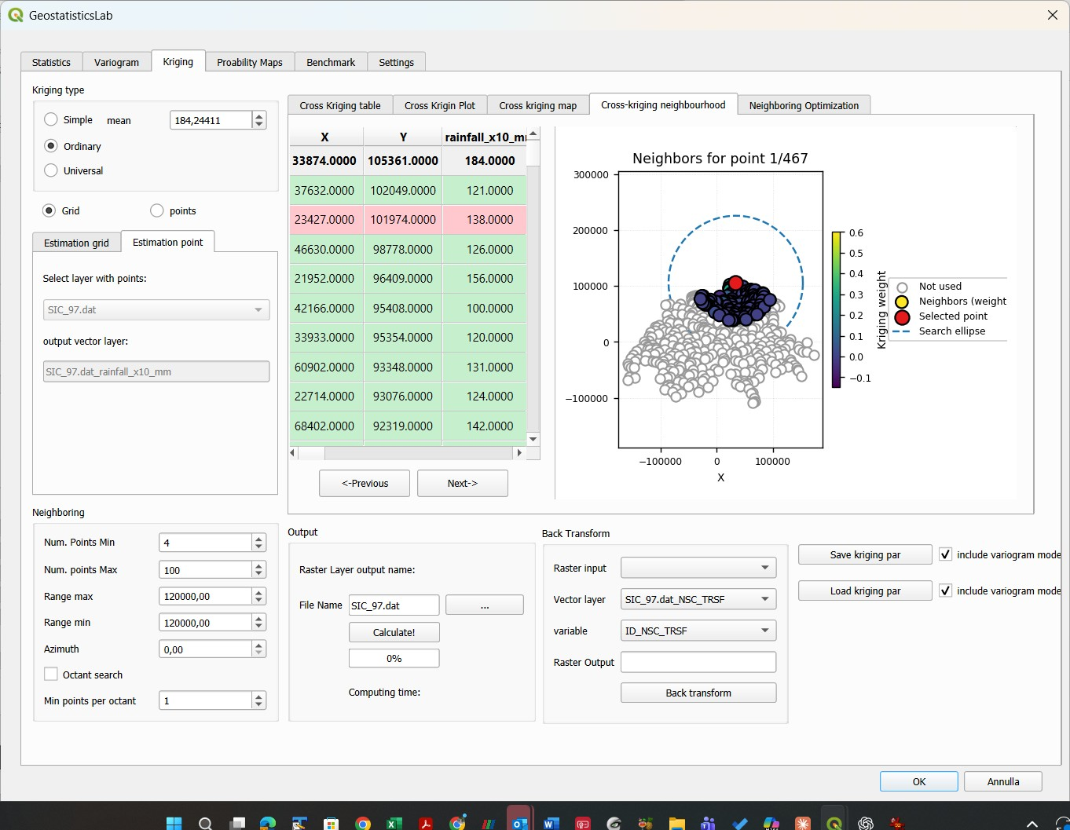
Figure 5.7 – Cross-kriging neighbourhood sub-tab: neighbours, kriging weights and search ellipse of the selected point.

5.11 Neighboring Optimization
New in version 2.0: the Neighboring Optimization sub-tab searches automatically the neighbourhood parameters that give the best cross-validation.
The search minimises the sum of the squared errors (SSE) of the leave-one-out cross-validation. The parameter sets to be tested are generated with a Latin Hypercube sampling plan within the bounds of each parameter; a set that leaves even one point without estimate is discarded, so that the SSE cannot decrease just because difficult points are skipped. The table lists the parameters that can be optimised:
Column | Meaning
Parameter | Min points, Max points, Search R max, Search R min, Azimuth, Octant search, Min pts/octant
Current value | Value in the Neighboring group at the time of the optimisation
Use | Include the parameter in the search (on by default)
Auto | The plugin sets the bounds automatically (on by default); if off, Min and Max can be edited
Min, Max | Bounds of the search for the parameter

- Num starting points – number of trials of the Latin Hypercube plan (80 by default).
- Seed – seed of the plan: the same seed gives the same trials, so the result is repeatable; if left empty a random seed is used and written in the field.
- Compute – runs the search, with a progress bar.

At the end the best parameter set is written into the widgets of the Neighboring group (if no configuration estimated all the data, the best one is proposed with a warning that reports the number of points estimated). The cross-validation can then be repeated with the new parameters.
Note: The Latin Hypercube search is a sampling plan and not an exact optimiser: the result is a good neighbourhood, not necessarily the optimal one. To check the robustness, repeat the search with different seeds, or use the optimisation benchmark of the Benchmark tab (section 7.4) to choose the number of starting points.
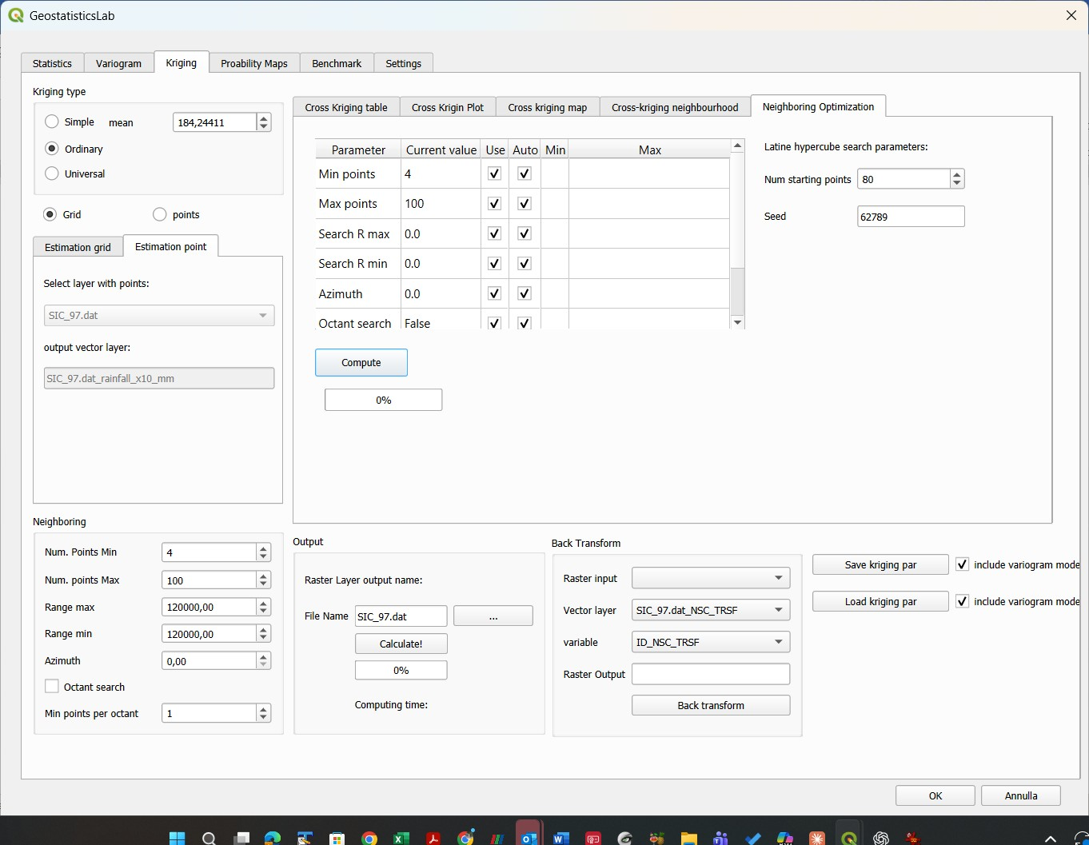
Figure 5.8 – Neighboring Optimization sub-tab.

5.12 Back Transform
The Back Transform group, at the bottom right of the Kriging tab, brings a raster estimated in the normal space (kriging performed on a variable previously transformed with the Normal Score, section 3.6) back to the space of the original variable, using the correspondence table created by the transformation.
- Raster input – raster already loaded in the project, obtained from kriging of the Normal Score variable.
- Vector layer – layer with the Normal Score transformation table (section 3.6); all the compatible layers of the project are listed.
- variable – the normal score field (suffix _NSC_TRSF) of the selected layer; the corresponding original value column is found automatically.
- Raster Output – path and name of the resulting GeoTIFF.
- Back transform – applies the inverse transformation pixel by pixel, by linear interpolation of the sorted table of original values and normal scores, and loads the result into the project. Values outside the range of the table take the minimum or the maximum of the original data.

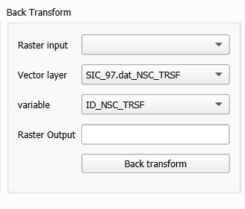
Figure 5.9 – Back Transform group: converting a raster estimated in normal space back to the original space.
Note: The back-transform requires the table layer to have been generated by the Normal Score Transform tool of section 3.6, because it relies on the naming convention of the columns (<variable>, <variable>_NSC_TRSF).

6. Probability Maps Tab
The Probability Maps tab computes, from a pair of estimate and variance rasters produced by kriging (section 5.5), the map of the probability of exceeding (or not exceeding) a critical threshold, assuming that the estimation error is Gaussian with variance equal to the kriging variance of each pixel.
This output is particularly useful in environmental and risk applications, for example to map the probability that a concentration or a rainfall exceeds a regulatory or design limit.

6.1 Input parameters
- Estimated data – estimate raster (first band of the kriging result), chosen among the rasters of the project.
- Variance data – kriging variance raster (second band of the same result); it must have the same dimensions as the estimate.
- threshold value – threshold with respect to which the probability is computed.
- Output: higher / Lower – higher gives the probability of exceeding the threshold, P(Z > threshold); Lower the probability of not exceeding it, P(Z ≤ threshold).
- Output name – name of the new raster; if left empty, <variable>_prob_<threshold> is proposed.
- Run! – computes the map pixel by pixel and adds it to the project.

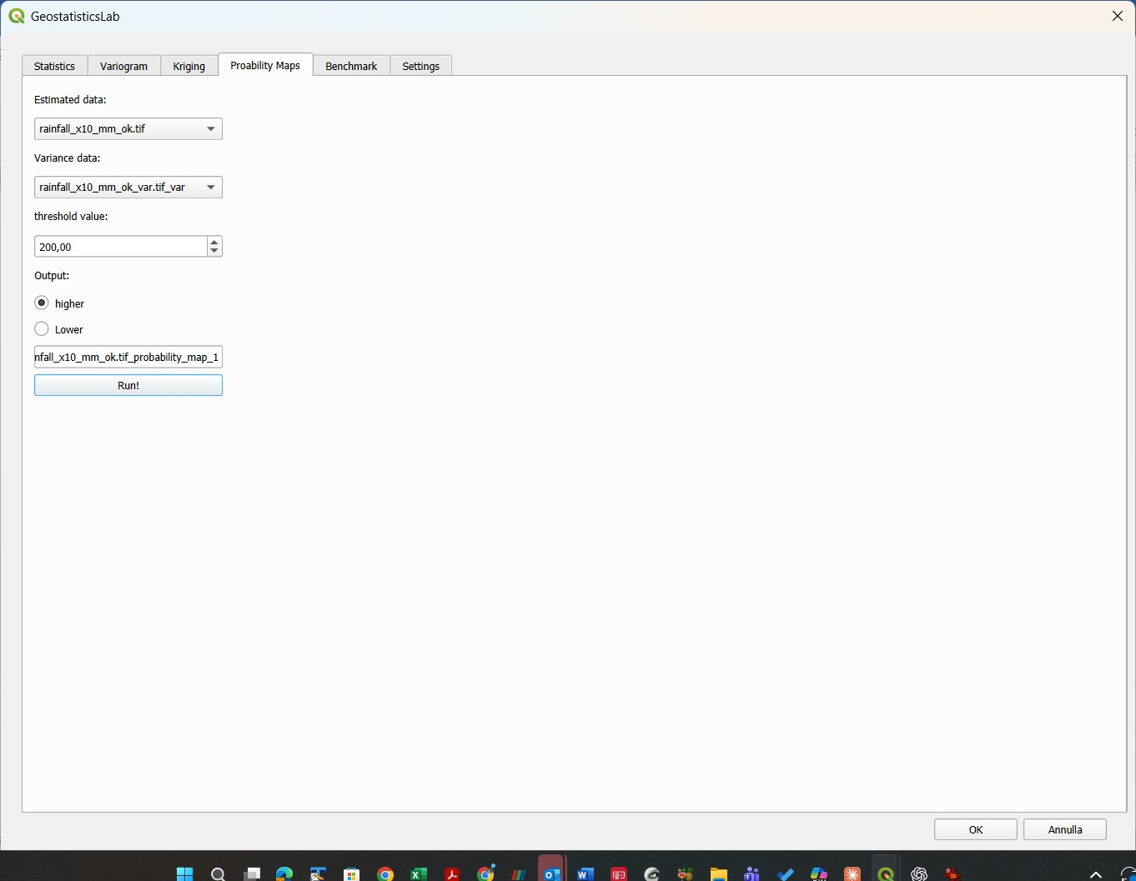
Figure 6.1 – Probability Maps tab: estimate and variance rasters, threshold and direction of the calculation.
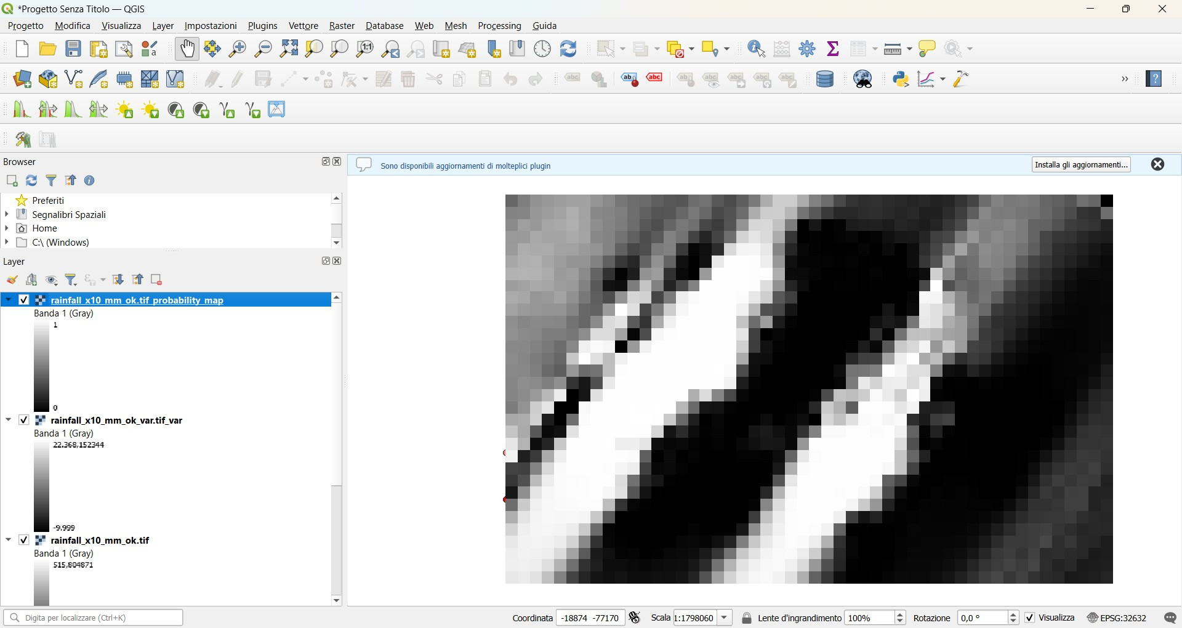
Figure 6.2 – Example of a probability map displayed in QGIS.

6.2 Notes on the computation
The calculation uses the Gaussian probability formula on each valid pixel (where estimate and variance are finite numbers and the variance is positive):
P(Z > threshold) = 1 − Φ((threshold − estimate) / σ) [higher]
P(Z ≤ threshold) = Φ((threshold − estimate) / σ) [Lower]
where Φ is the cumulative distribution function of the standard normal distribution and σ the square root of the kriging variance of the pixel.
The resulting raster is created entirely in memory (GDAL /vsimem/ driver) and is never written to disk automatically: it is displayed immediately in QGIS without temporary files. To keep it, export it from QGIS (Raster Layer → Save As…).
Note: Pixels where the estimate or the variance are not valid (NoData, non-finite values, zero or negative variance) are set to the NoData value (−9999) in the probability raster too.

7. Benchmark Tab
New in version 2.0: the Benchmark tab measures the computing time of the most demanding routines of the plugin on the computer of the user. It is used to document the performance and to estimate the time needed for a given dataset.
The tab has three groups of tests, whose results are shown in a table and in a plot (sub-tabs Table and Plot), a box with the description of the hardware and software, and the buttons to export the table (CSV) and the plot (PNG). The hardware box (processor, cores, memory, operating system, versions of QGIS, Python, NumPy, Matplotlib and GDAL) is written automatically and can be copied into a report or a paper.

7.1 Variogram benchmark
The test measures the time of the experimental variogram as a function of the number of points. For k = 1 … Exponent the plugin creates a layer with Base^k random points in a square field of side Field Size, and computes on it the experimental variogram with 11 lags (the last at the side of the field), for 1, 2 and 4 directions, with the same routine of the Variogram tab. The other parameters are fixed (first azimuth 0, angular tolerance 90° / number of directions, no bandwidth, no weights, no normalisation).
- Field Size (m), Base, Exponent – side of the field and number of points of each layer (the defaults, Base 2 and Exponent 12, give layers from 2 to 4,096 points).
- Remove layers after computation – removes every test layer from the project as soon as its variograms are computed.
- Run Vario Benchmark – starts the test.

The table has the columns Layer, N. points and the times for 1, 2 and 4 directions. The time is that of the search of the pairs and of the estimator; the reading of the points from the layer and the drawing of the plot are not included.
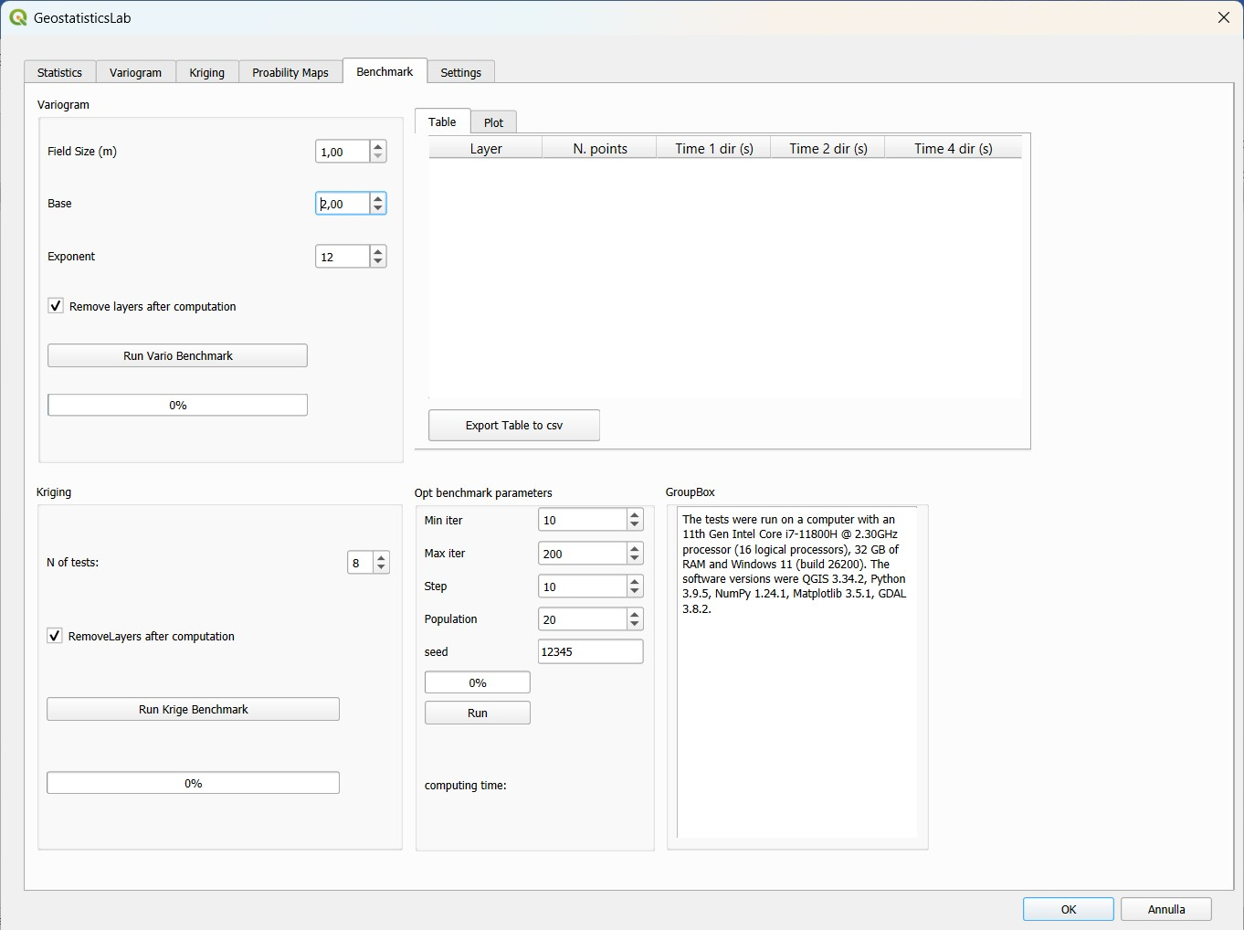
Figure 7.1 – Benchmark tab: variogram benchmark, results table and hardware description.
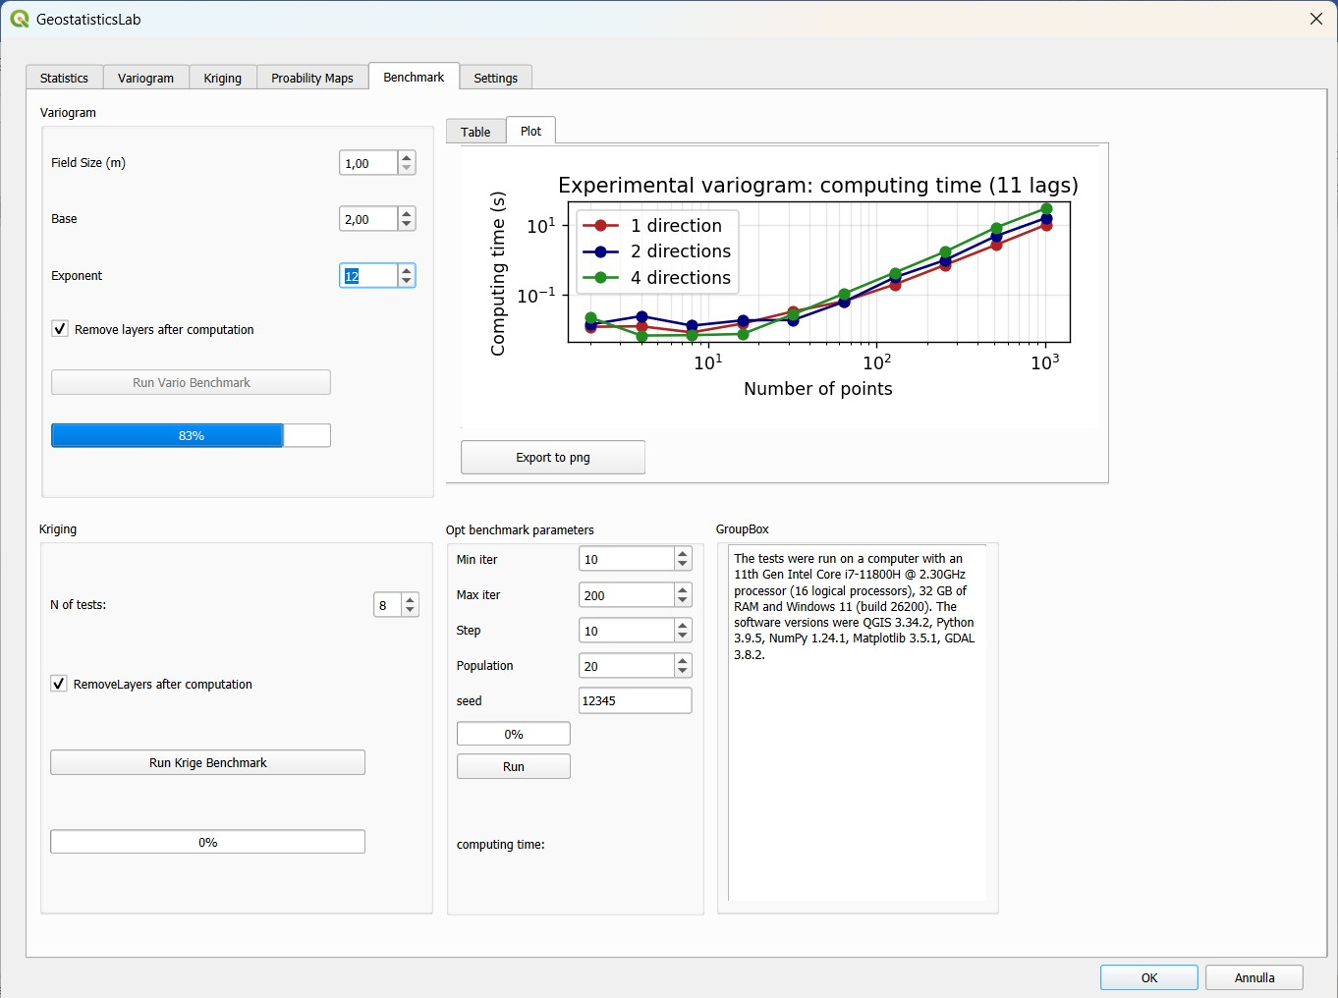
Figure 7.2 – Variogram benchmark plot.

7.2 Kriging benchmark
The test measures the time of the kriging as a function of the number of estimated nodes. It uses the data layer and field, the kriging type, the neighbourhood and the variogram model currently set in the GUI; a variogram model must therefore be defined before. The grid of the Kriging tab is test 1; in test k the extent is the same, while Nx and Ny are multiplied by k, so that the number of nodes grows as k². The timed part is the estimation of the grid (the same code as the Calculate! button); the building of the rasters is not included.
- N of tests – number of grids tested.
- RemoveLayers after computation – removes the in-memory rasters created by the test.
- Run Krige Benchmark – starts the test. The table has the columns Test, nx, ny, N. nodes and Time (s).

7.3 Optimisation benchmark
The test answers the question: how many starting points does the neighbourhood optimisation (section 5.11) need? For a number of starting points n that goes from Min iter to Population in steps of Step, the Latin Hypercube search is repeated Max iter times (number of repetitions) with n starting points, using the model and the parameters of the GUI. The minimum, the maximum and the mean of the cross-validation SSE over the repetitions are written in the table (columns Starting points, Min SSE, Max SSE, Mean SSE, Valid runs) and plotted against n. A repetition whose trials all leave some point unestimated has no valid solution and is not counted.
- Min iter, Max iter, Population, Step – parameters of the test as described above.
- seed – seed of the test; the seed of each repetition is derived from it, so the whole benchmark is repeatable.
- Run – starts the test; while it is running the button becomes Stop, and the rows already computed are kept. The computing time is shown in a label. The parameters of the GUI are never modified.

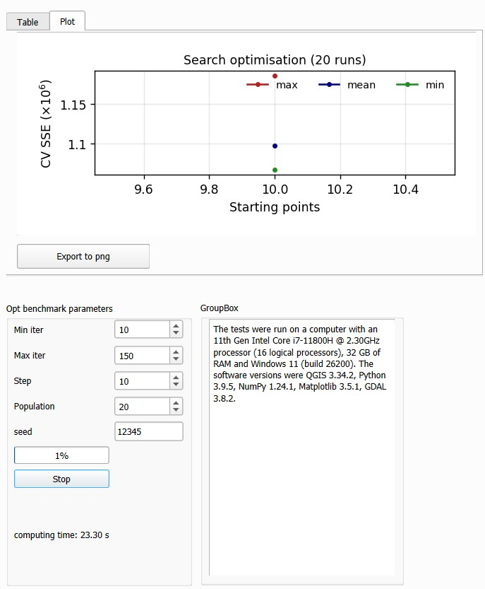
Figure 7.3 – Optimisation benchmark: SSE of the neighbourhood optimisation (plot sub-tab).

8. Settings Tab
New in version 2.0: the Settings tab customises the appearance of every plot of the plugin, for example to prepare the figures of a report or of a paper. The settings are saved automatically and loaded at the next session.

8.1 How it works
The tab has, on the left, the list of the plots of the plugin and, on the right, the properties of the plot selected in the list. A change is applied at once to the plot that is currently displayed (if it has already been drawn) and to the next drawings, and it is kept in the PNG files exported from the plot.
The plots in the list are: Histogram, Q-Q plot, Declustering, Variogram / AutoVar, Variogram map, Variogram map (3D), Cross-validation scatter plot, Cross-validation map, Cross-validation selected point and neighbours, and Benchmark.
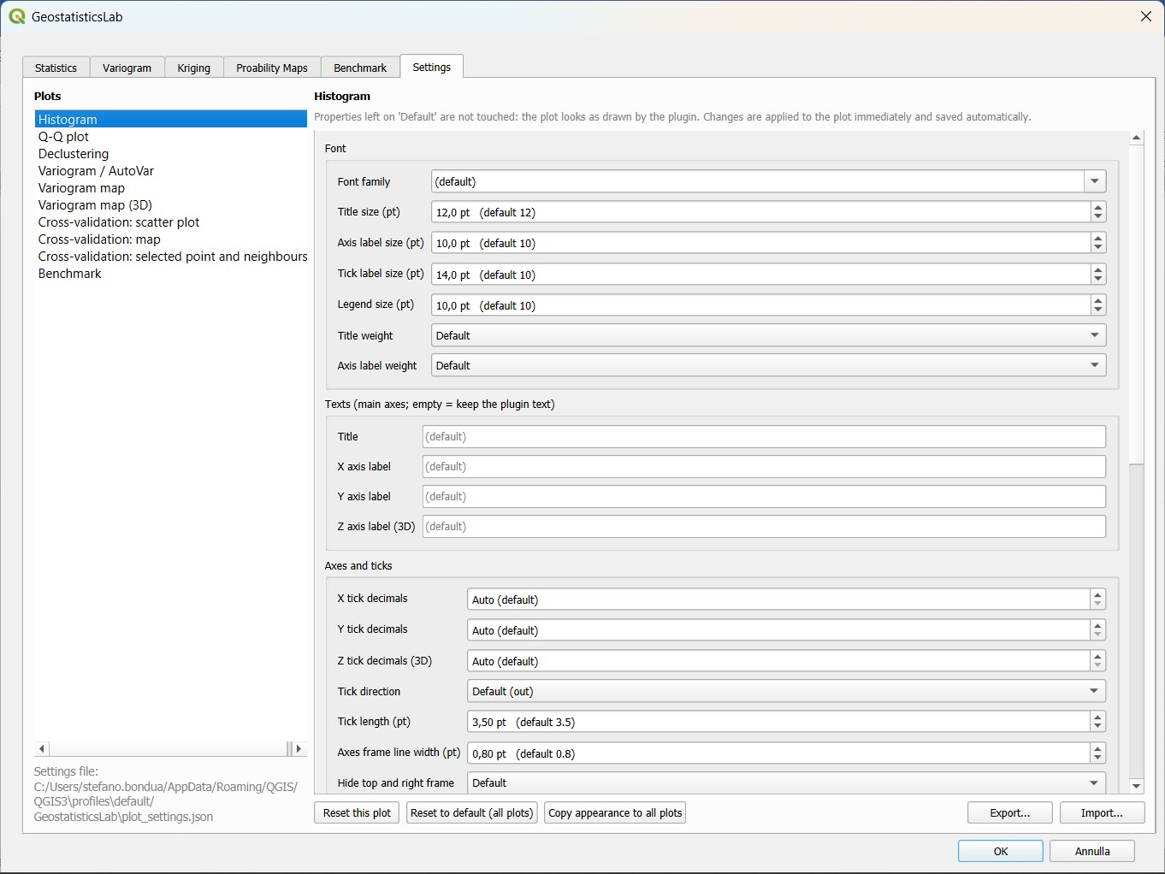
Figure 8.1 – Settings tab: list of the plots and editor of the properties.

8.2 Properties that can be customised
Each property shows the value used by the plugin for that plot, with the text “(default …)” next to it, and starts from that value; a property left at its default is never changed. The available properties are:
Group | Properties
Font | Font family; sizes of the title, of the axis labels, of the tick labels and of the legend; weight (normal/bold) of title and axis labels
Texts | Title and labels of the X, Y and Z axes (the text of the plugin is kept if the field is empty)
Axes and ticks | Number of decimals of the tick labels for X, Y and Z; direction and length of the ticks; line width of the frame; hide the top and right sides of the frame
Grid | Show or hide; line style (solid, dashed, dotted, dash-dot); line width
Lines and markers | Scale factors for the width of the lines and for the size of the markers
Legend | Show or hide; position; frame
Colours | Background of the figure and of the axes
Axis limits | Minimum and maximum of the X and Y axes (empty = automatic)

Note: Title, axis labels and limits act on the main axes of the plot (for the Q-Q plot, on the left panel). A limit that is set is kept also for other data: if a plot looks cut, clear the field.
Note: Font sizes lower than 4 pt cannot be set. The colour map of the variogram map and of the error maps cannot be changed from this tab.

8.3 Buttons
- Reset this plot – restores the default appearance of the selected plot.
- Reset to default (all plots) – restores the default appearance of all the plots, after confirmation. The plots already drawn return immediately to the aspect given by the plugin, without recomputing anything.
- Copy appearance to all plots – copies the settings of the selected plot (except texts and axis limits, which belong to each plot) to all the others, to obtain a uniform style.
- Export… / Import… – saves the settings in a JSON file or loads them from a file, for example to use the same style on another computer.

8.4 Where the settings are stored
The settings are written, at every change, in the file plot_settings.json in the folder GeostatisticsLab of the QGIS profile (the path is shown at the bottom of the list of plots). At start-up the file is read again, so the plots keep the same appearance from one session to the next. Only the properties that differ from the default are stored; values that are not valid are ignored. To return to the original appearance it is enough to use Reset to default or to delete the file.
Tip: For a figure for a publication: choose a font family and sizes, increase the tick label size, set the decimals of the ticks and hide the top and right frame; use Copy appearance to all plots; then export the images with the resolution required by the journal.

9. Recommended Workflow
Although the tabs of the plugin can be used independently, the typical workflow for a complete geostatistical analysis, valid for both sic97.dat and walker_lake_samples_.dat, is the following:
- Load the .dat file as a delimited text layer in QGIS (section 2.2).
- In the Statistics tab select the layer and the variable and press Run Analysis to examine the statistics and the histogram.
- If the samples are not uniformly distributed, use the Data Declustering sub-tab to generate a layer with the declustering weights.
- If needed (for example for strongly skewed data), apply the Normal Score Transform and verify its effect with the Q-Q plot sub-tab.
- In the Variogram tab compute the variogram map to identify the direction of anisotropy, then compute the directional experimental variogram with the azimuth found (fixed lag or auto lag spacing).
- Build the theoretical model manually, with Autofit (choosing the weights in the advanced sub-tab) or with AutoVar, checking the fit error and the visual appearance of the curve over the experimental data. Export the model if it is needed in other software.
- In the Kriging tab set the kriging type, the grid and the search neighbourhood (compatible with the ranges of the model).
- Run the Cross-Validation and examine the table, the scatter plot and the error map; if needed, use the Neighboring Optimization to improve the neighbourhood and repeat the cross-validation.
- Save the parameters with Save kriging par, so that the analysis can be repeated.
- When the model is satisfactory, press Calculate! to produce the estimate and variance rasters.
- If the kriging was performed on a Normal Score variable, apply the Back Transform.
- Finally, use the Probability Maps tab to obtain the exceedance probability maps for the thresholds of interest.
- Customise the plots in the Settings tab and export the figures to PNG; use the Benchmark tab if the computing times must be documented.

Tip: For sic97.dat the workflow is well suited to produce a map of the probability of exceeding a rainfall threshold; for walker_lake_samples_.dat it is useful to compare Ordinary and Universal Kriging on the variable V, validated by cross-validation.

10. Appendix: Interface Controls Summary
The following tables summarise the main controls of each tab, as a quick reference.

10.1 Statistics Tab
Control | Function
Point layer / Field | Selects the layer and the variable to analyse
Run Analysis | Computes the descriptive statistics and draws the histogram
Show cumulative histogram | Overlays the cumulative frequency curve
Transformed variable / Calculate (Q-Q plot) | Compares the normality of the original variable and of its Normal Score transform
Auto / user defined, Cell Size, min/max/steps, Decluster | Computes the declustering weights and the diagnostic curve
New vector layer / Transform | Applies the Normal Score Transform
Export to png | Saves the plot (histogram, Q-Q plot, declustering) as an image

10.2 Variogram Tab
Control | Function
fixed lag / auto lag spacing | Lag spacing mode (manual or automatic)
MaxDistance, num_lags, lag, lag_tolerance | Distance parameters of the experimental variogram
azimuth, Number of directions, angular_tolerance | Directions analysed and angular tolerance
bandwidth | Maximum lateral width of the directional sector
use_decl.weights | Weights the pairs with the declustering weights
Show num pairs, Show h box plot, Show var box plot | Display options of the experimental variogram
Normalize by variance, Effective distance | Normalised semivariance; plotting at the mean distance of the pairs
Calculate (Variogram) | Computes the multi-directional experimental variogram
Export Variogram to csv / png | Exports the experimental variogram
add / remove structure | Manages the structures of the theoretical model
Auto Fit, Num of autofit struct | Automatic search of the theoretical model
Settings (sub-tab) | Models allowed in Autofit
advanced (sub-tab) | Weights of the objective function and constraint on the sill
Run AutoVar, Save output results, Reproduce AutoVar behaviour | Automatic variogram calculation and modelling (AutoVar)
Export variogram model | Exports the model as a GSLIB text file
Calculate (Variogram Map) | Computes the 2D polar variogram map
Camp. princ. directions | Computes and draws the principal directions of anisotropy
Variogram Model (3D) | Overlays the theoretical model on the 3D surface

10.3 Kriging Tab
Control | Function
Simple / Ordinary / Universal | Selects the kriging type
Num. Points Min/Max, Range max/min, Azimuth | Geometry of the search ellipse
Octant search, Min points per octant | Search by octants
Grid / points | Estimation on a regular grid or on a point layer
Calculate! | Starts the kriging and produces the output raster (or layer)
Save kriging par / Load kriging par | Saves or loads the kriging parameters (and, optionally, the variogram model)
Calculate (Cross kriging) | Starts the leave-one-out cross-validation
Export Table to csv | Saves the results of the cross-validation
<-Previous / Next-> | Navigates the cross-validation results point by point
Neighboring Optimization: Compute, Num starting points, Seed | Searches the best neighbourhood parameters
Back transform | Brings a raster from normal space back to the original space

10.4 Probability Maps Tab
Control | Function
Estimated data / Variance data | Estimate and variance rasters used as input
threshold value | Threshold used in the probability computation
higher / Lower | Direction of the calculation (exceedance / non-exceedance)
Run! | Computes the probability map and adds it to the project

10.5 Benchmark and Settings Tabs
Control | Function
Field Size, Base, Exponent, Run Vario Benchmark | Computing time of the experimental variogram vs. number of points
N of tests, Run Krige Benchmark | Computing time of the kriging vs. number of nodes
Min iter, Max iter, Population, Step, seed, Run | Benchmark of the number of starting points of the neighbourhood optimisation
Table / Plot, Export to csv / png | Results of the benchmarks
List of plots, properties | Appearance of each plot (saved automatically)
Reset this plot / Reset to default (all plots) | Restore the default appearance
Copy appearance to all plots, Export / Import | Uniform style; exchange of the settings

10.6 References on the example datasets
- sic97.dat – Dubois, G. (ed.), “Spatial Interpolation Comparison 1997”, Journal of Geographic Information and Decision Analysis, 2(2), 1998; rainfall dataset used as a benchmark for spatial interpolation methods.
- walker_lake_samples_.dat – Isaaks, E. H. & Srivastava, R. M., “An Introduction to Applied Geostatistics”, Oxford University Press, 1989; teaching dataset sampled from the original Walker Lake dataset.

