Packet Tracer

Set secret password

* Enable
* Config terminal
* Enable secret [password]

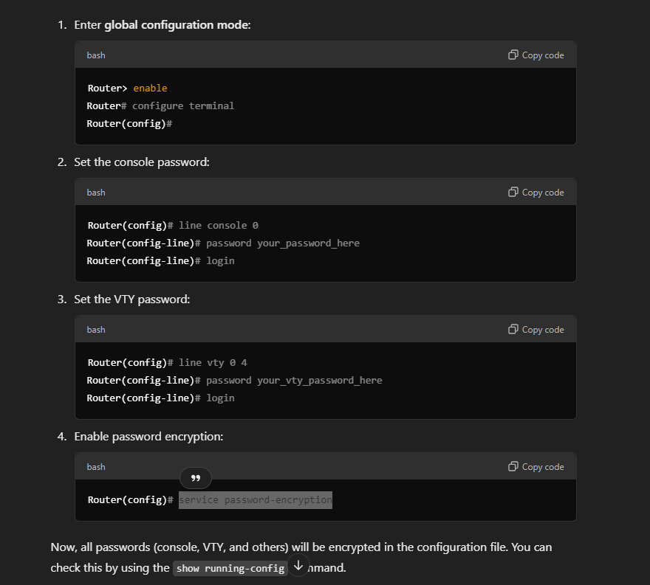

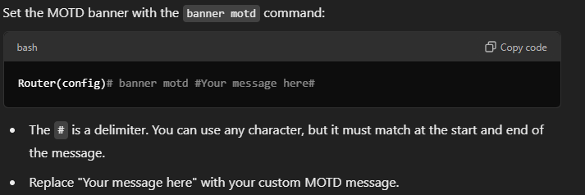

* enable
* config terminal
* line console 0
* see below

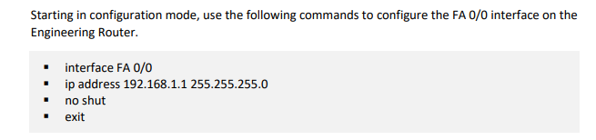

If in config > *do showing running* to display running config

Issue: RIP connections not showing

The following was seen:

Router#show ip int br

Interface IP-Address OK? Method Status Protocol

FastEthernet0/0 192.168.1.1 YES manual up up

FastEthernet0/1 192.168.2.1 YES manual up down

Vlan1 unassigned YES unset administratively down down

RECONNECTED CABLE AND SET NETWORK VALUES AGAIN

* show ip route
* show ip route rip